
l
Date: ________________________
Series: Meet the Amazing Jesus
Dec-Mar Year 3, Lesson 43

Be Raised from the Dead

Take Home Point: *Jesus has power over death.
*Repeat this phrase throughout the lesson.

Bible Event: Luke 8:40-56. Jesus raises Jairus’ daughter
Key Verse: John 11:25-26, “Jesus said to her, ‘I am the One who brings people back to life, and I am life itself. Those who believe in Me will live even if they die. Everyone who lives and believes in Me will never die.’“

We will help kids know:
- The Bible event of Jesus raising Jairus’ daughter to life.
- Jesus has power over death. This was demonstrated through His death and resurrection given for us.
- Jesus called His people to have faith in Him and not give up.

We will help kids feel:
- Amazed at Jesus’ power over death and His ability to give life to us.
- Protection from any fears of dying we might have.

We will help kids do:
- Identify the biggest thing they have ever asked God to do.
- Pray with confidence that God will make them alive if they die.
- Learn a card trick with which they can tell others about Jairus’ daughter being raised through Jesus’ power.

THIS LESSON’S ROADMAP

DESTINATION | PAGE # | DISCOVERIES ON YOUR JOURNEY | SUPPLIES NEEDED
  Small Group Warm-Up | 3 | Kids try to do the impossible: pick up an ice cube with only a piece of yarn. They are challenged to think of impossible requests they have asked of God. | - 12” strand of yarn for each group  - a large ice cube for each group  - a tablespoon of salt on a serviette for each group
Large Group   | 3  9  10  12 | Overview  Video: “The Miracle Maker,” by Family Home Entertainment, Inc. – the Bible event from Luke 8:40-56. Cue the video to start when Jairus returns home from the feast to his sick daughter. Stop the video when Jesus raises the girl from the dead and she begins to dance around.  Object Lesson: Illustration of Jesus Raising Jairus’ Daughter from Death: The presenter uses a card illusion to retell the Bible event.  Dao Dao’s Review Questions: Dao Dao helps kids review the main points in the Bible event. | - large sign that reads “Meet the Amazing Jesus”  - smaller signs hung in the front of the room, each with the word “amazing” printed on it  - Dao Dao  - the animated video, “The Miracle Maker ,” by Family Home Entertainment, Inc., 1999. www.booksofthebible.com  - two identical decks of cards  - a sport coat with an inside breast pocket
Small Group Application   | 4 | Kids learn a card trick with which they can tell others about Jairus’ daughter being raised through Jesus’ power.  Memory Verse Learning:  “Written On Linen”  John 11:25 will be emphasized in lessons 43-45 that each child be amazed at Jesus’ power over death and His ability to give life to us. | - deck of cards  - whiteboard and marker  - a strip of 60cm linen cloth for each child
Small Group Warm-Up: 15 minutes
Purpose: Get pointed in the right direction! Build relationships and help guests feel at ease. Do the learning readiness activity that will point your group in the right direction for the lesson.

Supplies needed: 12” strand of yarn for each group, a large ice cube for each group, a tablespoon of salt on a serviette for each group

Ask the kids to think about something that is impossible to do. Then give them the following challenge.

Set out one 12” strand of yarn, a large ice cube, and a tablespoon of salt on a serviette. Ask the kids to lift the ice cube without touching it using only the other supplies. They can only touch the yarn with one hand. The kids will have a fun time trying to figure out possible answers.

The solution is simple. Pour the salt on the top surface of the ice cube. Hold one end of the yarn and dangle the other end over the top of the ice cube. Lay on top of the ice cube as much of the yarn as possible. As the ice melts, the water will freeze and stick to the yarn. After a couple minutes, the ice cube can be picked up with the yarn.

As the children discuss the solution to this feat, ask them if they have ever asked anything of God that seemed to be impossible. Let the kids discuss things they or other people have asked for. Talk about how God can do the things that seem impossible to us.

Today we are talking about one of those seemingly impossible things that only God can do. A man, Jairus, prayed that God would heal his twelve-year-old daughter. It seemed impossible that Jesus could heal her because she had already died. But today we will discover that *Jesus has power over death.

Large Group Overview: 20-30 minutes
Purpose: Help kids observe what the Bible says. Present the Bible event in creative fashion. Help kids begin to interpret what it means.

Video: “The Miracle Maker,” by Family Home Entertainment, Inc. – the Bible event from Luke 8:40-56. Cue the video to start when Jairus returns home from the feast to his sick daughter. Stop the video when Jesus raises the girl from the dead and she begins to dance around.

Object Lesson: Illustration of Jesus Raising Jairus’ Daughter from Death—the presenter uses a card illusion to retell the Bible event.

Dao Dao’s Review Questions: Dao Dao helps kids review the main points in the Bible event.
Small Group Application: 20-25 minutes
Purpose: Help kids map out the meaning of the Bible event in their lives. Use the questions to stimulate discussion but don't feel tied to them. Allow the Holy Spirit to guide you. Include personal examples from your own faith journey. The example of Christ at work in your life will leave lasting impressions of how Christ can work in the children's lives.

Use your Bibles! Children need to learn how to look up references and follow along when scripture is read aloud. Allow for quality time of prayer at the close of the lesson.

Observation Questions: What happened?
Have kids find Luke 8: 40-56.

Why did the synagogue leader, Jairus, beg Jesus to come to his house? (Luke 8:42. His only 12 -old daughter was dying.)

Did Jesus seem to be in a hurry to get to Jairus’ house? How did He show this? (Luke 8:43-48. No. He stopped to find out who had touched Him and received healing. Then He had a conversation with this woman before going to Jairus’s house.)

What did Jesus say to Jairus when someone came and told him his daughter was dead? (Luke 8:50. He said, “Don’t be afraid! Just believe, and she will get well.”)

Why did the sad people at Jairus’ house laugh at Jesus? (Luke 8:52-53. Because Jesus said to them, “Don’t cry! She’s not dead. She’s just sleeping.” These people thought that was impossible.)

What were the people’s reactions to Jesus bringing the girl back to life? (Luke 8:56. They were amazed.)

Interpretation Questions: What does this mean?
Why do you think Jesus ordered the girl’s parents not to tell anyone He had brought her back to life? (Maybe He didn’t want people to think of Him just as a healer, but that He also came to bring spiritual healing for our sins.)

Application Questions: What does this mean to me?
Today we want to let kids talk about any of their fears of dying. We want to make sure they find security in Jesus’ promise to them. He has promised to give them life with Him forever, even after they die. All we have to do is trust in Him as our Savior since Jesus has power over death. Because of that, we don’t need to worry about what happens to us after we die. We will have a great time in heaven with Jesus!

How often do you think about dying? Is it something that is scary to you? Let kids discuss.

We don’t need to think about dying very often. That’s because God wants us to spend most of our time thinking about how we can live our very best for Him right now. But when we do think about it, we don’t need to be scared. We can know for sure that *Jesus has power over death. Just as sure as He raised Jairus’ daughter from the dead, so He will do for all people who trust in Him.

To discuss this application, begin with the trick “Flip Flop to the Top.” The trick will make a certain card come to the top of a deck. The trick reminds us how God has given us the power of resurrection. As we trust in Jesus as our Savior, we come to the top of the “deck.” We will live with Jesus in heaven. Kids can even show the trick at home and it will help them share the Bible truth: *Jesus has power over death.

Take a regular deck of cards and shuffle them. Fan the cards out to show everyone that it is a regular deck of cards. As you do so, note what the top card is. (In this illustration, it is the jack of diamonds.)

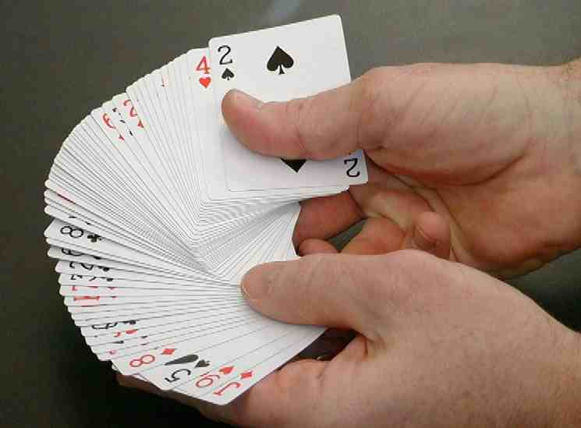

Place the deck face down. Ask someone to cut a section of cards off the top of the deck.
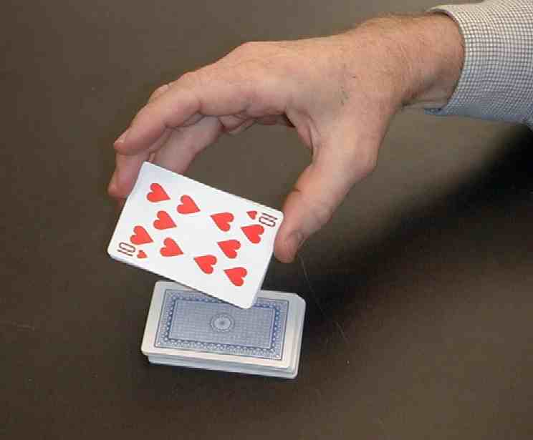

Flip this section over and set it back down on the deck. At this point you will have one section of cards facing down and one section facing up.
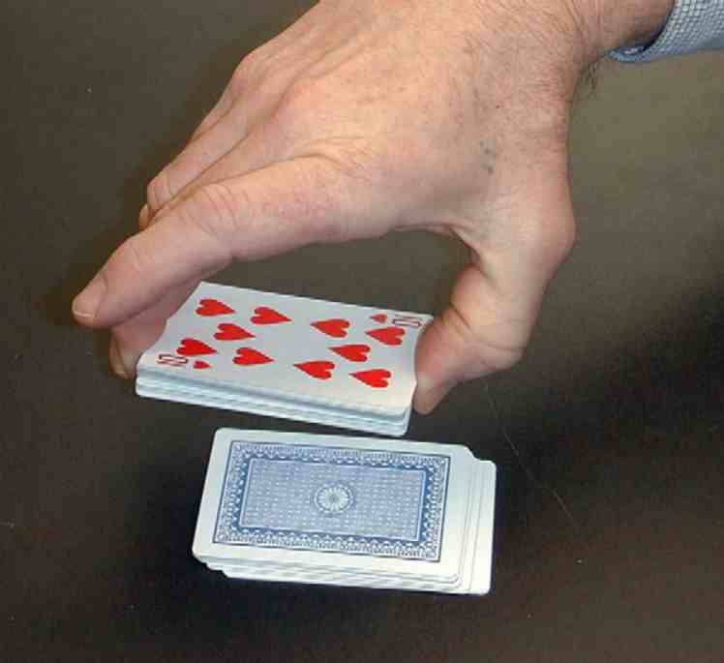

Ask a person to cut the deck again. This time the child is to cut a little bit deeper into the deck. Flip this entire section over and place it on top of the deck.

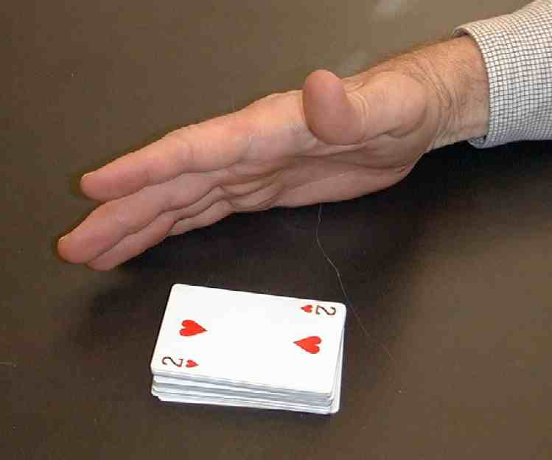

Though the deck has been cut twice, there will still only be one section of cards face up and another section of cards face down. The top section will be face up.

If you remove all of the face up cards that are on top of the deck, the very first face down card will be the original top card. The original top card is the one you took note of at the very beginning of the trick.

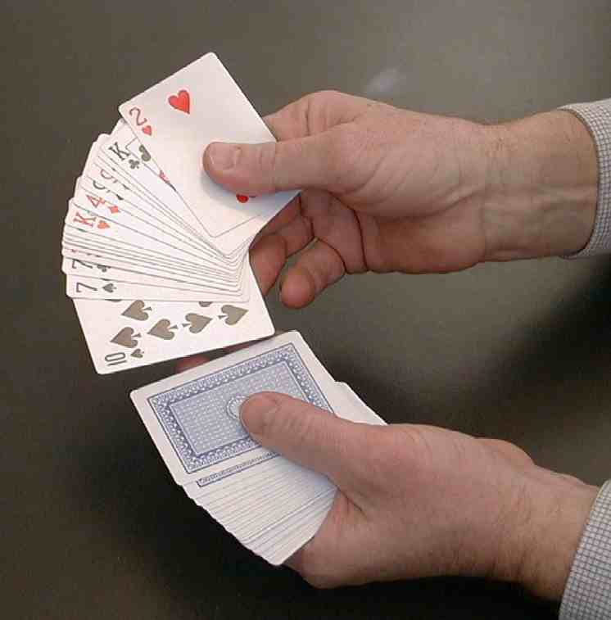

Announce that you can make a certain card come to the top of the deck. Say what the card is as you tap the top of the deck.

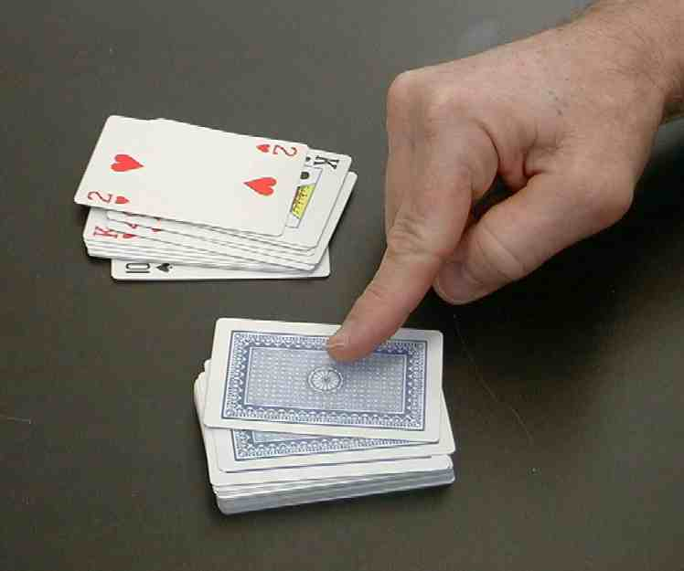

Flip the top card over and there will be the card you announced.

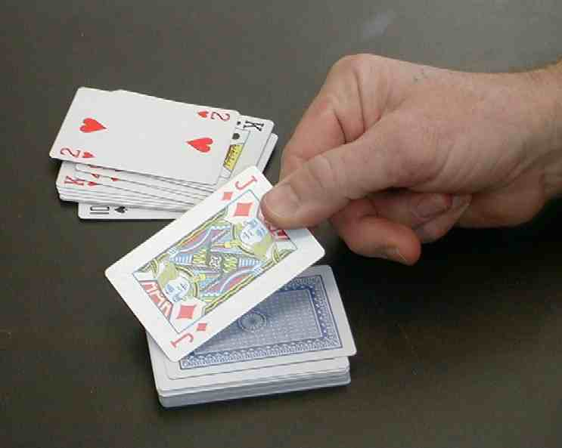

Though the trick seems amazing, it is only a trick. The greatest power is that God can say to us, “I have the power that allows you to live with Me in heaven forever.” God can raise us to the “top of the deck.”

Today’s key verse says in John 11:25-26, “Jesus said … ‘I am the One who brings people back to life, and I am life itself. Those who believe in Me will live even if they die. Everyone who lives and believes in Me will never die.’“

Because of this promise, we know that if we believe in Jesus as our Savior, we can be with God and all other believers in heaven after we die. *Jesus has power over death.

After the children have discussed their confidence in the power of Jesus’ resurrection as they have faith in Him, you have permission to show them how the trick was done. As you do this, have the children promise not to give the secret away. When they show the trick to others, they can talk about how Jesus gives us the power to raise us to the “top of the deck” and gives us life everlasting.
Memory Verse Learning: 5 minutes
Purpose: Help kids to memorize and keep scriptures at heart. Using creative ways to help kids enjoy learning the key verse and in small group setting.

Supplies needed: whiteboard and marker; a strip of 60cm linen cloth for each child

Memory Verse: John 11:25, “Jesus said to her, ‘I am the One who brings people back to life, and I am life itself. Those who believe in Me will live even if they die.’”

Memory Verse Learning: “Written On Linen”
Write the memory verse on the white board. Read several times with the children. Hand each child a strip of linen cloth saying that in Bible times people would wrap the dead with linen cloth. They are going to write the scripture verse on the cloth to remember how amazing Jesus has power over death and His ability to give life to us. Encourage the children to hang the cloth in their room to remember this powerful truth of God.

Prayer:
When you conclude in prayer, have the children mention people they are praying for that need to hear this story and learn this trick. Thank Jesus that He had the power to raise Jairus’ daughter and conquered death with His own resurrection, and, because of that, offers all who believe in Him the gift of everlasting life.

Safety and Security: Safety and security procedures are important for each church to carefully define and implement according to their unique needs. The security, safety, illness and accident procedures described in this curriculum are provided for example purposes only and may not be appropriate, applicable or adequate for every situation. Each church is responsible for determining whether any security, safety, illness and accident procedures contained in the curriculum are appropriate, applicable or adequate for its unique situation. The activities described in this curriculum require adult supervision and may not be suitable for each child and each situation. Each church is responsible for ensuring that adequate adult supervision is provided for all activities and for determining whether an activity is appropriate for each child and each situation. Kids Kount Publishing disclaims all liability for the implementation of any procedures or the performance of any activities described in this curriculum.

Large Group Presentation

Set design and props needed for this series will include a large sign that reads, “Meet the Amazing Jesus.” In addition to this sign, hang smaller signs in the front of the room with the word “Amazing” printed on each one. Kids will be prompted to say, “Simply amaaaazing,” (of course, the word “amazing” is drawn out) anytime the presenter points to one of the “amazing” signs. For additional dramatic effect, the large group presenter might want to use a pointer.

There are three sections to today’s large group presentation. The first section is a video presentation of the Bible event. The second section is a retelling of the event using an amazing object lesson. In the third section, Dao Dao, the puppet, helps kids review.

Adapt this lesson to use one or all of the following parts depending on availability of videos and/or illusion tricks.

Part One:
Begin with the animated video, “The Miracle Maker,” by Family Home Entertainment, Inc. Cue the video to start when Jairus returns home from the feast to his sick daughter. Stop the video when Jesus raises the girl from the dead and she begins to dance around.

Next, call Dao Dao out and ask that he would come back after the lesson has been taught. Dao Dao will help with the review questions. Ad-libbing these conversations is most effective, as long as it is kept brief.

Part Two:
Retell the story with the object lesson as follows.

Part Three
Dao Dao is invited to answer review questions along with the children.

.
PART ONE

Show the animated video, “The Miracle Maker,” by Family Home Entertainment, Inc. Cue the video to start when Jairus returns home from the feast to his sick daughter. Stop the video when Jesus raises the girl from the dead and she begins to dance around.

PART TWO

An Object Lesson Illustration of Jesus Raising Jairus’ Daughter from Death
Illustrations and Script for Luke 8:40-56

Props needed for illusion: two identical decks of cards

In advance of presentation, prepare the decks of cards for the illusion. From one deck ,take out the following cards and place them in order: the king of hearts, the jack of diamonds, the queen of diamonds, queen of spades, the eight of clubs, the nine of clubs, and the ten of clubs. Set aside the rest of this deck as it will not be used for the illusion.

Place these select cards with the face side of the king of hearts toward your chest into the inside breast pocket of your coat.

From the other deck, take out the same cards: the king of hearts, the jack of diamonds, the queen of diamonds, queen of spades, the eight of clubs, the nine of clubs, and the ten of clubs and place them on the top of the remaining deck so that the first card on the deck is the king of hearts followed by the jack of diamonds and so on.

Use this second deck to present the following:

I will use this deck of cards to help tell today’s Bible event about how Jesus raised Jairus’ daughter and healed a woman who could not stop bleeding.

Show the king of hearts card.

The king of hearts card reminds me of Jesus who is the King of all of our hearts.

Here is the jack of diamonds. This card reminds me of Jairus. Jairus was a synagogue leader or a very important religious leader. He was kind of like a leader of the church.

Here is the queen of diamonds. This card will represent Jairus’ daughter. To Jairus, his twelve-year-old daughter was like a queen of much worth to him.

Next, I have the queen of spades, which reminds me of a lady who had something wrong with her. She could not stop bleeding.

Finally, I have the three clubs; an eight, a nine, and a ten of clubs. These cards represent people at the funeral crying for the dead girl. They later laughed when they heard Jesus say, “Don’t worry. He’s not dead.”

Shuffle these cards back into the rest of the deck several times so it is apparent these cards are thoroughly mixed throughout the deck. Place this deck inside your coat breast pocket behind the cards already there.

Place the following script inside your Bible at Luke 8:40-56 to present the Bible event with the cues.

Script with cues

“When Jesus came back, a crowd welcomed Him.” Feel for and show the King of Hearts.

“Everyone was expecting Him. A man named Jairus, a synagogue leader, arrived and quickly bowed down in front of Jesus.” Produce the Jack of Diamonds.

“He begged Jesus to come to his home. His only daughter, who was twelve years old, was dying.” Produce Queen of Diamonds

“As Jesus went, the people were crowding around Him. A woman who had been suffering from chronic bleeding for twelve years was in the crowd.” Produce the Queen of Spades

“No one could cure her. She came up behind Jesus, touched the edge of His clothes, and her bleeding stopped at once.

“Jesus asked, ‘Who touched Me?’

“After everyone denied touching Him, Peter said, ‘Teacher, the people are crowding You and pressing against You.’

“Jesus said, ‘Someone touched Me. I know power has gone out of Me.’

“The woman saw that she couldn’t hide. Trembling, she quickly bowed in front of Him. There, in front of all the people, she told why she touched Him and how she was cured at once.

“Jesus told her, ‘Daughter, your faith has made you well. Go in peace!’

While Jesus was still speaking to her, someone came from the synagogue leader’s home. He said, ‘Your daughter is dead. Don’t bother the teacher anymore.’

When Jesus heard this, He told the synagogue leader, ‘Don’t be afraid! Just believe, and she will get well.”

Jesus went into the house. He allowed no one to go with Him except Peter, John, James, and the child’s parents. Everyone was crying and showing how sad they were.” Show the eight, nine and ten of Clubs

“Jesus said, ‘Don’t cry. She’s not dead. She’s just sleeping.’”

Conclude with presenter saying,

And THAT is…” Give a wide gesture and the kids respond… “simply amaaa-azing.

PART THREE

Dao Dao’s Review Questions

The following questions can be used for review of today’s Bible event. The puppet, Dao Dao, will be used. It works well to have a child or group of children ready to answer the questions correctly after Dao Dao has given his response, which will humorously miss the mark. The review questions will need to be presented in quick succession for the sake of the kids’ attention spans. If all questions are used, the review may be a bit long. Try to keep the review from dragging.

Dao Dao and the large group presenter can ad-lib their conversation around the following questions. After each question, the first parenthetical remark is Dao Dao’s response. The second parenthetical remark is the correct answer from a child.

Kids might even bring their Bibles to large group to search for answers as they listen to the following questions.

- (10 points) Jairus was a synagogue leader who came looking for Jesus. Why did he want Jesus to come to his home?
(He was having a party.)
(He needed Jesus to heal his daughter.)

- (Kids-10 points, Dao Dao-0. This is worth 20 points.) As Jesus was moving through the crowd, a woman touched Him. What happened when she touched Jesus’ clothes?
(She said, “Tag! You’re it.”)
(She was healed from the disease that caused her to bleed.)

- (Kids-30, Dao Dao-0. This is worth 30 more points.) When Jesus asked who touched Him, the woman admitted it was her and she had been cured. What did Jesus say?
(“You owe me five dollars for healing you.”)
(“Your faith has made you well. Go in peace!”)

- (Kids-60, Dao Dao-0. This is worth 60 points.) When Jesus got to Jairus’ house, everyone was crying because Jairus’ daughter was dead. When Jesus said she was just sleeping, what did the people do?
(They laughed at Him.)

Teacher: Dao Dao, you are right.

Dao Dao: I am?

- (Kids 60, Dao Dao-60. This is worth 100 points.) When Jesus said, “Child, get up!” what happened?
(She said, “I’m starving. What’s for dinner?”)
(First, Jairus’ daughter just came back to life. Then they gave her something to eat. Everyone was amazed.)

Dao Dao: Wait a minute, Teacher. I got at least part of it right. Jesus told her to get something to eat, so how do you know that she didn’t say, “I’m starving. What’s for dinner?”

Teacher: I guess you have a point there. I’ll give you partial credit. Okay, then it’s a tie!

Dao Dao: Yeah for Dao Dao… (singing) I’m no loser…

Teacher: Dao Dao, of course you’re not a loser. I think you’re missing the real loser here!

Dao Dao: But Teacher, wouldn’t that be you? Oh, but you weren’t even playing the game.

Teacher: No. The real loser here is death. This Bible event showed that Jesus has power over death.

Dao Dao: How does He do that?

Teacher: Dao Dao, He died on the cross for our sins, but then He rose again. Because of that, He has power over death. Even power over our death!
Jesus says in John 11:25-26, “I am the One who brings people back to life, and I am life itself. Those who believe in me will live even if they die. Everyone who lives and believes in me will never die.”

Dao Dao: How can that be?

Teacher: When we die, because we trust in Jesus as our Savior, He brings us to new life in heaven. We get a new and improved heavenly body, and we have fun with Him in heaven forever.

Dao Dao: That sounds cool!

Teacher: It is! And it’s available for anyone who trusts in Jesus. I am going to close us in prayer praying that we all trust Jesus and remember that *Jesus has power over death.

Dear God, I like the way Jesus has power over death. It’s neat how He brought back that girl in the Bible who had died. God, thank You that Jesus has power over death and that He gave up His life and then rose again. Help each person here to trust Him so that we can be in heaven forever someday… because *Jesus has power over death! Amen.

Lesson 43

Small Group Warm Up
- 12” strand of yarn for each group
- a large ice cube for each group
- a tablespoon of salt on a serviette for each group

Large Group Presentation
- large sign that reads “Meet the Amazing Jesus”
- smaller signs hung in the front of the room, each with the word “amazing” printed on it
- Dao Dao
- the animated video, “The Miracle Maker ,” by Family Home Entertainment, Inc., 1999. www.booksofthebible.com
- two identical decks of cards
- a sport coat with an inside breast pocket

Small Group Application
      - deck of cards

Memory Verse Learning
      - whiteboard and marker
      - a strip of 60cm linen cloth for each child

