
Date: ________________________
Series: Meet the Amazing Jesus
Dec-Mar Year 3, Lesson 44

Help a Person in Need

Take Home Point: *Who is my neighbor? The person in need! *Repeat this phrase throughout the lesson.

Bible Event: Luke 10:25-37. The Parable of the Good Samaritan
Key Verse: Luke 10:27, “…’Love the Lord your God. Love Him with all your heart, all your soul, all your strength, and all your mind.’ Also, ‘You must love your neighbour as you love yourself.’” (NCV)

We will help kids know:
- The Bible event of the Good Samaritan.
- Jesus helps us at our greatest points of need – forgiveness of our sin and friendship with him.
- We should love the Lord our God with all our heart, soul, strength, and mind. We should also love our neighbor as ourselves.
- Our neighbor is the person in need who we can help.

We will help kids feel:
- Amazed at Jesus’ compassion for us.
- Compassion for the person who is picked on by others or has special needs with which we can help.

We will help kids do:
- Identify themselves as ones who are in need of compassion from Jesus.
- Identify ways that Jesus understands and helps them.
- Identify and pray for people who are neighbors in need.

THIS LESSON’S ROADMAP

DESTINATION | PAGE # | DISCOVERIES ON YOUR JOURNEY | SUPPLIES NEEDED
  Small Group Warm-Up | 3 | Kids play ping-pong basketball and hear a story about a needy person. Hopefully they will begin to identify with the needy person. | - coffee mug with a ping- pong ball placed inside and plastic wrap stretched tightly over the top  - one additional coffee mug  - one additional ping-pong ball
Large Group   | 5  9  9  10  14 | Overview  Video: “The Miracle Maker,” by Family Home Entertainment, Inc. (www.booksofthebible.com)  – the Bible event from Luke 10:25-37, the Parable of the Good Samaritan. Start with Jesus being asked, “What must a man do to be saved?” End with Jesus saying, “Then go and do the same.”  Object Lesson of the Parable of the Good Samaritan – The presenter uses suspended ping-pong balls to tell the Bible event.  Dao Dao’s Review Questions: Dao Dao helps kids review the main points in the Bible event. | - large sign with “Meet the Amazing Jesus”  - smaller signs hung in the front of the room with “amazing” on them  - Dao Dao  - the video, “The Miracle Maker,” by Family Home Entertainment, Inc., 1999  - one yellow ping-pong ball with a face drawn on  - three white ping-pong balls with faces drawn on  - two different colored ping-pong balls with faces  - hairdryer with a paper roll taped to the muzzle (see picture)  - large clear glass bowl covered with plastic wrap except for a corner hole  - red marker
Small Group Application   | 5 | Kids discuss ways that Jesus understands and helps them and then discuss how they can meet the needs of others.  Memory Verse Learning:  “Find It Among The Flour”  John 11:25 will be emphasized in lessons 43-45 that each child be amazed at Jesus’ power over death and His ability to give life to us. | - same as Warm-Up  For each group  - two 23cm diameter round container  - 1 kg of flour  - 24 pieces of 2.5X5cm white paper strips  - masking tape
Small Group Warm-Up: 15 minutes
Purpose: Get pointed in the right direction! Build relationships and help guests feel at ease. Do the learning readiness activity that will point your group in the right direction for the lesson.

Supplies needed: Coffee mug with a ping pong ball placed inside and plastic wrap stretched tightly over the top, an additional coffee mug and an additional ping-pong ball

As the children arrive, engage them in a game of ping-pong basketball. Using the plastic wrapped coffee mug as a mini trampoline, bounce the ping-pong ball off the plastic wrap and into the coffee mug on the other side.

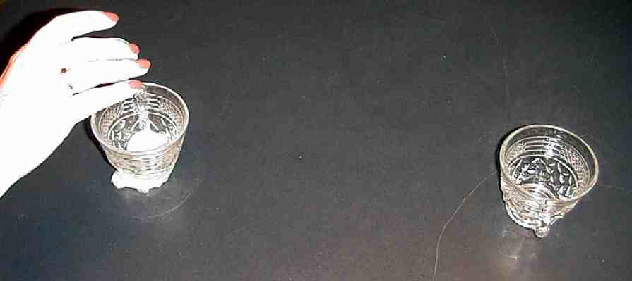

Have kids take turns bouncing the ball off the trampoline and trying to get it to land inside the coffee mug. As the children play this game, ask the following:

Let’s pretend that I am in (group’s grade in school) and I’m trying this game, but I cannot make the ping-pong ball go into the coffee mug. Everyone is laughing and making fun of me. Pretend to laugh and make fun of me now. Pause. How do you think I feel?

Does this kind of thing happen very often at school? Can you think of someone at school that many people laugh at or make fun of? What could you do to help that person? Today we are going to talk about that very thing.

Encourage discussion about how children might make fun of one another, pick on someone, or leave others out.

When there are only three minutes left, have the children stop playing the game, be still, and share the following story.

“Siew Cheng Has Kutu”
Tan Siew Cheng was in the (group’s standard in school), and she had kutu. No one knew why she had them but everyone knew that she did. Maybe she had kutu because she was bigger than any of the other girls. She was bigger than most of the boys! Maybe she had kutu because she never got good grades. Maybe it was because she wore the same old clothes and she never combed her hair. Sometimes Siew Cheng didn’t even smell that good. She may even have been poorer than the other kids.

No one knew for sure why Siew Cheng had kutu, but one thing was certain. It seemed that everyone knew she had them.

If a boy brushed up against Siew Cheng in the lunch line, he would shout, “Eewwwww! I have Siew Cheng kutu!” The boy would try to get rid of them by touching someone else. That child would also pretend to get sick with the kutu.

On the playground, Siew Cheng often played by herself. The other girls in her class would form groups and not let her join.

When it was time to be chosen for a team or group at school, Siew Cheng was always the last one picked. The kids would whisper about who would be stuck with Siew Cheng on their side. No one wanted her because she had kutu.

If you watched Siew Cheng really closely, you could see she knew the other children made fun of her. There was sadness in her eyes. Often times she just looked at the ground.

I wonder what she felt like. What do you think? What are some words you would use to describe what Siew Cheng felt like inside?

It is true that Siew Cheng had kutu, but one day her world began to change. It was like someone took her kutu away. Do you know what happened? I am not going to tell you what happened just yet. We are going to find out after we get back from large group. As a matter of fact, you are going to help me make up the end of this story.

In large group we will hear a story Jesus told about helping someone in need. Today we will learn *who is my neighbor? The person in need!

Large Group Overview: 20-30 minutes
Purpose: Help kids observe what the Bible says. Present the Bible event in creative fashion. Help kids begin to interpret what it means.

Video: “The Miracle Maker,” by Family Home Entertainment, Inc., 1999. Show the Bible event from Luke 10:25-37, the Parable of the Good Samaritan. Start with Jesus being asked, “What must a man do to be saved?” End with Jesus saying, “Then go and do the same.”

Object Lesson: Parable of the Good Samaritan: The presenter uses suspended ping-pong balls to tell the Bible event.

Dao Dao’s Review Questions: Dao Dao helps kids review the main points in the Bible event.

Small Group Application: 20-25 minutes
Purpose: Help kids map out the meaning of the Bible event in their lives. Use the questions to stimulate discussion but don't feel tied to them. Allow the Holy Spirit to guide you. Include personal examples from your own faith journey. The example of Christ at work in your life will leave lasting impressions of how Christ can work in the children's lives.

Use your Bibles! Children need to learn how to look up references and follow along when scripture is read aloud. Allow for quality time of prayer at the close of the lesson.

Observation Questions: What happened?
(Observation questions were covered in Dao Dao’s review.)

Interpretation Questions: What does this mean?
Why do you think the Samaritan would help a Jew who probably hated him? Do you think the Samaritan loved God? Why or why not?

Why do you think Jesus picked a Samaritan to be the good neighbor in this story?

Application Questions: What does this mean to me?
Using the coffee mug covered with a ping-pong ball inside and covered in plastic wrap, talk about the following:

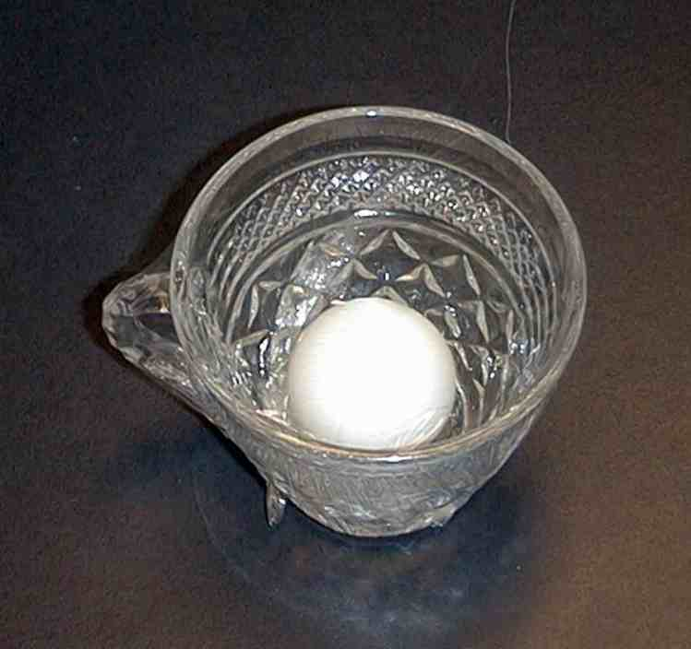

Let’s imagine that the ping-pong ball inside this mug is a person in need. This person is cut off from others and no one is there to help him or her. Who could the person be? Who has some ideas? It could be the person from Jesus’ parable, Tan Siew Cheng, or someone from your school that you know is in need.

I am thinking of someone that would really surprise you. Who wants to guess who I am thinking of? I am thinking of me! And I am thinking of you. Why is that? You and I have a need that is very great. We need to have God come into our lives to take away our sins and to make us friends with Him. That is exactly what Jesus did when He came into the world and gave His life for us on the cross. He gave us forgiveness and friendship.

Think of how our lives would be without Jesus. We would be separated from God and we could not be friends with Him. We would be all alone. God wanted to truly understand our lives so He did this.

Take another ping-pong ball and draw a cross on it. Place the ping-pong ball inside the mug with the “me” ping-pong ball.

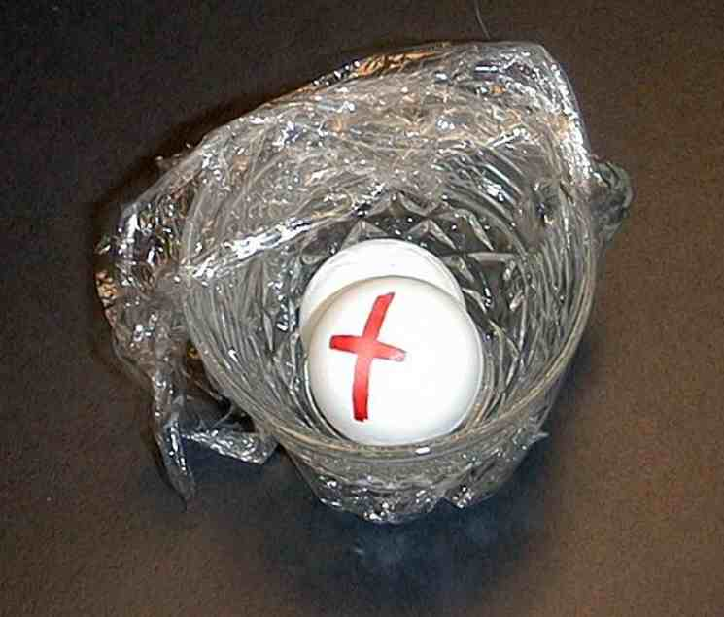

Jesus came into the world for me. I had a great need and so did you. Let’s give thanks to God by passing the ping-pong ball with the cross on it around the circle.

Let’s all think of one thing that God has done to help us. As the ball is passed around the circle, let’s each say a thank you to God for just one of the things He has done to help us. (For example: dying for our sins, rising again to give us eternal life, helping us with our problems, helpings us when we are lonely, giving us moms and dads, helping us at school, etc.)

Place the ping-pong ball with the cross on it back in the coffee mug. Take out the other ping-pong ball.

Because Jesus has helped us, we can be like the Good Samaritan and help others. We can come right alongside others and do things to help lift them up. I want you to think of a person at school, at home, or at church that you could help. This person is someone who Jesus would call your neighbor.

Today’s Bible verse says, “…’Love the Lord your God. Love Him with all your heart, all your soul, all your strength, and all your mind.’ Also, ‘You must love your neighbour as you love yourself.’”

Place the ping-pong ball you are holding into the other coffee cup. This represents another person who has a need. You might want to cover it with plastic wrap to demonstrate being separated from God or other people.

Our neighbor does not just live next door to us, but he is one who has a need in which we can help.

Try to think of someone with a need. As we pass this cup with the pong-pong ball around, mention a need that you might be able to help your neighbor with.

After discussion, place the ping-pong ball with a cross on it into the cup with the other ball.

We are like Jesus when we show others the same love that God has shown us. We can get into another person’s world or need and help lift them out. *Who is my neighbor? The person in need.

The final activity is completing the Tan Siew Cheng story. Have the children come up with their own ending based upon what a Good Samaritan might do if he were a part of Siew Cheng’s classroom. A Good Samaritan might choose Siew Cheng first for his team in kickball, be her friend during recess, or invite her to church.

A Good Samaritan is someone who shows her neighborly love. When that happens, people are ready to hear that Jesus wants to be their forever friend. The Good Samaritan in your story might be one who shares Jesus with Siew Cheng. Let the children create the conclusion of the story.

Memory Verse Learning: 5 minutes
Purpose: Help kids to memorize and keep scriptures at heart. Using creative ways to help kids enjoy learning the key verse and in small group setting.

Supplies needed: For each group - two 23cm diameter round container; 1 kg of flour; 24 pieces of 2.5X5cm white paper strips; masking tape

Memory Verse: John 11:25, “Jesus said to her, ‘I am the one who brings people back to life, and I am life itself. Those who believe in Me will live even if they die.’”

Memory Verse Learning: “Find It Among The Flour”
Before class, use masking tape to set two parallel lines that is 10 feet apart for the relay. Write the words of the memory verse on paper strips (see diagram below as to the breaking up of the verse). Write two sets and hide one set among the flour of one container and another set in the other container. During session, recite John 11:25 several times with the children. Then divide the children into two teams. Have the teams line up before one of the line and set the containers at the other line. Explain to the children that the idea of the challenge is to take turns to run to their container and search for a paper strip among the flour without messing the area outside the container. But one cannot just take any paper strip. It must be according to the sequence of John11:25 as learnt. If it is not the right one, one can go back to search again until the right one is found. They can confer as a team for subsequent words they are looking for. The first team that completes the verse wins.

John 11:25 | Jesus said to | her, “I am | the one who
brings people | back to life, | And I am life | itself. Those
who believe in | Me will live | even if | they die.

Closing prayer:
Thank Jesus that He came to the world to meet all our needs, especially the need for a Savior. Ask the Holy Spirit for open eyes to see the needs of our neighbours and to have open hearts to help them. Pray to love the Lord with all our heart, soul, strength and mind.

Safety and Security: Safety and security procedures are important for each church to carefully define and implement according to their unique needs. The security, safety, illness and accident procedures described in this curriculum are provided for example purposes only and may not be appropriate, applicable or adequate for every situation. Each church is responsible for determining whether any security, safety, illness and accident procedures contained in the curriculum are appropriate, applicable or adequate for its unique situation. The activities described in this curriculum require adult supervision and may not be suitable for each child and each situation. Each church is responsible for ensuring that adequate adult supervision is provided for all activities and for determining whether an activity is appropriate for each child and each situation. Kids Kount Publishing disclaims all liability for the implementation of any procedures or the performance of any activities described in this curriculum.
Large Group Presentation

Set design and props needed for this series will include a large sign that reads “Meet the Amazing Jesus.” In addition to this sign, hang smaller signs in the front of the room with the word “Amazing” printed on each one. Kids will be prompted to say, “Simply amaaaazing,” (Of course, the word “amazing” is drawn out) anytime the presenter points to one of the “amazing” signs. For additional dramatic effect, the large group presenter might want to use a pointer.

There are three sections to today’s large group presentation. The first section is a video presentation of the Bible event. The second section is a retelling of the event using an amazing object lesson. In the third section, Dao Dao, the puppet, helps kids review.

Adapt this lesson to use one or all of the following parts depending on availability of videos and/or illusion tricks.

Part One:
Begin with the animated video, “The Miracle Maker,” by Family Home Entertainment, Inc. Start with Jesus being asked, “What must a man do to be saved?” End with Jesus saying, “Then go and do the same.”

Next, call Dao Dao out and ask that he would come back after the lesson has been taught. Dao Dao will help with the review questions. Ad-libbing these conversations is most effective, as long as it is kept brief.

Part Two:
Retell the story with the object lesson as follows.

Part Three
Dao Dao is invited to answer review questions along with the children.

PART ONE

Show the video, “The Miracle Maker,” by Family Home Entertainment, Inc. Start with Jesus being asked, “What must a man do to be saved?” End with Jesus saying, “Then go and do the same.”

PART TWO

An Object Lesson of
the Parable of the Good Samaritan
Illustrations and Script

Supplies needed:
- one yellow ping-pong ball with a drawn on face to represent the Good Samaritan
- three white ping-pong balls with drawn on faces to represent the traveler, the priest, and the Levite
- two different colored ping-pong balls with faces for the robbers
- hairdryer with a paper roll taped to the muzzle (see picture)
- large clear glass bowl covered with plastic wrap except for a corner hole.
- red marker

In advance, place the two “robber” balls into the plastic covered bowl. Set the bowl on a table. The bowl represents the setting of the following story.

As you begin the Bible reading, turn on the hair dryer. Hold a white ping-pong ball above the hair dryer. When the ping-pong ball is released, it will be held in suspension in the air blown by the hair dryer.

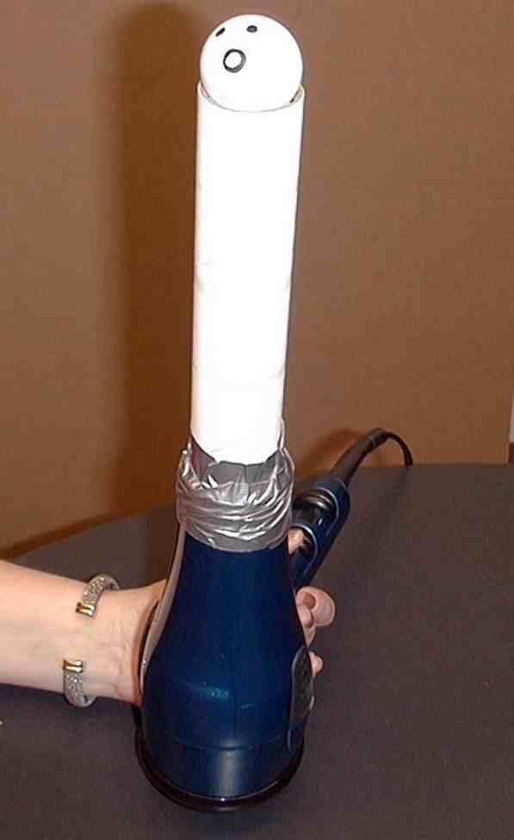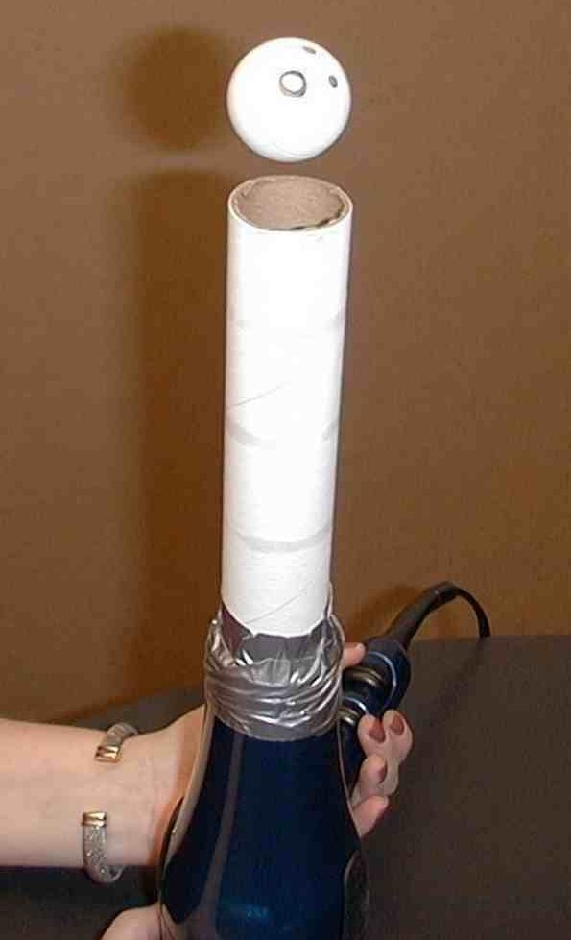

Luke 10:25-29

“Then a teacher of the law stood up. He was trying to test Jesus. He said, ‘Teacher, what must I do to get life forever?’
“Jesus said to him, ‘What is written in the law? What do you read there?’
“The man answered, ’Love the Lord your God. Love Him with all your heart, all your soul, all your strength, and all your mind.’ Also, ‘You must love your neighbour as you love yourself.’
“Jesus said to him, ‘Your answer is right. Do this and you will have life forever.’
“But the man wanted to show that the way he was living was right. So he said to Jesus, ‘And who is my neighbour?’”

Carry the hair dryer and ping-pong ball along an imaginary road from Jerusalem to Jericho. Continue with:

Luke 10:30

“To answer this question, Jesus said, ‘A man was going down the road from Jerusalem to Jericho.’”

Stop at the clear bowl on the table.

“‘Some robbers attacked him. They tore off his clothes and beat him. Then they left him lying there, almost dead.’

Shut the hair dryer off so the ping-pong ball falls onto the plastic wrapped large clear bowl. Cause the ping-pong ball representing the traveler to fall through the hole in the plastic. The ping-pong ball falling into the bowl will represent the traveler falling among robbers.

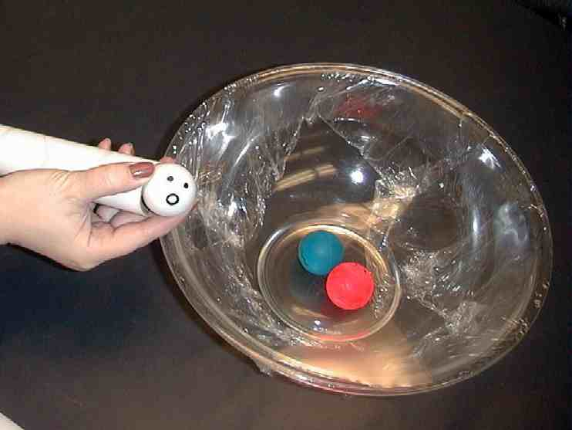

To illustrate the man being robbed and beaten, put the muzzle of the hair dryer into the hole at an angle. The ping-pong balls will move around each other.



Remove the clear plastic from the bowl and take out the two ping-pong balls representing the robbers. Mark the traveler with a red marker to show that he has been beaten.

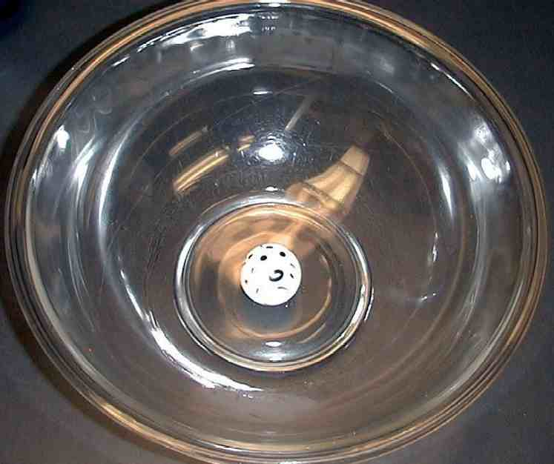

Take another white ping-pong ball and suspend it over the hair dryer. Move with the hair dryer and ping-pong ball down the imaginary road from Jerusalem to Jericho. When the ball is near the bowl with the wounded traveler, be sure to avoid the bowl by making a wide loop around it.

Repeat the process with another ping-pong ball for the Levite.

Luke 10:31-32

“It happened that a Jewish priest was going down that road. When the priest saw the man, he walked by on the other side of the road. Next, a Levite came there. He went over and looked at the man. Then he walked by on the other side of the road.”

While reading the rest of the passage, use the yellow ping-pong ball representing the Samaritan. When coming to the wounded traveler, tilt the air current from the hair dryer so that ball is released and falls into the bowl.

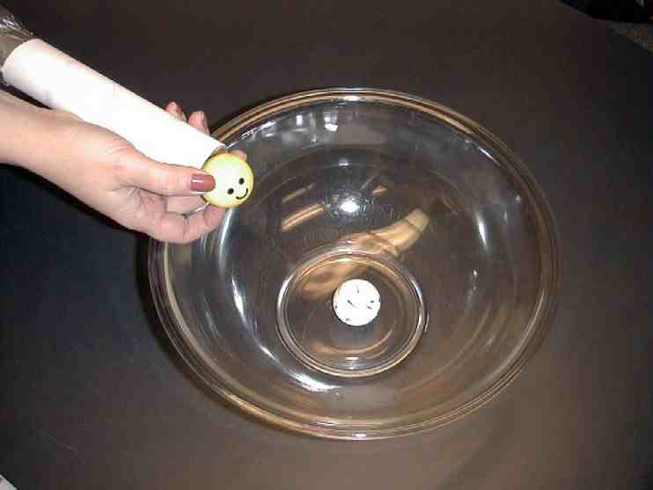

Use a small piece of plastic wrap to attach the two balls together representing the Samaritan bandaging the traveler’s wounds. Set the two balls outside the bowl and lightly blow them across the table illustrating the Samaritan carrying the traveler to safety.

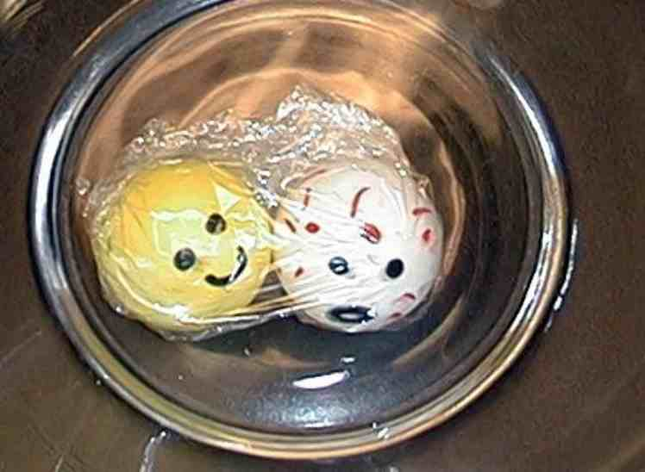

Luke 10:33-35

“Then a Samaritan traveling down the road came to where the hurt man was lying. He saw the man and felt very sorry for him. The Samaritan went to him and poured olive oil and wine on his wounds and bandaged them. He put the hurt man on his own donkey and took him to an inn. At the inn, the Samaritan took care of him. The next day, the Samaritan brought out two silver coins and gave them to the innkeeper. The Samaritan said, ‘Take care of this man. If you spend more money on him, I will pay it back to you when I come again.’”

Hold up the three ping-pong balls representing the priest, the Levite, and the Good Samaritan. Say:
The Jews thought the Samaritans were the very lowest of people. Jews had nothing to do with Samaritans because Samaritans were half foreigners and half Jewish by ancestry. Jews thought no Samaritan could be a good person. But who was the good person in this case?

Hold up the three ping-pong balls. Continue with:

Luke 10:36-37

“Then Jesus said, ’Which of these three men do you think was a neighbour to the man who was attacked by the robbers?’
“The teacher of the law answered, ‘The one who helped him.’
“Jesus said to him, ‘The go and do the same thing he did!’”

PART THREE

Dao Dao’s Review Questions
The parable of the Good Samaritan

The following questions can be used for review of today’s Bible event. This will be a contest between Dao Dao and the kids. Dao Dao assigns a scoring value to each question before that question is read. That number is in parentheses at the beginnning of the question. What makes it fun is that Dao Dao finally gets one correct at the end and that number helps him make a dramatic comeback. The kids typically win, but it might be interesting if, from time to time, Dao Dao wins. Adjust to your preference. One thing is important and will be vital to this script: move through your material quickly. By this time, the kids’ attention spans are short. You may even want to delete some of the questions if it is feeling a bit long.

After each question, the first parenthetical remark is Dao Dao’s response. The second parenthetical remark is the correct answer from a child.

Kids might even bring their Bibles to large group to search for answers as they listen to the following questions.

- (This is an important question. What do you say to a quick 100 points, Dao Dao?) A teacher of the Bible asked Jesus, “What must I do to be saved?” Jesus asked him, “What did the Bible say?” The teacher answered, “Love the Lord your God with all your…”
(Ping-Pong Balls.)
(Heart, soul, strength, and mind.)

- (Hmmm. Try something easier… 5 points.) The teacher also said we should love our neighbours as…
(As long as he lets us play with his Game Boy, right?)
(Ourselves.)

- (105 points for the kids. 0 for Dao Dao. 21 points for this one.) When the expert in the Law asked, “Who is our neighbor?” What parable did Jesus tell him?
(The parable of the fighting ping-pong balls.)
(The parable of the Good Samaritan.)

- (19 points for this question.) The traveler was beaten on the road from Jerusalem to what city?
(Kuala Lumpur.)
(Jericho.)

- (15 points) Two highly respected religious leaders passed by the beaten traveler. One was a Levite. Who was the other?
(Football player.)
(Priest.)

Teacher: 160 points for the kids and 0 for Dao Dao! YEAH, kids.

- (160 points for this one.) Did the Levite or the priest give any help to the wounded traveler?
(No. Hey, I got one right!)

Teacher: Good job, Dao Dao. Now it’s all tied up.

- (How about 8 points?) A Samaritan stopped to help the traveler. Samaritans were people from Samaria. Did the Jews think well of the Samaritans?
(Only if they were good at playing Nintendo.)
(No.)

- (Another 8 points for the kids. 12 points for this one.) What did the Samaritan do for the wounded traveler?
(He called 911.)
(He bandaged his wounds, put him on his donkey, took him to an inn, and paid for his stay while he recovered.)

Teacher: Last chance to redeem yourself, Dao Dao.

- (20 points) Which of these men was the neighbor to the man beaten by the robbers?
(The Good Samaritan. I’m da kid!)

Teacher: Well, I can’t believe it. A tie game today.

Dao Dao: Too bad. No winner today. It’s a tie.

Teacher: Wait a minute, Dao Dao. Someone wins. Those who are in need win if followers of Jesus are around.

Dao Dao: Oh yeah. I get it. That’s because if you’re the one in need, a follower of Jesus will get in there and help you!

Teacher: Bingo!

Dao Dao: Do I get a prize for getting that question right, then?

Teacher: No, Dao Dao. But you do get a reward every time you help your neighbour. And *who is your neighbour? The person in need!

Dao Dao: What do you mean?

Teacher: You know how Jesus gave His life for you, right?

Dao Dao: Right.

Teacher: And how He helped you by forgiving your sins, right?

Dao Dao: Right.

Teacher: And now when you help others in Jesus’ name, it shows your love for God and others… and Dao Dao, that feels good!

Dao Dao: Right, Teacher. It really does. I know what you mean. Especially helping people in need, because they are my neighbours!

Teacher: I think you’ve got it. So why don’t I close us in prayer now?

Dao Dao: Sure, Teacher.

Teacher: Dear Jesus, thanks for telling that great story about who really is our neighbour. Our neighbour is the one who is in need. Help each one of us to see some of the people in need so we can help them. And Jesus, thanks for helping us when we are in need and for giving Your life for us. We pray it in Your name. Amen.

Lesson 44

Small Group Warm-up
- coffee mug with a ping- pong ball placed inside and plastic wrap stretched tightly over the top
- one additional coffee mug
- one additional ping-pong ball

Large Group Presentation
- large sign with “Meet the Amazing Jesus”
- smaller signs hung in the front of the room with “amazing” on them
- Dao Dao
- the video, “The Miracle Maker,” by Family Home Entertainment, Inc., 1999
- one yellow ping-pong ball with a face drawn on
- three white ping-pong balls with faces drawn on
- two different colored ping-pong balls with faces
- hairdryer with a paper roll taped to the muzzle (see picture)
- large clear glass bowl covered with plastic wrap except for a corner hole
- red marker

Small Group Application
      - same as Warm-Up

Memory Verse Learning
For each group
      - two 23cm diameter round container
      - 1 kg of flour
      - 24 pieces of 2.5X5cm white paper strips
      - masking tape

