
Date: ________________________
Series: Meet the Amazing Jesus
Dec-Mar Year 3, Lesson 45

Experience His Power Over Death

Take Home Point: *Jesus has power over death.
(This take home point was also used in lesson 43.)
*Repeat this phrase throughout the lesson.

Bible Event: John 11:1-44
Key Verse: John 11:25, “Jesus said to her, ‘I am the One who brings people back to life, and I am life itself. Those who believe in Me will live even if they die.’”

We will help kids know:
- The Bible event of Jesus saving Lazarus from the dead.
- When Jesus has the power over death. This means that He can give us life after we die and a better life while we live now.
- Jesus wants us to have faith in Him as the one who has power over death.

We will help kids feel:
- Amazed at Jesus’ power over death and His ability to give life to us.
- Touched by the time when someone near to them was very sick or died.
- Say with confidence that God hears them at such times and still has all the power necessary to conquer our worst fears.

We will help kids do:
- Learn a card trick where they can tell others about Jesus’ power over death.

THIS LESSON’S ROADMAP

DESTINATION | PAGE # | DISCOVERIES ON YOUR JOURNEY | SUPPLIES NEEDED
  Small Group Warm-Up | 3 | A card trick helps introduce the kids to today’s Bible event: Jesus raises Lazarus. | - one deck of playing cards  - Appendix A
Large Group   | 3  6  7  12 | Overview  Video: The Miracle Maker video—Jesus raises Lazarus from the dead.  Object Lesson: A card trick reinforces the Bible event of Lazarus from John 11:1-44.  Dao Dao’s Review Questions: Dao Dao helps kids review the main points in the Bible event. | - “simply amaa-aazing” signs from previous lessons.  - playing cards  - The Miracle Maker video, Family Home Entertainment, Inc.—can be ordered from www.amazon.com. Begin at the quote, ”Teacher, I’ve ridden all night,” “Rueben, what happened?” Conclude the portion with this quote, ”Now they are ready to follow the Messiah to the holy city.”
Small Group Application   | 4 | The discussion relates to experiences with great illness, even death. Kids learn that Jesus has power over death.  Memory Verse Learning:  “To Wrap As A Team”  John 11:25 will be emphasized in lessons 43-45 that each child be amazed at Jesus’ power over death and His ability to give life to us. | - deck of cards  - a strip of 60cm linen cloth for each child  - masking tape for each team  - pencils  - a 1.5 liter bottle filled with water

Small Group Warm-Up: 15 minutes
Purpose: Get pointed in the right direction! Build relationships and help guests feel at ease. Do the learning readiness activity that will point your group in the right direction for the lesson.

Supplies needed: a deck of playing cards and directions to the card trick

In advance, practice the card trick “Rising to the top.” (See appendix A) Note that you will have to prepare your card deck beforehand.

Perform the trick for the kids and say,

As you know, this was a trick. But it did seem amazing. Today we will see Jesus do something amazing that wasn’t a trick at all. He told a dead man to come out of a tomb and the man came alive and walked right out. That’s because Jesus has power over death.

If we do a good job discussing our topic today, I’ll teach this card trick so you can tell others about this Bible event. We’ll do that after large group if we get a lot of cooperation.

To help us get ready for today’s lesson, let’s talk about a time that someone close to us might have been very sick or maybe even died. You don’t have to talk about this if you don’t want to, but maybe some of you have stories you would share.

Let kids share, then continue with:

Today we will hear a story about some of Jesus’ closest friends who had someone very close to them die. They couldn’t understand why Jesus didn’t answer their prayers right away. Even though it took him a long time to help them, they discovered that *Jesus has power over death.

Large Group Overview: 20-30 minutes
Purpose: Help kids observe what the Bible says. Present the Bible event in creative fashion. Help kids begin to interpret what it means.

Video: The Miracle Maker video—Jesus raises Lazarus from the dead.

Object Lesson: A card trick reinforces the Bible event of Lazarus from John 11:1-44.

Dao Dao’s Review Questions: Dao Dao helps kids review the main points in the Bible event.
Small Group Application: 20-25 minutes
Purpose: Help kids map out the meaning of the Bible event in their lives. Use the questions to stimulate discussion but don't feel tied to them. Allow the Holy Spirit to guide you. Include personal examples from your own faith journey. The example of Christ at work in your life will leave lasting impressions of how Christ can work in the children's lives.

Use your Bibles! Children need to learn how to look up references and follow along when scripture is read aloud. Allow for quality time of prayer at the close of the lesson.

Observation Questions: What happened?
With Bibles open to John 11, review the Bible event. Use some of the cards to help tell the story: i.e. the jack for Lazarus and the queens for Mary and Martha. Ask some questions about Jesus, the king of hearts.

What did Jesus say to the messenger who came to tell Jesus His close friend Lazarus was sick? (John 11:4. “This sickness will not end in death. It is for the glory to God….”)

After Jesus heard Lazarus was sick, how much longer did He wait until traveling to Lazarus’ home? (John 11:6. Two more days.)

Interpretation Questions: What does this mean?
If you were Mary or Martha, what questions might you be asking at this point? (I wonder where Jesus is. I wonder why He hasn’t answered us. I wonder if He still cares. I wonder if He is coming.)

In verse 11 when Jesus says, “Lazarus is sleeping. And I’m going to Bethany to wake him,” what did He mean? (John 11:13. Lazarus was dead and He would bring him back to life.)

Why was Jesus glad that He hadn’t been there to heal Lazarus? (John 11:15. So that people could grow in their faith.)

What did Martha think when Jesus said to her, “Your brother will come back to life?” (John 11:24. She thought Jesus was talking about the last day when everyone would come back to life.)

What did Jesus say about life and death in John 11:25-26? (“I am the One who brings people back to life, and I am life itself. Those who believe in Me will live even if they die. Everyone who lives and believes in Me will never die.”)

Read John 11:38-40.

What do you think you would have said if you were asked to roll away the stone and there was a dead body inside?

If you were there, what would you have said to Lazarus after he was unwrapped?

Application Questions: What does this mean to me?
Encourage kids to talk about times they prayed for something and God didn’t answer the way they wanted or as soon as they wanted. After the children describe the event, ask them how the situation ended. Did God answer their prayer in another way… or in a way that brought glory to Him? (You might mention that a believer who dies and goes to heaven is ultimately healed. You also might ask how people who died gave glory to God in their life and death.)

Ask:
How does the Bible event of Lazarus demonstrate Jesus had power over death? (Jesus raised Lazarus after he had been dead for four days and his body was already decaying.)

In what other more dramatic way did Jesus demonstrate His power over death? (He rose again after He had died Himself.)

In today’s key verse from John 11:25, Jesus said, “I am the One who brings people back to life, and I am life itself. Those who believe in Me will live even if they die.”

Jesus was not only talking about Lazarus but about His own death on the cross. What hope does this verse give you?

I will teach you the card trick so you can share this wonderful message that *Jesus has power over death with others to give them hope in hard times.

Concluding activity:
Supplies needed: a deck of cards

Teach the kids the card trick. It is important in teaching children card tricks that they know to keep it a secret and don’t tell others how it’s done. You do it only once to fool people. If you do it twice, they’ll be looking for ways to figure it out.

Memory Verse Learning: 5 minutes
Purpose: Help kids to memorize and keep scriptures at heart. Using creative ways to help kids enjoy learning the key verse and in small group setting.

Supplies needed: a strip of 60cm linen cloth for each child; masking tape for each team; pencils; a 1.5 liter bottle filled with water.

Memory Verse: John 11:25, “Jesus said to her, ‘I am the One who brings people back to life, and I am life itself. Those who believe in Me will live even if they die.’”

Memory Verse Learning: “To Wrap As A Team”
Review John 11:25 but tell them that they need to know the verse well to participate in the game. Divide the children into two teams and have them sit in a circle as a team. In the middle put the strips of linen, pencils, masking tape and the bottle. Explain to the teams that when the shepherd indicate to start, every team member must quickly write the memory verse on the linen cloth then use the masking tape to join all linen cloth together so it can be used to wrap the bottle like a neat mummy. The team that can wrap a very presentable mummy wins.

Closing prayer:
Pray for opportunities to share the good news that Jesus has power over death. Share this good news especially with people when they go through the hard times with someone who is really sick or when a loved one dies.
Safety and Security: Safety and security procedures are important for each church to carefully define and implement according to their unique needs. The security, safety, illness and accident procedures described in this curriculum are provided for example purposes only and may not be appropriate, applicable or adequate for every situation. Each church is responsible for determining whether any security, safety, illness and accident procedures contained in the curriculum are appropriate, applicable or adequate for its unique situation. The activities described in this curriculum require adult supervision and may not be suitable for each child and each situation. Each church is responsible for ensuring that adequate adult supervision is provided for all activities and for determining whether an activity is appropriate for each child and each situation. Kids Kount Publishing disclaims all liability for the implementation of any procedures or the performance of any activities described in this curriculum.
Large Group Presentation

Take Home Point: *Jesus has power over death

Set design and props needed for this series will include a large sign that reads, “Meet the Amazing Jesus.” In addition to this sign, hang smaller signs in the front of the room with the word “Amazing” printed on each one.

Prompt kids to say, “Simply amaaaazing,” when the presenter points up and says, “And THAT is…” the kids respond, “…simply amaaa-a-azing!” A sweeping arm gesture by the large group presenter as the kids say, “Simply amaaaa-a-azing” will add effect and emphasis. Use this technique as an attention grabber when presenting the main points.

There are three sections to today’s large group presentation. The first section is a video presentation of the Bible event. The second section is a retelling of the event using an amazing object lesson. In the third section, Dao Dao, the puppet, helps kids review.

Adapt this lesson to use one or all of the following parts depending on availability of videos and/or illusion tricks.

Part One:
Begin with the animated video, “The Miracle Maker,” by Family Home Entertainment, Inc.

Next, call Dao Dao out and ask that he would come back after the lesson has been taught. Dao Dao will help with the review questions. Ad-libbing these conversations is most effective, as long as it is kept brief.

Part Two:
Retell the story with the object lesson as follows. Object lesson with cards: The Story of Lazarus. (Pages 8-11)

Part Three
Dao Dao is invited to answer review questions along with the children.

PART ONE

Show the clip from The Miracle Maker video. Family Home Entertainment, Inc.—can be ordered from www.amazon.com or www.RoadtoGlory.com. Begin at the quote, ”Teacher, I’ve ridden all night,” “Rueben, what happened?” Conclude the portion with this quote, ”Now they are ready to follow the Messiah to the holy city.”

PART TWO

The Story of Lazarus

Object Lesson Using Playing Cards

What’s happening with the cards:

- Arranging the cards beforehand –
Pick out the following cards from the deck… the king of hearts, the queen of spades, the queen of clubs, the jack of clubs and the 5 of hearts. Hold the deck in your hand facing you. Flip the 5 over with it’s back facing you and place it as the bottom card. Then place the jack of clubs facing you as the new bottom card. You have just concealed the flipped over 5 which is covered by the jack of clubs. Place the other three cards – the king of hearts, queen of spades and queen of clubs in the middle of the deck, not necessarily next to one another, but grouped so you can quickly find them.

- Fan the cards and select the story cards—
Pick the cards up so that they are facing you. You will want to pull out the four story cards and place them face up on the table. Fan the deck and search for the three cards you placed in the middle. Finally, pull the deck to yourself so the audience does not see you pull out the bottom card, the jack of clubs. Place the deck face down on the table next to your 4 story cards that are face up.

What you are saying:

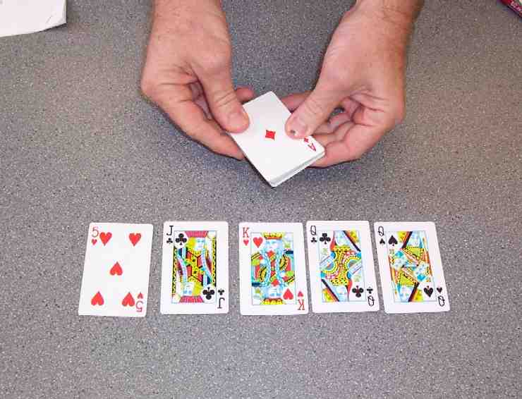

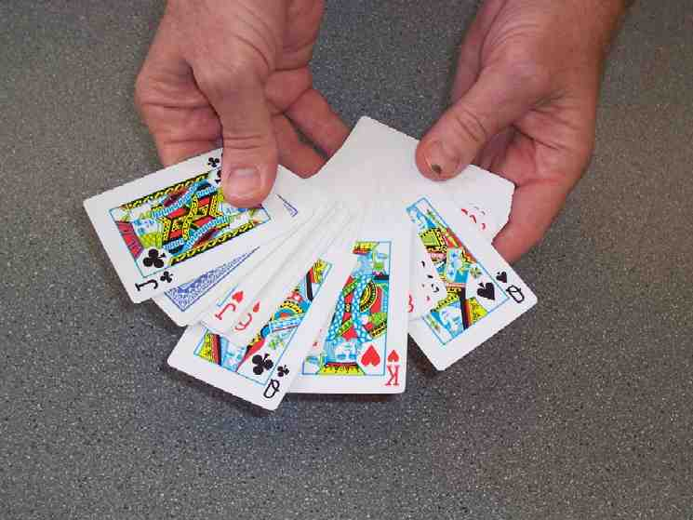

2. As you can see I have an ordinary deck of cards. But these cards will help me tell a story about how Jesus has power over death. Let me pull out the king of hearts that will remind me of Jesus. Then, two black queens that will remind me of Mary and Martha and, finally, the jack that will remind me of Lazarus.

- Tell the Story –
Pick each card up and show it to the group as you describe it. Leave the cards face up on the table. When you get to the part about Lazarus dying, either turn his card face down on the table or if you are holding it in your hand, turn it’s face over, so the audience gets the idea the card is “dead.”

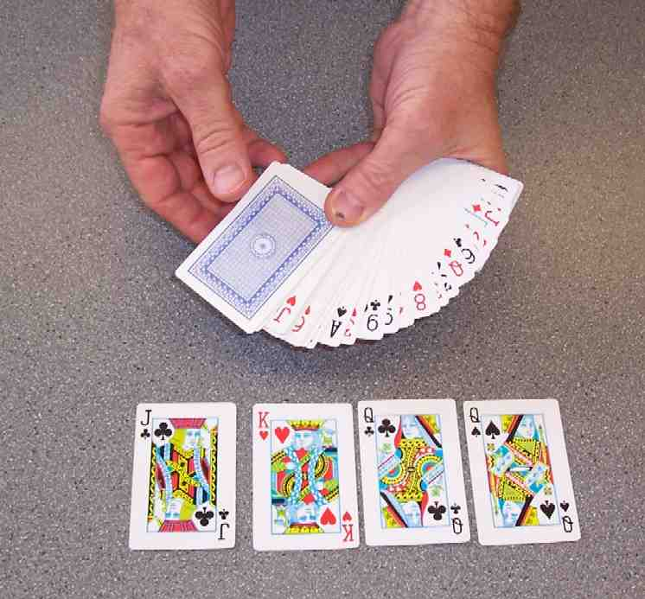

3. This king of hearts reminds me of Jesus. He is the king of the universe and Son of God. He came to this world to live as one of us and to win over a very powerful enemy—death. You can see the sword in the king’s hand. That reminds me of what Jesus did to defeat death.

Jesus loved people and had many close friends and family. These two cards remind me of Mary and Martha. They spent time together visiting, and telling stories. Jesus told them often about His kingdom. They were great friends, along with their brother, Lazarus, represented by this jack.

When Jesus was traveling and teaching about God’s kingdom, Lazarus became very sick. As you can imagine, Mary and Martha were worried and sent word for Jesus to come quickly. Surprisingly enough, Jesus didn’t come quickly and Lazarus died. (Flip over card.) It took Jesus four days to visit them. Lazarus had already been buried. Mary and Martha were heartbroken. Jesus was sad to see their sorrow.

They asked, “Why couldn’t You come earlier? If You would have, our brother would still be alive.” Jesus said that it had to be done this way, so that people could see the full power of God. Then Jesus said, “I am the resurrection and the life. If any One believes in Me, even if they die, they will come alive.” With that, Jesus spoke into Lazarus’ tomb and said, “Lazarus, come out.” (Flip the Lazarus card over – the jack) Lazarus came out.

That’s an amazing thing for Jesus to show his power over death. As a matter of fact, people might say it’s… (add a sweeping gesture to get the students to respond…) Simply am-aaaa-azing!”

4. Invite a believer to select a card—
As the believer is coming toward you, stack the story cards on each other. First place the king of hearts on the bottom, then the two queens, then the jack of clubs. Place these cards as a group on the bottom of the deck.

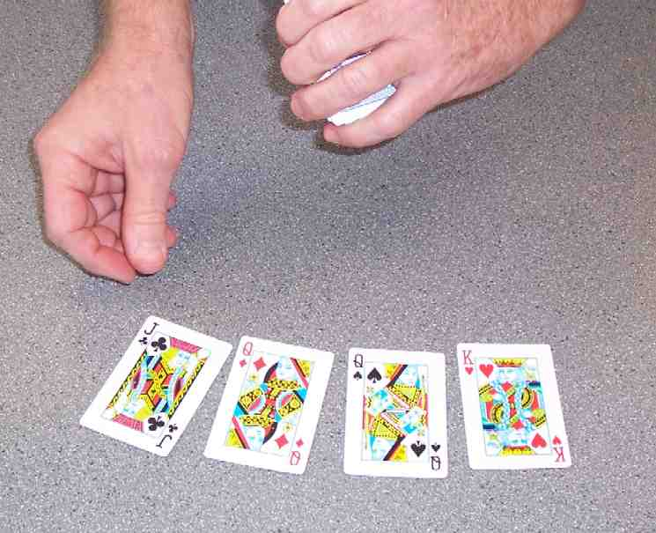

When the believer arrives, begin fanning the cards slowly until the person selects a card. Have him/her select one from around the middle of the deck, if possible. Remember you have to conceal the flipped over 5 which is near the bottom. After the believer selects the card, assure him/her that you cannot see it. Have the believer show the audience.

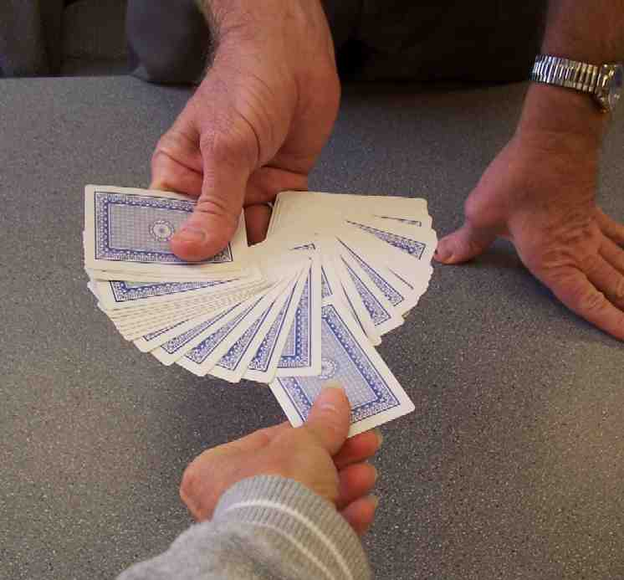

From wherever the believer pulled the card, you will now have two groups of cards. Hold the deck of cards so that you have cards face down in both your left and right hand. The story cards should be in your left hand stack of cards.

4. Tell the story. I’d like to ask for a volunteer from the audience. I need someone who believes that Jesus has power over death. As a matter of fact, one who trusts that Jesus defeated death when He gave His life for us on the cross. When we trust Him, we, too, will live even if we die.

Thank you, volunteer. Please take a card from the deck and don’t let me see. I’m fanning these cards out in front of you. Stop and pick a card that you think you’d like and pull it out. Show it to the audience. Don’t show me the card. Good. Remember that card. Now place it back in the middle of the deck. Place it right on top there – right in the middle of the deck.

Have the believer put his card face down on top of the split deck in your right hand. Then place the cards in your left hand on top of those in your right. They are now assembled as one deck.
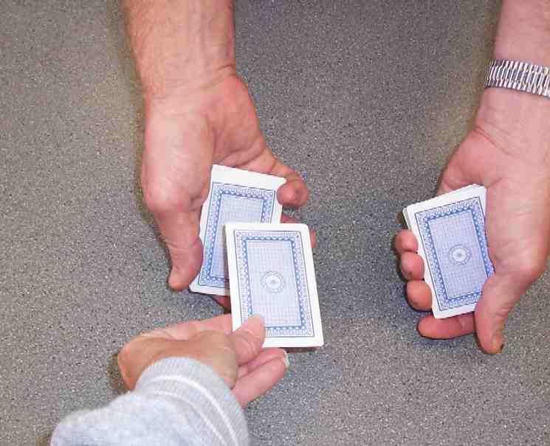

5. The five players –
Hold the deck in your left hand and tap it with your right when you claim to have made the “chosen” card turn over in the deck.

Fan the cards until you show the “5”. It is the wrong card placed face up. Set aside the top portion of cards already fanned through.
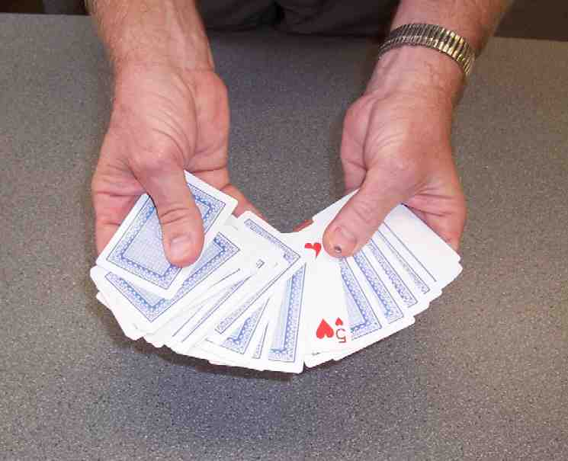
You will only need the bottom portion that has the “5” and the five cards immediately beneath it.

As you talk about the “5” being a clue to find the mystery card, set aside the “5,” then deal out the next five cards face down on the table. The last one dealt, which is the fifth card, can be turned over to reveal the mystery card. Then the four.

5. Now what I’m going to do is tap the top of this deck. And… I’m so amazing, that when I do, it’s going to make the card you chose pop out, turn over and go back in. When it does that, it will remind us how Jesus has power over death.

Are you ready? Here I go. “Tap!” Now I’ve turned over that card. Let me display all these cards in front of you. You’ll see – there it is—the “5!”

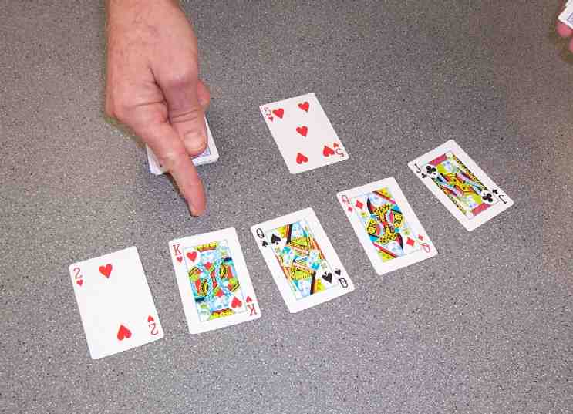
What? You mean that’s not it? Oh, well, maybe it’s a clue. Maybe that means that your card is five cards away. Let’s count down five cards and let me pull these out. Here’s one, two, three, four and five. And, the fifth
card is… that must be yours. Why don’t you turn it over? Why it must be yours, because you believe in Jesus. (Turn over the king of hearts.) The king of hearts—Jesus Himself and are amazed at His power just like…. (Pick cards can be turned over in order from the last dealt. The fourth dealt will be the king of hearts, the third and second will be the queens and the first dealt will be the jack. Up the two queens.) Mary and Martha when Jesus raised their brother, Lazarus. (Pick up the jack. Now all five cards are shown.) All this is possible because Jesus has the power over death. And…. that’s (use wide gesture to encourage audience response) simply am-a-aaa-azing!

PART THREE

Dao Dao’s Review Questions

The following questions can be used for review of today’s Bible event. This will be a contest between Dao Dao and the kids. Dao Dao assigns a scoring value to each question before that question is read. That number is in parentheses at the beginnning of the question. What makes it fun is that Dao Dao finally gets one correct at the end and that number helps him make a dramatic comeback. The kids typically win, but it might be interesting if, from time to time, Dao Dao wins. Adjust to your preference. One thing is important and will be vital to this script: move through your material quickly. By this time, the kids’ attention spans are short. You may even want to delete some of the questions if it is feeling a bit long.

After each question, the first parenthetical remark is Dao Dao’s response. The second parenthetical remark is the correct answer from a child.

Kids might even bring their Bibles to large group to search for answers as they listen to the following questions.

1 (Kids zero, Dao Dao zero. For 10 points) When Lazarus was sick, Jesus was not nearby. How did He find out about it?
(Dao Dao) He used His radar…? His brainwaves…? Don’t know.
(Kids) A servant was sent to tell Him.

2 (Kids 10, Dao Dao zero. For 17 points) When Jesus heard about the sickness, did He say He would come right away or did He wait awhile?
(Dao Dao) He came right away, of course.
(Kids) He waited awhile.

3. (Kids 27, Dao Dao zero. For 25 points) After Jesus heard Lazarus was sick, He stayed where He was for two more days. He said that through Lazarus’ sickness, God would receive glory. When He came, what was Lazarus doing?
(Dao Dao) Nothing… he was chilling out.

Teacher: Correct! He was chilling out. He was dead.

4. (Kids 27, Dao Dao 25. For 42 points) Mary and Martha were crying. Jesus knew that He would heal Lazarus. He said, “I am the One who brings people back to life and I am life itself.” Still He saw that everyone was sad. Did Jesus cry, too?
(Dao Dao) No, He’s no crybaby.
(Kids) Yes, He did cry.

Explain that Jesus was sad even though He knew He would raise Lazarus from the dead. Sometimes it’s sad to think about death and leaving people that you love.

5. (Kids 69, Dao Dao 25. For 45 points) When Jesus said, “Roll open the tomb,” what did Mary and Martha say?
(Dao Dao) I know, I know…. She said it would stink in there because Lazarus had been dead for four days.

Teacher: Right answer, Dao Dao.

Dao Dao: It’s easy for me to remember when people stink.

6. (Kids 69, Dao Dao 70. And the final points for the last question… 2 points.) What was it Jesus said when He went into Lazarus’ tomb to raise him from the dead?
(Dao Dao) Lazarus, come forth.

Dao Dao: Cool, Teacher. That was such a cool game, I don’t care who won.

Teacher: Well, one thing is for sure. We all win when we know Jesus’ power over death.

Dao Dao: Yeah, that death stuff is kinda creepy. Especially if they wrap them up like some sort of mummy.

Teacher: But, Dao Dao, we don’t have to be too scared about death. When we trust in Jesus, we know that He has power over death. As a matter of fact, He has the power to give life.

Dao Dao: Well, like you mean, when we go to heaven when we die?

Teacher: Yes, and more than that. When we trust Jesus as our Savior, He lives in our life. You can say He lives in our hearts.

Dao Dao: Oh, yeah, sure, I know that.

Teacher: And because of that, even when we are sad or scared, Jesus is right there with us.

Dao Dao: Well, what about the times when I’ve prayed and He doesn’t answer me right away?

Teacher: He didn’t answer Mary and Martha right away either, did He?

Dao Dao: No.

Teacher: But did He answer their prayer?

Dao Dao: Yeah, I guess so…. after Lazarus died.

Teacher: If Jesus would have answered them right away and healed Lazarus when he was sick, no one would have witnessed Jesus’ power over death when He raised Lazarus. Sometimes God has good reasons for waiting to answer our prayers.

Dao Dao: Yes, I guess He is the smartest.

Teacher: Yep, smarter than me, Dao Dao.

Dao Dao: Well, that might not be THAT hard, Teacher! Just kidding. I’m just glad we have power over death through Jesus.

Teacher: Me, too. Dao Dao, so I will close in prayer now.

Dear God, thank You for sending Jesus. Jesus, thank You for giving Your life for us. When you died on the cross, You showed You have power of death. Now, since our sins are forgiven, when we die, we won’t stay dead but will come alive again in heaven. Thank You for doing that for us. We believe it and trust it and will tell others about it. In Jesus’ name. Amen.

Lesson 45

Small Group Warm-up
- one deck of playing cards
- Appendix A

Large Group Presentation
      - “simply amaa-aazing” signs from previous lessons.
      - playing cards
      - The Miracle Maker video, Family Home Entertainment, Inc.—can be ordered from www.amazon.com. Begin at the quote, ”Teacher, I’ve ridden all night,” “Rueben, what happened?” Conclude the portion with this quote, ”Now they are ready to follow the Messiah to the holy city.”

Small Group Application
      - deck of cards

Memory Verse Learning
      - a strip of 60cm linen cloth for each child
      - masking tape for each team
      - pencils
      - a 1.5 liter bottle filled with water

Appendix A

Rising to the Top
Card trick for Warm-up

What’s happening with the cards:
1. Arrange the cards beforehand. Take a red eight and red four and place it on top of your deck. Then place a second red eight and red four together in the middle of your deck. Now you are ready to begin.

2. Trick shuffle keeping your two red cards on top of the deck. This can be done easily with a little practice. After shuffling two or three times with the kids watching, fan the cards out slowly, face up in your hand. Show them that it is an ordinary deck of cards. As you begin to fan the cards out and get close to the “planted” red eight or red four in the middle of the deck, tell the kids this: “Tell me when to stop.” As soon as they do, pull the first red four or eight and place it on the surface, face down. Continue to fan the cards slowly until you see the other red number. When you do, ask another student to tell you when to stop. If they pause, tell them to hurry up and say it. Pull the other “planted” red card in the middle of the deck and place it face down.

3. Pick up the two face down cards and show them very quickly to the kids. Return them to the surface and keep them face down. Be careful not to refer to the cards by their suit name. Since the kids have only a brief second to see them, most often all they will be able to remember is a red eight and a red four. Let them place the cards back in the deck anywhere they like except at the very top.

Here’s what you say:

2. As you work in front of the students and show the deck in front of them, here is what you say,
“As you can see, I have an ordinary deck of cards. When I start to fan them out, I want you to tell me when to stop… and we’ll select a card. Okay, you want me to stop fanning the cards here. Let me pull a card out. Oh, it’s a red four. I’ll place it on the table. Who else wants to tell me when to stop? Thank you. Here is the red eight. Let me place it on the table.

3. Show the cards quickly and return them face down to the working surface. Continue with:

Okay, now place your cards in the deck. I won’t watch. I’ll turn my head and not look.

- Raising the cards to the top—
Wrap the cards in a tissue and follow the spoken script.

4. Now I need to do something to make the two cards come to the top. Let me wrap them in a tissue… (Wrap the deck with a clean tissue.) and let me speak to the cards and tap the deck twice. (Tap the deck twice and say, “Eight and Four, come forth.”) Let’s see what happened. Let me unwrap the tissue and see what we have on the top. Were the four and eight raised to the top? Well, I’ll be. There’s the eight and the four. And that is… (Gesture widely encouraging a response from the kids) “Simply ama-a-aaa-azing!”

