
Date: ________________________
Series: Meet the Amazing Jesus
Dec-Mar Year 3, Lesson 47

Meet the One Who Died For You

Take Home Point: *Jesus’ amazing sacrifice equals eternal life for you. *Repeat this phrase throughout the lesson.

Bible Event: Luke 22:63-23:49. Jesus’ trial and crucifixion
Key Verse: John 3:16, “For God loved the world so much that He gave His only Son. God gave His Son so that whoever believes in Him may not be lost but will have eternal life.”

We will help kids know:
- Jesus’ death was the worst punishment of all time, but it was God’s plan to pay the punishment for all sin.
- Jesus died for me to pay for my forgiveness.

We will help kids feel:
- Amazed at how much Jesus went through because He loved us so much.
- Confident in their relationship with Jesus so that they might trust Him for salvation.

We will help kids do:
- Identify the way they have experienced punishment.
- Make gospel witnessing cards that use John 3:16 in a very personal way.

THIS LESSON’S ROADMAP

DESTINATION | PAGE # | DISCOVERIES ON YOUR JOURNEY | SUPPLIES NEEDED
  Small Group Warm-Up | 3 | What was the worst punishment that you have ever received? What was the worst punishment that has ever been given to anyone? Children discuss and conclude with a deeper understanding of Jesus’ death on the cross for our sins. | - hammer and a piece of wood  or  - two wooden blocks, two bricks, or any two objects that can be slammed hard together
Large Group   | 3  7  7  11 | Overview  Video: “The Miracle Maker,” by Family Home Entertainment, Inc. The section is about twenty minutes. Cue to start immediately after Jesus cleanses the temple and the Roman soldiers have marched away. End the video with the crucifixion of Jesus.  Object Lesson: “Gospel Illusion 4U”—A card illusion trick with John 3:16 written on the back so a child can fill in his name and be used to teach the take home point: *Jesus’ amazing sacrifice equals eternal life for you.  Dao Dao Review: Questions to review today’s lesson. | - large sign that reads “Meet the Amazing Jesus”  - smaller signs hung in the front of the room with the word “amazing” on them  - Dao Dao  - the video The Miracle Maker by Family Home Entertainment, Inc (www.booksofthebible.com)  - gospel illusion cards “For Whom Did Jesus Die?” Copy the cards on card stock so that “For Whom Did Jesus Die?” is on the front and John 3:16 (see script for details) is on the back.  - pencil
Small Group Application   | 4 | This is an important time to listen to each child. Try and understand where each might be in his/her own security and understanding of the salvation that Jesus won.  Memory Verse Learning:  “Team Hammering”  Rm. 5:1 is learnt in lessons 46 & 47 to help each child realize they are secure in their friendship with Jesus through faith in Him. | - gospel illusion cards “For Whom Did Jesus Die” for the shepherd and each child—this includes four full cards, a rubber band, and a half card with a question mark on it  For each group:  - 3X5 cards; markers  - two 1X4 four feet strip of wood  - hammers and nails
Small Group Warm-Up: 15 minutes
Purpose: Get pointed in the right direction! Build relationships and help guests feel at ease. Do the learning readiness activity that will point your group in the right direction for the lesson.

Supplies needed: hammer and a piece of wood or two wooden blocks, two bricks, or any two objects that can be slammed hard together

During the following discussion, use a visual illustration of a punishment that would be very hard. The illustration might be slamming two pieces of wood together, hitting a piece of wood with a hammer, or slamming two bricks together. Each child could do this action after he shares his response.

What was the worst punishment that you ever received? What was the worst punishment that has ever been given to anyone?

As children discuss the second question, mention Jesus’ death on the cross as the focus of today’s lesson.

Also discuss:

Can you imagine how much it would hurt if you had your fingers caught between two pieces of wood hitting together?

As the kids imagine this, they begin to imagine the sacrifice behind Jesus dying for the punishment of their sins. Shepherds need to be sensitive to the children during this discussion as the illustration may be too demonstrative for younger children. Wrap up the discussion with the take home point:

Today we will learn that *Jesus’ amazing sacrifice equals eternal life for you.

Large Group Overview: 20-30 minutes
Purpose: Help kids observe what the Bible says. Present the Bible event in creative fashion. Help kids begin to interpret what it means.

Video: The “Miracle Maker,” by Family Home Entertainment, Inc., 1999—the section is about twenty minutes. Cue to start immediately after Jesus cleanses the temple and the Roman soldiers have marched away. End the video with the crucifixion of Jesus.

Object Lesson: “Gospel Illusion 4U”—A card illusion trick with John 3:16 written on the back so a child can fill in his name to make the passage personal is used to teach the take home point: *Jesus’ amazing sacrifice equals eternal life for you.

Dao Dao Review: Questions to review today’s lesson.

Small Group Application: 20-25 minutes
Purpose: Help kids map out the meaning of the Bible event in their lives. Use the questions to stimulate discussion but don't feel tied to them. Allow the Holy Spirit to guide you. Include personal examples from your own faith journey. The example of Christ at work in your life will leave lasting impressions of how Christ can work in the children's lives.

Use your Bibles! Children need to learn how to look up references and follow along when scripture is read aloud. Allow for quality time of prayer at the close of the lesson.

Observation Questions: What happened?
Have kids refer to Luke 22:63-23:49 in their Bibles for the following questions:

What was Jesus accused of doing wrong? (Luke 23:2. He stirred up trouble among our people, He encouraged them not to pay their taxes, and He said that He is Christ, a king.)

Which accusations were incorrect and which was correct? (He did say He was the Christ, but a different kind of king. See John 18:36, Luke 22:25-30. His kingdom was not of this world. )

Was claiming to be Christ, the Son of God, a crime? (No, it was the truth.)

What were some of the ways Jesus suffered?
    - Luke 22:63-65. The Jewish guards beat Him and made fun of Him.
    - Luke 23:1-4. He was falsely accused of doing wrong.
    - Luke 23:11. Herod and his soldiers treated Him with contempt and made fun of Him.
    - Luke 23:18-24. The whole crowd of people turned against Him.
    - Luke 23:16 & 22. Pilate had Him whipped.
    - Luke 23:26-49. He suffered the painful death of crucifixion on a cross.)

What ways did Jesus show compassion to the people even when He was dying? (Luke 23:34-49. He asked God to forgive the people hurting Him. He promised eternal life to the one criminal on the cross next to Him.)

Interpretation Questions: What does this mean?
Three times Jesus was told, “If You are really the Messiah, save Yourself.” Do you think Jesus could have? (See Matthew 26:53.) Why didn’t He? (See John 18:11.)

Application Questions: What does this mean to me?

There are two key questions in today’s application. The questions will help the children talk about what Jesus has done for them. Be sure to listen to each child to understand where he might be in his own security and understanding of the salvation that Jesus won for him.

Supplies needed: gospel illusion “For Whom Did Jesus Die” for the shepherd and each child—this includes four full cards, a rubber band, and a half card with a question mark on it

Why do you think that Jesus would want to go through such punishment? (Jesus loved us and knew that His punishment and death were the only way for God to punish our sin. We could not bear the punishment of that sin ourselves. Jesus had to take the punishment for us.)

When you think about Jesus and what He did, do you feel His love? Do you believe He died on the cross for you?

Listen to the children talk about how they feel about Jesus and His love for them. If any child is unsure about it, let him know that he can trust in what God has done for him. A prayer is a good way to help the children express their trust. You may want to include such a prayer in closing prayers.

As the questions are discussed, demonstrate the gospel illusion that was shown in large group. (See the attached script “Gospel Illusion 4 U” for directions.) Give the children the opportunity to learn the illusion so that they may share it with their friends. Show the children how the gospel illusion works. Some children might want to have the opportunity to use this as a witnessing tool.

Give each child four full cards, a rubber band, and a half card with a question mark on it. Have kids read today’s Bible verse, John 3:16, from the back of the cards, inserting his own name in the blanks. Explain to the kids that they can share this verse with others and show them that Jesus died “4 U.”

Memory Verse Learning: 5 minutes
Purpose: Help kids to memorize and keep scriptures at heart. Using creative ways to help kids enjoy learning the key verse and in small group setting.

Supplies needed: For each group – 3X5 cards; markers; two 1X4 four feet strip of wood; hammers and nails

Memory Verse: Romans 5:1, “We have been made right with God because of our faith. So we have peace with God through our Lord Jesus Christ.”

Memory Verse Learning: “Team Hammering”
Before class, break up the memory verse and write them on the 3X5 cards – have two sets done for your group. During class lay the cards out randomly and have volunteers arrange the cards in sequence. Then divide the children into two teams and have them line up at one end of the room. Opposite the team, about eight feet apart, lay the strip of wood, hammer and nails. Right in the middle layout the 3x5 cards. Tell them that the challenge is to run, pick up the right card and hammer it on the wood. The first team that have the verse correctly arranged and hammered neatly on the wood wins.

Prayer:
Ask God to help all understand how much pain Jesus suffered in each person’s behalf. Thank Him for our costly salvation.
Safety and Security: Safety and security procedures are important for each church to carefully define and implement according to their unique needs. The security, safety, illness and accident procedures described in this curriculum are provided for example purposes only and may not be appropriate, applicable or adequate for every situation. Each church is responsible for determining whether any security, safety, illness and accident procedures contained in the curriculum are appropriate, applicable or adequate for its unique situation. The activities described in this curriculum require adult supervision and may not be suitable for each child and each situation. Each church is responsible for ensuring that adequate adult supervision is provided for all activities and for determining whether an activity is appropriate for each child and each situation. Kids Kount Publishing disclaims all liability for the implementation of any procedures or the performance of any activities described in this curriculum.
Large Group Presentation

Jesus’ Sacrifice

Set design and props needed for this series will include a large sign that reads, “Meet the Amazing Jesus.” In addition to this sign, hang smaller signs in the front of the room with the word “Amazing” printed on each one.

Prompt kids to say, “Simply amaaaazing,” when the presenter points up and says, “And THAT is…,” A sweeping arm gesture by the large group presenter as the kids say “simply amaaaa-a-azing” will add effect and emphasis. Use this technique as an attention grabber when presenting the main points.

There are three sections to today’s large group presentation. The first section is a video presentation of the Bible event. The second section is a retelling of the event using an amazing object lesson. In the third section, Dao Dao, the puppet, helps kids review.

Adapt this lesson to use one or all of the following parts depending on availability of videos and/or illusion tricks.

Part One:
Begin with the animated video, “The Miracle Maker,” by Family Home Entertainment, Inc. The video section for today will last approximately twenty minutes. Cue the video to start immediately after Jesus cleanses the temple and the Roman soldiers have marched away. End the video with the crucifixion of Jesus.

Part Two:
Retell the story with the object lesson as follows. The presenter will then retell the story using the object lesson (see attached script with illustrations). He then closes large group by reviewing the object lesson with the questions in the appendix.

Part Three
Dao Dao is invited to answer review questions along with the children.

PART ONE

Begin with the animated video, The Miracle Maker, by Family Home Entertainment, Inc. The video section for today will last approximately twenty minutes. Cue the video to start immediately after Jesus cleanses the temple and the Roman soldiers have marched away. End the video with the crucifixion of Jesus.

PART TWO

Gospel Illusion 4 U

Object Lesson with Illusion

Supplies needed: gospel illusion cards “For Whom Did Jesus Die?” Copy the cards on card stock so that “For Whom Did Jesus Die?” is on the front and John 3:16 (see script for details) is on the back, pencil

The gospel illusion is a wonderful way to make witness cards for the children to share the good news with others that Jesus died “4 U.” The gospel illusion involves making photocopies of a small card that reads “For Whom Did Jesus Die?” The bottom part of the card will say “4 U.” The backside of the card reads:

“For God so loved so much that He gave His only Son. God gave His Son so that __ believes in Him may not be lost, but ___________ have eternal life. “
John 3:16

In addition to this card, a card half the size of the above card is made with a large question mark printed on it.

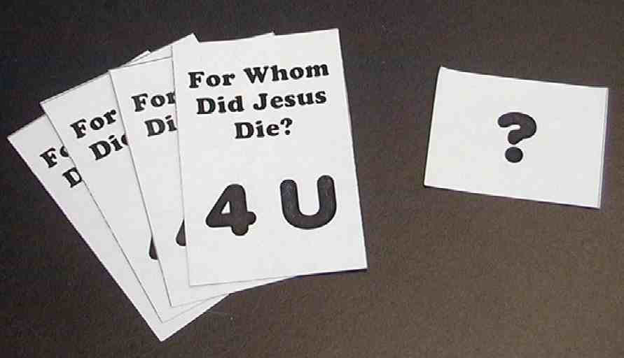

The gospel illusion works this way. There is a stack of four cards with a rubber band holding them together in the middle. The half-sized card with the question mark on it will be placed on the lower part of the “For Whom Did Jesus Die?” card.

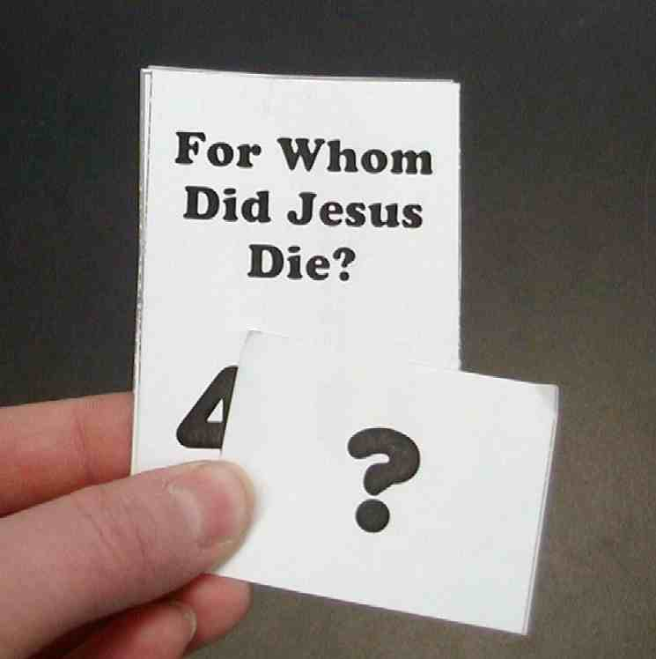
A rubber band is placed around the deck to conceal the “seam.” The top card would read, “For Whom Did Jesus Die?” Below the rubber band would be a large question mark.

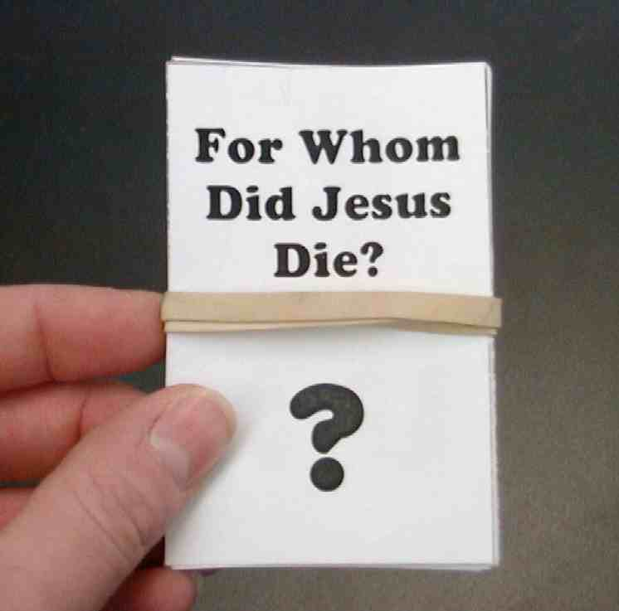

When the card is pulled off, the question mark would stay with the deck and the top card would be the trick card.

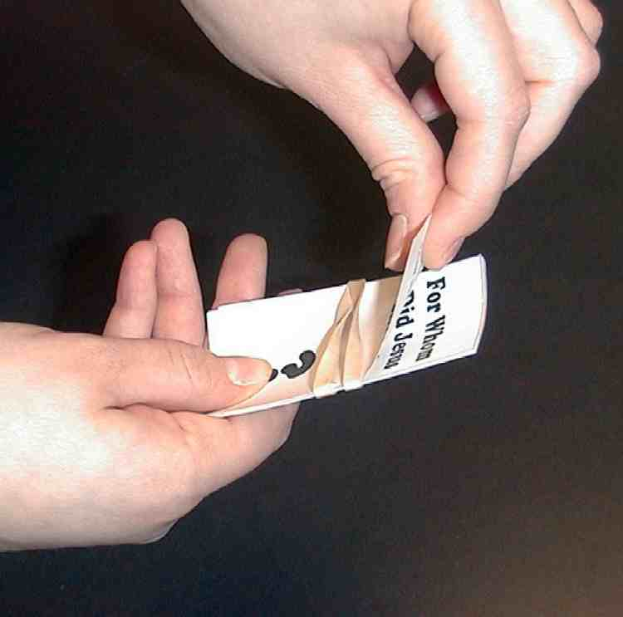

The card that is removed from the deck is placed face down on the table for the child to fill in the blanks on the back of the card with his name.

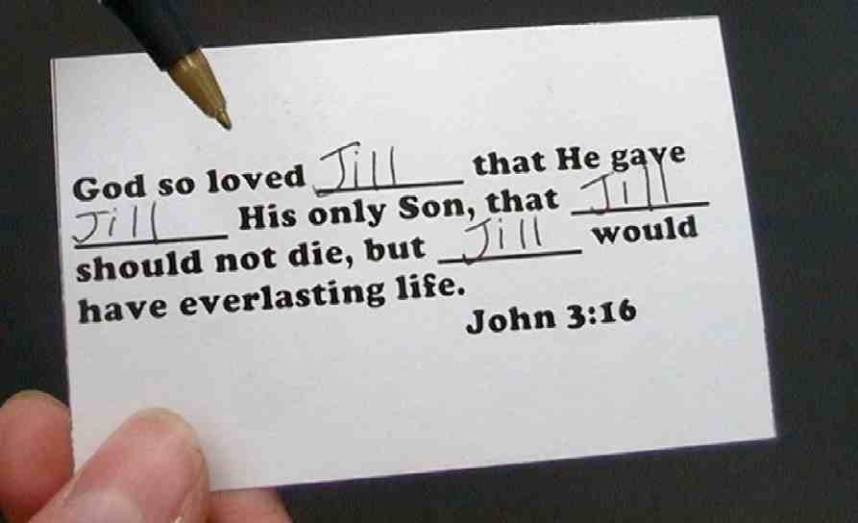
The card is turned over and the contestant is surprised to find the answer to the question, “4 U,” is now on the front of the card.



The following patter illustrates today’s story and makes application.

Show the stack of cards that are rubber banded together. Begin by talking about Jesus’ death.

Jesus truly was the Son of God. He came into the world to do the most amazing thing. Jesus came to take the punishment of sin for the entire world upon Himself. He did that when He was nailed to the cross and died. You can imagine how that must have hurt. Even though Jesus did not deserve such punishment, He did this as part of God’s plan. Jesus knew that on the cross He would take the punishment for all the sin of the world.

God is completely holy and perfect, and He is a God of love. He wants people to live with Him forever. All people have sinned and fallen short of God’s glory. We deserve punishment for our sins. If God punished each one of us for our sins, we would be separated from God forever. Knowing this, God placed the punishment of all our sins on someone who did not deserve it – His Son, Jesus. Jesus is the only One who could take our punishment from us and put it upon Himself. Jesus did not stay dead, but came back to life and lives forever.

Bring a contestant forward.

Let’s pull this card out and see if we can answer the question on it. The question is, “For whom did Jesus die?”

Have the child take the top card and pull it from the deck without looking at the front of the card. Be careful that the half card with the question mark on it is not removed from the deck so that it conceals the answer. Lay the card on the table. The back of the card will read, “For God so loved so much that He gave His only Son. God gave His Son so that __ believes in Him may not be lost, but ___________ have eternal life. “

The child should write his name in all the blanks.

The child is then asked, “For whom did Jesus die?” The child should answer that Jesus died for him.

Correct. Jesus died for you. Do you believe it? If you do, all the punishment for all the wrong things you have ever done or will ever do are taken off of you and put upon Jesus. That is how much God loves you.

Let’s see what the card says is the answer to the question “For whom did Jesus die?”

Flip the card on the table over to show the answer “4 U.”

That’s right! Jesus died for you.

PART THREE

Dao Dao’s Review Questions

The following questions can be used for review of today’s Bible event. This will be a contest between Dao Dao and the kids. Dao Dao assigns a scoring value to each question before that question is read. That number is in parentheses at the beginnning of the question. What makes it fun is that Dao Dao finally gets one correct at the end and that number helps him make a dramatic comeback. The kids typically win, but it might be interesting if, from time to time, Dao Dao wins. Adjust to your preference. One thing is important and will be vital to this script: move through your material quickly. By this time, the kids’ attention spans are short. You may even want to delete some of the questions if it is feeling a bit long.

After each question, the first parenthetical remark is Dao Dao’s response. The second parenthetical remark is the correct answer from a child.

Kids might even bring their Bibles to large group to search for answers as they listen to the following questions.
(Dao Dao comes in weaving and shadow boxing – punching the air. Teacher walks warily up to Dao Dao.)

Teacher: (Tries to avoid Dao Dao’s punches.) Dao Dao, what are you doing? Did you see the video?

Dao Dao: I don’t think I was paying much attention, I was just thinking of how “not fair” it was for Jesus to be punished. Everyone was so mean to Him. I wanted them to stop. (Slows his punches to a stop.)

Teacher: Yes, Dao Dao, but remember, his ama-a-zing sacrifice means eternal life for you! Now how about some review questions to remind you of that. Do you have the “fighting spirit” to compete against the kids?

Dao Dao: Go for it, Teacher. They know I’m prepared.

Teacher: Okay, this first question is worth 50 points.

- Did Jesus try to stop the Roman soldiers from arresting Him?
(Yes. He was playing hide and seek in a garden.)
(No. He was praying in the garden but He expected that He would be arrested.)

- (Kids, 50, Dao Dao zero. Next one… 123 points) Did Jesus ever tell His disciples that He would be arrested and be put to death?
(I don’t know. Did He?)
(Yes, He did. Several times. Jesus even talked about it during His Last Supper with the disciples.)

- (Kids 173, Dao Dao, zero. I know you can do better, Dao Dao. Try harder. 127 points.) When Jesus was put on trial, it really was not fair. What did Jesus do? Did He try to stop it and say it was not fair?
(Yes. He said, “No fair! No fair! I’m going to tell!”)
(Though it was not fair, Jesus did not resist. He knew that He had to go to the cross to die.)

- (Last chance, Dao Dao. Kids, 300. Dao Dao, zero. 300 points for the last question.) When Jesus died on the cross, was He sad? Did it hurt? Did He feel like He was being punished?
(I think it must have hurt, even if He was the Son of God. He took our punishment for us.)

Teacher: That’s the truth, Dao Dao. The score is 300 to 300. Everyone who
knows and believes what Jesus has done is a winner. *Jesus’ ama-a-azing sacrifice equals eternal life for you. Knowing that answer is very important for all of us to learn. We will close in prayer.

Dear God, thank You for sending Jesus to suffer on the cross for us. Thank You, God, for giving Your only Son for our sin. Help us to realize that we are sinners and cannot get to heaven without Jesus. We place our trust in Jesus’ finished work on the cross. In His name. Amen.

Lesson 47

Small Group Warm-up
- hammer and a piece of wood
or
- two wooden blocks, two bricks, or any two objects that can be slammed hard together

Large Group Presentation
- large sign that reads “Meet the Amazing Jesus”
- smaller signs hung in the front of the room with the word “amazing” on them
- Dao Dao
- the video The Miracle Maker by Family Home Entertainment, Inc (www.booksofthebible.com)
- gospel illusion cards “For Whom Did Jesus Die?” Copy the cards on card stock so that “For Whom Did Jesus Die?” is on the front and John 3:16 (see script for details) is on the back.
- pencil

Small Group Application
- gospel illusion cards “For Whom Did Jesus Die” for the shepherd and each child—this includes four full cards, a rubber band, and a half card with a question mark on it

Memory Verse Learning
For each group:
- 3X5 cards; markers
- two 1X4 four feet strip of wood
- hammers and nails

For Whom Did Jesus Die?  4 U | For Whom Did Jesus Die?  4 U
For Whom Did Jesus Die?  4 U | For Whom Did Jesus Die?  4 U

For God so loved _______ so much that He gave ________His only Son. God gave His Son so that ________ believes in Him may not be lost, but ___________ have eternal life.  (John 3:16 for you!) | For God so loved _______ so much that He gave ________His only Son. God gave His Son so that ________ believes in Him may not be lost, but ___________ have eternal life.  (John 3:16 for you!)
For God so loved _______ so much that He gave ________His only Son. God gave His Son so that ________ believes in Him may not be lost, but ___________ have eternal life.  (John 3:16 for you!) | For God so loved _______ so much that He gave ________His only Son. God gave His Son so that ________ believes in Him may not be lost, but ___________ have eternal life.  (John 3:16 for you!)

? | ?
? | ?

