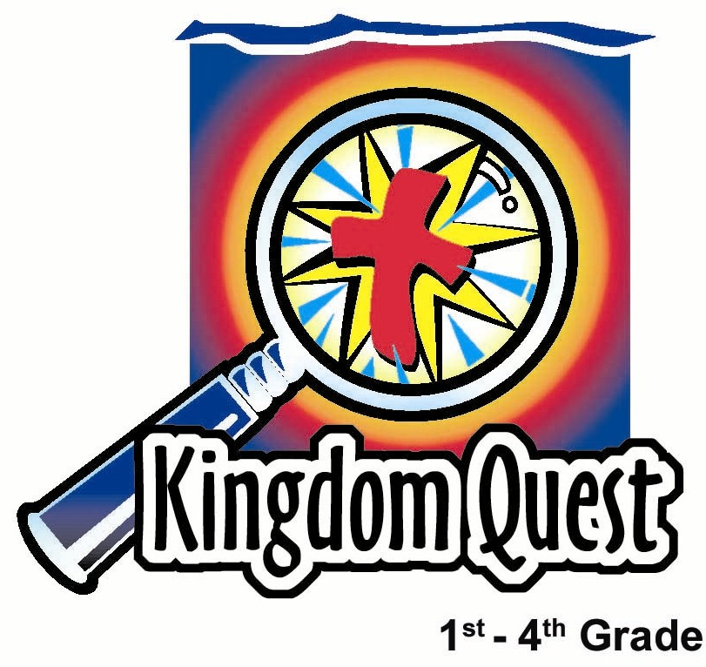
Date: _________________
Series: Mission Adventures
Apr-May Year 3, Lesson 54

Paul and Barnabas Separate

Take Home Point: *God works even when we disagree. *Repeat this phrase throughout the lesson.

Bible Event: Acts 15:30-41

Key Verses: Ephesians 4:26-27, “When you are angry, do not sin. And do not go on being angry all day. Do not give the devil a way to defeat you.”

We will help kids know:
- The Bible event of Paul and Barnabas disagreeing over whether to take John Mark with them. The disagreement led them to go on separate missionary adventures.
- God even works in our disagreements. In this event, God made two missionary teams instead of one.
- We have disagreements, even in the church. It is not wrong to disagree as long as we do not sin in our anger and hold a grudge.
- God placed His anger against sin on Jesus when He went to the cross. Since He does not hold His anger against us, we should not hold our anger against others.

We will help kids feel:
- Convicted of times when they hold anger and revenge against others who have wronged them.
- Encouraged that God still uses them for His purposes even if they get angry.

We will help kids do:
- Examine the Bible to see what it says about anger.
- Cut a mobius strip as an example of how they can remain separate but still connected to others while they deal with anger or disappointment.

THIS LESSON’S ROADMAP

DESTINATION | PAGE # | DISCOVERIES ON YOUR JOURNEY | SUPPLIES NEEDED
Small Group Warm-Up   | 3 | Kids make an angry list of those things that friends or family did to anger them. | - 8 ½ by 14 inch pieces of paper cut lengthwise and taped together securely to form a 26 by 4 inch strip. One of these per child is needed.  - pencils or markers  - optional: sour candy or lemon wedges
Large Group   | 4  7  10  10 | Overview  Puppet Presentation: “Aaron is a Big Rotten Egg” –Dao Dao explains why his anger list has “Aaron is a Big Rotten Egg” written all over it.  Video: The Visual Bible: Acts –show Acts15:30-41.  Teaching Point with Puppet Presentation Conclusion: “Aaron is a Big Rotten Egg”—Dao Dao learns that God even works when we disagree. | - small backpack for Dao Dao  - paper from small group with “Aaron is a Big Rotten Egg” written all over it  - Video—The Visual Bible: Acts, produced by Visual Bible International—order from http:/christiancinema.com/catalog/product_info.php?products_id=364  - suitcase  - one more strip of paper  - scissors  - marker  - tape  - cross
Small Group Application   | 4 | Kids write ways that God can possibly use the situations written on their sheets from small group Warm-Up for good. They tape and cut their own paper strips so they end up with two circles connected together.  Memory Verse Learning:  “Serve the Team”  1 Peter 4:10 will be emphasized in lessons 52-55 that each child understands with certainty that God calls them for a unique purpose and mission. | - paper strips from Warm-Up  - tape  - pencils or pens  - scissors  - masking tape  - for each team - 12 pieces of 4 X12cm tissue paper and one 9” flat plastic plate

Small Group Warm-Up: 15 minutes
Purpose: Get pointed in the right direction! Build relationships and help guests feel at ease. Do the learning readiness activity that will point your group in the right direction for the lesson.

Supplies: paper—8 ½” by 14” cut in half lengthwise—one per child, tape, pens or pencils, optional: sour candy or lemon wedges

Hand each kid two of the half sheets of paper. Have them overlap the two pieces together on the short sides and tape together. The two pieces together will make a 26- inch strip. Make sure kids tape the strips together well on both the front and back as this will be cut apart later in the lesson. (See small group application activity.)

Show kids your example of the paper and say:

This looks like something we might use to write our Christmas wish list, but actually this is our ANGER list.

Can you think of something that a friend or family member did that really made you angry? Please share these with the group and then write it on your list. Write big letters so it covers the front and the back.

Encourage kids to discuss as they write. Optional: pass out sour candy while discussing.

Do you think that people in the church ever get angry or disagree with one another?

People in the church do disagree and sometimes get very angry with one another. Does God still work when this happens? Yes, He can work, even when people in the church disagree. But He wants to show us what to do with our disagreements and our anger.

Today we will learn that *God even works when we disagree.

Large Group Overview: 20-30 minutes
Purpose: Help kids observe what the Bible says. Present the Bible event in creative fashion. Help kids begin to interpret what it means.

Puppet Presentation: “Aaron is a Big Rotten Egg”–Dao Dao explains why his anger list has “Aaron is a Big Rotten Egg” written all over it.

Video: The Visual Bible: Acts, distributed by Visual Bible International. Order from http:/christiancinema.com/catalog/product_info.php?products_id=364. Show the clip showing Acts15:30-41.

Puppet Presentation Conclusion: “Aaron is a Big Rotten Egg”—Dao Dao learns that God even works when we disagree.

Small Group Application: 20-25 minutes
Purpose: Help kids map out the meaning of the Bible event in their lives. Use the questions to stimulate discussion but don't feel tied to them. Allow the Holy Spirit to guide you. Include personal examples from your own faith journey. The example of Christ at work in your life will leave lasting impressions of how Christ can work in the children's lives.

Use your Bibles! Children need to learn how to look up references and follow along when scripture is read aloud. Allow for quality time of prayer at the close of the lesson.

Observation Questions: What happened?

Have kids refer in their Bibles to Acts 15:32-41.

Who did Barnabas want to take, along with Paul, back to the cities where they had spread God’s word? (Acts 15:37. John Mark.)

Why did Paul not want John Mark to go along? (Acts 15:38. John Mark had deserted them and had not gone with them to work on a prior occasion.)

Interpretation Questions: What does this mean?

What was the result of Paul and Barnabas’ strong disagreement? (Acts 15:39-40.They parted ways. Barnabas took Mark with him to Cyprus and Paul chose Silas to go along to Syria and Cilicia.)

Was this good or bad? Why? (It may have been sad that they parted company, but God used it to spread his word to more places.)

Application Questions: What does this mean to me?

The key verse for today from Ephesians 4:26-27 says, “When you are angry, do not sin. And do not go on being angry all day. Do not give the devil a way to defeat you.”

Does this verse say that anger is a sin? (No.)

How can anger sometimes cause us to sin? (We may try and get even or hurt someone back for hurting us.)

Anger that builds up becomes bitterness. When we become bitter toward someone else, we are allowing the devil an opportunity to work in our hearts.

What is God’s remedy for anger and bitterness? (Forgiveness.)

Is it easy or hard to forgive someone you are angry with? How can we do this knowing God wants us to? (Pray and ask for the power of the Holy Spirit. Sometimes we just have to make the choice to forgive even if we don’t feel like it.)

What can happen when we turn our anger over to God? (Just like with Paul and Barnabas, He can make something good come out of what may seem bad.)

Remember *God even works when we disagree. Think of some ways God can use any of the disagreements or anger you listed on your warm-up paper to help people grow closer to Him. An example might be if someone was mean to you and you didn’t get angry back. You might talk to them about how God didn’t stay angry with you, so you couldn’t stay angry with them.

Application Activity:
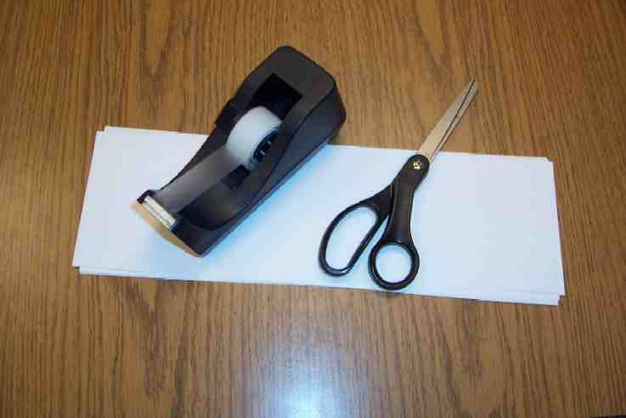
Supplies: paper from Small Group Warm-Up, scissors, pencils or pens, tape

Give kids pens or pencils, scissors and tape to make a mobius circle. Say:

Please take your paper from small group Warm-Up and write down ways that God might use a disagreement.

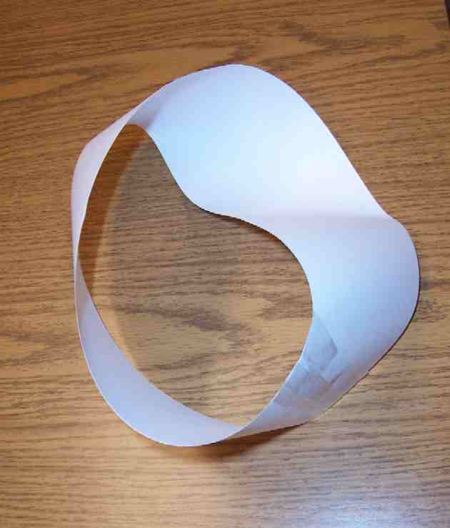
Give them time to write.

Now, put a half twist in your paper and tape it securely like this.

Show them how to do the half twist and tape the ends together.

With your scissors, start cutting 1/3 of the
way from the edge. Cut until you come toward the starting point. Cut around the circle again and back to the starting point.
When you are finished you will have two circles connected just like Dao Dao’s paper.
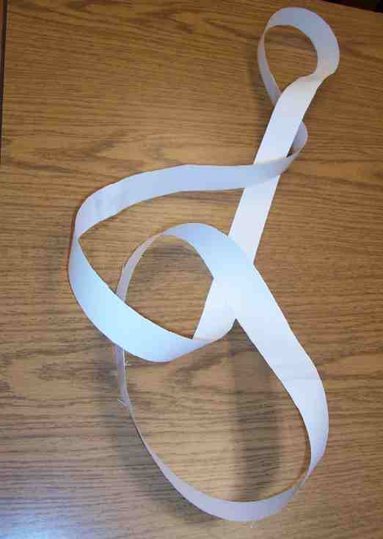

How does this activity remind us that *God even works when we disagree?

The scissors reminds us of what sin does.
It divides people from one another, just like
it divides God from us. God took His anger
and placed it on Jesus who took the
punishment for our sin when He died on the
cross. But, Jesus didn’t stay dead, He
became alive again. Through His Holy Spirit, He lives in the heart of every believer who trusts Jesus as Savior. That’s so we can be friends with God again.

Memory Verse Learning: 5 minutes
Purpose: Help kids to memorize and keep scriptures at heart. Using creative ways to help kids enjoy learning the key verse and in small group setting.

Supplies needed: masking tape; for each team - 12 pieces of 4 X12cm tissue paper and one 9” flat plastic plate

Memory Verse: 1 Peter 4:10 - “Each of you received a spiritual gift… So be good servants and use your gifts to serve each other.”

Memory Verse Presentation: “Serve the Team”
Before class, tape two parallel lines three meters apart to be start and finish. Recite the memory verse several times with the children. Tell the children that the challenge is to bring their set of tissue slips (laid on the floor in front of the team) to the other side before they can arrange them as a group. But the way to bring it over is to put only a slip onto the plastic plate, hold it like a waiter and quickly walk to the other side. Along the way if the tissue slip falls out, one has to go back to starting line to begin again. Some team members have to do twice. When all the slips are on the other side, the whole team can run over and quickly arrange the memory verse together. The quickest team to complete the course wins.

Closing Prayer:
Thank God that even though we do bad things to Him, He provides forgiveness through Jesus’ death. Ask for the Holy Spirit to help kids understand that because of God’s great love and forgiveness to them, they can choose to forgive others. Pray for anyone struggling with bitterness or anger that they can’t let go of.
Safety and Security: Safety and security procedures are important for each church to carefully define and implement according to their unique needs. The security, safety, illness and accident procedures described in this curriculum are provided for example purposes only and may not be appropriate, applicable or adequate for every situation. Each church is responsible for determining whether any security, safety, illness and accident procedures contained in the curriculum are appropriate, applicable or adequate for its unique situation. The activities described in this curriculum require adult supervision and may not be suitable for each child and each situation. Each church is responsible for ensuring that adequate adult supervision is provided for all activities and for determining whether an activity is appropriate for each child and each situation. Kids Kount Publishing disclaims all liability for the implementation of any procedures or the performance of any activities described in this curriculum.
Large Group Presentation:
20-30 minutes

Series Overview: MISSION ADVENTURES

We will investigate Paul’s first and second missionary journeys. Week to week children will be reminded that though Paul and others were set apart to be missionaries by vocation, God has not called all of us to be missionaries. He has, however, called us to have a mission. That mission is to serve Him.

A suitcase and a backpack are used to illustrate the main point in the large group presentation. The presenter uses the suitcase to talk about Paul and one of his adventures---specifically, a mission adventure. The small backpack or knapsack is attached to Dao Dao, the puppet. Some weeks Dao Dao will have an object in his pack that will help explain his perception of having a mission. Most weeks, however, an object from the traveling suitcase will be given to Dao Dao to be put in his pack. Week to week Dao Dao will discover more about how God has called him to serve.

Supplies: paper from small group attached to Dao Dao’s hand with “Aaron is a Big Rotten Egg” written all over it, suitcase, scissors, blank paper from small group already cut and taped, marker, table cross or one about that size

Aaron is a Big Rotten Egg

Puppet Presentation

Presenter: Good morning, kids. Shall we call Dao Dao?

Kids call for Dao Dao. Dao Dao… Dao Dao… Dao Dao…

Dao Dao enters with Aaron is a Big Rotten Egg paper on his hand.

Presenter: Well, good morning, Dao Dao. How are you doing today?

Dao Dao: I am SO glad I am here today, because we are talking about just what I want to!

Presenter: What do you want to talk about?

Dao Dao: AARON!

Presenter: Aaron? Who is Aaron?

Dao Dao: Aaron WAS one of my skateboard friends and I have made sure that everyone knows he USED to be one of my friends.

Presenter holds up Dao Dao’s paper.

Presenter: Dao Dao, this says, “Aaron is a Big Rotten Egg.”

Dao Dao: You got it. Aaron IS a Big Rotten Egg!

Presenter: That is pretty strong language. What happened to make you so angry?

Dao Dao: Well, Aaron asked to borrow my X-2000 Dominator skateboard and I let him. Maybe I am the rotten egg!

Presenter: No, you’re not. It is a good thing to share.

Dao Dao: You’re right. He is the rotten egg.

Presenter: Now, wait a minute!

Dao Dao: Let me tell you what he did, and I am sure you will agree!

Presenter: I am not sure about that, but please tell me.

Dao Dao: When he returned my skateboard, it had duct tape right across the middle of the board.

Presenter: That’s not such a big deal.

Dao Dao: I didn’t want duct tape on it, but Aaron told me that Ravindran had duct tape on his and all the really cool skateboarders put duct tape in the middle of their skatebaords. So, I left it on, cause you know how cool I am.

Presenter: That doesn’t seem like a problem.

Dao Dao: The duct tape isn’t the problem. Later that day I went skateboarding and when I was doing an old school underflip, I realized my skateboard had a new school UNDERCRACK!

Presenter: What do you mean?

Dao Dao: It was broken. The duct tape wasn’t for decoration, it was to hide the crack. I went back to Aaron to ask what happened. He said he was riding the pipe, jumping the grind, doing the kick flip with a full indi-grab, and finished with a bomb drop.

Presenter: Okay?? I’m not sure I understand.

Dao Dao: It means he BROKE it! That is why I call him Aaron is a Big Rotten Egg!

Presenter: I understand you are upset, but calling him names is not right. We need to do something about your anger.

Dao Dao: You don’t expect me to be his friend anymore. I’m not going to have anything to do with him! Everytime I think of him, I want to crack my skateboard over his head!

Presenter: Dao Dao, I can understand why you are very angry and you have a good reason to be.

Dao Dao: You bet I do!

Presenter: But I don’t think you are handling your anger very wisely.

Dao Dao: Should I hit him in the knees with my skateboard instead of the head?

Presenter: No! It is okay to get angry, but you have to let go of your anger and not hold a grudge. The Bible tells us not to go to bed angry. Don’t let anger break up your friendship.

Dao Dao: I know I shouldn’t, but this is really hard. I am really mad! I bet they never got mad in the Bible.

Presenter: Boy, I am glad you are here for this. Today we will find out that even in the church, people might have disagreements and get angry with each other. But did you know that God can still work? He wants our anger not to tear up our relationships.

I would like you to watch this Bible event where Paul is on a mission adventure. When it was time to start this adventure, he got into a disagreement about who should go with him.

On an earlier missionary adventure, he had taken John Mark. But John Mark left Paul and Paul felt hurt. Because of this, he did not want to take his friend again. Barnabas, who was Paul’s traveling partner, wanted to take John Mark. Let’s see what happened.

As you watch this, listen closely for the word “disagreement.” I want to see who can be the first to clap your hands once when you hear the word “disagreement.”

Video

Show the video, The Visual Bible: Acts, produced by Visual Bible International. Order from http:/christiancinema.com/catalog/product_nfo.php?products_id=364. Show the portion covering Acts 15:30-41. This will run 1 minute and 20 seconds.

Teaching Point
The following teaching point will be done with the presenter and Dao Dao.

Presenter: Dao Dao, did you see how even strong believers in Jesus have conflict and even anger?

Dao Dao: Yes, Paul and Silas went one direction and Barnacle…

Presenter: (Interrupting Dao Dao.) You mean Barnabas.

Dao Dao: Right. Barnacle and that John guy went another direction. That’s too bad.

Presenter: Even though they had anger, did they stay angry? I don’t think so. Also, God used their disagreement. Instead of having only one missionary team, God now had two teams.

Dao Dao: Wow, I never thought of it that way.

Presenter: There is something here that we can learn. It may help you and Aaron.

Dao Dao: You mean Aaron the BIG ROTTEN EGG!

Presenter: Dao Dao, that’s enough. Let me tell you how this works. Let’s see what is in our suitcase.

Take out the blank sheet of paper. At the top center, write the word GOD and write Dao Dao, the (presenters name), and a few other names on the bottom center of the strip.

This paper reminds me of how God wants to have a relationship with us. God’s name is at the top and our names are at the bottom.

Dao Dao: Yeah.

Presenter: What happens in our relationship with God? Do we have any confict or problems in our relationship with God?

Dao Dao: We all sin.

Presenter: Let me show you what that looks like.

Half twist the paper and securely tape it together. (See pictures in small group application activity.) Cut down the middle of the paper as you are talking. When you have finished cutting completely around the circle, do not reveal the finished product. Keep the paper gently folded up in your hand.

This scissors reminds us of what sin does. It divides people from one another just like it divides God from us. I am cutting this in half. God is angry against sin and has made a rule that all sin must be punished.

Dao Dao: That’s bad for us.

Presenter: It is especially bad if that causes us to be separated from God because of sin—just like I am cutting this paper.

Dao Dao: But, I don’t want to be cut off from God.

Hold the paper folded gently in your hand near the cross.

Presenter: The cross reminds us that God took His anger and placed it on Jesus who took the punishment for our sin when He died on the cross. But, Jesus didn’t stay dead, He became alive again. Through His Holy Spirit, He lives in the heart of every believer who trusts Jesus as Savior.
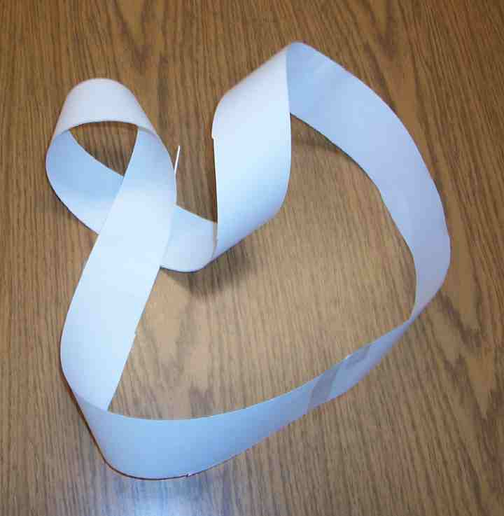
Dao Dao: That’s so we can be friends with God again.

Presenter: Right. It looks like this.

Reveal the paper in your hand. It should be one big circle.

Dao Dao: Wow! How did you do that?

Presenter: You will learn later in your small groups. But now I want to do something with your Aaron paper. May I have it, please?

Dao Dao: Here you go.

Take the paper from Dao Dao. Do the half twist and tape it together again like the last strip. Start cutting this time not in the center, but 1/3 of the way from the edge. Continue to follow that cut line until you come back to the starting place. Cut around the circle again.

Presenter: As I cut this paper, it will remind you of the anger that you have with Aaron. God doesn’t want you to hang onto your anger. He wants you to forgive Aaron, not call him bad names, and stop holding a grudge against him.

Again don’t reveal the finished product yet.

Dao Dao: What he did was wrong. Why should I forgive him?

Presenter: Dao Dao, that is because God forgave you.

Dao Dao: Oh, I get it.

Presenter: This is what it can look like for you and Aaron.

Open the paper you cut. There should be two circles still connected.

Even though there is conflict and anger, can you still stay connected together? Yes. Just like these two circles. This is what happended to Paul and Barnabas in today’s lesson.

Even though they went their different directions, they still both served God. Later in their life, we will see that Paul even asked John Mark to join him in his final days in Rome.

Dao Dao: Wow. So, I can still be Aaron’s friend?

Presenter: You bet you can. Remember that *God works even when we disagree. We should pray now.

Dear God, thank You that You didn’t stay angry with us for doing wrong to You. We thank You for Jesus who took all of our punishment on Himself. Thank You for being my friend because of what He did. And now help us to always let go of our anger before it is time for us to sleep. In Jesus’ name. Amen.

Dao Dao: You know something teacher.

Presenter: Yes, Dao Dao.

Dao Dao: My aunt from Australia is coming back to visit us tomorrow. She told me in her email that she got a skateboard for me.

Presenter: Wow! Dao Dao. See how God can make good things come out of your situation— just like Paul and Barnabas? *God works even when we disagree.

Lesson 54

Small Group Warm-Up
- 8 ½ by 14 inch pieces of paper cut lengthwise and taped together securely to form a 26 by 4 inch strip. One of these per child is needed.
- pencils or markers
- optional: sour candy or lemon wedges

Large Group Presentation
      - small backpack for Dao Dao
      - paper from small group with “Aaron is a Big Rotten Egg” written all over it
      - Video—The Visual Bible: Acts, produced by Visual Bible International—from http://christiancinema.com/catalog/product_info.php?products_id=364
      - suitcase
      - one more strip of paper
      - scissors
      - marker
      - tape
      - cross

Small Group Application
      - paper strips from Warm-Up
      - tape
      - pencils or pens
      - scissors

Memory Verse Learning
- masking tape
- for each team - 12 pieces of 4 X12cm tissue paper and one 9” flat plastic plate

