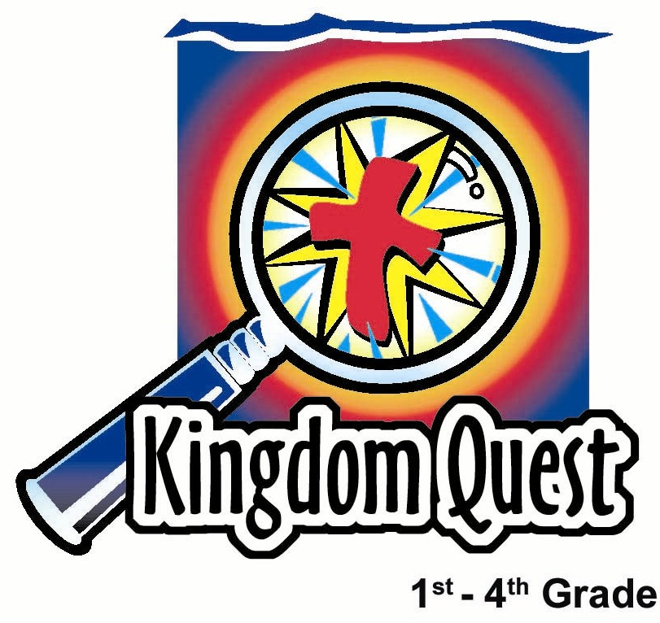
Date: ___________________________
Series: Real Life Stories of God Sightings
Dec-Mar Year 3, Lesson 30

Joseph and the Trip to Bethlehem

Take Home Point: *God guides us when we follow Him. *Repeat this phrase throughout the lesson.

Bible Event: Matthew 1:18-25, 2:13-23; Luke 2:1-7
Key Verse: Isaiah 58:11a, “The LORD will always lead you.” (NCV)

We will help kids know:
- The Bible event of an angel appearing to Joseph and telling him to take Mary as his wife. Joseph guided Mary to Bethlehem and later to safety in Egypt.
- God guides us today through His word and through other people who can help us apply His truths to our lives.
- Our destinies are not shaped merely by chance, but through God’s leading as we search His will.

We will help kids feel:
- Secure that God accompanies and guides them.
- Moved that God would use them to point to His love given to the world in Jesus.

We will help kids do:
- Identify ways in their lives that they could follow God’s guidance.
- Make an art project that demonstrates how some people feel merely pushed around by life’s circumstances while others, who are open to God’s guiding, can see direction and purpose so they can point the way to Jesus.

THIS LESSON’S ROADMAP

DESTINATION | PAGE # | DISCOVERIES ON YOUR JOURNEY | SUPPLIES NEEDED
  Small Group Warm-Up | 3 | Today’s art project will help us talk about how we, as Christians, are not pushed around by our circumstances. God guides us. And as He guides us, He gives us purpose. | - a large poster board cut into an arrow for each group. The arrow should keep intact as much of the poster board as possible as that will be the surface for the painting project.  - three jars of tempera paint, one of which is a light color  - cotton swabs  - straw for each student  - newspaper to cover the floor under the poster board
Large Group   | 4  8  15 | Overview  Puppet Presentation: “Dao Dao Needs Guidance”  Appendices | - a walking staff  - a pair of sandals  - Dao Dao  - clue printed in the appendix needs to be attached to the walking staff  - clue printed in the appendix needs to be taped to the bottom of one of the sandals
Small Group Application   | 4 | Discussion and questions will help reinforce the take home point…*God guides us when we follow Him.  Memory Verse Learning:  “Have Mule Will Travel”  Isaiah 58:11a will be emphasized in lessons 28-30 that each child is certain that God accompanies and guides them. | - a large silhouette cradle cut from colored poster board. On this design, the phrase “It’s all about Jesus” will be attached. See appendix for a sample of this art piece.  - 2 sets of arrows that is from lesson 29  - two air-con carton boxes  - masking tape  - white board

Small Group Warm-Up: 15 minutes
Purpose: Get pointed in the right direction! Build relationships and help guests feel at ease. Do the learning readiness activity that will point your group in the right direction for the lesson.

Supplies needed: a large poster board cut into an arrow for each group (The arrow should keep intact as much of the poster board as possible as that will be the surface for the painting project.), three jars of tempera paint, one of which is a light color, cotton swabs, straw for each student, newspaper to cover the floor under the poster board

The main activity of the Small Group Warm-Up and the Small Group Application will be an art project. The project begins with a large poster board arrow. Each small group will be given an arrow, three jars of tempera paint, cotton swabs, and straws for each student. It will be necessary to have newspaper underneath to the protect the floor.

Can you remember a time when someone made you go someplace that you did not want to go?
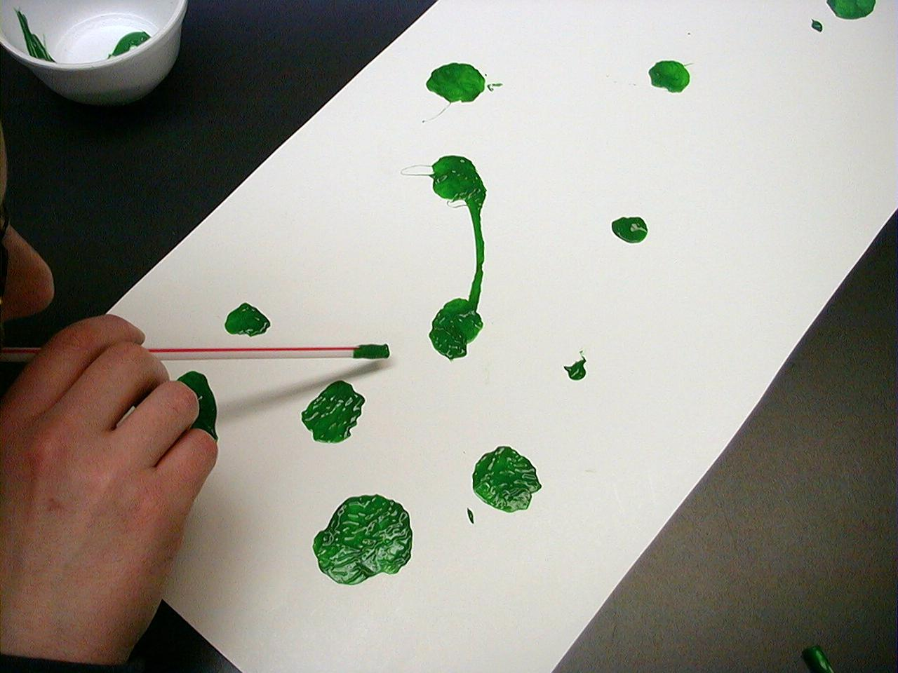
After a child explains an experience, you would dip a straw into a light color of paint. The child should then splatter some large drops of paint onto the poster board. Children will take their straws and blow the paint in different directions. After all of the children have shared, there should be a poster board arrow with a multitude of small trails of paint.

This is a picture of how many people feel. They feel their whole life is shaped by the circumstances pushing them around. Today we will be talking about how we, as Christians, are not pushed around by our circumstances. God guides us. And as He guides us, He gives us purpose. Like the arrow, we can point to Jesus.

God does not want you to feel that He pushes you around and He certainly does not want you to feel pushed around by things you don’t have any control over. Instead, God wants to guide you so you can follow Him. How do you think God guides you every day?

Discuss various responses from the children. Prepare for large group with the following.

Today we will meet a man who received guidance from an angel. This man then gave guidance to the mother of Jesus and helped protect her. Whom do you think we are talking about? We will find out in large group today.

Large Group Overview: 20-30 minutes
Purpose: Help kids observe what the Bible says. Present the Bible event in creative fashion. Help kids begin to interpret what it means.

Puppet Presentation: “Dao Dao Needs Guidance” – Dao Dao thinks he doesn’t have choices in life.

Small Group Application: 20-25 minutes
Purpose: Help kids map out the meaning of the Bible event in their lives. Use the questions to stimulate discussion but don't feel tied to them. Allow the Holy Spirit to guide you. Include personal examples from your own faith journey. The example of Christ at work in your life will leave lasting impressions of how Christ can work in the children's lives.

Use your Bibles! Children need to learn how to look up references and follow along when scripture is read aloud. Allow for quality time of prayer at the close of the lesson.

Observation Questions: What happened?
With Bibles open to Matthew 1:18-24 and Luke 2:1-6, review the story. Try to adjust the questions to fit the reading and learning level of the children.

Mary was engaged to Joseph, yet she is going to have a baby by the Holy Spirit. What was Joseph going to do about the fact that she would have a baby? (Matthew 1:19. He was going to break the marriage agreement with her secretly.)

Joseph changed his mind when God guided him to do something different. How did God get the message to Joseph? (Matthew 1:20. An angel of the Lord appeared to him in a dream.)

What did God tell Joseph to name the baby? (Matthew 1:21. Jesus, which means, “He saves.”)

What did Joseph do with the directions he received? (Matthew 1:24. He did what the angel of the Lord commanded him to do.)

Where did Joseph and Mary travel and why? (Luke 2:4-5. They traveled from Nazareth to Bethlehem to register for a census.)

Some time after Jesus was born, an angel appeared to Joseph in a dream. What did the angel say this time? (Matthew 2:13. Take Jesus and Mary to Egypt. King Herod wanted to kill Jesus.)

How did Joseph know when to leave Egypt and go back to Israel with Mary and Jesus? (Matthew 2:19-23. An angel of the Lord appeared to him in a dream and told him it was safe to return because King Herod was dead.)

Interpretation Questions: What does this mean?
Do you think it was hard for Joseph to do what the angel told him to do? Why?

Application Questions: What does this mean to me?
Can you give an example of something hard for you to do when someone tells you to, even if you know it is for your good?

God has a plan for us, for our good, just like He had a plan for Joseph even though Joseph might not have understood what God was doing. Because Joseph allowed God to guide him, he did great things like providing for and protecting Mary and Jesus, the Son of God.

Do you think it is easier to follow someone’s direction for you, if you know that God is guiding? Why or why not?

Application Activity:
Supplies needed: a large silhouette cradle cut from colored poster board. On this design, the phrase “It’s all about Jesus” will be attached. See appendix for a sample of this art piece.

The learning point to be emphasized is that God still guides us today through His word.

God’s word comes to us in the Bible. When we have a relationship with Jesus, we receive God’s word in our hearts. When we need guidance, God can remind us of His word that has been hidden in our hearts. In that way, Jesus speaks personally to us. In addition, God uses other people in our lives to give guidance, particularly parents and godly leaders who show us the way God would guide us.

Recall the opening Warm-Up question and event.

Can you remember a time when someone made you go someplace that you did not want to go?

Hopefully, this identifies with what children of this generation might feel—their futures are uncertain and there is no divine guidance available for their lives. As a result, they are simply pushed along through life by forces of circumstance. This is part of the post-modern worldview. However, the Christian worldview sees that God is active in our lives. He guides us through His word and we simply need to be ready to respond.

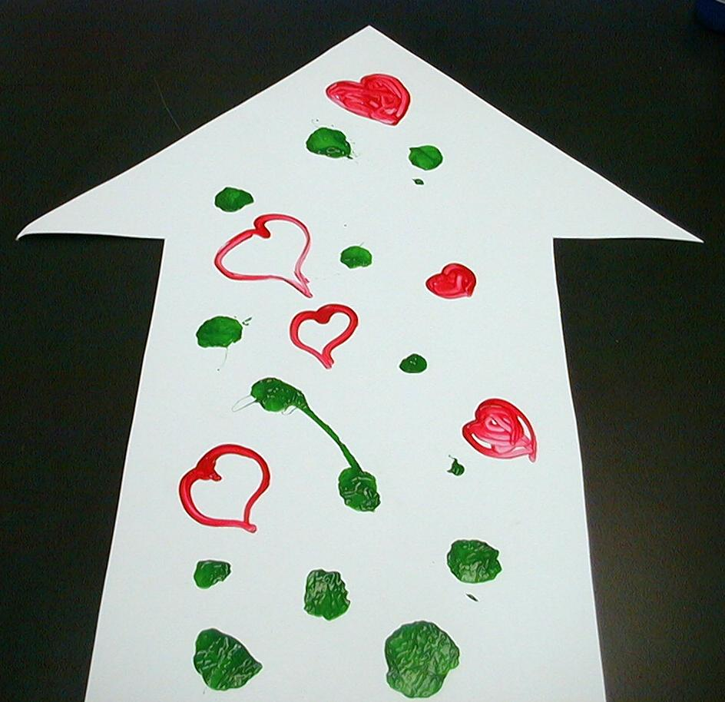
Pass out cotton swabs that will serve as the children’s paint brushes. Using a straw, take a large drop of a dark colored paint and place it in an open spot on the poster board arrow. With the cotton swab, fashion the drop of paint into the shape of a heart.

Each time someone answers a question, she will be given a drop of paint to fashion into a heart with a cotton swab. Try to keep the focus on the discussion by having only one child paint a heart at a time. This also helps kids from getting their hands or clothes smeared with paint.

Questions for Discussion:

God would like to guide you every day so you could follow Him. How do you think He does that? (God’s word – the Bible, God’s word that we remember and have in our hearts, God’s word that comes from adults and leaders who can help guide us, God’s word that we remember when we pray, God’s word when we are thinking about Him.)

Why do you think we are making hearts? What do they have to do with how God guides us? (God guides us because He loves us and wants the very best for us. He wants to guide us so we come to know Jesus as our Savior and Lord. When we really understand God loves us, we want to point other people to Jesus as well, so they come to know God’s love just like we do. This is one of God’s most exciting plans for us.)

When was the last time you were worried or scared? How did one of your parents help you to not be worried or scared?

As the kids answer, point out that God guides us and watches over us through our parents.

Our key verse for today is Isaiah 58:11a, “The LORD will always lead you.”

Remember that, just like Joseph, *God guides us when we follow Him.
To make a mural: Affix all of the small groups’ arrows to a wall in the corridor. The arrows should point a path to a large silhouette cradle cut from colored poster board. On this design, the phrase “It’s all about Jesus” will be attached. See appendix for a sample of this design.

The closing activity in the group might be to place the arrow on the wall.

Or…
Perhaps the coaches might do this later to give more time for the paint to dry.

Memory Verse Learning: 5 minutes
Purpose: Help kids to memorize and keep scriptures at heart. Using creative ways to help kids enjoy learning the key verse and in small group setting.

Supplies needed: 2 sets of arrows that is from lesson 29; two air-con carton boxes; masking tape; white board

Memory Verse: Isaiah 58:11a, “The LORD will always lead you.”

Memory Verse Presentation: “Have Mule Will Travel”
Before class tape two parallel lines that is 10 feet apart. The other side of the line put the whiteboard there with the arrows of the memory verserandomly stick to it with blue-tac. In the middle put the two carton boxes - one for each team. During memory verse learning, divide the children into two teams. Have all the team members go into their carton box and tell them it is their mule. Just like Joseph, Mary and baby Jesus have to travel, the team has to travel together to get the arrows in sequence of Isa. 58:11a and stick it to the wall nicely in order. The first team that can correctly arrange their memory verse arrows and recite it together, wins.

Prayer Time:
Close in prayer thanking God for His guidance. Ask Him for special help in the areas where the kids might mention that they need guidance.

Safety and Security: Safety and security procedures are important for each church to carefully define and implement according to their unique needs. The security, safety, illness and accident procedures described in this curriculum are provided for example purposes only and may not be appropriate, applicable or adequate for every situation. Each church is responsible for determining whether any security, safety, illness and accident procedures contained in the curriculum are appropriate, applicable or adequate for its unique situation. The activities described in this curriculum require adult supervision and may not be suitable for each child and each situation. Each church is responsible for ensuring that adequate adult supervision is provided for all activities and for determining whether an activity is appropriate for each child and each situation. Kids Kount Publishing disclaims all liability for the implementation of any procedures or the performance of any activities described in this curriculum.

Large Group Presentation

Dao Dao Needs Guidance

Puppet Presentation

Take Home Point: *God guides us when we follow Him.

The presenter will role play as an investigative reporter looking for real life stories of God sightings. Dao Dao will serve as his sidekick detective.

Props needed:
- “Real Life Stories of God Sightings” sign
- any props to create the setting of a live interview such as a director’s scene board clapped in front of the camera before the action goes live
- backdrops of palm trees and first century Judea villages could be used—use your imagination and facility to create a setting that resembles the landscape of Jesus’ birth

Costumes:
- The investigative reporter (presenter) needs costuming that fits his role—add a baseball cap with a front label, “God Watcher,” or the character could sit behind a desk in a suit coat and tie
- A child volunteer with safari-like costume
- Dao Dao would need a similar hat and could be in a safari shirt and/or have a set of binoculars around his neck
- Adult volunteer costumed to look like a biblical character

Each week the puppet drama will involve a volunteer looking for clues that give the identity of the person interviewed. After the child finds the clues, the character will enter and give his or her story based on the interview questions posed by the investigative reporter.

The two clues hidden in the audience to be discovered today by the child investigator are a walking staff and a pair of sandals. Tape the clues (see appendix) to the props.

Teacher: Hello, boys and girls. Welcome to our investigative report where we are looking for real life stories of God sightings. We will discover the truth about who God is. We will find Him and we will point Him out. Let me now point to my assistant, Dao Dao.

(Dao Dao does not appear.)

Teacher: I said this is my assistant, Dao Dao.

(Dao Dao still does not appear.)

Teacher: (Walks to the puppet stage and reaches in to pull Dao Dao out.) Dao Dao! It’s time for our investigative report. Are you ready?

Dao Dao: I guess so.

Teacher: Don’t you want to help us find real life stories of God sightings?

Dao Dao: I guess so.

Teacher: You don’t sound too excited.

Dao Dao: I guess so.

Teacher: What’s wrong, Dao Dao? Would you rather do something else?

Dao Dao: I guess so.

Teacher: But I thought you wanted to find real life stories of God sightings.

Dao Dao: I guess so.

Teacher: Can’t you say anything more than “I guess so?”

Dao Dao: I guess so.

Teacher: Okay, that does it! Dao Dao, what’s up? Something is wrong.

Dao Dao: I don’t think it makes any difference what I say because I don’t get to decide anything myself. Everyone makes all of my decisions for me. Everyone just keeps pushing me around.

Teacher: What do you mean?

Dao Dao: My parents, my teachers, and you even decide what I have to do. I have no choices!

Teacher: I don’t know if that’s quite true, Dao Dao.

Dao Dao: Well, I guess it doesn’t matter anyway. No one can change his or her future. We just kinda get pushed around through life. Whatever happens to us, we just have to accept it.

Teacher: I’m not sure that’s true! I think we all have choices.

Dao Dao: Like what?

Teacher: I think we can choose to follow the way God guides us or we can choose not to follow God’s way.

Dao Dao: What do you mean, “God guides us?” How does He do that?

Teacher: I think we will discover that today. We are going to meet someone who has a real life story of a God sighting. God guided him and he followed.

Dao Dao: You mean this guy had a choice?

Teacher: Of course he had a choice. He knew that in our lives we are not just pushed around by what people make us do. Instead, God can guide us.

Dao Dao: I really want to meet him. I’m going to get my tape recorder to make sure I don’t miss a thing! (Dao Dao exits.)

Teacher: Let’s find out about this case, but, first, I need another investigative reporter to volunteer who will help us find the clues to discover who we are looking for today.

Choose a child from the audience.

The first clue is: “I am a stick that helps with walking.” If you can find the object the clue is hinting at, you will find another clue.

Allow the child to look for the walking stick. If another child has spotted the walking stick, she can point it out. It might be interesting to offer special rewards for the child who is able to spot the walking stick.

Taped on the walking stick is the following clue:

“This person was guided by God to be the husband of Mary who would soon be the mother of Jesus.”

The child should be able to guess the person is Joseph.

Teacher: That’s right! It is Joseph. Here is the clue for the next object. “I am how they traveled in those days. I’m not a skateboard, but I’m underneath the same thing a skateboard is under.”

The next object is a pair of sandals on one of the adults in the room. On the bottom of a sandal is written this clue:

“Joseph was to guide Mary to their hometown. This was because the government required a census to be taken. People had to go to their hometown to be counted. It was prophesied that the Messiah, Jesus, would be born in this town. What town was it?”

Teacher: That’s right! The answer is Bethlehem. Thank you to our investigative assistant. You can be seated.

Today we are going to interview a man named Joseph. Joseph was important because he provided guidance and protection for Mary and the newborn Baby Jesus.

And now let’s meet our special guest, Joseph. Joseph? Are you there?

Joseph enters and takes the walking staff and puts on the sandals while he tells the story.

Teacher: Hello, Joseph. Thank you for visiting us today and telling us your story about how God has guided you. It is a real life story of a God sighting. Joseph, did God come down and talk to you? Did God really guide you?

Joseph: No. God did not talk to me personally but He did send an angel. When He gave me His directions and I followed them, my whole life was different.
First, there was Mary. She was beautiful. I loved her and it had been arranged that we would be married. One day she came to me and said she was going to have a baby. God told her that the baby was coming from Him.

Teacher: Wow, you must have been excited!

Joseph: Not at first! I didn’t know to believe her. I thought it might be someone else’s baby. I knew that it couldn’t be ours because we were not married yet. I decided to be kind to her and just break off our engagement. I was not going to accuse her of having another boyfriend that she had a baby with.

That is what I was going to do until God sent a messenger.

Teacher: Oh, you mean an angel?

Joseph: Yes, an angel who told me, “Don’t be afraid to take Mary as your wife. The baby in her is from the Holy Spirit. She will give birth to a son. You will name the Son Jesus.”

The name Jesus means “He saves.” He would save His people from their sins. You see, some day this little baby, the Son of God, would grow up and give His life for us all when He would die on the cross. Then, those who believe in Him would have Jesus living in their heart.

Teacher: So God was guiding you to go ahead and be Mary’s husband and the earthly father of Jesus?

Joseph: That’s true. God was guiding me. I knew it was true because what was happening had been talked about in the Bible. The prophets had written a long time ago that this unmarried girl would become pregnant and give birth to a son. They would call the child Emmanuel, which means “God with us.”

Teacher: Is there more to your story?

Joseph: I was supposed to take care of Mary. We had to take a trip of more than 70 miles to Bethlehem. It was a long walk.

God wanted the baby, Jesus, to be born in Bethlehem. The prophets long ago wrote that from Bethlehem, a leader would come who would shepherd God’s people of Israel. People expected that the Messiah would be born in Bethlehem.

God had the Roman government call for a census, which means everyone had be counted so they knew how many people lived in each country. To be counted, you had to go to your hometown. Mary’s and my hometown was Bethlehem.

Teacher: That was when Mary was just ready to have a baby. That must have been a hard trip.

Joseph: It was. I was glad I was there to help Mary and guide her along.

Teacher: Wow! God even used you to help guide her.

Joseph: That’s right. God guides our lives. He guides us with His word that we read in the Bible. He also uses people to help guide us.

Teacher: Did God guide you to any other places?

Joseph: Yes, He did. After three wise men visited us, God told me I was to take Mary and the baby to Egypt because the evil King Herod would try to kill him. It is a good thing I did because Herod killed many other small babies in Bethlehem when he found out that a king had been born.

Teacher: How long did you stay in Egypt?

Joseph: Until God showed me in a dream that I was to come back. I took Mary and Jesus back to Nazareth where Jesus grew up.

Teacher: So, there you have it. A real life story of a God sighting. Joseph was someone whom God guided. Anything else, Joseph?

Joseph: Yes. There is another reason God guided me. God guided me, and I think God guides others so we can find our way to Jesus, the Savior of the world. We can point Jesus out to others, as well. Jesus came into the world to give His life for us so He could guide us to heaven.

Teacher: A great real life story of a God sighting. Let’s give thanks to our special guest Joseph, with a round of applause. (Pause for clapping.) Dao Dao, now do you feel better?

Dao Dao: (Pops back up lugging a tape recorder.) Okay, I am ready to hear Joseph’s story now.

Teacher: Dao Dao, you missed it again!

Dao Dao: Oh, man!

Teacher: Don’t worry. I will fill you in on all the details later. This is a great lesson for you because you don’t have to believe that other people are always making decisions for you, pushing you around.

Dao Dao: I don’t?

Teacher: No. You will learn today that *God guides us when we follow Him. And we have many choices each and every day to follow Him. Let’s close in prayer, okay?

Dao Dao: Okay.

Teacher: Dear God, thank You for guiding us when we follow You. You showed Joseph the right direction and he followed You. Help us to do the same. Thank You for sending Jesus who is our Savior now and forever. In Jesus’ name, we pray. Amen.

Lesson 30

Small Group Warm-up:
- a large poster board cut into an arrow for each group. The arrow should keep intact as much of the poster board as possible as that will be the surface for the painting project.
- three jars of tempera paint, one of which is a light color
- cotton swabs
- straw for each student
- newspaper to cover the floor under the poster board

Large Group Presentation:
- a walking staff
- a pair of sandals
- Dao Dao
- clue printed in the appendix needs to be attached to the walking staff
- clue printed in the appendix needs to be taped to the bottom of one of the sandals

Small Group Application:
- a large silhouette cradle cut from colored poster board. On this design, the phrase “It’s all about Jesus” will be attached. See appendix for a sample of this art piece.

Memory Verse Learning:
- 2 sets of arrows that is from lesson 29
- two air-con carton boxes
- masking tape
- white board


Appendix

Attach this clue to the walking stick:

This person was guided by God to be the husband of Mary who would soon be the mother of Jesus.

Attach this clue to the sandals:

Joseph was to guide Mary to their hometown. This was because the government required a census to be taken. Everyone had to go to their hometown to be counted. It was prophesied that the Messiah, Jesus, would be born in this town. What town was it?

