
Date: _________________
Series: Real Life Stories of God Sightings
Dec-Mar Year 3, Lesson 32

Simeon Holds the Savior

Take Home Point: *God gives us eyes of faith so we can see Jesus. *Repeat this phrase throughout the lesson.

Bible Event: Luke 2:25-35
Key Verse: Luke 2:30-31, “I have seen Your salvation with my own eyes. You prepared Him before all people.” (NCV)

We will help kids know:
- God confirmed the identity of Jesus as the Savior and presented Him in the temple eight days after His birth.
- Jesus is our light that will show salvation to the nations.
- When kids think about the past year and the upcoming year, they can know that Jesus’ saving presence is with them.

We will help kids feel:
- Secure that Jesus is with us no matter what.
- Amazed at how God confirmed the person and mission of Jesus even when He was eight days old.

We will help kids do:
- Identify events that have occurred in their lives and those to which they look forward.
- Identify the tough times in their lives and how God has been with them.
- Make a picture that reminds them that Jesus is the light that shines in the “darkness” of troublesome events.

THIS LESSON’S ROADMAP

DESTINATION | PAGE # | DISCOVERIES ON YOUR JOURNEY | SUPPLIES NEEDED
  Small Group Warm-Up | 3 | Kids look back over the last year and identify some significant events in their lives. | - for each group have a six-foot roll of mahjong paper with the twelve months abbreviated across the top of the page at six-inch intervals  - glue  - half sheet of paper for each child  - markers or colors
Large Group   | 4  7 | Overview  Puppet Presentation: “Dao Dao Needs Eyes of Faith”—Dao Dao appears with his x-ray vision glasses to see God sightings. He encounters the man Simeon who waited his whole life to see the promised Savior. Simeon saw and blessed the Baby Jesus at eight days old. | - Dao Dao  - pair of binoculars or magnifying glass  - eyeglasses for both Teacher and Dao Dao that will be referred to as x-ray glasses (The eyeglasses can be some comical glasses from a novelty store or homemade with construction paper and colored cellophane.)  - clue attached to binoculars (see script)  - period costume for Simeon  - optional: singer to sing “The Nunc Dimittis”
Small Group Application   | 4 | The kids learn that God gives us eyes of faith so that we might see Jesus as our Savior, emphasizing how He has worked in our lives in the past and how He will work in the future.  Memory Verse Learning:  “See & Tell It”  Luke 2:30-31 will be emphasized in lessons 31-33 that each child knows Jesus’ saving presence is with them. | - half sheet of black sugar paper for each child  - a small amount of bleach in a cup for each group  - cotton swabs  - marker  - newspaper  - a set of “camera” flash cards per group

Small Group Warm-Up: 15 minutes
Purpose: Get pointed in the right direction! Build relationships and help guests feel at ease. Do the learning readiness activity that will point your group in the right direction for the lesson.

Supplies needed: a six-foot roll of mahjong paper with the twelve months abbreviated across the top of the page at six-inch intervals, glue, half sheet of paper for each child, markers or colors

The main activity for Small Group Warm-Up and application is to make a calendar of events on a six-foot piece of mahjong paper The project will give kids an opportunity to look back over the last year and identify some significant events in their lives. It will also help them identify times of need or disappointment. They will see how Jesus is with them not only in the good times but also in the “dark” times. As they reflect upon the past year, they will have opportunity to apply “eyes of faith” to those things they anticipate in the new year.

Begin by saying:

Think about this last year. What is one thing you really looked forward to and that finally happened? (Examples: a school holiday, a birthday, getting a new baby brother, etc.)

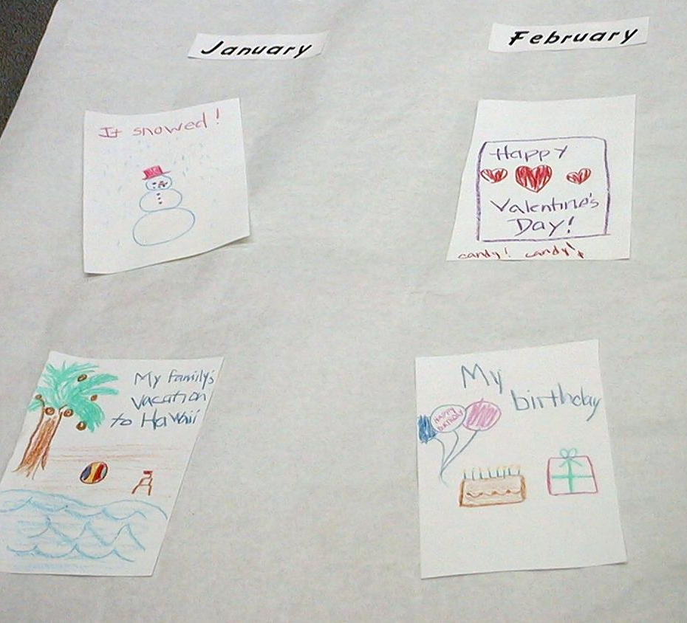
Have each child print a word or phrase which reminds them of the event on a half sheet of paper. Then affix the half sheets of paper to the six-foot roll of mahjong paper. (Some groups, especially the younger ages, might prefer to draw a quick picture of their event rather than write a word or phrase.)

When kids paste their events on the mahjong paper, the entire group can see the time line of the last year and when some key events occurred. This time of discussion can be a wonderful group builder as kids share happy memories of the last year and make a group illustration of their experiences.

Before going to large group, introduce the key point:

When we look over this mural, we can “see” the year at a glance and some of the significant things that have happened.

Today we will learn that *God gives us eyes of faith so we can see Jesus in all events that happen.

Large Group Overview: 20-30 minutes
Purpose: Help kids observe what the Bible says. Present the Bible event in creative fashion. Help kids begin to interpret what it means.

Puppet Presentation: “Dao Dao Needs Eyes of Faith”—Dao Dao appears with his x-ray vision glasses to see God sightings. He encounters the man Simeon who waited his whole life to see the promised Savior. Simeon saw and blessed the Baby Jesus at eight days old.

Small Group Application: 20-25 minutes
Purpose: Help kids map out the meaning of the Bible event in their lives. Use the questions to stimulate discussion but don't feel tied to them. Allow the Holy Spirit to guide you. Include personal examples from your own faith journey. The example of Christ at work in your life will leave lasting impressions of how Christ can work in the children's lives.

Use your Bibles! Children need to learn how to look up references and follow along when scripture is read aloud. Allow for quality time of prayer at the close of the lesson.

Observation Questions: What happened?
With Bibles open to Luke 2:25-35, briefly review the story. Try to adjust the questions to fit the reading and learning level of the children.

Where did Simeon live and what had he been waiting for? (Luke 2:25. He lived in Jerusalem and he had been waiting for the one who would comfort Israel, or the promised Savior.)

Where did Simeon meet Jesus? (Luke 2:27. In the temple courtyard.)

Why was Jesus brought to the temple when He was eight days old? (Luke 2:27. So they could do what Moses’ teachings required for new baby boys.)

What are some things Simeon said about Jesus when he met Him? (Luke 2:29-35. Jesus would bring salvation. He was a Light that would reveal salvation to the nations and bring glory to the people Israel. He would be the reason for many people in Israel to be either condemned or saved. He would be a sign that exposed the thoughts of those who rejected Him.)

Application Questions: What does this mean to me?
Application Activity:
The learning point to be emphasized is that God gives us eyes of faith so that we might see Jesus as our Savior. It is important that we can see how He has worked in our lives in the past and how He will work in our lives in the future. Especially today we identify how we can call upon Him in our “dark” times or times of fear or challenge.

Supplies needed: half sheet of black sugar paper for each child, a small amount of bleach in a cup (USE CAUTION), cotton swabs, marker, newspaper

Look back over the group time line of events which the kids favorably remember from the last year. Briefly discuss with the children ways in which God was with them during those times. Have the children each take a marker and draw a cross on their sheets of paper.

Next, take a half sheet of black construction paper and talk about one of the hard times you have experienced during the last year. This time would be identified as a “dark” time or time of difficulty. Is God still with us during these times?

Then take a cotton swab and dip it into the cup of bleach. Using the cotton swab, draw a cross on the dark paper. Tell how God still worked in your life during this dark time.

Jesus came as our Savior, giving His life for us on the cross so that He would be with us in dark times. Just like the bleach takes away the dark color in the paper, Jesus can take away the darkness that we face at times in our lives. He is our Savior. We can have eyes of faith. It is like our eyes can see His light in the middle of our darkness. That is what Simeon was describing. Jesus came to light up our lives and give us eyes of faith to see how He is our Savior.

Pass out half sheets of black sugar paper to the kids along with a sheet of newspaper for them to place under their sugar paper. Caution the kids to not get any of the bleach on their clothing. Instruct them to take a cotton swab and make a cross on the sugar paper after remembering a time of difficulty or special challenge they faced during the last year.

Can they see how God was with them as their Savior? Encourage them to share. If kids cannot remember an event, invite them to think how God might be with them in the future through times of difficulty. God will give them eyes of faith so that they might see how He will work in their lives.

Some kids may want to write their names on their black sugar paper with the bleach. After the pages are completed, they can be affixed to the time line.

Just like Simeon, we can know these words from Luke 2:30-31 to be true: “I have seen Your salvation with my own eyes. You prepared Him before all people.”

Today we learned that *God gives us eyes of faith so we can see Jesus in all events that happen.

Memory Verse Learning: 5 minutes
Purpose: Help kids to memorize and keep scriptures at heart. Using creative ways to help kids enjoy learning the key verse and in small group setting.

Supplies needed: a set of “camera” flash cards per group (from last week’s lesson)

Memory Verse: Luke 2:30-31, “I have seen Your salvation with my own eyes. You prepared Him before all people.”

Memory Verse Presentation: “See & Tell It”
Flash and review Luke 2:30-31 with to the children by using the “camera” flash cards. Make a quick flash through twice. Now mix and spread the flash cards before the children and be quick to ask a volunteer to “See & Tell It” – that is to see quickly, arrange the cards back into order, flash and tell it to the class. For every person who can do it correctly, give a great cheer. Have as many volunteers as time permits.

Prayer:
Have the kids give thanks for specific ways Jesus has been with them in the good times and in the dark times.

Safety and Security: Safety and security procedures are important for each church to carefully define and implement according to their unique needs. The security, safety, illness and accident procedures described in this curriculum are provided for example purposes only and may not be appropriate, applicable or adequate for every situation. Each church is responsible for determining whether any security, safety, illness and accident procedures contained in the curriculum are appropriate, applicable or adequate for its unique situation. The activities described in this curriculum require adult supervision and may not be suitable for each child and each situation. Each church is responsible for ensuring that adequate adult supervision is provided for all activities and for determining whether an activity is appropriate for each child and each situation. Kids Kount Publishing disclaims all liability for the implementation of any procedures or the performance of any activities described in this curriculum.

Large Group Presentation

Dao Dao Needs Eyes of Faith

Dao Dao Puppet Script

Take home point: *God gives us eyes of faith so we can see Jesus.

For the next few weeks, the presenter will role play as an investigative reporter looking for real life stories of God sightings. Dao Dao will serve as his sidekick detective.

Props needed:
- “Real Life Stories of God Sightings” sign
- any props to create the setting of a live interview such as a director’s scene board clapped in front of the camera before the action goes live
- backdrops of palm trees and first century Judea villages could be used—use your imagination and facility to create a setting that resembles the landscape of Jesus’ birth

Costumes:
- The investigative reporter (presenter) needs costuming that fits his role—add a baseball cap with a front label, “God Watcher,” or the character could also sit behind a desk in a suit coat and tie
- A child volunteer with safari-like costume
- Dao Dao would need a similar hat and could be in a safari shirt and/or have a set of binoculars around his neck
- Adult volunteer costumed to look like a biblical Simeon

Each week the puppet drama will involve a volunteer looking for clues that give the identity of the person interviewed. After the child finds the clues, the character will enter and give his or her story based on the interview questions posed by the investigative reporter.

The clue hidden in the audience to be discovered by the child investigator will be a pair of binoculars or a magnifying glass. The large group Bible event is presented in the context of the puppet script and the interview with the Bible character, Simeon.

Props and supplies needed: pair of binoculars or magnifying glass, eyeglasses for both Teacher and Dao Dao that will be referred to as x-ray glasses (The eyeglasses can be some comical glasses from a novelty store or homemade with construction paper and colored cellophane.), clue attached to binoculars (see script), period costume for Simeon, optional: singer to sing “The Nunc Dimittis”

Teacher: Welcome, boys and girls, to our special investigative report. We are looking for real life stories of God sightings. We will discover the truth about Jesus who came to this world claiming to be the Son of God. Let’s investigate some of those people who had God sightings when Jesus came into this world. To do that, I will need my assistant investigative reporter, Dao Dao. Let’s call him.

(Kids chant, “Dao Dao… Dao Dao… Dao Dao...” Dao Dao appears with the ridiculous x-ray glasses.)

Teacher: Wow! Dao Dao, what’s that on your face?

Dao Dao: (Enters wearing eyeglasses.) These are my famous x-ray glasses.

Teacher: What do you need x-ray glasses for?

Dao Dao: You call yourself an investigative reporter and you don’t even know how to use x-ray glasses?

Teacher: Well, I don’t know how to use something like that.

Dao Dao: These are my special x-ray glasses so that I might see what other people don’t see! If other people are going to miss seeing God, these x-ray glasses will help me find Him!

Teacher: If they worked, that would be pretty cool. I don’t know, though…

Dao Dao: I suppose you want a pair, too, so you can spot real life God sightings.

Teacher: I don’t know, Dao Dao…

Dao Dao: Come on, Teacher. Try these on.

Dao Dao hands another pair of glasses to Teacher.

Dao Dao: There! Now you’re ready with your own set! That will be $19.90, please.

Teacher: What?! You’re selling these glasses?

Dao Dao: Sure! Wouldn’t it be worth it if you could see God with them?

Teacher: It probably would be. But, Dao Dao, these glasses are not what is needed to see God. Instead, we need eyes of faith.

Dao Dao: What do you mean?

Teacher: Well, let’s get another assistant from the audience and look for our clues. We can discover how God wants to give us eyes of faith so we can see how He works in our lives.

Have a volunteer come forward.

Teacher: Here is your clue: That which is far away looks like it is up close.

Dao Dao: Do you want to borrow my x-ray glasses to find it?

Teacher: I don’t think that will be necessary, Dao Dao.

Have the volunteer look for the hidden clue and return with it to the front.

(The hidden object is a pair of binoculars or a magnifying glass. Attached to it is the following clue: This man waited His whole life to see the Savior, Jesus. Though it had been a long way off for Him, it finally happened.)

Dao Dao: Wow! That’s a hard clue. Are you sure you don’t need my x-ray glasses?

Teacher: I don’t think x-ray glasses are going to help. There is one other hint, though. This man had eyes of faith so that when he saw the Baby Jesus when only eight days old, he knew Jesus was the Savior of the world.

Dao Dao: Without x-ray glasses?

Teacher: That’s true.

Dao Dao: What’s his name?

Teacher: Let’s call him out here. His name is Simeon and he has a story to share.

Simeon enters.

Teacher: Simeon, tell us about yourself and how you had a real life event of a God sighting.

Simeon: It is true. I did see God. I waited my whole life to see the Promised One. God told me I would see Him before I died.

Teacher: Tell us, Simeon, where did you meet Him?

Simeon: I lived in Jerusalem. Much of my time I spent praying and worshiping God. I knew from God’s word that he promised to send a Savior. More than anything else, I wanted to see this Savior before my life was over.

Dao Dao: Did you?

Simeon: The Holy Spirit told me that I would meet the one to comfort God’s people before I died.

Dao Dao: Where did you meet Him? You were in Jerusalem and Jesus was born in Bethlehem.

Simeon: Bethlehem is not very far away from Jerusalem. It was our custom to bring new babies to the temple to dedicate them to the Lord. Jesus’ parents brought Him to the temple eight days after He was born.

Teacher: Then there must have been lots of people coming to the temple to dedicate their babies.

Simeon: Yes. There were also people there to offer sacrifices.

Dao Dao: How did you know who to look for? Did you have x-ray glasses?

Simeon: No. The Holy Spirit told me when I was to go to the temple courtyard. He would show me the baby who would be the Messiah. Then I saw them!

Teacher: Who did you see?

Simeon: Mary and Joseph. God told me their baby was the Messiah! I asked to take the baby from Mary’s arms When I did, I knew that I was holding the Messiah, the promised Savior. I praised God and told him, “Now, Lord, You can let me, Your servant, die in peace as You said. I have seen Your Salvation with my own eyes.”

Dao Dao: But you were just looking at a baby.

Simeon: I knew that He would be the salvation of all of His people. God wanted this salvation to be for all people to see. Jesus would be a light that revealed salvation to all the nations bringing glory to the people of Israel.

Dao Dao: That’s pretty amazing that the baby was just eight days old and you knew that!

Teacher: Dao Dao, it was a real life God sighting.

Simeon: Yes, but it is not just me who waits to see God’s salvation. You also wait.

Dao Dao; What do you mean?

Simeon: If you have eyes of faith, then you can see that Jesus is the Savior. He gave His life for you by dying on the cross and living again so that your sins are forgiven. He now lives with you every day.

Dao Dao: Wow! That is a real life God sighting.

Teacher: It sure is, Dao Dao. Today we will talk about having eyes of faith just like Simeon said.

Simeon: That’s right. Jesus is the light that will show His salvation to all people – especially to you, kids!

Teacher: Thank you, Simeon.

Simeon: Thank you. Now, Lord, You can let me, Your servant, die in peace as You said. I have seen Your Salvation with my own eyes. Bye, kids!

(An additional ending is optional for churches who might sing “The Nunc Dimittis.” The script would continue as follows.)

Dao Dao: Wow! That’s pretty cool. We have eyes of faith.

Teacher: Did you know, Dao Dao, that often in our worship services we sing Simeon’s song. It is called “The Nunc Dimittis,” which means, “You now dismiss.”

Dao Dao: How does it go?

Teacher: Let’s have someone sing it for us.

Singer: Lord, let now your servant depart in peace according to your word.
For my eyes have seen the glory of your salvation,
A light to enlighten the Gentiles,
And the glory of your people Israel.

Lesson 32

Small Group Warm-up
- for each group have a six-foot roll of mahjong paper with the twelve months abbreviated across the top of the page at six-inch intervals
- glue
- half sheet of paper for each child
- markers or colors

Large Group Presentation
- Dao Dao
- pair of binoculars or magnifying glass
- eyeglasses for both Teacher and Dao Dao that will be referred to as x-ray glasses (The eyeglasses can be some comical glasses from a novelty store or homemade with construction paper and colored cellophane.)
- clue attached to binoculars (see script)
- period costume for Simeon
optional: singer to sing “The Nunc Dimittis”

Small Group Application
- half sheet of black sugar paper for each child
- a small amount of bleach in a cup for each group
- cotton swabs
- marker
- newspaper

Memory Verse Learning
- a set of “camera” flash cards per group

The hidden object is a pair of binoculars or a magnifying glass. Attached to it is the following clue:

This man waited his whole life to see the Savior Jesus. Though it had been a long way off for him, it finally happened.

