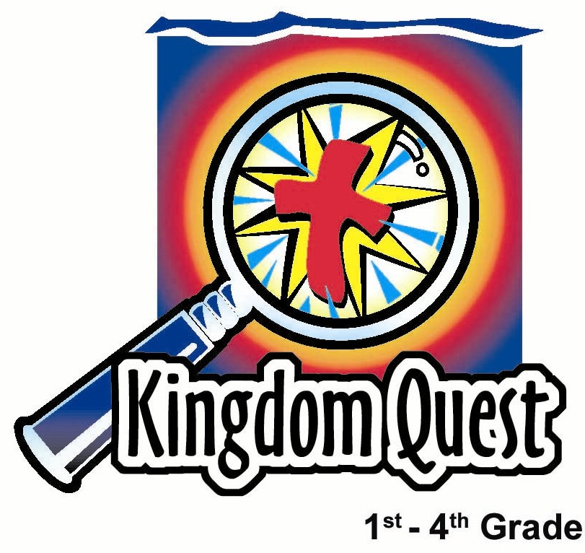
Date: _________________________
Series: Aliens in a Strange Land
Sep-Nov Year 4, Lesson 23

Daniel and the King’s Dream

Take Home Point: No matter what, trust in God.
*Repeat this phrase throughout the lesson.

Bible Event: Daniel 1 & 2; 1 Peter 2:11-12
Key Verses: 1 Peter 2:11 & 12, “Dear friends, you are like visitors and strangers in this world…So live good lives. Then they will see the good things you do, and they will give glory to God on the day when Christ comes again.” (NCV)

We will help kids know:
- The Bible event of Daniel’s captivity and his interpretation of King Nebuchadnezzar’s dream.
- The world will always apply pressure causing believers to compromise their faith.
- Because we are citizens of Christ in God’s kingdom, we do not belong to the evil ways of this world. Instead, we trust God and follow His ways.

We will help kids feel:
- Committed to follow God no matter what.
- Excited that they are part of God’s heavenly kingdom.

We will help kids do:
- Decorate sunglasses to help them look like aliens.
- See life differently than the world as a follower of Jesus.
THIS LESSON’S ROADMAP

DESTINATION | PAGE # | DISCOVERIES ON YOUR JOURNEY | SUPPLIES NEEDED
Small Group Warm-Up   | 3 | Students will discuss what they have seen or heard about aliens and how it feels to be a foreigner in a different place. | - alien trinket (any item looking like it is associated with alien things)
Large Group   | 3  8  10  10 | Overview  Puppet Presentation: “Dao Dao, the Alientologist” – Dao Dao finds out that he doesn’t know everything about aliens and just might be one himself.  Video Sketch: Daniel is spared to interpret the king’s dream.  Puppet Conclusion: “Dao Dao, the Alientologist” – A child volunteer is sent through the Alien Transporter Machine to discover what it’s like to be in a foreign land and trust God to do what’s right even if it means going against what everyone else is doing. | - alien-like accessories for the Dao Dao puppet: a headband with antennae, chaser lights, etc.  - alien transporter machine made from a decorated refrigerator box with special effects such as tin foil, lights, a fog machine, and fans blowing crepe paper  - video, “Animated Stories from the Bible: Daniel (Produced by Nest Family Entertainment, 1993, ISBN 1-56489-076-7), order from www.nestfamily.com
Small Group Application   | 4 | Students will decorate sunglasses to help them look like aliens seeing the world differently than someone who is not a follower of Jesus.  Memory Verse Learning:  “Memory Verse Slots”  1 Peter 2:11,12 learned in lessons 23-27 to encourage each child to be committed to follow God no matter what. | - bulk kid’s sunglasses as ordered from a party store  - items to decorate the sunglasses and make the kids look like aliens  - poster board with slots  - word strips

Small Group Warm-Up: 15 minutes
Purpose: Get pointed in the right direction! Build relationships and help guests feel at ease. Do the learning readiness activity that will point your group in the right direction for the lesson.

Supplies: an alien trinket or item reminding students of aliens—use as a conversation starter

Today we will talk about aliens or fictional visitors from other planets. We have all seen movies or television shows about aliens.

Let kids share some ideas or stories they have seen or heard about aliens. Then say:

The Bible doesn’t say there are aliens on other planets. There are no aliens like we see on TV. But today we are using our imaginations. So let’s pretend that you came here from another planet and visited your school for the first time.

How do you think you would feel? Do you think you would fit in? What do you think you would say?

One thing we can be certain of—an alien wouldn’t feel like he/she fit in very well. Have you ever felt like you didn’t fit in very well with a certain group? Would anyone like to share a story with us about a time when you didn’t feel like you fit in?

Surprisingly, we are going to find in the Bible today that there are, really, aliens right here on earth. But it will surprise you who the aliens are. We’ll discover that in today’s Bible event from the book of Daniel. We will learn *no matter what, trust in God.

Large Group Overview: 20-30 minutes
Purpose: Help kids observe what the Bible says. Present the Bible Event in creative fashion. Help kids begin to interpret what it means.

Puppet Presentation: “Dao Dao, the Alientologist” – Dao Dao finds out he doesn’t know everything about aliens and just might be one himself.

Video Sketch: Daniel is spared to interpret the king’s dream. Show the video The Animated Bible: Daniel by Nest Family Entertainment.

Puppet Conclusion: “Dao Dao, the Alientologist” – A child volunteer is sent through the Alien Transporter Machine to discover what it’s like to be in a foreign land and trust God to do what’s right even if it means going against what everyone else is doing.
Small Group Application: 20-25 minutes
Purpose: Help kids map out the meaning of the Bible event in their lives. Use the questions to stimulate discussion, but don't feel tied to them. Allow the Holy Spirit to guide you. Include personal examples from your own faith journey. The example of Christ at work in your life will leave lasting impressions of how Christ can work in the children's lives.

Use your Bibles! Children need to learn how to look up references and follow along when scripture is read aloud. Allow for quality time of prayer at the close of the lesson.

Observation Questions: What happened?
Have kids find the book of Daniel to see where the Bible Event is found.

What is an alien? (A visitor or foreigner from another land.)

How did Daniel become an alien? (Daniel 1:1-6. He was taken captive to Babylon after King Nebuchadnezzar attacked Jerusalem.)

How did Daniel and his friends not fit in or behave differently than their captors? (Daniel 1:8-16. They ate vegetables instead of the king’s rich food and wine.)

Interpretation Questions: What does this mean?
Read Daniel 1:14-20.

What was the result of Daniel and his friends not compromising their beliefs and convictions? (They were healthier and stronger than the young men who ate the king’s rich food. God caused them to be successful.)

How do you think their captors felt about them after three years? (They probably respected them for their strength and wisdom. King Nebuchadnezzar definitely did. See Daniel 1:19-20.)

Application Questions: What does this mean to me?
Supplies: inexpensive party glasses for each child and items to decorate the sunglasses making the kids look like aliens

Hand each child a pair of glasses and set the decorations in the center of the group. Explain that they should decorate their glasses to make themselves look like aliens (even the outer space kind, if they choose) or strangers.

While kids are making their craft, ask the following discussion questions.

What beliefs or convictions do you have as a follower of Jesus that the world would want you to compromise?(Being honest and not cheating or lying to get what you need or want, watch God-pleasing movies or listen to appropriate music, talking boldly about Jesus, calling a bad action a sin, etc.)

What are some of the wrong things many may be doing that we wouldn’t want to be part of?

Our key verse from 1 Peter 2:11 & 12. If we read the NIV version it begins with this:

“Dear friends, ‘I urge you as aliens and strangers in this world, to abstain from sinful desires.’” Then it says in verse 12 (NCV): “So live good lives. Then they will see the good things you do, and they will give glory to God on the day when Christ comes again.”

Why are we called aliens? (We are part of God’s kingdom and His way of doing things.)

What does this verse say will result when we act differently than the world and when we do good things? (Unbelievers at first may ridicule us, but will later praise God when He comes to help us.)

We see the world differently when we look through these alien glasses. What important things should we do that maybe other people wouldn’t say are very important? (Follow God. Live for Him. Trust Jesus.)

At times, we may feel uncomfortable or different when we don’t fit in with the ways of this world, but what do we learn from Daniel?

If we *trust in God, no matter what, we can be confident that God will be pleased with us and will bless us even if we don’t see the results right away.

Memory Verse Learning: 5 minutes
Purpose: Help kids to memorize and keep scriptures at heart. Using creative ways to help kids enjoy learning the key verse and in small group setting.

Supplies needed: poster board with slots; word strips

Memory Verse: 1 Peter 2:11 & 12, “Dear friends, you are like visitors and strangers in this world…So live good lives. Then they will see the good things you do, and they will give glory to God on the day when Christ comes again.”

Memory Verse Learning: “Memory Verse Slots”
Teach and memorize 1 Peter 2:11,12 by using the poster board and the word strips.

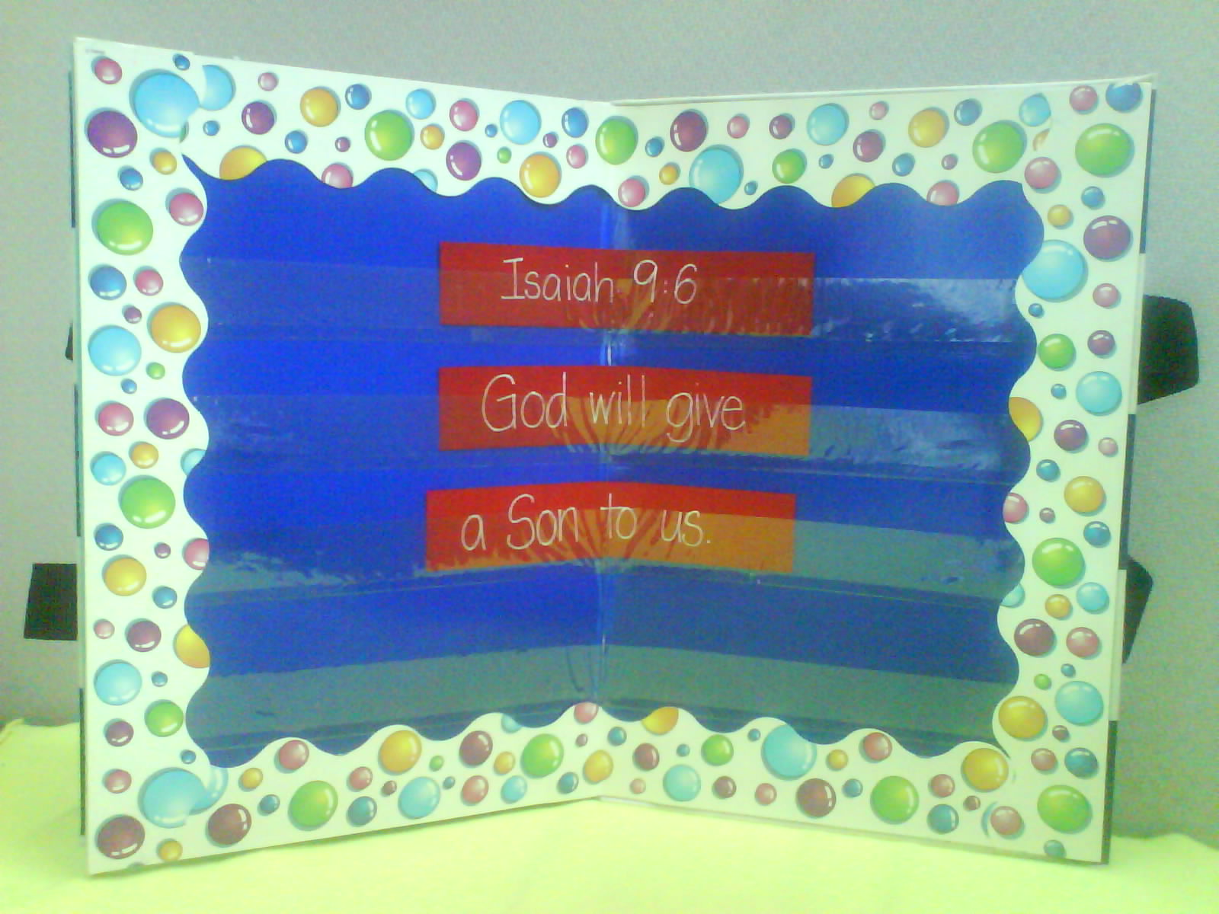

Closing Prayer:
Thank God for sending Jesus to this world. He was definitely treated like a stranger or an alien. Thank God that, because of Jesus we can be citizens of heaven, making us aliens in this world. Ask for strength to be confident and bold to be different, and live decent and God-pleasing lives.

Safety and Security: Safety and security procedures are important for each church to carefully define and implement according to their unique needs. The security, safety, illness and accident procedures described in this curriculum are provided for example purposes only and may not be appropriate, applicable or adequate for every situation. Each church is responsible for determining whether any security, safety, illness and accident procedures contained in the curriculum are appropriate, applicable or adequate for its unique situation. The activities described in this curriculum require adult supervision and may not be suitable for each child and each situation. Each church is responsible for ensuring that adequate adult supervision is provided for all activities and for determining whether an activity is appropriate for each child and each situation. Kids Kount Publishing disclaims all liability for the implementation of any procedures or the performance of any activities described in this curriculum.

Large Group Presentation: 20-30 minutes

Aliens In a Strange Land

This series covers the captivity in Babylon. Daniel and his friends were aliens in this strange land. Kids will discover that the word “alien” does not only mean “visitor from outer space,” but any person who is a foreigner from another land. Therefore, anyone who has faith in Christ is a citizen of heaven and an alien in this world. As a result, he or she doesn’t fit in with a sinful world. Many of the standards of this world are contrary to God’s kingdom.

Kids need to know that if they live their lives for Christ, they will receive pressure from the world to compromise their faith. But because they are citizens of God’s kingdom and foreigners, or aliens, to the ways of this world, they can trust God no matter what.

The metaphor of an alien will be used throughout the series. To help kids visualize this, construct an alien transporter machine from a cardboard refrigerator box or wall dividers. Use light, sound and spaceship decor. A child selected from the audience each week will appear from the machine and give an “alien’s perspective” on the lesson. Option: see picture.

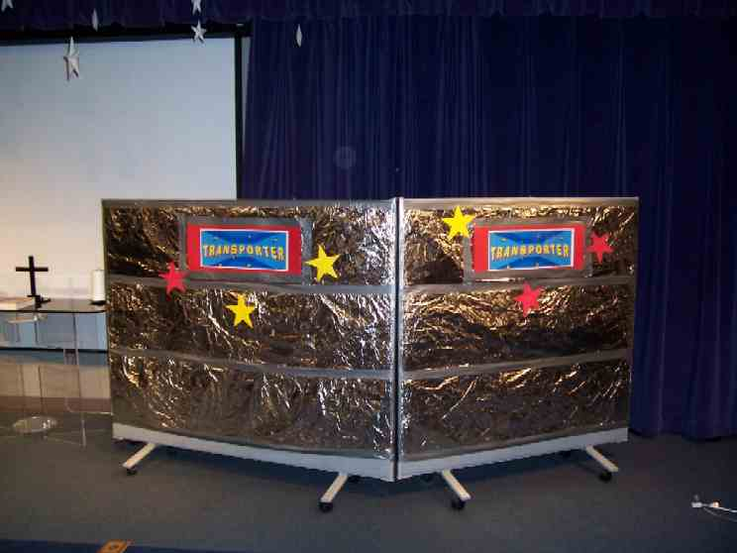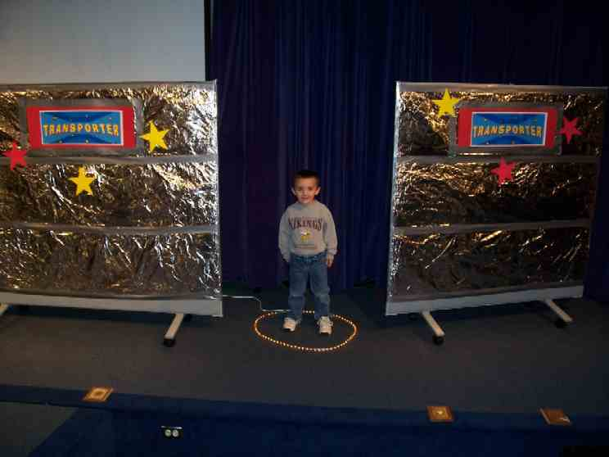

The Bible Event will use the video “Animated Stories from the Bible: Daniel” produced by Animated Bible Stories II, 1993. Sections of this video will be shown in the first four lessons. If you choose not to use the video, it would be simple to introduce a costumed character to tell the story.

After the video is shown for each lesson, Dao Dao who is the alientologist and the expert of aliens, wants to understand how these aliens think. The Large Group presenter will bring up a child to go through the alien machine and come out to answer questions relevant to the topic of that day which describe us as foreigners in a sinful world in which we don’t fit. The Large Group presenter will help the child through some application questions that lead us to the Take Home Point for each lesson.

Dao Dao, the Alientologist
Puppet Presentation

Presenter: Hi, kids. Welcome to Kingdom Quest. Let’s bring out Dao Dao. Are you there, Dao Dao? (Lead kids to call for Dao Dao.)

Dao Dao comes out with alien accessories such as a headband with antennae, chaser lights, etc. that makes him look like an alien.

Presenter: Dao Dao, my goodness, what are you wearing?

Dao Dao: Isn’t it obvious? I’m an alientologist.

Presenter: A what?

Dao Dao: An alientologist!

Presenter: What’s that?

Dao Dao: I’m an expert in aliens.

Presenter: Well, how did you end up being an expert in aliens?

Dao Dao: I hung around strange creatures long enough that I became an expert in them.

Presenter: What kind of strange creatures do you hang around with?

Dao Dao: Well, I hang around you quite a bit, don’t I?

Presenter: Now, Dao Dao, I don’t know that hanging around me would qualify you to be an expert in aliens.

Dao Dao: Oh, but I do know about aliens. I’ve seen all the alien movies, all the way from E.T. to Chewbacca, Star Trek, and alien invaders. I know all about aliens.

Presenter: Well, I’m glad you do, because today we’re going to see an alien right here.

Dao Dao: What? No way!

Presenter: Yes, way! And even better than that, we’re going to read about aliens in the Bible.

Dao Dao: No way, they didn’t have those green people in the Bible or I would have found it by now.

Presenter: Well, they didn’t have green people from outer space in the Bible, but they did have aliens. You see, the word alien means foreigner or visitor from another land.

Dao Dao: You mean like how aliens come from outer space and visit our place here on earth?

Presenter: Aliens can be people who come from another country and visit our country. They’re called aliens or foreigners.

Dao Dao: Oh, so where are they in the Bible?

Presenter: In the Bible, we’re going to find that Daniel and his friends were taken captive to another land. It was a foreign land called Babylon.

Dao Dao: How did that happen?

Presenter: Remember all the bad kings of Judah? God said He would punish His people if they kept following bad kings and false idols. And He did. He let the king of Babylon defeat Judah, capturing the people and making them captives in Babylon. So they were all aliens there.

Dao Dao: You mean like foreigners?

Presenter: That’s right. It wasn’t their home because their home was back in the promised land of Judah.

Dao Dao: So what happened when they became aliens?

Presenter: Well, watch this Bible Event. We’ll put it on our alien view screen and you can watch these aliens. Afterward, we’ll get to meet some aliens right here in this very room.

Dao Dao: Way cool, let’s go!

Video Sketch
Daniel

Animated Stories of the Bible: Daniel, 1993, ISBN# 1-56489-076-7. Show movie from opening credits until 10 minutes 30 seconds at the end of part one after Daniel is spared to interpret the King’s dream. Stop after the phrase, “Yes, that was my dream, precisely. Set them free.”

Dao Dao, the Alientologist
Puppet Conclusion

Props: An alien transporter machine made out of a refrigerator box or wall dividers, special effects with tin foil or a fog machine, fans blowing crepe paper (Needs to have a rear entrance where a child can walk through and appear.)

Presenter: So, Dao Dao, what did you think about Daniel and his three friends?

Dao Dao: Well, that was cool and everything, but I wanted to see aliens.

Presenter: Don’t you get it? They were aliens! They were strangers in a foreign land.

Dao Dao: Oh, yeah! I guess they were. But I guess I always thought aliens did weird stuff.

Presenter: Now you think about it, they did do weird things. For example, Daniel, Shadrach, Meshach, and Abednigo refused to eat the King’s special food, even though it was the finest food around.

Dao Dao: Yeah, why did they do that?

Presenter: Well, don’t you remember what Daniel said? “We can’t do that because it’s against the Law of Moses.” You see, that food had been offered to idols before it was served to them. Also, many of those foods were prohibited for the Jews to eat by Moses’ law.

Dao Dao: But they did pretty well when they only ate vegetables.

Presenter: That’s true, and they learned this truth: *No matter what, trust God. They followed Him, even if it meant going against what everyone else was doing in the foreign land. It would work out best and it did. Dao Dao, what other things did Daniel do as an alien in this strange land that were pretty special?

Dao Dao: Well, didn’t he do something about the king’s dream? I mean, no one else could interpret the dream.

Presenter: Yes, but more astonishing, the king wouldn’t tell anyone what the dream was. He wanted them to be able to tell him the dream.

Dao Dao: Yeah, and Daniel could do it because God gave Him the power. He trusted God.

Presenter: That’s right. And because of that, Daniel and his friends were saved.

Dao Dao: But there’s one thing about that dream I don’t understand. You know that big statue that represented lots of different kingdoms that would come, but finally it came crashing down? When did that happen?

Presenter: Well, at the end of that dream. Daniel talked about a kingdom that would someday come and it would have no end. And all the kingdoms of the world could not stand up against it. Do you know whose kingdom that is?

Dao Dao: The United States?

Presenter: No, it’s God’s kingdom. When God sent Jesus into the world, He destroyed the power that the devil has to hold us in a land of sin. He makes us citizens of His kingdom when we trust Jesus as our Savior. Then we no longer want to follow the sinful patterns of this world or even really belong to this world.

Dao Dao: Wait a minute. You think I don’t belong to this world?

Presenter: As a matter of fact, take a look at this. I’m going to introduce you to an alien.

Dao Dao: Finally, it’s about time. I’m ready to see a real, live alien.

Presenter: And that alien is right out here. I’m looking for someone who knows Jesus as Savior and wants to follow Him.

Have a volunteer come forward.

Dao Dao: Hey, wait a minute! I know that kid. That’s __________ (name the volunteer).

Presenter: Yeah, but just a minute, Dao Dao.

Call up a volunteer. Have him/her enter the back of the Alienl Transporter machine and walk through it to the front. Have any bells, wistles, horns, lights operating so as to give a sense of change.

This person is an alien in this world.

Dao Dao: Wait a minute, you just came through the alien machine, but you don’t look like an alien.

Presenter: Well, aliens are foreigners in a place. When we are citizens in God’s kingdom, we are foreigners in this evil world. Let me ask my special friend standing here a question or two.

Are there lots of people in this world that don’t care about God or want to follow Him at all? (Yes.)

Do you want to go along with them or do you want to follow God and his ways? (God and His ways.)

Well, then, you’re not of this world. Instead, you’re part of God’s kingdom, so you are an alien. Will you help me read the Bible? (Divide this verse according to the reading ability of the child. One who is not a good reader might only read special words that are “fill in the blank.”

“Dear friends, you are like visitors and strangers in this world. So I beg you to stay away from the evil things your bodies want to do. These things fight against your soul. People who do not believe are living all around you. They might say that you are doing wrong. So live good lives. Then they will see the good things you do, and they will give glory to God on the day when Christ comes again.” (1 Peter 2:11-12)

Presenter: So, Dao Dao, are you an alien in this world?

Dao Dao: Well, I thought I was an alien expert but maybe I am an alien because I am a follower of Jesus and I don’t like to go along with the things of this world that are against God’s commandments.

Presenter: Fantastic. Well, today, let’s pray that we would trust God no matter what, so that we choose to follow His way in this world. Why don’t we pray now?

Dear God, thank You for sending Jesus so that we can be part of Your world and Your kingdom. I guess that makes us aliens when we’re around people who don’t want to follow You. So help us, no matter what, to trust in You like Daniel and his friends did. Help us also tell others about You so they can trust in You also. In Jesus’ name. Amen.

Lesson 23

Small Group Warm-Up
- alien trinket (any item looking like it is associated with alien things)

Large Group Presentation
- alien-like accessories for the Dao Dao puppet: a headband with antennae, chaser lights, etc.
- alien transporter machine made from a decorated refrigerator box with special effects such as tin foil, lights, a fog machine, and fans blowing crepe paper
- video, “Animated Stories from the Bible: Daniel (Produced by Nest Family Entertainment, 1993, ISBN 1-56489-076-7), order from www.nestfamily.com

Small Group Application
- bulk kid’s sunglasses as ordered from a party store
- items to decorate the sunglasses and make the kids look like aliens

Memory Verse Learning
- poster board with slots
Making of a poster board
- Cover a firm board or carton box with a plain colour construction paper.
- From thick clear plastic sheet, cut out ten 3X60cm strips.
- Affix double-sided tape at one end of the 60cm strips.
- Peel and stick them on to board at 3cm apart from each other.
- You will have ten rows to slip in word strips for teaching. (See photo.)
- word strips

1 Peter 2:11 & 12, | “Dear friends, you are | like visitors and strangers
in this world… | So live good lives. | Then they will see
the good things you do, | and they will give | glory to God on the day
when Christ comes again.”

