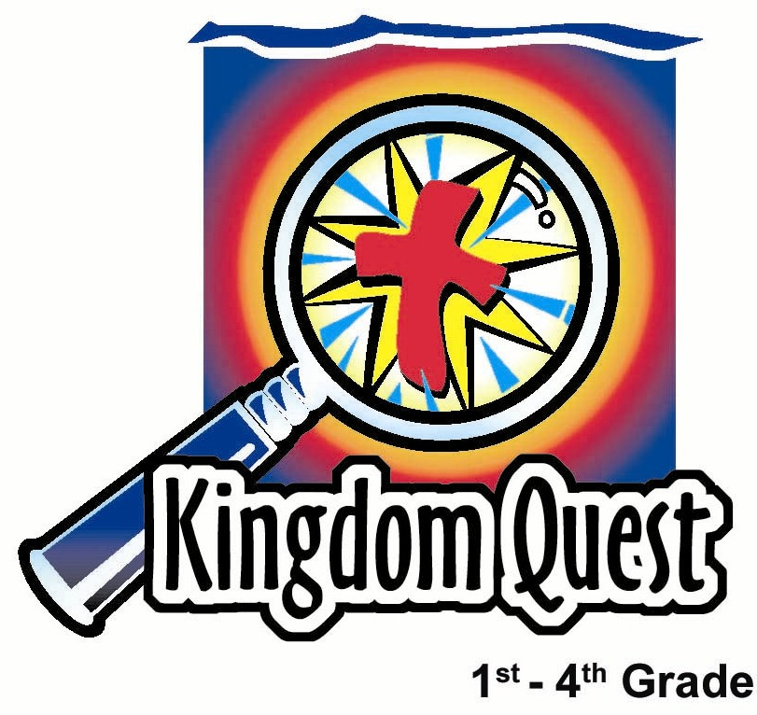
Date: ________________________
Series: Discovery Digs
Jun-Aug Year 4, Lesson 2

Kings of Israel Turn Away from God

Take Home Point: *Caution! Don’t turn away from God!
*Repeat this phrase throughout the lesson.

Bible Event: 1 Kings 11 and 1 Kings 12:25—14:20, 15:25-30, and 16:34
Key Verse: Hebrews 3:12, “So brothers, be careful that none of you has an evil, unbelieving heart. This will stop you from following the living God.”

We will help kids know:
- Rejecting God has serious consequences.
- After sin, comes God’s judgment. But His grace is even bigger than His judgment for those who turn back to Him.
- Solomon, Jeroboam, and other kings tried to work things out on their own and did not do what God considered right. They often ignored God’s warnings and commands. Now Jeroboam and the kings of Israel after him must suffer the consequences.

We will help kids feel:
- Respect for God and desire to obey His commands.
- Secure in his grace, through Jesus, that always welcomes us back.

We will help kids do:
- Make a caution sign to remind them that God will help us to turn back.
- Hear from God’s word the warnings given to His people and the consequences of turning away from Him.

THIS LESSON’S ROADMAP

DESTINATION | PAGE # | DISCOVERIES ON YOUR JOURNEY | SUPPLIES NEEDED
Small Group Warm-Up  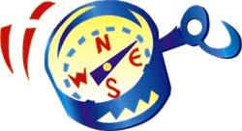 | 3 | Kids discuss various caution signs and what they mean. They also share about something they were warned not to do. | - sample of application craft—“Caution! God at Work!”
Large Group   | 3  8  10  17 | Overview  Puppet Presentation: “Jerry Dude Knows No Caution” – Dr. Ting and Dr. Ling discover some interesting warnings in the “sands of time.”  Dramatic Storytelling: “The Kings of Israel Turn Away From God”—The Bible event drives home the point of God’s cautions/warnings to the kings. Their disobedience brings consequences.  Puppet Presentation Conclusion: “Jerry Dude Knows No Caution” – Jerry learns from the Bible event that God gives warnings to help His people turn back to Him. God wants to continue to do a good work in our hearts when we turn to Him. | - tub of sand  - caution sign  - key with discovery point  - headpiece  - mousetrap  - signs of Kings’ names (see appendix)  - tube and rubber band
Small Group Application   | 4 | Kids make a caution sign to remind them that God will always warn us to turn back to Him if we turn away.  Memory Verse Learning:  “Assemble the MV”  Heb 3:12 learned in lessons 1-5 to give each child an early warning from God’s word the consequences of turning away from Him. | - yellow paper  - 1 1/2” black paper strips  - glue sticks  - copy of preprinted “Caution! God at Work” template  - scissors  - a set of word strips per child  - glue

Small Group Warm-Up: 15 minutes
Purpose: Get pointed in the right direction! Build relationships and help guests feel at ease. Do the learning readiness activity that will point your group in the right direction for the lesson.

Supplies needed: sample of application craft—“Caution! God at Work!”

For a visual, show a finished example of the craft (caution sign) kids will make in small group application. Then say:

There are signs everywhere to help us make good choices, to keep us safe and to keep us headed in the right direction. Can you think of any warning signs? (Yield signs, stop signs, cones, barricades, flashing lights etc.)

Have you ever noticed what colors are used to get our attention? (Bright yellow, oranges and reds.)

Signs are not the only way to help us. People can help teach us and remind us of the rules. When we stray, or begin to turn away from what we know is right, we then have consequences. If we continue to ignore the rules, warnings and signs, some consequences are very serious and can even lead to death.

Tell about a time in which you did something you had been warned not do and you did it anyway. What were the consequences?

Shepherd, share a personal example of something you were not suppose to do and the consequence that followed.

In large group today, we will hear about the kings of Israel. These kings received warnings from God but did not listen and turned away from God.

Today we will learn, *Caution! Don’t turn away from God!

Large Group Overview: 20-30 minutes
Purpose: Help kids observe what the Bible says. Present the Bible event in creative fashion. Help kids begin to interpret what it means.

Puppet Presentation: “Jerry Dude Knows No Caution”—Dr. Ting and Dr. Ling discover some interesting warnings in the “sands of time.”

Dramatic Storytelling: “The Kings of Israel Turn Away From God”—The Bible event drives home the point of God’s cautions/warnings to the kings. Their disobedience brings consequences.

Puppet Presentation Conclusion: “Jerry Dude Knows No Caution” – Jerry learns from the Bible event that God gives warnings to help His people turn back to Him. God wants to continue to do a good work in our hearts when we turn to Him.

Small Group Application: 20-25 minutes
Purpose: Help kids map out the meaning of the Bible event in their lives. Use the questions to stimulate discussion but don't feel tied to them. Allow the Holy Spirit to guide you. Include personal examples from your own faith journey. The example of Christ at work in your life will leave lasting impressions of how Christ can work in the children's lives.

Use your Bibles! Children need to learn how to look up references and follow along when scripture is read aloud. Allow for quality time of prayer at the close of the lesson.

Observation Questions: What happened?
Have kids read 1 Kings 11 in their Bibles.

What warning from God did King Solomon choose not to follow? (1 Kings 11:1-2. God told Solomon not to intermarry with any foreign women because they would tempt him to follow other gods.)

What dangerous thing happened to him? (1 Kings 11:4-7. In his old age, Solomon’s wives tempted him to follow other gods. So Solomon did what the Lord considered evil. He did not wholeheartedly follow the Lord as his father David had done. Instead, he built idols.)

What was his consequence for not obeying God’s command? (1 Kings 11:9-11. God would tear Solomon’s kingdom out of his hands and give it to his servant, Jeroboam.)

What mercy did God show Solomon because of his father, David? (1 Kings 11:12-13. God would not tear the kingdom away from Solomon, but from Solomon’s son. He would also let Solomon’s son keep a small part of the kingdom where Jerusalem and the temple were located.)

What warning from God did Jeroboam and all the kings of Israel (the Northern kingdom) not heed? (They all disobeyed God and worshiped idols instead of the one true God.)

Interpretation Questions: What does this mean?
Why do you think the kings did not listen and obey God’s warnings? What were their consequences? (God brought judgment and destruction.)

What do you think God would have done if the kings had repented and went back to worshiping the only true God?

Application Questions: What does this mean to me?
Our key verse for today in Hebrews 3:12 says, “So brothers, be careful that none of you has an evil, unbelieving heart. This will stop you from following the living God.”

What is the same warning God gave the kings of Israel and also gives to us? (Do not turn away from God.)

What are things we can make as idols that become more important to us than God?

What might be consequences for us if we did not heed God’s warning and turned away from Him?

God does not want anything bad to happen to us. Neither does He want us to turn away from Him, so He gives us warning signs along the way.

What are some examples of warnings He might give us to turn us to Him? (We can read in His word ways we should live. God gives us parents and Christian teachers to give us warnings when needed.)

Activity:
Supplies needed: black construction paper strips approximately two inches wide, yellow paper, preprinted label: “Caution! God At Work!”

Let’s make our own sign to remind us that God will always warn us to turn back to Him if we are getting near spiritual danger.

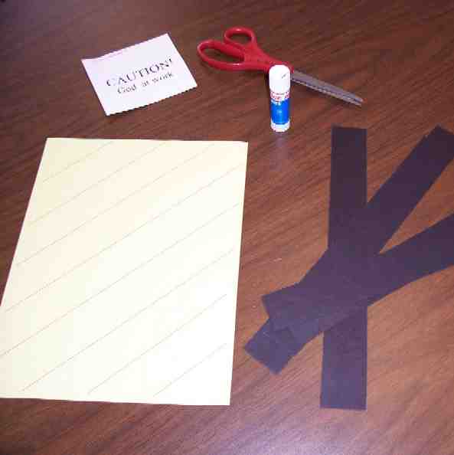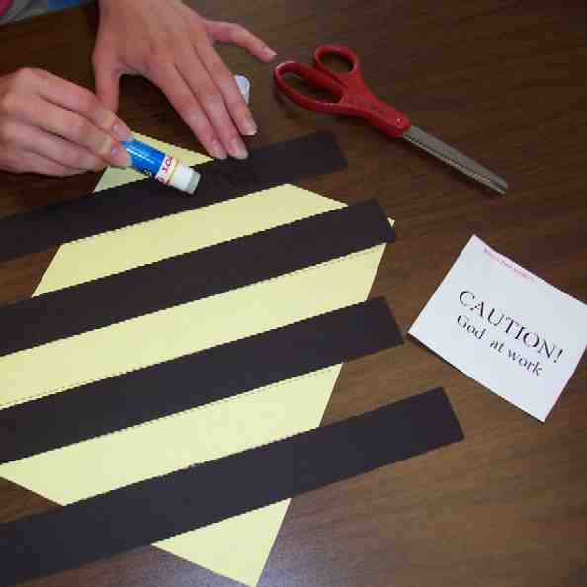

Show the children the warning sign they will make. Pass out yellow paper and black construction paper strips. Have kids glue the strips on the yellow paper in a diagonal pattern. Next, have them affix the label, “Caution! God At Work!”
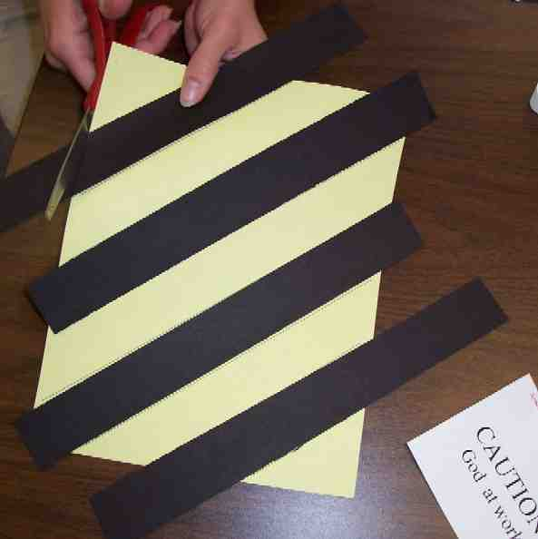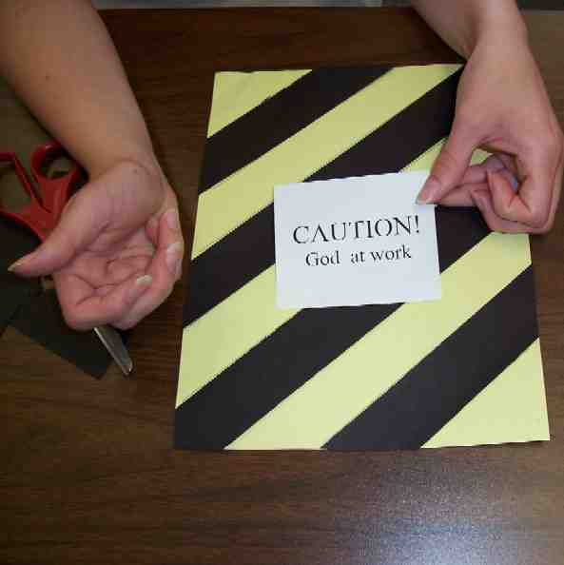

Discuss ways God is still at work in our lives.

Today, we learned it is important to have *Caution! Don’t turn away from God!

Memory Verse Learning: 5 minutes
Purpose: Help kids to memorize and keep scriptures at heart. Using creative ways to help kids enjoy learning the key verse and in small group setting.

Supplies needed: a set of word strips per child; glue

Memory Verse: Hebrews 3:12, “So brothers, be careful that none of you has an evil, unbelieving heart. This will stop you from following the living God.”

Memory Verse Presentation: “Assemble the MV”
Before class, cut out the word strips and make a set for each child. During class recite Heb. 3:12 several times with the children. Tell the children that they will be timed to see how fast they can assemble the word strips into the memory verse at the back of their signboard. After everyone has been timed and have assemble the memory verse, have the children glue the word strips on the signboard.

Closing prayer:

Thank God that He loves us so much he warns us when we are in spiritual danger. Thank Him that He will always forgive us because of Jesus’ death and resurrection. Even if we go astray, we can come back to Him.
Safety and Security: Safety and security procedures are important for each church to carefully define and implement according to their unique needs. The security, safety, illness and accident procedures described in this curriculum are provided for example purposes only and may not be appropriate, applicable or adequate for every situation. Each church is responsible for determining whether any security, safety, illness and accident procedures contained in the curriculum are appropriate, applicable or adequate for its unique situation. The activities described in this curriculum require adult supervision and may not be suitable for each child and each situation. Each church is responsible for ensuring that adequate adult supervision is provided for all activities and for determining whether an activity is appropriate for each child and each situation. Kids Kount Publishing disclaims all liability for the implementation of any procedures or the performance of any activities described in this curriculum.

Large Group Presentation

Caution: Don’t Turn Away from God!
Discovery Digs – Introduction

The theme for this series is "Discovery Digs.” Two characters will play the roles of explorers searching through the sands of time for lessons from God’s story in the Bible. The characters’ or story tellers’ are Dr. C. C. Ting and Dr. H.A. Ling. We suggest that both characters develop their own personality, accent and costume. Both are archeologists and historians. Both know the Bible events enough to tell them well. Since they are presenting to kids, it’s helpful to note that “overacting” works well with kids! Exaggerate expressions of surprise, exhortation or puzzlement.

Dr. C. C. Ting and Dr. H.A. Ling search through the “Sands of Time” and through the pages of the Bible for a special discovery each week. These are Bible truths that students not only discover, but truths that they put into practice. The Bible events are not told as exact readings of the Bible but are paraphrased. Still, it is a good idea to have a Bible in hand so that students can see the source. They might use a clipboard to hold their script, though it looks like archeologists notes.

Each week a student is brought forward to pull a special key out of the “Sands of Time”—a key that has a clue to the discovery of the day. It is helpful for the characters to use a dry paint brush to brush off the sand from objects pulled from the sand. There is special humor as the archeologists first put their hands in the sand to pull out a rather surprising or intimidating object. This creates just a bit more suspense for the student who then goes searching for the key. Then the characters tell their story in creative fashion using the student volunteer or perhaps the entire audience.

The puppet for this series is Dao Dao’s cousin, Jerry, the surfer dude. He speaks in surfer dude language. He came back to Malaysia for summer vacation and likes to come to Sunday school, especially since they play in the sand a bit. He serves as the one to start and close the large group presentation. He interacts with Dr. Ting and Dr. Ling. The presenter’s lines are labeled: Dr.________. (Both characters can be used in all presentations, but in the case of unavailable volunteers or a smaller congregation, one individual would be sufficient, as well. Fill in with whichever character is available this week.)

Props:
- a tub of sand, at least six inches deep. Label it, “Sands of Time”
- a yellow and black striped rectangular sign that means caution. This is made from construction paper like today’s craft. This will be the first item retrieved from the “Sands of Time”
- a large key with the discovery point written on a paper slip wrapped around it: “Caution: Don’t turn away from God”
- headpiece to put on a volunteer, giving him the look of a prophet
- mousetrap
- sign printed: “David’s Kingdom” (see appendix). This is placed in the tub of sand
- signs printed each with a king’s name: Solomon, Jeroboam, Nadab, Baasha, Elah, Zimri, Omri, Ahab,(see appendix). These should all be placed in order, rolled together and held with a rubber band. This tube of signs will be placed in the sand tub.

Jerry Dude Knows No Caution

Puppet Presentation

NOTE: If you took Meredeka Day weekend off in your children’s ministry, use the following to introduce the series. If you did not take the holiday weekend off, the introduction material was already been included in Lesson 1. Remove Jerry’s opening paragraph.

Jerry: Yo, dudes. Like everyone is here. Hi, dudes and dude-ettes. Maybe you don’t know me. I’m Jerry, Dao Dao’s cousin from California, and like I was out there riding some waves, hanging ten, and Dao Dao said why don’t you spend the summer with me and I said like that’d be totally awesome. But, when I got here, there was little beach, small waves, and no surfin’. So I asked Dao Dao what you guys do that is cool. And he said Sunday school is cool. He said he owned it. I said radical. He said I could take his place for the vacaton. I said totally awesome.

So, welcome everybody to Sunday school – where we are going to ride the big wave home. Now, our guests today are like two scientific discovery dudes. I’ll introduce them and they’ll come straight on out. Dr. C.C. Ting….Sisi. Ting? Bogus name, man. And then, Dr. H.A. Ling. Ha Ling? … Whoa, like bogus, too. So let me introduce Dr. Ling and Dr. Ting. You dudes tell us what you do.

Dr. ___: We dig through the sands of time, exploring the Bible so that we can discover truth.

Jerry: Discover truth? Far out, dude.

Dr. ___: That’s right. We are making a dig through HISTORY to reveal HIS STORY, God’s story, and to discover the truths that help us today.

Jerry: So, show me how you do it, man.

Dr. ___: I reach into the sands of time here…

Jerry: Oh you mean that box of sand?

Dr. ___: Yes.

Jerry: Gnarly, dude. I hope its California sand.

Dr. ___: Sorry it is not—and pull out this…. O-o-oo!

Pulls out caution sign.

Jerry: Whoa! Like, dude, what is that thing?

Dr. ___: I think it’s a caution sign… or maybe a crossing sign.

Jerry: I don’t know, man. Put your hand in there and see if you can find a yellow zebra.

Dr. ___: I don’t think so. It means caution. That means there might be something in the sand that is dangerous.

Jerry: Like, bodacious. But I think it’s going to be a huge, yellow zebra. Why don’t you check it out.

Dr. ___: I’ll show you there is no yellow zebra.

Sticks hand in. Fakes a scream as he picks up a mousetrap hidden in there and has it connected to his finger when he pulls it out of the sand.

Jerry: Whoa, bummer dude. I guess it does mean caution. Sorry about your hand, man.

Dr. ___: That is the risk of discovery.

Jerry: So, what else do you have in the tub?

Dr. ___: You mean the sands of time.

Jerry: Or like we say it… the sa-a-ands of ti-m-me (draw out words). Do you think there is anything else in the sand?

Dr. ___: I thought I felt something else in there. I’ll try again, but there better not be any more mousetraps.

Pull out large key and take off the paper.

Jerry: Whoa, dude. What does it say?

Dr. ___: I’ll bet we have a Bible event about caution, no doubt. This paper says *Caution! Don’t turn away from God! This must mean that in our Bible event today, there will be an important discovery about God’s truth about caution.

Jerry: Doctor, what do you think the key means?

Dr. ___: I think the key means this message is “key” to the truth that will help us in our lives today.

Jerry: Whoa, man, I don’t think I need that, dude. I know no caution because I’m a surfer dude, and surfer dudes know no caution. But I’m not sticking my hand in no sand like you did and get bit by a mousetrap.

Dr. ___: Jerry, this is a different kind of caution. Why don’t you listen to this Bible event as we describe true events from history of the kings of Israel and how they turned away from God teaching us *Caution! Don’t turn away from God!

Jerry: Sweet, dude. I’ll be right back here watching while you tell your stuff. Later, man.

Jerry exits.

Kings of Israel Turn Away From God

Dramatic Storytelling

For this presentation, select a volunteer from the audience and give him/her a headpiece so that he/she might play the role of prophet. Also, give this person the caution sign used in the puppet script. The volunteer will lead the rest of the students in reciting the take home phrase *Caution: Don’t Turn Away from God! while holding up the caution sign.

The stories of eight kings will be told in subsequent order. It is important to be brief when telling these stories but each king’s story will follow a similar presentation pattern. First, Dr. Ting explains what warnings God gave the king. The student holds the caution sign and leads the rest of the kids in a refrain. Then Dr. Ling describes what the king did. The student holds the caution sign again and Dr. Ling explains what happened as a consequence to the disobedience.

A few props are necessary. A sign for each king, retrieved from the “sands of time,” should be held up as each king’s story is told. Also, after telling Solomon’s story, a sign saying “David’s Kingdom” is retrieved and torn into many pieces leaving only one small piece to be torn in two. The entire Bible presentation becomes more fun when Dr. Ting after explaining what God says, makes his own caution noise which is the cue for the child prophet to yell, “Caution, caution, caution.”

Dr. ___: I will need an assistant from the audience. Thank you. Please step forward. Put on this headpiece. You are taking the role of prophet. Here is your sign. When you hear the sound of the siren, then you to say, “Caution, Caution, Caution!” and hold up this sign. Kids, when the “prophet” says “Caution, caution, caution,” you say, “Don’t turn away from God Let’s see you do it.

Volunteer says, “Caution, Caution, Caution!” Kids respond, “Don’t turn away from God!”

Dr. ___: That wasn’t bad. But, maybe you need some sound effects. Why don’t I give you a little background siren?

Makes siren noise then points to the sign. The volunteer leads all the kids, “Caution, caution, caution, don’t turn away from God.”

Okay, now I think we are ready to tell the Bible event.

Dr. ___: Are you sure there isn’t anything else in the sands of time?

Dr. ___: Be my guest and look again, but be careful.

Dr. ___ reaches in the sand and pulls out the tube. He opens the tube and pulls out the papers. He reads aloud the first two and shows them to the audience.

Dr. ___: I wonder what is in here. These are names of the kings of Israel. The first one says, “David’s Kingdom” and this one says, “Solomon.”

Dr. ___: I think I know where this dig is taking us. Listen as I tell about the kings of Israel.

SOLOMON - Object: Ripped heart… broken heart

Dr. ___: God told Solomon, “Follow Me with your whole heart as David your father did and obey all that I have told you and you shall never fail to have a one of your descendants on the throne of Israel. But, if you turn away from Me and go off and serve other gods, then I will reject you, I will reject this temple and I will reject this land.”

What do you think kids, does that sound like a caution?

Make caution siren noise and prompt volunteer.

Prophet: Caution, Caution, Caution!
Kids: Don’t turn away from God!

Dr. ___: Though King Solomon began with a listening heart to God, later in life he stopped listening and obeying. He loved many foreign women even though God told him to not marry women who worshiped idols, but he did. He married 700 wives and his wives led him astray. Solomon built temples for the gods of his foreign wives and even worshiped those idols along with worshiping the true God.

Dr. ___: What happened?

Dr. ___: So, the Lord became angry with Solomon and took his kingdom and told Solomon He would tear his kingdom in half.

Rip the sign David’s kingdom.
He will give one part to the descendants of Solomon and ten parts to other kings. This other part would now be called Israel and the part given to Solomon’s son would be called Judah. Solomon’s kingdom would be divided.

Let’s see who will be the king of the north part of Israel?

Hold up the Jeroboam sign.

Jeroboam was the first king of this new country called Israel. It was the part that God had torn away from Solomon and given to other kings.

JEROBOAM – Object: Golden Calf

Dr. ___: God told Jeroboam, “If you walk in My ways and do what is right in my eyes, I will give you a kingdom like the one I gave to David. But, don’t worship false gods.”

Make caution siren noise and point to the cue.

Prophet: Caution, Caution, Caution!
Kids: Don’t turn away from God!

Dr. ___: But Jeroboam worried about people leaving his land and going back to the land of Judea to worship God in the temple. So, he made his own temples for them to worship. The problem was that at each temple he made, he set up a golden calf, an idol, for the people to worship and even though prophets were sent to warn Jeroboam about leading the people away, he ignored them.

Make caution siren noise and point to the cue.

Prophet: Caution, Caution, Caution!

Kids: Don’t turn away from God

Dr. ___: What happened?

Dr. ___: What happened is God brought disaster on the house of Jeroboam. All of his descendents, except for one, had horrible deaths and were not even buried. Instead, the wild animals ate them.

Let’s see who will be the next king of the north part or Israel?

Hold up the Nadab sign.

Nadab was the son of Jeroboam and became the next king of Israel.

NADAB – Object:Toy knife

Dr. ___: God told him that he, too, should not follow false gods as his father did, but worship the true God.

Make caution siren noise and point to the cue.

Prophet: Caution, Caution, Caution!
Kids: Don’t turn away from God!

Dr. ___: Nadab ignored the warning and continued to do evil as his father had done.

Dr. ___: What happened?

Dr. ___: (Pull toy knife out of the sand.) Baasha, one of his soldiers who wanted to become king for himself, killed Nadab. Then Baasha killed Jeroboam’s whole family.

Show audience the paper sign with Baasha’s name on it.

BAASHA – Object: Toy knife

Dr. ___: God told Baasha to walk in the ways of David and to serve only God. He should turn away from other idols.

Make caution siren noise and point to the cue.

Prophet: Caution, Caution, Caution!
Kids: Don’t turn away from God!

Dr. ___: Baasha behaved just like Jeroboam and did evil in the sight of God, worshiping other gods.

Dr. ___: What happened?

Dr. ___: (Pull knife out of the sand.) Before Baasha died, God said that he would send ruin to all Baasha’s descendents just like Jeroboam’s. They would have terrible deaths and not even have funerals.

Show audience the paper/sign with Elah’s name on it.

ELAH – Object: Toy knife

Dr. ___: Elah was Baasha’s son. God told Elah to follow the God of David. Don’t turn away from God and don’t worship other idols. Boys and girls, I think I see a pattern here.

Make caution siren noise and point to the cue.

Prophet: Caution, Caution, Caution!
Kids: Don’t turn away from God!

Dr. ___: Elah continued to worship false gods like idols and led the people to worship false gods.

Dr. ___: What happened?

Dr. ___: (Pull toy knife out of the sand.) Zimri, one of Elah’s generals, attacked him while he was getting drunk and killed him. Then Zimri became king and killed all of Elah’s family just like God said would happen. Zimri was now the king of Israel.

Show audience the paper/sign with Zimri’s name on it

ZIMRI – Object: Toy knife

Dr. ___: God told Zimri to follow the God of David. Don’t turn away from God and don’t worship other idols.

Make caution siren noise and point to the cue.

Prophet: Caution, Caution, Caution!
Kids: Don’t turn away from God!

Dr. ___: Guess what… Zimri did not worship the true God either. He lived like Jeroboam and led Israel to sin.

Dr. ___: I hate to ask, but what happened?

Dr. ___: (Pull knife out of the sand.) Zimri did not honor God. He was king for only seven days because the other soldiers, who were angry with him for killing the king, attacked him and he burned up in a tower.

Show audience the paper/sign with Omri’s name on it.

Omri was the next king of Israel. Omri sinned more than anyone else before him.

OMRI – Object: Toy knife

Dr. ___: God told Omri to follow the God of David. Don’t turn away from God and don’t worship other idols.

Make caution siren noise and point to the cue.

Prophet: Caution, Caution, Caution!
Kids: Don’t turn away from God!

Dr. ___: He did evil in the eyes of the Lord and lived like Jeroboam. He caused Israel to sin and worship worthless idols.

Dr. ___: Go ahead tell us the bad news that happened to Omri.

Dr. ___: (Pull toy knife from the sand.) Omri died and left his son Ahab, the most wicked king of all, to rule over Israel.

Show audience the paper/sign with Ahab’s name on it.

AHAB

Dr. ___: God told Ahab to follow the God of David. Don’t turn away from God and don’t worship other idols.

Make caution siren noise and point to the cue.

Prophet: Caution, Caution, Caution!
Kids: Don’t turn away from God!

Dr. ___: Ahab was worse than all the kings before him. He not only lived like Jeroboam, he set up temple and altars for Baal and married a Baal priestess and supported many Baal priests.

Dr. ___: This story is beginning to sound like a broken record… I mean CD. These kids don’t go that far back in time to remember records.

Dr. ___: We will find out more about that in future weeks.

Jerry Dude Knows No Caution
Puppet Presentation Conclusion

Jerry: Whoa, dude. Mr. T, I don’t get it.

Dr. ___: What don’t you get Jerry?

Jerry: Those kings, they were major bogus.

Dr. ___: They were? What do you mean by that?

Jerry: I mean, like they were totally mentally blocked. God says don’t make false idols and don’t turn away from me and do what they do?

Dr. ___: What did they do, Jerry?

Jerry: They made idols and they turned away from God and all the people.

Dr. ___: That was a pretty important caution they missed.

Jerry: You bet it was. God was angry and He should have been. Like a total downer.

Dr. ___: So, did you learn anything from our discovery dig?

Jerry: Are you kidding? Like, *Caution dude! Don’t turn away from God!

Dr. ___: Have you ever done that, Jerry?

Jerry: Well, I’ve never made a seriously, mentally flawed, idol and worshiped it or anything.

Dr. ___: Yeah, (make siren noise) but do other things get in between you and God?

Jerry: Like what, man?

Dr. ___: Like surfing on Sunday morning...

Jerry: Uh-oh, whoa.

Dr. ___: Yeah, even that can be like turning away from God.

Jerry: I’m totally busted, man.

Dr. ___: But, Jerry, remember that God is always working on our hearts. He wants us to come closer to Him. So, if we turn away in our own selfishness, we can always turn back to Him.

Jerry: Totally. But what does He do, slap us down?

Dr. ___: No. When we turn to Him, He gives us Jesus who died on the cross for all of our sins and who wants to live in our heart.

Jerry: Well, what does He do there?

Dr. ___: When you turn to Him, it is like God begins a whole new work in your life.

Jerry: Totally awesome. So, God is at work right here, huh.

Dr. ___: That’s right. So maybe we can just say today, “Caution! God at work right in our heart.” Don’t turn away from Him and instead turn toward Him.

Jerry: That’s rad.

Dr. ___: Let’s have a closing prayer, and then we will go back to our small groups.

Dear God, You are the one who’s totally awesome. We don’t want to turn away from You, but if we ever do, it’s our big lost. Please help us to turn back. Help us to trust Jesus as our Savior and know that Jesus wants to live in our lives, so that He can begin a new work in our heart. Thank You, God. In Jesus’ name. Amen.

Lesson 2

Small Group Warm-Up
- sample of application craft—“Caution! God at Work!”

Large Group
      - tub of sand
      - caution sign
      - key with discovery point
      - headpiece
      - mousetrap
      - signs of Kings’ names (see appendix)
      - tube and rubber band

Small Group Applicaton
- yellow paper
- 1 1/2” black paper strips
- glue sticks
- copy of preprinted “Caution! God at Work” template
- scissors

Memory Verse Learning
- a set of word strips per child. See table below.
- glue

Hebrews 3:12 | So,  brothers | be  careful
that  none | of you | has an
evil, unbelieving | heart.  This | will stop
you from | following the | living  God.”

Templates: Various signs needed for Large Group

DAVID’S
KINGDOM

SOLOMON

JEROBOAM

NADAB

BAASHA

ELAH

ZIMRI

OMRI

AHAB

Lesson 2- Template for striping Caution Sign
