
Date: ___________________________
Series: Discovery Digs
Jun-Aug Year 4, Lesson 11

Jonah Runs from God

Take Home Point: *Don’t run from God’s purpose for you. *Repeat this phrase throughout the lesson.

Bible Event: Jonah 1-2
Key Verse: Matthew 4:19, “Jesus said, ‘Come follow Me, I will make you fishermen for men.’" (NCV)

We will help kids know:
- The Bible event of Jonah fleeing from God’s purpose and Jonah’s later repentance.
- God has a purpose for us and that is to share His love with others.
- We should be more concerned about following God than about what others think.

We will help kids feel:
- Remember what it is like to be afraid when accepting a certain challenge.
- Inspired to overcome fears of sharing God’s love with others.

We will help kids do:
- Identify a person they may have a hard time sharing God’s love with.
- Play a game that reminds them of sharing God’s love with others and praying for them even when challenged to do so.

THIS LESSON’S ROADMAP

DESTINATION | PAGE # | DISCOVERIES ON YOUR JOURNEY | SUPPLIES NEEDED
  Small Group Warm-Up | 3 | Children will be challenged to eat something that seems gross and then discuss how God has a purpose for them even when it seems challenging. | - bowl of Gummy worms or fish biscuits per group
Large Group   | 4  8  10  10 | Overview  Puppet Presentation: “Jerry Dude Faces a Challenge”—Jerry is scared when he is faced with a challenge.  Video Presentation: Testament: The Bible in Animation, Jonah, Diamond Entertainment Corporation, 1998  Puppet Conclusion: “Jerry Dude Faces a Challenge”—Jerry Dude learns about Jonah’s challenge and how his purpose is to share God’s love. | - tub of sand  - sign that says “Do You Dare?” (see appendix)  - video –Testament: The Bible in Animation, Jonah
Small Group Application   | 4 | Children will play a game to remind them of God’s purpose for them to be “fishers of men.”  Memory Verse Learning:  “Hang Up the Fishes”  1 Cor. 11;1 is emphasized in lessons 11-14 as to encourage every child to imitate Christ so that others follow their imitation also. | - box of small paper clips per group  - paper clip “fish”  - poster board with hooks  - six pieces of half A4 paper  - cellophane tape

Small Group Warm-Up: 15 minutes
Purpose: Get pointed in the right direction! Build relationships and help guests feel at ease. Do the learning readiness activity that will point your group in the right direction for the lesson.

Conceal the snack of either a bowl of gummy worms or fish snack biscuits.

Ask the kids:

Have any of you seen the show Fear Factor on TV or seen commercials for Fear Factor? (If program not available, insert any show that would show a great deal of fear in its actions.)

What are some things those contestants have to do that you would have a hard time doing?

After discussion, tell them:

I have a challenge for you. I challenge you to eat a bowl of worms (or a bowl of uncooked fish). Who will accept the challenge?

Take a volunteer and then reveal the hidden bowl with snack food.

Actually, let’s all share this bowl of worms (or fish). That seemed like a pretty scary challenge. God gives us another challenge we might be afraid of doing. What do you think is God’s challenge?

Let children discuss and then say:

The challenge God has for us is to share His love with other people. This is actually His purpose for us, but it might seem scary sometimes because we are afraid others might laugh at us and think we are weird. Also, it might be scary because we may not know how to share His love. Today, we are going to discover that God has a purpose for us and we need to share His love with others. *Don’t run from God’s purpose for you.

Large Group Overview: 20-30 minutes
Purpose: Help kids observe what the Bible says. Present the Bible event in creative fashion. Help kids begin to interpret what it means.

Puppet Presentation: “Jerry Dude Faces a Challenge”—Jerry is scared when he is faced with a challenge.

Video Presentation: Testament: The Bible in Animation, Jonah, Diamond Entertainment Corporation, 1998. Order from: http://www.christiancinema.com/catalog/product_info.php?products_id=878.

Puppet Conclusion: “Jerry Dude Faces a Challenge”—Jerry Dude learns about Jonah’s challenge and how his purpose is to share God’s love.

Small Group Application: 20-25 minutes
Purpose: Help kids map out the meaning of the Bible event in their lives. Use the questions to stimulate discussion but don't feel tied to them. Allow the Holy Spirit to guide you. Include personal examples from your own faith journey. The example of Christ at work in your life will leave lasting impressions of how Christ can work in the children's lives.

Use your Bibles! Children need to learn how to look up references and follow along when scripture is read aloud. Allow for quality time of prayer at the close of the lesson.

Observation Questions: What happened?
Have kids refer to Jonah 1-2 in their Bibles.

What did God want Jonah to do and what was Jonah’s response? (Jonah 1:1-3. Preach to Nineveh. Jonah ran away.)

How did God try to shake Jonah up on the ship bound for Tarshish? (Jonah 1:4-5. God sent a violent wind and the storm was so powerful that the ship was in danger of breaking up.)

The sailors on the ship were very superstitious and thought someone on board was responsible for causing the storm (like a curse was on them). How did they figure out who it was? (Jonah 1:7. They threw dice and the dice indicated that Jonah was responsible.)

What was Jonah’s response when they questioned him? (Jonah 1:9:10. He testified to God and told the sailors he was running away from God.)

What was Jonah’s solution to the problem? (Jonah 1:12. He told them he was responsible for the storm and to throw him overboard and the sea would become calm.)

What happened to Jonah after he was thrown overboard? (Jonah 1:17. God sent a big fish to swallow Jonah. Jonah was inside the fish for three days and three nights.)

What did he do while in the fish? (Jonah 2:1. He prayed.)

Interpretation Questions: What does this mean?
Why do you think Jonah ran from God’s command? (He was scared. He didn’t think he could do what God wanted him to do.)

Why do you suppose Jonah told the men to throw him in the sea? (He knew he had disobeyed God and thought this was the only way to fix it. Maybe he was so afraid to go to Nineveh, he would rather die.)

Why do you think God sent a fish to swallow Jonah to save him instead of just letting Jonah wash up on the shore or instead of letting Jonah die? (Accept answers. Maybe God wanted Jonah to spend time thinking about what he did, like a time out. Maybe God wanted Jonah to turn to God completely.

Application Questions: What does this mean to me?
What are some things God wants us to do that we might be afraid to do? (Accept answers.)

Are these things optional? (No, when God wants us to do something, it is a command! And you *don’t run from God’s purpose for you.)

What is God’s purpose and greatest command for us? I’ll give you a hint. It is the same thing he told Jonah to do. (To share His love with others.)

When Jesus was on earth He said that if we follow Him, He would make us “fishers of men.” What does that mean? (Bring others along with you to enjoy the kingdom of God.)
Activity
Supplies needed: box of small paper clips

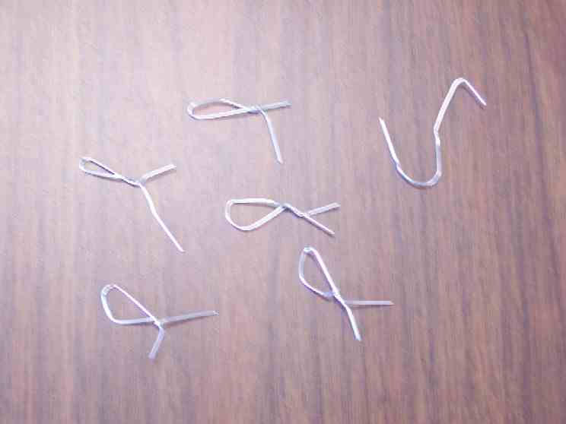
To get ready to play “Pick up Fish,” have each child bend two paper clips into the shape of a fish while you bend a clip into the shape of a fishhook. Toss all the fish into a pile in the middle of the group. Then explain how to play:

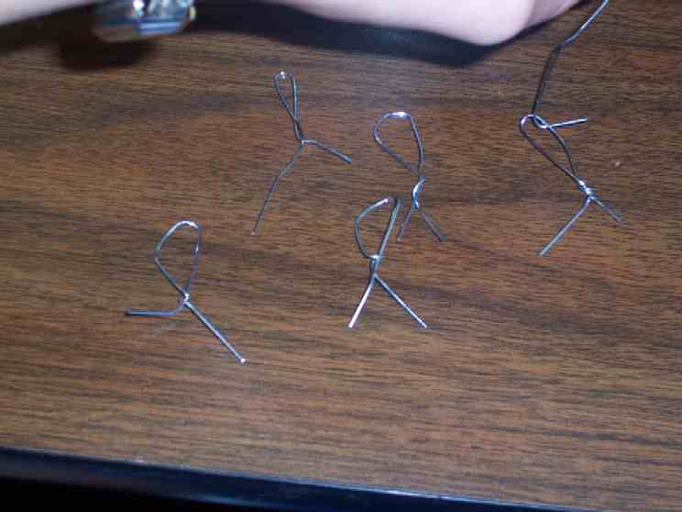
Each of you will get a turn to try and pick up as many fish with this hook as you can. However, you can’t move any other fish in the pile as you pick them up. The person who picks up the most fish wins. If you move any other fish when you try, then it is the next person’s turn.

This game will remind us that we are fishers of men. While we are playing, think of a person that needs to hear about God’s love but you might be afraid to share with them.

When the game is over say:

Today we learned *don’t run from God’s purpose for you. Instead Jesus tells us, “Come follow Me, I will make you fishermen for men.”

Memory Verse Learning: 5 minutes
Purpose: Help kids to memorize and keep scriptures at heart. Using creative ways to help kids enjoy learning the key verse and in small group setting.

Supplies needed: paper clip “fish”; poster board with hooks; six pieces of half A4 paper; cellophane tape

Memory Verse: I Corinthians 11:1, “Follow my example, as I follow the example of Christ.”

MV Presentation: “Hang Up the Fishes”
Before class, write the memory verse on the paper and with the cellophane tape the “fish” in the top-middle of the paper. (See diagram.) During this session, hang up the memory verse and use this visual to help the children memorize the verse.

1
Corinthians 11:1

Closing prayer: Have kids each mention the name of a person they thought of during the game, someone that needs to know God’s love. Pray for the people mentioned and also for God’s help to not be afraid to share his love with them.

Safety and Security: Safety and security procedures are important for each church to carefully define and implement according to their unique needs. The security, safety, illness and accident procedures described in this curriculum are provided for example purposes only and may not be appropriate, applicable or adequate for every situation. Each church is responsible for determining whether any security, safety, illness and accident procedures contained in the curriculum are appropriate, applicable or adequate for its unique situation. The activities described in this curriculum require adult supervision and may not be suitable for each child and each situation. Each church is responsible for ensuring that adequate adult supervision is provided for all activities and for determining whether an activity is appropriate for each child and each situation. Kids Kount Publishing disclaims all liability for the implementation of any procedures or the performance of any activities described in this curriculum.

Large Group Presentation

God Has a Challenge for You
Discovery Digs – Puppet Presentation

The theme for this series is "Discovery Digs.” Two characters will play the roles of explorers searching through the sands of time for lessons from God’s story in the Bible. The characters’ or story tellers’ are Dr. C. C. Ting and Dr. H.A. Ling. We suggest that both characters develop their own personality, accent and costume. Both are archeologists and historians. Both know the Bible events enough to tell them well. Since they are presenting to kids, it’s helpful to note that “overacting” works well with kids! Exaggerate expressions of surprise, exhortation or puzzlement.

Dr. C. C. Ting and Dr. H.A. Ling search through the “Sands of Time” and through the pages of the Bible for a special discovery each week. These are Bible truths that students not only discover, but truths that they put into practice. The Bible events are not told as exact readings of the Bible but are paraphrased. Still, it is a good idea to have a Bible in hand so that students can see the source. They might use a clipboard to hold their script, though it looks like archeologists notes.

Each week a student is brought forward to pull a special key out of the “Sands of Time”—a key that has a clue to the discovery of the day. It is helpful for the characters to use a dry paint brush to brush off the sand from objects pulled from the sand. There is special humor as the archeologists first put their hands in the sand to pull out a rather surprising or intimidating object. This creates just a bit more suspense for the student who then goes searching for the key. Then the characters tell their story in creative fashion using the student volunteer or perhaps the entire audience.

The puppet for this series is Dao Dao’s cousin, Jerry, the surfer dude. He speaks in surfer dude language. He came back to Malaysia for summer vacation and likes to come to Sunday school, especially since they play in the sand a bit. He serves as the one to start and close the large group presentation. He interacts with Dr. Ting and Dr. Ling. The presenter’s lines are labeled: Dr.________. (Both characters can be used in all presentations, but in the case of unavailable volunteers or a smaller congregation, one individual would be sufficient, as well. Fill in with whichever character is available this week.)

Props:
      - a tub of sand, at least six inches deep. Label it “Sands of Time”.
      - a sign that says “Do You Dare”

Jerry Dude Faces a Challenge
Puppet Presentation

Jerry Dude looks around from his clubhouse as if frightened. Dr.____ walks up to him as he is looking around.

Dr.____: Jerry? What are you doing?

Jerry: Oh, awesome dude, it’s only you, Dr.____.

Dr.____: Well, who did you want it to be?

Jerry: No, it’s more like who I didn’t want it to be.

Dr.____: Who’s that?

Jerry: This dude, Marcus.

Dr.____: What happened with Marcus?

Jerry: So like, I was down at this way cool park today and Marcus came up and dared me to jump off the top of the slide.

Dr.____: Did you do it?

Jerry: No way, man! I was way too scared to do something like that!

Dr.____: So then, what did you do?

Jerry: (Whispering) I ran.

Dr.____: (As if he didn’t hear) You what?

Jerry: (Looking embarrassed) I ran. Totally scamp out of that place, man.

Dr.____: Well, that sounds like what most people do when they are scared, Jerry. In fact, there was a man in the Bible named Jonah who also ran when he was faced with a challenge.

Jerry: Like, did someone dare him to jump off of a slide, too?

Dr.____: No, this was much too long ago for that.

Jerry: Oh, totally, like I forgot they didn’t have slides then. So what was his challenge?

Dr.____: His challenge came from God. Let’s take a look in the Sands of Time. Let’s see here…

Reach in and pull out “Do You Dare?” sign.

Jerry: But what does that have to do with that dude in the Bible?

Dr.____: You mean, Jonah? Well he was challenged to speak God’s word to the Ninevites.

Jerry: Who are the Ninevites, man? Is that like termites or something?

Dr.____: No, they were actually people from Nineveh that were Israel’s enemies and that is why Jonah was scared to talk to them. That is why instead of speaking God’s word, Jonah did something else.

Jerry: What did he do?

Dr.____: He ran away.

Jerry: Kind of like me. Where did Jonah go?

Dr.____: Well, let’s watch today’s video and find out.

Video

Show the video, Testament: The Bible in Animation, Jonah, produced by Diamond Entertainment Corporation, 1998, ISBN 1-56364-300-6. Order from: http://www.christiancinema.com/catalog/product_info.php?products_id=878. Play the video until 13 minutes, 40 seconds after the opening title. End it just after the fish returns into the sea.

Jerry Dude Faces a Challenge
Puppet Conclusion

Jerry: Like bummer, dude, Jonah just ran away from God’s purpose for him. What ended up happening to him?

Dr.____: We will find out next week. But did you know that sometimes we, too, run away from God’s purpose?

Jerry: You mean like jumping from slides?
Dr.____: No, something much more important than that, sometimes we run away from sharing God’s love with others. As a matter of fact, Jesus said He would make us “fishers of men.”

Jerry: Like what does that mean?

Dr.____: That we would catch people with God’s love.

Jerry: Like how do we do that, man?

Dr.____: We simply want to tell friends that Jesus is really God’s Son and He came to earth to give His life for them. And Jesus took away our sins with His death on a cross, so that we can be friends with God forever.

Jerry: Astounding, I believe that.

Dr.____: And now He wants you to share this good news and God’s love.

Jerry: And then I’m a fisher of men?

Dr.____: Yes, Jerry Dude. Then you are a fisher of men.

Jerry: I think I can do that.

Dr.____: Good! Let us prayer.

Dear God, thank You for giving us the purpose of sharing Your love with others. That is sometimes more of a challenge than like jumping off a slide. Sometimes, we might have problems sharing. Help us to find ways to share God’s love, especially to share the good news of what Jesus has done for us. In Jesus’ name Amen.

Lesson 11

Small Group Warm-Up
- bowl of Gummy worms or fish biscuits per group

Large Group
      - tub of sand
      - sign that says “Do You Dare?” (see appendix)
      - video –Testament: The Bible in Animation, Jonah

Small Group Application
      - box of small paper clips per group

Memory Verse Learning
      - paper clip “fish”
      - poster board with hooks
      - six pieces of half A4 paper
      - cellophane tape

DO

YOU

DARE?

