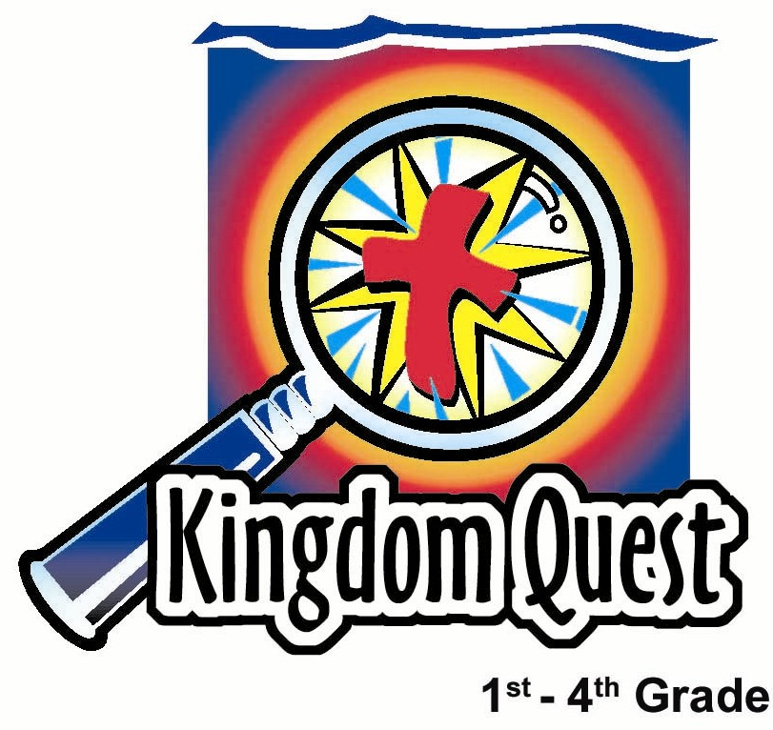
Date: _________________
Series: God in the Storms of Life
Apr-May Year 4, Lesson 53

Paul Escapes Death

Take Home Point: *Big problem? We have a bigger God. *Repeat this phrase throughout the lesson.

Bible Event: Acts 23:1-35

Key Verse: John 16:33, “I told you these things so that you can have peace in Me. In this world you will have trouble. But be brave! I have defeated the world!”

We will help kids know:
- The Bible Event of the promise of God’s deliverance and Paul’s rescue from death.
- No matter how big our problems are we have a bigger God.
- When facing our problems, we can pray and find help in Him.

We will help kids feel:
- Confidence as they share their struggles and find support from one another and in remembering God’s promises.
- Encouraged by the Bible Event as they face their own problems.

We will help kids do:
- Identify the size of their problems using different size cups.
- Explore the Bible to see how God delivered Paul.
- Make a craft that reminds them of how God deals with their problems.

THIS LESSON’S ROADMAP

DESTINATION | PAGE # | DISCOVERIES ON YOUR JOURNEY | SUPPLIES NEEDED
Small Group Warm-Up   | 3 | Kids use different size cups to illustrate the size of their problems. | - three different sized Styrofoam cups: small, medium, and large
Large Group   | 4  7  10  11 | Overview  Puppet Presentation: “Dao Dao Loses Kor Ler”—Dao Dao had a small problem that became a very large problem.  Video: Visual Bible: Acts—Acts 23:1-35. Paul had a big problem, but God was bigger.  Puppet Conclusion: “God is bigger”—Dao Dao realizes that even if he made a mistake, God can make something bigger come out of it. | - large broken Styrofoam cup taped or pinned to Dao Dao’s head or arm  - video, Visual Bible: Acts, produced by Visual Bible International, 1997—order from http://www.goccc.com/vibiacdvd1of.html  - raincoat, umbrella, boots, goggles (optional for the presenter)  - squirt gun or spray bottle
Small Group Application   | 4  6 | Kids smash their problem (cup) as a reminder that God is bigger than any problem they may face.  Memory Verse Learning:  “You Lead”  1 Cor. 15:58 is emphasized in lessons 52-55 so that each child is determined to stand for the Lord Jesus. | - small Styrofoam cups, one for each child  - wiggly eyes  - chenille stems  - yarn  - glue  - scissors  - flannel board  - word strips  - squirt gun or spray bottle

Small Group Warm-Up: 15 minutes
Purpose: Get pointed in the right direction! Build relationships and help guests feel at ease. Do the learning readiness activity that will point your group in the right direction for the lesson.

Supplies: three different Styrofoam cups: small, medium, and large

Place the cups in the center of the table and say:

Today we will talk about some of the problems that we face. Some of our problems are small, some are medium and some are very large.

Refer to the cups in the middle of the table.

Think about some of the problems you have had this past week. Would you call it a small, medium or BIG problem? I would like each of you to share with the group one of those problems. As you share, choose which cup is like your problem: small, medium or large.

Let me give an example. This week I had a ________________ problem.

Shepherd shares a problem that he/she faced while holding the appropriate cup. Allow all the kids to share if they want to. Then ask:

How did this problem make you feel? Did you feel sad, embarrassed, or angry?

Our question today is: What do you do with your problems especially if you feel you have a BIG one?

We will learn that if you have a great BIG problem, you have a BIGGER God that can take care of that problem.

This is what will happen to those problems.

Stand up. Place the large cup face down on the table and smash the cup. (This will surprise the kids. They will have a chance in small group application to smash cups and make a craft out of it. )

This problem doesn’t look so BIG now! Remember, do you have a *big problem? We have a bigger God. He can take care of it.

Large Group Overview: 20-30 minutes
Purpose: Help kids observe what the Bible says. Present the Bible Event in creative fashion. Help kids begin to interpret what it means.

Puppet Presentation: “Dao Dao Loses Herman”—Dao Dao had a small problem that became a very large problem.

Video: Visual Bible: Acts –Acts 23:1-35. Paul had a big problem, but God was bigger.

Puppet Conclusion: “God is bigger”—Dao Dao realizes that even if he made a mistake, God can make something bigger come out of it.

Small Group Application: 20-25 minutes
Purpose: Help kids map out the meaning of the Bible Event in their lives. Use the questions to stimulate discussion but don't feel tied to them. Allow the Holy Spirit to guide you. Include personal examples from your own faith journey. The example of Christ at work in your life will leave lasting impressions of how Christ can work in the children's lives.

Use your Bibles! Children need to learn how to look up references and follow along when scripture is read aloud. Allow for quality time of prayer at the close of the lesson.

Observation Questions: What happened?

Have kids refer to Acts 23 (beginning at Acts 22:30) for the following questions.

Why did the officer have Paul brought before the Jewish council? (Acts 22:30. He wanted to find out exactly what accusation the Jews had against Paul.)

The council was made up of what two groups? (Acts 23:6. Pharisees and Sadducees.)

Why did Paul say he was on trial? (Acts 23:6. Because he believed that the dead would come back to life.)

Which group did not believe this? (Acts 23:8. The Sadducees.)

What happened because the Sadducees and Pharisees disagreed? (Acts 23:7-10. They broke out in loud quarreling that became so violent the officer was afraid that they would tear Paul to pieces.)

The next night the Lord came and stood next to Paul. What did he say to Paul? (Acts 23:11. “Be brave! You have told people in Jerusalem about Me. You must do the same in Rome also.”)

How did the Lord protect Paul from being killed by the Jews? (Acts 23:12-32. Paul’s nephew overheard the Jews planning a conspiracy to kill Paul when he was again brought before the council. Word got back to the Roman officer of the conspiracy who then ordered infantrymen and soldiers to protect Paul and escort him to another city.)

Interpretation Questions: What does this mean?

Do you think Paul had a small, medium or large problem?

How did God show he was BIGGER than Paul’s BIG problem?

God helped Paul in a BIG way by sending 200 Roman soldiers, 200 spearmen and 70 horsemen to protect him.

For what purpose do you think God kept Paul safe? Hint: Remember what the Lord said to Paul when He came to him at night? (God told Paul that his life would be spared so he could tell about Jesus in Rome and God kept His word.)

Application Questions: What does this mean to me?

What does this Bible Event teach us about God? (That God keeps His word…. That with God all things are possible, even miracles…. That God is bigger than our biggest problems… We can trust Him even if it looks like things will turn out bad for us.)

Application Activity:
Supplies: small Styrofoam cup for each kid, wiggly eyes, chenille stems, yarn, other supplies to decorate cups, glue, scissors

Give each kid a small Styrofoam cup and say:

On the count of three, I would like you all to smash your cups just like I did in our Warm-Up time. Ready? One, two, three, smash!

What are some of the problems that you would like to see smashed in your life?

The key verse from John 16:33 says, “I told you these things so that you can have peace in Me. In this world you will have trouble. But be brave! I have defeated the world!”
How did Jesus overcome the world? (He died on the cross for us and defeated Satan. Nothing and no one in this world is more powerful than Jesus.)

How does that make you feel, especially when you think about your problems either big or small?

Shepherds, take notice of some of the problems discussed and in a few weeks ask them how those problems are going. If there are any serious problems, you may need to connect with the child’s parents or with a ministry staff person to help better minister to that child.

In the time remaining, let kids decorate their cups into something funny. They can use any of the material available. Have kids take their cups home and set it someplace where it can be a reminder that if there are….

*Big problems? We have a BIGGER God.

Memory Verse Learning: 5 minutes
Purpose: Help kids to memorize and keep scriptures at heart. Using creative ways to help kids enjoy learning the key verse and in small group setting.

Supplies needed: flannel board; word strips; squirt gun or spray bottle

Memory Verse: 1 Corinthians 15:58, “So my dear brothers, stand strong. Do not let anything change you. Always give yourselves fully to the work of the Lord. You know that your work in the Lord is never wasted.”

Memory Verse Learning: “You Lead”
This time, have volunteers to come up to arrange the word strips like a shepherd and lead everyone to recite the memory verse. But tell the children that if the arrangement is not right, you will squirt some water at him/her. Use the squirt gun (or spray bottle) for every mistake in the arrangement. Allow as many volunteers as time permits.

Closing prayer:

Have kids pray for their problems, stating after each petition, “Thank You, God, that You are bigger than my problem.” Close by thanking Jesus for giving His life to overcome Satan and our problems.
Safety and Security: Safety and security procedures are important for each church to carefully define and implement according to their unique needs. The security, safety, illness and accident procedures described in this curriculum are provided for example purposes only and may not be appropriate, applicable or adequate for every situation. Each church is responsible for determining whether any security, safety, illness and accident procedures contained in the curriculum are appropriate, applicable or adequate for its unique situation. The activities described in this curriculum require adult supervision and may not be suitable for each child and each situation. Each church is responsible for ensuring that adequate adult supervision is provided for all activities and for determining whether an activity is appropriate for each child and each situation. Kids Kount Publishing disclaims all liability for the implementation of any procedures or the performance of any activities described in this curriculum.

Large Group Presentation: 20-30 minutes

Dao Dao Loses Kor Ler

Puppet Presentation

Suppies: a large smashed Styrofoam cup taped to Dao Dao’s arm or head, video—The Visual Bible: Acts (cued to Acts 23), rain gear to wear, squirt gun or spray bottle

The presenter in this series has the option to be dressed with rain gear. This could be a rain coat, hat, umbrella, boots, goggles. He/she will need a squirt gun or spray bottle to be ready for the storms of life.

Presenter: Kids, should we call Dao Dao?

Kids call Dao Dao. Dao Dao… Dao Dao… Dao Dao.

Dao Dao enters.

Presenter: I can tell what size problem you have.

Dao Dao: I’ll say. It’s a SUPER SIZE problem.

Presenter: Sorry to hear that, Dao Dao. What is your problem?

Dao Dao: I lost my bug collection.

Presenter: So that’s the big problem. How many bugs did you have in your collection?

Dao Dao: One.

Presenter: One? That doesn’t seem like such a big problem.

Dao Dao: He was my favorite green grasshopper, Kor Ler.

Presenter: Oh, I see. Where did you lose him?

Dao Dao: I lost him at school.

Presenter: Did you take him for Show and Tell?

Dao Dao: Yeah, but I lost him before I had a chance to show him.

Presenter: Oh. When was the last time you saw Kor Ler?

Dao Dao: Going down the back of Ashley’s shirt.

Presenter: What?! How did he get there?

Dao Dao: I thought Kor Ler needed some exercise and Ashley needed some, too.

Presenter: Now I understand,Dao Dao. You really do have a problem!

Dao Dao: Ashley had a problem, too. Boy, can that girl dance.

Presenter: Dao Dao, what you did was wrong. You should have had some consequence for that.

Dao Dao: I did. I was sent ot the principal’s office.

Presenter: You definitely have a big problem, Dao Dao.

Dao Dao: It doesn’t stop there. The principal called my mom to explain what happened.

Presenter: Uh-oh.

Dao Dao: You think that was bad, he made me tell her what happened.

Presenter: That sounds reasonable. What did you tell your mom?

Dao Dao: I told her Ashley and Kor Ler were dancing. I don’t think they thought that was very funny.

Presenter: Dao Dao, that probably wasn’t very funny for Ashley.

Dao Dao: Sometimes I just can’t help it. I just do silly things, but I don’t mean to hurt anyone. Now Ashley won’t talk to me.

Presenter: You really do have a BIG problem, Dao Dao.

Dao Dao: What am I supposed to do? I don’t like being in trouble and I don’t like hurting Ashley’s feelings.

Presenter: Today we will find out that, when we have problems we can give them to God. He can help us find an answer. No matter how BIG our problems are, when we pray to Him, we will find that God is BIGGER.

We will discover this when we listen to what happened to Paul.

Dao Dao: What happened to Paul?

Presenter: Paul, on his third missionary journey, was going through the storms of life.

Dao Dao: A real storm?

Presenter: No, just troubled times.

Dao Dao: Did he do wrong stuff?

Presenter: No, he didn’t.

Dao Dao: Then why did he get into trouble?

Presenter: Even when we don’t do wrong stuff, we can still have problems. But God showed Paul that he was bigger than the problem. You see, Paul was arrested and brought before the religious leaders.

Dao Dao: That was bad.

Presenter: You think that was bad, it got even worse. They almost beat him up.

Dao Dao: Now, that was really bad.

Presenter: You think that was bad, it even got worse. People took an oath to not eat or drink anything until Paul was killed.

Dao Dao: That was really, really bad.

Presenter: You think that was bad, forty of these people hid, ready to kill Paul as he walked by.

Dao Dao: Paul had a very BIG problem.

Presenter: Yes, he did. But, Paul had a BIGGER God! God told Paul to take courage. The next part of the problem is amazing. Do you know what God did to protect Paul? He sent 200 Roman soldiers, 200 spearmen and 70 horsemen. Our BIG God helped Paul in a BIG way.

Dao Dao: Wow!

Presenter: Dao Dao, let’s watch this story now.

Dao Dao exits.
Video

Show the video: The Visual Bible: Acts. Watch Acts 23:1-35. (The video clip is five minutes and forty seconds.)

Video Review

Once again, I need three helpers who paid close attention to the video.

Choose three kids and bring them forward.

Last week when you answered my questions correctly, you got to squirt me. And, if you answered wrong, I got to squirt you! We are going to do the same today. Let’s find out what it means to have a big problem, but a bigger God.

Ask each volunteer one of the following questions. After they answer the question and have used the squirt gun, have the volunteer sit down.

Question #1:

A quarrel broke out among the Pharisees and Sadducees and the officer was afraid that they would tear Paul to pieces. So the officer ordered his soldiers to take Paul back to the barracks. What did the Lord say to Paul the next night? (“Be brave!” God told Paul. “You have told people in Jerusalem about Me. You must do the same in Rome also.”)

Use the squirt gun (or spray bottle) if the question was not answered correctly.

Question #2:

How many infantrymen and soldiers with spears were sent out to protect Paul? (200.)

Use the squirt gun according to the answer.

Question #3:

This is a really tough one. I hope you listened very closely to all the details in the movie. Are you ready? Do you know which pirate wore metal underwear? (Long John Silver.)

Squirt the volunteer.

God Is Bigger

Puppet Conclusion

Dao Dao enters laughing.

Dao Dao: Long John Silver. That was a great riddle.

Presenter: Thank you, Dao Dao. Now back to a more serious note. Do you see how Paul had courage to face his problems?

Dao Dao: I think so. He knew that God was always going to be with him.

Presenter: That’s right. God had told him that he would face many problems in life, but God would use Paul to tell rulers and kings about Jesus.

God turned those big problems into big opportunities to serve Him.

Dao Dao: What happened?

Presenter: This began Paul’s missionary journey that took him all the way to Rome. Although he faced many storms and many problems along the way, Paul knew God would always be bigger than those storms and problems. Paul knew God would use him so many other people could hear about Jesus.

Dao Dao: That means that God is even bigger than my problems.

Presenter: He sure is.

Dao Dao: How can He help me?

Presenter: Dao Dao, maybe you need to pray to Him and ask for forgiveness if something you have done has been mean. Then ask God to show you how your problem can be used to show others about Jesus.

Dao Dao: How can my problem ever show anyone about Jesus?

Presenter: Maybe you could talk to Ashley and say you are sorry.

Dao Dao: But, she’s a girl.

Presenter: Dao Dao. Maybe you could show her kindness. Maybe somehow you can be a friend to her. Maybe she would find out about Jesus by what you say and do. Maybe you could even invite her to church.

Dao Dao: Wow, I never thought of that. You know, maybe I could invite her on the Sunday we talk about the plague with all the grasshoppers overtaking Egypt. I bet she would really like that!

Presenter: Dao Dao. It’s time to pray.

Dear God, thank You for caring about our problems even when we make them ourselves. Thank You that You are bigger than our problems. Thank You that when we goof up, we have Your Son Jesus who paid the price for all the wrong things we do. In Jesus’ name. Amen.

Lesson 53

Small Group Warm-Up
- three different sized Styrofoam cups: small, medium, and large

Large Group Presentation
      - large broken Styrofoam cup taped or pinned to Dao Dao’s head or arm
      - video, Visual Bible: Acts, produced by Visual Bible International, 1997—order from http://www.goccc.com/vibiacdvd1of.html
      - raincoat, umbrella, boots, goggles (optional for the presenter)
      - squirt gun or spray bottle

Small Group Application
      - small Styrofoam cups, one for each child
      - wiggly eyes
      - chenille stems
      - yarn
      - glue
      - scissors

Memory Verse Learning
      - flannel board
      - word strips. From Lesson 52
      - squirt gun or spray bottle

