
Date: _________________
Series: Signs on Believers’ Hwy
Dec-Mar Year 4, Lesson 39

Healing at Bethesda Pool

Take Home Point: *Jesus is God’s Son—Jesus heals broken lives. *Repeat this phrase throughout the lesson.

Bible Event: John 5:1-47
Key Verse: Psalm 147:3, “He heals the brokenhearted. He bandages their wounds.” (NCV)

We will help kids know:
- The Bible event of Jesus healing a lame man at the pool of Bethesda.
- This was another sign to show He was God’s Son.
- He offers Himself. If anyone believes in Him, they will have eternal life.
- We experience brokenness when our bodies are hurt and also when we are injured in our spirit.
- We can believe in Jesus and find healing for our broken lives.

We will help kids feel:
- Excitement to see Jesus as God’s Son.
- Awed that Jesus heals broken lives.

We will help kids do:
- Discuss experiences from their lives in which they have felt broken.
- Make an art project that reminds them that Jesus heals broken lives.
- Pray for specific ways that they need Jesus’ healing.
THIS LESSON’S ROADMAP

DESTINATION | PAGE # | DISCOVERIES ON YOUR JOURNEY | SUPPLIES NEEDED
Small Group Warm-Up  (15 minutes)   | 3 | Children discuss times in their own lives when they have felt broken. | - broken toy  - Appendix-A1 copied on dark-colored paper (navy blue or brown) with words “My life feels broken when…” (see Appendix), one per child  - pens, pencils, markers
Large Group  (20-30 minutes)   | 4  8  11  12 | Overview  Puppet Presentation: “Dao Dao Goes for Broke”—Dao Dao wants to get back at his sister but ends up feeling twice as bad.  Video: The Gospel of John—The Bible event from John 5:1-47 is presented.  Puppet Conclusion: “Dao Dao Goes for Broke”—Dao Dao learns that because Jesus is God’s Son, He has the power to heal us inside and out. | - yellow construction vest  - work boots  - sign on stick that says, “The man couldn’t walk but Jesus didn’t turn aside.” On back it says, “Remember! He’s God’s Son. He___ (heals) broken ___ (lives).”  - two or four chairs  - cardboard car front  - DVD Gospel of John, produced by Visual Bible International, 2003.  - spray bottle of water or squirt gun
Small Group Application  (20-25 minutes)   | 4 | Children make an art project to demonstrate Jesus heals our broken lives with the same power that allowed Him to rise again from the dead and live in our lives.  Memory Verse Learning:  “Piece Mine Quick”  Psa. 145:13 will be taught in lessons 38-41 so that the child has hope that “everything will be okay,” because of Jesus’ love and promises to them. | - cross Appendix-A2 copied on light-colored paper  - Appendix-A3 and A4 copied back to back on medium-colored paper  - dark paper from Small Group  - scissors  - tape  - puzzle done by the children from lesson 39  - cooked mini sausages

Small Group Warm-Up: 15 minutes
Purpose: Get pointed in the right direction! Build relationships and help guests feel at ease. Do the learning readiness activity that will point your group in the right direction for the lesson.

Supplies: A broken toy from home, appendix page: “I feel broken when…” for each child (it will be used for the craft project during application time), pens, pencils, markers

Show broken toy and say:

What toy from home broke and you felt disappointed or sad?

Encourage all kids to talk about something they had that broke and left them feeling disappointed or sad.

Has anyone ever had a broken arm or broken bone?

Have any of you ever felt broken on the inside? Maybe someone said or did something mean to you. Maybe someone close to you left you or even died. Or, maybe you felt broken when you did something bad.

Let kids discuss a time they felt broken on the inside.

Pass out paper from appendix.

The top of this page says, “My life feels broken when…” Write down or draw some of those times when your life felt broken. It might have been when you had hurt feelings, or your favorite pet died, or someone was sick. Or, maybe you did something you wish you hadn’t done.

After kids have written or drawn on their page, say:

Today we will be amazed at how Jesus heals broken lives. The Bible tells us to go to Jesus with our troubles and that includes when we feel broken. He has the power to help us because He is God’s Son. In today’s Bible event, we will discover *Jesus is God’s Son—Jesus heals broken lives.

Large Group Overview: 20-30 minutes
Purpose: Help kids observe what the Bible says. Present the Bible event in creative fashion. Help kids begin to interpret what it means.

Puppet Presentation: “Dao Dao Goes for Broke”—Dao Dao wants to get back at his sister but ends up feeling twice as bad.

Video: The Bible event from John 5:1-47 is presented from the video, The Gospel of John, by Visual Bible International, 2003. Order from: www.visualbible.com.

Puppet Conclusion: “Dao Dao Goes for Broke”—Dao Dao learns that because Jesus is God’s Son, He has the power to heal us inside and out.

Small Group Application: 20-25 minutes
Purpose: Help kids map out the meaning of the Bible event in their lives. Use the questions to stimulate discussion but don't feel tied to them. Allow the Holy Spirit to guide you. Include personal examples from your own faith journey. The example of Christ at work in your life will leave lasting impressions of how Christ can work in the children's lives.

Use your Bibles! Children need to learn how to look up references and follow along when scripture is read aloud. Allow for quality time of prayer at the close of the lesson.

Observation Questions: What happened?

Have kids refer to the Bible event found in John 5:1-15 for the following questions.

Jesus went to a pool at Bethesda where a large number of sick people would lie. Some manuscripts and translations of the Bible add, “They would wait for the water to move. People believed that at a certain time an angel from the Lord would go into the pool and stir up the water. The first person who would step into the water after it was stirred up would be cured from whatever disease he had.” Jesus asked one man if he wanted to get well. What did Jesus know about this man? (John 5:6. That he had been sick for a long time.)

How long had this man been sick? (John 5:5. 38 years.)

What did the man think he needed to be healed? (John 5:7. He thought he had to get into the water when it was stirred, but there was no one to help him get in.)

What did Jesus do to heal this man? (John 5:8. He told the man to get up, pick up his mat, and walk.)

How long did it take for the man to be healed after Jesus spoke? (John 5:9. Immediately.)

Interpretation Questions: What does this mean?

How do you think it made the man feel that Jesus had picked him to heal? (Take any answer. May include that the man felt special, worth something to Jesus, or, even a little afraid.)

What did the man have to do to be healed? (He had to trust and obey Jesus and do what He commanded.)

Why do you think Jesus picked this man to heal from all of the other hurting people? (Maybe because Jesus felt sorry that the man had no one to help him. Maybe Jesus knew he was broken inside and didn’t have much hope. Maybe to show the power He had to heal since the man had been lame for so long.)

Read Isaiah 53:5.

How was Jesus “wounded for our rebellious acts and crushed for our sins”? (He died on the cross to take the punishment for our sins and rebellion.)

How do we receive peace and healing from his wounds? (His Spirit comes to us and heals us on the inside when we accept Jesus as our Savior. We can believe and trust in His promises for our lives now and have hope for eternal life.)

Application Questions: What does this mean to me?

Application Activity
Supplies: Appendix pages for each child, papers from small group, scissors, glue or tape, pens, pencils

Look at your paper again from small group Warm-Up. You wrote some words on it or drew some pictures that described ways we sometimes feel broken. Can you think of any other examples of times you have felt broken? If you can, write or draw them on this page.
When kids are finished, continue with:

Think about what it must have felt like for that man who had been unable to walk for 38 years. What do you think he felt like while he was just lying there? (Discouraged, sad, angry, depressed.)

How would you compare your feelings of brokenness to his?

How do you think he felt after Jesus healed his brokenness? (Happy, like dancing, excited.)

How do you think Jesus felt to see him healed? (Happy and excited, too.)

Today we saw how *Jesus is God’s Son and Jesus heals broken lives. He heals our lives when we come to Him and ask. When we pray to Him, He hears us and gives us just what we need. But He even knows how we hurt before we ask Him, just like He knew the man had been sick for a long time. How do you think it feels to experience Jesus healing our brokenness? (Happy and excited like the man.)

You each will make a picture of Jesus and the lame man who had been healed. They look excited and joyful standing under a column beside the pool.

Pass out the light colored paper and have kids follow the directions for cutting the cross. (For younger kids, demonstrate this.) After cutting and unfolding the paper, ask them what shape they just cut out. Have kids glue the cross in the center of their dark color paper even if it covers some of the written words. Then say:

This cross reminds us that Jesus was broken for our sins and for our problems. Because Jesus gave His life for us on the cross, He paid the price for our sin. Because of His great love for us, He gives us forgiveness and accepts us just as we are. Jesus showed His great power in dying for us, but also by coming alive. Through His love and power, He gives us healing on the inside, even if we are hurt in our spirit.

Next, pass out the medium-colored paper and have kids fold and cut it. Have them glue it to the dark colored page, flipping the cut page over so that no directions are showing. While kids are finishing their projects quote the key verse.

The key verse for today from Psalm 147:3 says, “He heals the brokenhearted. He bandages their wounds.” *Jesus is God’s Son. He has the power to heal broken lives.

Memory Verse Learning: 5 minutes
Purpose: Help kids to memorize and keep scriptures at heart. Using creative ways to help kids enjoy learning the key verse and in small group setting.

Supplies needed: puzzles done by the children from lesson 39; cooked mini sausages

Memory Verse: Psalm 145:13, “…The Lord will keep His promises. With love He takes care of all He has made.”

Memory Verse Learning: “Piece Mine Quick”
Recite Psalm 145:13 several times with the children. Explain to the children that today’s competition is simple – to quickly piece your friend’s puzzle. To get a puzzle, which is given out randomly, one has to quote Psalm 145:13. Go on to say that when one gets a puzzle, one also gets a sausage to eat. Before beginning the competition, tell the children that the winner of the game gets two sausages and the person who did the puzzle that the winner used also gets two sausages. When everyone has recited and obtained a puzzle, begins the competition. At the end reward the winner and everyone also gets a sausage.

Closing prayer:

During this prayer time, let’s pray about a feeling that we have had that reminds us of being broken and ask for Jesus’ power in our life to heal us. Remember, *Jesus is God’s Son—Jesus heals broken lives. Ask Him to give you healing. You know that He can heal because He gave His life for us when He died on the cross and is now alive to live with us right now.

Safety and Security: Safety and security procedures are important for each church to carefully define and implement according to their unique needs. The security, safety, illness and accident procedures described in this curriculum are provided for example purposes only and may not be appropriate, applicable or adequate for every situation. Each church is responsible for determining whether any security, safety, illness and accident procedures contained in the curriculum are appropriate, applicable or adequate for its unique situation. The activities described in this curriculum require adult supervision and may not be suitable for each child and each situation. Each church is responsible for ensuring that adequate adult supervision is provided for all activities and for determining whether an activity is appropriate for each child and each situation. Kids Kount Publishing disclaims all liability for the implementation of any procedures or the performance of any activities described in this curriculum.

Large Group Presentation: 20-30 minutes

Signs on Believers’ Highway
Series

The book of John points to miracles as signs and proof that Jesus is the Christ, the Son of God. The imagery of road construction signs will be used to exemplify the signs that Jesus performed as told in the book of John. The road worked on is referred to as “Believers’ Highway” to show we are all on a journey in our faith.

The presenter is dressed in a yellow construction vest and holds a different road sign each week that is fitting with the Bible event. Another important prop is the simulated car set-up with two or four chairs facing the audience and a cardboard car front. Shepherds and children are both involved as observers on the highway. They are called up to drive the car and answer questions, give feedback and interact with or about the event.

This series uses “The Gospel of John” DVD series as a visual to show the events of the Bible.

Supplies: yellow construction vest, sign on a stick copied front-to-back printed with, “The man couldn’t walk but Jesus didn’t turn aside.” On back it says “Remember! He’s God’s Son. He _____(heals) broken _____ (lives)”, two or four chairs, cardboard car front, spray bottle of water or squirt gun

Dao Dao Goes for Broke
Puppet Presentation

The presenter enters wearing a yellow construction vest and work boots.

Presenter: Shall we call Dao Dao?

Kids call for Dao Dao: Dao Dao, Dao Dao, Dao Dao. Dao Dao comes out with a bandage wrapped around his head.

Presenter: Dao Dao, are you hurt?

Dao Dao: What does it look like?

Presenter: Yes, it looks like you’re hurt.

Dao Dao: I should say so.

Presenter: What happened?

Dao Dao: Ting Ting, hit me and there’s a three-inch cut across my forehead.

Presenter: I’m sorry. That sounds terrible.

Dao Dao: Well it was. She’s crazy. Yesterday, she took the chair from her room and threw it and cut my head right open.

Presenter: Ouch!

Dao Dao: Yeah. I had to have 146 stiches.

Presenter: A 146 stiches? That’s a lot.

Dao Dao: The doctor says it would leave a nine inch scar.

Presenter: But you just said it was a three inch cut.

Dao Dao: Well, I meant nine. What else would you expect from someone who throws a table at you.

Presenter: I thought you said she threw a chair.

Dao Dao: No, it was a table.

Presenter: Something doesn’t sound right here.

Dao Dao: Yeah, it’s Ting Ting. She’s crazy.

Begin taking bandage off Dao Dao’s head as he objects.

Presenter: Dao Dao, let me have a look at that….

Dao Dao: Hey! Wait a minute. I’m injured. Can’t you tell?

Presenter: Dao Dao! There’s no cut here. What’s up with this?

Dao Dao: Well, maybe she missed. But I could have been injured.

Presenter: Dao Dao, tell me the truth. What happened?

Dao Dao: I’m sorry. I just got carried away with my story.

Presenter: Tell me what happened.

Dao Dao: Ting Ting and I got into a fight yesterday. We were arguing about something and I called her a name.

Presenter: A bad name?

Dao Dao: I won’t repeat it.

Presenter: And then what?

Dao Dao: She told on me and I got in trouble.

Presenter: So why did you fake the head injury and put on this bandage?

Dao Dao: I thought I might get back at her if people here at church thought she did something mean to me.

Presenter: It didn’t help, did it?

Dao Dao: No.

Presenter: Doing a wrong thing never helps. Especially when we are trying to fix another wrong thing.

Dao Dao: I know. I’m so embarrassed. I feel twice as bad now.

Presenter: Maybe it feels like you are broken on the inside.

Dao Dao: Yeah. I feel like I’m broken on the inside. We were talking about that in small group today.

Presenter: Dao Dao, watch today’s Bible event. In it we will discover Jesus fixes broken lives.

Dao Dao: What happens?

Presenter: Remember, we are looking for signs along Believers Highway that show Jesus is the Son of God. Sometimes He heals people to show He is the Son of God. And, Jesus doesn’t just heal us on the outside, but on the inside, too.

Dao Dao, why don’t you do this. Every time you hear the word Son in this video, tap your knee lightly with your hand. Maybe doing this will help us listen for how Jesus shows He is God’s Son and explains it. Kids, you do it, too. Let’s roll the video.

Video

Show The Gospel of John DVD, produced by Visual Bible International, 2003. Order from: www.visualbible.com.

Show the clip covering John 5:1-47. Begin just after narrator says, “So he and all his family believed. This was the second miracle…” and end it just after narrator says, “If you don’t believe what Moses wrote, how will you ever believe what I say?”

Signs Along Believers’ Highway

The presenter holds the sign, careful to show only the front for now until the back is needed for the game.

Presenter: I need two volunteers to come up and get in the car and get ready to drive.

Have them come up onstage and arrange them so that kids are in front driving and the shepherd is in the back.

On “Believers’ Highway,” kids can drive just as well as adults because we are all growing in our spiritual journey, learning to trust Jesus the Messiah, the Son of God. So buckle your seat belts, and let’s go for a ride!

Are you ready to figure out the missing words on the back of the sign? The front of the sign says, “The man couldn’t walk but Jesus did not turn aside.” The back says, “Remember! He’s God’s Son. He _______ (heals) broken _______ (lives).”

Allow for a few guesses, then say:

Last week I thought the questions were too easy. Today I’m making them extra hard. I’m going to see how well you listened for certain details in the Bible event. If you get the question right, you will get to squirt the audience. But, if you miss, I get to squirt you!

- What was the name of the pool the man was lying next to? (Bethesda.)

2. People would lie by the pool because they believed they could be healed if they were put into the water after the angels stirred the water. But this man had no one to help him get into the pool. He must have felt all alone. How many years did the man lie there? (Thirty-eight years.)
3. Jesus just spoke to him to heal him. He told him to get up and walk. He was also told to pick up something. What was he supposed to pick up? (His mat.)

4. On what special day did Jesus heal the man? (The Sabbath day.)

Dismiss volunteers to return to their seats.

Dao Dao Goes for Broke
Puppet Conclusion

Presenter: What did you think about the Bible event, Dao Dao?

Dao Dao: Wow. That would be terrible to lie there for 38 years.

Presenter: Yes. He must have really felt broken because he couldn’t walk. But he also might have felt broken on the inside.

Dao Dao: How’s that?

Presenter: I think he was feeling sorry for himself and discouraged because he had no one to help him.

Dao Dao: But Jesus did.

Presenter: You’re right. That’s what the man discovered. That’s what we can discover, too.

Dao Dao: I know that Jesus can help.

Presenter: Do you know how He can fix your brokeness inside?

Dao Dao: Well, He is God’s Son isn’t He?

Presenter: Yes. But He is God’s Son who came into the world to be broken for our sin. For all the wrong things we have done, He went to the cross. The Bible even says He was broken for our sins. In Isaiah 53:5 it says, “He was wounded for our rebellious acts. He was crushed for our sins. He was punished so that we could have peace, and we received healing from His wounds.”

Dao Dao: Does that mean He was broken for me trying to get back at my sister?

Presenter: That’s right. He forgives you when you come and tell Him about your sins. He lifts away that sin in your life so it doesn’t have power over you anymore. He also heals you from things that can be broken on the outside just like He healed the man at the pool so he could walk again.

Dao Dao: Wow. He really is God’s Son, isn’t He?

Presenter: He sure is. So let’s pray to Him and thank Him for that.

Dao Dao: Okay.

Presenter: Dear God, thank You for Jesus. He really is God’s Son and He showed it by doing a great sign that helped a man walk who was lame for 38 years. That’s a long time. Sometimes we feel broken. Help us on the inside when we feel broken and also if we have a broken head or something from a sister throwing a table at us. Help that get better, too. In Jesus’ name. Amen.

Lesson 39

Small Group Warm-Up
- broken toy
- Appendix-A1 copied on dark-colored paper (navy blue or brown) with words “My life feels broken when…” (see Appendix), one per child
- pens, pencils, markers

Large Group Presentation
      - yellow construction vest
      - work boots
      - sign on stick that says, “The man couldn’t walk but Jesus didn’t turn aside.” On back it says, “Remember! He’s God’s Son. He___ (heals) broken ___ (lives).”
      - two or four chairs
      - cardboard car front
      - DVD Gospel of John, produced by Visual Bible International, 2003.
      - spray bottle of water or squirt gun

Small Group Application
      - cross Appendix-A2 copied on light-colored paper
      - Appendix-A3 and A4 copied back to back on medium-colored paper
      - dark paper from Small Group
      - scissors
      - tape

Memory Verse Learning
      - puzzle done by the children from lesson 39
      - cooked mini sausages (About two per child plus two more.)

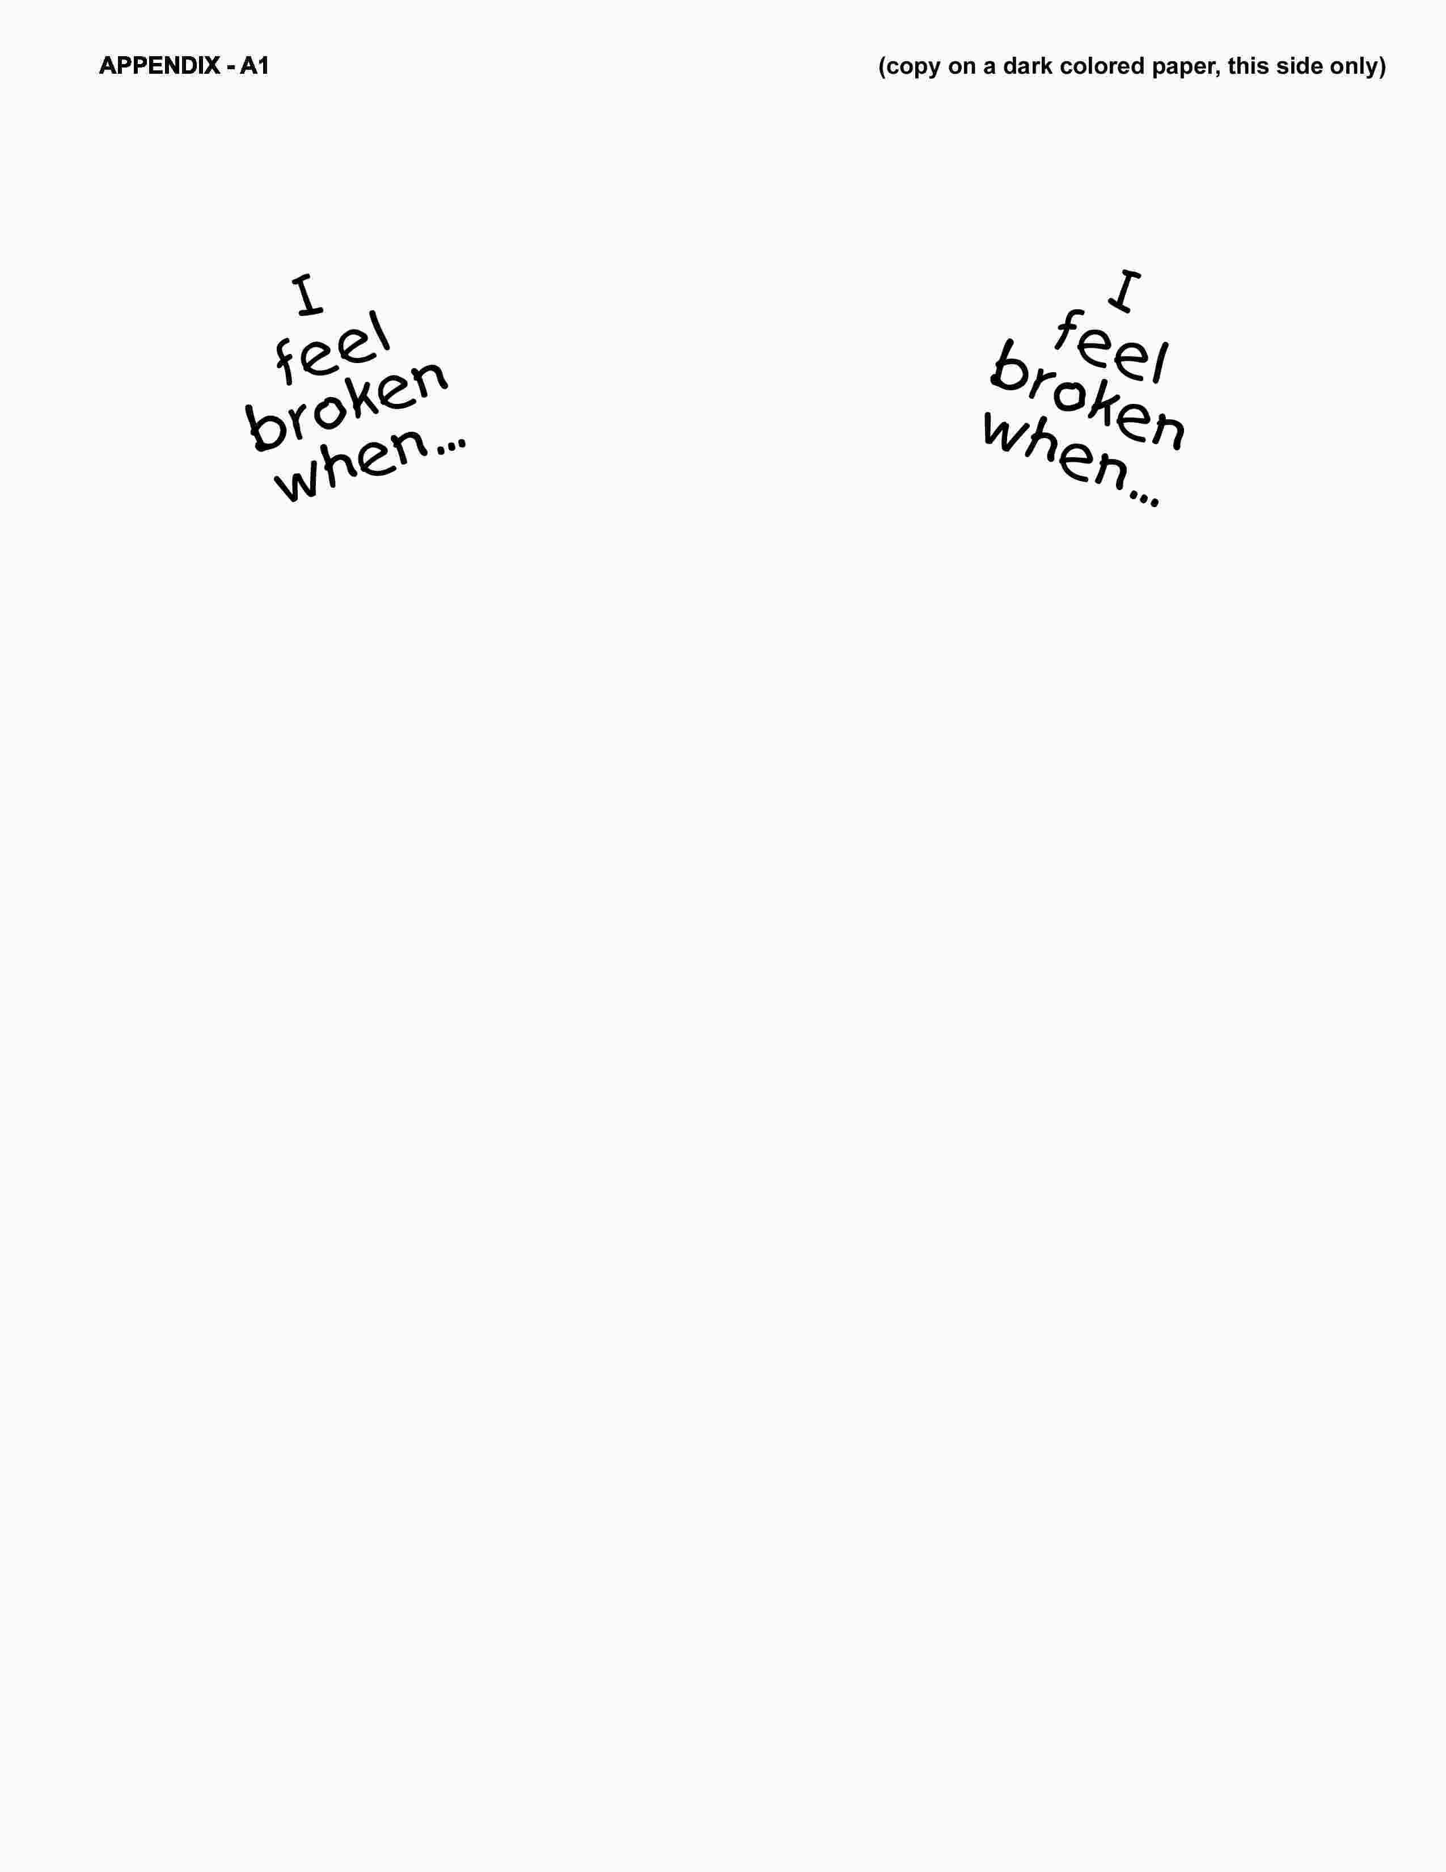


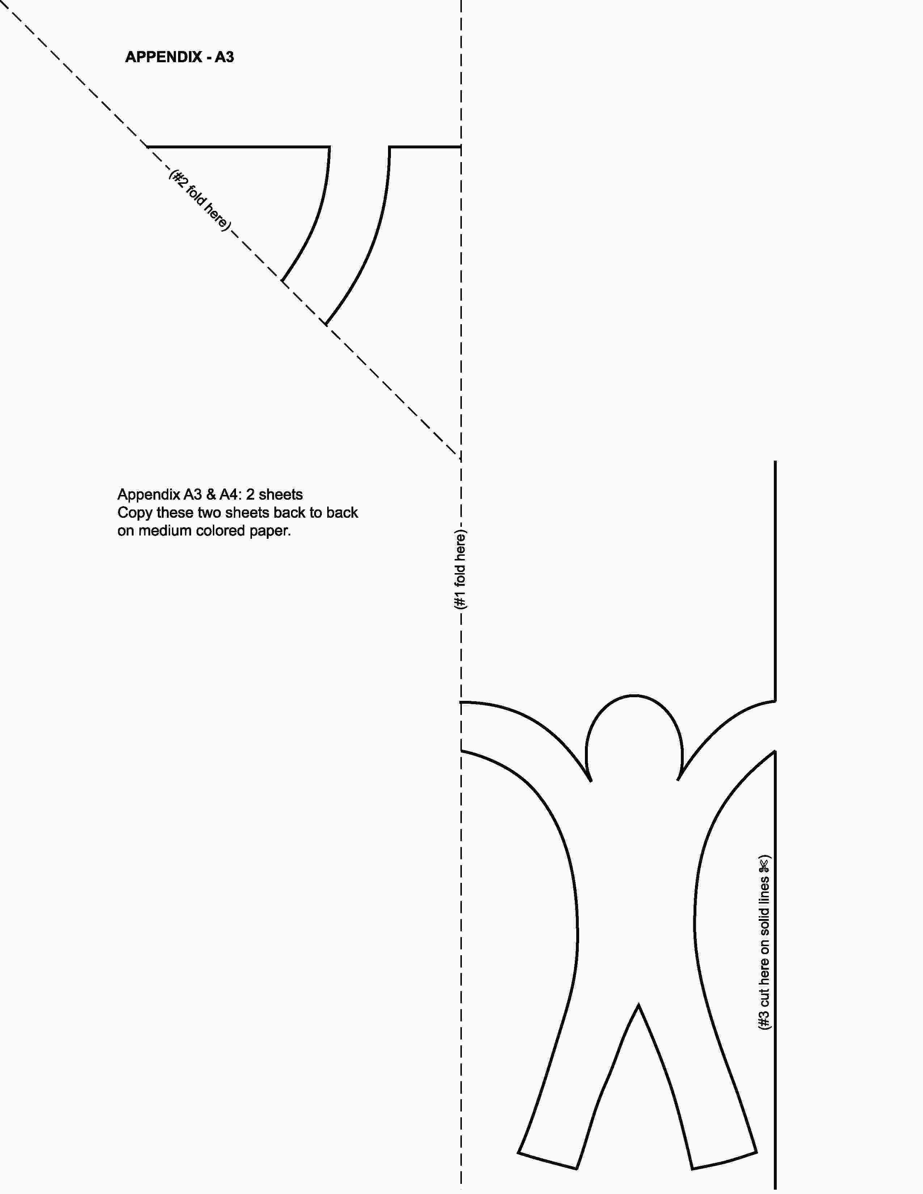



The man couldn’t walk but Jesus didn’t turn aside.

Remember! He’s God’s Son. He (heals) broken (lives).

