
Date: _________________
Series: Signs on Believers’ Hwy
Dec-Mar Year 4, Lesson 47

Jesus’ Trial and Crucifixion

Take Home Point: *Jesus is the King who died for me. *Repeat this phrase throughout the lesson.

Bible Event: John 18:19 to 19:30
Key Verse: Philippians 2:8, “He humbled Himself by becoming obedient to the point of death, death on a cross.”

We will help kids know:
- The Bible event of Jesus’ trial and crucifixion.
- The opposite of a king is a servant. Jesus was a king who also became a servant for us.
- Jesus served us by giving His life for us.
- Barabbas was guilty. Jesus was innocent. Jesus was punished so Barabbas could go free. The same is true for us.

We will help kids feel:
- Sadness that Jesus had to give His life so we could go free (be forgiven).
- Gladness that Jesus gave His life so that we could go free.

We will help kids do:
- Identify opposites and wrestle with the concept of Jesus doing two opposites at the same time. For example, he was both a king and a servant.
- Identify any wrongs in their life they feel badly about and give the wrongs to Jesus so that they might receive freedom.
- Make crosses out of palm branches.
THIS LESSON’S ROADMAP

DESTINATION | PAGE # | DISCOVERIES ON YOUR JOURNEY | SUPPLIES NEEDED
Small Group Warm-Up  (15 minutes)   | 3 | Children discuss opposites and are challenged to think about two opposites happening at the same time. | - SweeTART® candy
Large Group  (20-30 minutes)   | 4  8  11  11 | Overview  Puppet Presentation: “Dao Dao’s Opposite Game”—Dao Dao has fun creating opposites, but the game ends with a twist.  Video: DVD Gospel of John produced by Visual Bible International, 2003. Show clip covering John 18:19-19:30.  Puppet Conclusion: “Dao Dao’s Opposite Game”—Dao Dao learns that Jesus demonstrates again how amazing He is. He was both a king and servant at the same time. He was innocent but judged guilty and served the punishment for us. | - yellow construction vest  - work boots  - DVD Gospel of John produced by Visual Bible International, 2003  Choice of one of the following for the introduction of Large Group:  - The Legend of the Three Trees, produced by Tommy Nelson, 2001  - Greatest Adventure Stories from the Bible: The Easter Story (Warner Home Video, 1996)
Small Group Application  (20-25 minutes)   | 4 | Children make a cross out of palm leaves. This is a reminder that Jesus is the king who died so they might be free.  Memory Verse Learning:  “Flash Cards”  Heb, 10:23 will be emphasized in lessons 46-48 so that each child know Jesus is faithful even when we are not. | - palm leaves/branches  - illustrations from lesson 46 (also see page 15)

Small Group Warm-Up: 15 minutes
Purpose: Get pointed in the right direction! Build relationships and help guests feel at ease. Do the learning readiness activity that will point your group in the right direction for the lesson.

Supplies: High Sour candy

Today, everyone gets a High Sour candy as we talk about opposites. High Sour put two opposite tastes together: tart (sour) and sweet.

What are examples of foods that taste sweet? (Sugar, chocolate, ice cream, cake, cookies, etc.)

What foods taste tart? (Lemons, assam, etc.)

Let’s name some other opposites. I’ll say a word and you tell me its opposite. Black… (white), tall… (short), hot… (cold). Now it’s your turn. You think of some words and we’ll try to guess the opposites.

Let the kids take turns sharing words that have opposites.

I’m going to tell you some words from today’s lesson that I want you to think about. One word is guilty and the opposite word is innocent. Another pair of opposite words is slave and master.

What is the opposite of king? I’ll give you a hint. It is not queen. The opposite of king is servant. Perhaps the contrast between a king and a servant is the biggest opposite we have talked about so far.

The question for today is: Can one person be both of these at the same time? Could Jesus be a king and be a servant? Also, if Jesus was innocent, why was He be punished? If someone is guilty, how can they go free?

When we think of opposites, we might find that two opposites can happen in the same person, Jesus. Remember *Jesus is the king who died for me. Let’s see if, in the Large Group Presentation, you can figure out what those two opposites are.

Large Group Overview: 20-30 minutes
Purpose: Help kids observe what the Bible says. Present the Bible event in creative fashion. Help kids begin to interpret what it means.

Puppet Presentation: “Dao Dao’s Opposite Game”—Dao Dao has fun creating opposites, but the game ends with a twist.

Video: DVD Gospel of John, produced by Visual Bible International, 2003—John 18:19-19:30. Order from: www.visualbible.com.

Puppet Conclusion: “Dao Dao’s Opposite Game”—Dao Dao learns that Jesus demonstrates again how amazing He is. He was both a king and a servant at the same time. He was innocent but judged guilty and served the punishment for us.

Small Group Application: 20-25 minutes
Purpose: Help kids map out the meaning of the Bible event in their lives. Use the questions to stimulate discussion but don't feel tied to them. Allow the Holy Spirit to guide you. Include personal examples from your own faith journey. The example of Christ at work in your life will leave lasting impressions of how Christ can work in the children's lives.

Use your Bibles! Children need to learn how to look up references and follow along when scripture is read aloud. Allow for quality time of prayer at the close of the lesson.

Observation Questions: What happened?

Have kids refer to John 18:19-19:30 in their Bibles.

Read John 18:19-23.

How was Jesus treated, even when He spoke the truth openly? (He said He had done nothing in secret and had done nothing wrong, yet a guard slapped His face.) Is this the kind of reaction we would normally expect for speaking the truth? (No!)

Going deeper: (Use these questions if time is available.)

According to John 18:28, the Jews did not want to become unclean by going into the governor’s palace. How were their hearts really opposite? (They were dirty and sneaky for the way they treated Jesus.)

According to John 18:35-37, Pilate asked Jesus if He was the king of the Jews. What was the opposite? (Jesus’ kingdom is a heavenly kingdom. It doesn’t belong to this world.)
What did Pilate think opposite of what the Jews thought about Jesus? (John 18:38. He did not think Jesus was guilty of anything.)

How were Jesus and Barabbas opposites? (Barabbas was guilty of his crimes, Jesus was innocent.)

Pilate offered to free Barabbas, a criminal, as was the custom at Passover. How did the Jews respond opposite of what he expected? (John 18:39. They wanted Barabbas freed instead of Jesus.)

How was Jesus mocked or treated like a king even though they meant the opposite? (John 19:5, 19. They put a crown of thorns and a purple robe on Him. They put a sign on the cross that read, “Jesus from Nazareth, the king of the Jews.”)

According to John 19: 10-11, Pilate told Jesus he had the authority to free or crucify Him. What was the opposite? (Jesus told him the only authority he had over Jesus was given to him from above, or from God.)

Interpretation Questions: What does this mean?

How do you think Jesus felt on this day? (Sad.)

What does Hebrews 12:2b tell you about how Jesus felt? It says, “He saw the joy ahead of Him, so He endured death on the cross and ignored the disgrace it brought Him. Then He received the highest position in heaven, the one next to the throne of God.” (Jesus felt both sad and glad.)

What do you think He was sad about? (Pain, suffering, people rejecting Him, His followers abandoning Him, God‘s judgment on the cross.)

What could He be glad about? (He loves us so much that He was willing to suffer. His mission was accomplished. He would be in heaven with His Father again.)

Application Questions: What does this mean to me?

What are the two opposites that you learned from this Bible event? (Jesus is both king and servant. Jesus was both innocent yet declared guilty and received the punishment for our guilt. Because of this, we are then declared innocent, yet we are guilty.)

Application Activity:
Supplies: palm leaves

Today we will make a cross out of palm leaves. This is a way for us to remember Palm Sunday, about the time when Jesus rode into Jerusalem as a king. It was a happy day of celebration with palm branches, but later that same week, Jesus made His way all the way to the cross, which was sad.

Read Matthew 21:1-11 and Matthew 27:27-54 while folding a palm leaf into a cross. (For the sake of time, you might summarize the events.) The two accounts are Jesus’ triumphant entry into Jerusalem and Jesus’ suffering and crucifixion.

As these passages are read or told, use a palm branch to help tell the story. First, show the palm branch as a symbol of praise the people gave to Jesus the King. Then fold the palm branch into a cross to show how the king had been rejected and carried our sins upon himself on the cross. You might let the kids tell the rest of the account.

Folding the Palm Branch


- Tear the palm branch in half.

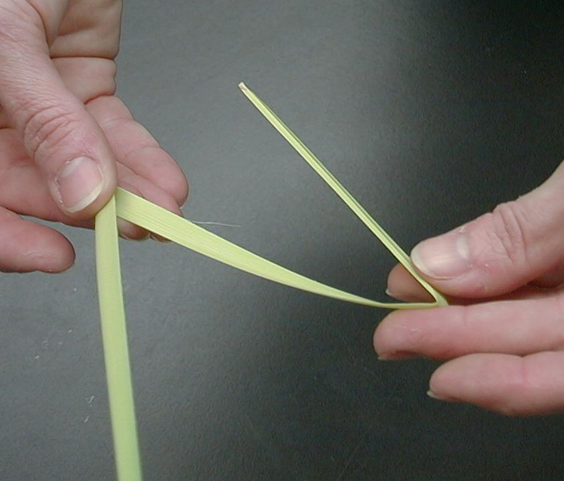
- Fold one of the halves into thirds. This will make the vertical beam of the cross. Leave about three inches of the branch unfolded. This will be used to connect the beams together.

- Fold the other half of the palm branch into fourths. This will make the horizontal beam of the cross.

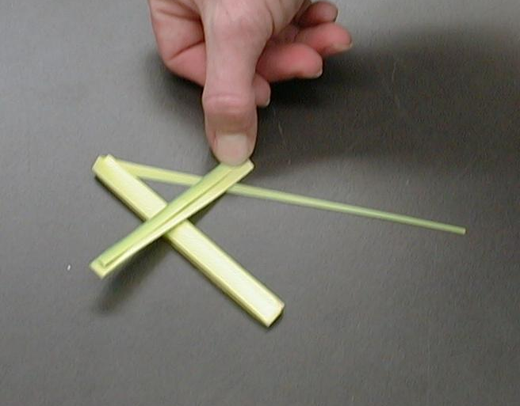
4. Lay the horizontal beam on top of the vertical beam.
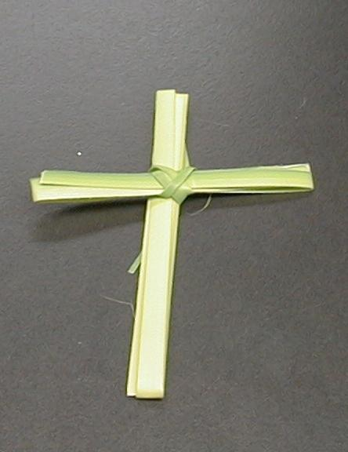

- Wrap the excess palm branch around the center of the cross to connect the two beams together.

After demonstrating, give kids palm branches to make a cross. Discuss the following while they make their crosses.

Can you think of a time you have done something wrong and you still feel bad or sad about it today?

Jesus was put to death on the cross many years ago, but we must remember He was thinking of us today. He went to the cross for you and me. He took our punishment so we can receive freedom. He forgives you and takes your wrongs so you can be free. We can ask for forgiveness and know that Jesus has washed those sins away.

The key verse for today from Philippians 2:8 says, “He (Jesus) humbled Himself by becoming obedient to the point of death, death on a cross.”

Yet later the opposite happened. Philippians 2:9-11 goes on to say, “This is why God has given Him an exceptional honor—the name honored above all other names—so that at the name of Jesus everyone in heaven, on earth, and in the world below will kneel and confess that Jesus Christ is Lord…” This was the joy Jesus saw beyond the cross.

Today we learned that *Jesus is the king who died for me. Even though that might make us sad, it can also make us happy. We know because of Jesus’ death we are forgiven and can be with Him in heaven some day.

Memory Verse Learning: 5 minutes
Purpose: Help kids to memorize and keep scriptures at heart. Using creative ways to help kids enjoy learning the key verse and in small group setting.

Supplies needed: illustrations from lesson 46 (also see page 15)

Memory Verse: Hebrews 10:23, “Let us hold firmly to the hope that we have confessed. We can trust God to do what He promised.”

Memory Verse Learning: “Flash Cards”
Taking the illustrations produced in lesson 46, flash them in sequence before the children and having them say out the memory verse. The illustrations should help them recall the words to Heb. 10:23. Do several rounds with the children. The shepherd could also ask a volunteer to flash the illustrations and lead the group.

Closing prayer:
Encourage kids to pray for specific things they are dealing with. Then close thanking God for his awesome plan of making us innocent and freeing us of the guilt of our sin through Jesus.

Safety and Security: Safety and security procedures are important for each church to carefully define and implement according to their unique needs. The security, safety, illness and accident procedures described in this curriculum are provided for example purposes only and may not be appropriate, applicable or adequate for every situation. Each church is responsible for determining whether any security, safety, illness and accident procedures contained in the curriculum are appropriate, applicable or adequate for its unique situation. The activities described in this curriculum require adult supervision and may not be suitable for each child and each situation. Each church is responsible for ensuring that adequate adult supervision is provided for all activities and for determining whether an activity is appropriate for each child and each situation. Kids Kount Publishing disclaims all liability for the implementation of any procedures or the performance of any activities described in this curriculum.
Large Group Presentation: 20-30 minutes

Signs on Believers’ Highway
Series

Due to long video and seriousness of the material, there will be no Believers’ Highway signs or volunteers coming forward to guess the riddle.

This series continues with “The Gospel of John” DVD series as a visual to show the events of the Bible.

Video options:

- The Legend of the Three Trees, produced by Tommy Nelson, 2001. Order from http://www.thomasnelson.com/consumer/product_detail.asp?sku=0849959438.
- Greatest Adventure Stories from the Bible: The Easter Story (Warner Home Video, 1996) Today only show the first 19 minutes of this video, up until the soldier says, “Surely this was the Son of God.” This time reference begins when the actual animation begins and not at the very beginning of the tape. This section will do an effective job of helping children connect together the different events of Jesus’ last week (Matthew 21-27). Order from: http://www.funksoulchannel.com/movies/dvd/81273/dvdmain.jhtml.

Introduction

As soon as you can, have the students settled down. Show one of the above video options as an introduction. Follow the showing with the puppet presentation.

Dao Dao Plays Opposites
Puppet Presentation

The presenter enters wearing an yellow construction vest and work boots.

Presenter: Today we are still traveling on “Believers’ Highway,” learning to trust Jesus the Messiah, the Son of God. But I did not bring my construction sign with me today so we can have more time to watch the video. Shall we call Dao Dao?

Kids call Dao Dao. Dao Dao. Dao Dao. Dao Dao.

Dao Dao: Hi, everybody.

Presenter: Hi, Dao Dao. How are you doing today?

Dao Dao: Great. I love that game we played using opposites. Do you want to play?

Presenter: What do you mean?

Dao Dao: You give me three opposites and I’ll guess. Then I’ll give you three.

Presenter: Oh well, okay. Let me think. Wide.

Dao Dao: That’s easy. Narrow.

Presenter: Light.

Dao Dao: Dark.

Presenter: Soft.

Dao Dao: (Screaming.) Loud! Okay, my turn. Pasta.

Presenter: What?

Dao Dao: Yeah, pasta. Angel hair pasta.

Presenter: I don’t know what the opposite of angel hair pasta is.

Dao Dao: Devil’s food cake.

Presenter: Wow. That’s clever, Dao Dao. How about another one.

Dao Dao: Skateboard.

Presenter: Skateboard? I don’t know. Surfboard?

Dao Dao: No, those are alike. We are talking opposites.

Presenter: So what is the opposite?

Dao Dao: The opposite of skateboard is walking stick. Here’s another one. Swim floaties.

Presenter: Swim floaties? What is the opposite of that?

Dao Dao: Fly swatter.

Presenter: Wow, Dao Dao. You are good at opposites.

Dao Dao: Thank you very much, but I don’t get what opposites have to do with Jesus and stuff we learn here.

Presenter: Well, today we want you to think of two opposites that are true at the same time.

Dao Dao: You mean like riding a skateboard while using a walking stick.

Continue below boxed area if you are not using this lesson on Palm Sunday.
Optional comments below if you are celebrating Palm Sunday on this Sunday.

Presenter: Not quite, Dao Dao. Let me explain it this way. This Sunday is known as Palm Sunday. In today’s worship services, we talk about Jesus coming into Jerusalem as a king. Everyone praised God and thought of Jesus as a king who would set up a mighty kingdom. But Jesus was a different kind of king. He was the King of the whole universe but He came to do exactly the opposite of what kings do. He came to serve people.

Dao Dao: What do you mean?

Continue here:

Presenter: Jesus is King and servant. Usually kings are served by their servants or their subjects. Jesus came as a king to serve His subjects. He was a servant to them. Even to us today.

Dao Dao: So how does Jesus do that? Does He bring food when you say, “Servant, bring me food?”

Presenter: No, He serves you in a whole different way. I’m going to see if you can figure this out as you watch today’s Bible event. It lasts 15 minutes, but every time you hear the word “king,” take your hands and make the sign for Jesus in sign language. That means you take your middle finger and touch the palm of the other hand. Then, take the other middle finger and touch the palm of the other hand. It’s two motions. Watch me.

Demonstrate for audience the sign for Jesus in sign language.

Now, can everyone try it. Good. Every time you hear the word, “king,” please do the sign language for Jesus because He is a special kind of king. *Jesus is the king who died for me. Let’s watch.

Video

Show The Gospel of John DVD, produced by Visual Bible International, 2003. Order from: www.visualbible.com.

Show the clip covering John 18:19-19:30. Begin just after narrator says, “So Peter went over and stood with them, warming himself.” and end it just after narrator says, “Jesus drank the wine and said, ‘It is finished!’ Then he bowed his head and died.” The length of the clip is approximately 15:00.

Dao Dao’s Opposite Game

Puppet Conclusion

Presenter: So, Dao Dao, what do you think?

Dao Dao: I hardly feel like talking.

Presenter: I understand, Dao Dao. It’s really moving to think of what Jesus has done for us.

Dao Dao: I’m really sad when I see Him die on the cross, especially since Jesus is the King. If He is the King, why did He have to die?

Presenter: Think about that, Dao Dao, and boys and girls. He was a king but He was also the opposite, a servant. And He had to die so that the punishment of our sins could be put on Him.

Dao Dao: You mean all the bad things I’ve done?

Presenter: Yes, you and me both…AND ALL of us. We are guilty and we deserve to be punished and die, but we can go free because Jesus was punished for us.

Dao Dao: That’s just like that Barabbas guy.

Presenter: Yes. He was guilty. Jesus was innocent. But the guilty went free and Jesus, the innocent, was punished.

Dao Dao: Jesus was innocent but He got punished like the guilty. He took the opposite for us.

Presenter: He sure did, Dao Dao. Because of that, we are no longer prisoners of our own sin anymore. We are free so we can serve God.

Dao Dao: That’s good news.

Presenter: It sure is. How does it make you feel?

Dao Dao: Glad, even though I was sad at the beginning.

Presenter: Sometimes we can be both things at the same time. When we think *Jesus is the king who died for us, we are sad that Jesus had to die, but glad that He died for us. Let’s just pray.

Dear God, thank You for Jesus. Thank You very much that He died for us. Jesus is King even though He made Himself a servant for us. Thank you, too, that even though He was innocent, He took the punishment of the guilty. If there is anyone here that doesn’t trust that Jesus did that for them, would you help them believe it? In Jesus’ name. Amen.

Lesson 47

Small Group Warm-Up
- High Sour candy

Large Group Presentation
      - yellow construction vest
      - work boots
      - DVD Gospel of John produced by Visual Bible International, 2003

Choice of one of the following for the introduction of Large Group:
      - The Legend of the Three Trees, produced by Tommy Nelson, 2001
      - Greatest Adventure Stories from the Bible: The Easter Story (Warner Home Video, 1996)

Small Group Application
      - palm leaves/branches

Memory Verse Learning
      - illustrations from lesson 46 (also see page 15)


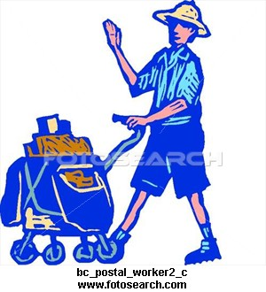

10:23, “Let us to the that have .
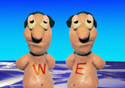




God to do what He .


