
Date: _________________
Series: Signs on Believers’ Hwy
Apr-May Year 4, Lesson 49

Jesus Shows Himself to His Followers

Take Home Point: *You can believe with your heart even if you can’t see with your eyes.
*Repeat this phrase throughout the lesson.

Bible Event: John 19:38-20:31

Key Verse: John 20:29b, “Those who believe without seeing me will be truly happy.”

We will help kids know:
- The Bible Event of Jesus’ resurrection and appearance to His followers on resurrection morning and the following Sunday.
- Even if we don’t see Jesus with our eyes, we can believe with our hearts that He is certainly alive and is the Lord.
- Because Jesus is alive, He has proven that He is the Messiah who has redeemed the world.

We will help kids feel:
- Confidence in the truth of Jesus’ resurrection and presence with them.
- Peace because Jesus is alive.

We will help kids do:
- Identify amazing things that would be hard to believe if they had not seen them.
- Encounter a seemingly impossible task (walking through a piece of paper) and seeing that it can be done. Remember that Jesus asked them to believe without seeing.
- Learn and practice a trick they can demonstrate to their family and friends about seeing and believing.

THIS LESSON’S ROADMAP

DESTINATION | PAGE # | DISCOVERIES ON YOUR JOURNEY | SUPPLIES NEEDED
Small Group Warm-Up   | 3 | Children talk about events they wouldn’t have believed with out seeing with their own eyes. | - “Seeing is believing but better yet…” paper (see Appendix)
Large Group   | 3  6  9  9  9 | Overview  Puppet Presentation: “Doubting Dao Dao”—Dao Dao needs to see before he will believe.  Video: Show The Gospel of John show the clip covering John 19:38-20:31.  Signs on Believers’ Highway: We investigate Jesus’ signs and miracles through the Book of John.  Puppet Conclusion: “Doubting Dao Dao”—Dao Dao has seen the signs (in the video) and knows he can read them in the Bible, too. He knows what it means to believe with your heart. | - Yellow construction vest  - work boots  - Dao Dao with his arm stuck through a piece of paper  - video DVD Gospel of John, produced by Visual Bible International—order from www.visualbible.com
Small Group Application   | 4  5 | Children cut and walk through paper. They learn they are blessed to believe without seeing.  Memory Verse Learning:  “Peep And Say”  John 20:29b is emphasized in lessons 49-50 so that each child comprehends that we can believe with our hearts Jesus is certainly alive and is the Lord. | - preprinted paper (two per child)  - scissors  - transparent tape (just in case a paper tears)  - peepbox  - flash cards

Small Group Warm-Up: 15 minutes
Purpose: Get pointed in the right direction! Build relationships and help guests feel at ease. Do the learning readiness activity that will point your group in the right direction for the lesson.

Supplies: half sheet of paper from Appendix with “Seeing is believing but better yet is believing without seeing” printed on it

What is one of the most amazing things that you have ever seen? Think about the circus or something you have seen on TV. Have you ever heard or read about something from “Believe It Or Not?”

Let kids talk about some amazing things.

If you had not seen it, would you have believed it? Can you think of anything else you wouldn’t believe unless you saw it?

Have you ever seen something and tried to convince another person that it really happened, but they didn’t believe you because they didn’t see it?

Hold up the “Seeing is believing but better yet…” paper.

How many of you believe that I can walk right through the middle of this paper? If you don’t believe me now, I’ll show you later. Today we will see how Jesus walked through something more serious than a piece of paper. It was death.

Jesus died on the cross but He did not stay dead. He came back to life to prove that He truly is the Promised One and the Savior of the world. Today you will learn that *you can believe with your heart even if you can’t see with your eyes.

Large Group Overview: 20-30 minutes
Purpose: Help kids observe what the Bible says. Present the Bible Event in creative fashion. Help kids begin to interpret what it means.

Puppet Presentation: “Doubting Dao Dao”—Dao Dao needs to see before he will believe.

Signs on Believers’ Highway: We investigate Jesus’ signs and miracles through the Book of John.

Puppet Conclusion: “Doubting Dao Dao”—Dao Dao has seen the signs (in the video) and knows he can read them in the Bible too. He knows what it means to believe with your heart.

Small Group Application: 20-25 minutes
Purpose: Help kids map out the meaning of the Bible Event in their lives. Use the questions to stimulate discussion but don't feel tied to them. Allow the Holy Spirit to guide you. Include personal examples from your own faith journey. The example of Christ at work in your life will leave lasting impressions of how Christ can work in the children's lives.

Use your Bibles! Children need to learn how to look up references and follow along when scripture is read aloud. Allow for quality time of prayer at the close of the lesson.

Observation Questions: What happened?

Have kids find John 19:38-20:31 to review the Bible Event. Have kids list the signs that Jesus had indeed risen from the dead and point out the verses where they are found.

1. The stone was rolled away. (John 20:1.)
2. The tomb was empty. (John 20:2,5.)
3. The linen cloth was folded. (John 20: 6-7.)
4. Angels sitting where Jesus’ body had been lying. (John 20:11-13.)
5. Jesus appeared to Mary. (John 20:14-18.)
7. Jesus appeared to the disciples behind locked doors. (John 20:19-23.)
8. Jesus appeared a second time. (John 20:26-28. Both times Jesus appeared, people could see His wounds and even touch Him.)

Interpretation Questions: What does this mean?

Read John 20:24-29 out loud.

Why do you think Jesus told Thomas to put his finger on the nail marks of His hands and where the spear pierced His side? (Thomas had not been with the others when Jesus appeared the first time and said he would believe only if he could see and feel Jesus’ hands and side.)

How do you think Jesus knew Thomas had said this? (Jesus is God and knows all things.)

Application Questions: What does this mean to me?

Supplies: two sheets of “Seeing is believing but better yet is believing without seeing” printed on it for each kid, the same piece of paper from Small Group Warm-Up, scissors, transparent tape

Application Activity:

Hold up preprinted paper and say:

Seeing is believing, but better yet is believing without seeing. During large group, we showed you how you can walk right through the middle of this paper. What do you think now that you saw it with your own eyes? Discuss.

Notice what is printed on the edges of the paper. “Those who believe without seeing me will be truly happy. John 20:29b” What does Jesus mean by this?

We were not able to be there when the actual resurrection of Jesus took place. We can only read it in the Bible or watch a re-enactment based on the Bible. Jesus knew there would be many people like us who would not see with their own eyes but would believe just the same.

That is why Jesus says we are blessed with faith to believe even though we didn’t see His resurrection. As a matter of fact, Jesus says we are more blessed than the disciples who knew Him and saw Him face to face. It takes more faith to believe without seeing Jesus than it did for those who did see Him. *You can believe with your heart even if you can’t see with your eyes.

On the back of this paper are the lines to follow for cutting. Let me show you how to cut it and how to step through it.

Have them practice with one copy and take the other copy home. Encourage kids to demonstrate how it works and what it means with family or friends.

You can demonstrate for family and friends. Ask them if seeing will help them to believe and then you can demonstrate for them.

Memory Verse Learning: 5 minutes
Purpose: Help kids to memorize and keep scriptures at heart. Using creative ways to help kids enjoy learning the key verse and in small group setting.

Supplies needed: peepbox; flash cards

Memory Verse: John 20:29b, “Those who believe without seeing me will be truly happy.”

Memory Verse Learning: “Peep and Say”
Put flash cards into this slot
Before class, put the flash cards into the
slot area of the peepbox. Have the children
sit in a circle. Tell the children that you are
going to give each person a turn to see into
the peepbox. The first person looking inside
reads out what he/she sees and the rest of the
group is to repeat what the person has read
out. The second persons reads and the group
says the first person’s reading and then cont-
inues with the second person’s. This continues
in the same manner until the whole verse is
recited out. Do another round before the
shepherd have the children recite by memory
John20:29b several times

Closing prayer:

Have kids pray for others who may not believe that Jesus is the Messiah or the Promised One because they have not seen Him. Thank God for the gift of Jesus we receive through faith.

Large Group Presentation: 20-30 minutes

Signs on Believers’ Highway Series

The Book of John points to miracles as signs and proof that Jesus is the Christ, the Son of God. The imagery of road construction signs will be used to exemplify the signs that Jesus did as told in the book of John. The road worked on is referred to as “Believers’ Highway” to show we are all on a journey in our faith.

Presenter is dressed in an yellowconstruction vest and holds a different road sign each week that is fitting with the Bible Event. Another important prop is the simulated car set-up with two or four chairs facing the audience and a cardboard car front. Shepherds and children are both involved as observers on the highway. They are called up to drive the car and answer questions, give feedback and interact with or about the event.

This series will continue using “The Gospel of John” DVD series as a visual to show the events of the Bible.

Doubting Dao Dao
Puppet Presentation

The presenter enters wearing an yellow construction vest and work boots. Dao Dao comes out with his arm through a piece of paper.

Presenter: Let’s call Dao Dao.

Kids call Dao Dao. Dao Dao... Dao Dao... Dao Dao.

Presenter: Hi, Dao Dao. What’s that on your arm?

Dao Dao: It’s the piece of paper I was trying to walk through.

Presenter: Is that the same one your shepherd said she could walk through?

Dao Dao: Yeah. She said she could but I don’t think I quite believe her. So I wanted to check it for myself. Guess what?

Presenter: What?

Dao Dao: It can’t be done.

Presenter: Because you tried to walk through it?

Dao Dao: And this is as far as I got. (Dao Dao shows tattered paper.)

Presenter: But Dao Dao, I’m telling you that it can be done.

Dao Dao: You can’t walk through this paper. It’s not possible. What are you going to do, shrink down to the size of G.I. Joe and cut your way through?

Presenter: No.

Dao Dao: I’m telling you it’s not possible.

Presenter: If you saw it happen, would you believe?

Dao Dao: Well, seeing is believing.

Presenter: Okay then, since you don’t believe me, I’ll let you see it after the video from the Gospel of John.

Dao Dao: Good. I love those video clips from the Gospel of John. What will we see today?

Presenter: It’s all about seeing is believing.

Dao Dao: I’m for that.

Presenter: And so was His disciple, Thomas. He said unless I see for myself, I won’t believe.

Dao Dao: You mean he wouldn’t believe if he didn’t see?

Presenter: That was his problem, but I think he had a change of heart. Let’s watch and see what happened when Jesus rose from the dead. We will have a quiz afterwards.

Dao Dao: About what?

Presenter: I’ll ask you how many different signs were there that proved Jesus had been raised from the dead.

Dao Dao: Like what do you mean—signs on a highway?

Presenter: No, signs like the rock sealing the tomb was rolled away. That’s a sign that He wasn’t there anymore. There are others. Maybe some of the kids can tell what they are after the video.

Dao Dao: All right.

Presenter: Then we will talk about seeing is believing.

Video

Show The Gospel of John DVD, produced by Visual Bible International, 2003. Show the clip covering John 19:38-20:31. Begin just after narrator says “And there is another scripture that says, “People will look at Him whom they pierced.” End it just after narrator says, “But these have been written in order that you may believe that Jesus is the Messiah, the Son of God and that through your faith in Him you may have life.” The length of the clip is approximately 8:00.

Signs Along Believers’ Highway

Presenter: I need some volunteers to come up and get into our car. On “Believers’ Highway” kids can drive just as well as adults because we are all growing in our spiritual journey, learning to trust Jesus the Messiah, the Son of God. So buckle your seat belts, and let’s go for a ride!

I want you to list some things we saw in the Gospel of John video that help prove that Jesus had risen from the dead. Let’s see if you can name them.

Let the volunteers name items. Give them hints or clues if necessary.

1. The stone was rolled away.
2. The tomb was empty.
3. The linen cloth was folded.
4. Angels were there.
5. Jesus appeared to Mary.
6. Peter and John told others the body of Jesus was missing.
7. Jesus appeared in person.
8. Jesus appeared a second time.
(Both times Jesus appeared, people could see His wounds and even touch Him.)

Doubting Dao Dao

Puppet Conclusion

Dao Dao: Hey, aren’t you going to give us a rhyming sign to figure out?

Presenter: Oh, you mean like I do every week with the Signs on Believers’ Highway?

Dao Dao: Yeah.

Presenter: No. Instead I’m going to show you how I can walk through the middle of this paper that has printed “Seeing is believing but better yet is believing without seeing.”

Dao Dao: What does that mean?

Presenter: Let me explain it to you while this paper is cut.

Have an adult assistant come up and cut the Appendix paper on the lines indicated. You may want to practice on a copy of this sheet before class.

NOTE: You may want to add some transparent tape at both ends to give support to the structure so it won’t tear.)

There are many signs that Jesus rose from the dead.

Dao Dao: Yeah.

Presenter: Many people saw those signs and it was easier for them to believe.

Dao Dao: Yes, especially like being able to touch Jesus’ side and hands.

Presenter: But there was one guy who said unless I see I won’t belive.

Dao Dao: Yeah. That Thomas guy.

Presenter: That’s why we call him doubting Thomas, but he actually became believing Thomas. After he saw, he believed. But what about you Dao Dao, have you ever seen the risen Jesus?

Dao Dao: No, of course not.

Presenter: Do you believe?

Dao Dao: Yeah, of course.

Presenter: Why?

Dao Dao: Well, because I believe what the Bible says about Jesus. It was written by the guys who were with Him and saw Him.

Presenter: You are correct.

Dao Dao: And when you pray to God, you can say, “I want to know if it is true that Jesus is your Son, that He gave His life for me on the cross and rose from the dead.” God gives you the power to believe it, even without seeing.

Presenter: So, Dao Dao, let me show you something with this paper.

Dao Dao: The paper that your helper cut?

Presenter: Yes. Now, I’m going to walk through it.

Dao Dao: But, it’s all cut up.

Presenter: Let me show you.

Carefully pull paper apart at the edges to make a large circle.

Dao Dao: Wow! It’s a big circle.

Presenter: Yes, Dao Dao, and now I can step right through the middle of this paper.

Step through.

Dao Dao: Yeah. I wouldn’t have believed it if I hadn’t seen it.

Presenter: But it would be true even if you didn’t see it.

Dao Dao: Sure.

Presenter: It’s true that Jesus is the Messiah, the Son of the Living God whether people see it or not. It is also true that by believing in Jesus, you will have life in His name. The Bible even says in John 20:29b, “Those who believe without seeing Me will be truly happy.”

Dao Dao: That is special.

Presenter: Let’s pray about it, Dao Dao, and remember *you can believe with your heart even if you can’t see with your eyes.

Dear Jesus, thank You for dying for us and coming back to life again. You showed lots of signs to everyone back then that You had become alive again. But today we can’t see You with our eyes. Help us believe, anyway. Help us believe and we’ll look forward to someday seeing you face-to-face when we live with You forever. In Jesus’ name. Amen.
Safety and Security: Safety and security procedures are important for each church to carefully define and implement according to their unique needs. The security, safety, illness and accident procedures described in this curriculum are provided for example purposes only and may not be appropriate, applicable or adequate for every situation. Each church is responsible for determining whether any security, safety, illness and accident procedures contained in the curriculum are appropriate, applicable or adequate for its unique situation. The activities described in this curriculum require adult supervision and may not be suitable for each child and each situation. Each church is responsible for ensuring that adequate adult supervision is provided for all activities and for determining whether an activity is appropriate for each child and each situation. Kids Kount Publishing disclaims all liability for the implementation of any procedures or the performance of any activities described in this curriculum.

Lesson 49

Small Group Warm-Up
- “Seeing is believing but better yet…” paper (see Appendix)

Large Group Presentation
      - Yellow construction vest
      - work boots
      - Dao Dao with his arm stuck through a piece of paper
      - video DVD Gospel of John, produced by Visual Bible International—order from www.visualbible.com
Put flash cards into this slot
Small Group Application
      - preprinted paper (two per child)
      - scissors
      - transparent tape (just in case a paper tears)

Memory Verse Learning
      - peepbox
      - flash cards. Cut manila card to size that fit
into the slot of the peep box.

Flash cards

John 20:29b | Those who | believe without
seeing me | will be | truly happy.

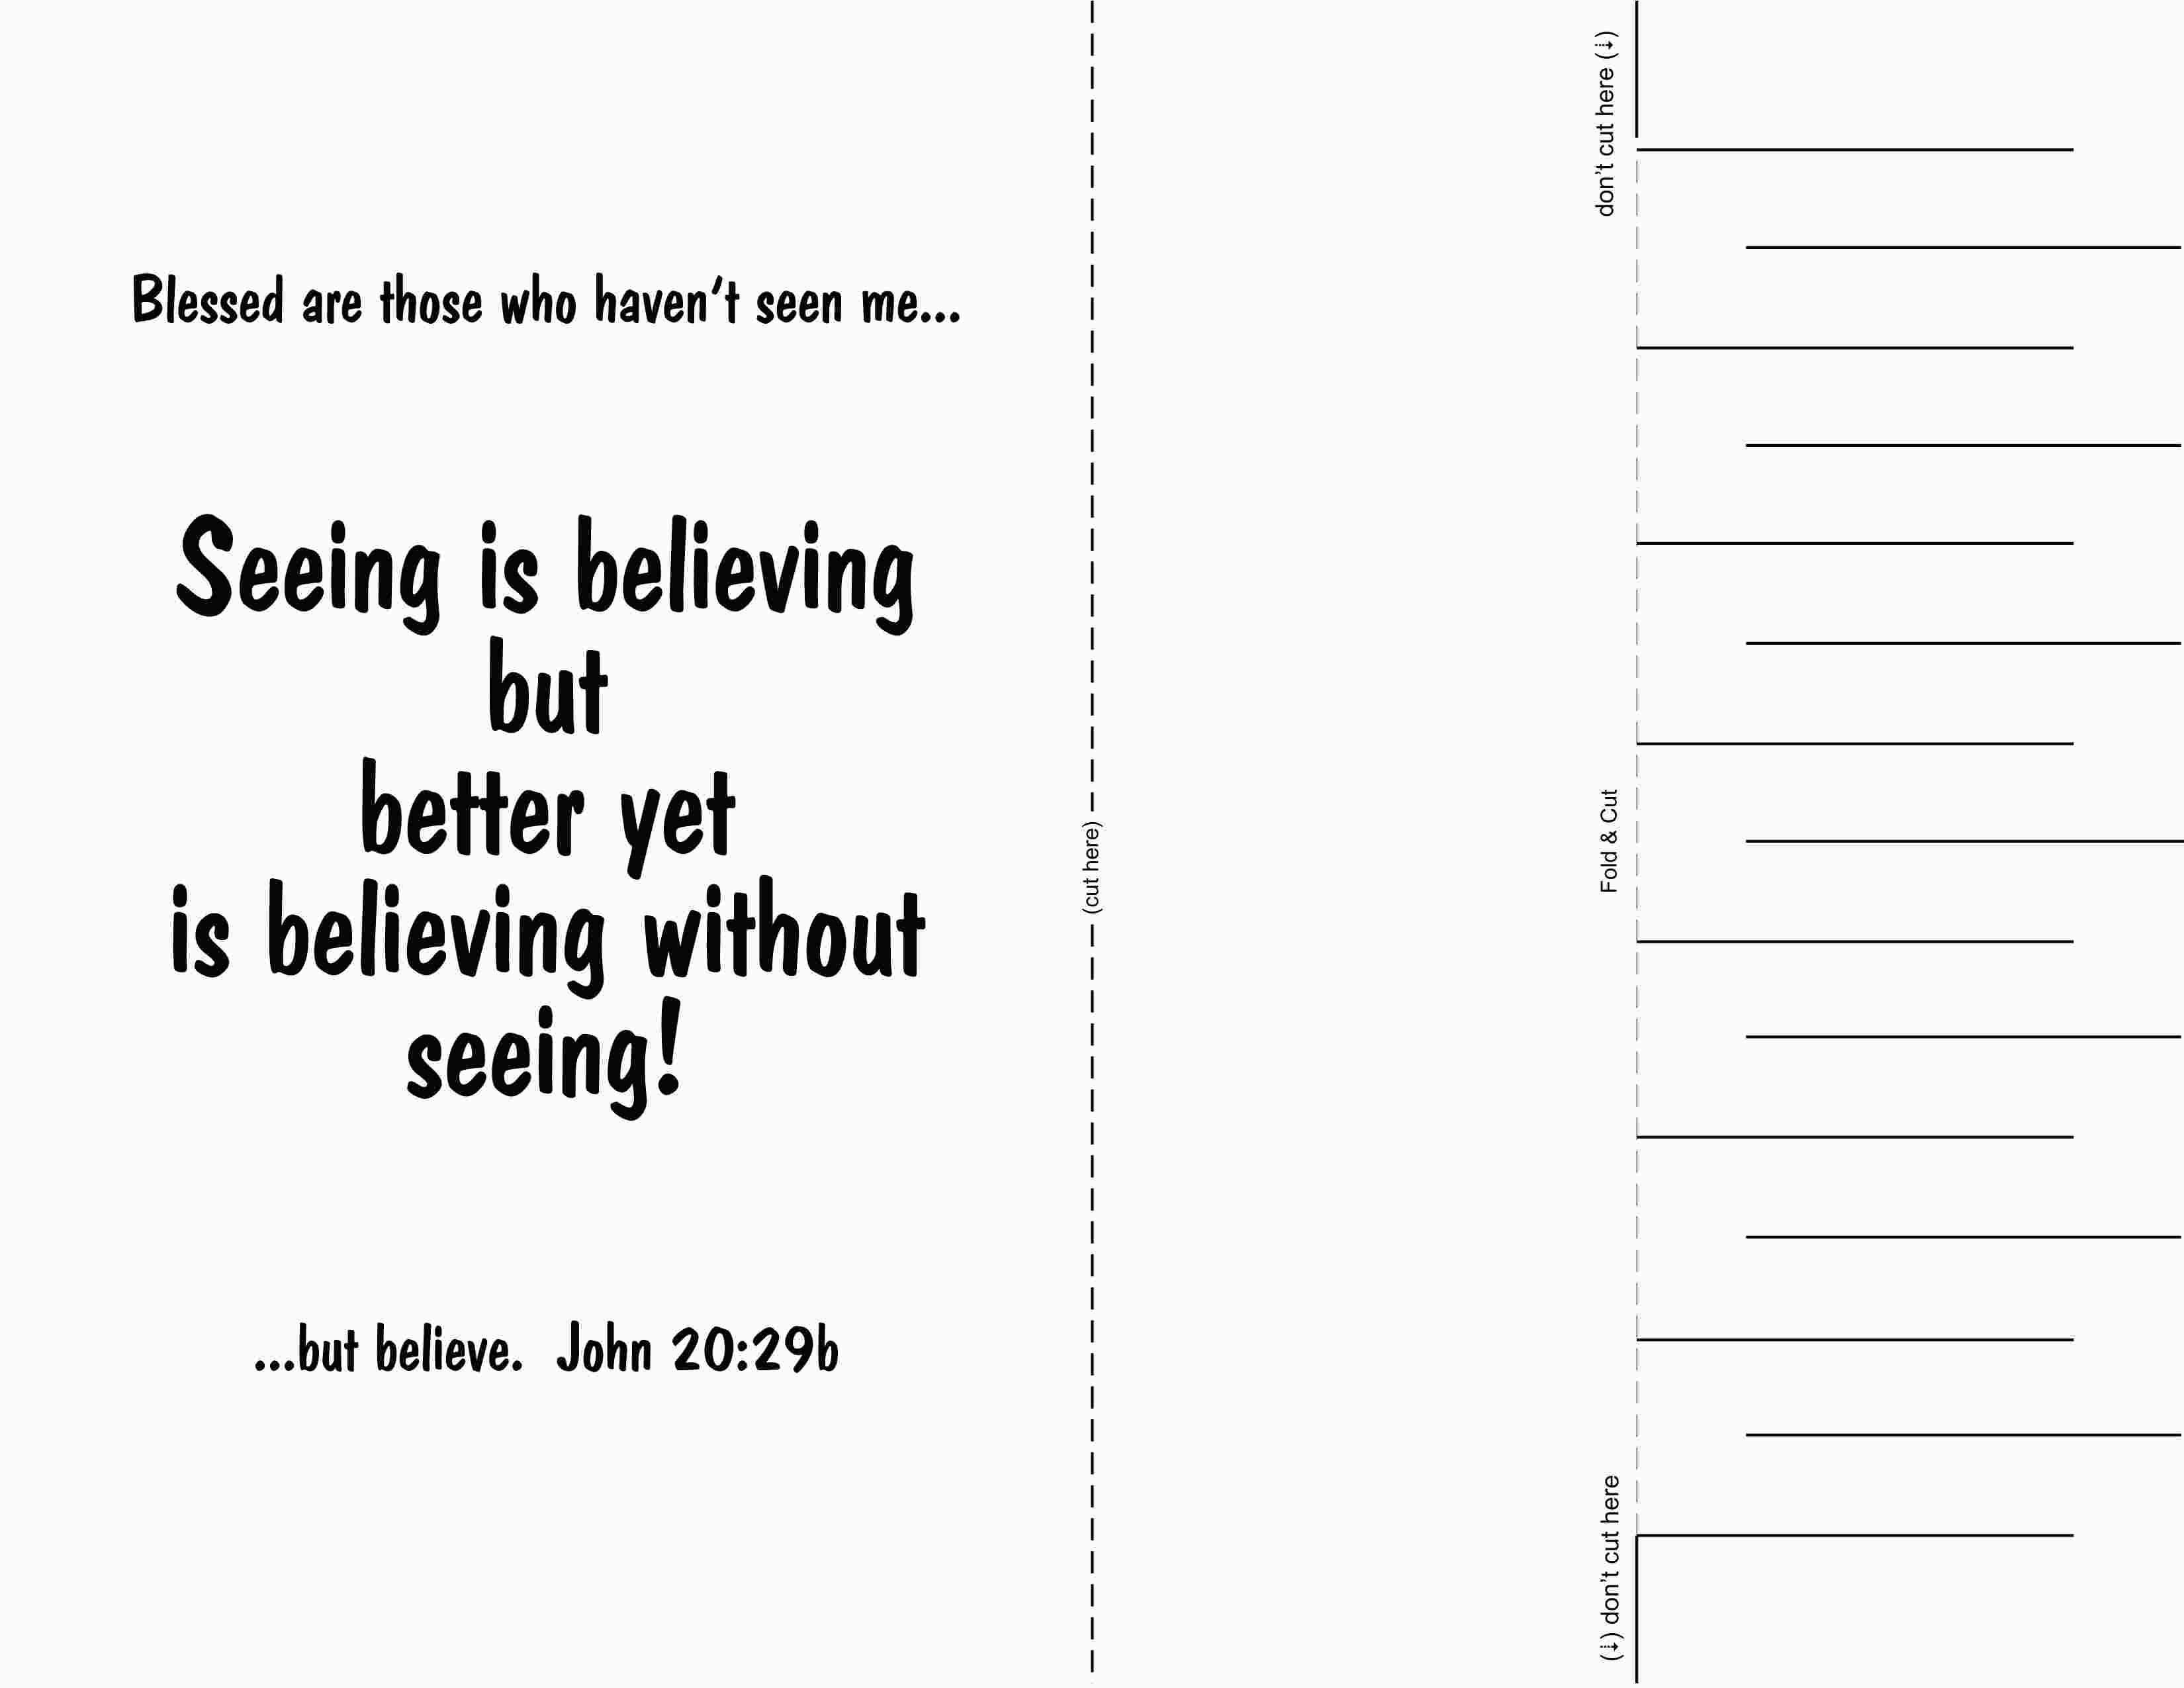
Those who believe without seeing me
…will be truly happy. John 20:29b

