
Date: _________________
Series: Signs on Believers’ Hwy
Apr-May Year 4, Lesson 50

Jesus Appears to His Disciples by the Lake

Take Home Point: *Even after mistakes, Jesus invites us to follow Him. *Repeat this phrase throughout the lesson.

Bible Event: John 21:1-25

Key Verse: Romans 5:8, “But Christ died for us while we were still sinners. In this way God shows His great love for us.”

We will help kids know:
- God takes away the shame of our failures. He forgives us and invites us to try again.
- Peter denied Jesus three times. Jesus appeared to Peter and gave Him three opportunities to express His love for Him. And, three times, Jesus invited Peter to take care of His flock.
- Jesus is alive and we can follow Him even if we can’t see Him.

We will help kids feel:
- Courage to follow Jesus.
- Comfort if they feel like a failure.

We will help kids do:
- Identify some of their own feelings when they think of past failures.
- Discuss how to give failures to God.
- Discuss the difference between failures and sins and learn that in both cases they can turn them over to God.
- Make a craft that reminds them of a fishing net and how they can show their love to Jesus as His disciples.
THIS LESSON’S ROADMAP

DESTINATION | PAGE # | DISCOVERIES ON YOUR JOURNEY | SUPPLIES NEEDED
Small Group Warm-Up   | 3 | Children talk about times they have made mistakes or let others down. | - 3” x 11” strips of paper  - pens
Large Group   | 4  8  11  14 | Overview  Puppet Presentation: “Dao Dao…Still in Business”—Dao Dao passes on (or procrastinates) an opportunity to share his faith.  Large Group: “Signs on Believers’ Highway – We investigate Jesus’ signs and miracles through the Book of John.  Video: Gospel of John, produced by Visual Bible International. Show John 21: 1-25.  Puppet Conclusion: “Dao Dao…Still in Business”— Dao Dao learns that he still has an opportunity to serve God even if he messed it up the first time. | - yellow construction vest  - work boots  - DVD Gospel of John  - sign: on front says, “When the stakes are great, because of the mistakes we make…” and the back says, “Don’t turn and flee because ______ says, ‘Follow _____.’”  - 6” x 11” paper  - pen  - transparent tape  - scissors  - appendix page with illustrations of craft
Small Group Application   | 4  7 | Children make a craft that reminds them of God’s love and acceptance despite their past mistakes.  Memory Verse Learning:  “Hear Then Find”  John 20:29b is emphasized in lessons 49-50 so that each child comprehends that we can believe with our hearts Jesus is certainly alive and is the Lord. | - paper from small group  - scissors  - transparent tape  - appendix page with illustrations of craft  - one 7X9 cm note pad  - ballpen

Small Group Warm-Up: 15 minutes
Purpose: Get pointed in the right direction! Build relationships and help guests feel at ease. Do the learning readiness activity that will point your group in the right direction for the lesson.

Supplies: a piece of paper approximately 3’ x 11” and a pen per child

Today we will talk about mistakes we have made. Maybe we could even call them failures. Let’s agree that when we talk about them that no one will laugh or make fun of anyone else’s past mistakes. Everyone makes mistakes and sometimes it can be very hard to leave them in the past and go on.

Let’s start with a question that everyone can probably relate to. Think about a time your parents asked you to do something and you said you would do it. Unfortunately, you ended up forgetting and didn’t do what you said you would. Who can think of a something like this happening to them?

Let kids each share.

How do you feel when you let someone down?

Would anyone share a story about something you did in the past that you wish you didn’t do or would like to do over?

After one or more have shared, continue with:

Sometimes the things we feel badly about are failures. They are ways we have disappointed others and even disappointed God. There are other things that we’ve done in the past that we might feel bad about but weren’t that serious. Maybe we just did something silly or foolish and we were embarrassed.

Today we will talk about Peter. He did something wrong in the past. He felt so bad about it, he wondered if Jesus would ever want to be his friend again. What did Peter do wrong? Yes, he denied Jesus three times.

Hand out paper and pens and say:

On one side of this paper draw some fish.

Continue discussion as kids draw.

Does anyone remember what Peter did for a living? Yes, he was a fisherman. One time Jesus told Peter that he would be a fisher of men. Jesus told Peter to follow Him and that is when Peter became a disciple.

Do you think Peter thought he could ever be a disciple again and be a follower of Jesus after his big mistake? He already saw Jesus alive from the dead, but he didn’t know if Jesus would still want him to be a follower.

Today we will find out what Jesus did when He met Peter fishing again. Remember this event takes place after Peter denied Jesus and Jesus was alive again. Today you will learn that*even after mistakes, Jesus invites us to follow Him.

Large Group Overview: 20-30 minutes
Purpose: Help kids observe what the Bible says. Present the Bible event in creative fashion. Help kids begin to interpret what it means.

Puppet Presentation: “Dao Dao…Still in Business”—Dao Dao passes on (or procrastinates) an opportunity to share his faith.

Large Group: “Signs on Believers’ Highway – We investigate Jesus’ signs and miracles through the Book of John.

Puppet Conclusion: “Dao Dao…Still in Business”—Dao Dao learns that he still has an opportunity to serve God even if he messed it up the first time.

Small Group Application: 20-25 minutes
Purpose: Help kids map out the meaning of the Bible event in their lives. Use the questions to stimulate discussion but don't feel tied to them. Allow the Holy Spirit to guide you. Include personal examples from your own faith journey. The example of Christ at work in your life will leave lasting impressions of how Christ can work in the children's lives.

Use your Bibles! Children need to learn how to look up references and follow along when scripture is read aloud. Allow for quality time of prayer at the close of the lesson.

Observation Questions: What happened? /Interpretation Questions: What does this mean?

Have kids refer to John 21 in their Bibles.

Why do you think Peter returned to his fishing business? (Maybe he felt disqualified to be in the disciple making business.)

How long had Peter and the other disciples fished and caught nothing? (John 21:3. All night.)

What did Jesus, standing on the shore, tell them to do to catch fish? (John 21:6. Throw the net out on the right side of the boat.) What happened when they did this? (They had so many fish in their net they were unable to pull it in.)

What can we learn from this about trying to fish for men? (When we try and try on our own and are unsuccessful, we should listen to Jesus and do it His way. Then we will be successful beyond imagination.)

Why do you think the disciples didn’t recognize Jesus until after they caught the fish? (Jesus wasn’t constantly with them after He rose from the dead. This was only the third time He had appeared to them after His resurrection (John 21:14), and they probably weren’t expecting Him. They recognized Him then because the same thing happened when He first called them to be His disciples as found in Luke 5:1-11.)

What crazy thing did Peter do when he realized it was Jesus on the shore? (John 21:7. He jumped in the water and swam to shore.) Why do you think he did this? (He was so eager to be with Jesus and couldn’t wait.)

Why did Jesus ask three times the same question of Peter, “Do you love me?” (Peter had denied Jesus three times, so Jesus gave him complete assurance he was forgiven.)

Why do you think Peter felt sad that Jesus had asked him this question three times? (Maybe it reminded him of the three times he denied Jesus. Maybe he wondered if Jesus really trusted him now.)

What did Jesus do and say that let Peter know Jesus still wanted Peter to be a fisher of men? (Jesus did the same miracle of filling the net with fish the first time he called Peter to be a disciple. Jesus asked Peter three times to feed His lambs and take care of His sheep, Jesus’ followers. Jesus told Peter again in John 21:22, “…Follow Me!”)

Application Questions: What does this mean to me?

The key verse for today from Romans 5:8 says, “But Christ died for us while we were still sinners. In this way God shows His great love for us.”

How does today’s Bible event and Peter’s relationship demonstrate this truth? (Jesus died for Peter even after Peter denied Him.)

How does this verse apply to us? (Jesus loves us so much, He died for us even though He knew we would still sin. God loves and accepts us despite our past mistakes.)

How does it make you feel that Jesus loves you this much?

Application Activity
Supplies: paper from small group Warm-Up, scissors, transparent tape, Appendix page with illustrations of craft

During large group, we showed you how to make this into a loop with one twist in it. Let’s do that now.

Twist paper once and tape the ends together. (See appendix page for pictures of the craft.) Continue discussion while kids make craft.

What do you think is the difference between a failure and sin?

You can give your failures to God just as you can give your sins to God. He will take your burdens and release you from them. Just like He will forgive you of your sins, talk to Him, tell Him you are sorry and you want to do better with His help. Remember you have access to God’s mighty power, the same power that conquered death, to change your life.

Now, let’s cut down the middle of this loop.

Show kids how to cut the loop. Let them cut their loops as you demonstrate.

Just like we saw in large group, we now have an even bigger loop. How might this remind us of Jesus’s love and acceptance? (Jesus‘ love grows for us just like this loop gets bigger despite our failures.)

Cut down the middle of the loop again. While doing so, continue with:

Now you will have two loops linked together to represent a net that’s woven together. Jesus performed a miracle allowing the disciples to catch a lot of fish. This craft can remind you of a fishing net and how you can show your love to Jesus by being His disciples because *even after mistakes, Jesus invites us to follow Him.

Memory Verse Learning: 5 minutes
Purpose: Help kids to memorize and keep scriptures at heart. Using creative ways to help kids enjoy learning the key verse and in small group setting.

Supplies needed: one 7X9 cm note pad; ballpen

Memory Verse: John 20:29b, “Those who believe without seeing me will be truly happy.”

Memory Verse Learning: “Hear Then Find”
Before class, write each word of the memory verse onto a piece of paper from note pad. For the reminding papers of the note pad, write other words that are not from the memory verse. The purpose of this activity is that a child needs to hear carefully the word the shepherd whisper in his/her ear. He/she will then find that word among the pile of papers.

During this session, have the children line up before you. Five feet away from the group, put the written paper as a heap. Explain to the children that you will be whispering in their ears a word from the memory verse. He/she then must shout out the word, runs to the pile, search for the word and brings it back to the shepherd. It should be done one at a time to ensure that all the children gets to hear the words of the memory verse. When the shepherd has all the paper, the group helps him to arrange the memory verse. The group will then recite John 20:29b several times with the shepherd.

Closing prayer:

Encourage kids to pray for the failures or burdens they mentioned and give them to God. Thank God for the power that raised Jesus from the dead and pray for victory in the areas that are causing trouble.

Safety and Security: Safety and security procedures are important for each church to carefully define and implement according to their unique needs. The security, safety, illness and accident procedures described in this curriculum are provided for example purposes only and may not be appropriate, applicable or adequate for every situation. Each church is responsible for determining whether any security, safety, illness and accident procedures contained in the curriculum are appropriate, applicable or adequate for its unique situation. The activities described in this curriculum require adult supervision and may not be suitable for each child and each situation. Each church is responsible for ensuring that adequate adult supervision is provided for all activities and for determining whether an activity is appropriate for each child and each situation. Kids Kount Publishing disclaims all liability for the implementation of any procedures or the performance of any activities described in this curriculum.

Large Group Presentation: 20-30 minutes

Signs on Believers’ Highway

The Book of John points to miracles as signs and proof that Jesus is the Christ, the Son of God. The imagery of road construction signs will be used to exemplify the signs that Jesus did as told in the book of John. The road worked on is referred to as “Believers’ Highway” to show we are all on a journey in our faith.

Presenter is dressed in an yellow construction vest and holds a different road sign each week that is fitting with the Bible event. Another important prop is the simulated car set-up with two or four chairs facing the audience and a cardboard car front. Shepherds and children are both involved as observers on the highway. They are called up to drive the car and answer questions, give feed back and interact with or about the event.

This series uses, “The Gospel of John,” DVD series as a visual to show the events of the Bible.

Supplies: yellow construction vest, sign on stick printed with, “When the stakes are great, because of the mistakes we make…” and printed on the back, “Don’t turn and flee because ______ says, ‘Follow _____.’” two or four chairs, cardboard car front, strip of paper 6” x 20”, tape, scissors and pen, appendix page with illustrations of craft

Dao Dao…Still in Business
Puppet Presentation

The presenter enters wearing an yellow construction vest and work boots.

Presenter: Kids, shall we call out Dao Dao?

Kids call Dao Dao. Dao Dao... Dao Dao... Dao Dao.

Dao Dao: Hi, everybody. Wow, did we have an interesting small group just now.

Presenter: What did you talk about?

Dao Dao: We talked about some of our failures or ways we messed up.

Presenter: Yes, today, we will discuss Peter’s failure and how Jesus responded.

Dao Dao: Do you want to hear my failure?

Presenter: I don’t know. Kids, do you want to hear it? Okay, go ahead, Dao Dao.

Dao Dao: Well, last Christmas, I had this Christmas cookie and a cup of Milo in my room.

Presenter: Wow. I didn’t think you could eat cookies and Milo in you room.

Dao Dao: I guess my mom didn’t either. She hollered from the other room, “Dao Dao, you better not be eating cookies and Milo in your room!”

Presenter: What did you say?

Dao Dao: I said, “I’m not, mom.”

Presenter: Dao Dao, that was a lie.

Dao Dao: Not exactly, ‘cause I did stop eating them before my mom came in.

Presenter: Well, did she find them?

Dao Dao: Not exactly, because I put them under the bed.

Presenter: Dao Dao, you were hiding the truth from your mom. That’s wrong. Did you continue to keep it a secret from her?

Dao Dao: Not exactly. You see, when mom was cleaning under my bed two weeks ago, do you know what she found?

Presenter: Don’t tell me. The Milo and Christmas cookie from Christmas.

Dao Dao: It wasn’t exactly Milo anymore. It was kinda this green fur and the cookie was kind of a cookie skeleton.

Presenter: Dao Dao, I bet you felt bad.

Dao Dao: I sure did especially since I wasn’t allowed to have Easter snacks for a week.

Presenter: That seems fair. But, your mom and dad still love you.

Dao Dao: Yeah, of course.

Presenter: But Dao Dao, let me ask you something about your relationship with God. Have you ever promised to do something for Him and then didn’t do it?

Dao Dao: Well, let me see. Once I made a promise that I would talk to Chow Seng Yu at school because no one plays with him very much.

Presenter: Yeah.

Dao Dao: And I kinda felt God wanted me to be his friend and even invite him to church.

Presenter: That sounds like a wonderful idea.

Dao Dao: So, I even prayed about it and told God that I would.

Presenter: Well, what happened?

Dao Dao: Ah-h-h, I’m still waiting.

Presenter: How long have you been waiting?

Dao Dao: Since before Christmas.

Presenter: Uh, oh. It sounds like that Christmas cookie to me.

Dao Dao: Well, sometimes I’m not very good at that stuff.

Presenter: Dao Dao, watch the video today and see what happened to Peter. Remember, Peter denied Jesus how many times?

Dao Dao: Three times.

Presenter: Right. And, Peter was one of Jesus’ closest friend.

Dao Dao: Yeah. He really goofed up.

Presenter: But, when Jesus rose from the dead, He appeared to the disciples by the lake. Peter was probably very worried that Jesus wouldn’t want him to be a disciple anymore. But, Jesus said some things that made him know that even after his mistakes, Jesus wanted Peter to continue to follow Him. Let’s watch this video from John, chapter 21. Remember, Dao Dao *even after mistakes, Jesus invites us to follow Him.

Show video.

Video

Show The Gospel of John DVD, produced by Visual Bible International, 2003. Order from www.visualbible.com.

Show the clip covering John 21:1-25. Begin just after narrator says, “But these have been written in order that you may believe that Jesus is the Messiah, the Son of God and that through your faith in Him you may have life.” End the clip just after narrator says, “Now, there are may other things that Jesus did. If they were all written down one by one, I suppose that the whole world could not hold the books that would be written.” The length of the clip is approximately 7:20.

Signs Along Believers’ Highway
John 21:1-25
NOTE: Before class, cut one 8 ½” x 11” sheet in half vertically. Tape one end of each strip together to make one long strip. Set it nearby until ready to use. Have a scissors ready, as well.

The presenter holds the rhyme sign, careful to only show the front for now, until the back is needed for guessing.

Presenter: I need two volunteers to come up, get in the car and get ready to drive.

Have volunteers come up on stage and arrange them so that kids are in front driving and the shepherd is in the back.

On “Believers’ Highway” kids can drive just as well as adults because we are all growing in our spiritual journey, learning to trust Jesus the Messiah, the Son of God. So buckle your seat belts, and let’s go for a ride!

While I ask you some questions about today’s Bible event, I will make something out of this strip of paper. First, I’m going to draw some fish on one side of it.

Draw fish on the prepared strip of paper.

The miracle that helps them recognize Jesus

When Jesus first called His disciples, some of them were fishing. Jesus told them they would become fishers of men. This happened several years before. These disciples followed Jesus and His teachings and watched Jesus die on the cross. They had seen the empty tomb and knew He was alive again.

Jesus appeared again and met them while they were fishing. Jesus did a miracle that helped them recognize Him. What was it? (He told them to put their nets on the side of their boat and they would catch a lot of fish.)

What did Peter do?

After drawing fish on strip of paper, make a loop with one twist in it and tape ends together. See Appendix for photos of craft.

Now I will make a loop by taping the ends of this paper together.

When Peter realized it was Jesus talking to them from the shore. He was very excited. What did Peter do? (He jumped out of the boat and swam to Jesus.)

What worried Peter?

Peter may have been very worried. He may have been wondering if Jesus would still want him to be a disciple since he had failed Jesus by denying Him three times. Peter was probably worried he could not be a fisher of men anymore and even worse, he probably felt he was no longer Jesus’ friend.

Begin cutting the strip of paper through the middle. While doing so, ask:

How many pieces of paper do you think I will end up with? (Two.) That’s what Peter was worried about that he would be cut off from Jesus and no longer be His disciple. But let’s see what happened.

Cut down the middle line all the way through the entire loop and you’ll find that it doesn’t separate into two but becomes one larger loop.

Wow! Look at this. Instead of two loops, we now have an even bigger loop.

How many times denied and how many affirmed?

How many times had Peter denied Jesus? Yes, three times. When Jesus appeared, He asked Peter the question, “Do you love Me?” How many times did He ask Peter this question? (Three times.)

Do you think this might have reminded Peter of the three times he denied Him? Do you think Jesus was telling Peter it was okay now? (Yes.)

Also, Jesus told Peter three times to feed Jesus’ sheep. What do you think He meant by that and who were the sheep? (The sheep are followers of Jesus. Peter would be one of the people to take care of these followers.)

Do you think Peter was still in the business of being a disciple?

Do you think Peter was still in business as a disciple? Do you think he was still a fisher of men? Let’s see.

Cut the loop one more time down the middle and now you will have two loops linked together to represent a net that’s woven together.

Now, you can think of these loops as a fishing net. Do you think Jesus would still let Peter serve Him? (Yes.)

Now we have two loops, one for me and one for a friend. After this, Peter continued to tell others about Jesus and, therefore, continued to be a fisher of men. We, too, can show our love to Jesus by being His disciples. Remember that *even after mistakes, Jesus invites us to follow Him.

Now read the front of the sign printed with, “When the stakes are great, because of the mistakes we make…” Then reveal the back of the sign and ask the volunteers to fill in the blanks to complete the riddle.

On the front of the sign it says, “When the stakes are great, because of the mistakes we make…” and the back says, “Don’t turn and flee because ______ says, ‘Follow _____.’” What words fit the Bible event and rhyme?

Take some time to get the answers. Then, share the answers: “Don’t turn and flee because ‘Jesus says, Follow Me.’”

Dao Dao…Still in Business

Puppet Conclusion

Presenter: So, Dao Dao, what do you think?

Dao Dao: Well, Peter was a fisher of men before his big mistake. Now Jesus is alive again and he was still a fisher of men.

Presenter: Yes.

Dao Dao: He was still in business.

Presenter: That’s right.

Dao Dao: Even after his mistake.

Presenter: Absolutely.

Dao Dao: Well, then, that’s the truth for us.

Presenter: You’re right, Dao Dao. Jesus invites us to follow Him even after our mistakes.

Dao Dao: Even if we try to hide our mistakes under the bed?

Presenter: Yes. And, more importantly even if we sometimes fail to show God’s love to others and invite them to meet Him. That’s very important.

Dao Dao: But if we forget, we can still be in business.

Presenter: That’s right, because Jesus invites us to follow Him and even gives us other chances.

Dao Dao: Like with Seng Yu

Presenter: Absolutely. Let us praynow.

Dear God, thank You for Jesus and making Him alive and being with us today. Jesus, thank You for inviting us to follow You even after we make mistakes. Help Dao Dao invite Seng Yu to church or talk to him about You. We don’t want to make a mistake and forget all about telling others You are the true God. So help us do it. In Jesus’ name. Amen.

Lesson 50

Small Group Warm-Up
- 3” x 11” strips of paper
- pens

Large Group Presentation
      - yellow construction vest
      - work boots
      - DVD Gospel of John
      - sign: on front says, “When the stakes are great, because of the mistakes we make…” and the back says, “Don’t turn and flee because ______ says, ‘Follow _____.’”
      - 6” x 11” paper
      - pen
      - transparent tape
      - scissors
      - appendix page with illustrations of craft

Small Group Application
      - paper from small group
      - scissors
      - transparent tape
      - appendix page with illustrations of craft

Memory Verse Learning
      - one 7X9 cm note pad (about 50 sheets)
      - ballpen

Appendix: Pictures of craft in a step by step process.

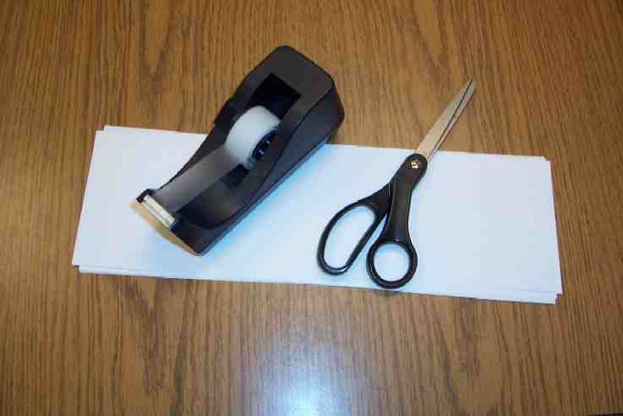
Step 1: Two strips of paper (8 ½” x 11” sheet cut in half vertically). Tape one end of each strip together to create one long strip

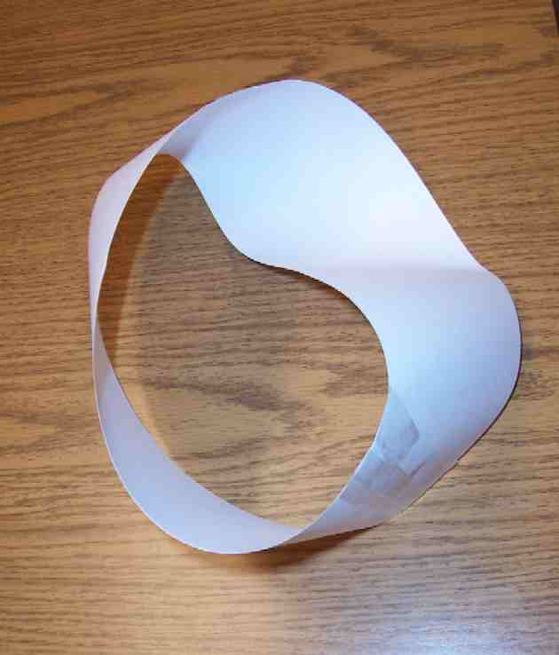
Step 2: Twist the strip once. Tape the remaining two ends together into a circle.

Step 3: With your scissors, cut in the middle of the strip all around the circle.

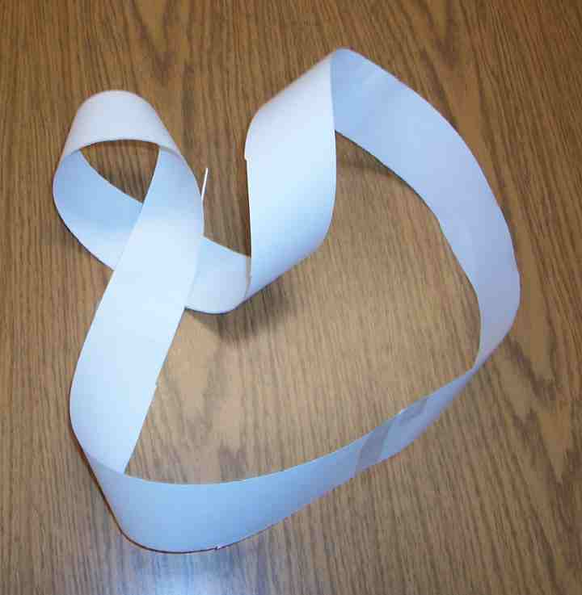

It will create one large circle.

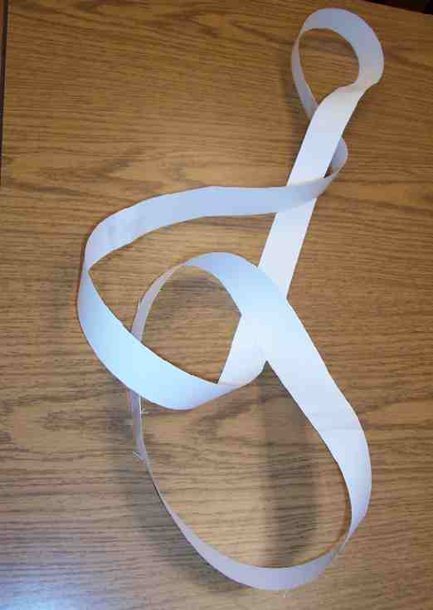

Step 4: Cut this this circle in half again. It will result in two interlocking circles.

When the stakes are great, because of the mistakes we make…

Don’t turn and flee because ______ says, “Follow _____.”

