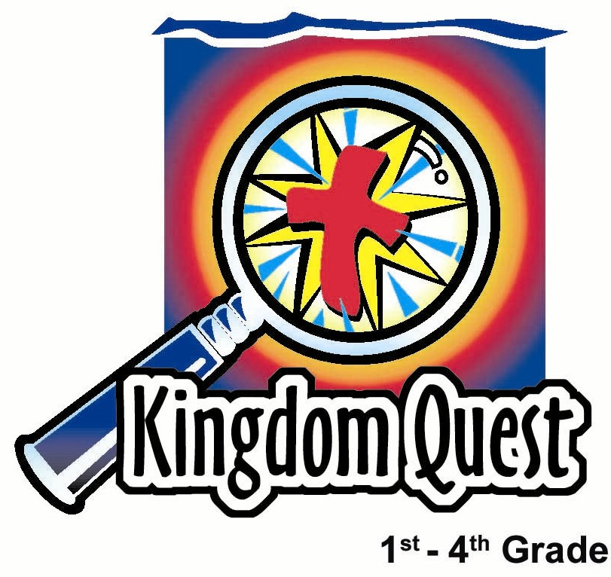
Date: _________________
Series: The Best Gift of All—Jesus
Dec-Mar Year 4, Lesson 31

God Gives Us a Gift—His Son

Take Home Point: *Jesus is a gift –God gives us His Son. *Repeat this phrase throughout the lesson.

Bible Event: John 1:29-51 and 5:16-26
Key Verse: John 20:31, “But these are written so that you can believe that Jesus is the Christ, the Son of God. Then, by believing, you can have life through His name.” (NCV)

We will help kids know:
- In Bible times, people were invited to come and see that Jesus was the Son of God. Jesus did amazing signs to prove His claim to be the Son of God.
- We, too, can come and see that Jesus is the Son of God. He does amazing things for us as we follow Him.
- Jesus is not just a gift to be kept in a box. He is the Son of God whom we can follow.

We will help kids feel:
- Amazed that God sent His Son to give His life for us.
- Joy in the Christmas season and sharing the gift of the Son of God.

We will help kids do:
- Find analogies in candy canes to help tell the story that Jesus is the Son of God.
- Make a craft using candy cane imagery and a poem. The craft can be shared with others, given as a gift, or kept as a personal reminder.

THIS LESSON’S ROADMAP

DESTINATION | PAGE # | DISCOVERIES ON YOUR JOURNEY | SUPPLIES NEEDED
Small Group Warm-Up  (15 minutes)   | 3 | The children discuss the attributes of a candy cane and they discuss what they would want to see Jesus do if they could. | - small candy cane per student
Large Group  (20-30 minutes)   | 4  7  8  9 | Overview  Puppet Presentation: “Dao Dao Sees More Than Candy Canes”—Dao Dao is excited about Christmas, yet his vision is clouded with candy canes.  Video Sketch: From the Visual Bible International (2003), The Gospel of John. Show chapter 1:29-51.  Puppet Conclusion: “Dao Dao Sees More than Candy Canes”—Dao Dao sees the reality of who Jesus is—the gift of the Son of God. | - kids’ silly sunglasses with candy canes glued or taped on them  - box wrapped like a gift with a removable lid  - sign with “Jesus – The Best Gift” to go on gift box  - large candy cane  - small candy canes for prizes  - video/DVD – The Gospel of John, produced by Visual Bible International 2003
Small Group Application  (20-25 minutes)   | 4 | Children create their own card, refrigerator magnet or tree ornament using candy canes and candy cane poem.  Memory Verse Learning:  “Memory Verse Clothesline”  John 20:31 will be taught in lessons 31-33 so that each child fully know that Jesus does amazing things for us as we follow Him. | - small candy canes  - glue  - crayons, pens, markers  - poem (see Appendix)  - scissors  - construction paper  - “Look at a Candy Cane” poem (see Appendix)  - magnet strips (for refrigerator magnet)  - yarn or ribbon for ornament  - eight cards with stockings  - post-it with verse  - clothes-line  - pegs

Small Group Warm-Up: 15 minutes
Purpose: Get pointed in the right direction! Build relationships and help guests feel at ease. Do the learning readiness activity that will point your group in the right direction for the lesson.

Supplies: small candy cane per child

Pass out small candy canes to each child. Ask them what attributes make a candy cane. For example:

What shape or color do candy canes usually have?

Then discuss how the candy cane can point us to Jesus as kids enjoy eating their candy cane. (See the following note.)
Note: Some may have already heard that the red might stand for the blood of Christ, the white, his purity. Also, the shape might stand for the letter “J” for Jesus, a shepherd’s hook or a fishhook.

If you could go back in a time machine to Jesus’ life, what would you like to see? (Some answers may be: when He was born, when He did one of His miracles, when He died on the cross, when He rose again, when He appeared to His disciples after He rose again.)

What would you ask Him?

We are going to hear how one person met Jesus and recognized that He was the Son of God. Jesus invited him to come and follow Him. This friend invited another friend to come and see who Jesus was, too.

Today we will learn that Jesus is the Son of God. He is a gift to the world. Have you ever thought about Jesus as a gift? Let’s think about that. Jesus is the gift to you and He is the Son of God. *Jesus is a gift—God gives us His Son.

Large Group Overview: 20-30 minutes
Purpose: Help kids observe what the Bible says. Present the Bible event in creative fashion. Help kids begin to interpret what it means.

Puppet Presentation: “Dao Dao Sees More Than Candy Canes”—Dao Dao is excited about Christmas, yet his vision is clouded with candy canes.

Video Sketch: The video, The Gospel of John, by Visual Bible International, 2003. Order from: www.visualbible.com.

Puppet Conclusion: “Dao Dao Sees More Than Candy Canes”—Dao Dao sees the reality of who Jesus is—a gift, God’s Son.

Small Group Application: 20-25 minutes
Purpose: Help kids map out the meaning of the Bible event in their lives. Use the questions to stimulate discussion but don't feel tied to them. Allow the Holy Spirit to guide you. Include personal examples from your own faith journey. The example of Christ at work in your life will leave lasting impressions of how Christ can work in the children's lives.

Use your Bibles! Children need to learn how to look up references and follow along when scripture is read aloud. Allow for quality time of prayer at the close of the lesson.

Observation Questions: What happened?

Ask kids the following questions from John 1:29-51.

According to John 1:32-34, how did John the Baptizer come to know that Jesus was the Son of God? (God told John that when he saw the Holy Spirit come down and stay on someone, that would be the Son of God. John saw a dove descend on Jesus at His baptism.)

According to John 1:29, what would this Lamb of God do? (Take away the sin of the world.)

According to John 1:35-51, what four men chose to come and see, or follow, this man named Jesus? (Andrew, Simon Peter, Philip and Nathanael.)

If you have time, read this additional material about Jesus as God’s Son. Ask kids the following questions from John 5:16-18.

Why were the Jews so intent on killing Jesus? (John 5:16-18. He broke the laws about the day of worship because He kept healing people on that day, and He made Himself equal to God when He said repeatedly that God was His Father.)

Read John 5:25-26.

Who is the source of life? (The Father. He enables the Son to be the source of life, too.)

Interpretation Questions: What does this mean?

How do you think Andrew, Simon Peter, Philip and Nathanael recognized Jesus as the Messiah, or the Son of God “whom the prophets wrote about”? (John the Baptizer pointed Him out, they spent time with Him and learned from Him, Jesus saw Nathanael under a fig tree before Philip called to him. See John 1:48-49. Apparently this was some kind of miracle. Jesus saw him without being present.)

Going deeper:

How can the dead hear the voice of God’s Son? (5:25) (Those who don’t trust in Jesus are spiritually dead. When they respond to His invitation to come and see Him, to accept His love and forgiveness, they are made spiritually alive.)

Application Questions: What does this mean to me?

How can we come and see Jesus or follow him? (We, too, can accept His gift of love and forgiveness.)

The key verse for today is John 20:31, “But these are written so that you can believe that Jesus is the Christ, the Son of God. Then, by believing, you can have life through His name.”

Jesus did many miracles to show He was the Son of God. What do you think was His greatest miracle and how does it affect you? (Jesus’ death and resurrection. When we accept this gift and follow Him, we, too, will have eternal life.)
In Large Group, Dao Dao’s vision wasn’t very clear. He was seeing only candy canes or the “stuff” of Christmas. Sometimes our vision is also clouded and we don’t see the real meaning of Christmas. However we learned today that candy canes could maybe help us see Jesus more clearly.

Application:
Supplies: small candy canes, “Look At a Candy Cane” poem (see Appendix) for each child, red or green construction paper, scissors, glue or glue sticks, magnet strips (optional), yarn or ribbon for ornament

Have kids make a card, a refrigerator magnet or a tree ornament using the candy cane poem and a candy cane. Explain to the kids that the craft can be shared with others, given as a gift, or kept as a personal reminder.

Sample:

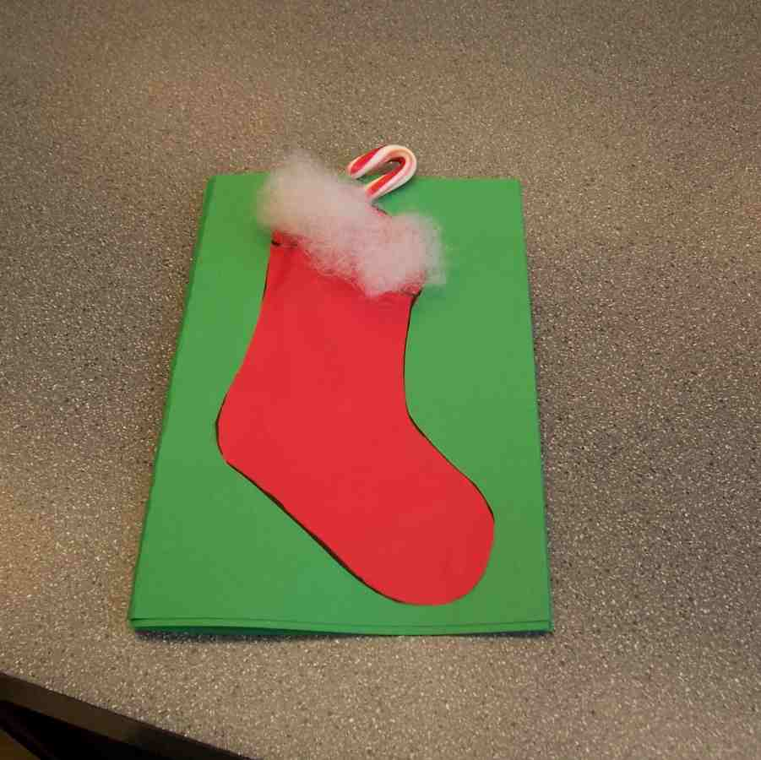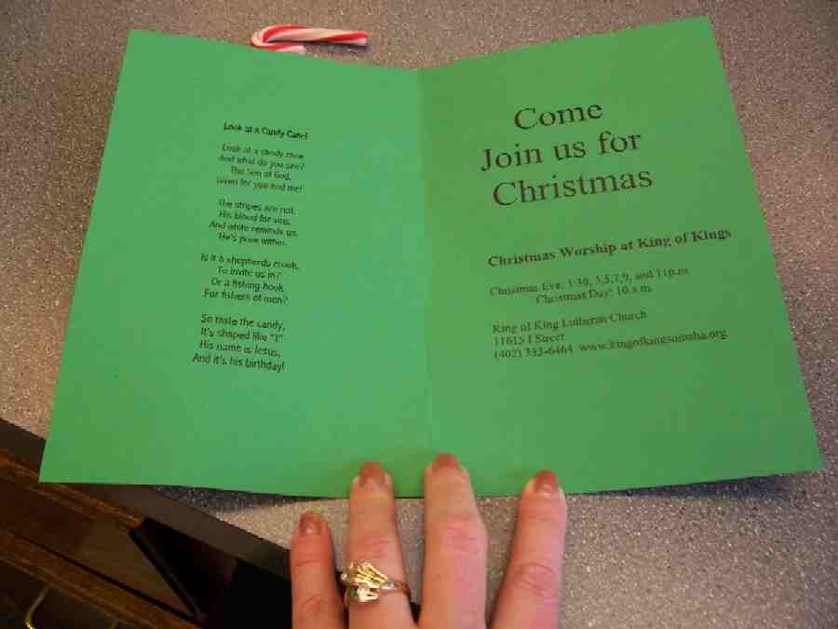

Today we have learned that *Jesus is a gift—God gives us His Son. Jesus is bigger than any gift we can ever receive. Whom do you know that has not seen or followed Jesus and you can share this gift with them at Christmas?

Memory Verse Learning: 5 minutes
Purpose: Help kids to memorize and keep scriptures at heart. Using creative ways to help kids enjoy learning the key verse and in small group setting.

Supplies needed: eight cards with stockings; post-it with verse; clothes-line; pegs

Memory Verse: John 20:31, “But these are written so that you can believe that Jesus is the Christ, the Son of God. Then, by believing, you can have life through His name.”

Memory Verse Learning: “Memory Verse Clothesline”
Bring out the clothes line and tire them appropriately before the children. Peg the cards on the line and then post verse like diagram below. Use this visual aid to help the children memorize the verse. As the children recite, you can take off cards randomly.

John 20:31 – But these

Closing prayer:
Have kids pray about whom they might share the candy cane poem with. Thank God for the miracle of Jesus’ birth. Thank God that He gives us the biggest and best gift possible, His Son. Pray for the Holy Spirit to open our eyes and see the wonder of His marvelous works.
If any child has not received Jesus and would like to, invite him/her to stay after for a minute and pray with them.

Large Group Presentation: 20-30 minutes

Dao Dao Sees More Than Candy Canes
Puppet Presentation

Dao Dao enters wearing a pair of silly sunglasses with candy canes glued on them.

Presenter: Kids, shall we call out Dao Dao?

Dao Dao: Ho! Ho! Ho! Merry Christmas, dude.

Presenter: Wow. Dao Dao, I can tell you are ready for Christmas. Who are you? The candy cane man?

Dao Dao: Well, I’m seeing candy canes for sure. Only ____ (insert the number of days) more days until Christmas.

Presenter: Yes, it’s great to be excited about Christmas, Dao Dao. I know you are excited about all the presents and vacation from school. But, what else do you see when you look forward to Christmas?

Dao Dao: What do you mean? I see candy canes.

Presenter: Not just candy canes. More than candy canes. Do you see the best gift of all?

Dao Dao: Yeah, sure. I see Jesus, of course.

Presenter: Well, did you know today we are going to discover in the Bible about some guys who said, “Come and see.” And, when they did, they realized who Jesus was.

Dao Dao: What do you mean who Jesus was?

Presenter: I mean He was the Son of God.

Dao Dao: Yeah, I know that.

Presenter: But, Dao Dao, stop to think about it. God is so big and powerful. God made everything. God had no beginning or end. God sees everything and knows everything.

Dao Dao: Yeah. Yeah.

Presenter: Well, this big God sent His Son, who is also God, to live for a time on earth.

Dao Dao: And your point is?

Presenter: Dao Dao, that’s an amazing gift! That’s the best gift!

Dao Dao: I guess when you stop to think about it, it really is something.

Presenter: Today let’s discover what it means to look at Christmas and see that *Jesus is a gift—God gives us His Son. Let’s watch this video from the Gospel of John. Every time the word Son or Son of God is mentioned, I want you to clap your hands just once. You really have to be paying attention. Let’s listen.

Video

Show movie The Gospel of John by Visual Bible International, 2003. Order from: www.visualbible.com.

Video name: THE GOSPEL OF JOHN
Start time after opening credits: approximately six minutes into the movie.
Spoken Cue: “The next day John saw Jesus coming toward him.”
End time: approximately 12 minutes
Spoken Cue: “…and the angels of God ascending and descending on the Son of Man.”
Total length of clip: six minutes.

Teaching Point
Props: an assistant brings in a large box. Inside the box is a large candy cane with several small candy canes to be used as prizes. The box has a sign on it that says “Jesus, the Best Gift.”

During the presentation, Dao Dao can ad-lib as needed. Presenter continues:

Remember your discussion about candy canes in small group? Well, here is your chance to show what you know. Let’s have a contest between the boys and girls and see who can give the most ideas for the meaning of the candy cane. We need a boy and girl volunteer to come forward now. You may call on a friend from the audience for help.

Have one boy and one girl volunteer come forward.

Take a look at this big candy cane. What are some of the meanings you might find that would remind you of Jesus? Remember, you have to look at it in different ways to get all the meanings. Answers may include: red for the blood of Christ, white for His pure, spotless life, the letter “J” for Jesus, shepard’s crook, fishing hook.

Great job, everyone. Thank you for helping us out.
Dao Dao Sees More Than Candy Canes
Puppet Conclusion

Presenter: Wow! I didn’t realize there were so many different ways to see candy canes.

Dao Dao: I’ve got one more. He makes your breath minty-fresh, just like a candy cane!

Presenter: I don’t think so, Dao Dao, but good try. So, Dao Dao, today we are not just looking at candy canes, we are looking at Jesus. When you look at Him, what do you see?

Dao Dao: Well, He is a gift.

Presenter: You’re right. And these last weeks we’ve talked about what that gift is. Can you remember any of those?

Dao Dao gets help from the kids in the audience.

Dao Dao: Life. Light. Messiah.

Presenter: And today, Dao Dao, we are talking about what?

Dao Dao: The Son of God.

Presenter: Do you know what is so special about that?

Dao Dao: Is it that He is so big and important and yet He came to earth born as a baby?

Presenter: Exactly. And even more important than that, He did something to serve all people.

Dao Dao: What’s that.

Presenter: A hint is in the Bible verse John 3:16. “For God loved the world so much that He gave His only Son. God gave His Son so that whoever believes in Him may not be lost, but have eternal life.”

Dao Dao: Oh, I know. He died on the cross.

Presenter: Yes, He did. God’s Son was given for us. Jesus died on the cross for us so we could be forgiven and have eternal life.

Dao Dao: Wow. That’s awesome.

Presenter: The verse to remember today is John 20:31. “But these are written so that you can believe that Jesus is the Christ, the Son of God. Then, by believing, you can have life through His name.”

Now let us all pray that we would look and see Jesus. Especially on Christmas that we would see *Jesus is a gift—God gives us His Son.

Dear Jesus, You are the Son of God. That is very important and still You are a gift to us. That is important, too. We trust You and we love You. Thank You that You came to our world and gave Your life for us. And now that You are still the ruling Son of God, please rule over us. Help us become more like You in every way. In Your name, we pray. Amen.

Safety and Security: Safety and security procedures are important for each church to carefully define and implement according to their unique needs. The security, safety, illness and accident procedures described in this curriculum are provided for example purposes only and may not be appropriate, applicable or adequate for every situation. Each church is responsible for determining whether any security, safety, illness and accident procedures contained in the curriculum are appropriate, applicable or adequate for its unique situation. The activities described in this curriculum require adult supervision and may not be suitable for each child and each situation. Each church is responsible for ensuring that adequate adult supervision is provided for all activities and for determining whether an activity is appropriate for each child and each situation. Kids Kount Publishing disclaims all liability for the implementation of any procedures or the performance of any activities described in this curriculum.

Lesson 31

Small Group Warm-Up
- small candy cane per student

Large Group Presentation
      - kids’ silly sunglasses with candy canes glued or taped on them
      - box wrapped like a gift with a removable lid
      - sign with “Jesus – The Best Gift” to go on gift box
      - large candy cane
      - small candy canes for prizes
      - video/DVD – The Gospel of John, produced by Visual Bible International 2003

Small Group Application
      - small candy canes
      - glue
      - crayons, pens, markers
      - poem (see Appendix)
      - scissors
      - construction paper
      - “Look at a Candy Cane” poem (see Appendix)
      - magnet strips (for refrigerator magnet)
      - yarn or ribbon for ornament

Memory Verse Learning
      - eight cards with stockings. Make eight cards like diagram below but let the top end opens like a pocket. These cards will be used for lessons 31-33.
      - post-it with verse. Write John 20:31 on post-it, dividing it like diagram below.
      - clothes-line
      - pegs

John 20:31 - But these | are written so that you | can believe that | Jesus is the Christ,
the Son of God. | Then, by belie-ving, | you can have life | through His name.”

Jesus,

The Best

Gift

Look At a Candy Cane!

Look at a candy cane

And what do you see?
The Son of God,
Given for you and me!

The stripes are red,
His blood for sins,
And white reminds us,
He’s pure within.

Is it a shepherd’s crook,
To invite us in?
Or a fishing hook
For fishers of men?

So taste the candy,
It’s shaped like “J”
His name is Jesus,
And it’s his birthday!

