
Date: _________________
Series: The Best Gift of All—Jesus Dec-Mar Year 4, Lesson 32

Jesus Calls His Disciples

Take Home Point: *Follow Jesus.
*Repeat this phrase throughout the lesson.

Bible Event: John 1:35-51
Key Verse: John 1:43b, “Jesus…said to him, ‘Follow Me.’” (NCV)

We will help kids know:
- Jesus invited His disciples to follow Him.
- Jesus invites us to follow Him.
- Our response is to invite others to “come and see” that Jesus is the Promised One.

We will help kids feel:
- Joy that they are called to be followers of Jesus.
- Excitement that Jesus leads them into their future.

We will help kids do:
- Play interactive games with shoes as they discuss how Jesus could lead them.
- Make a group craft demonstrating how we are all called to be followers of Jesus.
- Watch the video of the Bible event.

THIS LESSON’S ROADMAP

DESTINATION | PAGE # | DISCOVERIES ON YOUR JOURNEY | SUPPLIES NEEDED
Small Group Warm-Up  (15 minutes)   | 3 | Kids discuss places their shoes have been and where they may want to go. | - none
Large Group  (20-30 minutes)   | 4  8  10  10 | Overview  Puppet Presentation: “Dao Dao’s Lucky Socks”—Dao Dao has a lucky pair of socks he believes helps him win his basketball games. He wants to follow Jesus but would rather Jesus follow him—that would be better than lucky socks.  Video: The Gospel of John—John 1:35-51.  Puppet Presentation Conclusion: “Dao Dao’s Lucky Socks”—Dao Dao learns that Jesus wants us to follow Him. The closer we watch and follow Jesus, the more we become like Him. | - child-sized pair of tennis shoes  - dirty socks placed in the shoes  - video, The Gospel of John, produced by Visual Bible International, order from www.visualbible.com
Small Group Application  (20-25 minutes)   | 4 | Five options of games or craft to do to fill the remaining time:  Option #1: Orphaned Shoe  Option #2: Balloon Stomp  Option #3: Shoe Toss  Option #4 I Spy Game  Option #5: Craft  Memory Verse Learning:  “Pegging in Order”  John 20:31 will be taught in lessons 31-33 so that each child fully know that Jesus does amazing things for us as we follow Him. | - balloons – one per child  - two feet of string for each child  - bucket, box or trash can  - newsprint  - construction paper – two sheets per child  - crayons or markers  - scissors  - glue  - eight cards with stockings  - post-it with verse  - clothes-line  - pegs
Small Group Warm-Up 15 minutes
Purpose: Get pointed in the right direction! Build relationships and help guests feel at ease. Do the learning readiness activity that will point your group in the right direction for the lesson.

This being the Sunday after Christmas, many shepherds may be absent. The following activity can be done with one shepherd supervising a larger number of children, dividing them into groups of three or four to discuss the following questions.

Supplies needed: none

For the following discussion, have kids take off a shoe as each takes a turn sharing the following. (If this doesn’t seem appropriate for your students, they can leave their shoes on their feet.)

Say:
Each of our shoes has a story to tell. Our shoes have been to a lot of different places. I would like each of you to tell about a favorite place your shoe has gone or likes to go. This place might be a special place to play such as a basketball court, or a place where it has traveled like Disneyland, or, maybe even a place where it likes to sleep—like in your closet.

You have been on a journey with your shoes and I would like you to share that journey with us. I will begin.

Take your shoe off and begin.

This is my shoe and a favorite place my shoe has gone is…

Share your own experience, then encourage the kids to share in their small groups.

Then say:

Now let’s imagine where your shoe might want to go in the future. Would it enjoy a special team of other shoes, going to a friend’s house, or maybe going back to school after end of the year school break?

After discussion, say:

Today we are using shoes to talk about whom we follow and where He will lead. The Bible tells us that Jesus calls us to follow Him. I wonder where that will lead us.

When we follow Jesus, He does not just lead us to a certain place, but He leads us to become more and more like Him. I wonder what our life will be like when we become more and more like Jesus and follow Him. Today let’s remember to *follow Jesus.

Large Group Overview: 20-30 minutes
Purpose: Help kids observe what the Bible says. Present the Bible event in creative fashion. Help kids begin to interpret what it means.

Puppet Presentation: “Dao Dao’s Lucky Socks”—Dao Dao has a lucky pair of socks he believes helps him win his basketball games. He wants to follow Jesus but would rather Jesus follow him---that would be better than lucky socks.

Video: The Gospel of John—John 1:35-51.

Puppet Presentation Conclusion: “Dao Dao’s Lucky Socks”—Dao Dao learns that Jesus wants us to follow Him. The closer we watch and follow Jesus, the more we become like Him.

Small Group Application: 20-25 minutes
Purpose: Help kids map out the meaning of the Bible event in their lives. Use the questions to stimulate discussion but don't feel tied to them. Allow the Holy Spirit to guide you. Include personal examples from your own faith journey. The example of Christ at work in your life will leave lasting impressions of how Christ can work in the children's lives.

Use your Bibles! Children need to learn how to look up references and follow along when scripture is read aloud. Allow for quality time of prayer at the close of the lesson.

Since this is a Sunday after Christmas and shepherds might be missing, a variety of games and a craft can be done with one or two people supervising a larger number. Choose what games or craft activity you would like to do.

Optional: Observation/Interpretation Questions:

When Jesus invited the disciples to come and see where He was staying, what did the disciples do? (John 1:39. They spent the rest of the day with Jesus.)

What does this teach us? (We need to spend time with Jesus to become more like Him.)

Who did Andrew invite to follow Jesus? (John 1:40-42. Simon Peter.)

Who did Philip invite to also follow Jesus? (John 1:45-46. Nathanael.)

All these men became Jesus’ disciples. How are Andrew and Philip examples for us? (When we become followers of Jesus, we are to invite others to follow Him, too.)

GAMES
Option #1: Orphaned Shoe

Have each child take off one shoe and place it in a large pile in the middle of the room.

When I say “go,” quickly run and find your shoe, come back to your seat and put it on. The first one to stand with his/her shoe on, wins. Ready, set, go.

Another variation of this game is to put both shoes in the middle. It will take longer to find them.

Teaching point:

Jesus asks us to follow Him. Just like all these different shoes, each of us has a different path in life. Though we have many different paths in life, we all can follow Jesus in the path He has given us.

Just like we must put our shoes on before we walk out of the room, we must be ready to follow Jesus wherever He takes us.

Option #2: Balloon Stomp

Supplies: balloons (one per child), two feet of string per child

Give every child a balloon. Have them blow it up and tie a knot. Give each child a two-foot piece of string. Tie one end of the string to the balloon and the other end to one ankle.

When everyone is ready, have all come to the center of the room. Give them boundaries where they must stay.

Instruct:

The object of this game is to pop everyone else’s balloon while protecting yours from getting popped. When I say “go,” try to pop the balloons. You must stay within the boundaries. If your balloon gets popped, you must sit down outside of the play area.

Teaching point:

Jesus asks us to follow Him. There are times the devil will want to stomp on us to keep us from following Jesus. But, Jesus gives us the power or the authority over the devil when we follow Him. We can stomp on the devil just like we did these balloons.

Option #3: Shoe Toss

This is best played if you have wide, open spaces.

Set up a target, such as a bucket, box or trashcan.

I would like each of you to take your shoe part way off. I have a target set up at the other end of the room. One at a time, each of you will try to toss your shoe with your foot into the target. We will divide into two teams and the team with the most shoes in the target will win.

Divide into two teams. Have kids take their shoes half way off and use their feet to toss the shoes into the target.

Option: Have kids kick shoes off as far as they can go—or the farthest distance.

Appoint one person from each team to count the number of shoes from their team that make it into the target. Ready, set, go!

Teaching point:

When we follow Jesus, there is finally a purpose to life. Because Jesus has given His life for us, and we trust Him and follow Him, someday we will be able to live with Him forever in heaven. The shoes flying off of our feet and going way in front of us remind us that Jesus is leading us to a whole new place called heaven—a place that is completely perfect.

Option #4: “I Spy” Game

Have all the kids sit in a circle with their knees bent and feet down and in front of them so everyone’s shoes are showing. The leader will describe a certain shoe and have the kids guess which shoe he/she is describing.

I am looking at all of your shoes very carefully. As I describe a specific shoe, you need to guess which one it is. For example, I might say, “I spy a shoe that is shiny,” or “I spy a red shoe with a buckle.”

After we have we have guessed which shoe it is, the person owning that shoe gets to describe the next shoe for us to guess. Are we ready? I will begin. I spy a shoe that…

Teaching Point:

Just like each of us has our own special shoes, God has a special path for each of us to follow. Because He made each one of us very special and unique, we all have our very own paths to walk. When we are obedient to Jesus, we show our love for Him in the way we live.

Option #5: Craft Project

Supplies: two pieces of colored paper per child, scissors, crayons or markers, and glue

Give two pieces of paper to each child. Have kids trace their shoes on the paper and cut them out. Have the kids write on one shoe, “_______ (insert your name) will follow Jesus.”

On the other shoe, they are to write what they will do because they are following Jesus. For example: “I will be more kind, pray more often, help my mom and dad more often, etc.”

When the kids are finished, have them glue their shoes on a large piece of newsprint so it looks like feet walking on a path. Draw a cross at the end of the path so it looks like the shoes are walking towards the cross and following Jesus.

Memory Verse Learning: 5 minutes
Purpose: Help kids to memorize and keep scriptures at heart. Using creative ways to help kids enjoy learning the key verse and in small group setting.

Supplies needed: eight cards with stockings; post-it with verse; clothes-line; pegs

Memory Verse: John 20:31, “But these are written so that you can believe that Jesus is the Christ, the Son of God. Then, by believing, you can have life through His name.”
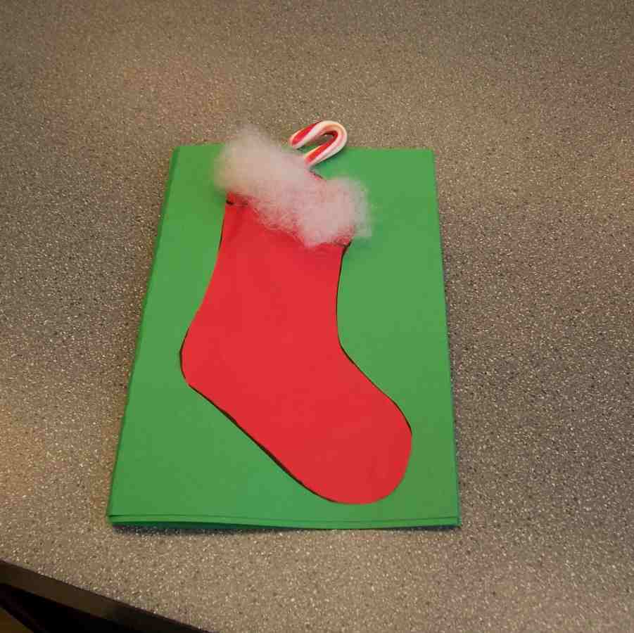

Memory Verse Learning: “Pegging in Order”
Hang out the clothes line and peg the cards on the line. Then stick the memory verse at the “stockings” in its sequence. Use this visual aid to recite the memory verse with the children. After several times, take off all the cards and mix them. Ask for a volunteer to peg the cards correctly. When complete, have the children recite the verse. Do this several rounds as time permits.
John 20:31 – But these

Closing Prayer:

In prayer, focus on service being for Jesus not ourselves. Ask God to lead, guide and direct the children, so that they might serve Him well. Invite any child who does not know Jesus as Savior to place their trust in Him.

Encourage children to come speak with you after class, should they want to have their questions answered.

Safety and Security: Safety and security procedures are important for each church to carefully define and implement according to their unique needs. The security, safety, illness and accident procedures described in this curriculum are provided for example purposes only and may not be appropriate, applicable or adequate for every situation. Each church is responsible for determining whether any security, safety, illness and accident procedures contained in the curriculum are appropriate, applicable or adequate for its unique situation. The activities described in this curriculum require adult supervision and may not be suitable for each child and each situation. Each church is responsible for ensuring that adequate adult supervision is provided for all activities and for determining whether an activity is appropriate for each child and each situation. Kids Kount Publishing disclaims all liability for the implementation of any procedures or the performance of any activities described in this curriculum.

Large Group Presentation 20-30 minutes

Dao Dao’s Lucky Socks

Puppet Presentation

Supplies: small child-sized pair of sneakers with dirty socks stuffed in them, Gospel of John video

Presenter: Kids, should we call Dao Dao?

Kids: Dao Dao… Dao Dao… Dao Dao. Dao Dao enters and puts his shoes and socks on the ledge.

Presenter: Hi, Dao Dao. I see you brought your shoes with you today.

Dao Dao: We were talking about them in Small Group, so I wanted you to see mine first-hand. These are my famous basketball shoes.

Presenter: Ooooo…(holding his nose). What do I smell?

Dao Dao: That is the smell of victory.

Presenter: I think it’s the smell of dirty socks. Picks up a dirty sock.

I bet this is what I smell.

Dao Dao: Put that down!

Presenter: Gladly, That is one DIRTY sock.

Dao Dao: It’s not a dirty sock.

Presenter: It’s not?

Dao Dao: No, it is my lucky sock.

Presenter: Dao Dao, that sock smells terrible. Why don’t you wash it?

Dao Dao: A person never washes LUCKY socks. When I wear these socks, my team usually wins.

Presenter: I think it is more than the socks that help you win. Dao Dao, today we are talking about where our shoes take us.

Dao Dao: These take me to the gym.

Presenter: We are also talking about shoes reminding us that we are to follow Jesus.

Dao Dao: I am all over that one!

Presenter: You are?

Dao Dao: Yes. You see, I talked to my shoes and my shoes told me that they would like Jesus to follow them.

Presenter: Where are they going?

Dao Dao: They are going to play basketball against the toughest team in the league. Just imagine, if Jesus came along then we would have no trouble winning the game and I would be the greatest basketball player in the world!

Presenter: So, you are saying if Jesus followed you, you would win all of your basketball games?

Dao Dao: That’s right.

Presenter: Maybe you wouldn’t need your lucky socks any more.

Dao Dao: Hold it. I don’t know if I can go that far.

Presenter: Dao Dao, today we are not talking about Jesus following you.

Dao Dao: Doesn’t He like basketball?

Presenter: I’m sure He does. He goes with you wherever you go.

Dao Dao: I know He’s always there. I just want Him to help my basketball game.

Presenter: But Jesus invites you to *follow Him.

Dao Dao: Can we still go to the gym?

Presenter: Sure, Dao Dao. God will still help you, but He really wants you to follow Him.

Dao Dao: What do you mean?

Presenter: He wants to help you become more like Him. Not in just playing basketball, but in your attitude—to be just like Jesus in all you do.

Dao Dao: I still don’t understand.

Presenter: We will talk about that in a minute, Dao Dao. I would like you to watch this video about Jesus calling His disciples.

They realized that Jesus was the Messiah that God had promised for hundreds of years. He was the one who would rescue His people from their sin and selfishness.

As you go back to watch the video, notice what Jesus said so people would come and follow Him. Take your shoes with you as you go.

Video

Show the video, The Gospel of John from Visual Bible International. Show the clip of John 1:35-51. This lasts 5 minutes and 5 seconds.

Dao Dao’s Lucky Socks
Puppet Conclusion

Presenter: What words did Jesus use to get people to follow Him?

Dao Dao: He didn’t say much.

Presenter: But, what did He say?

Dao Dao: All He said was, “Follow Me.”

Presenter: That’s right. He also told them to come and see that He is God’s Son, the Savior of the world.

Dao Dao: Jesus never did play basketball did He?

Presenter: I don’t think they played basketball back then. But He did show His disciples how they could follow Him in all that they did.

Dao Dao: How did they do that?

Presenter: The closer they watched Him and did as He did, the more they behaved like Jesus. Dao Dao you can become more like Jesus. For example, you can become more like Jesus even in the way you play basketball.

Dao Dao: Will He help me win?

Presenter: I hope you will have a winning attitude. He will help you encourage other players and be a good sport.

Dao Dao: I could use some help in those areas.

Presenter: You know what else? I don’t think you will need your lucky socks anymore. You could even wash them.

Dao Dao: My mom would like that!

Presenter: I think we all would! Today, Dao Dao, let’s think about how Jesus lived. He gave His life for us and even took the punishment for our sins so we could be forgiven and be free to live a life that cares for other people—just like Jesus did. We are going to pray right now, praying that we would all *follow Jesus.

Dear Jesus, sometimes we get mixed up and we try to get You to follow us. But it is more important that we follow You. Thank You for asking us to come and see how You live. Help us to live like You do in everything we do. In Your name, we pray. Amen.

Dao Dao exits.

Option: the Large Group Presenter can give instructions to all the kids for the games and crafts to be done the rest of the hour.

Lesson 32

Small Group Warm-Up
- none

Large Group Presentation
      - child-sized pair of tennis shoes
      - dirty socks placed in the shoes
      - video, The Gospel of John, produced by Visual Bible International, order from www.visualbible.com

Small Group Application
      - balloons – one per child
      - two feet of string for each child
      - bucket, box or trash can
      - newsprint
      - construction paper – two sheets per child
      - crayons or markers
      - scissors
      - glue

Memory Verse Learning
- The supplies are similar to lesson 31.
      - eight cards with stockings. Make eight cards like diagram below but let the top end opens like a pocket. These cards will be used for lessons 31-33.
      - post-it with verse. Write John 20:31 on post-it, dividing it like diagram below.
      - clothes-line
      - pegs

John 20:31 - But these | are written so that you | can believe that | Jesus is the Christ,
the Son of God. | Then, by belie-ving, | you can have life | through His name.”

