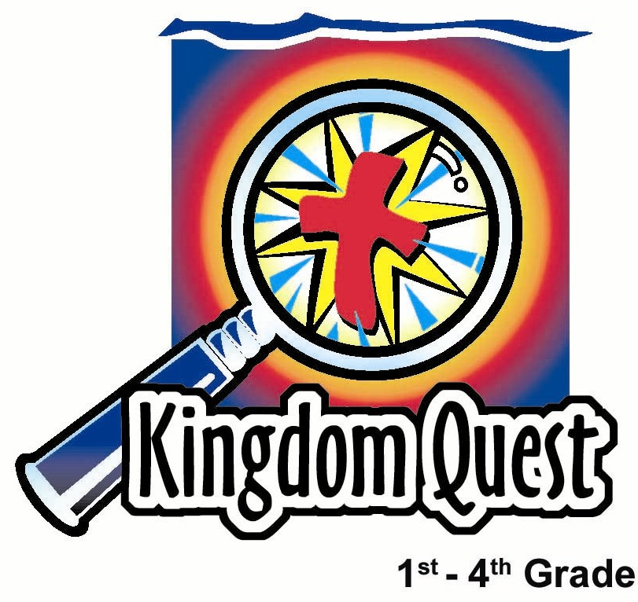
Date: _________________
Series: The Best Gift of All—Jesus
Dec-Mar Year 4, Lesson 33

A Treasure for Us

Take Home Point: *Serve God—it’s a gift for Him and a treasure for us. *Repeat this phrase throughout the lesson.

Bible Event: Matthew 2:1-12 and 6:19-21
Key Verse: Matthew 6:20, “So store your treasures in heaven. The treasures in heaven cannot be destroyed by moths or rusts. And thieves cannot break in and steal that treasure.” (NCV)

We will help kids know:
- Heaven is a gift through Jesus who gave His life for us.
- What we do now to serve God is a gift back to God.
- What we do now to serve God is also a treasure for us stored in heaven.
- They now can place their hearts’ “desires” in their treasures stored in heaven.
- The Bible event of the three wise men’s visit to Baby Jesus.

We will help kids feel:
- Thankfulness for the gift God has given them in Jesus, His only Son.
- Surprised at how treasures on earth will not bring lasting happiness.

We will help kids do:
- Plan ways they can serve God in the New Year.
- Make a group craft demonstrating acts of service that are gifts to the King.
- Visualize the treasures we can store in heaven.

THIS LESSON’S ROADMAP

DESTINATION | PAGE # | DISCOVERIES ON YOUR JOURNEY | SUPPLIES NEEDED
Small Group Warm-Up  (15 minutes)   | 3 | Children discover a special gift they can all give Jesus and receive a treasure in return. | - picture of treasure chest (see Appendix)
Large Group  (20-30 minutes)   | 4  8  11  11 | Overview  Puppet Presentation: “Dao Dao Discovers True Treasures”—Dao Dao shares the treasures he received as Christmas presents only to discover they are not the things to truly treasure.  Video Sketch: The Visual Bible, The Gospel of Matthew, 2:1-12  Puppet Conclusion: “Dao Dao Discovers True Treasures”—Dao Dao learns what it means to serve God. This is like taking a treasure from his treasure chest and giving it to Jesus. It serves as a gift to Jesus and a heavenly treasure for Him. | - box wrapped like a gift with a removable lid  - sign with “Jesus, the Best Gift” to go on gift box  - hand-shaped paper cut-outs with names printed on them (see presentation)  - video/DVD – The Visual Bible, The Gospel of Matthew by Visual Bible International 1997 (order from www.amazon.com)  - treasure chest
Small Group Application  (20-25 minutes)   | 4 | Children plan ways they can serve God. They write their plans on hand cutouts. They learn that serving is a way to give back to Jesus and in return are storing treasures in heaven.  Memory Verse Learning:  “Make a Guess”  John 20:31 will be taught in lessons 31-33 so that each child fully know that Jesus does amazing things for us as we follow Him. | - construction paper  - pens, pencils, markers  - scissors  - Helping Hands preprinted service ideas (see appendix)  - eight cards with stockings  - word strips with verse written  - clothes-line  - pegs
Small Group Warm-Up: 15 minutes
Purpose: Get pointed in the right direction! Build relationships and help guests feel at ease. Do the learning readiness activity that will point your group in the right direction for the lesson.

Supplies: picture of a treasure chest (see appendix)

Today we will talk about treasures.

Show picture of treasure chest and say:

Let’s use our imagination and picture a real treasure chest like this in the center of our group. It’s about this high, this deep, and this wide.

Use hands to emphasize measurements.

Let’s open our imaginary treasure chest and put imaginary treasures in it. How about putting inside the chest some of your Christmas presents? What was your favorite Christmas present this year?

As you tell us about your Christmas treasure, pretend to put it in the treasure chest.

Are there any gifts that you have grown tired of already? Have you grown tired of any Christmas presents from last year? Do you still play with them?

How long does happiness with a toy last?

Having toys is not wrong. Toys are wonderful blessings from God. But, it is not good when a toy becomes a child’s most treasured possession.

If our treasure chest is filled with only things from earth, we will tire of it. Today we will discuss a different kind of treasure chest. It is a treasure chest that each of us has in our lives. Stored in this treasure chest are all our gifts, talents, and abilities. From the treasure chest in each of us, we can use our gifts, talents, and abilities to serve God. It is a way we can give back a gift to Jesus for the gift of His life given for us. Surprisingly enough, when we give a treasure to God, we are storing treasures for ourselves in heaven. Today we learn: *Serve God—it’s a gift for Him and a treasure for us.

Large Group Overview: 20-30 minutes
Purpose: Help kids observe what the Bible says. Present the Bible event in creative fashion. Help kids begin to interpret what it means.

Puppet Presentation: “Dao Dao Discovers True Treasures”—Dao Dao shares the treasures he received as Christmas presents only to discover they are not the things to truly treasure.

Video Sketch: The Visual Bible: The Gospel of Matthew, 2:1-12. Produced by Visual Bible International, 1997. Order from: http://www.amazon.com/gp/offer-listing/B0002UBX54/ref=dp_pb_a/104-9844794-4669549?condition=all

Puppet Conclusion: “Dao Dao Discovers True Treasures”—Dao Dao learns what it means to serve God. This is like taking a treasure from his treasure chest and giving it to Jesus. It serves as a gift to Jesus and a heavenly treasure for Him.

Small Group Application: 20-25 minutes
Purpose: Help kids map out the meaning of the Bible event in their lives. Use the questions to stimulate discussion but don't feel tied to them. Allow the Holy Spirit to guide you. Include personal examples from your own faith journey. The example of Christ at work in your life will leave lasting impressions of how Christ can work in children’s lives.

Use your Bibles! Children need to learn how to look up references and follow along when scripture is read aloud. Allow for quality time of prayer at the close of the lesson.

Observation Questions: What happened?/Interpretation Questions: What does this mean?

Have kids refer to the Bible event of the wise men in Matthew 2:1-12. Read Matthew 2:11.

What did the wise men do when they saw Jesus? (They bowed down and worshiped Him.)

What gifts from their treasure chests did they offer Jesus? (Gold, frankincense, and myrrh.)

What do you think God treasured most, the gifts from the wise men’s treasure chests or their act of worship? (No right or wrong answer. God looks at the heart of man, so He knows which acts are meant to glorify Him.)
Read Matthew 6:19-21.

What are examples of treasures we store up on earth where moths and rust destroy and thieves break in and steal? (Material things that people value such as money, possessions, and power. These things cannot be taken with us after we die.)

What are examples of treasures we store up in heaven that moths and rust cannot destroy or thieves steal? (Acts of kindness or good works that bring glory to God. These are things that please God and have eternal value.)

What does it mean that, “Your heart is where your treasure is”? (We seek after what we value. Our desires can be for material things or for heavenly things. These desires determine our actions.)

How did the wise men store up gifts in heaven? (God was pleased with their acts of worship and gifts that theyprovided for Jesus. They did not keep their costly possessions for themselves but gave them to the King.)

Application Questions: What does this mean to me?

What do you think brings lasting joy, Christmas gifts and presents or good works that glorify God and help others? Why?

What will you choose? Remember, presents and gifts are good and given from God. How can they become treasures that rust and moths destroy? (When they become the focus for our joy or happiness instead of God.)

How can giving gifts to God become treasures for us? (Good works do not earn us salvation, but God does reward us in heaven. We will see the fruits of our labor in heaven. See 1 Timothy 6:18-19.)

Application Activity
Supplies: construction paper, pencils or pens, scissors

Pass out supplies. Have kids trace their hands and cut them out. Have them write their name on their hand cut-out and one thing they can do to serve God. Kids can trace and cut as many hands as they wish.

These become treasures that are given to the King but are then stored up for us in heaven.

Arrange kids’ hands into a mosaic on the wall or as a group art project or a mobile. The hands should be arranged so they appear to be flowing into the treasure chest (see appendix).

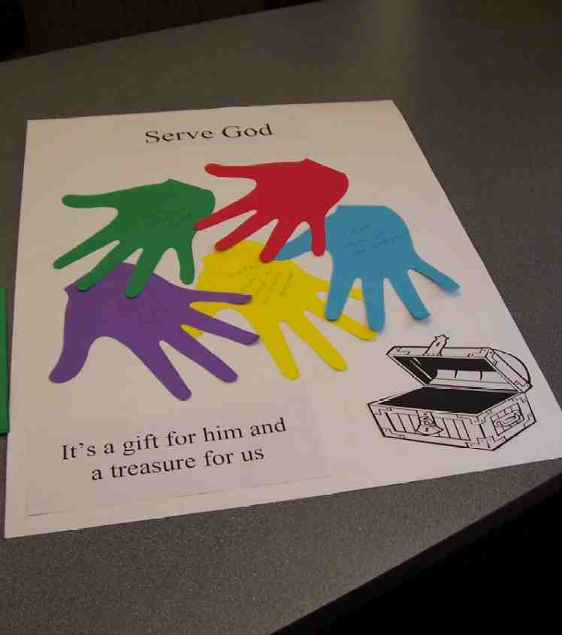

For the younger children, it will be more age appropriate to focus on how they can serve their family. They may want to paste a picture of how they can serve rather than write it on the hand (see appendix.)

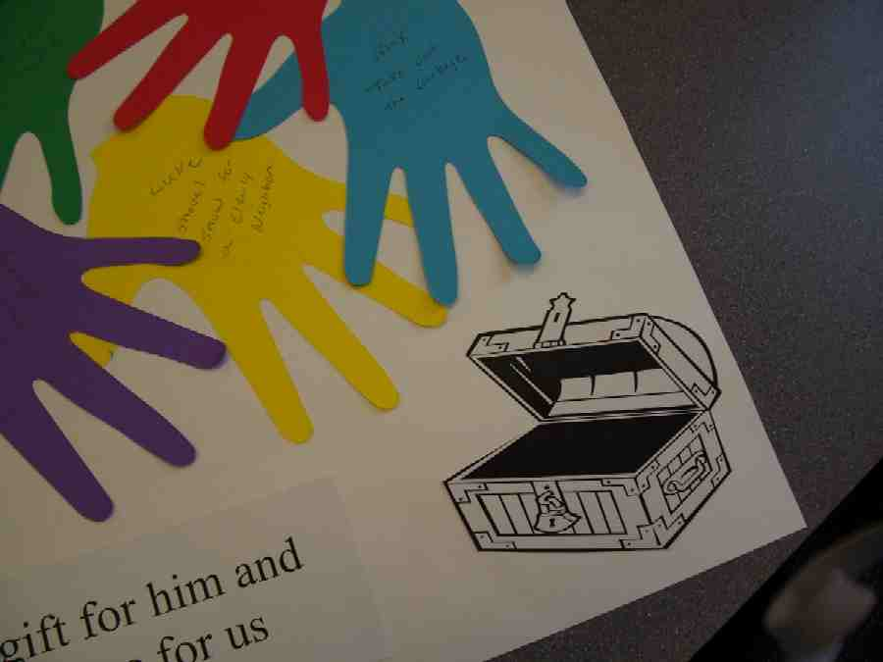

To help children brainstorm service ideas, you may mention the different ways to serve. Serving can mean to help others, to spend time with others, to work, to be obedient, to give honor, and to pray.

Also, they could first ask themselves who can they serve and then ask how can they serve. From these two questions, they may come up with something like this: I can help serve my family by spending time reading to my little sister. (Mom gets time to herself and I spend time with my sibling.) Or, I can help serve my neighbor by shoveling their sidewalk and driveway, etc.

You may also want to bring up any service projects your Sunday school has been involved with throughout the year and how that is serving the community and world.
Wrap up the activity by restating the Take Home Point: *Serve God—it’s a gift for Him and a treasure for us.

Memory Verse Learning: 5 minutes
Purpose: Help kids to memorize and keep scriptures at heart. Using creative ways to help kids enjoy learning the key verse and in small group setting.

Supplies needed: eight cards with stockings; word strips with verse written; clothes-line; pegs

Memory Verse: John 20:31, “But these are written so that you can believe that Jesus is the Christ, the Son of God. Then, by believing, you can have life through His name.”

Memory Verse Learning: “Make a Guess”
Before class, insert the word strips in the “stockings.” During memory verse learning, hangout the clothes line and peg the cards on the line. The memory verse should be mixed up and a volunteer is to guess which card is in the next sequence. In order to have a guess, the volunteer must first quote the verse. Recite John 20:31 with the children before beginning “Make a Guess.”

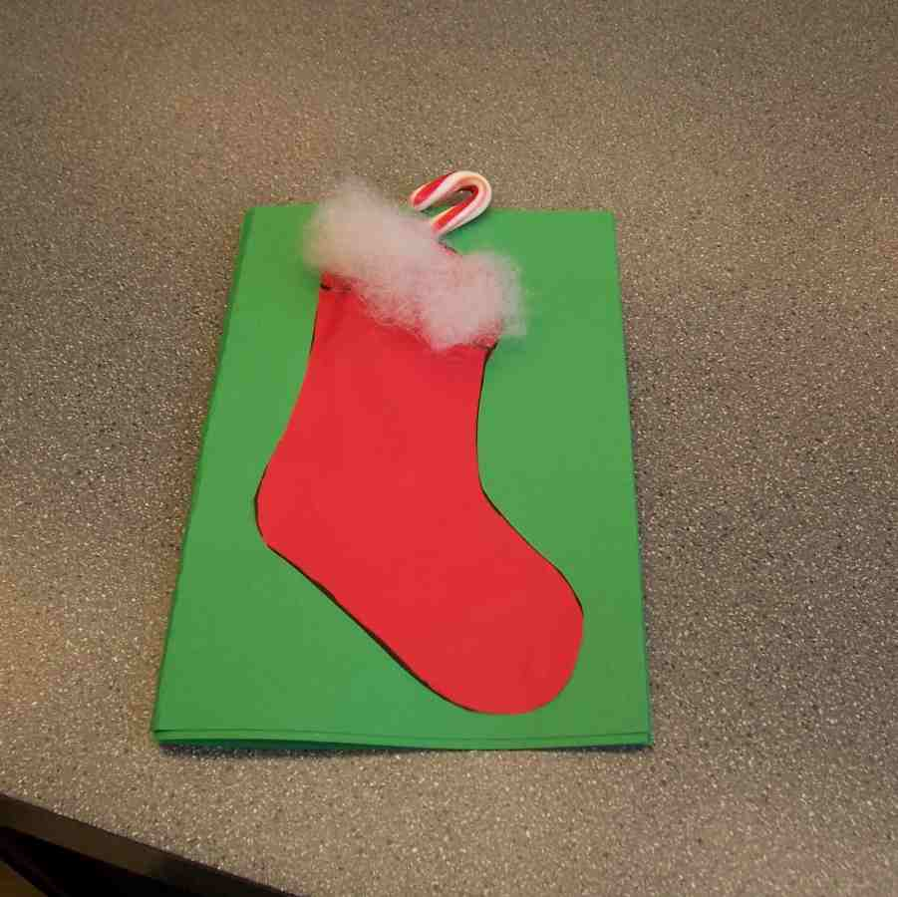
John 20:31 – But these

Closing prayer:
Thank God for His perfect and wonderful gift, Jesus. Pray for all to put their hearts in the treasures that last eternally. Have kids pray for the specific ways they will serve God and help others.

Safety and Security: Safety and security procedures are important for each church to carefully define and implement according to their unique needs. The security, safety, illness and accident procedures described in this curriculum are provided for example purposes only and may not be appropriate, applicable or adequate for every situation. Each church is responsible for determining whether any security, safety, illness and accident procedures contained in the curriculum are appropriate, applicable or adequate for its unique situation. The activities described in this curriculum require adult supervision and may not be suitable for each child and each situation. Each church is responsible for ensuring that adequate adult supervision is provided for all activities and for determining whether an activity is appropriate for each child and each situation. Kids Kount Publishing disclaims all liability for the implementation of any procedures or the performance of any activities described in this curriculum.

Large Group Presentation: 20-30 minutes

The Best Gift of All—Jesus
Series

This series looks at the book of John and how Jesus is the gift to each one of us. Each week a different object will be presented to remind the kids of Jesus. A child from the audience will have a chance to guess how the gift reminds them of Jesus.

Each week the gift is brought out with a sign that reads, “Jesus is the Gift.” The large group presenter who each week becomes the salesperson for the store “Gifts R Us” will introduce the gifts. The presenter will help lead the children to a different aspect of Jesus being the real gift.

Supplies: video/DVD – The Visual Bible, The Gospel of Matthew by Visual Bible International 1997, box wrapped like a gift with a removable lid, sign with “Jesus, the Best Gift” to go on the gift box, hand-shaped paper cut-outs, a treasure chest

Dao Dao Discovers True Treasure
Puppet Presentation

Presenter: Shall we welcome Dao Dao?

Children call for Dao Dao, who comes out full of energy and excitement.

Presenter: Dao Dao, I hope you had a great Christmas.

Dao Dao: I sure did and I love to talk about it.

Presenter: Did you talk about Christmas presents during the small group today?

Dao Dao: Sure, we put them in the treasure chest, but our treasure chest wasn’t big enough.

Presenter: Well, it was just an imaginary treasure chest.

Dao Dao: Well, then they didn’t imagine it big enough.

Presenter: Wow, your group must have a lot of presents.

Dao Dao: I don’t know if our group had a lot.

Presenter: I thought you said your group ran out of room in the imaginary treasure chest.

Dao Dao: We did run out of space. But, we ran out of time before I could share my Christmas gifts.

Presenter: Your gifts?

Dao Dao: Yeah. I have some cool gifts.

Presenter: But, Dao Dao, didn’t you listen to some of the other kids?

Dao Dao: I got a skateboard.

Presenter: Dao Dao.

Dao Dao: I got a cool GameBoy® soccer game.

Presenter: Dao Dao, what about the others….

Dao Dao: I got an electronic Battle Ship®. Bet you don’t have one of those.

Presenter: Dao Dao, I don’t. But, you are only talking about yourself…

Dao Dao: I got Monopoly®.

Presenter: I’m glad for you, Dao Dao, but…

Dao Dao: I got new underwear but that doesn’t count. I also got a bicycle helmet.

Presenter: Dao Dao.

Dao Dao: I got a new video.

Presenter: Dao Dao, you got a lot.

Dao Dao: I’m not even through yet, so please don’t interrupt me. I got a…

Presenter: Dao Dao, I am interrupting you.

Dao Dao: Well, what do you want now?

Presenter: Those Christmas presents seem pretty important to you.

Dao Dao: You bet.

Presenter: They seem like treasures.

Dao Dao: Of course, they are treasures.

Presenter: Do they make you happy?

Dao Dao: Well, they are fun to play with except for the underwear.

Presenter: Dao Dao, where are your presents from last year?

Dao Dao: I don’t play with them anymore.

Presenter: All of them?

Dao Dao: No, some of them have broken. Bummer, dude.

Presenter: And what about the others?

Dao Dao: Well, they are just boring now.

Presenter: But I thought you said Christmas presents were treasures.

Dao Dao: This year’s Christmas presents are.

Presenter: Dao Dao, you need to learn something about true treasure. The Bible says to stop storing up treasures for yourself on earth where they can break or become lost.

Dao Dao: Yeah. Sometimes my sister gets into my stuff.

Presenter: Yep. That can happen. So Jesus teaches us that these things, even toys, on earth aren’t the things to truly treasure. Listen to what is say in Matthew 6:20-21. “But store your treasures in heaven they cannot be destroyed by moths or rusts and where thieves cannot break in and steal them. Your heart will be where your treasure is.”

Dao Dao: I don’t get it. How do you store treasures in heaven? We can’t send our skateboards up there, can we?

Presenter: No, we can’t. But we can use our skateboards and any gifts to serve God. When we spend our time or a talent to serve God, we are storing up treasures for ourselves in heaven.

Dao Dao: I’m still not sure I understand.

Presenter: Well, let’s begin by watching this video from Matthew, chapter 2. This is when the wise men came to honor Jesus as the King of kings. They bowed down and worshiped Him. They opened their treaure chests and gave their most precious possessions to Him. Maybe you will discover how to do the same. Let’s watch.
Video Sketch
The Gospel of Matthew

Show movie The Visual Bible, The Gospel of Matthew , chapter 2:1-12. Produced by Visual Bible International, 1997.

Part 2 Demonstration—Gifts R Us Sketch

Give Gifts to the King

An assistant brings in a large box marked “Jesus, the Best Gift.” Inside this box is a treasure chest filled with paper hand-shaped cut-outs. On the cut-outs are kids’ names from Kingdom Quest, as well as Dao Dao’s name and the presenter’s name.

Dao Dao Discovers True Treasurers
Puppet Conclusion

Dao Dao: Oh, are we still talking about that box? Christmas is over.

Presenter: Remember we are Gifts R Us and we are still celebrating the best gift of all. Even though Christmas day is over, we are still remembering that Jesus is the best gift. As a matter of fact, Jesus is the best gift. Maybe you can remember the Bible verse John 3:16, or better yet, maybe we can all say it together. Ready, let’s say it together.

Optional: You may want to show the verse on the screen, overhead projector, or poster board for those who don’t have it memorized.

“For God loved the world so much that He gave
His only Son. God gave His Son so that whoever
believes in Him may not be lost, but have eternal
life.”

Presenter: In today’s video, we saw how wise men from the east came and worshiped the Baby Jesus. What gifts did they bring to Jesus?

Dao Dao: Gold, frankinstein and myrrh.

Presenter: No. Gold, frankinSCENSE, and myrhh. These were gifts fit for a king. They were very expensive and valuable at that time. The wise men recognized that Jesus was the Promised One that God had sent to the world. He was the King. Dao Dao, here is the question. What treasures do we have that we can give the King?

Dao Dao: Treasures. You mean like Christmas presents? I could give Him last year’s Christmas presents.

Presenter: Dao Dao, you could give Him this year’s Christmas presents.

Dao Dao: But how can I do that?

Presenter: Let’s call a volunteer from the audience and maybe he or she can answer some questions about storing up treasures.

Bring a volunteer up on stage.

Let’s ask our special guest. Here is the clue. Anything we do that can serve Jesus is giving Him a gift. If we used any of our toys to help others or use them to give glory to God, it is just like a gift to Him. Can you give me an example of how you can use a toy to serve the King?

Give an example for volunteer, if necessary, such as: You could share a toy with a friend that is feeling sad.

Presenter: Dao Dao, there are many other ways we can give treasures to the King. Let me open this treasure box and show you.

Open the gift box and pull out the treasure chest. Take some of the hand cut-outs from the treasure box.

Dao Dao: Wow, what do those hands mean?

Presenter: Well, these hands have names on them.

Dao Dao: Like mine.

Presenter: Yes, your name is here. So are mine and others. These hands remind us that all that we have, including our time and our abilities, can be used to serve God. We don’t serve God just on Sundays when we are in church. We serve God in the ways that we help others throughout the week. These hands remind us that we can help others. Dao Dao, can you think of a way to help someone?

Dao Dao: Well, yeah, there is this one second grader that gets picked on at school and I kinda watch out for him.

Presenter: That’s wonderful. That’s a way to serve God. And that’s like taking a treasure out of your treasure chest and giving it to the King.

Dao Dao: Wow! That’s pretty cool.

Presenter: Not only that, it’s stored up for you in heaven.

Dao Dao: What does that mean?

Presenter: Well, it means that when you get to heaven, you can hand to Jesus personally all the gifts of the things that you have done to serve God.

Dao Dao: I bet that would be fun.

Presenter: It sure would be. Remember, you don’t get to heaven by just doing good things for God.

Dao Dao: I know that. It’s only through the gift of Jesus.

Presenter: You’re right. It’s what He has done for us. And, because He has done so much for us, we want to give treasures back to Jesus. We want to *serve God—it’s a gift for Him and a treasure for us. So let us pray now.

Dear Jesus, thank You for coming as a King to this world and just like those wise men gave You gifts from their treasure chest, we want to give gifts to You also. Help us to *serve God because it’s a gift for You and a treasure for us. In His name, we pray. Amen.

Lesson 33

Small Group Warm-Up
- picture of treasure chest (see Appendix)

Large Group Presentation
      - box wrapped like a gift with a removable lid
      - sign with “Jesus, the Best Gift” to go on gift box
      - hand-shaped paper cut-outs with names printed on them (see presentation)
      - video/DVD – The Visual Bible, The Gospel of Matthew by Visual Bible International 1997 (order from www.amazon.com)
      - treasure chest

Small Group Application
      - construction paper
      - pens, pencils, markers
      - scissors
      - Helping Hands preprinted service ideas (see appendix)

Memory Verse Learning
      - eight cards with stockings. These cards are similar to lessons 31-32. Make eight cards like diagram below but let the top end opens like a pocket.
      - word strips with verse written
      - clothes-line
      - pegs

John 20:31 - But these | are written so that you | can believe that | Jesus is the Christ,  John 20:31 – But these
the Son of God. | Then, by belie-ving, | you can have life | through His name.”

