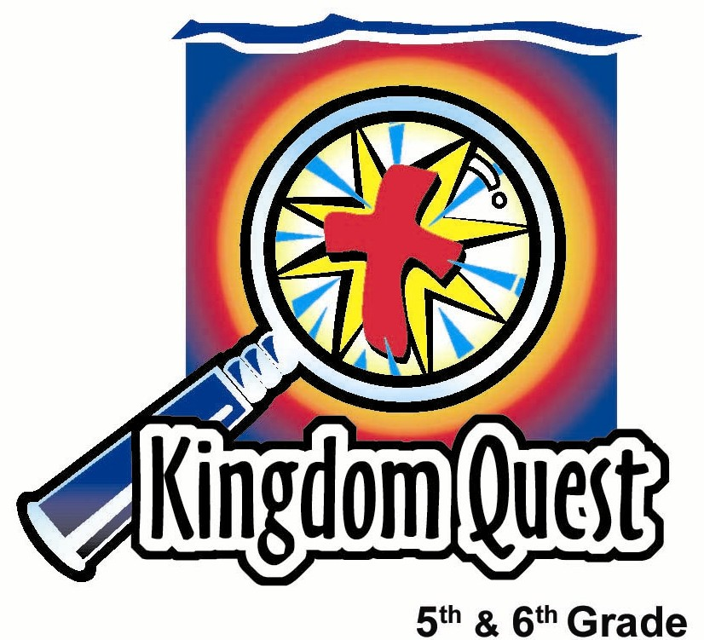
Date: ______________________
Series: A Whole New You (Sept-Nov)
Year 1, Lesson 21

A New Heart

Take Home Point: *Trade in your hard-heartedness for a new heart in Christ.
*Repeat this phrase throughout the lesson.

Bible Event: Sections concerning Pharaoh’s hard heart (Exodus chapters 4-11.)
Key Verses: 2 Corinthians 5:17: “If anyone belongs to Christ, then he is made new. The old things have gone; everything is made new!”

Ezekiel 36:26: “...I will put a new way to think inside you. I will take out the stubborn heart like stone from your bodies. And I will give you an obedient heart of flesh.”

We will help kids know:
- The heart is the center of our desires and thoughts. When the Bible speaks about “the heart,” this can mean our attitude toward God.
- A hard heart is stubbornness toward God. It says, “I don’t want your way, God. I want my way.”
- We should not try to retain a hard heart, but rather trade it in for a whole new heart that Jesus will give us – a heart like His.
- God gives us a new heart when we humble ourselves and come to Him to receive Jesus’ forgiveness and filling in our new hearts.

We will help kids feel:
- Conviction over their hard-heartedness if they are stubborn toward God by resisting His influence in their life.
- Security and joy when God gives them a new heart through faith in Jesus.

We will help kids do:
- Identify hard-hearted attitudes in their life.
- Pray to trade in their hard hearts for a new heart from God.
- Trust in Christ as their Savior.
THIS LESSON’S ROADMAP

DESTINATION | PAGE # | DISCOVERIES ON YOUR JOURNEY | SUPPLIES NEEDED
Small Group Warm-Up   | 3 | The hard candy shell of a Tootsie Roll pop illustrates a hard heart…not caring what God thinks. Learn how God removes our hard hearts. | - a “Dynamite” choco-filled mint sweet per student
Large Group   | 4  9-11  10 | Overview  Dramatic Presentation: “Mah Morphesus – Discovery of a New Creature”  A specialist in discovering new species, introduces his study of creatures called “new believers.” In the next weeks, he will be studying these different parts of the new believer—a new heart, mind, eyes, ears, hands, and feet.  Video: Prince of Egypt. (Dreamworks Home Entertainment, Inc. 1999). Show the video clip from 1 hour 1 minute…where Ramses is on the boat and Moses is on the bank saying, “Ramses, let my people go.” End it 5 minutes, 47 seconds later at 1 hour, 6 minutes, 47 seconds. It will be before the tenth plague, after song ends and darkness sweeps across the land. | - explorer or scientist outfit  - plastic butterfly, or some butterfly-likeness, simulated cocoon made from wetted and dried paper or a wad of masking tape.  - a paper mache heart with an inflated heart-shaped balloon inside of it. See script. Page 8.  - roll together a three-foot piece of newspaper, taping it tightly so it maintains its shape.  - hammer with a cross taped to it.  - a Bible  - labels in the shape of a cross  - video: Prince of Egypt
Small Group Application   | 4-7  8 | Kids examine both Pharaoh’s heart and their hearts. Are they hardened? What may occur in our lives if our hearts aren’t changed?  Memory Verse Learning:  “Ball Toss”  2 Corinthians 5:17. This verse will remain for lessons 21-24 to reinforce the truth that in Christ the children are new creations. | - a wrapped “Dynamite” choco-filled mint sweet  - a hammer with a cross drawn on it  - soft (not stale) “Dynamite” choco-filled mint sweet  - Beach Ball
Small Group Warm-Up: 15 minutes
Purpose: Get pointed in the right direction! Build relationships and help guests feel at ease. Do the learning readiness activity that will point your group in the right direction for the lesson.
As kids gather: Listen to memory verses from last week and give coupons for memory verses, remembering to bring your Bible, and bringing a guest.
Begin: Review the group covenant signed by all. This can be as simple as reading it and reminding all that they have signed it. (See lesson 16.) Welcome new kids and invite them to sign the covenant.

Supplies needed: a “Dynamite” choco-filled mint sweet per student

- Give each kid a Dynamite” choco-filled mint sweet after they answer the following discussion starter. Explain that they can start eating the sweet but the objective is to see how long they can make the Dynamite” choco-filled mint sweet last. They will have to put the sweet back into the wrapper when it’s time to go to large group, but they will get it back after large group.

Discuss the following:

Tell about a time when your mom or dad wanted you to do something and you just did not want to. Instead you wanted to do what you wanted to do.

I’ll go first with my story…

- After everyone has shared, let students compare their “Dynamite” choco-filled mint sweet. Have them pay particular notice to the hard sweet surface.

The hard outer shell reminds us of our hearts when we are stubborn. The Bible calls it being hard-hearted. It’s when we say, “I don’t care what you want from me, God, I will do what I want.”

Give some examples of people who might do something and not care what God thinks. Instead they just do what they want to do because their heart is hardened or stubborn at that time.

Today we are going to learn how God removes our hard hearts and gives us a new heart…a whole new heart like the heart that Jesus had. God wants us to *trade in our hard-heartedness for a new heart in Christ.

Large Group: 20-30 minutes
Purpose: Help kids observe what the Bible says. Present the Bible Event in creative fashion. Help kids begin to interpret what it means.

Supplies needed: explorer or scientist outfit; plastic butterfly, or some butterfly-likeness, simulated cocoon made from wetted and dried paper or a wad of masking tape; a paper mache heart with an inflated heart-shaped balloon inside of it. See script. Page 8.; roll together a three-foot piece of newspaper, taping it tightly so it maintains its shape.; hammer with a cross taped to it.; a Bible; labels in the shape of a cross; video: Prince of Egypt

Overview

Dramatic Presentation: “Mah Morphesus Discovers a New Creature”
A specialist in discovering new species introduces his study of creatures called “new believers.” In the next weeks, he will be studying these different parts of the new believer—a new heart, mind, eyes, ears, hands, and feet.

This week, Mah Morphesus focuses on God softening our hard hearts through Jesus. The example he gives of a hard heart is the Egyptian Pharaoh from the video.

Video: Prince of Egypt. (DreamWorks, Inc.)

Small Group Application: 20-25 minutes
Purpose: Help kids map out the meaning of the Bible event in their lives. Use the questions to stimulate discussion, but don't feel tied to them. Allow the Holy Spirit to guide you. Include personal examples from your own faith journey. The example of Christ at work in your life will leave lasting impressions of how Christ can work in the children's lives.

Use your Bibles! Children need to learn how to look up references and follow along when scripture is read aloud. Allow for quality time of prayer at the close of the lesson.

Supplies needed: a wrapped “Dynamite” choco-filled mint sweet; a hammer with a cross drawn on it; soft (not stale) “Dynamite” choco-filled mint sweet

Observation Questions: What does it say?
Have kids look up the following passages in their Bibles and discuss. Do not feel like you have to read all the passages. These are some suggestions. Follow the Holy Spirit’s leading. (In God’s Word for the Nations translation, “hard-hearts” is replaced with “stubborn.”)

The following passages mention how many times Pharaoh experienced a hard heart. Instead of reading each verse you may say:

The Bible mentions Pharaoh’s hard heart in: Exodus 4:21; 7:3, 14,22; 8:15,19,32; 9:7,12,34,35; 10:1,20,27; 11:10. (Kids may try and look up as you are giving the reference but don’t pause too long.)

How many times does it say Pharaoh’s heart was hard? (Fourteen times.)

Interpretation Questions: What does this mean?

Why do you think God mentions this so many times? What does this tell us about Pharaoh’s perspective of the one true God? Why do you think Pharaoh would not soften his heart toward God even though he was given so many chances? How did God try and soften Pharaoh’s hard heart? (God sent the plagues to show Pharaoh His might and to convince him that God was more powerful than any Egyptian god.)

Each plague became more severe until God crushed Pharaoh’s heart by killing all Egyptian first-born children including Pharaoh’s own son.

What do the following passages tell us about hardened or stubborn hearts? How does God respond to hard-hearted people?

Be sure to read Ezekiel 11:19. Choose among the following passages according to your time. Point out that continuing in sin builds a hard wall between God and us. God’s power works against those who resist him.

Zechariah 7:12 “They made their hearts as hard as rock. They would not listen to the teachings of the Lord of heaven’s armies. And they would not hear His words through the earlier prophets. So the Lord of heaven’s armies became very angry.”

Proverbs 28:14 “Those who always respect the Lord will be happy. But those who are stubborn will get into trouble.”

Romans 2:5: “But you are hard and stubborn and refuse to change. So you are making your own punishment greater and greater on the day God shows His anger…”

Proverbs 29:1 “Some people are still stubborn after they have been corrected many times. But they will suddenly be hurt beyond cure.””

Hebrews 3:13: “But encourage each other every day. Do this while it is “today”. Help each other so that none of you will become hardened because of sin and its tricks.”.”

Ezekiel 33:11: “The Lord God says: As surely as I live, this is true. I do not want a wicked person to die. I want him to stop doing evil and live…”

Application Questions: What does this mean to me?

Give an example of something that happened in school this week that showed a hard-hearted attitude.

Give an example of a hard-hearted attitude that you saw on TV or the news. Remember, it’s an attitude that says, “I’ll do what I want, God, and I don’t care what You want.”

Give an example of how you might have been hard-hearted this week. (Don’t push too hard for answers if kids aren’t ready to talk about it.)

God does not want us to remain hard-hearted. (Ezekiel 33:11) Just like He did with Pharaoh, God gives us many chances to turn to Him. If we remain stubborn, God may do things in our lives to crack our stubborn hearts. Often times He just lets us experience the consequences of our sin until we are in such a mess, we have nowhere else to go but to Him.

- Hold up a wrapped “Dynamite” choco-filled mint sweet and say:

- We are all like this by nature. We have a hard outer shell. Tap the “Dynamite” choco-filled mint candy twice on a hard surface like a table. (tap tap)
We might say to ourselves, “I want to do things my way.” (tap tap)
“God, I don’t want to do things your way.” Does this sound like Pharaoh? (tap tap)
“I want to be God.” (tap tap)
“I am my own God, I don’t need another.” (tap tap)
“I’m not a sinner, I just make mistakes like everyone else.” (tap tap)
“I don’t need a savior, I’ll get to heaven on my own.” (tap tap)

- Now, use a hammer with a cross drawn on it to hit the Dynamite” choco-filled mint sweet after each of the following phrases. Be sure the kids see the cross.

God in His mercy will try to break through our hard-heartedness.
(tap tap)
There is a God and you aren’t Him. (tap tap)
He says there is such a thing as sin and sinners and you are one.
(tap tap)
I admit that I need God. I am a sinner. (crack)

Continue with:

At first, sin might look like fun, but it will destroy your life and your happiness. God says to us, “Repent, turn to Me and give me your sin.”

Pull off the sweet wrapper and say:

See all the shambles that hard-heartedness can bring? God wants to break all of that away so He can get to the soft part inside.

- Pass out “Dynamite” choco-filled mint sweet and let kids put them in their mouths.

- Close your eyes and think with me while you chew the soft “Dynamite” choco-filled mint sweet.

Let’s think now about a soft heart.

God, make our hearts soft toward You.
I am sorry for my sin.
I need a savior.
Jesus, I know You gave Your life for me and died for my sin.
I turn my sin over to You.

Hear these promises God gives us when we soften our hearts to Him:

Ezekiel 36:26: “I will put a new way to think inside you. I will take out the stubborn heart like stone from your bodies. And I will give you an obedient heart of flesh” (Ezekiel 11:19 is similar.)

Jeremiah 24:7: “I will make them want to know me. They will know that I am the Lord. They will be my people and I will be their God. This is because they will return to me with their whole hearts.”

What will you choose? A hard heart like Pharaoh or a heart softened toward God? *Trade in your hard-heartedness for a new heart in Christ.

Memory Verse Learning: 5 minutes
Purpose: Help kids to memorize and keep scriptures at heart. Using creative ways to help kids enjoy learning the key verse and in small group setting.

Supplies needed: a beach ball.

Memory Verse: 2 Corinthians 5:17: “If anyone belongs to Christ, then he is made new. The old things have gone; everything is made.”

MV Presentation: “Ball Toss”
Have the children stand in a circle. Toss a ball to a child and the child who catches the ball will have to say the first sentence. He/she will toss the ball to another child who will say the next sentence. Continue tossing the ball until the entire verse has been recited. Repeat the game as time permits.

Prayer Time:
Thank God that in Christ we have forgiveness of our sins and as a result we are all new creations. That God will help us to live our life in a brand new way with a heart that is changed to be like Christ.

Large Group Presentation

“Mah Morphesus – Discovery of a New Creature”
Introducing ”A Whole New You” Series

Material:
- explorer or scientist outfit for Mah Morphesus
- plastic butterfly, or some butterfly-likeness, simulated cocoon made from ruined paper or a wad of masking tape
- a paper mache heart with an inflated heart-shaped balloon inside of it. Prepare this by placing a heart-shaped balloon inside another heart shaped balloon and inflating the interior balloon to about half size. Tie it off tightly. Next inflate the outer balloon and tie it off. This outside balloon is then paper mached and left to dry. Pop the outer balloon when paper mache is dry.
Optional: Paint the outside shell gray to look like a rock. When the hardened outer shell is broken with a hammer the inflated interior balloon will be revealed.
- roll together a three-foot piece of newspaper, taping it tightly so it maintains its shape
- hammer with a cross taped to it
- a Bible
- labels in the shape of a cross

Hello, I’m Mah Morphesus, the famous explorer and discoverer of new species. My specialty is to find creatures that have emerged as new from something old. A-HA, here I have one. You see this butterfly (Hold up butterfly.) has emerged new out of something old, a cocoon. (Hold up cocoon.) Very interesting. But of all the creatures who come out as new creatures, the most interesting is one called “a believer and talking about these next six weeks.

For today’s lesson I need a volunteer who believes in Jesus as his/her Savior and Lord.

Bring forward a volunteer from the audience.

And now, let’s examine this person as described in our “New Creatures Manual.” (Hold up Bible.) Here in 2 Corinthians 5:17. (Read from the Bible.)

The next few weeks, we will study this new believer in Christ, a new creation. We will talk about a new way of living and examine a whole new set of parts used in this Christian life.
Let me label them for you. We will have (affix cross shaped labels to the following body parts on the “new creation” volunteer.) a new heart, new mind, new eyes, new ears, new hands and new feet. AAH, see all these wonderful new parts a believer has? We will talk about these new parts each week, and today we will talk about a new heart.

Have the volunteer find a seat close to the front. Hold up the paper mache heart and say:

This is not an ordinary heart, but a hard heart. (With each explanation, thump the hard heart.) A hard heart is a heart that says, “I don’t care what you want, God, I want to do everything my way.” (Thump.) A hard heart also says, “I want to be God here, so I don’t need You.”(Thump.) A hard heart is stubborn against God and refuses to obey him. (Thump.)

Show the video film clip from Prince of Egypt (Dreamworks Home Entertainment, Inc. 1999). Show the video clip from 1 hour 1 minute…where Ramses is on the boat and Moses is on the bank saying, “Ramses, let my people go.” End it 5 minutes, 47 seconds later at 1 hour, 6 minutes, 47 seconds. It will be before the tenth plague, after song ends and darkness sweeps across the land.

Can you see how Pharaoh’s heart was hardened against obeying God? Because of Pharaoh’s hard heart, God brought destruction on his entire kingdom and finally, on Pharaoh’s own family and his own life. Being hard-hearted against God is a dangerous thing to do. But God wants to crack our hard-heartedness so that we may become new creations. Now I’m going to set the hard heart on the table and give the believer two tools that might break open this hard heart.

The first tool is this rolled up newspaper. Why don’t you give it a few slugs and see if you can break the heart. (These attempts will be futile but set up the following explanation).

Many people have hard hearts today and many stubbornly refuse to obey God. If they listen to society and the world around them, the world says, “What you’re doing is just fine.” (Hold up the rolled up newspaper.) Some of the messages in the newspaper or in the world around us would likely not find anyone worried about sin or rebelling against God. Instead, the world around us says, “You can be your own God and you don’t have to listen to what God says. Make up your own rules.” You also may hear the message, “That’s not sin, everyone does it so it’s okay.” If we listen to these messages, our hearts will stay hard-hearted.

Now let’s try this tool. It is a hammer but it has a cross on it. How might that break our hard hearts? You know that Jesus died on the cross. And it was a horrible death. Jesus died a horrible death because rebellion against God is such a horrible thing. God must punish a horrible thing such as our sin. But God sent Jesus into the world to die for us. When we repent and say we are sorry for our sins and turn to Jesus for forgiveness, with the power of his cross, He shatters our hard heart and breaks it open.

(Break open the paper mache heart.) Now, God replaces our hard hearts with a soft heart. (Show the inside inflated balloon.) In Ezekiel 36:26 God says, “I will give you a new heart and put a new spirit in you. I will remove your stubborn hearts and give you obedient hearts.”

When we believe in Jesus, we become new creatures, and we have a new heart. We also receive new minds, eyes, ears, hands and feet, but we’ll talk about these in the future weeks.

LESSON 21
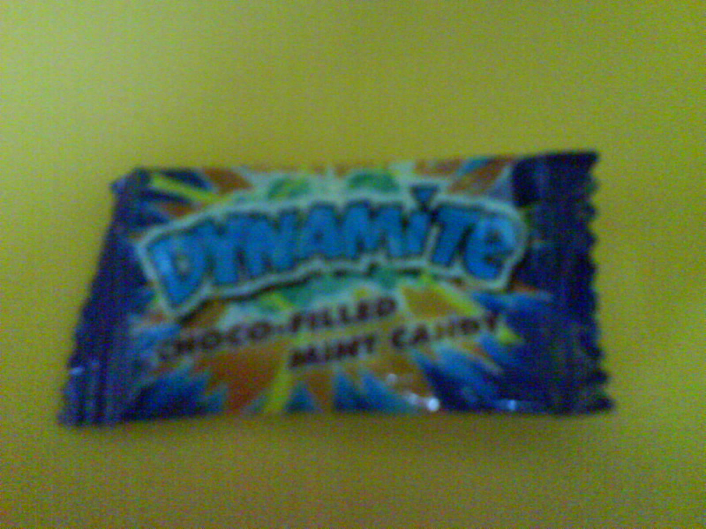

Small Group Warm-Up
- a “Dynamite” choco-filled mint sweet per student

Large Group
- explorer or scientist outfit
- plastic butterfly, or some butterfly-likeness, simulated cocoon made from wetted and dried paper or a wad of masking tape.
- a paper mache heart with an inflated heart-shaped balloon inside of it. See script. Page 8.
- roll together a three-foot piece of newspaper, taping it tightly so it maintains its shape.
- hammer with a cross taped to it.
- a Bible
- labels in the shape of a cross
- video: Prince of Egypt

Small Group Application
- a wrapped a “Dynamite” choco-filled mint sweet
- a hammer with a cross drawn on it
- soft (not stale) a “Dynamite” choco-filled mint sweet

Memory Verse Learning
- Beach Ball

