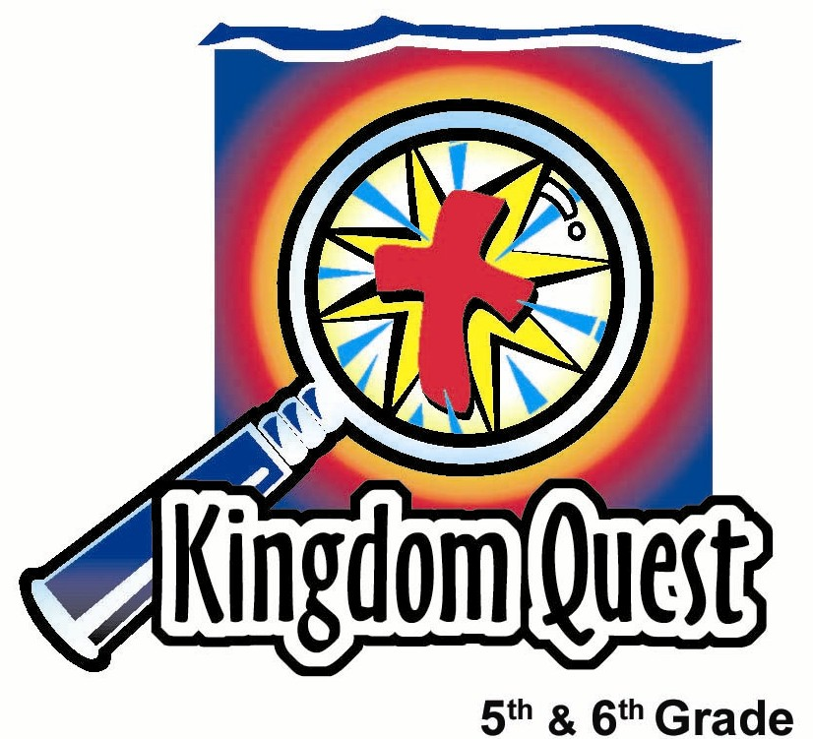
Date: _________________________
Series: Labor Day (Sep-Nov)
Year 1 Lesson 15

New Friends—New Year

Take Home Point: *Include others just as Jesus includes you.
*Repeat this phrase throughout the lesson.

Bible Event: Acts 10:22-48, Cornelius the Gentile
Key Verses: John 15:12-13, “This is My command: Love each other as I have loved you. The greatest love a person can show is to die for his friends.” (NCV)

We will help kids know:
- Jesus’ life and death in our behalf includes us into God’s family.
- We, too, can include others as we accept one another and build friendships in the church.
- The Bible event of the Gentile, Cornelius, and how he was included into the early church, which had few Gentiles.

We will help kids feel:
- Excitement as the year begins.
- Accepted and encouraged as members of the church.

We will help kids do:
- Play a simulation game to experience exclusion and inclusion.
- Help each other make a Friendship Rojak to create team unity.
- Pray for one another.
THIS LESSON’S ROADMAP

DESTINATION | PAGE # | DISCOVERIES ON YOUR JOURNEY | SUPPLIES NEEDED
Small Group Warm-Up   | 3-4 | An elimination game is played to exclude one child (temporarily) from getting a piece of sweet. This is a simulation of what it feels like to be included and excluded. | - one “San Cha Peng” for each student  - one spoon per group
Large Group   | 4  8-10  9  9-10 | Overview  Bible Event: the Visual Bible, Acts, showing Acts 10:22-48.  Video Clip: A three-minute clip from the movie, “The Sandlot” will emphasize how to include others as friends.  Large Group Game: Strung Together: Kids will play a relay game threading a spoon and yarn through the sleeves of each team member until all our connected in a circle. They then discuss how this is like the church. | - video: “The Visual Bible, Acts”  - video: “The Sandlot”(PG) Youth Specialties and Alive Communications. ISBN 0-310-23115-9, 1999. Start at 19:30 and stop at 22:18.  - a thirty-foot piece of yarn tied to a spoon for each group
Small Group Application   | 4-7  7 | Kids discuss the Bible event and make Friendship Sundaes to create team unity.  Memory Verse Learning:  “50 Hearts”  John 15:12-13 is recommended for lesson 15-17 so the children would desire to be selfless towards others in the Lord. | - one bowl and one spoon per student  - rojak sauce  - varieties of fruits cut into wedges for rojak  - serviettes  - a set of 50 hearts for each team  - masking tape  - mahjong paper  - whiteboard and marker

Small Group Warm Up: 15 minutes
Purpose: Get pointed in the right direction! Build relationships and help guests feel at ease. Do the learning readiness activity that will point your group in the right direction for the lesson.
As kids gather: Listen to memory verses from last week and give coupons for memory verses, remembering to bring your Bible, and bringing a guest.
Begin: On this holiday weekend, there often is excitement about the school year starting, and yet, the attendance may be low. Use this as a Sunday to build excitement about the new school year and being together at church. Take into account that not everyone will be in attendance.

An Exclusion Experience
In this experience, one of the students will be excluded and the entire group may feel the pain of that exclusion, yet it is just temporary. Be sensitive not to push the experience so far that a child’s feelings are crushed.

Supplies needed: one “San Cha Peng” for each student; one spoon per group

Begin with:

Today is a special Sunday. We are starting the new year and meeting new friends. I want you to know that as your shepherd, I will do everything I can to give you good guidance and will be an adult friend to you. So, I brought some “San Cha Peng” to share.

Show one less piece of “San Cha Peng” than the number of students present. Then say:

Oops, we are short one piece of “San Cha Peng”. I guess I don’t have enough for everyone. To make it fair, we will play an elimination game to see who gets the tit-bits. We will play One Potato, Two Potato. Put both of your fists in the middle of the circle and I will tap them with this spoon as I go around the circle. The person who has both fists removed will be eliminated and will not receive a piece of “San Cha Peng.”

Chant goes like this:

One potato, two potato, three potato, four
Five potato, six potato, seven potato more.

Explain that the last fist you tap on the word, “more” has to be taken out of the circle. Continue until one kid has both fists eliminated.

Give the “San Cha Peng” to everyone but that child and say:

I’m sorry, but sometimes that is the way it goes. We don’t always get what we want. I guess for everyone else it feels good to get that tit-bit, doesn’t it… or does it?
How does it make you feel when one of your friends is left out and doesn’t get a piece of “San Cha Peng”? Share a time when you felt left out. How did you feel?

You may need to begin the discussion with your own experience. After the discussion, give the left out child a piece of “San Cha Peng”and say:

Today, we will talk about what it means to accept one another and how it feels when we exclude one another. Jesus did a lot to include us into his family. As a church, we want to make sure we have that same attitude toward others. We want to *include others just as Jesus includes us. Let’s think of ways we can do a great job of including new people or anyone feeling left out.

Large Group: 20-30 minutes
Purpose: Help kids observe what the Bible says. Present the Bible event in creative fashion. Help kids begin to interpret what it means.

Supplies needed: video: “The Visual Bible, Acts”; video: “The Sandlot”(PG) Youth Specialties and Alive Communications. ISBN 0-310-23115-9, 1999. Start at 19:30 and stop at 22:18.; a thirty-foot piece of yarn tied to a spoon for each group

Overview

Bible Event: the Visual Bible, Acts, showing Acts 10:22-48.

Video Clip: A three-minute clip from the movie, “The Sandlot,” will emphasize how to include others as friends. Marketed by Youth Specialties and Alive Communications. ISBN 0-310-23115-9, 1999. Start at 19:30 and stop at 22:18.

Large Group Game—Strung Together: Kids will play a relay game threading a spoon and yarn through the sleeves of each team member until all our connected in a circle. They then discuss how this is like the church.

Small Group Application: 20-25 minutes
Purpose: Help kids map out the meaning of the Bible event in their lives. Use the questions to stimulate discussion, but don't feel tied to them. Allow the Holy Spirit to guide you. Include personal examples from your own faith journey. The example of Christ at work in your life will leave lasting impressions of how Christ can work in the children's lives.

Use your Bibles! Children need to learn how to look up references and follow along when scripture is read aloud. Allow for quality time of prayer at the close of the lesson.

Observation Questions: What happened?
Have kids refer to Acts 10:22-48 in their Bibles to answer the following:

What was Cornelius’ occupation? (Acts 10:22. He was a Roman army officer.)

What did Cornelius think about the one true God? (Acts 10:22. He had respect for God and had God’s approval.)

What did the Jewish people think of Cornelius because of this? (Acts 10:22. They had respect for him, also. Note: Explain that this was very unusual because the Jews did not like the Roman government that ruled over them.)

What did Peter say as he entered Cornelius’ home? (Acts 10:28. “You people understand that it is against our Jewish law for a Jew to associate with or visit anyone who is not a Jew. But God has shown me that I should not call any person ‘unholy’ or ‘unclean.’)

Why did Cornelius send for Peter? (Acts 10:30-32. God told him to.)

In verses 45-47, the Bible says that all the non-Jewish believers received the gift of the Holy Spirit just as the Jews did on Pentecost. So Peter ordered that they too should be baptized in the name of Jesus Christ. How did the non-Jewish believers respond to Peter? (Acts 10:48. They asked him to stay with them for several days.)

Why do you think they did this? (Because they had become friends and wanted to fellowship with Peter. Perhaps they wanted him to teach them more about Jesus.)

Interpretation Questions: What does this mean?

Why do you think God would want Peter to go and visit Cornelius? Was it more for Cornelius’ benefit or for Peter’s?

What do you think Peter learned from this? What do you think Cornelius and the non-Jews learned?

For whom did Jesus come to earth and die on the cross? (All people) How should we treat others, even those who are different from us?

Application Questions: What does this mean to me?

Friendship Rojak
Supplies needed: one bowl and one spoon per student, rojak sauce; varieties of fruits cut into wedges for rojak, serviettes

Explain to the kids that this is a Friendship Rojak because they cannot put any of these ingredients on their own bowl, but they can use their spoon to put ingredients on other people’s bowl. However, there is one other catch. No one can ask for an ingredient but they can ask another if they can put ingredients on their bowl. Say something like the following.

You cannot ask for anything to be put on your rojak, however, you can answer, “yes” and “no.” So, someone next to you can ask you if you want some pineapple. Then you can say, “yes” or “no.” They then will use their spoon to put pineapple on your bowl. If you want mango, but no one asks you if you want them, that’s too bad. But another way to hint you want mango is to ask someone if they want mango. If they say no, you might keep asking others if they want mango until finally someone gets the idea that you want to be asked to have mango.

While the kids eat their rojak, tell them the following story:

One time a man had a dream. In the dream he had a chance to see what was going on in Hell. There he saw a large table with fine and wonderful food. But everyone around the table was thin and weak. They were starving to death. You see each one of them had ten-foot long spoons and they could not eat any of the food, because they could not get the spoons into their mouths.

Then the man had a dream of Heaven. There, too, was a large table filled with fine and wonderful food. Everyone there was happy and well fed. They also had ten-foot long spoons. What was the difference? Can you guess? Right. They fed each other.

Of course, this was just a dream, but how is this like what we can do as the church today?

What are ways you can welcome someone visiting church for the first time and help him or her feel included?

Our key verse for today from John 15:12-13 says, “This is my command: Love each other as I have loved you. The greatest love a person can show is to die for his friends.”

We know that Jesus gave his life for us when he died on the cross for the punishment of our sins. He did this so we can be included in His family and live with Him forever in Heaven. But how can we lay down our life for our friends? What about kids in our group? (Help kids see they give of themselves when they think of the needs of others before their own needs. They can behave selflessly and go out of their way to help others, especially to not forget to include someone new or shy.)

Today we learned to *include others just as Jesus includes us.

Memory Verse Learning: 5 minutes
Purpose: Help kids to memorize and keep scriptures at heart. Using creative ways to help kids enjoy learning the key verse and in small group setting.

Supplies needed: a set of 50 hearts for each team; masking tape; mahjong paper; whiteboard and marker

Memory Verse: John 15:12-13 ~ ““This is My command: Love each other as I have loved you. The greatest love a person can show is to die for his friends.”

MV Presentation: “50 Hearts”
Before class use masking tape to tape the 50 hearts on mahjong paper randomly. (See picture) During memory verse presentation, write out today’s Bible verse on whiteboard and recite several times with the children. Tell them it will be helpful to them if they remember this verse by hard before the start of a game – “50 hearts.” Now paste the mahjong paper on whiteboard and explain to the children that they have to take turns in a relay to come pick a heart, look behind it to see if it has a word of the memory verse. If it has, he/she takes it back to the group. If it is blank, leave the heart there, run back and tag the next person. As team members are getting the hearts, the rest of the team at their base can arrange the hearts into today’s Bible verse. The first team to complete the verse wins.

Prayer Time:
Thank Jesus that He gave His life to include us into His family. Pray that all would remember to include others just as Jesus includes us. Pray for the Holy Spirit to help kids remember ways they can give of themselves.

Large Group Presentation

New Friends—New Year

Supplies needed: Video: “The Visual Bible, Acts” and the video: “The Sandlot”

Introduction
Let’s start with remembering a very important point, *Include others just as Jesus includes you.

In your small groups you discussed what it was like to be left out of a group. If there is any one place where we want to feel included, it is here at church. At the beginning of this new school year, we are asking that each person will do what he or she can do to include others, just as Jesus included you into His family when He gave His life for you. How much did it cost? What did God have to do to include you into His family?

The Bible verse for the day from John 15:12-13 says, “This is My
command: Love each other as I have loved you. The greatest love a
person can show is to die for his friends.”

That is how far God went to include you. He gave His life for you so you can include new people into your group throughout this year. This will help them become friends with God as well.

Video introduction
Our video today is straight from the Bible. In the book of Acts, Jesus had already died and rose again but He had sent the Holy Spirit to fill people’s lives so that they could continue to do His important ministry. One of the early leaders of the church was Peter, one of Jesus’ closest friends.

Peter was a Jew. Jews typically did not like Romans or other non-Jews. God had chosen the Jews to be His people because of the promise He made with Abraham. God wanted the Jews to be a witness against idolatry, to show the blessings of serving the one true God, to receive the written Word of God and pass it on, and to be the family through whom the Messiah would come.

In order for this to happen, God wanted the Jews to remain apart from the idolatrous religions of the rest of the world. In some ways the Jews thought the Gentiles were not fit to be brought into God’s kingdom. So they were not to be included. But God showed Peter this was no longer the case. There was a Roman soldier named Cornelius. He was not a Jew, but he desired a relationship with God, as well as the Jews. This is what happened when God invited him into His family.

Show the Visual Bible, Acts, from Acts 10:22-48. You may have the kids also follow along in their Bibles.

Through Cornelius, God showed Peter, a leader of the early church, that now all believers of the one true God, from all races were to be included into God’s family.

How can we include others?
Since God includes us into His family by giving us Jesus who gave His life up for us, then you can see how important it is that we include others. Let’s watch this next video clip from the movie, Sandlot, and see if you can tell me how this movie is similar to the church and what we need to do as believers in Christ.

Show the three-minute video clip from The Sandlot. Marketed by Youth Specialties and produced by Alive Communications. ISBN 0-310-23115-9, 1999. Start at 19:30 and stop at 22:18.

Large Group Game: “Strung Together”
Supplies needed: a thirty-foot piece of yarn tied to a spoon for each group

Divide kids into teams of boys and teams of girls with the same number of kids in each team. Say:

To remind us how we are all connected together, we will play a game called, Strung Together.

Explain that the object of the game is to thread the whole team together by using the spoon with the yarn as a needle and thread and passing it up one sleeve of the first kid’s shirt threading out through the other sleeve and passing it along to the next person who also threads it through both his/her sleeves and passes it along to the next person. When the spoon/yarn is threaded through all team member sleeves, tie the spoon to the other end of the yarn making the team form a circle.

Once a team has tied the spoon to the other end of the yarn and formed a circle, have the team sits down. When all groups have been seated, continue with:

This seems like a silly game but it can remind us of the church. How do you think this game might be like the church? (People have to work together for a common goal. Each person is a part. We need to help each other. The church is a place to come together.)

Take two or three answers and then adjourn with prayer.

Dear Father, Thank You for letting us be Your friends by giving us Your Son, Jesus. Sometimes it is easy as the church not to think about new people or how important it is to make new friends. Sometimes we just become comfortable in our own group. Forgive us for any times that we have not included others. Help us this year to invite new friends into our church and into our groups. Help us work together to have a great time learning about You. In Jesus’ name we pray, Amen.

Lesson 15

Small Group Warm-up
- one small “San Cha Peng” for each student
- one spoon

Large Group Presentation
- video: “The Visual Bible, Acts”
- video, “The Sandlot”(PG) Youth Specialties and Alive Communications. ISBN 0-310-23115-9, 1999. Start at 19:30 and stop at 22:18.
- a thirty-foot piece of yarn tied to a spoon for each group

Small Group Application
- one bowl and one spoon per student
- rojak sauce
- varieties of fruits cut into wedges for rojak
- serviettes

Memory Verse Learning:
- a set of 50 hearts for each team. Cut 50 hearts from pink manila card. Write a word of John 15:12-13 on each heart. As for the remaining hearts, write other words that do not belong to John 15:12-13. This is to confuse players so you can misspell words.
- masking tape
- mahjong paper
- whiteboard and marker

