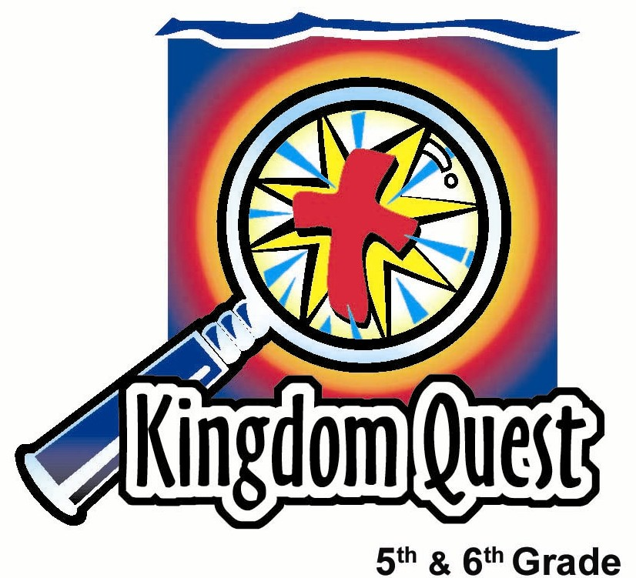
Date: _________________________
Series: Fitting In and Finding Friends (Sep-Nov)
Year 1, Lesson 16

Let’s Make a Deal for True Friendship

Take Home Point: *Commit to being friends in Christ.
*Repeat this phrase throughout the lesson.

Bible Event: 1 John 3:16-18; 23
Key Verse: 1 John 3:23: “This is what God commands: that we believe in his Son, Jesus Christ, and that we love each other, just as he commanded.” (NCV)

We will help kids know:
- Christian community is vital to one’s spiritual growth. We need to invest in each other so we all may grow in Christ.
- Jesus invites them into friendship with himself through what he has accomplished on the cross. When we receive his forgiveness, we are friends with God.

We will help kids feel:
- The fun of getting to know friends who are Christians.
- Commitment to one another.

We will help kids do:
- Play several community building games to help the kids get to know each other.
- Sign a covenant, which expresses their intent for spiritual growth and commit-ment in their group.

THIS LESSON’S ROADMAP

DESTINATION | PAGE # | DISCOVERIES ON YOUR JOURNEY | SUPPLIES NEEDED
Small Group Warm-Up   | 3-4 | Most of this lesson is dedicated to getting acquainted. Usually the kids gather in their small groups during this time and work independently as groups. Today all small groups will meet in one area to play warm-up games. Each small group will compete as a team. | - one whiteboard and marker or a mahjong paper with markers  - pencils  - sections of mahjong paper for each group  - ridiculous prize for each group
Large Group   | 5-7 | Large Group Teaching | - large section of mahjong paper with markers or one whiteboard and marker  - handheld cross  - three-inch paper heart for each kid
Small Group Application   | 8-9 | Each group will make a covenant, or a promise that people make with one another so they can have a deeper friendship. Then make a covenant snack mix, and enjoy it as your group visits and prays.  Memory Verse Learning:  “Hearts Slot”  John 15:12-13 is recommended for lesson 15-17 so the children will be prompted to always love each other in the Lord. | - copy of “Our Covenant Together” for each group (page 10)  - manila card for each group  - paper heart for each student  - glue  - markers  - two paper cups for each kid  - ingredients for camping mix that might muruku, kacang, corn crackers, sunflower seeds, Frosty cereal, cocoa cereal, and chocolate chips  - prayer journal for each group (optional)  - a set of memory verse hearts for each team  - masking tape  - poster board slot
Small Group Warm-Up: 30 minutes
Small Group Warm-Up is usually 15 minutes long.
Purpose: Get pointed in the right direction! Build relationships and help guests feel at ease. Do the learning readiness activity that will point your group in the right direction for the lesson.

As kids gather: Listen to memory verses from last week and give coupons for memory verses, remembering to bring your Bible, and bringing a guest.
Begin: Welcome new kids to the group and smile to make everyone feel at ease. Keep the conversation flowing, as children may not feel comfortable with one another yet.

Supplies needed: one whiteboard and marker or a mahjong paper with markers; pencils; sections of mahjong paper for each group; ridiculous prize for each group

Most of this lesson is dedicated to getting acquainted activities. Usually the kids gather in their small groups during this warm-up time and work independently as groups. But today all small groups will meet in one place so the large group leader can direct their warm-up games. Each small group will compete as a team.

The large group leader facilitates the following interactive games. Begin with small groups each clustered in their own circle, ready to send representatives to the front. Assign a number to each group and write these numbers on the scoreboard. (Later the teams will decide on group names they will keep throughout the year.)

Play “Bring Me”
The leader begins each round of “Bring Me” by saying, “The first person to bring me…” and names one of the items from the list below. The leader has absolute rule on any questionable interpretation of what is brought forward. Each item is worth 100 points to the team of the person who brought it.

Items that might be brought to the leader could include:

- white sock not attached to a foot
- a 20 cents coin made before 2000
- Bible with a blue cover
- black ballpen
- white sports shoe not attached to a foot
- pink purse

- sunglasses
- paper clip
- a pair of earrings
- brown wallet
- 73 cents in change
- rubber band
- a driver’s license

Play “Knots”
For instructions, say the following:

The first team to listen to my directions and solve a team knot will win 500 points. Second place wins 300 points, and third place wins 100 points.

This is what you are to do. Get in a circle. Reach out to someone in your circle, other than the person standing next to you, and grab his hand. With the other hand, grab someone else’s hand. You are now a group that is knotted together. See if your team can untangle itself without anyone letting go of the hands you are holding. See if you can end up in a circle. (It might end up where you are in two circles, and it is okay if kids are facing in different directions within the circle.)

Play “Points in Common”
Each group will have five minutes to think of things each person has in common with everyone else in their group. For example, “We all play the guitar.” They write them on mahjong paper. Then all the papers are brought forward and compared.

When two or more groups list the same item, it is cancelled out and is not a score for either team. The scoring works this way:

- 50 points for any thing in common that is obvious or observable. For example, everyone in the group is wearing socks.
- 100 points for those things in common that require more investigation. For example, everyone in the group was born in the same state.

Points are awarded solely at the discretion of the large group leader. Some commonalities need to be omitted altogether if they are so common that almost all people have them. An example of this would be “five fingers on each hand.”

Option: If time is a factor, have the presenter ask each small group to share only one commonality in their group they think no other group has listed.

After completing this game, tally all the points from each game earned for each group, and award some ridiculous prize to every group according to their ranking.

Large Group: 20 minutes
Large Group is usually 20-30 minutes long.
Purpose: Help kids observe what the Bible says. Present the Bible
Event in creative fashion. Help kids begin to interpret what it means.

Supplies needed: large section of mahjong paper with markers or one whiteboard and marker; handheld cross; three-inch paper heart for each kid

While the small groups remain clustered together, the large group leader presents the following:

Question 1
“What do I want from this time together week to week?”

We have just finished a game that showed us what we have in common in our small groups. But I wonder if we have in common some of the same reasons for even coming here today. Let’s find out.

In your small group, spend five minutes discussing this question. “What do I want from this time together week to week?” Use a sheet of mahjong paper and write down your top five ideas.

Allow the groups to work for five minutes. Then have shepherds from each group bring up their team’s mahjong paper and briefly share their group ideas.

Question 2
“What does God want from this time we spend together week to week?”

Supplies needed: a small hand held cross and a red paper heart.

Ask:

Now that we have talked about what WE want to get out of our experience together, what does GOD want us to get out of our experience together? What do you think God wants out of our time together?

Before taking any answers from kids, hold up the cross and a paper heart and continue with:

There are two main things that God wants us to experience each week together. Here are two objects that might help you guess. I will award 100 points to a group that can guess one of the two right answers.

Look for the answers:
- Trusting Jesus, loving Him, knowing Him, or having a relationship with Him.
- Love each other as Jesus has loved us.

If no one guesses, have someone read 1 John 3:23 while everyone else follows in their Bibles.

Read the Bible and Teach

Read 1 John 3:23.

“This is what God commands: that we believe in his Son, Jesus Christ, and that we love each other, just as he commanded.”

Point to the cross.

Two commandments are listed in this scripture. What is the first commandment as listed in this verse? (To believe in God’s Son, Jesus Christ.)

What does it mean to believe in Jesus? Does it mean to only believe that He is a good man or a wise teacher? (No. He was a good man and wise teacher, but He is also God’s Son, a part of the Trinity. Our friendship with God had been broken because of our sin. Jesus came to our world to give His life as a sacrifice for us so we could have a friendship with God. Jesus’ action on our behalf took away our sin. To believe in Him means to trust Him to be our rescuer or savior from sin. Jesus then lives in us and takes an active role in our decision-making.)

Show students a cutout heart.

What is the second commandment in 1 John 3:23? (To love each other as He commanded us.)

What does it mean to love each other? Let’s check 1 John 3:16-18. Follow along in your Bibles with me.

“This is how we know what real love is: Jesus gave His life for us. So we should give our lives for our brothers. Suppose a believer is rich enough to have all that he needs. He sees his brother in Christ who is poor and does not have what he needs. What if the believer does not help the poor brother? Then the believer does not have God’s love in his heart. My children, our love should not be only words and talk. Our love must be true love. And we should show that love by what we do.”

How do you think we might be able to show God’s love to each other in our groups? Take a few minutes to discuss that now.

- Listen to one another and respect one another when discussing things in the group.
- Share whatever we have with another person who might have a need for it.
- Pray for one another.
- Keep confidential any personal matter mentioned in small group discussion.

Small Group Contract

The large group leader explains:

You standard 5s and 6s are in for a wonderful year here together. We believe it is going to be one of the best years so far in how you grow spiritually.

Here are some important things to know. You will be in the same small group for the entire year and your small group time is very valuable. Here’s why.

- You cannot grow as a Christian unless you regularly meet with other believers and talk about things that are important to you and important to God.
- You need to experience God’s love through other believers and share God’s love with others as well.
- You need other believers to be there as your friends.
- And you need these friends to be honest with you and help remind you to live your life for God, especially if you are doing things that ignore Him.
- You need friends who will take a stand and say encouraging things to you if other people make fun of you for doing what God wants.
- You need an adult shepherd who will help you and guide you.

To show your commitment to one another, I’m going to ask that each small group make a covenant together. A covenant is a special agreement, like a promise that people make with one another so they can have a deeper friendship. This is what the covenant says…

Read “Our Covenant Together” on page 10.

Small Group Application: 20-25 minutes
Purpose: Help kids map out the meaning of the Bible event in their lives. Use the questions to stimulate discussion, but don't feel tied to them. Allow the Holy Spirit to guide you. Include personal examples from your own faith journey. The example of Christ at work in your life will leave lasting impressions of how Christ can work in the children’s lives.

Use your Bibles! Children need to learn how to look up references and follow along when scripture is read aloud. Allow for quality time of prayer at the close of the lesson.

Supplies needed: a copy of “Our Covenant Together;” manila card for each group; paper hearts for each student; glue; markers; two paper cups for each kid; ingredients for camping mix that might muruku, kacang, corn crackers, sunflower seeds, Frosty cereal, cocoa cereal, and chocolate chips; prayer journal for each group (optional)

Optional: Guide your group in coming up with a group name that might describe something about them or fit them in some way. The kids will have plenty of suggestions. Once they have agreed on a name, send someone to the large group leader for final approval of the group name. You have veto power if you disapprove of the name.

Affix the covenant onto the manila card. After the group name is selected, write it on the manila card leaving enough room to glue on all the hearts. Leave room for future hearts of any new student choosing to make the covenant commitment.

When your group is ready, take them all to the large group leader or the designated area where the food is served. Each student will receive one empty paper cup and another paper cup partially filled with a camping mix ingredient.

The mixed ingredients is called covenant snack. If you have more kids in a group than the number of different snacks, let two kids have each have the same ingredient. For the snack, use this list or create your own.

- Muruku
- Kacang
- corn crackers
- Sunflower seeds
- Frosty cereal
- Cocoa cereal
- Chocolate chips

Upon returning to your group say:

The Bible says we need each other to grow as Christians. In fact, the one thing we have in common is that all of us who are believers in Christ are filled with God himself. First I John 3:23 says, “This is what God commands: that we believe in his Son, Jesus Christ, and that we love each other, just as he commanded.”

We all have this in common. But we are also all different. Each person has his own personality, gifts, and talents to share with others in our group.

That is like this snack. If we want to make a really good snack, we need ingredients from each other. If we want to have a really good small group, we need what each person has to share.

To show this, I want you to figure out a way to share your covenant mix ingredient with others so everyone will have a mix of all the ingredients they want. You have an empty cup that you can use to put your covenant mix together.

Let kids make and enjoy their snacks. While eating, ask about things the group can pray for. It might even be helpful to keep a weekly journal of prayer requests to see how God answers.

Memory Verse Learning: 5 minutes
Purpose: Help kids to memorize and keep scriptures at heart. Using creative ways to help kids enjoy learning the key verse and in small group setting.

Supplies needed: a set of memory verse hearts for each team; masking tape; poster board slot

Memory Verse: John 15:12-13 ~ ““This is My command: Love each other as I have loved you. The greatest love a person can show is to die for his friends.”

MV Presentation: “Hearts Slot”
Before class make two parallel line 10 feet apart. Review John 15:12-13 with the children before the relay. In the middle of the parallel lines, layout the memory verse hearts – words facing up. Put the poster board slots (see picture) after one line and the teams stand behind the line at opposite end. At the shepherd’s indication the first person runs and pick up the first word of the memory verse, runs to slot it on the poster board, then runs back and touches the hand of the next team member. The next person does the same until the whole team completes the memory verse. Relay is won by correct arrangement of the verse.
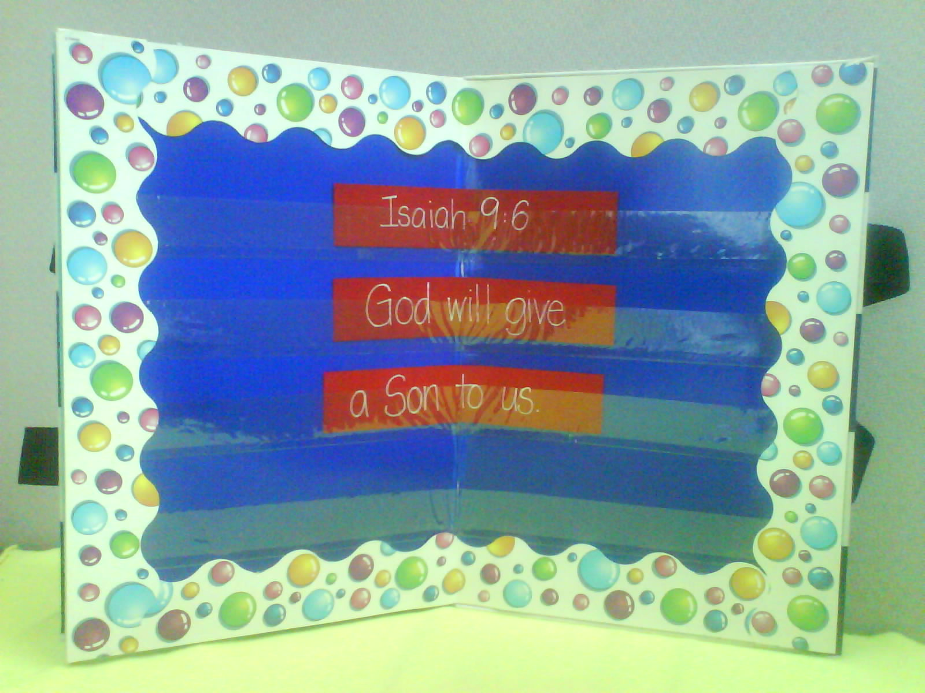

Prayer Time:
Close with prayer. Encourage each kid to say at least one thank You to God and a request if they have one.


“I will give my best to my small group. Every time we gather I will:

- Be here regularly.

- Search for how God wants me to grow closer to him.

- Pray with my group and watch God work.

- Talk about what I really think and feel.

- Listen with respect to others and not betray another’s secret, unless he/she is in danger.

Lesson 16

Small Group Warm-up
- one whiteboard and marker or a large section of butcher paper with markers
- pencils
- sections of mahjong paper for each group
- ridiculous prize for each group

Large Group Presentation
- large section of butcher block paper with markers or one whiteboard and marker
- handheld cross
- three-inch paper heart

Small Group Application
- copy of “Our Covenant Together” for each group (page 10)
- manila card for each group
- three-inch paper heart for each kid
- glue
- markers
- two paper cups for each kid
- ingredients for camping mix that might muruku, kacang, corn crackers, sunflower seeds, Frosty cereal, cocoa cereal, and chocolate chips
- prayer journal for each group (optional)

Memory Verse Learning
- a set of memory verse hearts for each team
- masking tape
- poster board slot

