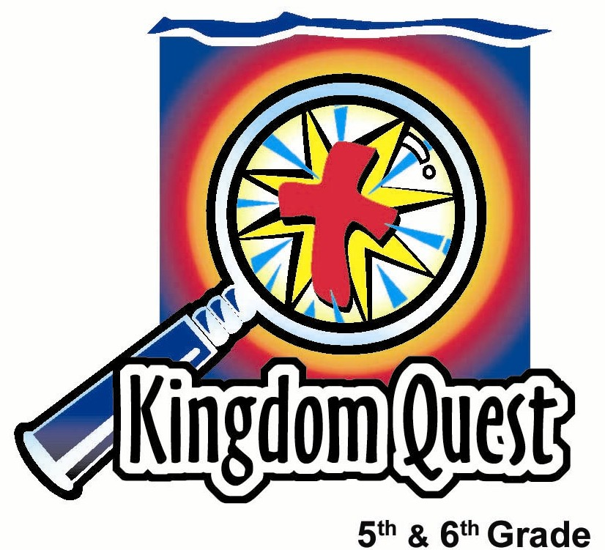
Date: ___________________________
Series: God’s Top Ten (Dec-Feb)
Year 1, Lesson 34
Keep God
Number One!

Take Home Point: *Keep God Number One. (The first commandment in both Augustine and Orthodox numbering.)
*Repeat this phrase throughout the lesson.

Bible Event: Exodus 20:3-6; Mark 10:17-27
Key Verses: Exodus 20:3,4, “You must not have any other gods except me. You must not make for yourselves any idols… You must not worship or serve any idol.”

We will help kids know:
- Ten key images that will help them remember the Ten Commandments.
- The first commandment tells us to never have other gods, in other words, keep God number one.
- A false god can be anything that we place on “the throne of our heart” in God’s place of honor and trust.
- The Bible event of the rich young ruler who placed riches on “the throne of his heart” in God’s place.

We will help kids feel:
- Excited to remember and review their memory game recalling the Ten Commandments.
- Convicted that they need to think of God and honor Him throughout their daily activities.
- Comforted in the gospel of forgiveness through Jesus.

We will help kids do:
- Share with their group their #1 favorite thing to do in a typical day.
- Identify ways they can honor God (keeping him #1) even while they do their favorite #1 activities.
- Continue their art project depicting the Ten Commandments, writing out the first commandment.
THIS LESSON’S ROADMAP

DESTINATION | PAGE # | DISCOVERIES ON YOUR JOURNEY | SUPPLIES NEEDED
Small Group Warm-Up   | 3 | Kids write down on a strip of paper their favorite activities and things to do and place the paper strips in a “Number One Box.” | - box decorated to look like a treasure box  - paper slips and pencils
Large Group   | 4  7  8  14 | Overview  Dramatic Presentation: “The Hunkel Doobergood Talk Show”  Hunkel Interviews “The Rich Young Ruler”  Appendices | - overhead projector or power point presentation (See appendix)  - interview desk and chairs  - title sign for name of show  - two Bibles  - period costume for rich young ruler  - optional: video camera  - chair decorated as throne  - sign with “Jesus” printed on it to hang on volunteer or tape to shirt
Small Group Application   | 4  6 | Giving our “Number Ones” to Jesus to control helps us keep Him number one and on the throne of our hearts.  Memory Verse Learning:  “Out of Order”  Matthew 22:37, 39 will be emphasized for next 3 lessons to reinforce in the children to have fear and love for God. | - scissors, magazines, and newspapers  - empty egg carton to collect additional letters: K, P, N, U, M, B and 1—add to last week’s letters  - mahjong papers with memory verse pre-written
Small Group Warm-Up: 15 minutes
Purpose: Get pointed in the right direction! Build relationships and help guests feel at ease. Do the learning readiness activity that will point your group in the right direction for the lesson.

Supplies needed: a small box labeled “Number One Box,”; pencils and three strips of paper for each child

As kids gather: Listen to memory verses from last week and give coupons for memory verses, for remembering to bring Bibles, and for bringing a guest.

One of the challenges for this series, God’s Top Ten, is that Christianity today has two ways of numbering the Ten Commandments. Your leader or supply coordinator will supply the appendix pages that give you the numbering system your church uses (either Appendix A or B). If you are using the Augustine Numbering (Appendix A), you are covering the first commandment today. If you are using the Orthodox Numbering, you are covering the first and second commandments today.

During this warm-up time, review the bizarre story from last week that is a memory game. This is printed on the bottom of your appendix page and will help the kids learn a series of images that help them recall the Ten Commandments. After only a few minutes of review, continue with the following.

Hold up a small box labeled “Number One Box.” Say:

Today we will discuss some of the number one things people in our group like to do. Think of the number one thing you like to do in a typical day at school.

Have kids write the activity on a slip of paper. Then have them take turns talking about their number one activity as they put the paper slip in the “Number One Box.”

Now, what is the number one thing you like to do after school?”

In the same way, have kids write out and share what their number one activity is to do after school. Then have them put the slips in the box as it is their turn to share.

Next, have them write down and discuss their favorite or number one activity to do on the weekend. Have them also put these strips in the box after they have shared.

Today we will learn about the first commandment that can be said this way: “*Keep God Number One.” I wonder how we can keep God number one, even when we are doing some of our number one things!
Large Group: 20-30 minutes
Purpose: Help kids observe what the Bible says. Present the Bible event in creative fashion. Help kids begin to interpret what it means.

- Supplies needed: overhead projector or power point presentation (See appendix); interview desk and chairs; title sign for name of show; two Bibles; period costume for rich young ruler; optional: video camera; chair decorated as throne; sign with “Jesus” printed on it to hang on volunteer or tape to shirt

Overview

Dramatic Presentation: “The Hunkel Doobergood Talk Show”
Hunkel interviews Mr. Rich Young Ruler. Kids do a scavenger hunt to find items that often take the number one seat in our lives.

Small Group Application: 20-25 minutes
Purpose: Help kids map out the meaning of the Bible event in their lives. Use the questions to stimulate discussion, but don't feel tied to them. Allow the Holy Spirit to guide you. Include personal examples from your own faith journey. The example of Christ at work in your life will leave lasting impressions of how Christ can work in the children's lives.

Supplies needed: scissors, magazines, and newspapers; empty egg carton to collect additional letters: K, P, N, U, M, B and 1—add to last week’s letters

Use your Bibles! Children need to learn how to look up references and follow along when scripture is read aloud. Allow for quality time of prayer at the close of the lesson. They need to learn how to ask observation questions: “What happened?” Then they can ask interpretation questions: “What does this mean?” Finally, help them apply it with “What does it mean to me?" Allow for quality time of prayer at the close of the lesson.

NOTE: Many newspapers and advertising inserts will be needed for this craft project. Be sure to let your suppliers know in advance (1-2 weeks minimum) of your need.

Observation Questions:
Have kids look up Mark 10:17-27.

What did the rich young ruler (title found in Luke 18:18) ask Jesus? (Mark 10:17 What should I do to inherit eternal life?)

What was Jesus’ answer? (Mark 10:19 Obey the commandments.)
What did Jesus say the ruler still needed to do? (Mark 10:21 “Go and sell everything you have, and give the money to the poor… Then come and follow Me”)

Interpretation Questions:

Why do you think Jesus said to the ruler, “Why do you call Me good? No one is good except God alone.” (Maybe He was testing the man to see if he knew Jesus was God’s Son; maybe to show the rich young ruler that no man can keep the commandments perfectly, so we need a Savior to do so for us. Then we can inherit eternal life when we believe this.)

Why do you think the man couldn’t sell all of his possessions, give to the poor and follow Jesus? (He put his money and himself on the throne of his life.)

Which commandment could the rich young ruler not keep? (First commandment -“Love the Lord your God with all your heart, soul, and mind.” Matthew 22:37.)

Do you think the rich young ruler knew who Jesus really was, the Son of God? Do you think he may have responded differently if he did believe Jesus was God?

Application:

Why do you think people sometimes fall short of the first commandment to *keep God number one in their lives?

Could it be that we do not believe or sometimes forget that God is the only, number one God of the universe, or that we do not know for sure that Jesus is God’s only begotten Son who died so that we can have life?

If people really believe God is who He says He is, or that He really did what He did, would it be easier to *keep God number one?

Activity:
Have kids read Exodus 20:3-5,

“You must not have any other gods except Me. You must not make for yourselves any idols… You must not worship or serve any idol.”

Remind kids that God commands us to keep Him number one in our lives. One at a time, read the slips of paper put in the Number One Box in the warm-up activity. Ask this question for each of the number one things kids like to do throughout a typical week:
How can you do this “Number One” thing in such a way that you honor God when you do it?

While discussing; have kids cut out the letters: k, p, n, u, m, b and 1 from newspapers or magazines. These can be collected and stored in egg cartons.
Have kids glue letters on their Ten Commandment Craft spelling the phrase, “Keep God Number 1.” Or “Keep God Number One.”

Be sure that the phrases from last week are glued on first: “Love God…” on one tablet and “Love others” on the other tablet. (See appendix A1 or B1.)
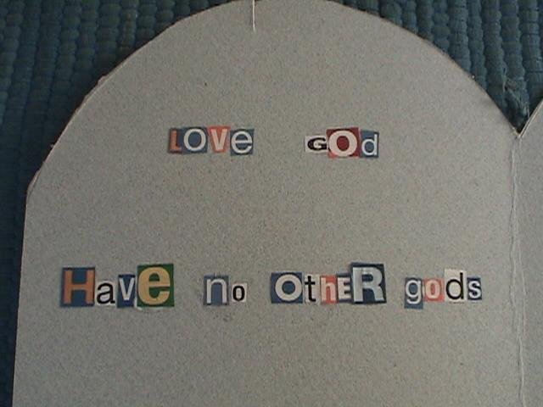

Today we learned how we are to *keep God number one in our lives.

Memory Verse Learning: 5 minutes
Purpose: Help kids to memorize and keep scriptures at heart. Using creative ways to help kids enjoy learning the key verse and in small group setting.

Supplies needed: mahjong papers with memory verse pre-written (see example).

Memory Verse: Matthew 22:37, 39 ~ “Love the Lord your God with all your heart, soul and mind….Love your neighbor as you love yourself.”

MV Presentation: “Out of Order”
Randomly call different children to read the memory verse on the mahjong paper and point out which words are out of order. Then say the memory verse in the correct order. Repeat the game by printing several sheets of the mahjong paper with different words out of order.

Closing prayer: Thank God that He is number one and He sent His number one Son to die for the punishment we deserve. Pray for the Holy Spirit to show us ways we can honor God above all things and for the strength to *keep God number one in our lives.
Large Group Presentation

The Hunkel Doobergood Talk Show
Dramatic Presentation

Take home point: Keep God number one.

The series, God’s Top Ten, will use a spin-off from a television talk show format to present the topic. For our purposes, we are calling it the Hunkel Doobergood Talk Show, but feel free to rename it to better suit your setting (e.g. Sunday Morning Live, Early Morning with Hunkel, etc.). If a lady is the talk show host, it would be the Harriet Doobergood Talk Show.

The set for this may be elaborate or as simple as you desire. It would be helpful to have a title sign, an interview desk and some chairs for guests. We would recommend that you have someone slightly off the set who could hold up the cue cards that say, “laugh,” “applause” or “moan.” These cue cards will be necessary to enhance the jokes. You may need to warm up the audience by practicing the signs. You might even have someone video record it as if it were a T.V. studio. The video clips could then be shown elsewhere to promote your 5th-6th grade program.

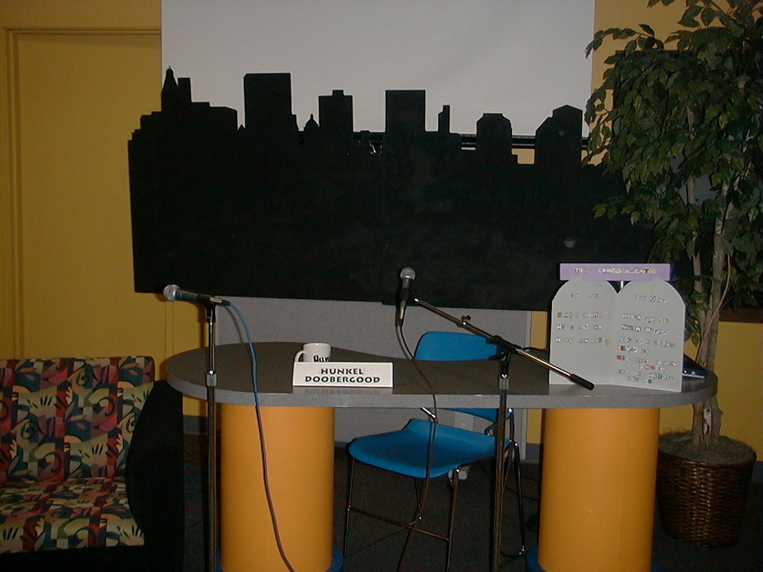

Opening joke
Sometimes people are in a contest to be number one, to be the best, to be the biggest. For example, a Texan goes to Australia for a vacation. There he meets an Australian farmer who begins talking “big” to him. The Aussie (that’s what they call Australians) shows off his big wheat field and says this wheat field is the largest in this part of the world. The Texan goes, “Ha! I’ve got a wheat field twice that size in my back yard.” They walk around the ranch a little, and the Aussie shows off his herd of prize-sized cattle. The Texan immediately says, “I have longhorns on my spread that were twice that size when they were just calves!” The Aussie is by now irritated at the Texan’s attitude, so he doesn’t say anything else. Just then a herd of kangaroos came hopping through the field. The Texan takes off his hat and points to them in surprise! “Would you look at that! What in the dickens are them critters?” “Those?” replied the Aussie. “What…you mean you don’t have field mice in Texas?”

Introduction
We have a wonderful show for you this morning. We are talking about God’s Top Ten for the next ten weeks. Today we are talking about commandment number one, which is all about keeping God number one in your life. We’ll meet a rich young ruler who thought he had it all worked out as far as keeping the Ten Commandments, but all along he missed them because he didn’t know that he let something else take the place of God in his life! It will just go to show you…*keep God number one!

Top ten list:
The following list is available in the appendix and can be read in the following form: “Number ten…. Number nine…” etc. For a better effect, have them on power point, revealed one at a time or placed on overhead and revealed one at a time.

“Top Ten False Gods that Might Take the Place of GOD”

10. My personal happiness is the most important thing in my life.
9. Some force floating out there—like the force in Star Wars.
8. Worshiping stars or horoscopes.
7. Worshiping popularity.
6. Success in sports as the most important purpose in life.
- Totally addicted to video games.
4. Worshiping good grades more than a good God.
3. Loving new clothes more than loving the God who gives them to you.
- Loving money most of all.
1. Watching so much T.V. that it rules your life.

A Rich Young Ruler Who Turned Away from Jesus
Guest Interview

A guest actor portrays a rich young ruler who turned away from Jesus. This is recorded in Mark 10:17-27. (Luke 18:18 calls him a ruler.) The character can wear a period costume or come nicely dressed in contemporary clothes. A great option is to invite a teenager to practice the lines beforehand and present the character. Another option for presenting this material is to show a video clip rather than a live interview. A video clip of this account can be seen on the Visual Bible: Matthew 19:16-30. Also it is available on Nest Entertainment animated video series: “Treasures in Heaven.”

Hunkel Doobergood continues:

Today’s guest comes to us from a very famous book, the Bible. The story is found in Mark 10:17-27.

But now here is the rich young ruler to explain it for himself. Give him a warm welcome.

The rich young ruler, as well as Hunkel, might have their notes or scripts inserted in a Bible. Throughout, the actors ad lib the dialogue. The topics of the conversation are underlined.

Rich young ruler’s introduction:

Hunkel: So, Mr. Rich Young Ruler, we’re happy to have you with us today. Can you tell us a little bit more about yourself?

Rich Young Ruler: I’m on the fast track to success. I’m young, as you can see… good lookin’, as you can see, and… well, I’ve got money. I’ve also got influence because I serve on some very important religious counsels that call on me as a ruler. When it comes to having it together, well, I graduated at the top of my class. So, that pretty well covers it. Oh, did I mention humble?

Hunkel: No-o-ooo, you didn’t. But that’s okay. We’ll, skip that part. So tell me, you had an encounter with Jesus. What exactly happened?

Rich Young Ruler: Well, as you know, sharp guys like me want to know the answers to religious questions; and I am quite an expert in religious stuff. Jesus was quite a famous teacher and very well might have been the Messiah, the promised one from God. So I honored Him as teacher, bowed before Him and asked Him the big question… “What shall I do to inherit eternal life?”
Hunkel: And what did He say?

Rich Young Ruler: Well, first Jesus said, “Why do you call Me good? There is only one that is good and that is God.” I thought that was kind of a strange answer.

Hunkel: Maybe it was because Jesus was trying to figure out whether you saw Him as just another good man or if you saw Him truly as God. Did He ask you anything else or tell you how to inherit eternal life?

Rich Young Ruler: Well, yes. He told me to keep the commandments and even listed them… never murder—check, did that; never commit adultery—check, did that; never steal—check, did that; check, check, check as he named a few more. I had it covered, case closed, pen in pocket. I got it, anything else?

Hunkel: So, then did Jesus say, “Well, you’ve kept all the commandments so you will inherit eternal life?

Rich Young Ruler: Well, not exactly. As a matter of fact, not at all. He looked at me in the strangest way.

Hunkel: I see here in the Bible that it says that He looked at you with love. I guess He really loved you.

Rich Young Ruler: Yeah, I suppose He did. But it made me feel worse later on.

Hunkel: How’s that?

Rich Young Ruler: Well this is what He told me I should do. After I told Him that I had kept all the commandments, He said, “One thing you’re still lacking. Go, sell everything you have and give to the poor. Then, come, follow me.” Well, I just couldn’t do that. I was on the fast track to success. I had money and influence. I couldn’t just leave all those things and give it away. That’s the craziest thing I ever heard.

Hunkel: So what did Jesus do?

Rich Young Ruler: Well, it’s not what Jesus did; it’s what I did. I was depressed; I couldn’t take it, even if He did love me. I couldn’t leave my things, so I left Him. I went away to think it over or figure out another deal. I couldn’t stay there any longer.

Hunkel: What did Jesus do when you left?
Rich Young Ruler: Nothing. He let me go.

Hunkel: You mean He didn’t come after you or try to make you come back and follow Him?

Rich Young Ruler: No, He left it to me and … I… well, … did I tell you about the new camel I’m going to buy? No? It’s a beauty. It’s something rich young rulers like me buy. It’s a sports model, has two humps and gets great mileage on a gallon of water!

Hunkel: Well, thank you for the interview today, and let’s have a round of applause for the rich young ruler. Thank you for being here with us.

The rich young ruler leaves.

The Hunkel Demonstration

Props:
- Chair, decorated like a throne
- Number One Box (from small group warm-up)
- A sign that could be put around someone’s neck or taped to his or her shirt that says, “Jesus.”

The Rich Young Ruler’s problem

Kids, you can see that the rich young ruler had a real problem because he wanted to make himself number one. Well, this is a picture of what happened. This throne represents the throne of your life. It’s the highest place in a person’s life. Jesus Christ is the rightful King to sit on this throne in our lives. Jesus Christ came to give His life for us so that He might be number one in our lives.

But here’s the problem. Sometimes we replace Him on the throne with other things. Let’s consider some of the things the rich young ruler placed on his throne.

Place a Number One Box (from the warm up activity) on the throne and open it up.

Explain to the kids that they will be involved in a scavenger hunt to find things that people tend to put on the throne of their lives. Explain that each group will work together to come up with the object needed, but that one “runner” from each group needs to be chosen to race with the object to be the first to put it in the Number One Box.
For the first item, have kids search in their group for a $20.00 bill (a shepherd might have one, the larger the currency the better). When it is found, have the runner race to put the money in the box. Then make the following point.

Sometimes we make money or possessions number one in our lives. That was one of the problems the rich young ruler had.

Remove the money from the box and ask kids to search for any “beautification” items (e.g. comb, brush, makeup or Chap stick, lipstick, hair accessories, mirror, etc.). After some or several have retrieved an item and placed it in the Number One Box, continue with:

Sometimes we think the number one thing in our lives is “looking good… or being beautiful.” This can take the place of Jesus on the throne and the number one position in our life. The rich young ruler might have had a problem with that also.

Have kids scour the room for a sports item such as a ball or poster or other items that might have been planted in the room having to do with sports. It could even be taking a tennis shoe off of someone. Then say:

Sometimes we might even make sports so important to us that our athletic events or even watching games on T.V. become like a god. It becomes number one and sits on the throne of our lives.

All these can be like gods.

The Bible says that we should have no other gods in our lives. There is nothing wrong with money, popularity or sports. But if they become too important to us, they can become our primary focus just like serving a false god. If we look to them and trust in these things to give us the entire fulfillment we need in life, they can become just like a god and can sit on the throne of our hearts. The Bible clearly says to *keep God number one or don’t have any other gods before me.

Now there are other kinds of false gods we could worship. That can happen if we worship and trust gods of other religions such as Hinduism or a religion that believes that God is in all things, or the belief that everything is a god. Or maybe a religion teaches there are many gods. It could even be a false belief that God is not a being, only some kind of force in the universe that we can tap into by using crystals or other objects. Believing in these is also like making idols.

For a visual, use an object like a magic eight ball or a crystal planted somewhere in the room that can be put in the Number One Box to demonstrate having other gods and how this commandment could be broken.

Exodus 20:3-4 says, “You must not have any other gods except Me. You must not make for yourselves any idols. Don’t make something that looks like anything in the sky above or on the earth below or in the water below the land.”

We summarize this by saying, *Keep God number one. How do we do that?

Put a sign that says “Jesus” on the throne. Then say:

We know that Jesus came to earth as a man and gave His life for us. We know that if we trust Him as our Savior, He will live in our lives and rule in our hearts. He should rightfully sit on the throne of our life.

What, then, are we to do with this box of number one things? Is it wrong to have things or do things we enjoy? Is it wrong to have number one fun activities? Of course not, but instead of letting those activities or things rule our lives, we take them and we place them at the foot of the throne. Just like this.

Place the Number One Box with some of the things and listings of activities from the Small Group Warm-up on the floor in front of the throne.

Closing prayer:

Dear God,
We want to keep You number one in our lives. But sometimes we forget about You and put other stuff on the throne of our lives. Please forgive us for Jesus’ sake.

Lord Jesus, would You please sit on the thrones of our hearts and rule there? We place in Your hands all the things we do that are “number one” activities for us. Please use them any way You want to show people that You are the true and living God. In Jesus’ Name. Amen.

This Is Hunkel Doobergood saying “Good night” (or maybe “Good morning”). Remember to keep the commandments because they are good for God and good for you… and this week’s commandment, Keep God number one.”

SUPPLY LIST

Lesson 34
Small Group Warm-Up
- box decorated to look like a treasure box
- paper slips and pencils

Large Group
- overhead projector or power point presentation (See appendix)
- interview desk and chairs
- title sign for name of show
- two Bibles
- period costume for rich young ruler
- optional: video camera
- chair decorated as throne
- sign with “Jesus” printed on it to hang on volunteer or tape to shirt

Small Group Application
- scissors, magazines, and newspapers
- empty egg carton to collect additional letters: K, P, N, U, M, B and 1—add to last week’s letters

Memory Verse Learning
- blank mahjong papers. Print the memory verse on several mahjong papers and each one with two or more words out of order.

EXAMPLE:
Love the Lord your God with all your soul, all your mind, and all your heart….Love your neighbor as you love yourself.”

Love your neighbor as you love yourself…..love the Lord your God with all your heart, all your soul, and all your mind.”

Love your God the Lord with all your mind, all your heart, and all your soul…Love your neighbor as you love yourself.”

Love the Lord your God with all your heart, all your mind, and all your soul…Love yourself as your love your neighbor.

Cut: Slips of paper needed for kids to write their Number One things on.
Appendix A

The Ten Commandments – Augustine Numbering
(Used by Roman Catholics and Lutherans)

Number | Commandment | For the memory  game, picture…
1st | “You must not have any other gods except me. You shall not make for yourself any idols.” | …a big, fat, stone idol. Out of it’s mouth flows the …
2nd | “You must not use the name of the LORD your God thoughtlessly. | large block letters, N-A-M-E. They float down and land on a long, wooden church bench.
3rd | “Remember to keep the Sabbath as a holy day.” | The church pew begins to move.
4th | “Honor your father and your mother.” | It’s being pulled by your parents! Where is it going?
5th | “You must not murder anyone.” | They are pulling it across a very large knife!
6th | “You must not be guilty of adultery.” | The knife falls and stabs through a Playboy magazine.
7th | “"You must not steal.” | A huge fist grabs the magazine! Then…
8th | “You must not tell lies about your neighbor in court.” | two very red ears come out of each side of the fist .
9th | “You must not want to take your neighbor’s house.” | Pop, one arm comes out and reaches for a lady driving a sports car, then, pop…
10th | “You must not want to take anything that belongs to your neighbor.” | the other arm reaches for her house.

Narration

For the memory game, picture a big, fat, stone idol. Out of it’s mouth flows huge block letters… N-A-M-E. That spells “name.” The letters now float down and land on a long, wooden church bench. The church bench begins to move! Your parents are pulling it! Where is it going? They’re pulling it across a very large knife. The knife falls and stabs through a Playboy magazine. A huge fist grabs the magazine. Then, two very red ears come out of each side of the fist. POP! One arm comes out and reaches for a lady driving a sports car, then, POP, the other arm comes out and reaches for her house.

Appendix A1 – Augustine Numbering: Ten Commandments Craft

LOVE GOD… LOVE OTHERS

- Keep God #1 4. Honor parents

- Honor God’s name 5. Never murder

- Honor God’s worship 6. Never commit adultery

7. Never steal

8. Never gossip
9. Never covet someone’s
household

10. Never desire someone’s stuff

Appendix B

The Ten Commandments – Orthodox Numbering
(Used by Greek Orthodox and most Protestant churches)

Number or Word | Commandment | For the memory  game, picture…
1st | “"You must not have any other gods except me.” | …a big, fat, stone idol. Someone is…
2nd | “You must not make for yourselves any idols.” | …hitting the idol with a chisel.
3rd | “You must not use the name of the LORD your God thoughtlessly.” | Some large block letters, N-A-M-E, float out of the idol’s mouth…
4th | “Remember to keep the Sabbath as a holy day.” | and land on a long,  wooden church  bench. What is happening?
5th | “Honor your father and your mother.” | It is being pulled  by your parents!
6th | “You must not murder anyone.” | They are pulling it across a very large knife.
7th | “You must not be guilty of adultery.” | The knife falls and stabs through a Playboy magazine.
8th | “You must not steal.” | A huge fist grabs the magazine! Then, pop…
9th | “"You must not tell lies about your neighbor in court.” | two very red ears come out of the big fist. And…
10th | “You must not want to take your neighbor’s house. You must not want his wife or his men or women slaves. You must not want his ox or his donkey. You must not want to take anything that belongs to your neighbor." | out of the ear comes an arm that reaches for a lady in her house.

Narration

For the memory game, picture a big, fat, stone idol. Someone is using a hammer and chiseling pieces out of the idol. Out of the idol’s mouth flows huge block letters… N-A-M-E. They spell “name.” The letters now float down and land on a long, wooden church bench. The church bench begins to move! Your parents are pulling it! Where is it going? They’re pulling it across a very large knife. The knife falls and stabs through a Playboy magazine. A huge fist grabs the magazine. Then, two very red ears come out of each side of the fist. Then, all of a sudden, one arm comes out of the ear and reaches for a lady in her house.

Appendix B1 – Orthodox Numbering: Ten Commandments Craft

LOVE GOD… LOVE OTHERS

1. Keep God #1 5. Honor parents

2. Make no idols 6. Never murder

3. Honor God’s name 7. Never commit adultery

4. Honor God’s worship 8. Never steal

9. Never gossip
10. Never covet someone’s family or stuff

“Top Ten False Gods that Might Take the Place of GOD”

10. Any god made of rock, paper or scissors.
9. Some force floating out there—like the force in Star Wars.
8. Worshiping stars or horoscopes.
7. Worshiping popularity.
6. Success in sports as the most important purpose in life.
5. Totally addicted to video games.
4. Worshiping good grades more than a good God.
3. Loving new clothes more than loving the God who gives them to you.
2. Loving money most of all.
1. Watching so much T.V. that it rules your life.

