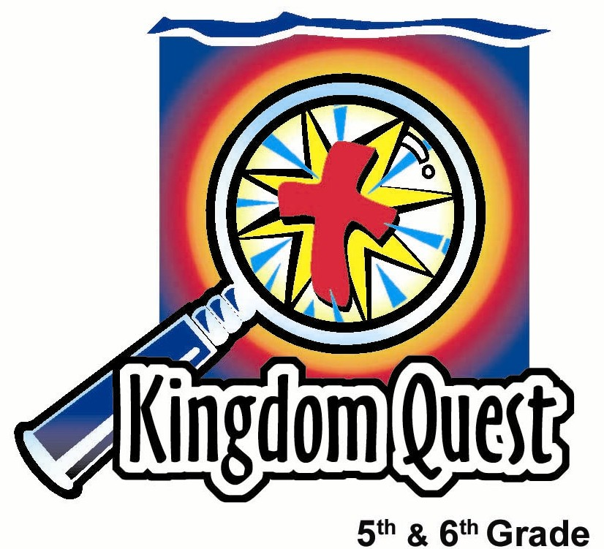
Date: _________________________
Series: Greatest Stories Ever Told (Jun-Aug)
Year 1, Lesson 13

Unmerciful
Servant

Take Home Point: *Forgive as you have been forgiven.
*Repeat this phrase throughout the lesson.

Bible Event: Matthew 18:21-35
Key Verses: Ephesians 4:32, “Be kind and loving to each other. Forgive each other just as God forgave you in Christ.” (NCV)

We will help kids know:
- Forgiveness means to release a debt or injury another person has caused and to not try to “get even” or pay back out of vengeance.
- We have been forgiven much more from God for our wrongs than we have to forgive others from their wrongs against us.
- Jesus’ parable of the unmerciful servant.

We will help kids feel:
- Convicted of holding any grudges against those who have wronged them.
- The peace of releasing their injury or bitterness to God and not trying to “pay back” the other person.

We will help kids do:
- Identify grudge areas in their lives.
- Participate in a contemporary drama version of the unmerciful servant.
THIS LESSON’S ROADMAP

DESTINATION | PAGE # | DISCOVERIES ON YOUR JOURNEY | SUPPLIES NEEDED
Small Group Warm-Up   | 3-4 | Volunteers act out a “Payback” drama and then associate the smell of vinegar with the bitterness of unforgiveness. | - a small plastic bottle or water bottle filled half way with vinegar
Large Group   | 4  7-11 | Overview  Volunteers act out a contemporary version of the Unforgiving Servant parable from Matthew 18:21-35. | - three half sections of paper towel or three napkins, one jar or bowl filled with water and vinegar  - costumes/props: teacher attire such as a vest and/or tie, glasses, pointer stick, blackboard or eraser board, table, chair  - tennis shoes for Howard character  - “The Visual Bible: Matthew” video distributed by Visual Bible International, 1997 – show the portion: Matthew 18:21-35  - video, “The Animated Stories from the New Testament: Forgive Us Our Debts” distributed by Nest Family Entertainment, 1991 (ISBN #1-56489-008-2)
Small Group Application   | 4-6  6 | Kids compare the contemporary version to Matthew 18:21-35. They visually experience the effects of bitterness with vinegar and baking soda.  Memory Verse Learning: “Clothes Scramble”  Eph. 4:32 will help students resolve to forgive others from their wrongs against us. | - a bottle of vinegar  - a cork to fit tightly or another type of material that can be pressed tightly in the bottle, like a slice of potato  - a teaspoon of baking soda on a square of toilet tissue  - 2 sets of “Memory Verse Cards”  - 2 laundry baskets  - 2 clotheslines  - 18 clothes pegs for each team
Small Group Warm Up: 15 minutes
Purpose: Get pointed in the right direction! Build relationships and help guests feel at ease. Do the learning readiness activity that will point your group in the right direction for the lesson.

As kids gather: Listen to memory verses from last week and give coupons for memory verses, remembering to bring your Bible, and bringing a guest.

Easier Summer Option: Instead of having kids in small groups with an assigned shepherd, the kids can meet all together and divide themselves into triads (groups of three). This allows for larger ratios between students and shepherds. Shepherds will monitor the kids’ activity as needed by roaming from group to group. The questions and directions for all the kids and their groups are by the large group presenter. IF this is used, go to the introduction of large group to introduce the main character used in this series.

Regular Shepherd Option: Do the Warm-Up activity as a small group. If you like, you can still divide into triads within your small group. This helps each child participate more.

Supplies: a small plastic bottle or water bottle filled half way with vinegar

Select two volunteer to play act in the drama game called, “Payback.” Then give the following instructions:

One person will make a tiny paper wad and flick it at the other person. The other person will pretend that this is an injury or a wrong committed against him. They will then flick something back to “get even,” but maybe their wad will be just a tad bit bigger than the first person’s wad.

Person number one then has to “payback” a flick with something even bigger. Let’s see how they “payback” one another as they seek to “get even” when wronged.

Play the game and discuss.

How is this game like life? Do we ever try to get even or try to get back at others?

Tell about a time when someone did something against you and you wanted to get even. What happened?

Pass the vinegar bottle around.

Everyone take a smell. Smell how this is sour and strong smelling. Vinegar is an acid. The smell is a reminder of the bitterness we have in our hearts when we hold a grudge against another person.

Today we will learn how to “let go” of our need to “get even.” This is called forgiveness. Because we have been forgiven much, we can forgive others. *Forgive if you’ve been forgiven.

Large Group Overview: 20-30 minutes
Purpose: Help kids observe what the Bible says. Present the Bible event in creative fashion. Help kids begin to interpret what it means.

Volunteers act out a contemporary version of the Unforgiving Servant parable from Matthew 18:21-35.

Small Group Application: 20-25 minutes
Purpose: Help kids map out the meaning of the Bible event in their lives. Use the questions to stimulate discussion, but don't feel tied to them. Allow the Holy Spirit to guide you. Include personal examples from your own faith journey. The example of Christ at work in your life will leave lasting impressions of how Christ can work in the children's lives.

Use your Bibles! Children need to learn how to look up references and follow along when scripture is read aloud. Allow for quality time of prayer at the close of the lesson.

Observation Questions: What happened?/Interpretation Questions: What does this mean?

Read Matthew 18:21-35 together and find commonalities between Jesus’ parable in the Bible and the dramatic presentation, “Michael and His Payback.”

The king and the teacher were both merciful and forgave the large debt owed them by the servant and student/Michael. Both Michael and the servant in Matthew demanded payment of a debt that was much smaller than the debt they owed. Both the king in the parable and the teacher in the story found out that the one they forgave did not forgive another and so asked for payback.

Why in this parable, do you think Jesus had the loving God hand over the unforgiving servant to the torturers? (Maybe to show how we can be tortured by our bitterness when we choose not to forgive others. There are consequences for not forgiving. Maybe to show how serious God takes it, when we know we have been forgiven much yet choose not to forgive someone else.)

Application Questions: What does this mean to me?
How can we release a debt from someone else, instead of trying to pay him or her back with another wrong or injury? (We release it to God. We tell Him about it. God is the one who ultimately judges good and evil.)

Think of a very serious injury that a person has done to you. This injury may not be a physical injury but may be some other way they hurt or disappointed you. Sometimes it hard to let go of the pain because in hurt so much. That is why it is so important to tell God to lift it off of you, because it is too heavy a burden to carry. It doesn’t mean you won’t hurt or feel the pain from it. And, it doesn’t mean that the other person won’t have consequences if they hurt you badly. You still can forgive them and not want to be around them. That is still forgiveness. But not forgiving them is wanting to payback and get even with them.

Application: A Science Experiment

Supplies: a bottle of vinegar; a cork to fit tightly or another type of material that can be pressed tightly in the bottle, like a slice of potato; place a teaspoon of baking soda on a square of toilet tissue, closing and wrapping it tightly

Drop the square of toilet tissue wrapped baking soda in the vinegar bottle. This should give you enough time to get the cap or cover on completely.

This bottle is sometimes like our lives. When we hang on to our desire to get even with someone else, it becomes bitterness. It’s like the vinegar. It’s bitter and acid in our lives. It hurts us. As a matter of fact, it gives us a “stinky” attitude—just like the vinegar smell. But what else happens? Eventually, it bubbles up and causes an explosion. (The cap pops off the top.) We think we are hurting someone else but the truth is we are really hurting ourselves when we don’t forgive others.

Shepherd, tell about a time you had bitterness toward someone else and asked God to help you forgive that person and the effect it had on you.

On the cross, Jesus forgave the people that were hurting and killing him. How did He do it? Jesus was of course perfect, but He promises to give us His resurrection power when we believe in Him and accept Him as Savior. One way for us to do this is to picture Jesus on the cross. We can take our hurt to Jesus and lay it at the foot of His cross and ask Him to forgive for us. The Holy Spirit can supernaturally take away the bitterness or grudge we hold when we release it to Him.

Today’s key verse from Ephesians 4:32 says, “Be kind and loving to each other. Forgive each other just as God forgave you in Christ.”

With the help of the Holy Spirit, we can *forgive because we have been forgiven.

Prayer time:
Have the kids talk about any areas of bitterness. Encourage them to release those areas to God. As a group, let them pray together for God’s power to forgive.

Memory Verse Learning: 5 minutes

Purpose: Help kids to memorize and keep scriptures at heart. Using creative ways to help kids enjoy learning the key verse and in small group setting.

Supplies needed: 2 sets of “Memory Verse Cards” pinned on to T-shirts; 2 laundry baskets; 2 clotheslines; 18 clothes pegs for each team

Memory Verse: Ephesians 4:32, “Be kind and loving to each other. Forgive each other just as God forgave you in Christ.”

MV Presentation: “Clothes Scramble”
Before class, string a clothesline for each team. When teaching the verse, shepherd pin up T-shirts and recite. Have the children recite a few rounds but each time take down one T-shirt randomly. Then divide the children into two groups and line them up about 10 feet from clothesline. Place one laundry basket with a set of T-shirts near the clothesline with clothes pegs close by for each team. Explain to the children that this is a relay in which the first team member runs to their laundry basket picks the T-shirt that has the beginning word of Eph. 4:32 and peg it on the clothesline. The next person is to find the following word. The first team that has the entire scripture verse pegged on the clothesline in the correct order wins.

Large Group Presentation

Though Jesus makes up the stories, they are taken from slices of real life such as farming, family, or debt repayment. In other words, Jesus’ parables had real life characters. This series will challenge kids to see afresh the truth of these parables by experiencing them in a contemporary context. The large group presenter will take the persona of a director of small theater company called “Great Stories Theater.” The director might even have a mega phone, a director’s beret for a hat and a director’s chair.

Characters: Michael, Ah Keong, and Encik Chan, a teacher

Supplies: Three half sections of a paper towel or three napkins, one jar or bowl filled with water and vinegar

Costumes/Props: teacher attire: vest and/or tie, glasses, pointer stick, blackboard or eraser board, table, chair; sports shoes for Michael character

Michael and His Payback
Dramatic Presentation

The actors are volunteers that listen to their parts and act them out to illustrate what the narrator is reading.

Call up volunteers to play Encik Chan, the teacher, and the students, Michael and Yun Arn. Instruct the actors to listen carefully and do what is read.

Encik Chan’s science class was studying about acids. For this part they were using vinegar.

Show the vinegar jar.

It made the whole room smell. But they were doing some fun experiments with it. Encik Chan was called out of the room for a quick phone call.

Encik Chan exits.

Michael saw his opportunity.

He went to the demonstration table and took one of the paper towels. He dipped it into the vinegar and wadded it up into a paper wad.

Pause for Michael to complete this task.

He then teased some of the other students by holding it in front of their nose until they turned away.

Tease some students in the audience.

Then he noticed an opportunity to do something he thought would be really funny. He walked to the window, opened it, and tossed it outside. He watched it from the second story window sail toward the ground and then hit, S-P-L-A-T, right on top of Encik Chan’s car.

That’s funny, he thought. Some of his friends were laughing, as well. Quickly he got another piece of paper and dipped it into the vinegar, wadded it up, and tossed it out of the window—splat on the hood of Encik Chan’s car. He had hit again!

Would he have enough to make one more before Encik Chan got back? He thought so. He made another vinegar wad, returned to the window, let the third wad sail! Plop, right on the back fender of the car. He considered his mission over. He didn’t want to press his luck and get caught.

Howard made it back to his seat just in time before Encik Chan returned.

The next day, Encik Chan called the class together with a stern look on his face. Before him were three dried pieces of paper. They still smelled of vinegar. The room got very quiet, and the students glanced toward Michael.

“It seems that someone yesterday dropped some of these paper wads soaked in vinegar on my car. Who here can tell me what happened?”

The room was quiet and more kids were staring at Michael. Encik Chan expected the truth.

“Michael, did you throw those paper wads and hit my car.”

“No, it wasn’t me,” Michael said as he shook his head.

“Well, who did it then?” asked Encik Chan.

The room was quiet. Michael knew he was caught. “Well, I didn’t mean to,” he said. “It just seemed funny at the time.”

“Maybe it seemed funny at the time,” said Encik Chan, “but the problem is, it ate the paint off my car. I will need a new paint job. I’ve taken my car to the body shop and they tell me it will cost RM1,400 to repaint. Now, that means you owe me RM1,400 to fix my car. What are you going to do?”

“I don’t know. I don’t have RM1,400.”

“Well, I think you need to call your parents and we will discuss what can be done” said Encik Chan.

“They would never give me the money,” said Michael. “Please think of something else.”

“Well, I still need to call your parents—but how about this. I’ll let you earn back the RM1,400 by staying after class everyday and helping me clean the classroom and grade papers. You ought to be able to finish paying it off in a year or two if you work everyday after school.”

Michael put his head down on his desk. He felt like this school year… or maybe the next two years were ruined. Why did he make such a big mistake? The next morning, Michael came in early to talk to Encik Chan.

“Encik Chan, sir, I know I need to work and pay back the money. But I also wanted to play football and be on the team after school, and I can’t do that now. I guess I’ll never be able to do it. Is there any other deal that we could work out?”

Encik Chan looked at him with a sigh. “Yes, we could do this. I could forgive the debt you need to pay back and let you go free. That’s what I’ll do. How about that?”

Michael was elated. “Fantastic,” he thought to himself. “What a break.”

The next day in science class, the students were working with ink dye. Yun Arn was carrying some ink on a teaspoon when he was bumped. It fell and landed on Michael’s shoelaces.

“What!! You stained my shoelaces. These are my brand new shoes. You have to buy me brand new shoes.”

Yun Arn said, “No, I can’t buy you new shoes. I’m sorry about your shoelaces. I’ll get you new laces.”

“No, I want new shoes. These shoelaces came with these shoes. They are ruined, so I need new shoes. You have to pay me RM120.”

“I don’t have RM120,” said Yun Arn.

“Then you have to be my slave. You have to do my homework for me everyday until Deepavali,” said Michael.

“But your shoelaces aren’t that big a deal!

“Oh, they are a big deal to me. You have to pay me back,” said Michael! And with that, he held up his fists.

Yun Arn knew a fight was imminent. It seemed like the only thing he could do was to go along with Michael.

After school that day, Encik Chan called Michael to the front of the classroom.

“Some of the students told me what happened when I wasn’t around yesterday. They said you are forcing Yun Arn to pay back RM120 for just a silly shoestring that he stained. How could you do that after I didn’t make you pay back RM1,400? If I had mercy on you and forgave you, why couldn’t you forgive someone who owed you just a little? I’m very disappointed in you. I don’t think you’ve learned your lesson. In fact, I think its time you join me after school and help clean up this room until you pay back all that you owe.”

And that’s the story of Michael and his payback. Let’s have a handclap for our actors.

Discuss the story with the students—their feeling, thoughts, and reactions.

Use one of the three options to present the Bible event.

- Read Matthew 18:21-35. Read the Bible event from your Bibles, with the kids following along.
- Show “The Visual Bible: Matthew” video distributed by Visual Bible International, 1997. Show the portion: Matthew 18:21-35.
- Show the video, “The Animated Stories from the New Testament: Forgive Us Our Debts” distributed by Nest Family Entertainment, 1991. (ISBN #1-56489-008-2). This animated telling of Jesus’ parable lasts 12 minutes.
- Begin seven minutes after the opening credits when Peter comes to Jesus and says, “I’m sorry, Master, I know you are tired, but there is something I must ask you.” Conclude with jesus’ words, “We must forgive not only seven times but seven times seventy.”

Conclusion:

Read Ephesians 4:32.

“Be kind and loving to each other. Forgive each other just as God forgave you in Christ.”

If God charged us for what we owed Him, who could pay it back? We owe Him a perfect life and perfect loyalty. No one could ever do that. If He were to pay us back for our wrongs, He would have to punish us forever. But, instead, God laid our punishment on Jesus when He died on the cross for us. That is how God offered us forgiveness.

When we receive God’s forgiveness through Jesus Christ, the debts that we owe God are lifted off and placed on Jesus.

When we trust in what Jesus did for us, He gives us the power to forgive others. When others sin against us, we can lift off the debts they owe us and give them to God. Because of God’s great mercy, He has forgiven us. Remember *forgive as you have been forgiven.

SUPPLY LIST

Lesson 13

Small Group Warm-Up:
- a small plastic bottle or water bottle filled half way with vinegar

Large Group:
- three half sections of paper towel or three napkins, one jar or bowl filled with water and vinegar
- costumes/props: teacher attire such as a vest and/or tie, glasses, pointer stick, blackboard or eraser board, table, chair
- tennis shoes for Howard character

Small Group Application:
- a bottle of vinegar
- a cork to fit tightly or another type of material that can be pressed tightly in the bottle, like a slice of potato
- a teaspoon of baking soda on a square of toilet tissue

Memory Verse Learning:
- 2 sets of “Memory Verse Cards”
- Write the words on A4 paper
Be kind and
with a marker. Below is a sample of how to split up the
verse. Pin A4 paper on T-shirts
like sample on the right.
- 2 laundry baskets
- 2 clotheslines
- 18 clothes pegs for each team

Ephesians 4:32 | Be kind and | loving  to
each  other. | Forgive each | other  just
as  God | forgave you | in  Christ.

