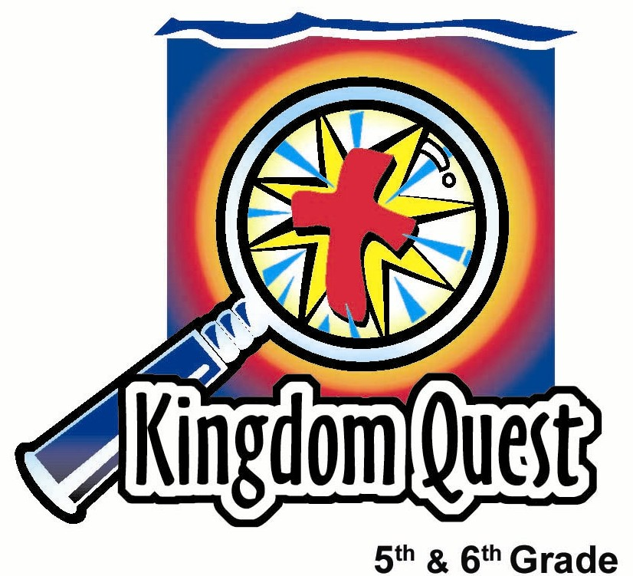
Date: ________________
Series: Holy Spirit Blaze (Jun-Aug)
Year 1, Lesson 2

God Sends the Holy Spirit

Take Home Point: *God sends the Holy Spirit to fill us with His presence.
*Repeat this phrase throughout the lesson.

Bible Event: Acts 2:1-41
Key Verses: John 14:17, “The Helper is the Spirit of truth... He lives with you and He will be in you.

We will help kids know:
- The Holy Spirit is God. He is the third Person of the Trinity, equal with God the Father and God the Son.
- God sends the Holy Spirit to fill us with His holy presence and direct our life. He is our coach.
- The Holy Spirit is sometimes seen in wind and fire throughout the Bible such as at the Pentecost event.

We will help kids feel:
- Awe at God’s desire to fill us with Himself.
- Comfort that we are not alone and can invite the Holy Spirit’s presence.

We will help kids do:
- Make wind racers as an example of the Holy Spirit filling our lives.
- Discuss some of their experiences on teams and with different coaches or teachers.
- Discuss how they see themselves on God’s team and interacting with their coach the Holy Spirit. correction
THIS LESSON’S ROADMAP

DESTINATION | PAGE # | DISCOVERIES ON YOUR JOURNEY | SUPPLIES NEEDED
Small Group Warm-Up   | 5-6 | Kids make wind racers as an example of the Holy Spirit filling our lives. | - racer kit for each triad: includes kite string about 15 feet long, large deflated balloon, piece of tape about four inches long, plastic straw cut in half
Large Group   | 9-11 | Overview  Coach Widaspirit teaches basic truths about the Holy Spirit, inviting kids to join the team, Holy Spirit Blaze. Coach Widaspirit explains the person of the Holy Spirit to the kids.  Video: Visual Bible Acts 2:1-41, produced by Visual Bible International, 1997 illustrates the Holy Spirit descending on Jesus’ followers at Pentecost. | - chalkboard, dry erase board or poster board (see appendix)  - prizes  - video, Visual Bible: Acts, produced by Visual Bible International, 1997  - cardboard crosses 6 X 4 inches – one for each team
Small Group Application   | 7-8  8-9 | Kids discuss what part of the game of life they are playing and how the Holy Spirit is the coach.  Memory Verse Learning:  “Up and Down”  John 14:17 is reinforced for lessons 2-5 as we come to the studies on the Holy Spirit. | - none  - a chair for each child

Introduction to the Series:
Holy Spirit Blaze

This series is designed for convenience in summer when there may be fewer shepherds or inconsistent attendance of the kids, making it harder for the groups to have the regular “small group” dynamic. This easier summer option will give the large group presenter an opportunity to lead the Warm-Up and Application activities while the kids are divided into triads or groups of three. The large group presenter plays the role of the coach and uses different games with the kids to illustrate the learning points. The kids are invited to join the team—Holy Spirit Blaze.

The character for this series is dressed in a coach’s outfit including a baseball cap and whistle. Across the presenter’s t-shirt or jersey is the team’s name- HOLY SPIRIT BLAZE. This could be as simple as taping the words to the t-shirt or as elaborate as painting them on. The coach is a visual reminder of the Holy Spirit as one who teaches and coaches us. His/her name is Coach Philip/ (Saying the first and last name together will sound like “fill up with the Spirit” or “fill us with the Spirit.”)

Series lessons:

Lesson #2 God Sends the Holy Spirit

Lesson #3 The Holy Spirit Brings Us to Faith

Lesson #4 The Holy Spirit Equips to Serve

Lesson #5 The Holy Spirit Produces Evidence of Faith

Lesson #6 Pray to Be Filled with the Holy Spirit
Small Group Warm Up: 15 minutes
Purpose: Get pointed in the right direction! Build relationships and help guests feel at ease. Do the learning readiness activity that will point your group in the right direction for the lesson.

As kids gather: Listen to memory verses from last week and give coupons for memory verses, remembering to bring your Bible, and bringing a guest.

Regular Shepherd Option: Do the Warm-Up activity as a small group. If you like, you can still divide into triads within your small group. This helps each child participate more.

Easier Summer Option: Instead of having kids in small groups with an assigned shepherd, the kids can meet all together and divide themselves into triads (groups of three). This allows for larger ratios between students and shepherds. Shepherds will monitor the kids’ activity as needed by roaming from group to group. The questions and directions for all the kids and their groups are by the large group presenter. IF this is used, go to the introduction of large group to introduce the main character used in this series.

Supplies: one racer kits per group which includes: kite string cut about 20feet long; one large deflated balloon; one piece of tape about four inches long; a plastic straw cut in half

Building the Wind Racers

As kids enter, the large group presenter (for the easier summer option) or shepherd for small group blows his whistle and gives the following directions.

If you use the easier summer option, the large group presenter, Coach Widaspirit, introduces him/herself from the script on page 9. Then Coach Widaspirit gives directions as follows:

As you come in, find two other people to be in your triad. Make up groups of three. Send one person up to get a wind racer kit. You will build a racer with the supplies and see how far it can go.

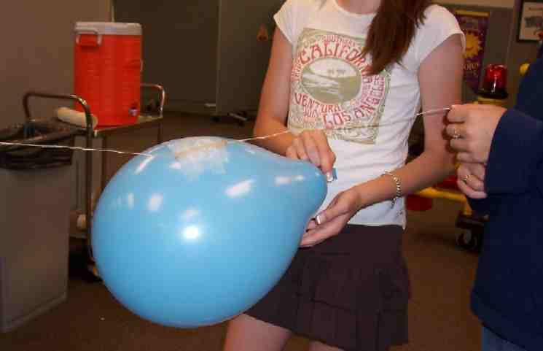
When groups have their supplies give the following directions step by step for building the wind racers.
- Insert the string through the straw so it can travel freely.
- Have two kids hold the string tight.
- The third kid should blow up the balloon but not tie it.
- While holding the balloon at the end so air does not escape, he/she should tape the balloon to the straw with the open end of the balloon facing the person holding it.
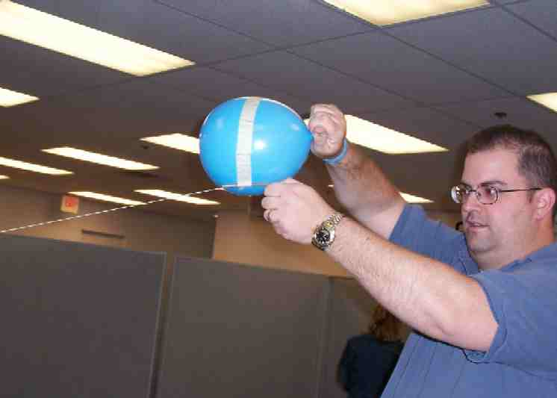
- As he/she lets go of the balloon, the air coming out will force the balloon and straw across the string.

Have kids take turns holding the string and letting go of the balloon. See if kids can get their balloon to travel all the way across the string. Compete against other teams.

Allow ten minutes for this activity and then blow your whistle. Then have kids sit down in groups as each person is given an opportunity to discuss the following with their partners:

Tell about a favorite coach or teacher that you have had. This could be from a sport, school, or maybe a piano teacher.

Blow your whistle when you are ready to move on to the next question.

Now, talk about a coach or teacher that was your least favorite.

Again, blow your whistle to get the kids attention and draw them all together. Then say:

Today we will learn how the Holy Spirit is like a coach to us, guiding us and giving us direction for life. Just like this balloon was full of invisible air that propelled the wind racers to sail, *God sends the Holy Spirit to fill us with His presence.

Large Group Overview: 20-30 minutes
Purpose: Help kids observe what the Bible says. Present the Bible event in creative fashion. Help kids begin to interpret what it means.

Supplies needed: chalkboard, dry erase board or poster board (see appendix); prizes; video, Visual Bible: Acts, produced by Visual Bible International, 1997; cardboard crosses 6 X 4 inches – one for each team

Coach Widaspirit teaches basic truths about the Holy Spirit, inviting kids to join the team, Holy Spirit Blaze. Coach Widaspirit explains the Person of the Holy Spirit to the kids.

Video: Visual Bible Acts 2:1-41, produced by Visual Bible International, 1997 illustrates the Holy Spirit descending on Jesus’ followers at Pentecost.

Small Group Application: 20-25 minutes
Purpose: Help kids map out the meaning of the Bible event in their lives. Use the questions to stimulate discussion, but don't feel tied to them. Allow the Holy Spirit to guide you. Include personal examples from your own faith journey. The example of Christ at work in your life will leave lasting impressions of how Christ can work in the children's lives.

Use your Bibles! Children need to learn how to look up references and follow along when scripture is read aloud. Allow for quality time of prayer at the close of the lesson.

Application Questions: What does this mean to me?
After kids return to their triads, continue:

Let’s consider that we are in a baseball game right now. If the Holy Spirit is your coach, where are you in the game? There are no incorrect answers. This is just a visual way of seeing how much you are a part of the Holy Spirit’s team following Christ.

Are you in the stands watching the game? Possibly you are on the bench waiting to get into the game.

Are you on the playing field?

What position are you playing?

Let kids discuss where they see themselves and why.

If you are sitting in the stands wanting to be a part the team, you can be right now. Admit to God that you have done things that are wrong, and your relationship with God is broken. Claim what Jesus Christ has done for you by dying for your sins on the cross and rising again. Ask for forgiveness, and ask that Jesus would live in your life.

*God sends the Holy Spirit to fill us with His presence. The Holy Spirit can direct you to Jesus, and you need to put your faith and trust in Him, allowing Him to be the Lord of your life. The Holy Spirit then becomes your coach and directs your life.

The key verse for today from John 14:16-17 says, “I will ask the Father, and He will give you another Helper. He will give you this Helper to be with you forever. The Helper is the Spirit of truth... He lives with you and He will be in you.

Let’s pray. If you have never been on this team, trust Jesus as your Savior and thank Him when you pray with us. You, too, can be a part of the HOLY SPIRIT BLAZE team.

Dear God, thank you for letting us talk to You. We know that You hear us, even if we are talking to You just in our thoughts. Thank You for sending the Holy Spirit who teaches us about You and leads us to faith in You.

Each one of us comes to You, admitting that we are sinners and need the power of Your forgiveness. We have faith that Jesus’ death and resurrection for us has the power to take away our sin. We ask now that You would forgive us.

We pray that Jesus would live in our life as Lord and Savior, and, through the Holy Spirit, He would guide and direct us in all that we do. In Jesus’ name. Amen.

Memory Verse Learning: 5 minutes
Purpose: Help kids to memorize and keep scriptures at heart. Using creative ways to help kids enjoy learning the key verse and in small group setting.

Supplies needed: a chair for each child

Memory Verse: John 14:17 The Helper is the Spirit of truth... He lives with you and He will be in you. (NCV)

MV Presentation: “Up and Down”
Write the memory verse on the white board. Have the children recite a few times until they have memorized the verse. Tell the children that they are going to compete with one another through “Up and Down” game. They are to stand in a circle with a chair right behind them. The aim of the game is to get to sit down on their chair. To begin, a child starts by say the first word of the verse. The child on the right continues with the next word of the verse. It continues until the verse is completed. But if a child cannot continues the memory verse, he/she is to stand and will keep standing until he can continue with the next word to the verse. When everyone gets to be seated, give a great cheer together to express “we did it together.”

Large Group Presentation

The character for this series is dressed in a coach’s outfit including a baseball cap and whistle. Across the presenter’s t-shirt or jersey is the team’s name---HOLY SPIRIT BLAZE. This could be as simple as taping the words to the t-shirt or as elaborate as painting them on. The coach is a visual reminder of the Holy Spirit as one who teaches and coaches us. His/her name is Coach Philip/Phyllis Widaspirit. (Saying the first and last name together will sound like “fill up with the Spirit” or “fill us with the Spirit.”)

Supplies needed:
- chalk board, dry erase board or poster board for the chart (see appendix )
- video Visual Bible Acts 2:1-41, produced by Visual Bible International, 1997
- 4 X 6 inch cardboard cross cutouts per team
- prizes as rewards

Introduction of Philip (Phyllis) Widaspirit:

Let me formally introduce myself to you. I am Coach Widespirit, Philip (Phyllis) Widaspirit. Just so you will NOT forget my name repeat after me… Philip (Phyllis) Widaspirit.

Have kids repeat.

You got it. That is what we will do today. We are going to fill up with the Spirit.

I am the coach of the team, Holy Spirit Blaze. It is my privilege to welcome you to training camp. Since you have all been hand selected, I know this is going to be a champion team!

One of our objectives as a team is to learn all about the Holy Spirit. He is the presence of God in your lives and is your ultimate coach.

One of the greatest forces on earth is the Holy Spirit of God. He wants us to be filled up with Himself. When we are, we are BLAZING!

Now, let’s get down to business.

The Holy Spirit is God

Let me explain our game plan.

Draw the diagram of the Trinity from the appendix page.

This is our ball field. This will help you understand the coaching system. This is one way of looking at God. God the Father, God the Son and God the Holy Spirit are all Persons of God. But, the Father is not the Son, the Holy Spirit is not the Father, and the Son is not the Holy Spirit.

The three are different Persons with different roles. God the Father created us, God the Son gave His life for us, and God the Holy Spirit fills us with God’s presence.

Okay, team, here is a quick quiz to see if you understand the field we play on. We have one God in three Persons. Who are the three persons of God? (Father, Son and Holy Spirit.)

The Holy Spirit Fills and Directs Our Lives

Have your Bibles ready, as we will look up verses together that help us understand how the Holy Spirit fills and directs our lives. He is like a coach.

Let’s start by looking up John 14:16-17.

Give the kids time to look it up and read it together.

“I will ask the Father, and He will give you another Helper. He will give you this Helper to be with you forever. The Helper is the Spirit of truth... He lives with you and He will be in you.

Now, stay in the same chapter but go down to verse 26. Who will read this verse for us?

Have a volunteer stand and read the verse.

“But the Helper will teach you everything. He will cause you to remember all the things I told you. This Helper is the Holy Spirit whom the Father will send in My name.”

In chapter 16 verses 7 and 8 of the book of John, Jesus tells His disciples about the Holy Spirit who will come after Jesus leaves.

Have a volunteer stand and read John 16:7-8 from his/her Bible.

“But I tell you the truth. It is better for you that I go away. When I go away I will send the Helper to you. If I do not go away, the Helper will not come. When the Helper comes, He will prove to the people of the world the truth about sin, about being right with God, and about judgment.”

Have prizes handy to give three volunteers who answer the following question.

I have a special prize to give to three people who can tell me one thing the Holy Spirit will do when He comes upon you. Each answer must be different. (Choices for answers include: be with you forever, live with you and in you, teach, remind us of what Jesus taught, convict the world of sin, show the world God’s approval, convince the world that God judges it.)

Let’s take a look at when the Holy Spirit came upon the people. Forty days after Jesus’ crucifixion, He ascended into heaven. People were waiting for Jesus to send the promised Holy Spirit who would fill them with the presence of God.

Finally ten days after Jesus’ ascension into heaven, on the day of Pentecost, something incredible happened. Let’s watch and see what occurred.

Video
Show the video, Visual Bible: Acts (produced by Visual Bible International, 1997) from Chapter 2:1-41. This will run for six minutes and 45 seconds.

After the video, continue with:

Wind and Fire

Throughout the Bible, the presence of God is sometimes pictured for people as fire and wind. I have a special prize for anyone who can think of a time in the Bible when God’s presence was seen in fire. (Accept any one or two examples: the burning bush with Moses, the pillar of fire leading the children of Israel, the fire stopping the chariots from pursuing the children of Israel across the red sea.)

One thing significant about Pentecost is now God’s presence is put into people’s lives. God dwells within our lives. He is not just seen from afar.

Refer to your HOLY SPIRIT BLAZE jersey.

If we have the Holy Spirit within us, we actually have God’s presence in our lives. This is like the early disciples that had fire on top of their head as a visible way that people saw the Holy Spirit in their lives.

What Does the Holy Spirit Do?

Have teams pick up their racers from the beginning of the lesson. Have them each place a cross on the end of the string where the balloon finishes the race. Do this by putting a small hole in the middle of the cross and pulling the string through it. Tie the string on the back of the cardboard cross.

Allow the teams to race their racers seeing whose racer gets to the cross first or goes the farthest. Give a prize to the winners.

Conclusion
Have the kids sit down and listen. Then continue with:

The cross at the end of the string reminds us that the Holy Spirit guides us in our lives. Blowing up the balloon is like God breathing into our lives His breath, or Holy Spirit, through which He points us to the cross. The Holy Spirit helps us to have faith in Jesus Christ, our Savior, and helps us serve and follow Jesus. *God sends the Holy Spirit to fill us with His presence.

Have kids return to their triads or small group area where they will continue.

If staying in large group, the presenter leads kids through the small group application time.

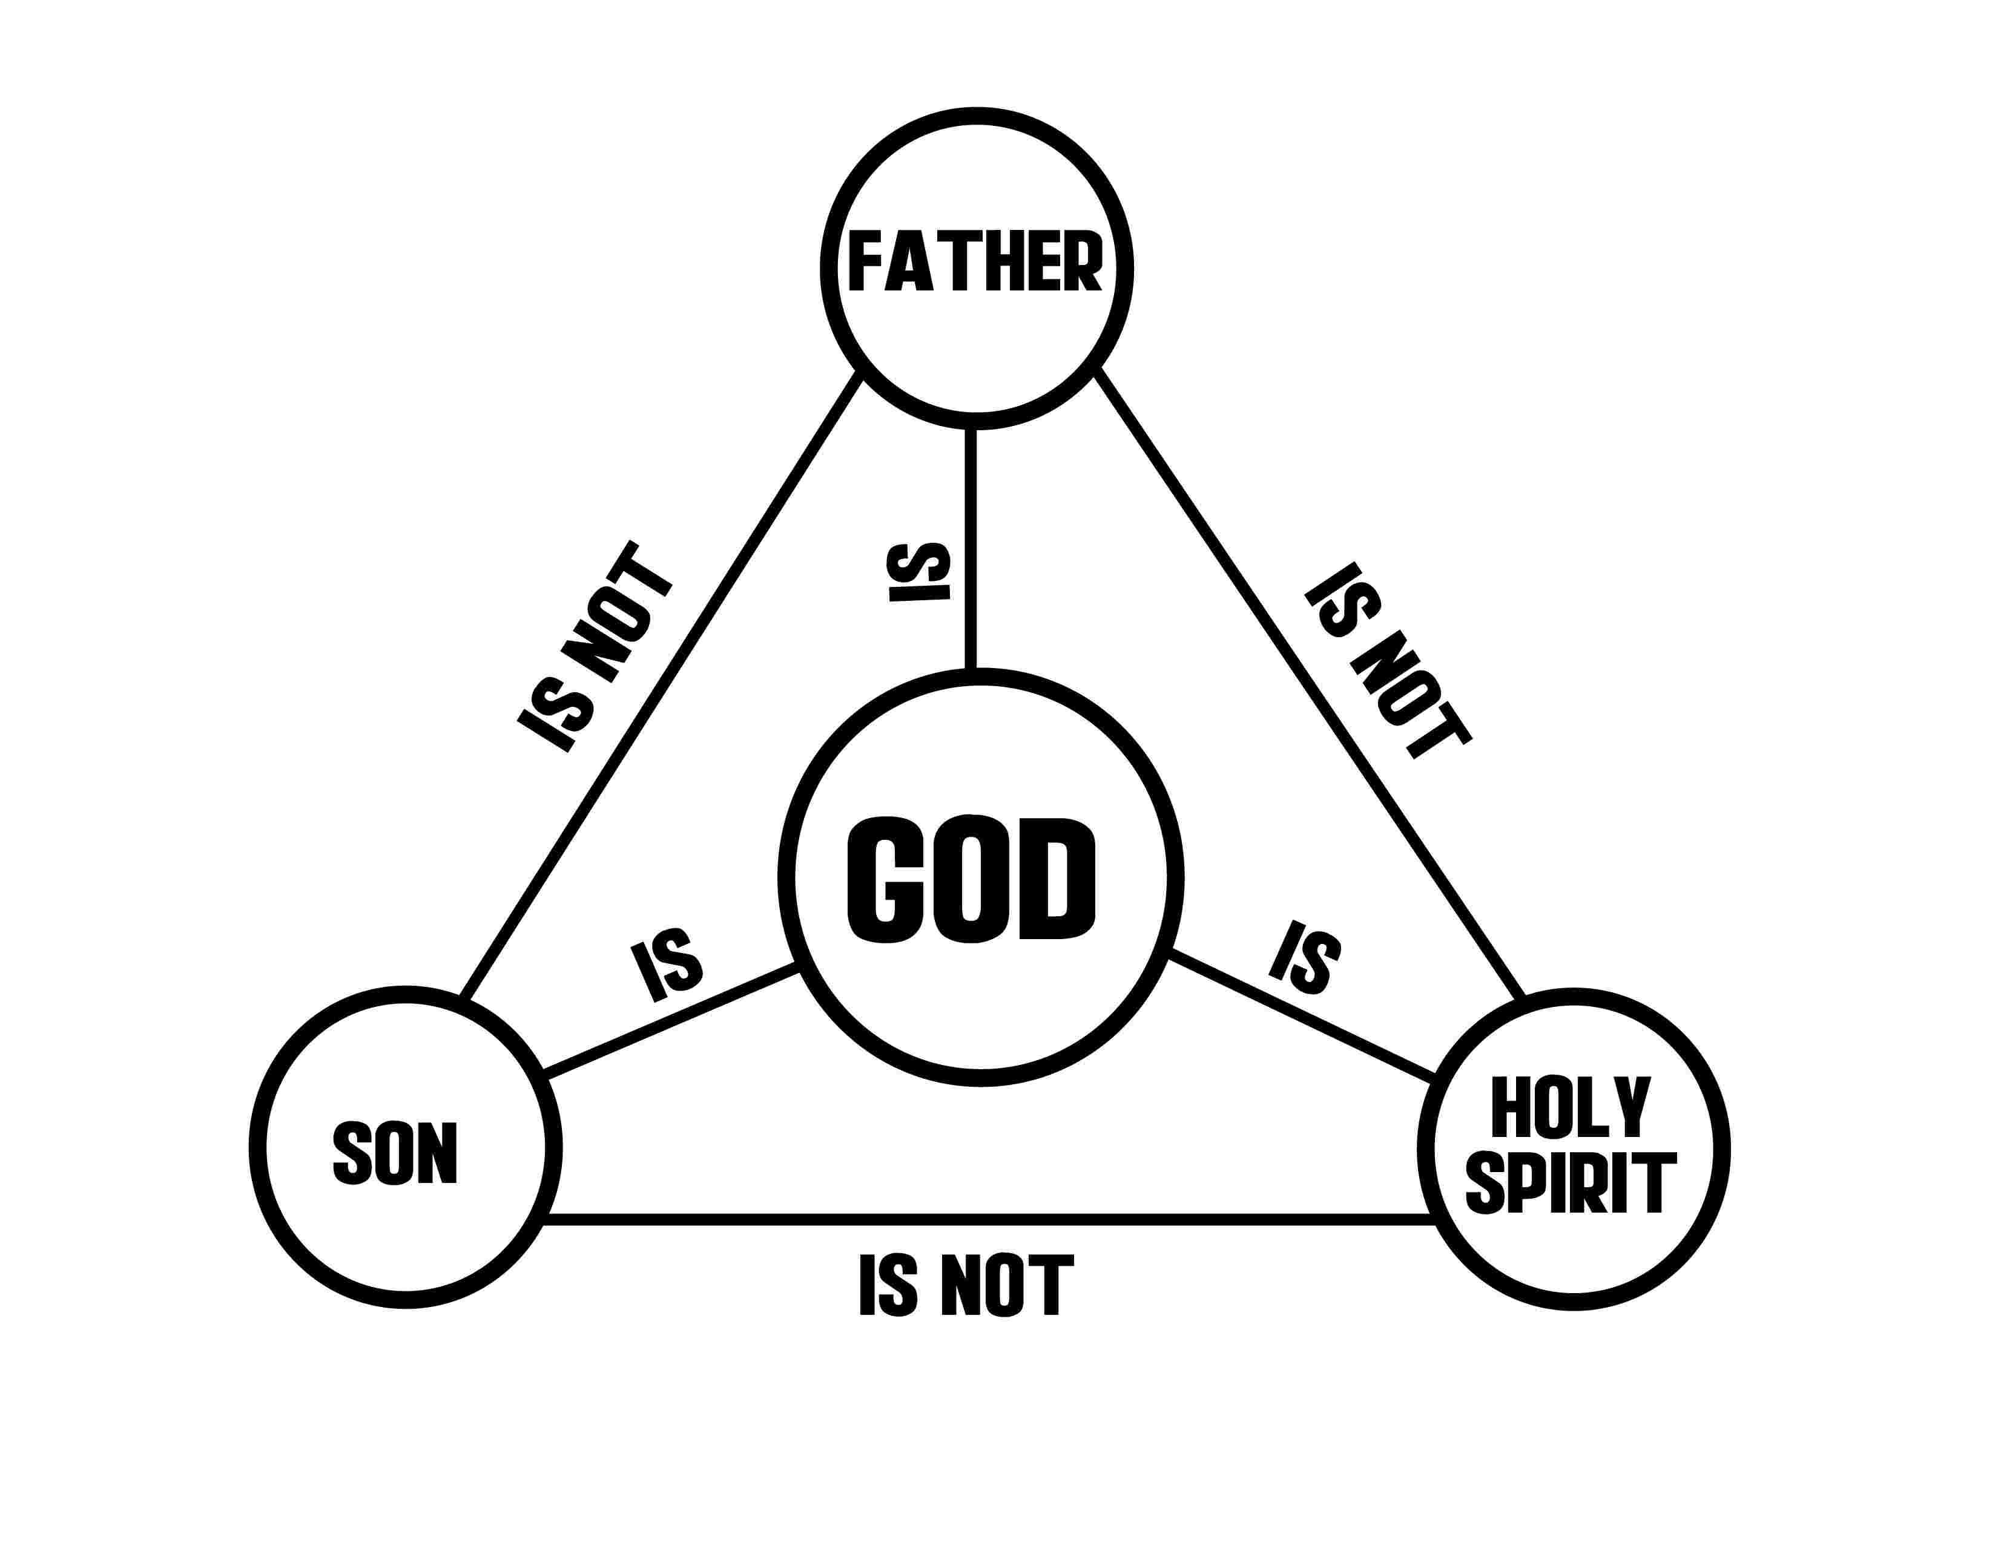

SUPPLY LIST

Lesson 2
Small Group Warm-Up:
- kite string about 15 feet long
- large deflated balloon
- piece of tape about four inches long
- plastic straw cut in half

Large Group:
- chalkboard
- dry erase board or poster board (see appendix)
- prizes (such as stationery)
- cardboard crosses 6 X 4 inches – one for each team

Small Group Application:
- none

Memory Verse Learning:
- a chair for each child.

