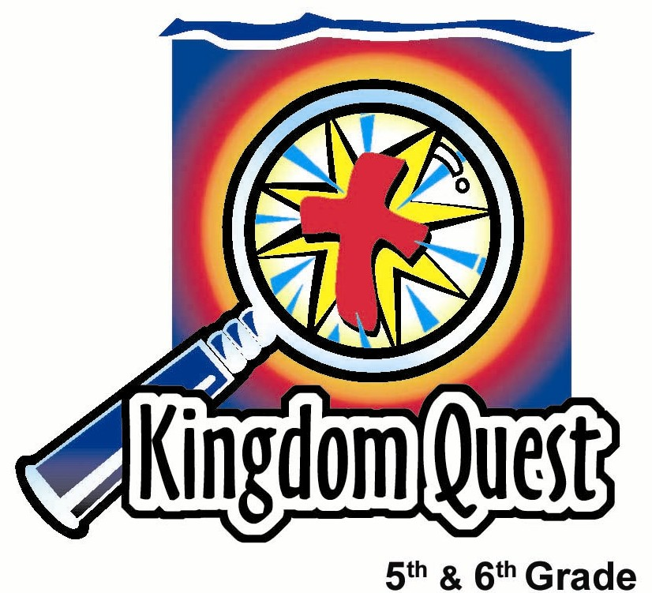
Date: _________________________
Series: Holy Spirit Blaze (Jun-Aug)
Year 1, Lesson 5

The Holy Spirit Produces Fruit

Take Home Point: *The Holy Spirit produces fruit in our lives.
*Repeat this phrase throughout the lesson.

Bible Event: Galatians 5:16-25
Key Verses: Galatians 5:22-23a, “But the Spirit gives love, joy, peace, patience, kindness, goodness, faithfulness, gentleness, self-control.” (NCV)

We will help kids know:
- We live with two natures—our sinful nature and our spiritual nature. Our spiritual nature is that which is filled with the Holy Spirit.
- We should give the Holy Spirit control in our lives so that we demonstrate the Holy Spirit’s fruit.
- The fruit of the Spirit are qualities that He produces like love, joy, peace, patience, kindness, goodness, faithfulness, gentleness and self-control.

We will help kids feel:
- Inspired to show the fruit of the Spirit in their lives.
- Confident that God is working in their lives.

We will help kids do:
- Identify a person they know who best demonstrates the life of a Christian.
- Identify a fruit of the Spirit they would like.
- Make an art project reminding them of one of the fruit of the Spirit for which they are praying.
THIS LESSON’S ROADMAP

DESTINATION | PAGE # | DISCOVERIES ON YOUR JOURNEY | SUPPLIES NEEDED
Small Group Warm-Up   | 3 | While tasting the different flavors of sweets , kids discuss the different fruit of the Spirit. | - fruit flavored sweets
Large Group   | 4  7-9 | Overview  Game: “Fruit Challenge Sponge Throw”—Kids have a contest to determine the different flavor of fruit sweets, emphasizing there are different fruit of the Spirit.  The teaching point will help the children understand that the power to be like Jesus comes from the Holy Spirit. | - one dry sponge  - two wet sponges  - fruit flavor sweets  - small bucket of water
Small Group Application   | 4-6  6 | Kids pray for the fruit of the Spirit they would like to acquire and make an art project they can display or take home.  Memory Verse Learning:  “Fruits to Taste”  1 Cor. 3:16 is reinforced for lessons 5 & 6 as we continue to study on the Holy Spirit. | - “Lord, give me the fruit of the Spirit” sheet for each student (see appendix)  - newsprint or poster board (optional)  - paint and brushes or markers, etc.  - nine types of fruits cut to small pieces for tasting

Small Group Warm Up: 15 minutes
Purpose: Get pointed in the right direction! Build relationships and help guests feel at ease. Do the learning readiness activity that will point your group in the right direction for the lesson.

As kids gather: Listen to memory verses from last week and give coupons for memory verses, remembering to bring your Bible, and bringing a guest.

Regular Shepherd Option: Do the Warm-Up activity as a small group. If you like, you can still divide into triads within your small group. This helps each child participate more.

Easier Summer Option: Instead of having kids in small groups with an assigned shepherd, the kids can meet all together and divide themselves into triads (groups of three). This allows for larger ratios between students and shepherds. Shepherds will monitor the kids’ activity as needed by roaming from group to group. The questions and directions for all the kids and their groups are by the large group presenter. IF this is used, go to the introduction of large group to introduce the main character used in this series.

Supplies: Fruit flavor sweets

Think of a strong Christian that you know. How does he or she best demonstrate what it means to be a Christian?

Have each student share the name of the person they are thinking of, and then talk about why they chose that person.

Read Galatians 5:22-23a listing the qualities known as the fruit of the Spirit. (Note that the NIV uses the title “fruit of the Spirit” and God’s Word translation describes it as “the spiritual nature.”)

When you look at this list of the fruit of the Spirit, what one quality best describes what you have seen in the person who is a great Christian example to you?

After discussion, pass out a small amount of sweets to the group for a snack. Continue speaking.

Just like the different fruit tastes of sweets are pleasant to eat, when God’s Holy Spirit lives inside you, He produces qualities that are pleasant. *The Holy Spirit produces fruit in our lives.

Today we will discover how we can turn more control over to the Holy Spirit in our lives and live with His power working through us instead of living as slaves to our old sinful nature.

Large Group Overview: 20-30 minutes
Purpose: Help kids observe what the Bible says. Present the Bible event in creative fashion. Help kids begin to interpret what it means.

Supplies needed: one dry sponge; two wet sponges; fruit flavor sweets; small bucket of water

Game: “Fruit Challenge Sponge Throw”—Kids have a contest to determine the different flavor of fruit sweet, emphasizing there are different fruit of the Spirit.

The teaching point will help the children understand that the power to be like Jesus comes from the Holy Spirit.

Small Group Application: 20-25 minutes
Purpose: Help kids map out the meaning of the Bible event in their lives. Use the questions to stimulate discussion, but don't feel tied to them. Allow the Holy Spirit to guide you. Include personal examples from your own faith journey. The example of Christ at work in your life will leave lasting impressions of how Christ can work in the children's lives.

Use your Bibles! Children need to learn how to look up references and follow along when scripture is read aloud. Allow for quality time of prayer at the close of the lesson.

Observation Questions: What happened?/ Interpretation Questions: What does this mean?
Answer the following application questions either in small group or with the presenter asking the questions to triads. Have kids refer to Galatians 5:19-24 in their Bibles.

The Bible says we grow character fruit. The kind of fruit grown depends on the type of tree. If we do what our sin nature wants, we grow bad fruit. If we do what God wants, we grow good fruit.

Name some of the bad fruit produced from our corrupt nature as found in Galatians 5:19-21. (sexually unfaithful, not being pure, taking part in sexual sins, worshiping false gods, doing witchcraft, hating, making trouble, being jealous, being angry, being selfish, making people angry with each other, causing divisions among people, having envy, drunkenness, wild partying, etc.)

What happens to people who do these kinds of things without repentance? (Galatians 5:21. Those who do these things will not be in God’s kingdom.)

Name the fruit of the Spirit as found in Galatians 5:22-23. See how many you can name without looking. (Love, joy, peace, patience, kindness, goodness, faithfulness, gentleness, and self-control.)

According to Galatians 5:24, who demonstrates these characteristics? (Those who belong to Christ Jesus.)

Application Questions: What does this mean to me?
How do we produce this fruit in our lives? (We read the Bible to learn what kind of person we should be, love and obey God, pray for the Holy Spirit to produce this fruit in us.)

Activities:
Supplies needed: “Lord, give me the fruit of the Spirit” sheet for each student (see appendix), newsprint or poster board (optional), paint and brushes or markers, etc.

Pass out the “Lord, give me the fruit of the Spirit” sheet to each kid. Ask:

Which of the spiritual fruit listed in Galatians do you want the Holy Spirit to produce more of in you?

Option A: Group project.

The closing art activity can be done as an entire group, such as eight students making a mural out of newsprint, or three students using poster board or small sections of newsprint.

Have each student use paint and brushes or markers to write the fruit of the Spirit that they would like more of in their life. Title this mural or poster board with “Lord, give us the fruit of your Spirit:”

This mural, or these group posters, may decorate your classroom for a period of time.

Option B
Copy the appendix on 8 ½” x 11” cardstock. Give each student a sheet to decorate and take home using paint and brushes or markers.

Which nature produces spiritual fruit according to the key verse from Galatians 5:22-23a, “But the Spirit gives love, joy, peace, patience, kindness, goodness, faithfulness, gentleness, self-control.”? (Our spiritual nature.)

Today we learned that *the Holy Spirit produces fruit in our lives.

Prayer Time:
Kids gather in small groups or triads to pray for which spiritual fruit they want the Holy Spirit to develop in their lives.

Memory Verse Learning: 5 minutes
Purpose: Help kids to memorize and keep scriptures at heart. Using creative ways to help kids enjoy learning the key verse and in small group setting.

Supplies needed: nine types of fruits cut to small pieces for tasting

Memory Verse: 1 Corinthians 3:16, “You should know that you yourselves are God’s temple. God’s Spirit lives in you.”

MV Presentation: “Fruits to Taste”
Divide the children into two teams. Explain that the game is to see which team has better “tasters.” Each team members has to take turns to taste one type of fruit. One has to be blindfolded. If a taster would like to give out the answer, he/she must first say 1 Cor. 3:16 before he/she can give out the answer. When correct, the person get 1,000 points for his/her team but if an answer is said out before reciting the memory verse, 500 points is minus from the team’s score.

Large Group Presentation

The Holy Spirit Produces Fruit

The character for this series is dressed in a coach’s outfit including a baseball cap and whistle. Across the presenter’s t-shirt or jersey is the team’s name---HOLY SPIRIT BLAZE. This could be as simple as taping the words to the t-shirt or as elaborate as painting them on. The coach is a visual reminder of the Holy Spirit as one who teaches and coaches us. His/her name is Coach Philip/Phyllis Widaspirit. (Saying the first and last name together will sound like “fill up with the Spirit” or “fill us with the Spirit.”)

Supplies: one dry sponge, two wet sponges, fruit flavored sweets, small bucket of water

Opening Game: Fruit Challenge Sponge Throw

The entire large group is divided into two teams such as boys against girls. Each team will send up one contestant at a time that is willing to possibly get hit with a wet sponge. Explain the rules as follows.

These two contestants will represent each of your teams. The first contestant will take the fruit challenge.

I will place a sweet in this person’s hand while his/her eyes are closed. That person must eat the sweet without looking at the color. If that person can guess the correct color and meet the challenge, then they get to throw a sponge at the other contestant standing 15 feet away. If they miss the fruit challenge and do not guess correctly, the other contestant will throw a wet sponge at the person who missed the fruit challenge.

Say to the contestant:

Are you ready? Okay. Close your eyes and hold out your hand. Everyone else will see the color of the sweet that I place in your hand. Here it is.

The contestant takes the sweet, puts it in his/her mouth and tries to identify the color. If identified correctly, that person can throw a wet sponge at the other contestant. If the person fails to guess correctly, a sponge is thrown at him/her.

That concludes round one. Who would like to be part of round two?

Take two more contestants. Repeat this process according to how much time you would like to spend with it.

Teaching Point: Two different natures.

Hold up a dry sponge and a wet sponge.

These two sponges remind us of the two natures inside of us. One is the spiritual nature… Hold up the wet sponge.

And the other is the sinful nature (hold up the dry sponge), or as some Bibles call it, the corrupt nature. Your nature is who you are on the inside. We all have two different natures on the inside.

The natures fight against each other.

The Bible says that these natures are opposed to each other, because they both want us to do opposite things. In Galatians 5:16 and following it says, “So I tell you: Live by following the Spirit. Then you will not do what your sinful selves want. Our sinful selves want what is against the Spirit. The Spirit wants what is against our sinful selves. The two are against each other. So you must not do just what you please.”

The effects of the corrupt nature

Hold up the dry sponge.

Galatians 5:19 says, “The wrong things the sinful self does are clear: sexually unfaithful, not being pure, taking part in sexual sins, worshiping false gods, doing witchcraft, hating, making trouble, being jealous, being angry, being selfish, making people angry with each other, causing divisions among people, having envy, being drunk, having wild and wasteful parties, and doing other things like this. I warn you now as I warned you before: Those who do these things will not be in God’s kingdom.”

You see, if you are not a Christian it is easy to do what your sinful nature wants. For example, we were just playing for fun in the fruit challenge. But maybe you have been in a game where things turned ugly. You wanted to hurt your opponent or say bad things about them, or lose control and have angry outbursts. Those kinds of actions come from one’s sinful nature, like this dry sponge. It is hard and brittle.

The fruit of the Spirit

On the other hand, when the Holy Spirit brings you to have faith in Christ and you trust Him as your Savior, the Holy Spirit fills you with His presence just like this wet sponge—full of water. No longer is it dry and hard. Now it is soft and filled with God’s presence. Because of that, the actions that God wants us to have are the same as the actions Jesus demonstrated. They are called fruit of the Spirit, or our spiritual nature.

The Bible says it this way in Galatians 5:22, “But the Spirit gives love, joy, peace, patience, kindness, goodness, faithfulness, gentleness, self-control.”

How to have fruit of the Spirit

To have the fruit of the Spirit, we can pray that God’s Holy Spirit would fill us just like this sponge dipped into the water. By faith we are washed clean of our sin. The water, which is a picture of the Holy Spirit, oozes out. It shows others the same kinds of actions that Jesus did. We can be like Jesus when He showed love, peace, patience, and kindness to others.

Everyday we should ask God to fill us with His Spirit so that we produce those kinds of fruit and that God’s presence would flow from us in our lives. *It is the Holy Spirit who produces this fruit in our lives.

Conclusion:

Return to your small groups or triads for application questions and activities.

SUPPLY LIST

Lesson 5

Small Group Warm-Up:
  - fruit flavor sweets for each child

Large Group:
  - one dry sponge
  - two wet sponges
  - fruit flavor sweets
  - small bucket of water

Small Group Application:
- “Lord, give me the fruit of the Spirit” sheet for each student (see appendix)
- newsprint or poster board (optional)
- paint and brushes or markers, etc.

Memory Verse Learning:
- nine types of fruits cut to small pieces for tasting

“Lord, give me fruit of the Spirit.”

FRUIT OF THE SPIRIT
Galatians 5:22,23a

Love

Joy

Peace

Patience

Kindness

Goodness

Faithfulness

Gentleness

Self-control

