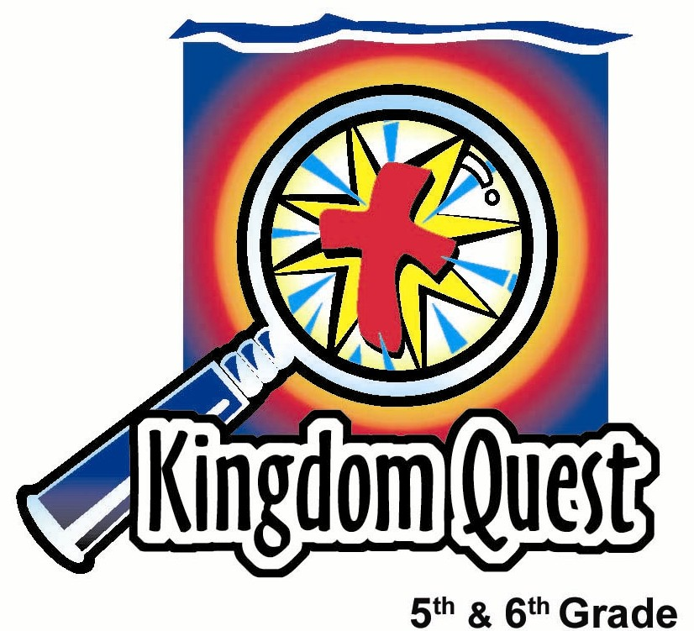
Date: _________________________
Series: Holy Spirit Blaze (Jun-Aug)
Year 1, Lesson 6

Ask to Be Filled With the Holy Spirit

Take Home Point: *Ask to be filled with the Holy Spirit.
*Repeat this phrase throughout the lesson.

Bible Event: Luke 11:9-13
Key Verses: 1 Corinthians 3:16, “You should know that you yourselves are God’s temple. God’s Spirit lives in you.” (NCV)

We will help kids know:
- A review of the previous lessons in this series on the Holy Spirit.
- The best gift we can ask for is not a thing, but a person—God’s Holy Spirit.
- God wants us to ask and He will give us the Holy Spirit.

We will help kids feel:
- Excited as they have fun reviewing the main teachings about the Holy Spirit.
- Awed that God will fill them with His Holy Spirit when they ask Him to do so.

We will help kids do:
- Asking, through prayer, to receive the Holy Spirit in class and daily throughout the week.
- Play some shaving cream games that review the teaching of recent lessons about the Holy Spirit.
THIS LESSON’S ROADMAP

DESTINATION | PAGE # | DISCOVERIES ON YOUR JOURNEY | SUPPLIES NEEDED
Small Group Warm-Up   | 3 | Kids talk about presents they have received or wanted and not received. The biggest present they could ask for is not a thing but a person—the Holy Spirit. | - none
Large Group   | 7-11 | Overview  Many activities will be done with shaving cream as the lessons in this series are reviewed. The kids will build a shaving cream mountain and then mold it into a cross, make handprints on a painting canvas, add pictures of fruit to the painting, and finally decorate the face of one of the group members who asks to have his/her face painted. | - painting canvas—place a black garbage bag over a piece of manila card (one per group)  - shaving cream (one per group)  - Biocolor® foam paint – from Discount School Supply 1-800-627-2829 in several colors  - extra plastic bags to place over the head of one person from each group to use as a paint shirt  - wet wipes  - tables (Enough table space needs to be available for each team to build a shaving cream mountain.)
Small Group Application   | 4-6  6 | Discuss times the kids have felt the presence of God. If they have never trusted Jesus to be their Savior, the opportunity is available. As believers, kids will be encouraged to pray for the filling of the Holy Spirit in their life.  Memory Verse Learning:  “Word Scramble”  1 Cor. 3:16 is reinforced for lessons 5 & 6 as we continue to study on the Holy Spirit. | - none  - 2 or 3 sets of memory verse flash cards. Each set contains a word of the memory verse.
Small Group Warm Up: 15 minutes
Purpose: Get pointed in the right direction! Build relationships and help guests feel at ease. Do the learning readiness activity that will point your group in the right direction for the lesson.

As kids gather: Listen to memory verses from last week and give coupons for memory verses, remembering to bring your Bible, and bringing a guest.

Easier Summer Option: Instead of having kids in small groups with an assigned shepherd, the kids can meet all together and divide themselves into triads (groups of three). This allows for larger ratios between students and shepherds. Shepherds will monitor the kids’ activity as needed by roaming from group to group. The questions and directions for all the kids and their groups are by the large group presenter. IF this is used, go to the introduction of large group to introduce the main character used in this series.

Regular Shepherd Option: Do the Warm-Up activity as a small group. If you like, you can still divide into triads within your small group. This helps each child participate more.

After kids have gathered together in their small group or triads, have them discuss the following:

Tell the other members of your triad about a present you received for Christmas, your birthday, or simply a surprise present that was one of your favorites.

What was the biggest present you ever asked for and received?

What is the biggest you asked for but didn’t receive?

If you could ask God for any present what would ask Him for?

Today we will discover that the biggest present we can ask for is not a thing, but a Person. *Ask to be filled with the Holy Spirit.

Large Group Overview: 20-30 minutes
Purpose: Help kids observe what the Bible says. Present the Bible event in creative fashion. Help kids begin to interpret what it means.

Many activities will be done with shaving cream as the lessons in this series are reviewed. The kids will build a shaving cream mountain they will then mold into a cross, make handprints on a painting canvas, add pictures of fruit to the painting, and finally decorate the face of one of the group members who asks to have his/her face painted.

Small Group Application: 20-25 minutes
Purpose: Help kids map out the meaning of the Bible event in their lives. Use the questions to stimulate discussion, but don’t feel tied to them. Allow the Holy Spirit to guide you. Include personal examples from your own faith journey. The example of Christ at work in your life will leave lasting impressions of how Christ can work in the children’s lives.

Use your Bibles! Children need to learn how to look up references and follow along when scripture is read aloud. Allow for quality time of prayer at the close of the lesson.

Have kids go back to their triads to answer the following questions.

Observation Questions: What happened?/ Interpretation Questions: What does this mean?
Review Luke 11:9-13.

Summarize in one sentence what Luke 11:9-10 says to you. (God wants us to ask because He wants to give to us.)

Have kids read Luke 11:11-13.

Who does God compare Himself to? (Our earthly fathers who want to give their children good things.)

How much better is God in giving to us than our earthly fathers? (Even though our earthly fathers are sinful (the text says evil), they know how to give good gifts, so our heavenly Father who is not sinful can give us even better things.)

What does God want us to ask for in verse 13? (His Holy Spirit.)

Application Questions: What does this mean to me?
Today’s key verse from 1 Corinthians 3:16 says, “You should know that you yourselves are God’s temple. God’s Spirit lives in you.”

How does it make you feel to know that God would want to live in you and set you apart like His holy temple?

Have any of you ever felt God’s presence in your life? What does that feel like?

God’s presence is more than a feeling, but there can be strong feelings because of His presence. If we have His presence, we will know this most important truth: that God gave His only Son, Jesus, to take away our sin. Because of Jesus death on the cross and resurrection, we can have a relationship with Him and He will fill us with His presence. This will give us a great amount joy even though our circumstances may be filled with trials or difficulties.

We will also exhibit Jesus’ character or the fruit of the Spirit. We will live showing others love, joy, peace, patience, kindness, goodness, faithfulness, gentleness, and self-control.

Is there anyone here who has never trusted Jesus to be his/her Savior? If you haven’t, today you will have an opportunity to commit yourself to Him. I am going to pray a prayer out loud as you pray it in your heart.

Dear heavenly Father,

First of all, I thank You for loving me so much. I recognize that I am separated from You because of the wrong things that I have done. I admit my sin and my need for You and Your forgiveness.

I recognize that Your Son, Jesus, gave His life for me on the cross and died for my sin. He rose again and is alive right now.

Please forgive me and come into my life. Let me live for You. You said You would give your Holy Spirit to those who asked. God, I ask that the Holy Spirit come in and fill my life. Do that now and please allow me to serve You. In Jesus’ name. Amen.

What do you want the Holy Spirit to do in your life? Are you feeling that you don’t have much peace or is there something that you are struggling with? Is there something you don’t understand? Maybe you don’t feel like you are serving God very well.

Pause for reflection and then continue.

Let’s pray that the Holy Spirit will come into your life and help with whatever it is. Each one of you say your own prayer as you go around the circle in your triad asking the Holy Spirit for help.

Let groups pray together. Conclude by restating the take home point.

Today we learned that the biggest present we could ask for is not a thing, but a Person. *Ask to be filled with the Holy Spirit.

Memory Verse Learning: 5 minutes
Purpose: Help kids to memorize and keep scriptures at heart. Using creative ways to help kids enjoy learning the key verse and in small group setting.

Supplies needed: 2 or 3 sets of memory verse

Memory Verse: 1 Corinthians 3:16, “You should know that you yourselves are God’s temple. God’s Spirit lives in you.” (NCV)

MV Presentation: “Word Scramble”
Review 1 Cor. 3:16 with the children and tell them that the review is to prepare them for a challenge. Then divide the class into two groups. Scatter the memory verse flash cards before each group. Tell the children that the challenge is called “Word Scramble” and the thing the groups have to do is to arrange the flash cards according to 1 Cor. 3:16.
Sure sound simple isn’t it? There is a catch. Team members have
to be blindfolded to unscramble the flash cards. But the team
will choose one member to guide them and this person is the
only one in the team that can see. He/she will instruct verbally
three feet away from the other team members.

Get each team to sit in a roll, blindfold themselves and take a few cards each. At the shepherd’s indication, teams can begin whereby the sight team members give instructions and the first team that completes the verse wins.

Large Group Presentation

Ask to Be Filled With the Holy Spirit

The character for this series is dressed in a coach’s outfit including a baseball cap and whistle. Across the presenter’s t-shirt or jersey is the team’s name – HOLY SPIRIT BLAZE. This could be as simple as taping the words on or as elaborate as painting it.

The coach is a visual reminder of the Holy Spirit as one who teaches and coaches us. His/her name is Coach Widaspirit with the first name being Philip or Phyllis. Saying the name together will sound like “fill up with the spirit” or “fill us with the spirit.”

Supplies:
- one painting canvas per group (a piece of cardboard or poster board covered with a black garbage bag)
- white shaving cream (one per group))
- Biocolor® Foam Paint (This can be ordered from Discount School Supply-1-88-627-2829. One can provides 14 cups of paint, so a little bit of this paint will last a long time. It is the consistency of shaving cream and is great fun to have in your supply closet.)
- plastic garbage bag with a hole cut out on the bottom so it can be worn over clothes to protect from paint and shaving cream (one per triad)
- wet wipes
- tables (Enough table space needs to be available for each team to build a shaving cream mountain.)

Divide the group into teams of six to eight kids. If kids were in triads earlier, put two triads together.

Introduction

Today it is time for our final Olympics. We have been training very hard over the past few weeks for our team, HOLY SPIRIT BLAZE, and learning how God has sent His Holy Spirit to fill us up.

Each of our Olympic events will remind us of one of the main teaching points that we have had about the Holy Spirit.

Our first event will be a race to see how high a mountain you can build.

Shaving Cream Mountain Review: God Sends the Holy Spirit

We will have a relay race to see who can build the tallest mountain with the shaving cream in this can.

Hold up a can of shaving cream.

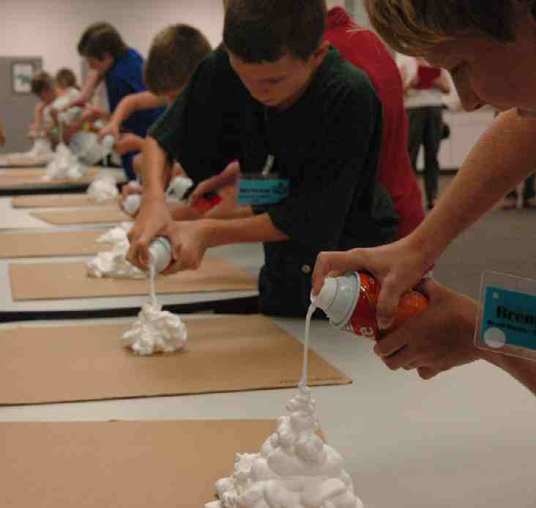
Here are our rules. When I blow the whistle, the first person in each team will run forward to their spot on the table and begin spraying out the shaving cream from their can. The goal is to get the highest mountain possible.

When I blow the whistle again this person will put the shaving cream can down beside their mountain, run back to their line and tag the next person. The next person runs up and begins spraying out the shaving cream adding to the mountain.

This will continue until I decide to end the relay. This means you might get to go twice, so be ready, just in case.

This way everyone will have a turn in case there are uneven teams.

The winner will be the team with the highest mountain of shaving cream when I call time. On your mark, get set, go!

When the relay is finished, direct kids’ attention to an empty can next to a mountain of shaving cream.

Notice the little can next to this large amount of shaving cream. It doesn’t seem likely that so much shaving cream could be put into one of these little cans.

This is also a wonderful illustration of God’s Holy Spirit. All of the presence of God is put into our lives and still fits. This seems impossible, but is true!

God says it this way in 1 Corinthians 3:16, “You should know that you yourselves are God’s temple. God’s Spirit lives in you.” Think about it. You are the dwelling place for the almighty, powerful and wonderful God who lives in you through His Spirit. We are nothing but a can that His presence fills. (Point to the shaving can.) INCREDIBLE!

The Holy Spirit Brings Us to Faith

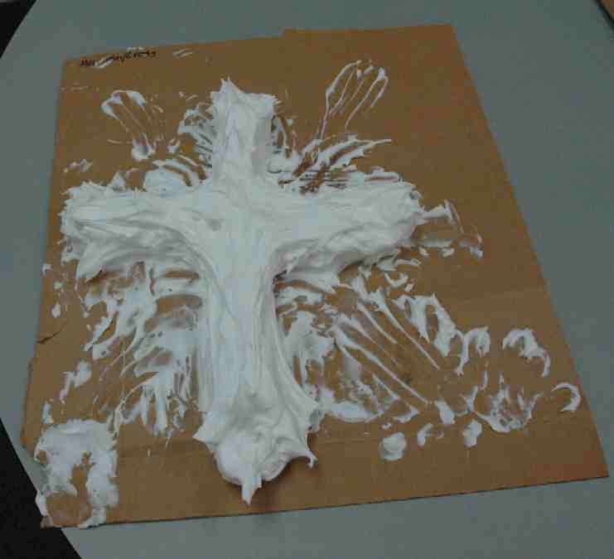
The Holy Spirit does not point to Himself, but always points to Jesus and what He has done for us. It is through the power of the Holy Spirit who gives us faith that we are saved. To give us salvation, the Holy Spirit will always point us to the cross.

For the next contest in our Olympics, I will blow the whistle and the first team member will come up and begin to sculpt this mountain of shaving cream into a cross using your hands. This could look like a thick layered cake, fat or thin, laying flat on the table.

It is up to your team how you decide to shape your cross. Take the next thirty seconds to decide. Go ahead and plan your cross.

Blow your whistle for the kids to discuss, and blow it again in 30 seconds for them to stop.

Each one of you will get your hands full of shaving cream as you take turns shaping a cross with your pile of shaving cream. But don’t wipe it off on a towel or anyone else. It will be used later on.

Each time I blow the whistle, the person shaping will run back and the next person will come forward and continue working on the cross until the whistle blows again. Ready, set, go!

Continue this until everyone in each team has had a turn trying to shape the cross.

Choose the best looking cross, the most original, or the most unique. Then say:

1 Corinthians 12:3b tells us, “… And no one can say, ‘Jesus is Lord,’ without the help of the Holy Spirit.” The Holy Spirit will always point us to the cross.

The Holy Spirit Equips Us to Serve

The Holy Spirit equips us to serve. Service reminds us of our hands. I noticed that all of your hands are now full of shaving cream. Our next activity will help us get some of that off our hands.
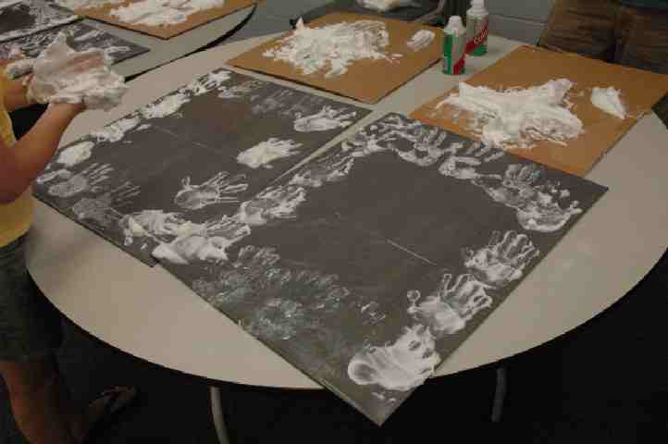

Each group has a black plastic garbage bag over a piece of cardboard. This is your painting canvas. I would like each group to make a border on the outside of your canvas with your handprints.

Once you have finished the handprints on the canvas, take extra shaving cream and design other body features. For example, eyes, ears, mouth or feet that will remind us that we are all a part of the body of Christ, connected together to serve one another.

Do an art-judging contest.

The Holy Spirit Produces Fruit

Using the Biocolor® Foam paint and mixing it with the shaving cream to give color to the shaving cream, will dry 3-dimentional.

Spray a small amount of each color available by each mountain of shaving cream. Kids will mix the paint with the shaving cream to produce the appropriate colors for making fruit.

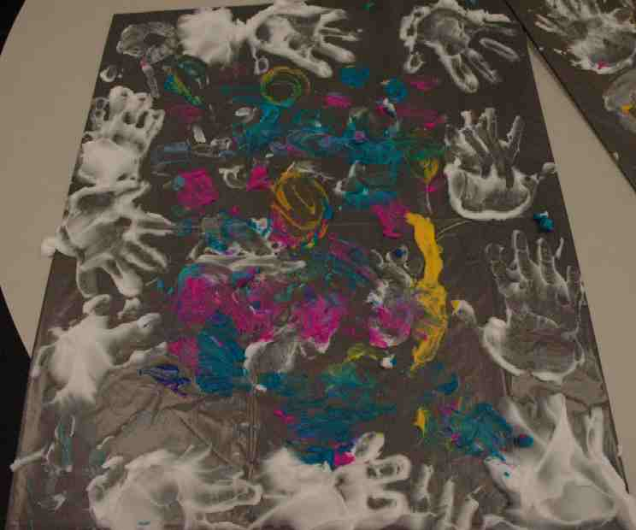
The Holy Spirit produces spiritual fruit in our lives. Notice the paint I have put on the table next to your crosses of shaving cream. Use the paint to mix with the shaving cream to create the colors necessary to paint fruit on your canvas. You can either create a fruit… or write words that list the fruit of the spirit found in Galatians 5:22-23 which are love, joy, peace, patience, kindness, goodness, faithfulness, gentleness, and self-control.

Ask to Be Filled With the Holy Spirit

Earlier you talked about the greatest present you ever received. Who would like to share some examples of those gifts?
Take a few answers from kids.

Did you know that your Heavenly Father wants to give you the greatest present He could possibly give? Often times we think of “things” when we talk about gifts.

God wants to give you something better than a “thing.” He wants to give you a Person. He wants to give you Himself. If you accept this gift, God the Holy Spirit will dwell in your life. You will experience what it is like to have the character of Christ living in you.

This is what it says in Luke 11: 9-13, “So I tell you, continue to ask, and God will give to you. Continue to search, and you will find. Continue to knock, and the door will open for you. Yes, if a person continues asking, he will receive. If he continues searching, he will find. And if he continues knocking, the door will open for him. what would you fathers do if your son asks you for a fish? Would any of you give him a snake? Or, if your son asks for an egg, would you give him a scorpion? Even though you are bad, you know how to give good things to your children. So surely your heavenly Father knows how to give the Holy Spirit to those who ask Him.”

Visual Reminder

Let’s have a visual reminder. We need one volunteer from each group to sit in a chair in the center of your group. The rest of the group will take some of their shaving cream and carefully decorate the volunteer’s face.

This person must ask the group to decorate his/her face before anyone is allowed to do this. This is very true for us. We must ask God to send His Holy Spirit to fill us up and decorate us inside. If we ask He will fill us.
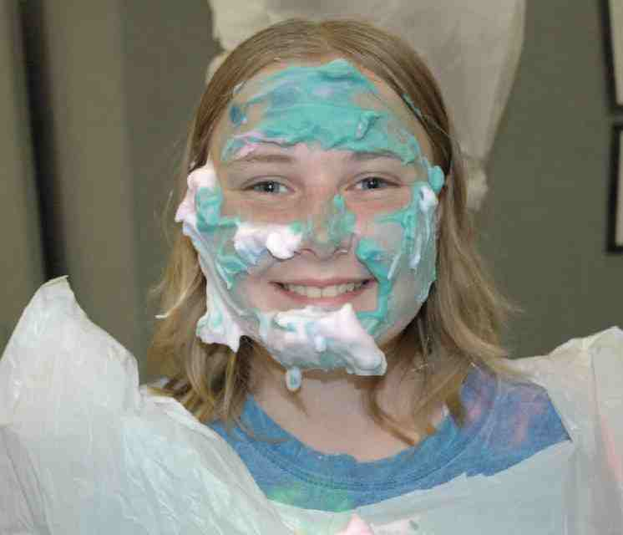
The person volunteering to be decorated should place his/her head through a garbage bag that has a hole cut out of it so no shaving cream or paint will get on their clothes. Emphasize that the people decorating must be very careful not to get any of the shaving cream in or near their eyes. Have wet-ones available to clean off hands and faces.

Go ahead and decorate your volunteer after he/she asks to be decorated.

Again, judge the most unique or creative.

After you have completed the judging contest, have the kids return to their small groups or triads for application.

SUPPLY LIST

Lesson 6

Small Group Warm-Up:
- none

Large Group:
- painting canvas—place a black garbage bag over a piece of cardboard or poster board (one per group)
- shaving cream (one per group)
- Biocolor® foam paint – from Discount School Supply 1-800-627-2829 in several colors. (If you can’t find this paint, you might like to try food colouring powder or solution.)
- extra plastic bags to place over the head of one person from each group to use as a paint shirt
- wet wipes
- tables (Enough table space needs to be available for each team to build a shaving cream mountain.)

Small Group Application:
- none

Memory Verse Learning:
- 2 or 3 sets of memory verse. Each set contains each word of the Memory Verse on a separate piece of paper.

