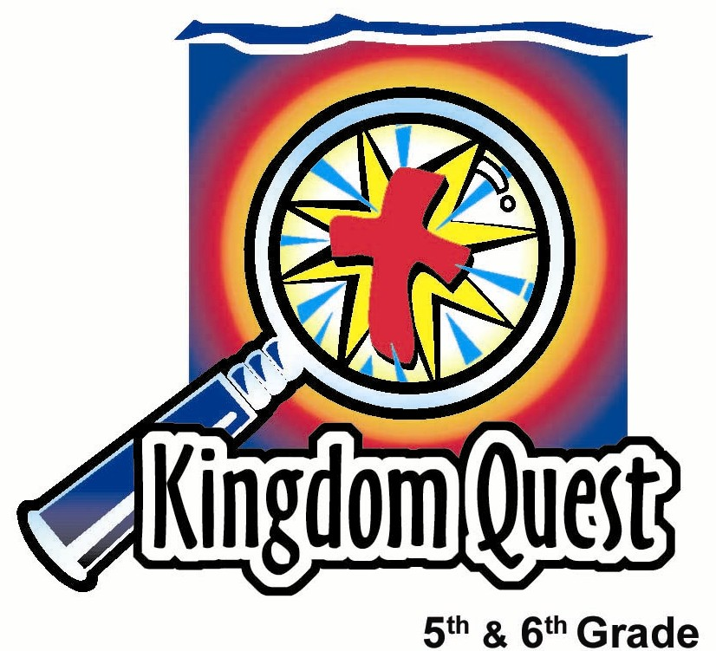
Date: ___________________________
Series: Jesus Isn’t Santa Claus (Dec-Feb)
Year 1, Lesson 29
Meet Jesus—He Deals With Our Sin

Santa is nice but… if he sees who is naughty why doesn’t he do anything about it?

Take Home Point: *Meet Jesus—He deals with our sin.
*Repeat this phrase throughout the lesson.

Bible Event: 2 Corinthians 5:21, Romans 3:23-25
Key Verse: 2 Corinthians 5:21, “Christ had no sin, but God made Him become sin so that in Christ we could become right with God.

We will help kids know:
- God is not like a type of Santa who, when He sees that we are naughty, just gives a wink and says, “It doesn’t matter.”
- Sin is serious. God must punish sin. It separates God from His people.
- God dealt with our sin. He sent Jesus to become sin for us and take the punishment we deserved, so that we could be sinless in God’s eyes.

We will help kids feel:
- Awed by the depth of God’s love.
- Secure in the confidence of having our sin removed through faith in Christ.

We will help kids do:
- Discuss what they might get from God if it were solely based on what they earned or deserved.
- Examine the Bible to see that all their good works are but filthy rags, so it is impossible to earn their way to heaven.
- Make a Christmas card to give to a family member or friend sharing the gospel of Jesus.
THIS LESSON’S ROADMAP

DESTINATION | PAGE # | DISCOVERIES ON YOUR JOURNEY | SUPPLIES NEEDED
Small Group Warm-Up   | 3 | As kids write their lists, have them discuss whether they deserve their gifts… and have they been “naughty or nice.” | - one sheet of paper and a pencil for each student.
Large Group   | 4  5 | Overview  Interactive Presentation: “Jesus Isn’t Santa Claus – Week 2” —Jesus deals with our naughtiness with His death on the cross for our sins. The visual aid of a dirty, stained t-shirt (our filthy righteousness) is exchanged for a clean, white t-shirt (Jesus’ righteousness) at the cross. | - beard, Santa hat and red coat for volunteer  - cross  - cradle  - two clean white t-shirts: one for cradle and one for using as an eraser  - white board with markers or chalkboard and colored chalk
Small Group Application   | 4  5 | Questions and discussion will review the truth of sin and how God offers a solution in Jesus Christ.  Memory Verse Learning  “Memory Verse Chain ”  John 1:14 is reinforced for 4 lessons (28-31) to enable the children to know the eternal nature of Christ. | - Color cards for making Christmas cards  - items to decorate the cards: markers, glitter, glue, etc.  - No supplies needed
Small Group Warm-Up: 15 minutes
Purpose: Get pointed in the right direction! Build relationships and help guests feel at ease. Do the learning readiness activity that will point your group in the right direction for the lesson.
As kids gather: Listen to memory verses from last week and give coupons for memory verses, for remembering to bring Bibles, and for bringing a guest.

Give each kid a piece of paper and pencil and have them write out a list of what they want to receive from Santa for Christmas. Then, discuss together as each child shares his/her list.

Lead the discussion with this question:

Can you finish this rhyme or jingle? “Santa is making a list and checking it twice, he’s going to find out whose _______ and ______.”(naughty and nice)

When you consider the list that you have for Santa, is this what you deserve from him? If you got what you truly deserved from Santa, would it be more or less?

After discussion have them consider the following:

This lyric indicates that Santa checks who’s naughty and nice. But it seems Santa brings presents to the naughty as well as the nice. It’s as if Santa sees who’s naughty but just winks and grins and says, “That’s okay, I’ll give you presents anyway.”

Sometimes we think of God in the same way. We think we are more nice than naughty, so we deserve Heaven. Our minor sins are not that serious, so God just winks at them. Do you think God is like Santa, so nice that when He sees who’s naughty He doesn’t do anything about it? Why or why not?

Today we will learn that Jesus is not like Santa Claus. *Jesus deals with our sin. We will discover how He does that.

Large Group: 20-30 minutes
Purpose: Help kids observe what the Bible says. Present the Bible event in creative fashion. Help kids begin to interpret what it means.

Overview

Interactive Presentation: “Jesus Isn’t Santa Claus – Week 2”—Jesus deals with our naughtiness with His death on the cross for our sins. The visual aid of a dirty, stained t-shirt (our filthy righteousness) is exchanged for a clean, white t-shirt (Jesus’ righteousness) at the cross.

Small Group Application: 20-25 minutes
Purpose: Help kids map out the meaning of the Bible event in their lives. Use the questions to stimulate discussion, but don't feel tied to them. Allow the Holy Spirit to guide you. Include personal examples from your own faith journey. The example of Christ at work in your life will leave lasting impressions of how Christ can work in the children's lives.

Use your Bibles! Children need to learn how to look up references and follow along when scripture is read aloud. Allow for quality time of prayer at the close of the lesson.

Observation Questions: What happened?
Have kids refer to the following Bible verses for discussion:

Can our sin be paid for with our good works? According to Isaiah 64:6, to what are our righteous acts or good works compared? (permanently stained rags.)

Which of us can boast about being “nice” enough to go to heaven according to Romans 3:23? (No one. “. . .all people have sinned, and they have fallen short of God’s glory.”)

God is holy. So if we got what we deserved, what would it be? (Romans 6:23, “The reward for sin is death.”)

According to 2 Corinthians 5:21, how does God deal with our sin? (“Christ had no sin, but God made Him become sin so that in Christ we could become right with God.” God sent Jesus to take our sin on Himself at the cross and exchange it for His righteousness. Now God looks at us and sees Jesus’ perfection.)

How do we get to heaven even though we have been naughty? (Through faith in Jesus and confidence in His shed blood on the cross that our sins are forgiven.)
Interpretation Questions: What does this mean?
How is Santa not like God? And how is Santa like God? Share your answers.

Let’s imagine that God was like Santa and let people into Heaven not based on how naughty or how nice they were. Would you worry about whether or not you did enough nice things to earn your way to Heaven? Which way would be easier for you… to earn your way to heaven or to trust Jesus who did it for you? Why?

Application Questions: What does this mean to me?
Have you received the best gift of all, that which we don’t deserve, Jesus?

Have kids make a Christmas card that can be shared with someone at home or a friend. Let each kid choose one of the following statements and write it on the inside cover:
- “God is better than Santa. . .,”
- “Have you been naughty or nice? Someone’s watching.”
- “Something better than Santa? This Christmas try. . .“

Let the students write Bible verses that might help explain this. Use the Bible verses discussed above.

Memory Verse Learning: 5 minutes
Purpose: Help kids to memorize and keep scriptures at heart. Using creative ways to help kids enjoy learning the key verse and in small group setting.

Supplies needed: None

M/V Presentation: Memory Verse Chain

Memory Verse: John 1:14 ~ “The Word became a man and lived among us. We saw His glory – the glory that belongs to the only Son of the Father. The Word was full of grace and truth”. (NCV)

Have children sit in a circle. The first person says the first two words of the memory verse. The next child continues with the next two words. Continue until the whole verse is completed. Repeat at least another round.

Prayer Time:
Thank God for loving us enough to deal with our sin so we do not have to be separated from Him forever. Thank Jesus for His death so we could gain God’s approval and not depend on our own good works to earn heaven. Pray the Holy Spirit’s leading to share this good news with someone this Christmas season.

Large Group Presentation

Jesus Isn’t Santa Claus—Week 2
Interactive Presentation

Take Home Point: Meet Jesus – he deals with our sin.

“Jesus Isn’t Santa Claus” is the series title for the four Sundays preceding Christmas. Each week a topic will be explored that tracks how Jesus is different from Santa Claus. This is not an attempt to poke fun or ridicule Santa Claus. By contrasting Jesus with Santa, fifth and sixth graders will be more keenly aware of the miracle of the incarnation and the person and work of Jesus. Each week a different volunteer is selected from the audience who will be partially costumed like Santa Claus as part of the presentation. The first week, the volunteer receives a beard and a hat. The second week, in addition to the beard and the hat, the volunteer receives a red overcoat. The third week, the costumed volunteer will also receive Santa’s bag. And, the fourth week, a wagon, our version of a sled, will be added. Each one of these items will help demonstrate the teaching point that Jesus is not Santa Claus. In fact, He’s much better.

Place a cradle on the stage that contains a clean, nearly new, white t-shirt. Put a cross large enough to hold the weight of two t-shirts on a table.

The presenter narrates the drama and provides the teaching as follows.

Kids, today we have a very famous guest with us. He is someone who certainly was very important to you, not so many years ago. I would like to introduce to you, Santa Claus. Today, playing the part of Santa Claus we have_____ (a volunteer from the audience). Thank you. Come forward.

Put the beard and Santa’s hat on child. This week add a red coat of some sort. It does not have to be a Santa coat. The presenter can make some comments about Santa updating his fashions.

Put beard, hat and red coat on volunteer.

Now Mr. Santa Claus, we’re so delighted that you can join us today. You have been a part of so many fond memories we have when we were small kids. Could we ask you a few questions?

Santa Claus, we notice this week that you are wearing a red coat. Is this a part of your attire every year? Is there any special reason why you like the color red? Wait for response. Well, we would like to compliment you on your fashion-setting standards.

Now, for the real questions of the day. We would like to talk to you about your list. We understand from the song that, well, let me get it correct… “Santa’s making a list, checking it twice, he’s going to find out who’s __________” …what? Let Santa answer—naughty and nice. Yes, that’s what we want to talk about today. Who’s naughty and who’s nice?

Now, how is it, Santa, that you can tell who is naughty and who is nice? (Any answer will do but you may have fun with it. )

As you look around this room who can you tell is nice and who can you tell is naughty? (Accept any answer. Have fun with the process.)

Well, Santa, I now understand that probably everyone has some nice in them and some naughty in them, but it seems to me that you give presents to about everyone, so does that mean that they have more nice in them than naughty? (Any answer will do.)

Santa, if you will allow me, I would like to do a quick survey in our group to see how many people here have all nice in them.

Address the audience.
I would like all the students to stand, as I will give you a “niceness” test. If I describe something that you’ve done that may be, well, less than nice, I’d like you to sit down. Let’s see who stands the longest.
- If you came into class today and you did not smile and say, “Hi” to someone, please sit down.
- At home today, when you were getting ready for church did you say anything grumpy to a parent or brother or sister? If you did, please sit down.
- If you did not make your bed today, sit down.
- If you did not wash the breakfast dishes before you left, please sit down.
- If you did not bring a friend with you today, please sit down.

Well, look at how many nice people we have left standing. Not too many.

The following is a visual illustration that all of our righteousness is like filthy rags, if we depend upon it to get to Heaven.

You will need a white board with markers or a chalkboard with colored chalk. In either case, you will need a clean white shirt that will serve as an eraser for the board. As you erase the chalkboard or white board, use different sections of the t-shirt to get it as covered in filth as possible.

Let’s say that God looks at you like Santa Claus does and He wants to make a list of how many nice things you do. Will you please help me think of nice things you can do for others? Let’s see how many we can list on the white board or chalkboard.

Have another adult write the responses while you ask for answers. After recording several answers, ask the kids:

How much does God require you to do to prove you are nice enough to earn Heaven? Think about that question while I read the following verse.

Isaiah 64:6. “All of us are dirty with sin. All the right things we have done are like filthy pieces of cloth.” It’s like this.

Wipe the board with the shirt and show the dirty shirt.

In other words, if we are trying to get into Heaven just by doing nice things, we can never do enough. All our acts would be like this shirt is now. Why? Because the Bible says in Romans 3:23, “All have sinned and are not good enough for God's.”

We all have sinned and fallen short, and we can’t make up for our sin by doing enough nice things. Let’s see if it’s true that all have sinned… or if all have been naughty.

Everyone stand up. Sit down if you have done one of these things: Disobeyed a parent or talked about someone behind their back. Wow, I had a whole list here and I didn’t get past number two!

Option: the following list can be illustrated on poster board, overhead projector or power point.

Do you want to hear the rest of the list? Well, there’s stuff like failing to help someone in need when you had the resources to help, not spending quality time with God at least once a week, hating another person, wishing bad for another person because they had something you wanted, lying, not giving God credit for your talents and abilities, not forgiving another person but holding on to revenge.

Each one of these is an example of sin, and sin is serious. Since God is holy and perfect, He is without sin. He cannot live with sin in His presence. So sin separates people from God and no one with sin can enter Heaven. No matter how many nice things we do, it does not erase the wrong we have done.

But Jesus is not like Santa Claus. He does something about our naughtiness. While Santa just winks and says, “It doesn’t really matter,” Jesus says, “It does matter. It is so serious that I am the only One who can fix the situation and take your sin away.”

Because of the sin that separates us, God sent His Son, Jesus, into the world. Jesus was perfect and without sin. Jesus came to this world for one main mission and that was to take the sin of the world on Himself.

Now the Bible says in Romans 6:23, “When people sin, they earn what sin pays - death.” But Jesus did not sin. He didn’t deserve to die. Yet He went to the cross because He wanted to trade His perfect life for our sinful life.

Hang the dirty t-shirt over one arm of the cross. Take the clean white t-shirt from the cradle, hold it up saying it represents Jesus perfect life and then lay it over the other arm of the cross.

So, I will place this perfectly clean t-shirt as a symbol of Jesus’ perfect life on the cross. On the other arm of the cross, I will place the dirty t-shirt that is a reminder that our own righteousness (or good works) is like permanent stains. Jesus took the punishment for our sin on Himself.

When Jesus was on the cross He said, “My God, My God, why have You abandoned me?” What did He mean? At that time, God was letting Jesus feel the full anger that He held against sin. It was as if God were turning His head away from Jesus and letting Him feel abandoned from His Heavenly Father. It was like the entire punishment of Hell was rolled up and placed on Him. It’s the punishment we deserved, not Jesus. It was our sin that He was paying the price for.

It says in the Bible in 2 Corinthians 5:21, “God had Christ, who was sinless take our sin so that we might receive God’s approval through Him.”

Jesus took our sin away from us on the cross and replaced it with God’s approval. This is like trading this dirty shirt left here as a reminder of our sin for the clean white shirt, Jesus’ perfection.

Have a volunteer come forward and put on the white shirt over his clothes.

The person who trusts in Jesus as their Savior, says, “I’m trading in my sin to You, Jesus, so that You will give me Your holiness.” When God looks at the believer, He sees Jesus. God sees all of His sin removed and instead He now wears the righteousness (perfection) of Jesus.

If there is any person here, who thinks that if they are more nice than naughty they can earn Heaven, we want you to know that God says Jesus earned Heaven for you. God will take away your naughtiness and give you the righteousness of Jesus. Let’s pray for that right now.

Dear God,
Thank You for sending Jesus. He deals with our naughtiness. He paid the price for our sin when He died on the cross. We thank You that the debt was paid once and for all. Thank You that if we now believe in Jesus, we can be sure we are forgiven and our sin taken away. Because of Jesus’ trade, we can live with You forever in Heaven, and live with You now as your children. Show us today how serious our sin is. Let us confess it to You and claim the forgiveness that You gave us by sending us Jesus.

If there is any one here that doesn’t trust in Jesus as their Savior, let them trust You and say this simple prayer right now… Dear God, I admit that I am a sinner. I need Your forgiveness. I trust what Jesus has done for me. Thank You for taking away my sin. Now fill my life with Your love and help me follow You. In Jesus’ name. Amen.

SUPPLY LIST

Lesson 29

Small Group Warm-Up
- one sheet of paper and a pencil for each student.

Large Group
- beard, Santa hat and red coat for volunteer
- cross
- cradle
- two clean white t-shirts: one for cradle and one for using as an eraser
- white board with markers or chalkboard and colored chalk

Small Group Application
- Color cards for making Christmas cards
- items to decorate the cards: markers, glitter, glue, etc.

Memory Verse Learning
- Mahjong Paper

