
Date: ___________________________
Series: Jesus Isn’t Santa Claus (Dec-Feb)
Year 1, Lesson 30
Meet Jesus—He Wants to
Fill Your
Heart

For Christmas joy Santa fills your stocking with presents, but…

Take Home Point: *Meet Jesus—He wants to fill your heart with His presence.
*Repeat this phrase throughout the lesson.

Bible Event: Ephesians 3:16-19
Key Verse: Ephesians 3:17, “I pray that Christ will live in your hearts by faith.”

We will help kids know:
- Materialism never has any lasting satisfaction and does not fulfill one’s happiness.
- Jesus dwells in our hearts through faith. We can be fulfilled through Him.
- The depth of God’s love toward us as seen in the giving of His Son is literally immeasurable.

We will help kids feel:
- Surprised at their own reliance on material possessions to bring them happiness.
- Overwhelmed by God’s love for them in Christ.
- A desire to be filled with the fullness of Christ.

We will help kids do:
- Ask God that they would be filled with the fullness of Christ.
- Make a craft of a woven heart that reminds them that their hearts can be filled with Christ.
THIS LESSON’S ROADMAP

DESTINATION | PAGE # | DISCOVERIES ON YOUR JOURNEY | SUPPLIES NEEDED
Small Group Warm-Up   | 3 | A Christmas stocking is passed around as kids remember and share what they received for Christmas last year. | - A Christmas stocking
Large Group   | 5  7 | Overview  Interactive Presentation: “Jesus Isn’t Santa Claus” – Kids see how Santa’s bag of goodies is filled with “stuff” that doesn’t last.  Teaching on Ephesians 3:16-19, “Jesus Isn’t Santa Claus” – Jesus wants to fill your heart with His presence. | - beard, Santa hat and red coat for volunteer  - Bible  - cradle  - a red Santa’s bag  - stack of newspapers for each group  - masking tape starting lines and destination squares  - plastic grocery bags that have been decorated with markers to look “somewhat” like a Christmas stocking for each group  - example of Small Group Application craft (woven paper heart) See appendix
Small Group Application   | 5 | Kids discuss Ephesians 3:16-19 and make a craft to remind them that Jesus fills our hearts with His presence.  Memory Verse Learning  If time permits, revise the memory verse. John 1:14 is reinforced for 4 lessons (28-31) to enable the children to know the eternal nature of Christ. | - materials for craft paper heart (see appendix)  - scissors and glue or stapler  - no supplies is needed
Small Group Warm-Up: 15 minutes
Purpose: Get pointed in the right direction! Build relationships and help guests feel at ease. Do the learning readiness activity that will point your group in the right direction for the lesson.
As kids gather: Listen to memory verses from last week and give coupons for memory verses, for remembering to bring Bibles, and for bringing a guest.

Each shepherd will need a Christmas stocking as an object lesson for today’s story and discussion starter.

Listen as I read the following story. Afterward, I would like to hear what you think.

Carmen and Tommy were unpacking Christmas decorations with their parents. As they got out their Christmas stockings, they talked about some of the things they wanted for Christmas.

“What do you think Santa will put in your stocking? Carmen asked Tommy. “I don’t know about you, but I think I’ll need a bigger stocking.”

Their dad interrupted the conversation. “Tommy and Carmen, we are going to do things a little differently this year. I’ve been meaning to talk to you about it and I think now is a good time. This year for Christmas, we aren’t going to spend any money buying presents for each other.

“What!” shouted the kids. “What do you mean?”

“This year we will take the money we usually spend on presents and give it to help several kids in_____ (name of children’s home in your town). We will use our Christmas money for that. We feel that God has given us enough things already. We want to share. And this is a way to share the love of Jesus with kids who need to be adopted into an orphanage.”

Tommy interrupted, “But what about us? We’ll have a lousy Christmas with no presents!”

“Are presents that important?” said Dad.

“They are if you don’t get them!” whimpered Carmen.

Dad paused for a moment then spoke up. “Let me make a deal with you. You say that presents are so important. Well if they are, can you remember what you got for Christmas last year? If you can remember one thing you received last year, then I’ll change my mind.” Dad waited for their answer. (Pause) Silence.

Tommy and Carmen couldn’t remember one thing they received the previous Christmas.

After the story, begin the following discussion.

Can you remember a present you received last year?

Hold up the Christmas stocking and say:

I will pass this stocking to those who can share what they remember about last year’s Christmas presents.

Have kids pass the stocking around as they share their stories. Then continue with:

Think back to the one thing you wanted for Christmas more than anything else. Can you remember it? Where is that present now?

Pass the stocking around again as each child shares.

Option: If time allows, tell about a gift you received that was the “best ever.” Where is that gift now? Broken or lost?

Today we will learn that to really be happy, we don’t need to fill our stockings with presents, we need to fill our heart with Jesus. *Meet Jesus—He wants to fill your heart with His presence.
Large Group: 20-30 minutes
Purpose: Help kids observe what the Bible says. Present the Bible event in creative fashion. Help kids begin to interpret what it means.

Overview

Interactive Presentation: “Jesus Isn’t Santa Claus” – Kids see how Santa’s bag of goodies is filled with “stuff” that doesn’t last. They play a game: The Overstuffed Stocking.

Teaching on Ephesians 3:16-19, “Jesus Isn’t Santa Claus” Jesus wants to fill your heart with His presence.

Small Group Application: 20-25 minutes
Purpose: Help kids map out the meaning of the Bible event in their lives. Use the questions to stimulate discussion, but don't feel tied to them. Allow the Holy Spirit to guide you. Include personal examples from your own faith journey. The example of Christ at work in your life will leave lasting impressions of how Christ can work in the children's lives.

Use your Bibles! Children need to learn how to look up references and follow along when scripture is read aloud. Allow for quality time of prayer at the close of the lesson.

Observation Questions: What happened?
Reread Ephesians 3:16-19 out loud.

How does Christ live in our lives? (Ephesians 3:17 Through faith.)

What will we be able to understand when we have faith? (Ephesians 3:18-19 How wide, long, high, and deep is God’s love for us, which goes far beyond our comprehension.)

Why does Paul pray this for all believers? (Ephesians 3:19 So that we may be completely filled with God.)

Interpretation Questions: What does this mean?
How is your life different after Jesus lives in your heart as opposed to before He lived in your heart?

What do you want to be filled with?

The following are personal questions for reflection, not necessarily answered out loud. Be prepared to pray with any student who may want to receive faith. You could make the offer to pray with anyone who is unsure of his or her salvation after dismissal.

Do you know for sure you have faith in Christ and He lives in your heart? If you are not sure, you can check it out with the following questions:

Have you admitted to God that you are a sinner and need His forgiveness? Have you admitted that you need a Savior?

Have you said, “Jesus, I know that You died on the cross for my sins and rose again so that You live inside of me and all who believe in You? I believe in You.”

Then know for sure: He lives in your heart!

Application Questions: What does this mean to me?
Allow plenty of time to make the paper heart. (See appendix for directions and pattern.) Upon completion of the heart, have each child think of a friend and write his/her name on the handle followed by the words “Jesus loves you.” and invite him/her to church this Christmas season.

Say:
*Meet Jesus—He wants to fill your heart with His presence. Just as Jesus fills your heart, out of your heart you can share Him with others.

Shepherds, if there is time after completing the craft, revise orally the memory verse of John 1:14 with the children

Memory Verse: John 1:14 ~ “The Word became a man and lived among us. We saw His glory – the glory that belongs to the only Son of the Father. The Word was full of grace and truth”. (NCV)

Closing Prayer:
Ask God to help all see the greatness of His love, how wide and long and deep and wide it is. Pray to be so filled with God’s presence that it overflows to others.
Large Group Presentation

Jesus Isn’t Santa Claus
Interactive Presentation

Take home point: Meet Jesus – He wants to fill your heart with his presence.

“Jesus Isn’t Santa Claus” is the series title for the four Sundays preceding Christmas. Each week a topic will be explored that tracks how Jesus is different than Santa Claus. This is not an attempt to poke fun or ridicule Santa Claus. By contrasting Jesus to Santa, standard five and six children will be more keenly aware of the miracle of the incarnation and the person and work of Jesus. Each week a different volunteer is selected from the audience who will be partially costumed like Santa Claus as part of the presentation. The first week, the volunteer receives a beard and a hat. The second week, in addition to the beard and the hat, the volunteer receives a red overcoat. The third week, the costumed volunteer will also receive Santa’s bag. And, the fourth week, a carton box, our version of a sled, will be added. Each one of these items will help demonstrate the teaching point that Jesus is not Santa Claus. In fact, He’s much better.

For the setting, place the guest Santa on one side of the stage and the manger on the other side. A Bible is always in the manger and will be taken out for the teaching section. As well, there is another object in the manger that helps illustrate the lesson of the day.

Today that object is an example of today’s craft activity: a heart that opens as a basket. The presenter narrates the drama and provides the teaching as well.

Kids, today we have a very famous guest with us. He is someone who certainly was very important to you not so many years ago. I would like to introduce to you, Santa Claus. Today, playing the part of Santa Claus we have_____ (a volunteer from the audience). Thank you. Come forward.

Put the beard and Santa’s hat on child. Add the red coat used last week. In a moment, present him with a bag of some sort that may look like a Santa’s bag. It should be filled with stacks of newspapers that will be used for today’s game.

Put beard, hat and red coat on volunteer.
Mr. Santa Claus, we’re so delighted that you can join us today. Here is your Santa’s bag. Present the bag. Could we ask you a few questions about your bag?

For the following questions, take any answers, but use it as a time to ad lib and have fun with Santa’s responses.

How do you get all those presents in that bag?

Why do you give those presents? To make kids happy?

How much happiness do you think these presents bring to kids?

How long do you think this happiness lasts?

Santa Claus, I notice that you have some stacks of newspaper in your bag. Could we borrow them for a group game? Thanks, you’re such a good Santa!

Game: Christmas Stocking Overstuff

Materials required:
- Stacks of newspapers in Santa’s bag that can be distributed to each group so that each group has at least 6 inches of newspaper.
- Masking tape to mark the destination squares and starting lines. This should be done beforehand. Mark destination squares on one side of the room and the starting line on the other side of the room.
- Plastic grocery bags that have been decorated with markers to look “somewhat” like a Christmas stocking.

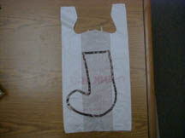

Presenter:
Kids, we are going to play Christmas Stocking Overstuff. Here are the rules of the game. Every small group will have the challenge to see how much newspaper they can wad up, transport and deliver to their three foot by three foot space called a destination square. These destination squares are marked with masking tape.

Point to the destination squares at one side of the room. Point to the line on the other side of the room from the destination squares.

Each team will have a stack of newspaper and be positioned behind that line. Your team will have only one minute to take individual pieces of paper, wad them up and stuff them in one of these plastic grocery bags… oops, I mean one of these Christmas stockings. The whole team works together on this. But before the minute is over, one person must carry this bag across the room and dump out the contents in the destination square for that group.

Here are some glitches. First, if any paper falls out of the bag while being carried, the entire bag must be returned to the starting line, emptied and reloaded. Second, the person carrying the “Christmas stocking” cannot touch any paper that is about to fall out. If he or she does, that group must return, empty their bag, reload it and try to get to the destination square in time.

Shepherds, you will be the referees to make sure there is no cheating.

Third, I won’t warn you when the minute is about up. You’ll have to guess. But after one minute, I will ring this Christmas bell and all destination squares are closed. They can’t receive any more paper wads. The game is over and you missed your chance if the paper isn’t already in the square. Then we will see which destination square has the most presents.

Let me show you which destination squares are assigned to which groups and put a stack of newspapers at your starting point. Don’t touch any paper until I say “begin.” Then you will have one minute. Remember that every sheet of paper put in the bag must be a single sheet and wadded up. Everyone ready? Okay. Begin.

If there is time, you might call for a rematch.

Jesus Isn’t Santa Claus
Jesus wants to fill your heart with His presence

Make sure the stage is set again with Santa on one side of the stage and the manger with a Bible and paper heart craft on the other side.

Begin by holding up one of the overstuffed “stockings” from the game.

Well, Santa, we would like to thank you for sharing your old newspaper… er, I mean gifts… from your bag there. I appreciate how you like to give presents so that we can have Christmas joy. My question though, is how long does the joy from merely getting more things last?

Let’s think about this game we just played. Who can think of ways this is like our life? What are some of the meanings you got out of the game? (Take any answer, i.e., sometimes we try to get too much in our stocking (possessions) and we lose everything; presents and stuff don’t last real long, just like the newspaper becomes outdated; filling up with “stuff” doesn’t really fill us up on the inside when we have spiritual hunger.)

Was your team ever sure when the time would run out? What is this like in real life? (We never know for sure when our life will be over. We can spend all our time racing to fill it with more “stuff.”)

Let’s see what the Bible has to say about this.

Take the Bible from the manger and read Ephesians 3:16-18. (The following teaching notes can also be placed inside the Bible.) You also may invite the kids to follow along in their Bibles.

Today’s reading is from Ephesians 3:16-18. Ephesians is a book that Paul wrote to an early Christian church. There is truth here for us today as well. This is what he says:

“I’m asking God to give you a gift from the wealth of His glory.”

What is he asking God to give you? A gift! Right! And imagine what it must be like if it comes from the wealth of His glory. Now let’s figure out what that gift is.

“I pray that He would give you the power to be strong inwardly through His Spirit.”

So what is the gift? Right! Inner strength and power. Now why would we want inner strength and power? The next verse says it:

“Then Christ will live in your hearts by faith.”

Who lives in us? Christ! How does He live in us? By faith!

One version of the Bible says it this way: “So that Christ may dwell in your hearts through faith.” (NIV)

The point is, when we trust Christ as our Savior, He lives in our hearts. He lives in our lives. And that lasts forever!

Now here is one of the big differences between Jesus and Santa. Refer back to Santa and to the manger in contrast. I’m not cutting you down Santa, but you give us joy by filling our stockings. And while that is sure nice of you, it doesn’t really last that long and it might never fill what we need inside our hearts.

On the other hand (refer to the manger), Jesus is different. Jesus wants to fill our hearts with His presence.

Hold up the heart shaped craft project.

This heart reminds us of what we really need… our hearts to be filled.

Today I will think of this paper cutout heart as my heart. It needs to be filled with God Himself, Jesus. Jesus came to our world, not only to go to the cross and die for our sins, but to come back to life and offer to live in the hearts of every single person who believes in Him.

Finish the Bible reading while holding up the heart.

I know this is just an example and the paper won’t last long. But what it stands for will last forever. Let me read the rest, verses 18 and 19.

“And I pray that you and all God's holy people will have the power to understand the greatness of Christ's love - how wide and how long and how high and how deep that love is. Christ's love is greater than anyone can ever know, but I pray that you will be able to know that love. Then you can be filled with the fullness of God.”

Let’s close with prayer.
Dear Heavenly Father, thank You that You want to fill our hearts with something that lasts. That something is more of a “someone.” Fill us with Jesus. Give us the power and inner strength to trust Him and let Him live in our hearts by faith. During Christmas season, don’t let us get too caught up in getting presents from Santa in our stockings, but rather the presence of Jesus in our hearts. In Jesus’ name. Amen.

SCANDINAVIAN HEART BASKET

Copy the pattern sheet on lightweight cardstock. You may want to do separate colors for added effect, such as red and green. Each kid will receive two pieces and a handle.

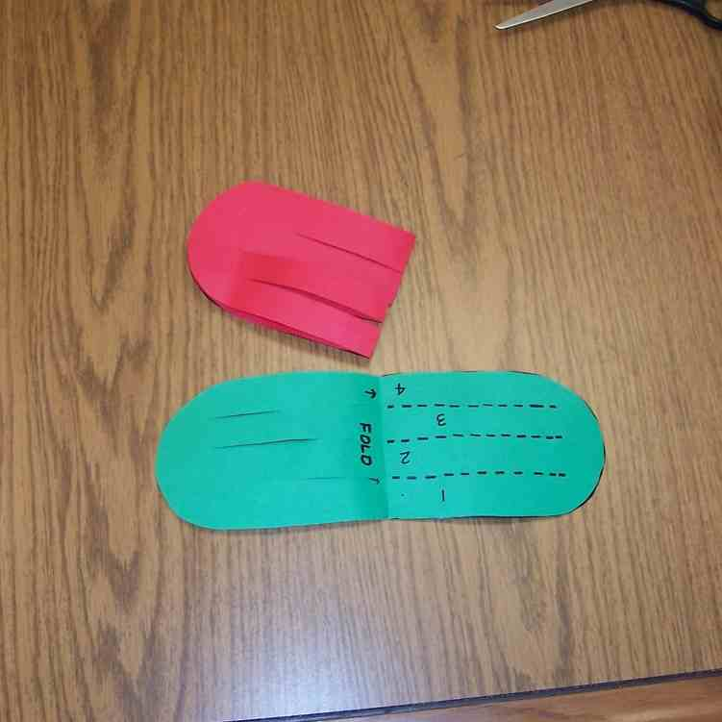
This is a weaving project with a spectacular result.

- Cut apart the two patterns (A & B)
- Fold each pattern in half. Cut out the pattern along dotted lines. Cut out handle and set aside.
- From this point on, you will be weaving the rows of Pattern “A” into pattern “B.” Once the concept of weaving is understood, repetition will complete the project.

Begin weaving the basket by placing the pattern tables at right angles to each other.
  - Insert tab 5 inside tab 1.
  - Insert tab 1 inside tab 6.
  - Insert tab 7 inside tab 1.
  - Insert tab 1 inside tab 8.

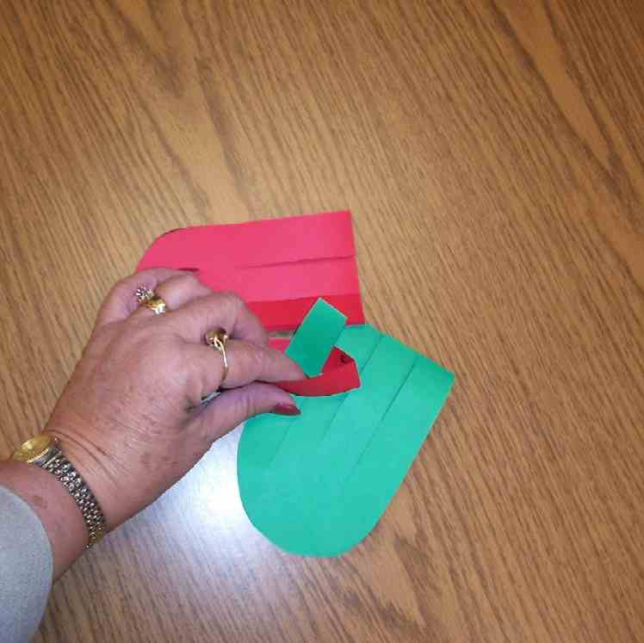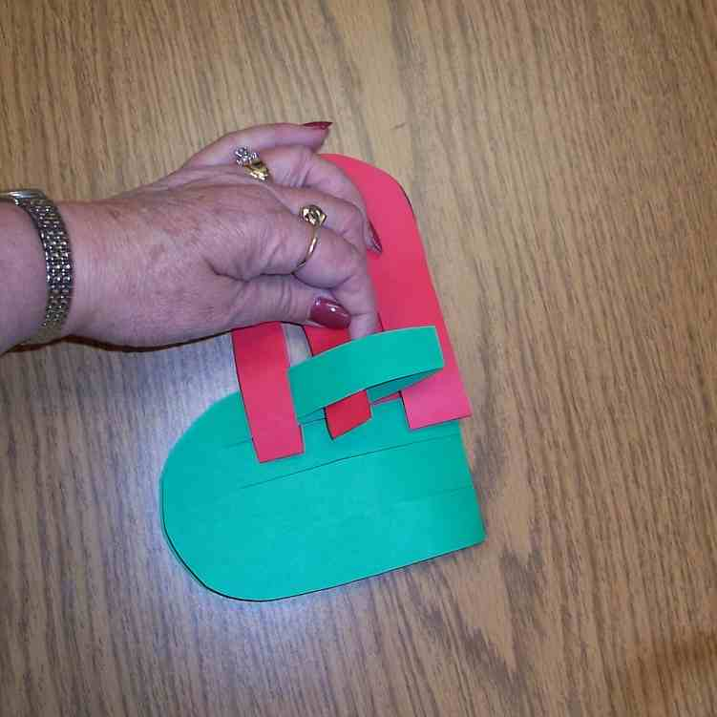
Alternate your weaving of tab 2.

Slide “A” toward the top of “B” to begin weaving tab 2.
- Insert tab 2 inside tab 5.
- Insert tab 6 inside tab 2
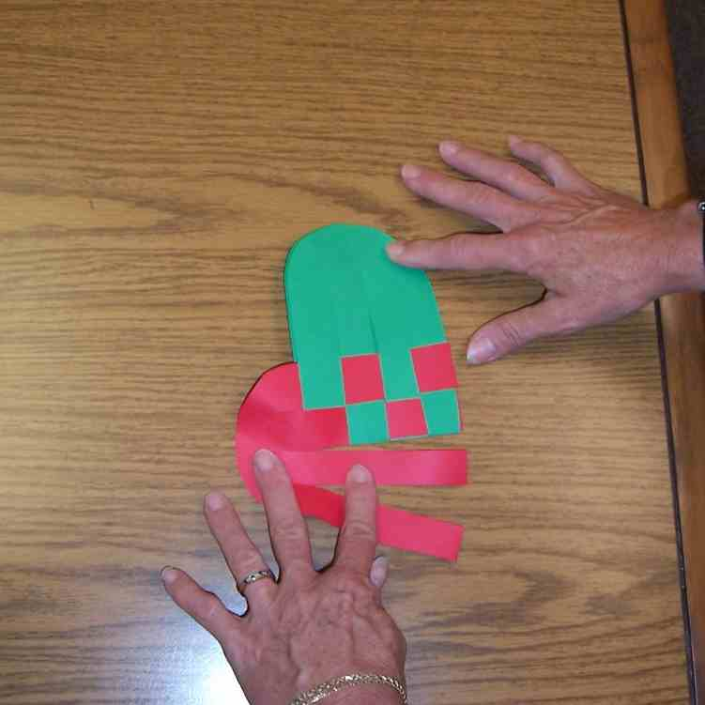
- Insert tab 2 inside tab 7.
- Insert tab 8 inside tab 2.

Continue alternating this pattern of weaving until completed.

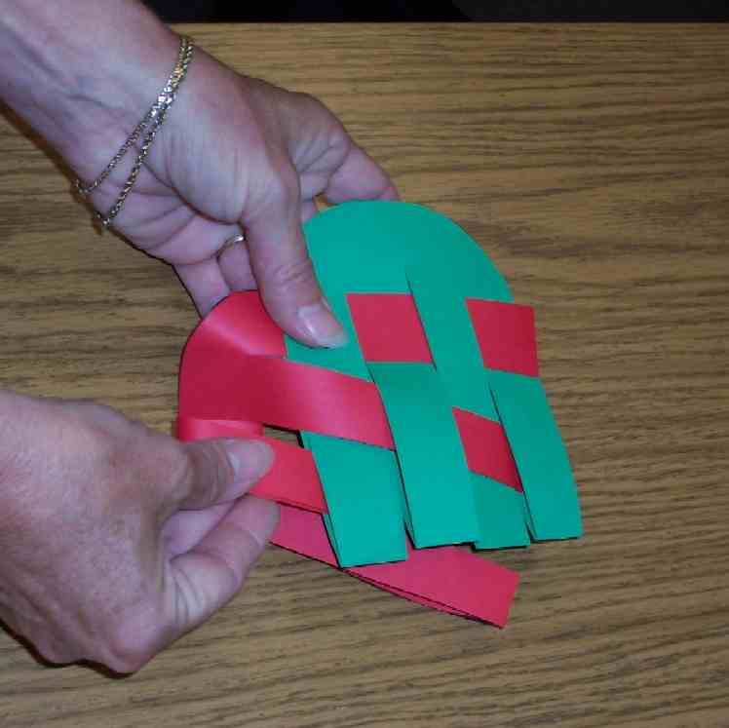

Tape handle to the insides of the heart center to complete the basket.

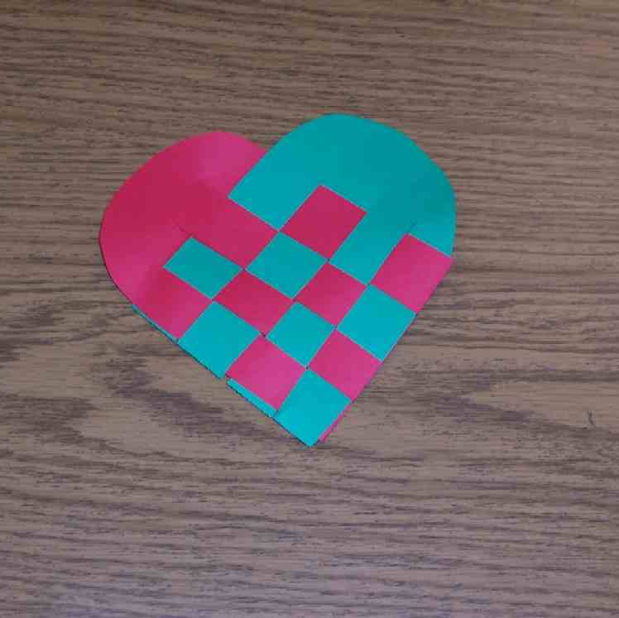
Carmen Low, Jesus loves you
Handle

SUPPLY LIST

Lesson 30

Small Group Warm-Up
- A Christmas stocking

Large Group
- beard, Santa hat and red coat for volunteer
- Bible
- cradle
- a red Santa’s bag
- stack of newspapers for each group
- masking tape starting lines and destination squares
- plastic grocery bags that have been decorated with markers to look “somewhat” like a Christmas stocking for each group
- example of Small Group Application craft (woven paper heart) See appendix

Small Group Application
- materials for craft paper heart (see appendix)
- scissors and glue or stapler

Memory Verse Learning
- no supplies is needed

