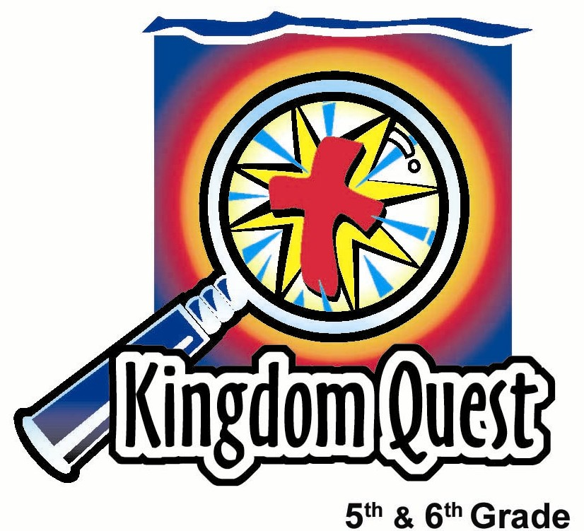
Date: ___________________________
Series: Jesus Isn’t Santa Claus (Dec-Feb)
Year 1, Lesson 31

Meet Jesus—He Makes Us
a Gift to
Others

Santa is giving but… he keeps our focus on what we receive.

Take Home Point: *Meet Jesus—He makes us a gift to others.
*Repeat this phrase throughout the lesson.
Bible Event: Matt. 20:25-28; Acts 20:35; I Peter 4:10
Key Verse: I Peter 4:10, “Each of you has received a gift to use to serve others. Be good servants of God's various gifts of grace.”

We will help kids know:
- Jesus came to serve others, not to be served. Because Jesus served them, they can serve others.
- God has entrusted them certain talents and spiritual gifts that He expects them to use to serve others.
- It is more blessed to give than to receive.

We will help kids feel:
- Inspired to serve others as a gift to them, rather than only receive gifts themselves.
- Humbled to not just think about themselves, but others.

We will help kids do:
- Play a game that demonstrates our desire to be on top.
- Identify some of the gifts that God has given them.
- Identify ways they can use those gifts to serve others.
- Make a Christmas box that helps them picture the ways that they might be a gift to others.
THIS LESSON’S ROADMAP

DESTINATION | PAGE # | DISCOVERIES ON YOUR JOURNEY | SUPPLIES NEEDED
Small Group Warm-Up   | 3 | Kids will discuss favorable character traits and how they are a gift from God. | - a wrapped box or gift bag per group
Large Group   | 4  7  9 | Overview  Interactive Presentation: “Jesus Isn’t Santa Claus”----The contrast of Santa giving gifts for our benefit is contrasted with Jesus giving us “gifts” to serve others.  Teaching on Matt. 20:25-28; Acts 20:35---Because Jesus came to serve us and to lay down His life for us, He asks us to in turn serve others with the gifts He has given us. | - beard, Santa hat and red coat for volunteer  - Bible  - cradle  - a red Santa’s bag  - a carton box decorated to look like Santa’s sleigh  - wrapped gift box with a lid that can easily be removed  - a mirror inside the gift box, turned up so the person who opens it will easily see his or her reflection  - one stick of nuggets
Small Group Application   | 4 | Kids review scripture and teaching points. They make a Christmas box that helps them picture the ways that they might be a gift to others.  Memory Verse Learning  “Memory Verse Cube ”  John 1:14 is reinforced for 4 lessons (28-31) to enable the children to know the eternal nature of Christ. | - Box pattern for each child (see appendix page 13)  - scissors  - glue  - craft items such as glitter, markers, ribbons, sequins, etc.  - Memory Verse Cube  (See appendix page 12)
Small Group Warm-Up: 15 minutes
Purpose: Get pointed in the right direction! Build relationships and help guests feel at ease. Do the learning readiness activity that will point your group in the right direction for the lesson.
As kids gather: Listen to memory verses from last week and give coupons for memory verses, for remembering to bring Bibles, and for bringing a guest.

Special note for today:
Likely with school out, some shepherds may be absent or there may be more substitute shepherds present. This lesson can be easily adapted for fewer adults available. The warm-up questions and craft activity can be done in groups of three kids sharing their answers with one another versus a whole group discussion. One adult can monitor 6 to 8 such triads. Also, the large group occupies more time if the game is allowed to continue longer. This game involves everyone. Adapt the lesson accordingly.

Every group will need a small wrapped present, or even a gift bag. It will be used as an object lesson and focus of conversation. The gift is passed to the person talking. Encourage all others to listen attentively to the person speaking and holding the gift.

Hold up the gift bag and begin with the following question.

Who would like to receive a gift?

Pass the bag around to those who share the following:

One character trait I like about my (mom/dad) is…

After all have shared, continue with the next question.

One character trait my (mom/dad) would say they like about me is …

Then say:
Consider this quality or attribute that your parent likes about you. How is it you came about having this trait? Where did it come from? Did you inherit it from your parents?

Is it possible that this character trait is a gift from God given to you and maybe others in your family? I think so.

Let kids discuss and arrive at the conclusion that God gives them gifts. Open the bag and show that nothing is inside.

These last several weeks, we have talked about gifts and Christmas. But today we will talk not about the gifts that we get, but rather the gifts that we are! We are gifts and have special gifts given to us in our personality, our talents, and even spiritual gifts that we can use to serve others.

Today we will *meet Jesus—He makes us a gift to others.

Large Group: 20-30 minutes
Purpose: Help kids observe what the Bible says. Present the Bible event in creative fashion. Help kids begin to interpret what it means.

Overview

Interactive Presentation: “Jesus Isn’t Santa Claus” – Santa giving gifts for our benefit is contrasted with Jesus giving us “gifts” to serve others.

Game: “Smack Over” – Kids play several rounds of a game designed to knock their partner off balance until one player emerges “on top.”

Teaching on Matt. 20:25-28; Acts 20:35 – Because Jesus came to serve us and to lay down His life for us, He asks us to in turn serve others with the gifts He has given us.

Small Group Application: 20-25 minutes
Purpose: Help kids map out the meaning of the Bible event in their lives. Use the questions to stimulate discussion, but don't feel tied to them. Allow the Holy Spirit to guide you. Include personal examples from your own faith journey. The example of Christ at work in your life will leave lasting impressions of how Christ can work in the children's lives.

Use your Bibles! Children need to learn how to look up references and follow along when scripture is read aloud. Allow for quality time of prayer at the close of the lesson.

Observation Questions: What happened?
Have students find Matthew 20:25-28 in their Bibles. Explain to the kids that this was Jesus’ response to His disciples after James and John’s mother asked Jesus to let her sons have authority with Jesus in His kingdom. Jesus told them what the authority of His kingdom would look like.

What did Jesus say one should do to become great and important? (Matthew 20:26-27 One would have to become a servant and a slave.)

What do you think he meant?

Jesus said He didn’t come so others would serve Him. What did He come to do? (Matthew 20:28 “He came to serve others and to give His life to save many people.)

Interpretation Questions: What does this mean?
Jesus didn’t just tell the disciples to be servants. He showed them by His example how to serve others. What was His ultimate act of service? How does this benefit us?

Application Questions: What does this mean to me?
Acts 20:35 says, “It is more blessed to give than to receive.” Explain how you think this is possible.

Can anyone share a time that they gave a gift of time or service to someone else and felt good about it? Give your own personal example to encourage kids to discuss.

Have a volunteer read 1 Peter 4:10.

How do we serve others? According to this scripture we are to use the gift that God has given us to serve others.

Think about the special character traits that we talked about in the warm up activity. God made you to have these special traits. He also gave you unique talents and abilities that He wants you to use to help others.

What are your unique traits and abilities? How can you use them to help others?

The application activity is to fold and affix together a box that begins in the shape of a cross. (See appendix.) On each of the six sides of the box (the inside), kids should write a characteristic or ability they have that are gifts God has given them to use serving others. Kids can decorate the outside of the box with any craft items such as glitter, markers, ribbons, sequins, etc. This little gift box can then be placed under the Christmas tree at home as a reminder that we are a gift to others.

As kids begin writing down their unique gifts, ask kids to notice the shape of the box pattern, a cross. Then read 1 Peter 4:11:

The person who serves should serve with the strength that God gives. You should do these things so that in everything God will be praised through Jesus Christ. Power and glory belong to Him forever and ever! Amen.

As we use the gifts that God has given us, who will receive glory? When we use our talents and abilities to serve others, we are also giving a gift to God.

Today we learned that when we *meet Jesus—He makes us a gift to others.

Memory Verse Learning: 5 minutes
Purpose: Help kids to memorize and keep scriptures at heart. Using creative ways to help kids enjoy learning the key verse and in small group setting.

Supplies needed: Memory Verse Cube

Memory Verse: John 1:14 ~ “The Word became a man and lived among us. We saw His glory – the glory that belongs to the only Son of the Father. The Word was full of grace and truth”. (NCV)

Prayer Time:
Thank God that He sent Jesus to not only serve us but to show us how to serve others. Thank Him for the gifts He gives each one of us in our talents and personality traits and makes us unique. Pray that He would show all how to use these gifts to give glory to Him!
Large Group Presentation

Jesus Isn’t Santa Claus
Interactive Presentation

Take Home Point: Meet Jesus – He makes us a gift to others.

“Jesus Isn’t Santa Claus” is the series title for the next four weeks. Each week a topic will be explored that tracks how Jesus is different than Santa Claus. This is not an attempt to poke fun or ridicule Santa Claus. By contrasting Jesus to Santa, fifth and sixth graders will be more keenly aware of the miracle of the incarnation and the person and work of Jesus. Each week a different volunteer is selected from the audience who will be partially costumed like Santa Claus as part of the presentation. The first week, the volunteer receives a beard and a hat. The second week, in addition to the beard and the hat, the volunteer receives a red overcoat. The third week, the costumed volunteer will also receive Santa’s bag. And, the fourth week, a carton box, our version of a sled, will be added. Each one of these items will help demonstrate the teaching point that Jesus is not Santa Claus.; In fact, He’s much better.

For the setting, place the guest Santa on one side of the stage and the manger on the other side. A Bible is always in the manger and will be taken out for the teaching section. As well, there is another object in the manger that helps illustrate the lesson of the day.

Today that object is a wrapped present with a lid that can easily be removed. A mirror is inside, turned up so the person who opens it will easily see his or her reflection. The presenter narrates the drama and provides the teaching as well.

Kids, today we have a very famous guest with us. He is someone who certainly was very important to you not so many years ago. I would like to introduce to you, Santa Claus. Today, playing the part of Santa Claus we have_____ (a volunteer from the audience). Thank you. Come forward.

Put Santa’s beard, hat, and red coat on child. Add the Santa’s bag used last week. Pull out a wagon simulated as a sleigh with the following dialogue.

Now Mr. Santa Claus, we’re so delighted that you can join us today. And we are so impressed that you brought your sleigh with you. It’s amazing how much your sleigh looks like a carton box. How do you get it to do that? (Take any answer, but ad lib for humor.)

One thing we have been so impressed about you, Santa, is how you give and give and give. I mean you cram a lot of presents on that sleigh every year, don’t you? Well, this sometimes presents us with a problem…and I’m not blaming it on you…but it has to do with presents this time of year. Sometimes we think so much about what we are going to get that we forget all about what we are to give! Sometimes we get so self-centered that we don’t care about anyone but ourselves. Just as long as we get what we want, just as long as we are on top, then we’re happy.

So I suggest we play a game that is fun and might illustrate this point. The game is called “Smack Over.” I need a volunteer to come up and demonstrate with me. Here’s what we do.

Have the volunteer stand facing you about a foot or two away, feet squarely planted. Then both of you should hold your hands up, bending elbows with palms facing partner (like surrendering, “hands up”).

Explain that the object of the game is to smack the other person’s palms so hard that it causes them to lose balance and to move a foot. If you move either foot even one inch while playing “Smack Over,” you lose and must sit down. You may not hit the other person’s body – just their hands. No pushing hands – just hit! If you lose your balance because the other person hits your arm or any other part, you are still in the game.

Now, it might seem that this would hurt your hands, but it doesn’t. One of the tricks of the game is to get the other person to try to smack you, but instead you dodge and move your hands so that the other person loses balance.

After demonstrating, divide the group into pairs and let them practice. Then explain that this will be a tournament with several rounds until one winner is identified. Each round lasts 20 seconds. Use a noisemaker to begin and end each round. At the end of 20 seconds, if neither partner has won, then both partners lose and are seated.

Everyone who loses the first round sits down and watches the rest of the time. The winners from round one pair up to compete in round two, and so on, until there is only one person “on top,” or the winner. Give the winner a piece of stick of nuggets to elicit stronger feelings of envy from the other children.

Interview the winner.

How did it feel to be on top? How do you like your nuggets?

Address the rest of the kids. Get brief answers from kids, not long interviews.

How many of you wanted to be up here in this winner’s place? What were you feeling? I’ll take some comments from the audience.

Is it wrong to want to win? Of course not. But what might be wrong about wanting to be on top? Take only one or two responses. (The teaching section will address the concept that wanting to be on top so much that one forgets about others is the real problem.)

Jesus Isn’t Santa Claus
Teaching Session: Jesus makes us a gift to others.

Set the stage with Santa on one side and on the other side, the manger with a Bible and a gift-wrapped box with mirror inside.

Wel, Santa, we would like to thank you once again for how you give us gifts. But sometimes this sets us up to think that the most important thing in life is to be on top and have others serving us and giving us things. It may not be your fault, but our own selfish nature kicks in and tries to make sure that we stay on top. Then all we might care about is pushing others down so that we get our own way.

I need a volunteer to come forward to demonstrate how Jesus is different. Volunteer comes forward. As I look over here to the manger, I see the Bible and this wrapped present. Now, this present is quite a remarkable gift that God gave the world. I would like to ask our expert volunteer to guess what this gift might be. I will give you three guesses. What is the gift that God gives to be a big blessing to others here?

The volunteer will likely answer “Jesus.” If so, then say that it is true that Jesus is a great gift to the world, but that’s obvious so that’s not what you are thinking. After the volunteer’s second guess, give a hint. Have him/her open the box. Inside the box is a mirror. As they gaze at the mirror, help him/her conclude: “I am the gift” God is giving to others.

There you have it. The gift that God gives to this world is not only His Son, Jesus, but also you and me, as well. He makes us gifts to others. This happens when we don’t just think about being on top, but we think of others and how we might serve them.

Read the Bible passage. A student who is an excellent reader might read it out loud. Otherwise, read it yourself. Just make sure it is read well.

The Bible says in Matthew 20:25-28:

Jesus called all the followers together and said, "You know that the rulers of the non-Jewish people love to show their power over the people. And their important leaders love to use all their authority. But it should not be that way among you. Whoever wants to become great among you must serve the rest of you like a servant. Whoever wants to become first among you must serve the rest of you like a slave. In the same way, the Son of Man did not come to be served. He came to serve others and to give His life to save many people.”

Consider this. What is the greatest thing that Jesus ever did?

Take answers from the audience.

It is surprising that of all the great things Jesus ever did, the greatest was to die on the cross for our sins. One would think that the greatest thing Jesus did would put Him “on top,” but, instead, it put Him as low as He could go, into the grave and even experiencing hell.

But Jesus is alive, reigning in heaven now to serve us still. Why? So that our lives could be used to serve Him and help build His kingdom.

Since Jesus has served us and as we have received Him by trusting Him as our Savior, we now become presents ourselves for others. This is a very satisfying way of living. The Bible says in Acts 20:35, “It is more blessed to give than to receive.”

Today we are going to learn in our small groups ways that we can be gifts to others. God has given each one of us unique personality characteristics and talents so that we might serve others.

Let’s pray.

Dear Jesus, thank You that You came as a gift into the world. You wanted to serve more than to be served. Now You have made each one of us a gift so that we might be given to others and help them. Today please show us some of the special ways we can use our talents and personalities to serve others. We pray in Jesus’ name. Amen.

SUPPLY LIST

Lesson 31

Small Group Warm-Up
- a wrapped box or gift bag per group

Large Group
- beard, Santa hat and red coat for volunteer
- Bible
- cradle
- a red Santa’s bag
- a carton box decorated to look like Santa’s sleigh
- wrapped gift box with a lid that can easily be removed
- a mirror inside the gift box, turned up so the person who opens it will easily see his or her reflection
- one stick of nuggets

Small Group Application
- Box pattern for each child (see appendix page 13)
- scissors
- glue
- craft items such as glitter, markers, ribbons, sequins, etc.

Memory Verse Learning
- Memory Verse Cube (Do the box on page 12.)

Memory Verse Learning:
- This diagram can be enlarged to A3 size through photocopying machine.
- Colour; paste on manila card and assemble for teaching.

MEMORY VERSE CUBE

Son of the
Father. The Word

We saw
His glory –
the glory
that belongs to the only

a man and
lived
among us.

John 1:14
- The Word
became

