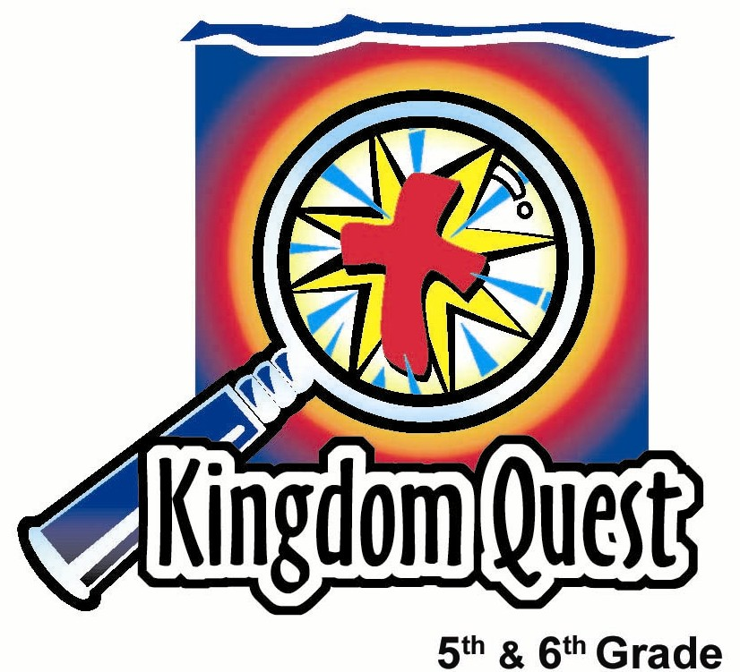
Date: _________________________
Series: Jesus Now… (Apr-May)
Year 1, Lesson 53

Heaven—Life Forever with Jesus
Take Home Point: *Heaven is face-to-face with Jesus—and it’s a blast!
*Repeat this phrase throughout the lesson.

Bible Event: John 14:1-6
Key Verses: John 14:2-3, “My Father’s house has many rooms. If that were not true, would I have told you that I am going to prepare a place for you? If I go to prepare a place for you, I will come again. Then I will bring you into my presence so that you will be where I am.”

We will help kids know:
- Jesus says that He is “the” way to heaven. Through faith in Him, we are assured of life with Him forever.
- Heaven is a place that is more real, vivid and beautiful than anything here on earth. It is where millions of heavenly creatures and people with heavenly bodies will live.
- The best thing about heaven will be experiencing God’s love for us as we live face-to-face with Jesus.
- That God sees Jesus and His believers in heaven celebrating like a wedding feast and living in a new home together. Jesus is the bridegroom and the church is the bride.

We will help kids feel:
- Secure in their hope of heaven through faith in Christ.
- Motivated to be faithful and serve God now knowing there are rewards in heaven for how we live on earth.

We will help kids do:
- Imagine their ultimate vacation destination and compare it to heaven.
- Ask questions about heaven.
THIS LESSON’S ROADMAP

DESTINATION | PAGE # | DISCOVERIES ON YOUR JOURNEY | SUPPLIES NEEDED
Small Group Warm-Up   | 3 | Kids play a guessing game about their imaginary ultimate vacation and compare it with what they think heaven will be like. | - snack food that reminds kids of treasures (example: chocolate gold coins or biscuits)
Large Group   | 4  8  9 | Overview  Presentation: Heaven—Life Forever with Jesus – Kids view a video of what heaven is not like. Using the visual of the Christ Candle, kids learn from John 14:1-6 how heaven is a face-to-face relationship with Jesus.  Video clip from The Littlest Angel.  Available from Family Home Entertainment, Inc., 2000 and/or www.amazon.com. Show the first two minutes beginning right after the opening credits and ending when the littlest angel comes crashing through from his flight. | - video, The Littlest Angel. Original Hallmark Hall of Fame movie (1969)  - the Christ Candle—this can be a large thick plain white candle or it can have some ornamentation that signifies it as a Christ Candle  - three 12” mirror tiles or 14x14 inch cardboard squares covered with aluminum foil or painted with gold glitter paint  - an additional loop to the wick of the Christ candle, so that it will burn extra brightly  - crown – place it around the Christ Candle  - quiet contemplative music as background music  - tea light candles  - wedding symbols (veil, ring, unity candle, etc.)
Small Group Application   | 4 | Kids are given the opportunity to discuss what they have learned about heaven and if their ideas have changed.  Memory Verse Learning:  “Listen Up”  John 11:25 will be repeated for lessons 49-53 to reinforce the truth that Jesus is alive and in trusting Him, the children will also live forever with Him. | - snack food that reminds kids of treasures (example: chocolate gold coins or biscuits)  - blindfold  - blank A4 size paper
Small Group Warm-Up: 15 minutes
Purpose: Get pointed in the right direction! Build relationships and help guests feel at ease. Do the learning readiness activity that will point your group in the right direction for the lesson.
As kids gather: Listen to memory verses from last week and give coupons for memory verses, remembering to bring your Bible and bringing a guest.

Supplies needed: snack food that reminds kids of treasures (example: chocolate gold coins or biscuits)

For discussion:

Imagine the ultimate place to go on vacation. Think about what it would look like and what you would do. Imagine that you have been planning this trip for a long time. Who would you want to take along?

Pause and let the kids reflect for a moment.

Explain that you will play a guessing game. Have each student describe the setting of their ultimate vacation without naming the location and tell what they would pack to take along. Have the rest of the group guess the location after each kid describes the destination.

Pass out some candy or snack food that reminds the kids of treasures. Now ask:

What do you think heaven will be like? How do you think heaven compares with your ultimate vacation setting? Who would you want to take along? Is heaven a cloudy place that seems kind of boring?

Many people have this idea of heaven. They imagine heaven to seem kind of shadowy because we can’t see the spiritual world. But the Bible describes earth as the shadowy place of the more real heaven. On earth what we see is only temporary and a shadow of the real things in heaven. That is where the ultimate fun is.

Today we will learn that *Heaven is face-to-face with Jesus—and it’s a blast!

Large Group: 20-30 minutes
Purpose: Help kids observe what the Bible says. Present the Bible event in creative fashion. Help kids begin to interpret what it means.

Overview
Presentation: Heaven, Life Forever with Jesus—Kids view a video of what heaven is not like from The Littlest Angel, originally published by Hallmark Hall of Fame (1969). Available from Family Home Entertainment, Inc., 2000 and/or www.amazon.com.

Using the visual of the Christ Candle, kids learn from John 14:1-6 how heaven is a face-to-face relationship with Jesus.

Small Group Application: 20-25 minutes
Purpose: Help kids map out the meaning of the Bible event in their lives. Use the questions to stimulate discussion, but don't feel tied to them. Allow the Holy Spirit to guide you. Include personal examples from your own faith journey. The example of Christ at work in your life will leave lasting impressions of how Christ can work in the children's lives.

Use your Bibles! Children need to learn how to look up references and follow along when scripture is read aloud. Allow for quality time of prayer at the close of the lesson.

Observation Questions: What happened?
Read John 14:1-6.

According to these verses, where is Jesus right now? (John 14:2-3 .He is preparing a place for us in His Father’s house.)

When we get there, whose presence will we be in? (John 14:3 We will be with Jesus where He is right now, heaven.)

How do we get to the Father? (John 14:6 Only through Jesus who claimed to be the only way, truth and life.)

Interpretation Questions: What does this mean?
In your own words, what is the only way to get to heaven? (Belief in Jesus as the Savior of the world and acknowledging that Jesus saved me personally from my sins.)

Application Questions: What does this mean to me?
Supplies needed: snack food that reminds kids of treasures

Let your group discuss what they have learned about heaven. Ask if any of their ideas about heaven have changed. While discussing, pass out some more of the snack used in the Warm Up activity.

Don’t be fearful of admitting you don’t know the answers. God doesn’t give us all the answers to questions. He gives us the most important information we need to know and then we rely on faith. Challenge kids to use a concordance to find answers to their questions and report back next week.

Read any of the following additional references about heaven as you see fit. See:
- Revelation 4:2-3 (Description of God’s heavenly throne.)
- Revelation 7:9-17 (Worshiping the lamb of God sitting on the throne.)
- Revelation 21:1-4 (The New Jerusalem. God residing with His people. No more pain or crying.)
- Revelation 22:1-5 (The heavenly city. God as the only light.)

For references about our transformed bodies, see Philippians 3:21 and 2 Corinthians 5:1-5.

For references about rewards received in heaven, see Matthew 16:27 and 1 Corinthians 4:5.

Typical questions kids often ask:
- What are we going to do when we get there? (Worship God and enjoy a friendship with Him, enjoy the people and creatures with us, have the greatest party with the greatest friends and the greatest God forever.)
- Are there dogs (or pets) in heaven? (There will be many heavenly creatures, beyond our imagination. The Bible does not say anything about animals we had as pets on earth having spirits that resurrect like humans. However, heaven will be so wonderful, we won’t miss them.)
- What does it look like? (See Revelation 21 and 22. This is John’s vision that describes heaven in picture language, sometimes using symbols. He describes as best as possible in human words, but the glory of heaven is beyond our comprehension.)
- Are the streets really made of gold? (Revelation 21:21 says, “The street of the city was pure gold, as clear as glass.” The gold would not be gold like on earth. It would be more glorious than our most precious metals and stones.)
- Will we wear white robes? (Revelation 3:4 and 7:13 talk about white robes. The picture might be like the white linens people wore for weddings in Jesus’ time. Another picture of believers as the bride of Christ made spotless and clean and radiant in heaven. This may be describing more about our holiness and perfection than the clothes we wear.)
- Do we get to fly? (Scripture does not address. Heaven will be in a different dimension than time and space as we have on earth, so again this is beyond our imagination. Certainly, flying heavenly creatures are described around God’s throne. Seraphs are mentioned in Isaiah 6:2.)
- Are there clouds? (We probably picture clouds because Jesus ascended into heaven in a cloud and the sky is filled with them.)
- Who will be there? (All who have trusted in God’s forgiveness purchased by Christ will be there. This is from Adam and Eve’s day through the last day. In addition, there will be many heavenly creatures. But best of all will be, God, the Father, His Son, Jesus, and the Holy Spirit that fills all of heaven.)
- How old am I going to be in heaven? (We will be ageless with a new eternal body.)
- Will some have bodies that look like a seven year old and some have bodies that look like a 70 year old? (We don’t know, but we know that each one will be special, not based on their outward appearance, but on their individual uniqueness of their personality and soul.)
- Can we see things happening on earth? (Probably not, since there wouldn’t be any purpose in us seeing sad events of a fallen world. Angels can see from heaven because they have a purpose. They are messengers of God to this world.)
- Do people become angels? (No. Angels are created beings. We receive a new body but do not become something else.)
- Do we get new parts to our body if present parts have become disabled or removed? (We receive an entirely new body.)
- What are the different kinds of heavenly creatures? (Angels, seraphim and cherubim are mentioned in the Bible. Some descriptions are also found in Revelation 4. There are probably more kinds of creatures than we have in the biggest zoo on earth. Each creature would be spiritually alive and more magnificent than any creature we’ve ever seen on earth. When John saw the creatures of heaven, he was so overwhelmed that he fell down to worship. The creature said, “No! Worship only God!” Revelation 22:8-9)
- Will I live with my family? (Don’t know. But in heaven all are united as one family of God. We won’t have the same kind of needs as we do now for a family to nurture us and teach us like we do now. We will be as close as family to everyone.)
- Are there other planets that we don’t see now? (Don’t know. Scripture does not talk about specific planets but the heavenlies or firmament. Imagine how big God is and it seems that our life with Him might give us a great deal of space or places to travel as we enjoy Him and the wide variety of activities.)
- What other things do we see in heaven? (Read Revelation 21 and 22.)
- How do other religions view heaven? (Religions that believe in a heaven often view it as a pleasant place of peace or rest where the attention is centered on me being happy. The Christian view of heaven instead sees the joy of heaven comes from serving God, which, in turn, makes us happy.)
- Do we live in mansions? (Better than we can imagine here on earth.)
- Can you communicate from heaven to earth? (Angels can. People can’t.)
- Are there ghosts? (These are spirits that go to heaven or hell and wait until the last day when a new body will be given them. However, people who try to communicate with deceased loved ones and feel like they connect with their “ghosts” are likely connecting to demon spirits who disguise themselves as the ghosts of loved ones.)

Conclude with the following:

In our key verse, John 14:2-3, Jesus promised that He is preparing a place for us and He will come back to bring us home to where He is. We have learned that *Heaven is face-to-face with Jesus—and it’s a blast!

But we can also remember that the kingdom of heaven doesn’t only happen in the future. It happens right here, wherever people love God. We have the kingdom of heaven in our hearts right now when we believe in Jesus. Luke 17:21 says, “…the kingdom of God is within you.”

Memory Verse Learning: 5 minutes
Purpose: Help kids to memorize and keep scriptures at heart. Using creative ways to help kids enjoy learning the key verse and in small group setting.

Supplies needed: blindfold, paper with memory verse printed

Memory Verse: John 11:25 ~ “I am the resurrection and the life. Those who believe in Me will have life even if they die.” (NCV)

MV Presentation: “Listen Up”
Ask a volunteer to stand on one side of the room. Blindfold the volunteer. Remaining students stand on other side of classroom. Give papers with the memory verse to two children who quietly position themselves at random in the room. At your signal, student with the first part of the memory verse read the verse slowly several times. Blindfolded volunteer moves toward the child by listening to his or her voice. After finding the first child, volunteer repeats the process to find the second child. Continue with this memory verse game as time permits.

Prayer Time:
Thank God for the hope of heaven we have through our Savior, Jesus Christ. Ask for the Holy Spirit’s guidance in understanding anything about heaven kids are unsure of. Pray for others to enter the kingdom of heaven.

Large Group Presentation

Heaven, Life Forever with Jesus

Series: Jesus Now…

Five Weeks Following Easter

Introduction to the Series:
#49 Resurrection—Jesus is Alive
#50 Ascension—Jesus Reigns in Heaven
#51 Pentecost—Jesus Gives the Holy Spirit
#52 Last Day—Jesus Returns as Judge
#53 Heaven—Life Forever with Jesus

Much emphasis is usually given to teaching the Bible events around Jesus’ earthly life and ministry. Yet equally important is Jesus’ life and ministry now! Kids need to know that Jesus’ ministry continues after His mission of going to the cross.

- Resurrection. Jesus rose to show His victory over sin and death. He promises those who trust in Him the resurrection into life with Him forever in heaven.
- Ascension. Jesus ascended into heaven to be seated in a position of power and authority. From this position, He rules over us and intercedes at the Father’s right hand for us.
- Pentecost. Jesus gives us the Holy Spirit so that we might continue His ministry here on earth.
- Last Day. Jesus will return to bring a close to earth and judge all people according to their relationship with Him.
- Heaven. The Bible describes the main attraction of heaven as a very close relationship each person will have with Jesus, God the Father, and the full flowing of the Holy Spirit.

Supplies needed:
- Video, The Littlest Angel, Original Hallmark Hall of Fame movie (1969). Available from Family Home Entertainment, Inc., 2000 and/or www.amazon.com.
- The Christ Candle. This can be a large thick plain white candle or it can have some ornamentation that signifies it as a Christ Candle.
- Three 12” mirror tiles or 14x14inch cardboard squares covered with aluminum foil or painted with gold glitter paint.
- Add an additional loop to the wick of the Christ candle, so that it will burn extra brightly.
- Crown – place it around the Christ Candle.
- Quiet contemplative music as background music.
- Tea light candles.

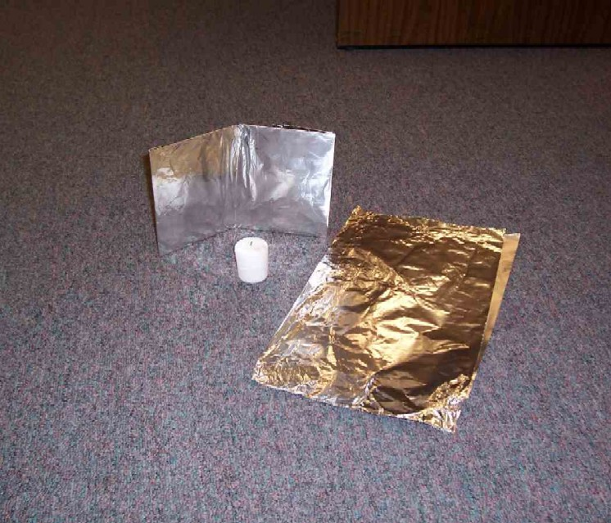 v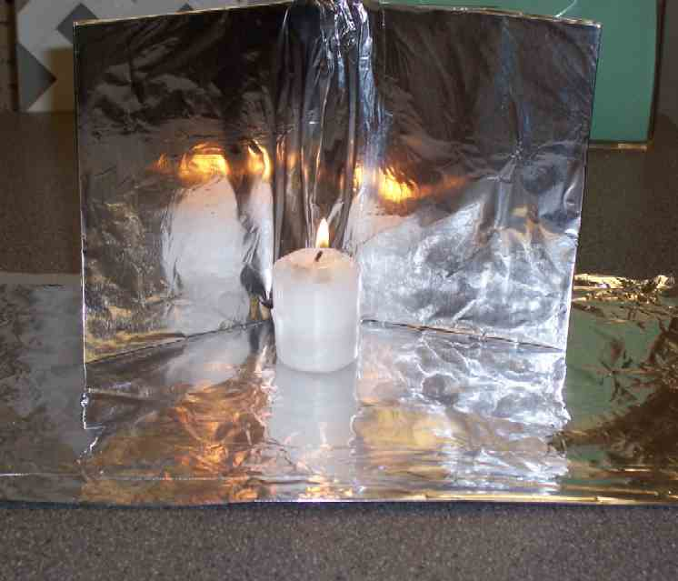

INTRODUCTION
Last week we talked about how Jesus promised that He would return on the Last Day as judge. Then there would be a new heaven and new earth. Maybe another way to describe it is simply “heaven.”

In these lessons, perhaps you have been thinking about what heaven is like. Some people imagine heaven to be like this….

Video
Show video clip of The Littlest Angel. Show the first two minutes beginning right after the opening credits and ending when the littlest angel comes crashing through from his flight.

This is not a very accurate picture of heaven according to the Bible. This makes heaven seem like a fairytale land. Although we can’t imagine the splendor of heaven completely, the Bible does give us a glimpse of the glory of heaven and what it will be like.

Read the Bible, John 14:1-6. For the reading of this passage ask for one volunteer to come forward to read the part of Thomas. The presenter reads Jesus’ portion. Thomas’ part is in italics.

“Don't let your hearts be troubled. Trust in God, and trust in Me. There are many rooms in my Father's house; I would not tell you this if it were not true. I am going there to prepare a place for you. After I go and prepare a place for you, I will come back and take you to be with Me so that you may be where I am. …

Indicate to the volunteer that it is his turn to read.

“Lord, we don’t know where you’re going. So how can we know the way?”

Jesus answered him, “I am the way, and the truth, and the life. The only way to the Father is through Me.”

CHRIST CANDLE AS AN OBJECT LESSON

In advance, prepare the room by covering windows or other sources of light so it will be completely dark.

Darken the room and light the Christ Candle. Play instrumental music in the background to create a contemplative mood. Maintain it throughout the presentation.

The Christ Candle reminds us of Jesus. He came into our world as the very Son of God. But when we saw Him in our world, He had set aside His heavenly glory and splendor and took on the human form of a man. Now, His form completely reveals His heavenly glory. When He comes on the Last Day as judge, He will shine brightly. For some, the Day of Judgment will be a great homecoming. These people will be filled with joy because they know Jesus as their Savior and look forward to spending time in heaven with Him. For others who have rejected Jesus, they will get their wish and live apart from Jesus and His glory. They will live in darkness forever, a place called hell.

Let’s imagine what heaven will be like.

Take the candle and place it on the table. Place the three mirrored or painted squares behind it, so that the Christ Candle’s light is reflected.

Notice the candle burns extra bright at this time. In heaven, the glory of Christ shines brighter than anything else. As a matter of fact, there is no need for the sun because the glory of the Father and His Son provide all the light that is needed. (Revelation 21:23.) Heaven’s light is fueled by the glory of God which will be a wonderful thing to behold. It is so wonderful that we cannot look at it in our sinful state. We would first have to have all our sin removed before we could gaze on this glorious light.

Light, which is the glory of God, bounces off all that is in heaven so that everything shines with radiance and beauty. Everything points back to how wonderful God is and how amazing is His gift of love for us in giving Jesus as our Savior.

WE REFLECT HIS GLORY
Light a few small tea light candles and set them next to the large Christ candle.

Remember how on Pentecost the Holy Spirit was poured out on the disciples? We pictured that as the small birthday candles were lit. Each one of them represented us.

What will it be like in heaven? Much the same. Each one of us will have our unique personality and gift, but now we will be filled with God’s glory in a way that is more than we have ever experienced. It will be His light burning inside of us.

Look at each other and notice each unique personality and appearance. In heaven, we will have a closer bond there than we have ever had with anyone here on earth. That bond is formed as we all shine with the glory of God. We will be holy and perfect.

WHAT WILL WE DO IN HEAVEN?
The Bible describes the activity of heaven in Revelation as millions and millions of heavenly creatures and humans having a massive worship time. Maybe it will sound like a rock concert or wonderful symphony. We know that it will be an amazing thing to hear and to see, but more than that, to experience. It will be fulfilling because that is what God created us to do.

What else will we do in heaven? The Bible does not tell us a whole lot about the things we will be doing there. One thing it does tell us is that we will never be bored there. It tells us that there will be no more crying or dying. (Revelation 21:4.)

Will we have things to do? Absolutely. Will there be things like playing baseball or hanging out with friends or seeing new places? Yes. It may not be in the same way we experience it here on earth, but we will have wonderful, enjoyable experiences there. It will be like a joyous, wonderful wedding feast. We will have all of heaven to explore. The big difference will be the main attraction.

THE MAIN ATTRACTON OF HEAVEN
The main attraction of heaven is God. What is so wonderful about Him is not how mighty He is and big and holy and powerful, but how amazing His love is for us. For you see, in heaven, we will see Jesus face-to-face. We will be able to talk to Him. We will know Him quite well, just as He knows us.

But the one thing that Jesus brought to heaven from earth was the holes in His hands. They remind everyone of how it was possible for sinful people like us to be forgiven and receive the gift of heaven. To see Jesus face-to-face, He had to die for us. In heaven, we get to see personally how much God loves us. In all of heaven, there is a party celebrating God and His love for us.

On earth, often times our parties celebrate us. There’s nothing wrong with that. But there is something wrong if we think that we are the center of the universe and happiness is getting everything we want. That is not true on earth and it is not true in heaven. God is the center of the universe. True happiness is found in doing what He wants and giving Him glory. It’s just that in heaven, we get to do it face-to-face. Heaven becomes a place where we can feel God’s love better than at any other time we have experienced it. *Heaven is face-to-face with Jesus… and it’s a blast.

OBJECT LESSON TEACHING
Use a wedding veil or some other visual from a marriage ceremony to share the following example.

The most frequent way the Bible describes heaven is like a wedding. The Bible says that Jesus is the groom and the church is the bride. The church is people who know and trust Jesus. Heaven is where the bride is presented to the groom and they are married and celebrate their life together. This symbol that I have in my hand is what we use in our weddings today.

Show veil, ring, marriage license or unity candle.

In Jesus’ day, however, marriages were different than they are today. The father of the groom and the father of the bride arranged the marriage. When they reached agreement, they would seal the deal with a glass of wine. Oftentimes, there was a price the bridegroom paid for the bride. The bride would then be known as one “bought with a price.” The groom would go back to his father’s home and begin to build walls connected to the family house. You see, families often didn’t live in separate houses, but in rooms next to each other. They would just continue building rooms on to the existing house as each of the sons got married and brought their wives home to raise families. Therefore, families grew up with uncles and aunts and cousins and grandparents—all nearby in the same large complex. That is another picture of heaven, a place where we are with many other people—as close as family.

As the groom prepared the extra rooms for his bride, it often took many months. The bride didn’t know when it would be completed. But once it was, the groom went into town, blew the ram’s horn and went to the house of his bride. He then took the bride through the village to his house, gathering wedding guests along the way as he went. Once they were at his house, they had a seven-day wedding party after the bride and groom were married.

Can you see how this was as Jesus described in our reading today? He compared Himself to a groom who chose us as His bride. He paid a costly price for us by giving His life on the cross for our sin. Now He has gone to prepare a place for us at His Father’s house, which is heaven. He will come to take us, His bride, home with Him to heaven.

Prayer:
Heavenly Father, You are so wonderful for loving us so much. Thank You for giving us Jesus. Because of His life given for us, we will live with You forever. Thank You, Jesus, that right now You are preparing a place for us to be with You forever in heaven. You love us more than any groom would love his bride here on earth. Thank You for loving us so much. In Jesus’ name. Amen

Lesson 53

Small Group Warm-up
- snack food that reminds kids of treasures (example: chocolate gold coins or Hershey’s Treasures)

Large Group Presentation
- video, The Littlest Angel. Original Hallmark Hall of Fame movie (1969)
- the Christ Candle—this can be a large thick plain white candle or it can have some ornamentation that signifies it as a Christ Candle
- three 12” mirror tiles or 14x14 inch cardboard squares covered with aluminum foil or painted with gold glitter paint
- an additional loop to the wick of the Christ candle, so that it will burn extra brightly
- crown – place it around the Christ Candle
- quiet contemplative music as background music
- tea light candles
- wedding symbols (veil, ring, unity candle, etc.)

Small Group Application
- snack food that reminds kids of treasures (example: chocolate gold coins or biscuits)

Memory Verse Learning
- blindfold
- half a A4 paper. Divide the words of the memory verse into two parts. Print each part on a separate sheet of paper.

