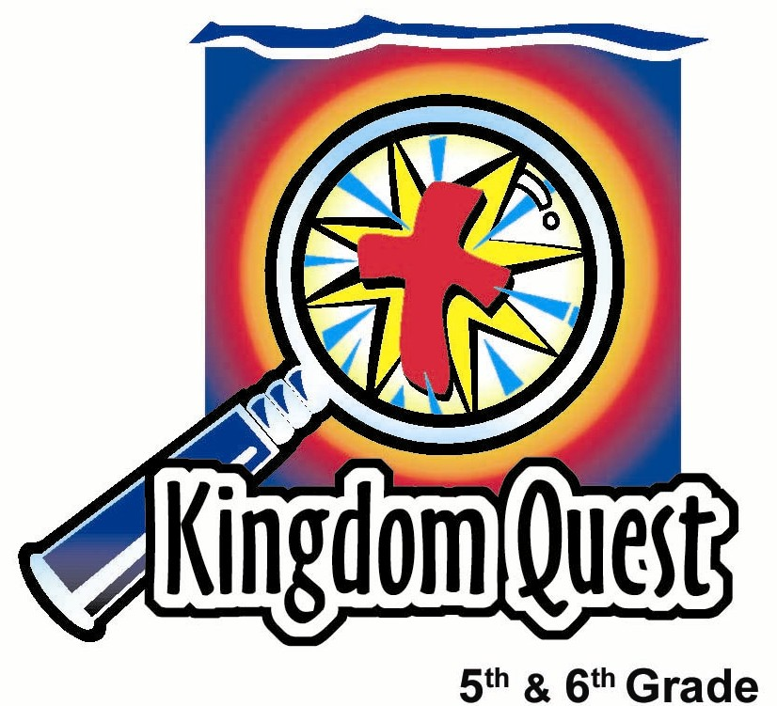
Date: _________________________
Series: Raising Your Parents (Jun-Aug)
Year 1, Lesson 9

Take Home Point: *Communicate well with your parents. Listen carefully—talk openly.
Talking Openly with Your Parents
*Repeat this phrase throughout the lesson.

Bible Event: Ephesians 4:29-32; Exodus 20:12
Key Verse: Ephesians 4:29 “When you talk, do not say harmful things. But say what people need – words that will help others become stronger. Then what you say will help those who listen to you.” (NCV)

We will help kids know:
- God desires we communicate well with our parents.
- The first step in good communication is to really care about the other person, just as Christ has cared about us.
- The second step in good communication is to listen carefully to the other person.
- The third step in good communication is talk openly and honestly.
- Blocks can get in the way of communication—such as negative emotions and poor communication skills.

We will help kids feel:
- Love for their parents and a desire to be kind and understanding toward them.
- Safe enough to talk about problems and conflict areas in their homes.

We will help kids do:
- Discover what type of communication pattern is most common between them and their parents.
- Have a relay using building blocks to learn hands-on the foundation of good communication, especially with their parents.
- Kids role-play different scenarios to demonstrate good and bad communication skills.
THIS LESSON’S ROADMAP

DESTINATION | PAGE # | DISCOVERIES ON YOUR JOURNEY | SUPPLIES NEEDED
Small Group Warm-Up   | 3-4 | Kids discuss ways they communicate with their parents and discover some of the most common responses kids and parents share in communicating. | - (optional) sweets contained in a “handphone” that reminds kids of the topic of communication.
Large Group   | 5  7-12 | Overview  Kids have a relay using building blocks to learn hands-on the foundation of good communication especially with their parents.  Kids role-play different scenarios to demonstrate good and bad communication skills. | - set of Jenga® type building blocks for every six to nine students
Small Group Application   | 5-6  7 | Kids discuss Ephesians 4:29-32 and Exodus 20:12 to see what God gives us as our responsibility toward our parents.  Memory Verse Learning: “Race and Write  1 Thess. 3:12 will be the memory verse for lessons 7-10, to encourage the bound of love to be developed more and more in parent-child relationship. | - (optional) Same sweets from warm up activity  - whiteboard and two markers
Small Group Warm Up: 15 minutes
Purpose: Get pointed in the right direction! Build relationships and help guests feel at ease. Do the learning readiness activity that will point your group in the right direction for the lesson.

As kids gather: Listen to memory verses from last week and give coupons for memory verses, remembering to bring your Bible, and bringing a guest.

Easier Summer Option: Instead of having kids in small groups with an assigned shepherd, the kids can meet all together and divide themselves into triads (groups of three). This allows for larger ratios between students and shepherds. Shepherds will monitor the kids’ activity as needed by roaming from group to group. The questions and directions for all the kids and their groups are by the large group presenter. IF this is used, go to the introduction of large group to introduce the main character used in this series.

Regular Shepherd Option: Do the Warm-Up activity as a small group. If you like, you can still divide into triads within your small group. This helps each child participate more.

Supplies: (optional) sweets contain in a “handphone” that reminds kids of the topic of communication.

Assign each corner of the room a number such as #1, #2, #3, and #4. This will be used in the “Go to the Corners” portion of this lesson.

Introduction

Today we will talk about good communication with our parents. You have some questions to discuss in your triads. As you discuss them, I will come by and give you one of the snacks that remind us of communicating well.

Give kids the following questions to discuss while you pass out the sweets.

Questions

Which of your parents (or caregivers) is easiest to talk to? Why?

What are some things that are very easy to talk about with your parents?

What is something that is hard for you to talk about with one of your parents? For example, it might be something you disagree about or even argue about—like what clothes you wear. Or, it might be a topic that makes you feel uncomfortable to talk about like certain things that are happening with your friends at school.

Go to the corners

Now think about one of the times when you spoke to your parent(s) about something that is hard to talk about. When you spoke, which of these four communication styles best describe your conversation? Share your answer with your group.

- We both spoke calmly and both listened.
- You kept your feelings to yourself, because you don’t like talking about them.
- You kept arguing with your parents when you didn’t get your way, even though they considered the conversation finished.
- Neither you nor your parents really listened to the other person because you both were so interested in what you wanted.

Now go to a corner of the room that matches the answer you just shared. Each one of the four corners will represent the number of the type of communication you had. Everyone who answered number one, “We both talk calmly and both listen,” please go to this corner.

Continue instructing the kids to go to their numbered corners according to the questions above.

Point out which corner has the greatest number of kids, and which corner has the least amount of kids.

Which type of communication seems to be the most common? Why do you think this is the pattern or why do most people talk this way?

Which type of communication seems to be the least common? Why do you think it is harder to communicate like this?

Which types of communication do you think are the most God pleasing?

Today we will learn to *communicate well with your parents. Listen carefully—talk openly.

Have kids return to their triads or small groups.

Large Group Overview: 20-30 minutes
Purpose: Help kids observe what the Bible says. Present the Bible event in creative fashion. Help kids begin to interpret what it means.

Overview

Kids have a relay using building blocks to learn hands-on the foundation of good communication especially with their parents.

Kids role-play different scenarios to demonstrate good and bad communication skills.

Small Group Application: 20-25 minutes
Purpose: Help kids map out the meaning of the Bible event in their lives. Use the questions to stimulate discussion, but don't feel tied to them. Allow the Holy Spirit to guide you. Include personal examples from your own faith journey. The example of Christ at work in your life will leave lasting impressions of how Christ can work in the children's lives.

Use your Bibles! Children need to learn how to look up references and follow along when scripture is read aloud. Allow for quality time of prayer at the close of the lesson.

Observation Questions: What happened?
Have kids read together Ephesians 4:29-32.

Today’s key verse is verse 29: “When you talk, do not say harmful things. But say what people need – words that will help others become stronger. Then what you say will help those who listen to you.” (NCV)

What does this passage say we should do and not do in order to communicate well? (We should not say anything that is hurtful, but instead speak only what is good to give help where it is needed.)

Does your communication with your parents look like verse 31? How often? Only sometimes? Frequently?

How should our communication look differently according to Exodus 20:12?

What does God command us to do regardless of how we feel? (Honor our fathers and mothers.)

Interpretation Questions: What does this mean?
According to the above verses, does God give us the option to honor our parents only when we feel like it? What is our responsibility regardless of how we feel about our parents?(To show them honor and respect.)

Give examples of how our communication demonstrates honor and respect. (When we listen actively to our parents by looking them in the eye and not playing with something else, when we answer kindly, when we ask questions to help understand what they are asking, etc.)

Application Questions: What does this mean to me?
Supplies needed: (optional) same sweets from Warm-Up activity

Pass out the snack or sweet as a reminder for kids to communicate in a sweet way with their parents.

Ask kids to each share two things they have learned to communicate well with their parents that they will try this week at home.

(Optional) What is one topic that you wish was easier to talk about with your parents?

Today we learned to *communicate well with our parents. Listen carefully—talk openly.

Prayer Time:
Thank God for Jesus’ resurrection power to help us forgive and to act kindly even when we don’t feel like it. Have kids pray for specific ways they felt conviction to better communicate with their parents.

Memory Verse Learning: 5 minutes
Purpose: Help kids to memorize and keep scriptures at heart. Using creative ways to help kids enjoy learning the key verse and in small group setting.

Supplies needed: whiteboard and 2 markers

Memory Verse: 1 Thessalonians 3:12, “We pray that the Lord will make your love grow more and more for each other and for all people.”

MV Presentation: “Race and Write”
Write the memory verse on the whiteboard board and read it in unison with the children several times. Then divide the children into two teams and instruct them to line up. Divide the white board in half. Give the first child in each team a marker. On a signal from the shepherd, the teams should begin a relay race to write the memory verse on the half of their white board. Each child is to write only one word, and then pass the marker to the next child in line. A player can erase incorrect words and replace them only if they are next in line after a mistake is made. The team that correctly writes the memory verse on the whiteboard wins. The team completed writing the memory verse correctly is the winner.

Large Group Presentation

Talk Openly with Your Parents

Introduce the topic: Honor your parents with good communication

Exodus 20 records the Ten Commandments. Verse 12 tells us how God wants us to respond to our parents. It says: “Honor your father and your mother.” One of the most important ways we can honor our parents is to communicate well with them. Today we will learn how we can honor our parents by communicating with them in a better way. *Communicate well with your parents. Listen carefully—talk openly.

For the following game, groups of six to nine kids will compete against each other. It is best for each group to have a Jenga® set (or building blocks that can be stacked as a tower and different pieces pulled out without the structure falling). Finally, when enough pieces are removed the tower collapses. If you use Jenga®, it is best to have 27 blocks per team.

You may want to divide one Jenga® set in two for two teams. If you don’t have enough sets for every group, you may have just two teams, boys against girls.

Set the building blocks on a table near one side of the room. Line up each team on the other side of the room. Have kids remain seated in a line, and explain that this is a quiet relay game as we are concentrating on good communication and listening. Each team will send one person at time to set up one building block. As the players go and stack their blocks, the presenter reads the communication learning points.

Demonstrate how the building blocks are to be set up in the Jenga style with three blocks forming a square on the first laver, three blocks crisscrossing the first layer and three blocks again criss-crossing for the third layer. The tighter the blocks are stacked, the better they will support the structure later.

Introduce the Game: Building blocks of good communication.

To help us learn about communicating with our parents, we will build towers. Good communication is like a tower. Good communication skills are like building blocks. When they are all in place, we have a tower of good communication.

Foundation of good communication: Really caring about your parents.

The beginning of good communication is like building the foundation. The foundation is made of the first nine blocks that need to be in place.

Each team will send a person over to put one of the foundation blocks in place and then return to their team to tag the next person. That person will then go put another block in place.

While the first nine blocks are put in place, I will read nine statements about the foundation of good communication. What we are creating is a foundation that shows you really care about your parents.

When I say, “go,” the first person can begin. Everyone else listen to what I say about this foundation building block. Ready, set, GO!

Read one of the following as the each new block is laid in place.

- The foundation of good communication with your parents is to really care about them.
- The Bible reads in Ephesians 4:32…”Be kind to each other.” Don’t you think that you should especially be kind to your parents?”
- The verse continues: “Be sympathetic.” That means you want to understand your parents better.
- The verse continues: “…forgiving each other as God has forgiven you through Christ.” Kindness means forgiving your parents even if you think they have done something wrong against you.
- The ultimate kindness is to not hold grudges. You don’t hold grudges when you forgive another person.
- This kindness is possible because God has been kind to us. He has forgiven us far more than we could ever forgive another person.
- The foundation of good communication is to want to be kind to your parents and to understand them.
- God gives us His love and kindness by giving His own Son, Jesus, for us.
- When we trust Jesus as our Savior, He lives in our life so we can show His love to our parents.

Second step of good communication: Listen carefully

Now let’s put the next section of nine blocks on the tower. This will remind us of the second step of good communication: Listen carefully. Are the relay people ready to put more blocks on the tower? Let’s go.

Repeat in the same manner as above as three new layers of blocks are added.

- Listening carefully is the second phase of good communication.
- When you listen carefully to another person, you help that person feel that what they are saying is important.
- To listen carefully, look at the person who is talking to you.
- To listen carefully, don’t try to do something else that is distracting.
- To listen carefully, nod your head to show that you understand.
- To listen carefully, ask questions so that the other person can further explain.
- To listen carefully, tell the other person what you understand them to say.
- To listen carefully, listen for feelings, not just words.
- To listen carefully, don’t interrupt them when they are talking.

Third step of good communication: Talk openly

The last section of the tower reminds us of the third phase of good communication. This is to “talk openly.” Everyone listen as you hear the nine points about how to talk openly. Relay runners and builders are you ready? Let’s go.

Repeat in the same manner as above as three new layers of blocks are added.

- Talking openly shows that you trust your parents. Your parents need to know that you trust them.
- Talking openly means saying what is on your mind in a respectful manner.
- Talking openly means you don’t feel like you have to hold back if there is something your want to say.
- Talking openly means being honest.
- Talking openly means it’s okay to show how you feel.
- Talking openly means showing your parents who you really are.
- Talking openly helps you better understand yourself.
- Talking openly helps your parents trust you.
- Talking openly means you sometimes go to your parents and say, “I have something that I would like talk about with you.”

Blocks to good communication

See how we have built wonderful towers that remind us of good communication with our parents? Now, what are some of the things that break down good communication? Maybe it has to do with not really caring enough about the other person. Or, maybe it’s about not listening well or talking openly. The relay will continue as I read blocks to good communication. But this time, each relay runner pulls out a block instead of adding one.

There are two special rules. One, remember to listen as I read the learning point. Two, when you pull out a block, you can only touch the one block you pull out. You can’t hold the tower with the other hand or touch any other block. Okay? Let the relay begin.

- You hold a grudge against your parents, so you pout and don’t talk to them.
- You don’t care what your parents have to say, so you really don’t listen to them.
- You don’t really try to understand your parent’s point of view.
- You avoid looking your parents in the eye when they talk to you.
- You bounce a ball or fiddle with another object when they are trying to talk to you.
- Even though you don’t understand what your parents are saying, you don’t ask any questions.
- You ignore your parents when they begin talking to you.
- You interrupt them when they are talking.
- You don’t want them to know what you are really feeling.
- You hold back and don’t say what’s on your mind.
- You don’t help your parents understand, because you won’t talk openly.
- You are not honest with them.

Processing the collapse

By the end of the exercise, all the towers probably have collapsed. Ask:

These towers have just collapsed. Who can describe what it is like in a house where the communication has collapsed?

Take three or four answers.

What is it like in your home when you communicate well with your parents?

Take three or four answers.

Acting it out: Scene 1 and 2:

Let’s role-play some of these situations to see how good communication works. Here’s the scenario.

There once was a 6th grader named Michael who had several friends in the neighborhood that were going to ride their bikes to the mall and hang out for an hour or so on Saturday afternoon. He didn’t know if his mom would let him go, so he thought it might be better to just do it without talking to her since he was over at his friends’ house, anyway. Maybe she would never notice. But just then, his mom dropped by on her way to do an errand to tell him that she would not be at home until later. Let’s see what happened in their communication.

Can I have a volunteer play Michael? I want you to show an example of poor communication? Who would play the part of the mom?

Let them act it out. Encourage Michael to show as many poor examples of communication as possible. Then take new actors who would demonstrate someone communicating well with his parent.

Act It Out: Scene 3 and 4

Siew Mei s troubled because some of her friends at school have been making fun of her. They say that she is old fashioned because of the clothes she wears and the fact that she doesn’t wear any make-up. Her father notices that something might be bothering her and asks how things are going at school.

Who will act out Siew Mei’s part as if she doesn’t communicate well? Who will be Siew Mei’s father?

Choose volunteers to act it out. Then select new actors who will demonstrate communicating well in this scene.

Thank all volunteers and have them return to their seats.

Closing prayer

Heavenly Father, thank You for our parents and the opportunity to honor them, just like You told us to. Help us *communicate well with them. Help us listen carefully to them and talk openly with them. Help us care about them. We want our relationship to get better and better with our parents. To do this, we need Your power. You loved us and gave us Jesus. You gave us the power of Your forgiveness and love. Now help us share that with our parents. In Jesus’ name. Amen.

SUPPLY LIST

Lesson 9

Small Group Warm-Up:
- (optional) sweets contained in a “handphone” that reminds kids of the topic of communication.

Large Group:
- set of Jenga® type building blocks for every six to nine students

Small Group Application:
- (optional) Same sweets from warm up activity

Memory Verse Learning:
- whiteboard and 2 markers

