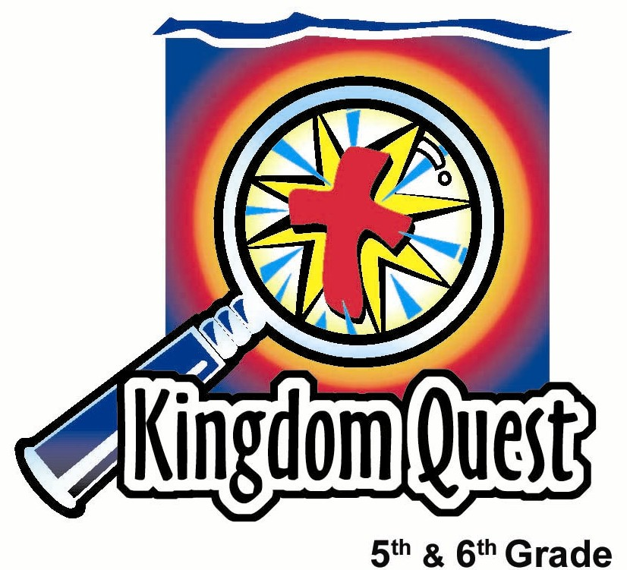
Date: _________________________
Series: Spring Cleaning (Apr-May)
Year 1, Lesson 55

Dust Away Disobedience
Take Home Point: *Dust away disobedience—obey God.
*Repeat this phrase throughout the lesson.

Bible Event: Deuteronomy 7:12; Deuteronomy 26:16; John 14:15-17; Ephesians 5:6; Hebrews 12:11
Key Verses: John 14:15, “If you love Me, you will obey My commands.”

We will help kids know:
- Different reasons to obey God: negative consequences, rewards, protection, a love for God, it is the right thing to do.
- The power to obey comes from the Holy Spirit.
- It is easier to decide beforehand to obey God and those in authority, than to consider each request.

We will help kids feel:
- Uncomfortable as they discover their own patterns of disobedience.
- Affection for God that is strong enough to obey Him in all things.

We will help kids do:
- Take a personal inventory of obedience.
- Examine why they obey.
- Identify and record areas in which they can improve their obedience.

THIS LESSON’S ROADMAP

DESTINATION | PAGE # | DISCOVERIES ON YOUR JOURNEY | SUPPLIES NEEDED
Small Group Warm-Up   | 3 | Kids collect sticky dots on the back of their hands as a discussion starter about obedience. | - sticky dots (five per student)
Large Group   | 4  6 | Overview  Interactive Teaching: Ah Kow the Spring Cleaner or Ah Lan Chea discuss reasons why we should obey God. Kids use sticky dots to match the reason why they would obey in the given situation.  They learn that God can dust away disobedience and gives the power of the Holy Spirit to help them obey. | - cleaning costumes: jeans, sweats, bandana or sweat band  - spray bottle, dust rags  - appendix pages on 8 ½ x 11 inch paper  - one candy bar  - duster  - talcum powder  - dustpan with cross on it (from last week)  - Option. Have the following passages printed on cards: Deuteronomy 7:12, Deuteronomy 26:16, John 14:15, Ephesians 5:6, Hebrews 12:11
Small Group Application   | 4 | Kids match Bible passages with reasons why they should obey. They identify and record areas in which they can improve their obedience.  Memory Verse Learning:  “Picking Up Together”  Ephesians 6:7 will be repeated for lessons 54-58 to help the children understand and experience the joy of serving others. | - “Dust Away Disobedience” copied front to back with “Obey God” - one per student (see appendix)  - pencils or pens  - index cards  - rough papers  - large basket/bucket

Small Group Warm Up: 15 minutes
Purpose: Get pointed in the right direction! Build relationships and help quests feel at ease. Do the learning readiness activity that will point your group in the right direction for the lesson.

As kids gather: Listen to memory verses from last week and give coupons for memory verses, remembering to bring your Bible, and bringing a guest.

Supplies: sticky dots (5 per student)

Explain to kids that you will ask them five questions. For every answer each student gives you, he/she will collect a sticky dot to place on the back of his/her hand. The goal is to collect five sticky dots to take to large group.

Allow the students to respond one time to each of the following questions, giving them a dot for each answer.

The first question is, if you could change any rule at home what rule would you change?

What rule would you change at school?

What rule would you change at church (or the name of your program)?

From these examples, which rule is easiest to break or disobey?

Which of God rules is easier for you to break or disobey?

Today we will learn why we should obey God’s rules and the people He has put in authority over us, like our parents, teachers, and police officers. We will learn we can *dust away disobedience—obey God.

Remind kids not to remove the sticky dots because they will be very important in large group. Encourage them to take their Bibles to large group also.

Large Group: 20-30 minutes
Purpose: Help kids observe what the Bible says. Present the Bible event in creative fashion. Help kids begin to interpret what it means.

Overview

Interactive Teaching: Ah Kow the Spring Cleaner or Ah Lan Chea discuss reasons why we should obey God. Kids use sticky dots to match the reason why they would obey in the given situation. They learn that God can dust away disobedience and gives the power of the Holy Spirit to help them obey.
Small Group Application: 20-25 minutes
Purpose: Help kids map out the meaning of the Bible event in their lives. Use the questions to stimulate discussion, but don't feel tied to them. Allow the Holy Spirit to guide you. Include personal examples from your own faith journey. The example of Christ at work in your life will leave lasting impressions of how Christ can work in the children's lives.

Use your Bibles! Children need to learn how to look up references and follow along when scripture is read aloud. Allow for quality time of prayer at the close of the lesson.

Observation Questions: What happened?
Have kids read John 14:15-17 for the following questions:

What should we do to show God we love Him? (John 14:15. Obey His commandments.)

Who does God give us to help us obey? (John 14:16-17. The Spirit of Truth or the Holy Spirit.)

How do we know we have the Holy Spirit’s help? (John 14:17. God promised that He would be with us and in us when we believe.)

Interpretation Questions: What does this mean?
If time allows, have kids look up the following passages and match them to the five reasons to obey God (Gonna Get in Trouble, Gonna Get a Reward, It’s Best for Me, I Love the Person Who Asked Me, It’s the Right Thing to Do).

Deuteronomy 7:12—Gonna Get a Reward
Deuteronomy 26:16—It’s the Right Thing to Do
John 14:15—I Love the Person Who Asked Me
Ephesians 5:6—Gonna Get in Trouble
Hebrews 12:11—It’s Best for Me

Application Questions: What does this mean to me?
Supplies: “Dust Away Disobedience” copied front to back with “Obey God” ---one per student (see appendix), pencils or pens

Pass out the pages and pencils or pens. Then say:

We are going to take a few minutes to reflect on our own disobedience. Look at your sheet with the cross on a dustpan. Think about the areas that you struggle to obey and write them on the dustpan.

Give the kids time to think and write down their responses.

Now, turn the paper over. In the dust clouds, write the areas in which you need the Holy Spirit’s help to obey.

After kids have had time to write their examples, give them time to share some of the things they wrote.

Why should we obey God? (I love God and it is the right thing to do.)

Our key verse from John 14:15 says, “If you love me, you will obey my commands.”

It is hard to obey God in our own strength. We love our parents but we still sometimes disobey them because we are sinful. God gives us forgiveness through Jesus when we fail and the power of the Holy Spirit to obey Him.

Today we learned to *dust away disobedience—obey God.

Memory Verse Learning: 5 minutes
Purpose: Help kids to memorize and keep scriptures at heart. Using creative ways to help kids enjoy learning the key verse and in small group setting.

Supplies needed: index cards, large basket/bucket, rough papers

Memory Verse: Ephesians 6:7 ~ “Do your work with enthusiasm. Work as if you were serving the Lord, not as if you were serving only men and women.” (NCV)

MV Presentation: “Picking Up Together”
Divide the children into two teams. Have the children line up approximately 3 feet from the basket. Mix up the index cards and place one stack facedown near each team. The first child in each team crumples a rough paper to make a paper ball and attempts to throw it into the basket. If the paper ball goes into the basket, the child takes a card from their team’s stack but none for those who misses the basket. The game continues until all the cards have been collected. The team who have all the cards will work together to put the cards in order. Once this is done, the team will recite the verse together. After the game, have all the children pick up all the paper balls and clean the room together.

Prayer Time:
Have the children spend time on their own specifically asking forgiveness for the things written on their papers. Have them thank God for the Holy Spirit and ask for His help in obeying Him.

Large Group Presentation

Supplies: cleaning costumes: jeans, sweats, bandana or sweatband; extra props: spray bottle, dust rags; appendix pages on 8 ½ by 11 inch sheets of paper (Gonna Get in Trouble, Gonna Get a Reward, It’s Best for Me, I Love the Person Who Asked Me, It’s the Right Thing to Do); one candy bar; dust pan with the cross on it from last week; duster with talcum powder in it

Option. Have the following passages printed on cards: Deuteronomy 7:12, Deuteronomy 26:16; John 14:15; Ephesians 5:6; Hebrews 12:11

Introduction of Presenter
Ah Kow the Spring Cleaner or Ah Lan Chea comes forward dressed in the proper cleaning attire. This presenter needs a duster loaded with talcum powder. He/she shakes it over the group to give the effect of dust.

Today we will dust away disobedience. This may not be a popular topic, but as we just saw, there is an awful lot of dust in this room that needs to be removed. We need to dust it away so we can replace it with obedience to God. When we obey God that means we also obey our parents, teachers, law officers, and others in authority.

The problem is obedience is hard. Sometimes we just don’t feel like doing it! Let’s look at some reasons why we would want to obey.

Introduce the Five Reasons to Obey
Show the five sheets copied from the appendix. Tape them on the wall as you show them.

The first reason to obey is, “Gonna Get in Trouble.” Sometimes we obey because if we don’t, we might get grounded, sent to our rooms, yelled at, or receive some other bad consequence.

The next reason is, “Gonna Get a Reward.” If you sit here obediently and listen to me, I might be tempted to give you a reward. In fact, I see this person right here doing just that. I have a gift for you.

Pick a person sitting very nicely and listening and give him/her a little gift.

Thank you for doing such a great job. So, obedience does have its advantages!

Show next page.

This reason says, “It’s Best for Me.” This means that God’s rules for us are given to protect us. There is a rule about playing in the street. Why would that rule be best for you? (Protects us from being run over.)
“I Love the Person Who Asked Me” is our next reason for obeying. This means we obey simply because we respect the person who has asked us, especially if it is God.

Our last reason to obey is, “It’s the Right Thing to Do.” We simply want to do the right thing.

Voting for the Reasons

We are now going to use the dots that are on your hand. I would like you to listen to the following situations and with each one consider the reason you would obey and place your dot on the corresponding paper.

Here is our first situation. Your mom tells you to clean your room before you go out. Would you obey this because…1) You would get into trouble, 2) You would get a reward like some money, (3) It’s best for you (no one wants rats), 4) Because you love your mom, or finally 5) It’s the right thing to do. You have 30 seconds to vote.

Have children remove one sticker from their hand, come forward and place it on the reason they would obey.

Let’s see which reason got the most votes.

Count the stickers.

Can I have one person come up and explain why they feel this was the best reason?

Choose one student to come forward and share.

Continue in the same way with each of the following statements.

Your teacher wants you to complete your math assignment by Monday and be ready to take the quiz. You obey this because…. 1) You will get into trouble if you don’t, 2) You will get a reward if you do, 3) It is best for you (you could be a nuclear scientist when you grow up), 4) You like your math teacher, or 5) It’s the right thing to do. Please use one more of your stickers and make your vote.

Have students vote with their dots. Then choose one student to explain why the specific reason won.

Here is our next situation. Don’t say bad things about others behind their back. Go ahead and vote.

Bring up another volunteer to explain the reason for the winning reason.

Do not watch inappropriate movies or T.V. This one really gets to be tough when you have friends who can see a movie that your parents say “no” to.

Read through the list of reasons again and have them vote. Once again bring up a volunteer to explain the winning vote.

Here is our last one. Spend time with God in reading the Bible and praying every day. Which one of these reasons is why you should obey? Go ahead and place your last sticker on your vote.

Have a volunteer come up one last time and explain why they feel this was the winner.

Examining our Reasons for Obeying

I need five volunteers to come forward and read a Bible verse for each one of these reasons for obeying.

Bring up five volunteers to read the following passages. Encourage kids in the audience to follow along in their Bibles. (You could have these verses printed out beforehand to save time.)

Please read Ephesians 5:6 for the reason, “Gonna Get in Trouble.”

“Do not let anyone fool you by telling you things that are not true, because these things will bring God's anger on those who do not obey.”

Our next verse is Deuteronomy 7:12 for the reason, “Gonna Get a Reward.”

“If you pay attention to these laws and obey them carefully, the LORD your God will keep His agreement and show His love to you, as He promised your ancestors.”

“It’s Best for Me.” Please read Hebrews 12:11:

“We do not enjoy being disciplined. It is painful, but later, after we have learned from it, we have peace, because we start living in the right way.”

Please read John 14:15 for, “I Love the Person Who Asked Me:”

“If you love Me, you will obey my commands.”

“It’s the Right Thing to Do.” Let’s read Deuteronomy 26:16:

“Today the LORD your God commands you to obey all these rules and laws; be careful to obey them with your whole being.”

Have volunteers sit down.

Which of these reasons seems to be the most important?

Let kids vote overall which is the most important by raising their hands. Help them come to the conclusion that it is because “I love the person who asked me” and “it is the right thing to do.”

Dusting Away Disobedience

How do we take care of the times that we have failed in obeying God? We have to dust them away. Remember sweeping away our wrongdoing from last week?

Show dustpan with the cross on it from last week.

We receive power in the name of Jesus to admit to God our areas of disobedience so that He will forgive us.

We know that Jesus completely and perfectly obeyed His Father. He went to the cross and took our sin on Himself. He took our punishment so we could be free from continuing our patterns of disobedience.

Think of the ways in which you have disobeyed. As I am dusting into this dustpan, it is just like your sins are being dusted away with Jesus’ forgiveness and now you have the freedom to obey.

Obedience Comes with the Help of the Holy Spirit

Obedience is an important part of living as a Christian. If you had to stop and think every time you were asked to obey, you would continually be wrestling with decisions. But, if you decide right now that you want to obey God because you love Him, the decision is already made.

In John 14:15, Jesus says, “If you love Me, you will obey My commands.” Make that decision right now. The only way you have the power to obey God is in verses 16 and 17 of John 14. “I will ask the Father, and He will give you another Helper to be with you forever the Spirit of truth. The world cannot accept Him, because it does not see Him or know Him. But you know Him, because He lives with you and He will be in you.”

Let’s close today by asking for God’s power to be obedient.

Dear God, we thank You for the gift of Jesus. He obeyed You completely when He gave His life for us on the cross. Many times we have disobeyed, but You give us Your forgiveness and dust it away. Thank You for Your Holy Spirit that will help us obey. We want to obey simply because we love You. In Jesus’ name. Amen.

Lesson 55

Small Group Warm-up
- sticky dots (five per student)

Large Group Presentation
- cleaning costumes: jeans, sweats, bandana or sweat band
- spray bottle, dust rags
- appendix pages on 8 ½ x 11 inch paper
- one candy bar
- duster
- talcum powder
- dustpan with cross on it (from last week)
- Option. Have the following passages printed on cards: Deuteronomy 7:12, Deuteronomy 26:16, John 14:15, Ephesians 5:6, Hebrews 12:11

Small Group Application
- “Dust Away Disobedience” copied front to back with “Obey God” - one per student (see appendix)
- pencils or pens

Memory Verse Learning
- index cards
- rough paper
- large basket/bucket

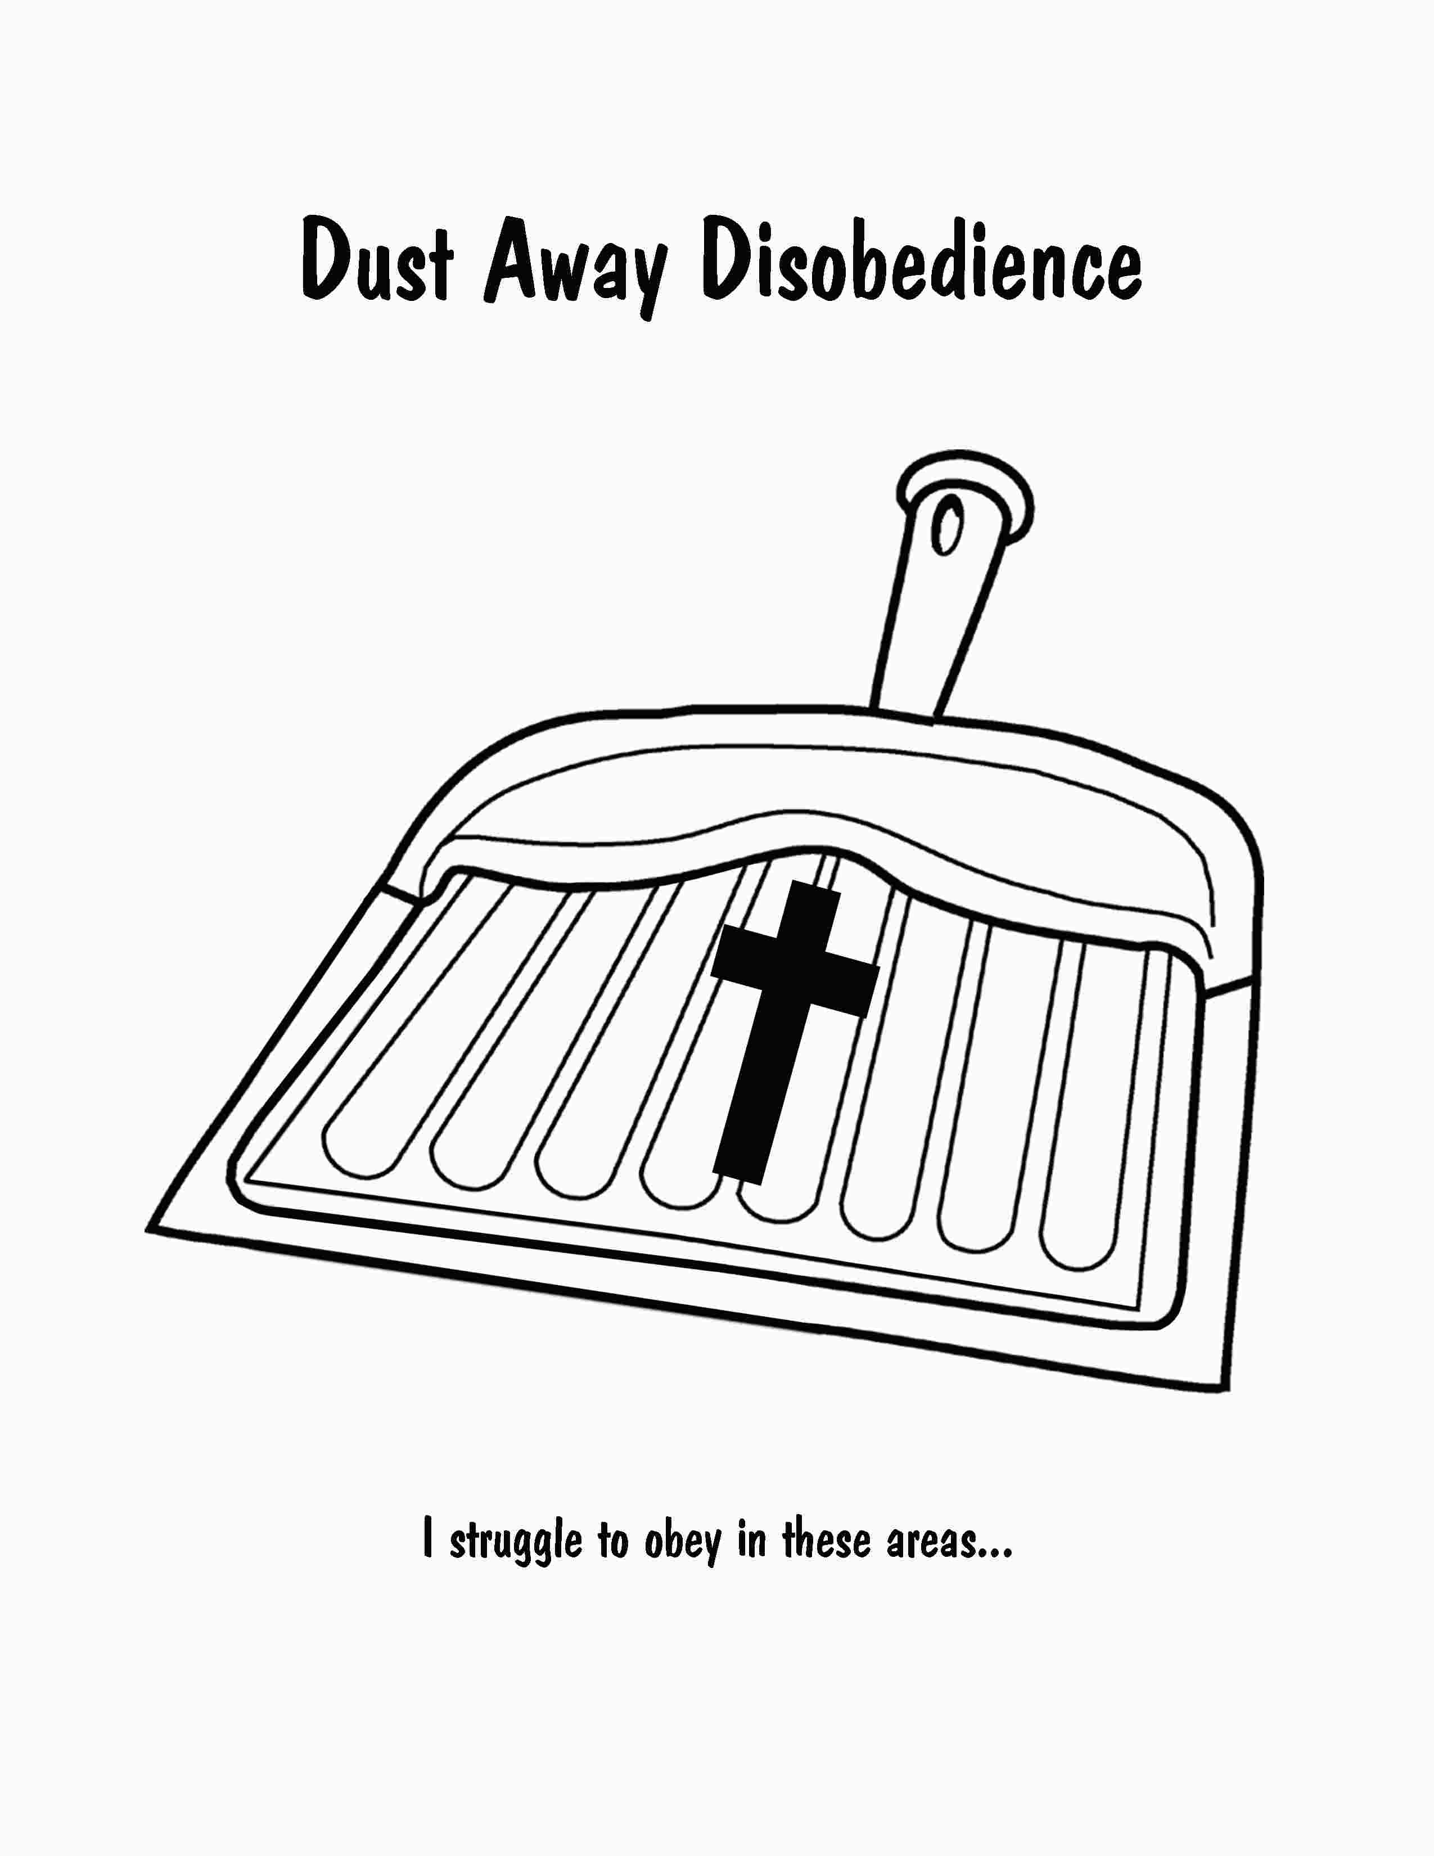

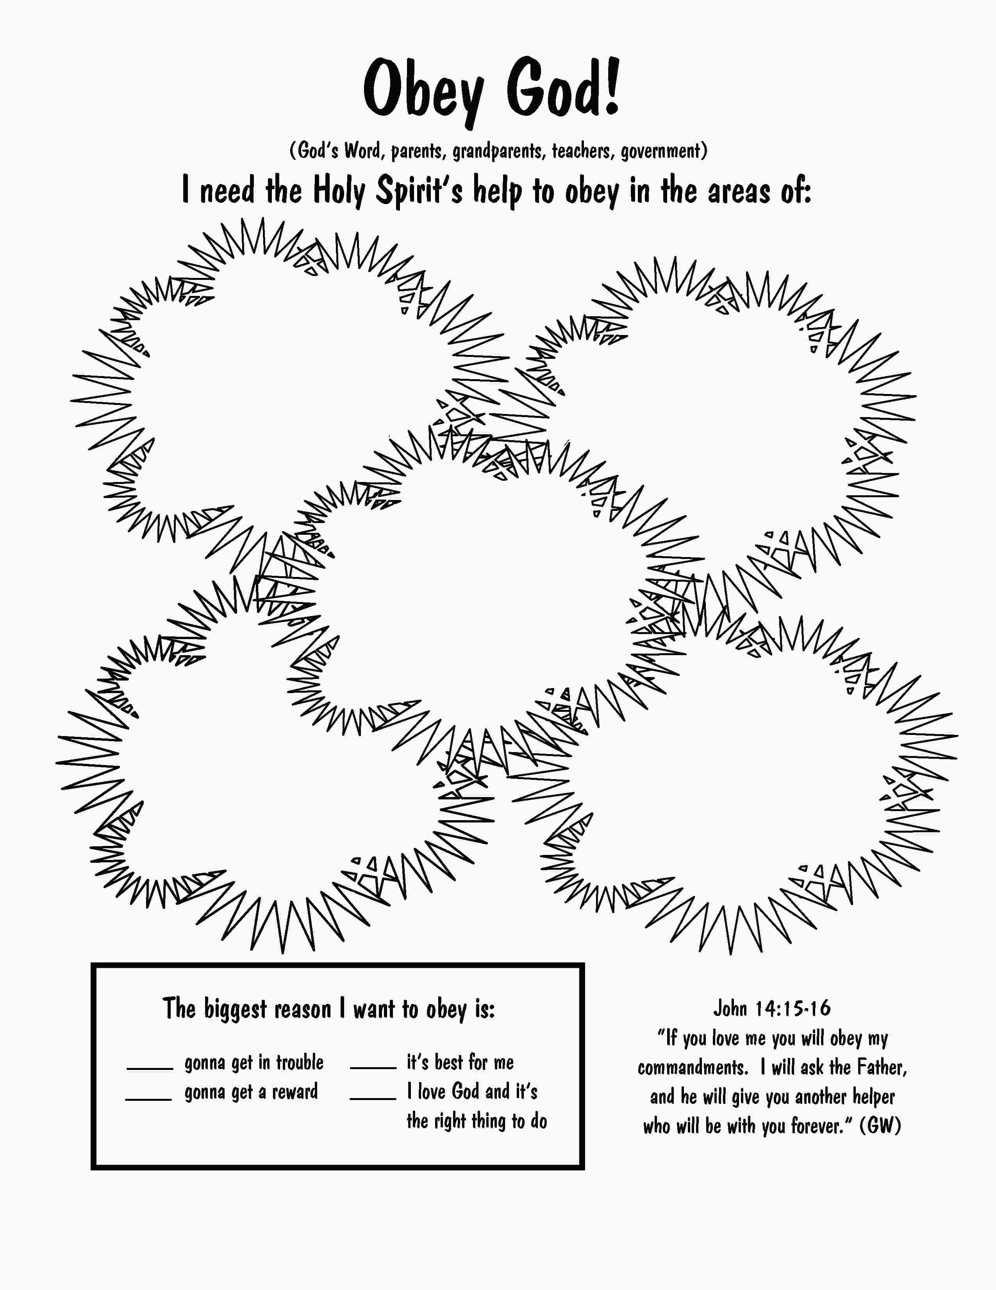Gonna

Get in

Trouble
Gonna

Get a

Reward

It’s Best

for Me

I Love the

Person

Who

Asked Me

It’s the

Right

Thing to

Do
Scripture Cards for “Reasons”
Ephesians 5:6 for the reason “Gonna Get in Trouble”

“Don’t let anyone deceive you with meaningless words. It is because of sins like these that God’s anger comes to those who refuse to obey Him.”

Deuteronomy 7:12 for the reason “Gonna Get a Reward”

“If you listen to these rules and faithfully obey them, the Lord your God will keep His promise to you and be merciful to you, as He swore to your ancestors.”

Hebrews 12:11: for the reason “It’s Best for Me”

“We don’t enjoy being disciplined. It always seems to cause more pain than joy. But later on, those who learn from that discipline have peace that comes from doing what is right.”

John 14:15 for the reason “I Love the Person Who Asked Me”

“If you love Me, you will obey My commandments.”

Deuteronomy 26:16 for the reason “It’s the Right Thing to Do”

“Today the Lord your God is commanding you to obey these laws and rules. You must faithfully obey them with all your heart and with all your soul.”

