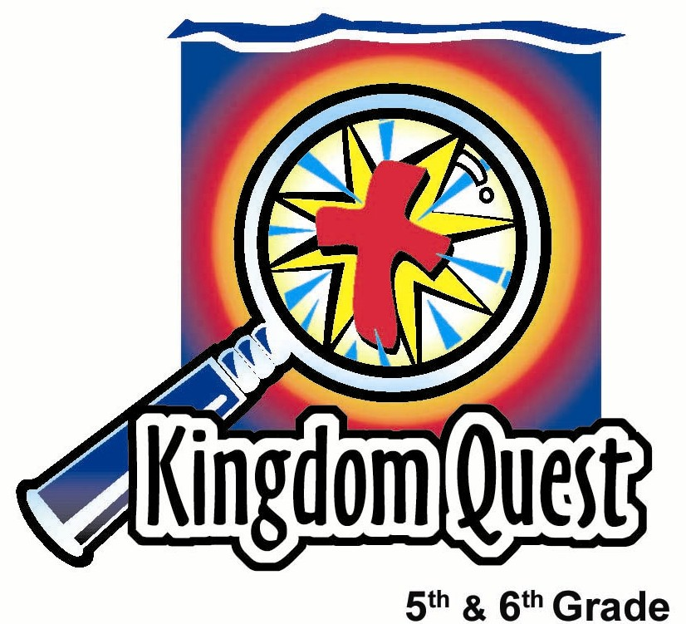
Date: _________________________
Series: Spring Cleaning (Apr-May)
Year 1, Lesson 57

Wash Away Prejudice

Take Home Point: *Wash away prejudice. Accept others who are different.
Repeat this phrase throughout the lesson.

Bible Event: Colossians 3:11-13; Luke 10:25-37
Key Verse: Colossians 3:12-13, “God has chosen you and made you His holy people. He loves you. So always do these things: Show mercy to others, be kind, humble, gentle, and patient. Get along with each other, and forgive each other… because the Lord forgave you.”

We will help kids know:
- Prejudice is judging or disliking people because they are different in skin color, speech, appearance or customs.
- The power to stop prejudice comes from how God has treated us. He has no prejudice and accepts us with His forgiveness.
- Acceptance is understanding, appreciating, and defending people who are different.

We will help kids feel:
- Convicted about times they have acted out in prejudicial ways towards others.
- Empathy for those who are victims of prejudice.

We will help kids do:
- Identify ways people express prejudice in their worlds.
- Play a game that points out how ridiculous prejudice is.
- Participate in a learning activity to wash off words of prejudice and create a window of acceptance.
THIS LESSON’S ROADMAP

DESTINATION | PAGE # | DISCOVERIES ON YOUR JOURNEY | SUPPLIES NEEDED
Small Group Warm-Up   | 3 | Kids describe groups of people who are typical victims of prejudice and the ways people show those attitudes toward them. | - window magic markers or water-based markers  - access to a window or a laminated white plastic surface  - damp towel
Large Group   | 4  7  10 | Overview  Game: Ah Kow the Spring Cleaner or Ah Lan Chea, will lead kids in a game to exploit their differences.  Interactive Story: The Good Samaritan—Luke 10:25-37.  Kids learn that we can accept others because God accepts us as we are. God has forgiven us and washed away our sins through Jesus’ death for us on the cross. | - two beach balls to be named “Prejudice Balls”  - masking tape dividing line across the center of the room  - wash bucket with a cross on it filled with warm, soapy water and a rag
Small Group Application   | 4 | Kids ask God to wipe them clean of sin as they take wet wipes to clean their own dirty index finger representing prejudice against another person or group.  Memory Verse Learning:  “Get it Right”  Ephesians 6:7 will be repeated for lessons 54-58 to help the children understand and experience the joy of serving others. | - wet wipes for each student  - bean bag  - 24 index cards

Small Group Warm Up: 15 minutes
Purpose: Get pointed in the right direction! Build relationships and help quests feel at ease. Do the learning readiness activity that will point your group in the right direction for the lesson.

As kids gather: Listen to memory verses from last week and give coupons for memory verses, remembering to bring your Bible. and bringing a guest

Supplies: Water-base markers or specialized window markers from Crayola. White plastic writing surface (blank overhead projector transparency sheets, laminated poster board, vinyl three-ring binder sheet protectors, or plastic cling wrap spread around a section of white poster board.)

If your room has windows, use that as your writing surface. Have a wet towel handy so kids don’t have to lick their fingers or wet them to wipe the surface clean.

Say:
Prejudice is disliking or judging another person because they are different. Some ways people are different include skin color, intelligence, athletic ability, language, habits, or appearance.

Describe a kid or group of kids in your school that others show prejudice towards. What ways do people show their prejudices?

As kids tell their stories, have them (or the shepherd) write some of the actions of prejudice on the window or plastic with the special markers.

What group of people from our community may be victims of prejudice? What ways do people show their prejudices against them?

Discuss and continue writing those ideas on the selected surface.

Now, have kids try to clean the words describing prejudices from the plastic or glass surface with their index fingertip. Produce the handy wet towel to moisten fingers for this task.
Don’t let kids clean the resulting smudge off their fingertip. It will be used at the end as part of the teaching point.

Have kids look at their fingertip and say:

When prejudice is expressed, it’s like pointing a dirty finger at someone else. But the problem isn’t with someone else, the problem is within each of us. Today we will learn to *wash away prejudice and accept others who are different.

Large Group: 20-30 minutes
Purpose: Help kids observe what the Bible says. Present the Bible event in creative fashion. Help kids begin to interpret what it means.

Overview

Ah Kow the Spring Cleaner or Ah Lan Chea, will lead kids in a game to exploit their differences.

Interactive Story: The Good Samaritan—Luke 10:25-37.

Kids learn that we can accept others because God accepts us as we are. God has forgiven us and washed away our sins through Jesus’ death for us on the cross.

Small Group Application: 20-25 minutes
Purpose: Help kids map out the meaning of the Bible event in their lives. Use the questions to stimulate discussion, but don't feel tied to them. Allow the Holy Spirit to guide you. Include personal examples from your own faith journey. The example of Christ at work in your life will leave lasting impressions of how Christ can work in the children's lives.

Use your Bibles! Children need to learn how to look up references and follow along when scripture is read aloud. Allow for quality time of prayer at the close of the lesson.

Observation Questions: What happened?/Interpretation Questions: What does this mean?
How is the Samaritan in Luke 10 like Jesus? (He forgave the Jew and helped him even though as a nation, Jews were prejudiced against Him. Jesus forgives us even though we have sinned against Him. It cost the Samaritan to save the man from death. It cost Jesus His life to save us from eternal death.)

Why are we prejudiced against some people? (They may act or look different. We might think we are better than them for some reason. We may be afraid of them or feel uncomfortable about the way they live or the customs they have.)

Why is this wrong? (God accepts us for who we are. He loves all people the same, so we should, too.)

How should we treat people that live in sin? (We should love the person who sins while not accepting the act of sin. Examples would include sexual promiscuity or sins of abuse such as drugs or alcohol.)

How can you do this? (We don’t call these people names but admit that we think the action is wrong. Be understanding that these people may have spiritual wounds.)

Application Questions: What does this mean to me?
The key verse for today from Colossians 3:12-13 says, “God has chosen you and made you His holy people. He loves you. So always do these things: Show mercy to others, be kind, humble, gentle, and patient. Get along with each other, and forgive each other… because the Lord forgave you.”

Who are we according to this verse? (Chosen and loved.) Why should we forgive others? (Because He forgave us.)

How else should we treat other people? (Be sympathetic, kind, humble, gentle, and patient.) Does this mean we should be kind, sympathetic, and humble to only those people we choose?

Application Activity
Supplies: Wet baby wipes (one for each child) or wet paper towels.

It is important to recognize that many times, people can’t help what it is that makes them different. Those people are well aware of their differences, flaws and weaknesses and wish they could change certain things about themselves. Other times people love the ways they are different. We shouldn’t point a finger at them just because they are different from us.

When we catch ourselves being prejudiced or unkind to another, we must ask God to wipe us clean of that sin.

Let’s take turns telling God that we’re sorry about any comments we’ve said or things we’ve done against another person or group.

Pass out one wet baby wipe for each child. Have them use the wipe to clean their dirty index finger. Then say:

We need to ask God to help us look at our own flaws instead of others’ because there really is only one perfect person. Jesus Christ came to earth and lived a perfect life to save us from our imperfect lives.

Now, hold up your clean pointer finger and point it straight up to God. Because of what Jesus did for us, we are all clean.

What are words that we can say to others that show acceptance? Think of the people that others in your school are prejudiced against. How can you show them acceptance?

Have kids share some ideas.

Memory Verse Learning: 5 minutes
Purpose: Help kids to memorize and keep scriptures at heart. Using creative ways to help kids enjoy learning the key verse and in small group setting.

Supplies needed: a bean bag for each team, index cards with memory verse printed

Memory Verse: Ephesians 6:7~ ““Do your work with enthusiasm. Work as if you were serving the Lord, not as if you were serving only men and women.” (NCV)

MV Presentation: “Get it Right”
Place index cards facedown in four rows of six cards each row per team on the floor. Divide the children into two teams. Have the children stand 5 to 6 feet away from their team’s index cards. The first child from each team throws the bean bag onto the cards. Child picks up the card on which the bean bag lands. If the bean bag misses the card, the next child continues the game until all the cards have been picked. The first team to collect all the cards must arrange the verse in order. Everyone recite the memory verse at the end of the game.

Closing prayer:
Pray and intercede for target groups, not just for groups in schools or in the city where kids live, but around the world, and for those who are hurt by others who harbor prejudicial attitudes. Especially pray that the Christian Church be defenders of those who are downtrodden and victims of discrimination.

Large Group Presentation

The presenter for this series will dress for spring-cleaning. This person’s name is either Ah Kow the Spring Cleaner or Ah Lan Chea. They could be dressed in jeans or sweats with t-shirts. Maybe wear a bandana or sweatband. Add any props that might enhance “Spring Cleaning,” for example: spray bottles, rags, and dusters.

Each week of this series a different cleaning item will be used.
Week one: a broom and dustpan
Week two: a duster
Week three: a trash can
Week four: a wash bucket

The emphasis of this series is to find the power in Jesus Christ through His death and resurrection and replace the traits of our sinful nature such as self-centeredness, disobedience, disrespect, and prejudice with service, obedience, respect, and acceptance.

Supplies:
- two beach balls to be named, “Prejudice Balls”
- masking tape dividing line (on floor) across the center of the room
- wash bucket with a cross on it filled with warm, soapy water and a rag
- water-based marker

Introduction of Presenter and Play a “Wash Away Prejudice“ Game

Ah Kow the Spring Cleaner or Ah Lan Chea comes forward dressed in proper cleaning attire.

Hello everyone, my name is Ah Kow, the Cleaner, (or Ah Lan Chea, if a woman). I am an expert cleaner. I don’t just clean stuff on the outside, I’m also interested in cleaning the dirt on the inside. Before we clean today, I believe that we should play a game. The game is about how different all of you are from one another because…my-oh-my, looking at you now…I can’t help but to notice how different you all really are!

Round One – Physical Differences

I can’t help but to notice how you all have different color clothes. I see that some of you have jeans and there are some in blue/green/yellow tee-shirts in the room too… My, my, my.

Let’s have all of you with jeans (light or dark) gather on this side of the line.

Point to one side of the tape dividing line. Then pointing to the other side, say:

Now, everyone should sit in a row behind the divider line facing someone from the other side of the line. Now pretend that your color of clothes makes you a better person than the guy or gal on the other side.

As a matter of fact, I bet there are probably some really pretty nasty things that the people in jeans can say about the other people. And there may be nasty things that the other people can say about those in jeans.

Just to get us started, I’m going to join up with these good sisters and brothers on this side of the line since I’m in a blue top.

Go to the appropriate side, sit down on the line facing a child on the other side and look at his/her clothes.

Hmmm. I’m looking into your clothes and do you know what? I think that all people in jeans are dirty people who never clean between their toes. Yuck! I’m glad I am not wearing jeans!

I wonder what you people on the other side might say about the group of people on my side? Don’t answer that yet. Listen to how the game works.

Have an assistant toss you a beach ball and hold it up.

We are going to bat this beach ball back and forth from one side to the other. If you catch it on your side, you need to stand and say, “ People in jeans always _____________.”

Or you could say, “All people in jeans _______________.” You must use the words “all” or “always” to refer to all of the other group and then insert an original unkind statement into the blank. That’s because when we are prejudiced against a type of person, we categorize all that have that trait together.

Point out that the assistant has another beach ball and a marker to write down (directly on beach ball number two) some of the insults overheard during the game. Knock the first ball to the other side and let whoever catches it, stand and say something about the other group using the words “all” or “always.” Hit the ball back and forth to exchange insults for a time.

When this round is over. Have kids remix themselves in the middle of the room, sit down and listen to the groupings for round two.

Note: It seems strange that we’re asking kids to insult one another with prejudicial comments. That is a deplorable activity. However, it is part of having the kids learn to think on their feet and be able to respond and experience the reality of what it feels like to be a target of unkind and hurtful comments.

Round Two – Ability (Tongue rollers)

There are two types of people in the world. Tongue rollers and flat-tongued people. Tongue rollers can do this…

Demonstrate how it looks to make a circle with the tongue by curling up the sides.

Flat-tongued people can’t do this.

Let’s have the tongue rollers on this side of the line (point to a side) and all the flat-tongued people on the other side.

Continue with the game. Toss the ball back and forth while the tongue rollers and flat-tongued people hurl insults at each other. When the round is over, have kids remix in the center of the room. Then describe round three.

Round Three - Culture (Birthplace)

Now everyone knows that the best citizens in our great town of __________ (insert your town name) were actually born here. So, divide yourselves into two groups. Those born in _______ (state the name of your town), please move to this side of the line. (Motion towards a specific side.) Those born out of _____ (name of your town), move to the other side of the line.

Continue the game in the same manner. _______ (name of your town) people - what do you have to say about those strange classmates who were born in another town? Remember to use the word “all” or “always” in your insults.

Teaching Point: Jesus’ acceptance washes away prejudice.

Colossians 3:13 says, “Get along with each other, and forgive each other. If someone does wrong to you, forgive that person because the Lord forgave you.”

Forgiveness means that God has forgiven us and washed away our sins through what Jesus has done for us on the cross. He accepted us even though He had every right to be prejudiced against us. After all, we were His enemies because of sin. He made us and even more than that. He made us His children through Jesus’ death on the cross. Because of that, He wants to do this…

Take the wet rag and wipe off the insults written on beach ball number two while quoting the scripture verse.

“Get along with each other, and forgive each other. If someone does wrong to you, forgive that person because the Lord forgave you.” (Vs. 13)

“In the new life there is no difference between Greeks and Jews, those who are circumcised and those who are not circumcised, or people who are foreigners, or Scythians. There is no difference between slaves and free people. But Christ is in all believers, and Christ is all that is important.” (Vs. 11)

Maybe we could also say that, when this happens, there are no brown-eyed, blue-eyed, rolled tongue or flat tongued, instate or out of state people because Christ is everything and in everything.

Teaching Story – The Good Samaritan (Luke 10:25-37)

Jesus tells a story about how not to be prejudiced.

In Jesus’ day, the Jews were very prejudiced against the Samaritans. If a Jew walked down the street and a Samaritan approached from the opposite direction, a Jew would often cross the street to avoid being near him. If he touched a Samaritan, he considered himself unclean. In today’s language, it might sound like this: “Ewww, yuck - a Samaritan!”

Pretend that you are the Jews listening to this story that Jesus told. Every time you hear the word “Samaritan” say, “Ewww yuck, a Samaritan!”

To further involve the audience, students from the audience can act out the different characters: a priest, Levite, a Samaritan or the person who was robbed. Give actors a sign or headdress to designate their character.

Leader:
A lawyer came to Jesus and asked Him a question. “Who is my neighbor?” Jesus told him this story. We know it as the story of the Good Samaritan.

Kids:
Ewww, yuck - a Samaritan!

Leader:
One day a man traveled from Jerusalem to Jericho. On the way, robbers attacked him, stole his money, took his clothes, beat him, and left him for dead. Soon, a Jewish religious leader, or priest, passed by. Although he saw the man, he did not stop to help.

Next, a Levite came by. He, too, saw the wounded man but did not stop to help and left the man to die.

Finally, a traveler came along who was a Samaritan.

Kids:
Ewww yuck - a Samaritan!

Leader:
When he saw the suffering man, the Samaritan…

Kids:
Ewww yuck - a Samaritan!

Leader:
…stopped his mule, climbed down and went over to the injured man. The injured man was a Jew. But this traveler was a Samaritan.

Kids:
Ewww yuck - a Samaritan!

Leader:
Would this person help? Especially since Jews hated Samaritans?

Kids:
Ewww yuck - a Samaritan!

Leader:
First he poured oil on the man’s wounds., He bandaged them, lifted the man onto his mule and took him to an inn where he cared for the man. The next day the Samaritan…
Kids:
Ewww yuck - a Samaritan!

Leader:
… had to continue on his journey. But he promised to pay the innkeeper any amount of money necessary to help the man recover. Nobody can argue that this man is generous even though he is a Samaritan.

Kids:
Ewww yuck - a Samaritan!

Leader:
So Jesus asked the people, “Which was the neighbor? The priest? The Levite? Or was it the Samaritan? ”

Kids:
Ewww yuck - a Samaritan!

As you can tell, the Samaritan is the one who showed understanding and acceptance. He even helped and defended the person who was prejudiced against him. This is how we can deal with people who are different than us. The ball that we hit back and forth at each other should never be the prejudice ball, but, instead, the acceptance ball. Here’s a verse to describe that concept.

Colossians 3:12 says, “As holy people whom God has chosen and loved; be sympathetic, kind, humble, gentle, and patient.”

When we go into our small groups today, we will think about how we can wash away prejudice in our lives and instead, give people the acceptance that God has given us.

Hold up the beach ball and wipe it off again with the rag from the bucket of warm soapy water.

Prayer

Heavenly Father, thank You for accepting us when You had every right to be prejudiced against us. Thank You for the gift of Jesus and His forgiveness that washes us from any way we have mistreated or thought less of people who are different from us. Show us when we hold these attitudes in our hearts so that we can have them washed away with Your forgiveness and be freed to better accept others. This we pray in Jesus’ name. Amen.

Lesson 57

Small Group Warm-up
- window magic markers or water-based markers
- access to a window or a laminated white plastic surface
- damp towel

Large Group Presentation
- two beach balls to be named “Prejudice Balls”
- masking tape dividing line across the center of the room
- wash bucket with a cross on it filled with warm, soapy water and a rag

Small Group Application
- wet wipes for each student

Memory Verse Learning
- a bean bag per team
- 24 index cards. On separate index cards, write the memory verse, one word on
each card (see example below). Make two sets. The cards will be used again in
the next lesson.

Do | your | work | with | enthusiasm. | Work
as | if | you | were | serving | the
Lord, | not | as | if | you | were
serving | only | men | and | women | Ephesians 67

