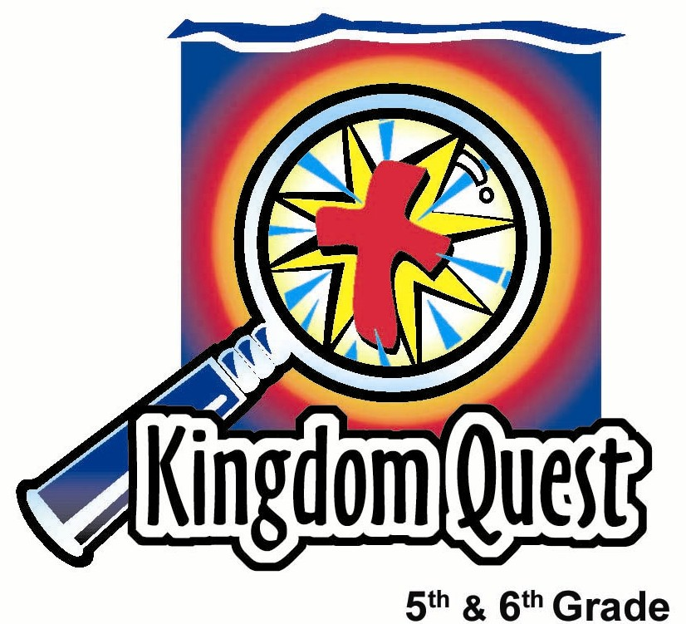
Date: ___________________________
Series: Surrender U (Dec-Feb)
Year 1, Lesson 46

Jesus is
Tempted:
Worship Me

Take Home Point: *Give up worshiping false gods—GET GOD’S PRESENCE
*Repeat this phrase throughout the lesson.

Bible Event: Matthew 4:1-10 Jesus’ temptation; Romans 1:21-25; Romans 8:1-4, 9-10
Key Verse: Matthew 4:10, Jesus said to the devil, "Go away from me, Satan! It is written in the Scriptures, 'You must worship the Lord your God and serve only Him.' "

We will help kids know:
- Satan tempts us in many subtle ways to worship false gods or false ideologies.
- Worshiping God above all means, not only honoring Him as God, but loving and serving Him.
- All failures of honoring Him as God are subtle forms of idolatry. But forgiveness is given through Jesus, who completely surrendered to the Father’s will on the cross.
- We will help the children know the Bible event of Jesus’ temptation by Satan to worship Him, and, in return, Jesus would receive all the kingdoms of this world.

We will help kids feel:
- Challenged by the notion of surrendering anything in their lives they may hold in a higher position than God.
- Excited about worshiping and loving God more fully and receiving His presence.

We will help kids do:
- Identify some of their beliefs and actions that might be from false gods of the day.
- Give their life whole-heartedly to God in worship and prayer.
THIS LESSON’S ROADMAP

DESTINATION | PAGE # | DISCOVERIES ON YOUR JOURNEY | SUPPLIES NEEDED
Small Group Warm-Up   | 3 | Play a game of tick-tac-toe while discussing people or things that are number one in our lives instead of the one true God. | - one pencil and one three inch square with an O or X on it. This can be copied from the appendix  - masking tape to make the # 1 sign (see appendix)
Large Group   | 5  7  8 | Overview  Dramatic Presentation:  “Professor Givitup Talks About Not Worshiping False Gods  Video: Show the video, The Animated Stories from the New Testament: Jesus, the Son of God by Nest Entertainment. Show the temptation of Jesus. Published by Nest Masters, 1990 | - mortar board cap and gown  - bold colored tie, poorly tied (feather boa or scarf for female professor) to wear outside the gown for comic effect  - white gloves  - volunteer to be Surrender Hands  - curtain or partitioned area  - two mechanical pencils  - small box with sign “Create Your God Kit” (Appendix)  - crystal, playing card, money, trophy with sign – Good Works (appendix)  - pencil with sign “One God-many paths” (appendix), 5-12 inch strings of yarn, signs that say Christianity, Buddhism, Hinduism, Islam, Voodoo (appendix)  - video, The Animated Stories of the New Testament: Jesus, the Son of God
Small Group Application   | 5  6 | Kids will learn the importance of keeping God number one in their lives.  Memory Verse Learning:  “ One of a Kind”  Proverbs 3:5-6 is reinforced for the next lesson to encourage the children to trust God for everything. | - none needed  - 16 4x8 index cards  - 4 different color markers
Small Group Warm-Up: 15 minutes
Purpose: Get pointed in the right direction! Build relationships and help guests feel at ease. Do the learning readiness activity that will point your group As kids gather: Listen to memory verses from last week and give coupons for memory verses, for remembering to bring Bibles, and for bringing a guest.

In this activity, emphasize that we are filled with the presence of Jesus and his forgiveness. Everyone should be under conviction of the things that take the number one place in our lives. Every intentional sin is a reflection of the fact that something else has become more important than worshiping God above all. We all have mild forms of idolatry. It is not by our abilities to perform perfectly and keep the law that we have Jesus’ presence, but by the power of Jesus and his forgiveness that we have his presence.

Supplies needed: one three-inch square with an O or X and a pencil per child and masking tape

In advance, make a large number sign (#) on the table or floor using masking tape. The tapelines need to be four inches apart and 12 inches long. Next to the number sign, make the number one. Use two, three foot strips of masking tape that are four inches apart. Close the top and bottom with tape.

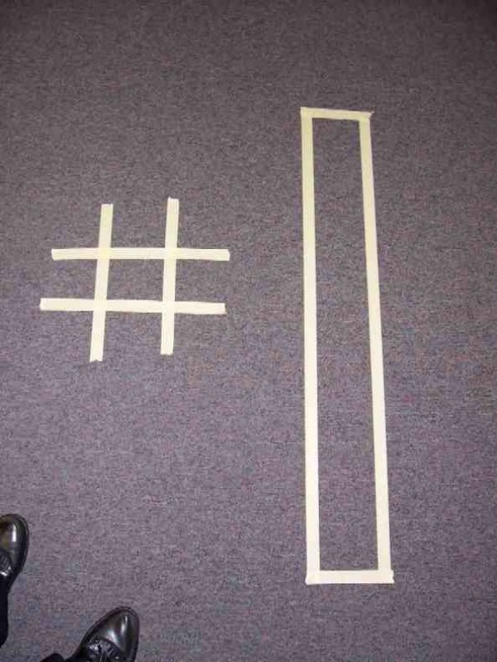

Today we will talk about what people might consider number one, or first priority in their lives. For example, it might be money. Some might think that money really makes them happy and fulfills them. These people will live for making more and more money. There are many other things, as well, that people live for instead of God. I would like you to think about what some of those other things may be. As you do, we will play a game of tick-tack-toe.

Divide the group into two teams. One team is X’s and the other O’s. The children will need pencils to mark on their piece of paper as they play tic-tac-toe. Pass out an X or O to each child. This will determine which team the child is on. Then say:

For you to be able to put down your X or O, you must write at the top of your X or O, one word that is something or someone that a person might consider to be the number one thing they live for other than God. The catch is that for you to be able to play your X or O for your team, you must come up with a word that no one has used already.

Have kids lay down their X’s and O’s in the taped number sign on the floor or table. Play another round of Tick-Tack-Toe thinking of other gods people might worship. A few examples would be: worshiping the earth, Buddha, or the stars. Then say:

Satan often tempts us to put other things as number one instead of God. These begin to be our focus instead of God, or in other words, people begin to worship these things. Have you ever struggled with keeping God number one in your life?

Today we are going to find out that God makes a way for us to worship Him and keep Him number one even if we struggle. He gives us Jesus and the power of His forgiveness to fill our lives so we can worship Him above all else. God says He wants to be number one in our lives.

Remove the tape # sign, and rearrange the 1 into the shape of a cross. Next, using the X or O squares, have kids write a note to God asking him to be number one in their lives. They could tell God they love Him or can ask God to fill their life. Say:
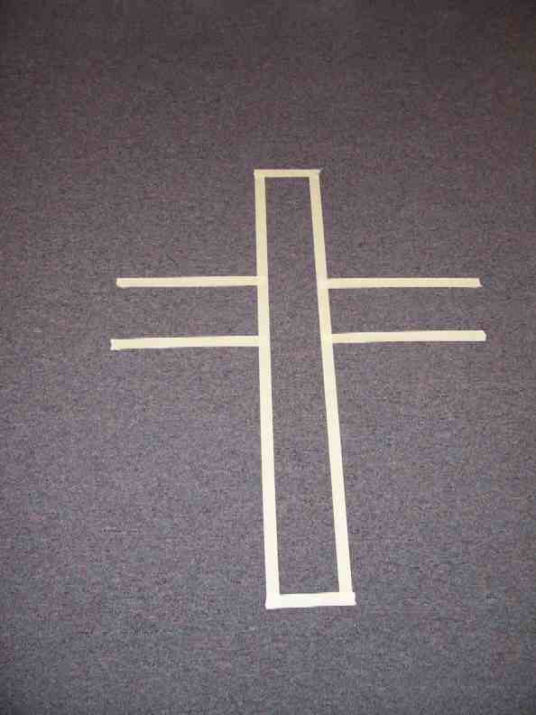
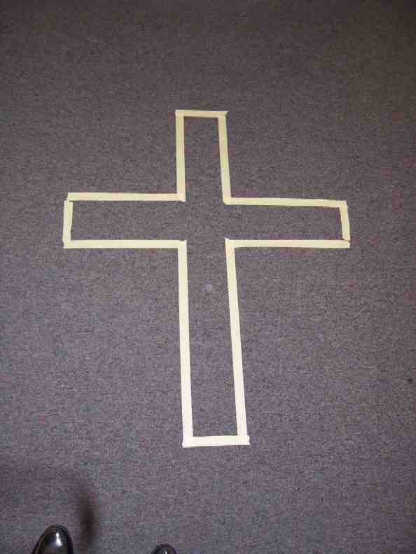

Write a special note to God. When you are finished, put your square face down on the cross we have made with the tape. This is a reminder that God’s presence fills us. It is through Jesus that we can *Give up worshiping false gods—GET GOD’S PRESENCE.

Large Group: 20-30 minutes
Purpose: Help kids observe what the Bible says. Present the Bible event in creative fashion. Help kids begin to interpret what it means.

Supplies needed: mortar board cap and gown; bold colored tie, poorly tied (feather boa or scarf for female professor) to wear outside the gown for comic effect; white gloves; volunteer to be Surrender Hands; curtain or partitioned area; two mechanical pencils small box with sign “Create Your God Kit” (Appendix); crystal, playing card, money, trophy with sign – Good Works (appendix); pencil with sign “One God-many paths” (appendix), 5-12 inch strings of yarn, signs that say Christianity, Buddhism, Hinduism, Islam, Voodoo (appendix); video, The Animated Stories of the New Testament: Jesus, the Son of God

Overview

Dramatic Presentation: “Professor Givitup Talks About Not Worshiping False Gods

Video: Show the video, The Animated Stories of the New Testament: Jesus, the Son of God by Nest Entertainment. Show the temptation of Jesus.

Small Group Application: 20-25 minutes
Purpose: Help kids map out the meaning of the Bible event in their lives. Use the questions to stimulate discussion, but don't feel tied to them. Allow the Holy Spirit to guide you. Include personal examples from your own faith journey. The example of Christ at work in your life will leave lasting impressions of how Christ can work in the children's lives.

Use your Bibles! Children need to learn how to look up references and follow along when scripture is read aloud. Allow for quality time of prayer at the close of the lesson.

Observation Questions and Interpretation Questions:
What happened and what does this mean?
Read Romans 1:21-25:
What is idolatry? (Idolatry is worshiping anything other than the one true God.)
What are some gods that people might worship today? (Examples may be, earth, stars, cards, money, etc.)

Read Romans 8:1-4:
How is it that we are given the freedom of worshiping God? (The only way we can ever worship God is that He gives us faith in Christ. It is through Jesus that we have access to God.)

Read Romans 8:9-10:
Who lives within us and helps us see when we are worshiping other gods? (We are Spirit–filled. God’s Spirit lives in our lives and we are under His control.)

Application Questions: What does this mean to me?
It is easy to allow things or people instead of God to be number one in our lives. But, if we put our faith and trust in Jesus Christ, we will be filled with the Spirit of God. The Holy Spirit will empower us to overcome the temptations of the world. Just as Jesus said in Matthew 4:10, we can say, “Go away from me, Satan! It is written in the Scriptures, 'You must worship the Lord your God and serve only him.' “
We will be able to *give up worshiping false gods—GET GOD’S PRESENCE.

Memory Verse Learning: 5 minutes
Purpose: Help kids to memorize and keep scriptures at heart. Using creative ways to help kids enjoy learning the key verse and in small group setting.

Supplies needed: 16 4x8 index cards; 4 different color markers.

Memory Verse: Proverbs 3:5-6 ~ “Trust the LORD with all your heart, and don't depend on your own understanding. Remember the LORD in all you do, and He will give you success.” (NCV)

MV Presentation: “One of a Kind”
Distribute the cards facing down to the children. At your signal, the children are to walk around the room until you ask them to stop. They are to turn over the index card and quickly gather together in one group of the same color. The children will stand in a line holding the card in front of them with the verse in the right order and recite aloud together. Repeat if time permits.

Prayer Time:
Let each person pray and ask God to forgive them for allowing other people or things to be number one in their lives. Ask for God’s full power to fill them and help them overcome the temptations of idolatry.

Large Group Presentation

Professor Givitup Talks about Worshiping False Gods
Dramatic Presentation

Take home point: Give up worshiping false gods—get God’s presence.

Supplies needed:
- Mortar board cap and gown
- Bold colored tie, poorly tied (feather boa or scarf for female professor) to wear outside the gown for comic effect
- White gloves
- Curtain or partitioned area
- A box that is labeled “Create Your Own God” kit
- In the box is a crystal, playing card, money, a trophy with a “Good Works” sign taped to it, pencil with five pieces of 12 inch yarn taped to the eraser, a sign on the eraser says “One God, many paths,” at the end of each strand of yarn is another sign that says Buddhism, Hinduism, Islam, Christian, and Voodoo. (See appendix page with the card to be cut out)
- White board, flip chart or chalkboard with Professor Givitup’s name and topic.

Enter Professor Givitup. If feeling exceptionally adventurous, speak in a German accent.

Good morning, students, welcome to Surrender University. My name is Wilhelm (female will be Wilhelmina) U. Givitup, or as my friends call me, Will U. Givitup. (Willa U. for a female professor.) Here at Surrender U., we study surrendology, where we study what it means to surrender our lives to God and receive from Him true life. May I have a student come forward to read a key verse for us?

Read 2 Corinthians 5:15,

“Christ died for all so that those who live would not continue to live for themselves. He died for them and was raised from the dead so that they would live for Him.”
Let’s pray for that now.

Dear God, You have given us Jesus who didn’t just live for Himself. Instead, He surrendered His life to what you wanted. He died on the cross for us. He chose not to bow down to anyone else or anything else. Help us to surrender our lives to You as well, and not bow down to anyone else or anything else. In Jesus’ name. Amen.

Today, we will begin with seeing the temptations of Jesus, especially the third and final one. This temptation is when Satan tempts Jesus to bow down and worship him and, in return, Jesus would receive all the kingdoms of the world. Let’s watch the video.

Show the video, The Animated Stories from the New Testament: Jesus, the Son of God by Nest Entertainment. Show the temptation of Jesus. Published by Nest Masters, 1990

I need a volunteer. I have a mechanical pencil here for anyone who will bow down and say, “I am the most brilliant professor you have ever met.”

Bring up a volunteer. To the volunteer, say:

But, you must say, “I am the most brilliant professor you have ever met.”

If they do say it, give him the mechanic pencil. Ask the question,

Did he do anything wrong? No, he wasn’t saying he was a god or anything like that. He was just repeating what I asked him to say.

Keep the volunteer up front for the following dialogue.

Now, I have another mechanical pencil here for you if you would say, “All I have to do to get to heaven is do enough good things.”

BEFORE he can say anything, cut him off!

Hold it! Stop! I am not going to let you say that, because that would be one form of bowing down to a false god – the false god of good works. You can have this mechanical pencil if you say, “It doesn’t really matter what you believe, as long as you are sincere.” No! No! I can’t have you say that either. How about if you say, “It doesn’t matter who you believe in, because they all lead to heaven.”

Again, STOP him before he can say the line.

Oh, no! I can’t have you say that.

Have the volunteer sit down. To the audience:

We are going to find out more about this as we go to the hands of surrender.

Get out the box “Create your own god” kit. Have the hands hold the box as you show each item inside, one at a time.

Let’s look at what is inside the box. Oh, look, here is a crystal. What is this about? How might this be a false god? Some people believe there are magical powers in crystals that bring you in harmony with the earth. That is not what God’s Word says.

What about the playing card? Can we depend on a card to tell us the future? How is that bad? Right, because trying to predict the future by going through any kinds of mediums or spirits is following a false god.

Oh, look, we have a trophy here that says “good works” on it. How about this? Can we do enough good works to get to heaven? (No)

How about money? How can that be a god? Money is not evil, but the love of money can be. And finally, we have the one god, many paths.

Show the pencil with the different religion signs attached to it. Talk about how God says that the path to heaven is very narrow. Say:

There is only one way to heaven, through Jesus Christ.

The hands take the box down behind the curtain and put inside the paper with the cross and the dove on it (see appendix). Wait to hold it up a little later.

Read Romans 1:21-25.

This is what the Bible says about people who refuse to believe there is one God and we are to worship the one and only God. People worshiped all kinds of created things, rather than the Creator.

How can we be sure that we are worshiping the one true God?

Read Romans 8:1-4, 9-10. Then say:

When we surrender to God, and say to Him, “I only want to worship You and love You above all else.” Through faith in Jesus Christ, we have forgiveness for all of our faults. We have His approval so we can worship Him. We can know for sure that we are completely filled with the Spirit of Christ.

The Surrender Hands bring up the box. Pull out the paper with dove and cross and show it to the students.

This picture reminds us to *give up worshipping false gods—GET GOD’S PRESENCE.

Final gospel point:
Jesus worshiped only God and did not fall into temptation with Satan. He was willing to die on the cross for each one of us. After Jesus’ death, resurrection and ascension, God gave us a helper in the Holy Spirit so we can always have God’s presence in our lives. He will help us keep God as number one in our lives. When we fail, God will forgive us and help us again to worship only Him.

Closing prayer:
Heavenly Father,
Thank You that You gave us Jesus who surrendered His life for us. Now we want to surrender ourselves to You. Sometimes we allow other things or people to become number one in our lives. We surrender that desire. In Jesus’ name. Amen. .

SUPPLY LIST
Lesson 46
Small Group Warm-Up
- one pencil and one three inch square with an O or X on it. This can be copied from the appendix
- masking tape to make the # 1 sign (see appendix)

Large Group
- mortar board cap and gown
- bold colored tie, poorly tied (feather boa or scarf for female professor) to wear outside the gown for comic effect
- white gloves
- curtain or partitioned area
- volunteer to be Surrender Hands
- curtain or partitioned area
- two mechanical pencils
- small box with sign “Create Your God Kit” (Appendix)
- crystal, playing card, money, trophy with sign – Good Works (appendix)
- pencil with sign “One God-many paths” (appendix), 5-12 inch strings of yarn, signs that say Christianity, Buddhism, Hinduism, Islam, Voodoo (appendix)
- video, The Animated Stories of the New Testament: Jesus, the Son of God

Small Group Application
- none needed

Memory Verse Learning
- 16 4x8 index Cards. Using different color markers, make four sets of the memory verse on index cards. Each index card will contain one section of the verse (see example). There will be four index cards with sections of the verse written in one color e.g. red and the next set in green and so on.
- 4 different color markers

Trust the Lord with all your heart | And don’t depend on your own understanding | Remember the Lord in all you do | And He will give you success. Proverbs 3:5-6

Buddhism Christianity

Hinduism Islam

One God

Voodoo Many Paths

Create Your
Own God
Kit

Good Works

One God-many paths

