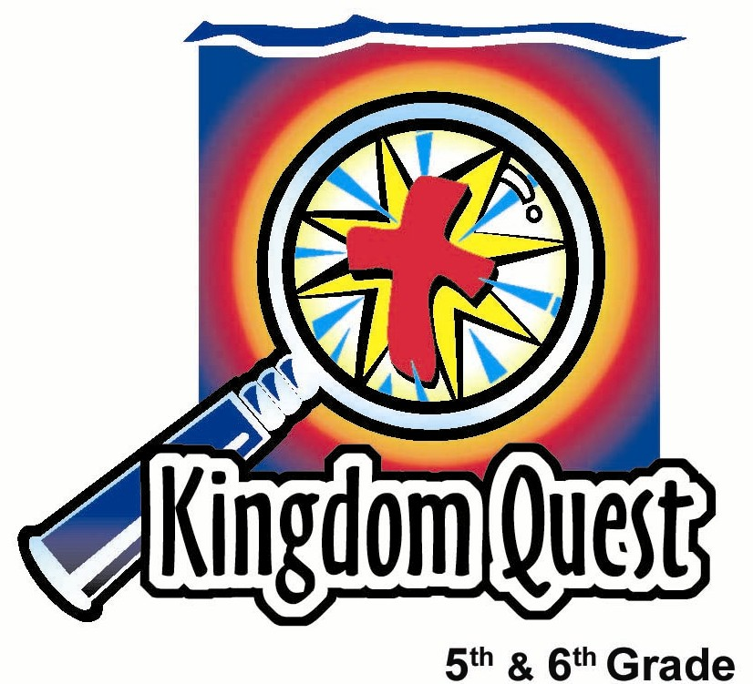
Date:_________________________
Series: A-MAZE-IN Life (Jun-Aug)
Year 2, Lesson 5
Clothes and Image… What Will You Choose?

Take Home Point: *Let God guide your choices in clothes and image.
*Repeat this phrase throughout the lesson.

Bible Event: Matthew 6:28-33; 1 Peter 3:3b-4; Galatians 5:22-24
Key Verses: Isaiah 61:10, “The LORD makes me very happy; all that I am rejoices in my God. He has covered me with clothes of salvation and wrapped me with a coat of goodness...”

We will help kids know:
- Every person creates an outward image of who they are through their choices of clothes and style.
- It can be a problem when kids are more concerned about their appearance than who they are on the inside.
- God wants us not to worry about things like clothes, but, rather, to seek His Kingdom.
- God wants us to be confident in whom we are on the inside because we have been dressed with the spiritual clothes of His salvation.

We will help kids feel:
- Content with clothing and style choices that make each person unique and special.
- Aware of being more concerned about image choices than thoughts about God’s Kingdom.
- Satisfied with the fruits of the spirit we wear on the inside.

We will help kids do:
- Identify labels and style choices that create a cool or uncool image.
- Make auction bids against each other, with Kids’ Cash, on clothes and styles that are cool.
- Read the Bible about the God pleasing robe of righteousness and label the fruits of the spirit people should wear on the inside.
THIS LESSON’S ROADMAP

DESTINATION | PAGE # | DISCOVERIES ON YOUR JOURNEY | SUPPLIES NEEDED
Small Group Warm-Up   | 3 | Students will trace an outline of a volunteer to create a cool or uncool image. Discussion will include the brand names and styles that people wear. | - mahjong papers  - washable, water-based markers (Test to make sure they don’t “bleed” through to the other side of the newsprint.)
Large Group   | 4  7  8  8 | Overview  Attention Grabber—Video clip Shrek, Dreamworks, 2001, ASIN B00003cxxi: Kids are reminded that inner beauty is more important than outer beauty.  Begin Time: 1:22  Begin Cue: Shrek runs into church interrupting wedding and yelling, “I OBJECT!”  End Time: 1:27  End Cue: Shrek says to Fiona: “But you ARE beautiful!”  Clip Duration: 5 minutes  Clothing and Style Choice Auction: Four volunteers are given $100 of Kid’s Cash to bid on apparel.  Bible Reading: Matthew 6:28-33 and Isaiah 61:10. It is more important to be concerned about seeking God’s Kingdom and His righteousness than worry about outward appearances. | - video, Shrek  - Kids’ Cash  - white robe, sheet or drape  - Kids’ creations from small group  - masking tape  - an appealing award
Small Group Application   | 4 | Kids make a new kid creation drawing and label it with the fruit of the Spirit to show how living in the image of Christ should look.  Memory Verse Learning:  “Hop and Stop”  1 Corinthians 10:31 will be repeated for lessons 4 – 7 to help the children choose to do the things that will glorify God. | - Mahjong paper from small group warm-up  - washable, water-based markers  - Bibles  - none
Small Group Warm-Up: 15 minutes
Purpose: Get pointed in the right direction! Build relationships and help guests feel at ease. Do the learning readiness activity that will point your group in the right direction for the lesson.
As kids gather: Listen to memory verses from last week and give coupons for memory verses, remembering to bring your Bible, and bringing a guest.

Supplies needed: mahjong papers join together to trace a child’s outline and washable, water-based markers

Large Group leader: If not already, be sure each small group consists of either all boys or all girls. Assign each small group one of the following images: Joe Cool or Suzy Cute for a cool look, or Nick Nerd or Lucy Loser for an uncool look to contrast the groups. (If there is only one small group, focus on the cool image only. If you have two groups, have one of each image, and if you have three groups, have two be cool and one group be uncool. With more than four groups, assign the different images as equally as possible.)

Shepherds: To begin Small Group Warm-Up, ask for one volunteer to lie down on the mahjong paper to be traced. After the student’s outline has been drawn, title the drawing with the name of the character you have been assigned. For whichever type of image your group has, say the following:

Think of the brand names and labels of the coolest (or most uncool) kinds of clothes and styles that you have seen people wear, then we will draw our kid creation.

As you think of brand name clothing, write what it is on the picture and draw how it would look. Let’s draw the coolest (or most uncool) kinds of shirts, pants, shoes, jewelry, hairstyle, and accessories, such as tattoos, nail art or handbags.

When the body outline has been covered and labeled (be sure the name brand is visible), ask:

Why are certain brands or styles better than others? How many of you wear these kinds of brands or styles? How important are name brands to you?

Today we are going to talk about the *choices you make in clothing and image.

Assign a volunteer to take the kid creation to the large group and help tape it on a wall in the front.

Large Group: 20-30 minutes
Purpose: Help kids observe what the Bible says. Present the Bible event in creative fashion. Help kids begin to interpret what it means.

Overview

Attention Grabber—Video: clip from Shrek, Dreamworks, 2001, ASIN B00003cxxi. Kids are reminded that inner beauty is more important than outer beauty.

Begin Time: 1:22
Begin Cue: Shrek runs into church interrupting wedding and yelling, “I OBJECT!”
End Time: 1:27
End Cue: Shrek says to Fiona: “But you ARE beautiful!”
Clip Duration: 5 minutes

Clothing and Style Choice Auction: Four volunteers are given $100 of Kids’ Cash to bid on apparel drawn on images from small group.

Bible Reading: Matthew 6:28-33 and Isaiah 61:10. It is more important to be concerned about seeking God’s Kingdom and His righteousness than worry about outward appearances.

Small Group Application: 20-25 minutes
Purpose: Help kids map out the meaning of the Bible event in their lives. Use the questions to stimulate discussion, but don't feel tied to them. Allow the Holy Spirit to guide you. Include personal examples from your own faith journey. The example of Christ at work in your life will leave lasting impressions of how Christ can work in the children's lives.

Use your Bibles! Children need to learn how to look up references and follow along when scripture is read aloud. Allow for quality time of prayer at the close of the lesson.

Observation Questions: What happened?
During our style auction, whenever there was a winner, there was also a loser. Let’s read a passage from 1 Peter 3:3b-4 and think about how everyone can win with God.

Read 1 Peter 3:3b-4 starting with, “Beauty doesn’t come from…”

Where does true beauty come from? (The inside. “The internal.”)

What happens to hairstyles, gold jewelry or clothes but cannot happen to internal beauty? (They can be destroyed.)

How does inner beauty express itself? (In a gentle and quiet attitude.)

How does God consider this expression of beauty? (As precious.)

Interpretation Questions: What does this mean?
Read Matthew 6:28-30.
According to these verses, what do you think God is saying about clothes and worrying? (Why worry about what we wear, God will provide for our needs. Even Solomon in all his majesty was not dressed as fine as one of the simple flowers of the fields. Material things will not last forever, “Today it’s alive, and tomorrow….”)

Read Matthew 6:33.
What does God say should be our first concern? (Be concerned about His kingdom and His approval.)

What do you think will be the rewards if you live life seeking God’s kingdom and His approval over the approval of people?

Application Questions: What does this mean to me?
Turn over the kid creation drawing and make a body outline again on the backside of the paper.

Draw a heart on the body and write Jesus inside the heart.

When we seek Jesus and His kingdom, we can receive His forgiveness through faith. Then people see Jesus in us. What do we look like to others? Let’s read what God says we can clothe ourselves with on the inside.

Read about the fruit of the Spirit in Galatians 5:22-24. Have kids write the fruit of the Spirit on the inside, outside and all around the body outline of the kid creation. Then say:

We have now made a brand new outline of our volunteer and labeled how we should appear in God’s image. If you are clothed in these traits, how will you feel? How will you act? Discuss.

Take a moment to think about each fruit of the Spirit labeled on our kid creation outline. Which of these fruits are you best at? Of all those pieces labeled on our picture, which would you most like to have? Why? Discuss.

Our key verse for today from Isaiah 61:10 says, “The LORD makes me very happy; all that I am rejoices in my God. He has covered me with clothes of salvation and wrapped me with a coat of goodness...”

Have each one of you come to that point where you said, “Jesus, I trust You to be my Savior and I want to wear Your robe of righteousness that replaces the dirty rags of my own sinful self?” If not, you can pray and ask Him to fill your heart.

Memory Verse Learning: 5 minutes
Purpose: Help kids to memorize and keep scriptures at heart. Using creative ways to help kids enjoy learning the key verse and in small group setting.

Supplies needed: none

Memory Verse: 1 Corinthians 10:31 ~ “...if you eat or drink, or if you do anything, do it all for the glory of God.” (NCV)

MV Presentation: “Hop and Stop”
Review the memory verse a few times before beginning the game. Ask all the children to hop around the room until you shout, ‘Danger – a fox!’ Then they must stop and stand very still. Anyone who moves is out. When you shout, ‘Its ok, danger’s gone,’ they can start hopping around again. After every three stops, have all the remaining children recite the memory verse before resuming the game. Game continues as time permits.

Prayer Time:
Heavenly Father, help us to see that too much time spent thinking and worrying about how we look draws us away from You. We want to be concerned with Your kingdom and are thankful that Jesus has purchased a robe of righteousness for us and is eager to place it on our shoulders. Fill us with contentment for our unique and individual styles but keep us moving toward the goal of becoming conformed to the image of Christ. We pray that You will also *guide us in our choices about clothing and image. In Jesus’ name. Amen.

Large Group Presentation

Clothes and Image…What Will You Choose?

Props Needed:
- Shrek video
- Kids’ Cash (Appendix A)
- White robe, sheet or drape
- Masking tape
- An appealing award

As small groups arrive, tape their image drawings to a wall in front.

Introduction
The Keeper of the Clues begins:

Welcome, kids, to the A-MAZE-IN adventure of life and all the choices you face. I am the Keeper of the Clues who will give you clues to help guide your choices through the maze that you face. Today we are talking about choices you make in clothes and style. We know these are important because every person creates some type of outward image of who they are through the choices they make in their clothes and style. But is who you are only measured on your outward appearance?

Attention Grabber: Video, Shrek
Introduce the video clip with the following:
Can an ogre live happily ever after? That was the charming twist at the end of Shrek One. You may remember the beautiful princess, Fiona, who chose to embrace her inner ogre full-time instead of only at night so she could live happily ever after with her true love, the ogre, Shrek. Fiona could have chosen to marry a handsome prince, but instead she followed her heart to match Shrek’s style and live in swamp happiness forever.

Show the video clip:
Begin Time: 1:22
Begin Cue: Shrek runs into church interrupting wedding and yelling, “I OBJECT!”
End Time: 1:27
End Cue: Shrek says to Fiona: “But you ARE beautiful!”
Clip Duration: 5 minutes

Concluding remarks about video
As Fiona discovered, it is not just our outward appearances, but who we are on the inside that really counts. However, we spend a lot of time and attention on our outward appearance. When do outward appearances become too important? Let’s find out as we look at the A-MAZE-IN adventure of choices dealing with our clothes and image.

Activity: Clothing and Style Choice Auction
Select four volunteer contestants, two boys and two girls, and give each $100 in Kids’ Cash. Refer to the images taped to the wall and explain that the contestants have $100 to bid on five pieces of clothing or accessories, pretending they would actually obtain the real item.

The winner is awarded the cool item selected (for pretend) by writing his/her name and the loser is assigned the uncool equivalent. Have an adult assistant write the names of winning and losing bidders directly on the kid creation drawings.

Have kids bid on the following items. They must pay for the item immediately after they have won the bid.
- Have kids bid on some type of headwear or jewelry.
- Have kids bid for a shirt or blouse.
- Have kids bid on something to wear on an arm or held in a hand (i.e. purse, or bag).
- Have kids bid on a skirt, pants, or shorts.
- Have kids bid on shoes.

When the auction is over, tell kids:

These are the pieces that you purchased through choices and bids that you made. The amount of money you spent indicates the importance of this item to you. Now, I would like you to make one more choice. Would you trade all these clothes and styles for one other thing: contentment in your heart for who you really are?

Take answers and then have contestants return to their seats.

Bible reading
Ask for another volunteer who is willing to help read a section of scripture, in tandem, from Matthew 6:28-33. Leader begins and student reads the sentence in italics.

“And why do you worry about clothes? Look at how the lilies in the field grow.

“They don't work or make clothes for themselves.

“But I tell you that even Solomon with his riches was not dressed as beautifully as one of these flowers.

God clothes the grass in the field, which is alive today but tomorrow is thrown into the fire.

So you can be even more sure that God will clothe you. Don't have so little faith!”

Don't worry and say, 'What will we eat?' or 'What will we drink?' or 'What will we wear?'

The people who don't know God keep trying to get these things, and your Father in heaven knows you need them.

The thing you should want most is God's kingdom and doing what God wants.

Then all these other things you need will be given to you.”

Refer again to the images of Joe Cool, Suzy Cute, Nick Nerd, and Lucy Loser hanging on the wall. Say:

It is easy for us to worry about a lot of things, including our clothes and appearance. Every person creates an outward image of who they are through their choices of clothes and style. This is not a bad thing because we have our own unique and special style. But God tells us that we should not let how we look become so important that we worry about it. What does he tell us we should be concerned with instead?

Offer an enticing reward to someone who can remember and fill in the blank from this Bible passage.

“Be concerned about His ____________________ and what has His approval.” (Kingdom.)

How can we be concerned about His kingdom? Let me show you this way.

Drape the white robe or sheet around the student while reading Isaiah 61:10.

“The LORD makes me very happy; all that I am rejoices in my God. He has covered me with clothes of salvation and wrapped me with a coat of goodness, like a bridegroom dressed for his wedding, like a bride dressed in jewels.”

This is the robe of righteousness. This is the way God sees you when you have faith and a relationship with Him. Jesus came to give His life for us so that all of our filthy sins would be covered and He would clothe us in a pure robe of His righteousness.

Let’s trade in our desire for only looking good on the outside and be content with whom we are on the inside because we seek God’s kingdom.

Prayer:
Dear God, help us understand the importance of how You see us on the inside, that we are completely forgiven and righteous in Your sight because of Jesus’ life and death on our behalf. Help us not get too carried away with our image on the outside that is not as important as whom we are on the inside. In Jesus’ name. Amen

Before dismissing students back into small groups, have the students who brought in the kid creation images detach the pictures for use again in small groups.

Lesson 5
Small Group Warm-Up

Friendship Labels:
- Mahjong papers join together to trace a child
- washable, water-based markers (Test to make sure they don’t “bleed” through to the other side of the mahjong paper)

Large Group
- video, Shrek
- Kids’ Cash
- white robe, sheet or drape
- Kids’ creations from small group
- masking tape
- an appealing award

Small Group Application
- original mahjong paper from small group warm-up
- washable, water-based markers
- Bibles

Memory Verse Learning
- none

Kids Cash $1.00 – Copy on different color paper than $5.00
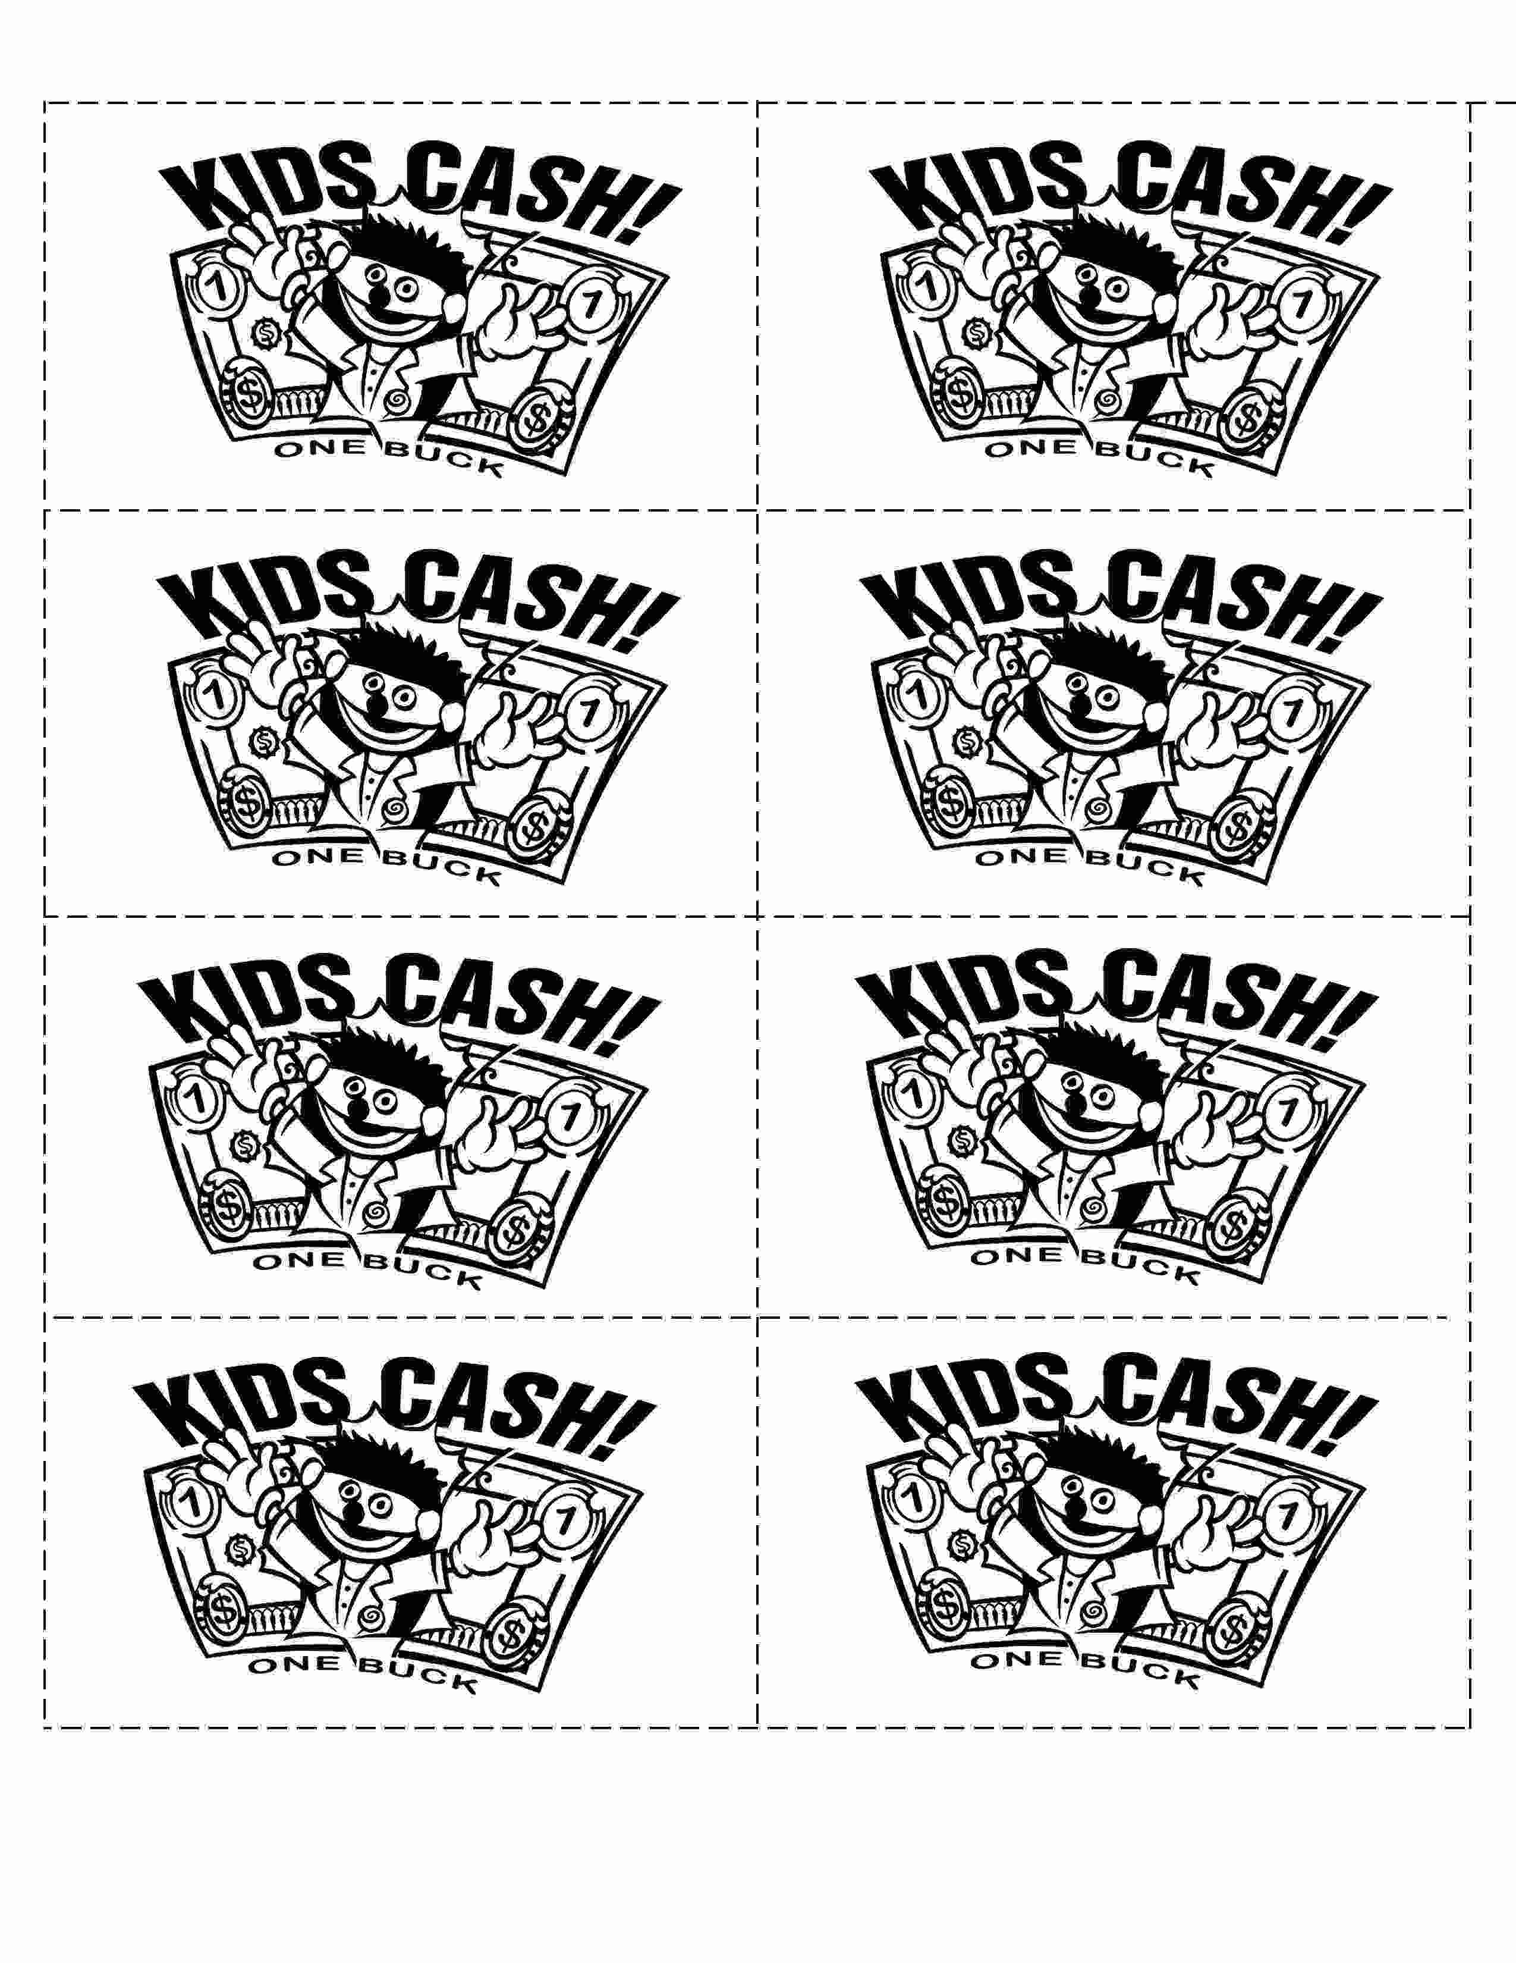

Kids Cash $5.00 – Copy on different color paper than $1.00
