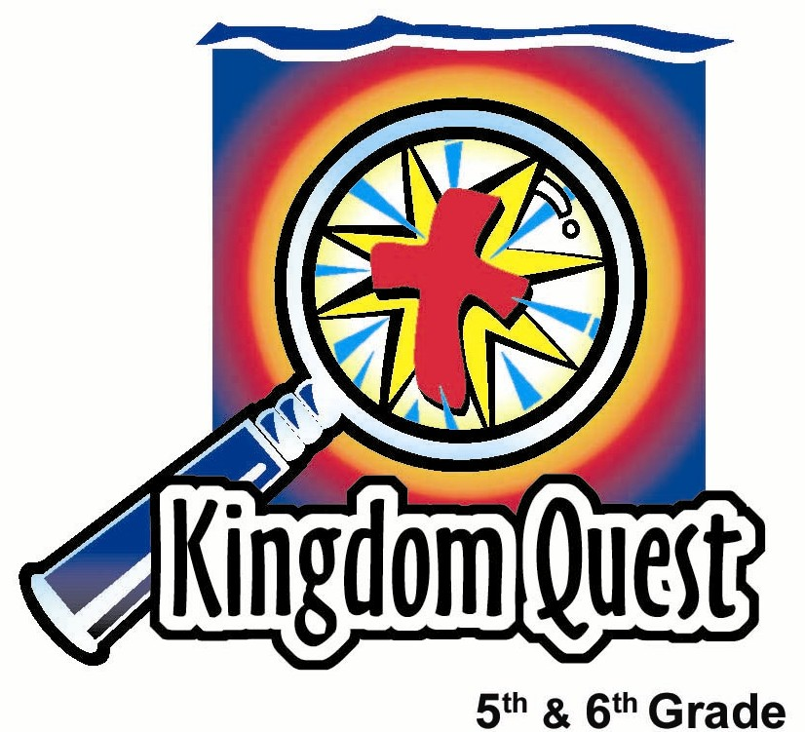
Date: _________________________
Series: A-MAZE-IN Life (Jun-Aug)
Year 2, Lesson 8
Friendship…
What Kind of Friend Will You Choose to Be?

Take Home Point: *Let God guide the ways you choose to be friends to others.
*Repeat this phrase throughout the lesson.

Bible Event: John 15:12-17 and 2 Corinthians 5:17
Key Verses: John 15:12, “This is my command: Love each other as I have loved you.”

We will help kids know:
- God has chosen to love us unconditionally and calls us “friends” through Jesus.
- We, too, can be friends to others with unconditional love just as God loves us.
- They can influence others with friendship characteristics they choose to demonstrate.

We will help kids feel:
- Joyful and secure in God’s friendship for them through Christ.
- Challenged to see themselves in a new way.
- Motivated to be a better friend to others.

We will help kids do:
- Identify some qualities of a great friend.
- Name a best friend and a quality they appreciate in that friend.
- Play a mixer game, guessing what friendship quality has been tagged on their backs.
THIS LESSON’S ROADMAP

DESTINATION | PAGE # | DISCOVERIES ON YOUR JOURNEY | SUPPLIES NEEDED
Small Group Warm-Up   | 3 | The Choice is Yours! - Game: Kids will name one best friend and one friendship characteristic they would like to have themselves. | Friendship Labels:  - one 3x5 inch card per student  - strong tape  - markers
Large Group   | 5  10  10  11  12 | Overview  The A-MAZE-IN Life…What Will You Choose?  Attention Grabber: a video selection from The Mighty. Copyright is 1998 from Miramax Film Corp. It shows two outcast kids who complement each other and develop friendship characteristics that result in a strong bond.  Friendly Animal Guests – Interactive Game: Shepherds tape friendship labels on students’ backs and kids figure out what friendly animal guest they are.  Choose to be a Friend Like Jesus: Find out which characteristics students choose to have and which clue is the one God commands. The Keeper of the Clues reads John 15:12-17 and a discussion of selfless love follows. | - animal friendship labels from small group  - tape  - The Mighty video, copyright 1998 from Miramax Film Corp, ISBN 0-7888-1569-5 (To purchase, call 1-800-477-2811.)
Small Group Application   | 5 | Friendship Pets: Kids mold friendship creatures from plasticine to remind them of the friendship trait that would help them be a better friend to others. Discussion includes the Bible verses from John 15:12-17 and 2 Corinthians 5:17.  Memory Verse Learning:  “Find Your Friend”  John 15:12 will be repeated for lesson 8 and 9 to motivate the children to be better friends to others. | - one 3x5 inch card per student  - different colored plasticine for each group  - Bibles  - CD and player
Small Group Warm Up: 15 minutes

Purpose: Get pointed in the right direction! Build relationships and help guests feel at ease. Do the learning readiness activity that will point your group in the right direction for the lesson.

As kids gather: Listen to memory verses from last week and give coupons for memory verses, remembering to bring your Bible, and bringing a guest.

Supplies Needed: two 3”X5” cards and marker for each child, and masking tape for each child to attach a “nametag” to their shirts

Pass out a 3”X5” card and marker to each student. Then say:

Think of a friend you have and write that person’s name on one side of your 3”X5” card. On the other side, write one word that describes what you like about this person. The word should be an adjective such as loyal, fun, encouraging, helpful, listening, trustworthy or any word you would use to describe this good friend.

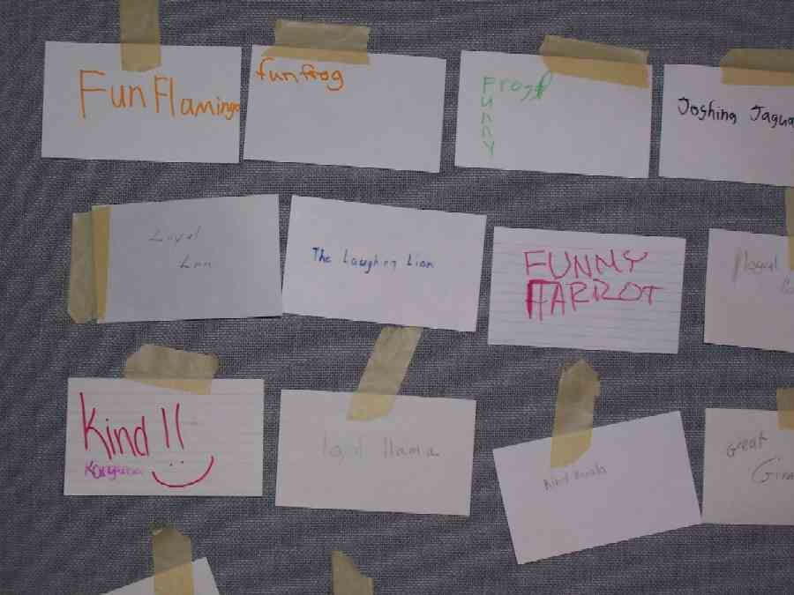

After everyone has written a friend’s name and their word to describe that person, have each student share the descriptive word they chose. Then place the cards in the middle of the group, descriptive word side up, for the following activity.

Explain the game, The Choice is Yours. Determine the game leader as the one whose friend lives the farthest away from church. The game then progresses around the circle to the right of the leader until everyone has had a turn.

The leader gets to choose whatever card he/she likes as the number one desired quality a good friend possesses and that he/she would also like to have. In other words, if you thought the most important quality that you would like to have as a friend is trustworthiness, you would choose that card. Then take a strip of tape and stick the card to your shirt.

The second person to choose a card can either choose from any of the cards in the middle or take the card taped to the first person. If he/she also thinks that trustworthy is what he/she would like to be as a friend, this leaves the first person without a card, who then gets to choose another card from the floor.

The next person can take any card from the floor or either card from the first two kids. If a card is taken from you, you cannot take it right back, but you can take it from another person who then has to pick another card from either the pile or someone else. A card can only be transferred or taken from someone else three times, then it has to stay on the fourth person to choose it.

This game continues until all students have a tag with their choice of friendship characteristic, even if it was not their first choice.

This game can be a lot of fun and kids can enjoy taking nametags from other kids. If kept lighthearted, it will cause no hurt feelings, but it might lead to some interesting conversation about what characteristics kids most prize as the quality of friendship they would choose to have.

Then ask:

Which card was the most highly desired trait? What is it about this one characteristic of friendship that makes it the most desired?

If the card or trait was taken from you, how did that make you feel?

Would one person tell about a time when a friend did something for you that really helped you or made your friendship grow?

Take one person’s answer and then continue with the next question.

Can you also give an example of when you chose to do something similar—to be a friend to someone else or this same person?

Today we will discover what it means to *let God guide the ways you choose to be friends to others.

As many of you probably know, God chose to be a good friend to us when He gave us His Son, Jesus. Because of that, we, too, have choices we can make to be good friends to others. Choosing to be a good friend is the best way to make good friends.
Before kids leave small group, have them write the name of an animal along with a friendship characteristic that begins with same first letter as the animal name on another 3X5 card. For example: a loyal lion or a trustworthy tiger. Have them attach another piece of masking tape and put the cards in a central place in the large group area where the Shepherds can easily distribute and place quickly onto students’ backs.

Large Group: 20-30 minutes
Purpose: Help kids observe what the Bible says. Present the Bible event in creative fashion. Help kids begin to interpret what it means.

Overview

Attention Grabber: Video clips from (The) Mighty. Copyright is 1998 from Miramax Film Corp. ISBN 0-7888-1569-5. To purchase, call 1-800-477-2811.

Friendly Animal Guests – Interactive Game: Shepherds tape friendship labels on students’ backs and through “yes” and “no” questioning, kids figure out what friendly animal guest they are.

Choose to be a Friend Like Jesus: Find out which characteristics students choose to have and which clue is the one God commands. The Keeper of the Clues reads John 15:12-17, and a discussion of selfless love follows.

Small Group Application: 20-25 minutes
Purpose: Help kids map out the meaning of the Bible event in their lives. Use the questions to stimulate discussion, but don't feel tied to them. Allow the Holy Spirit to guide you. Include personal examples from your own faith journey. The example of Christ at work in your life will leave lasting impressions of how Christ can work in the children's lives.

Use your Bibles! Children need to learn how to look up references and follow along when scripture is read aloud. Allow for quality time of prayer at the close of the lesson.

Observation Questions: What happened?
Have students read John 15:12-17.

How are we to love each other? (Verse 12. As Jesus loved us.)

What is the greatest love anyone can show another? (Verse 13. To give their life for them.)

How can we show God we are His friends? (Verse 14. Obey His commandments.)

Why does Jesus call us His friends? (Verse 15. Because He told us everything He heard from His Father. He shared everything with us about His relationship to His Father and how we can have that same relationship. He did not keep any good secrets from us.)

Who chose whom to be a friend? (Verse 16. Jesus first chose us.)

What does Jesus command us to do? (Verses 12 & 17. Love each other as He loved us.)

Interpretation Questions: What does this mean?
What was the greatest thing Jesus did to prove His love and friendship for us? (He gave His life and died on the cross.)

Pick the friendship labels that describe Jesus’ friendship qualities. (Discuss) How can we love others like Jesus loves us? (He chooses us even when we don’t show good character traits, so we can love others in spite of their bad qualities. He gave selflessly, and we can also.)

Application Questions: What does this mean to me?
In the movie, The Mighty, both boys lacked certain things. At one point in the movie, Max says, "He [Kevin] became my brain and I became his feet." Do we have that kind of appreciation for our brothers and sisters in Christ? Why or why not?

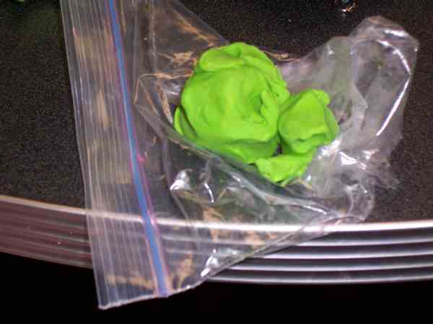
If you wanted some of those friendship qualities in your life, where would be the best place to get them? (The filling of his Holy Spirit gives us the power to be more like Jesus.)

Activity:
Supply needed: different colored lumps of plasticine

Have kids take a small portion of plasticine and make an animal that reminds them of the friendship characteristic they would most like to possess. They can use one of the friendship labels or pick their own word and add an animal name that begins with the same letter. For example, if they want to be more loving, they might make a Loving Lizard as a reminder to show love to their friends.

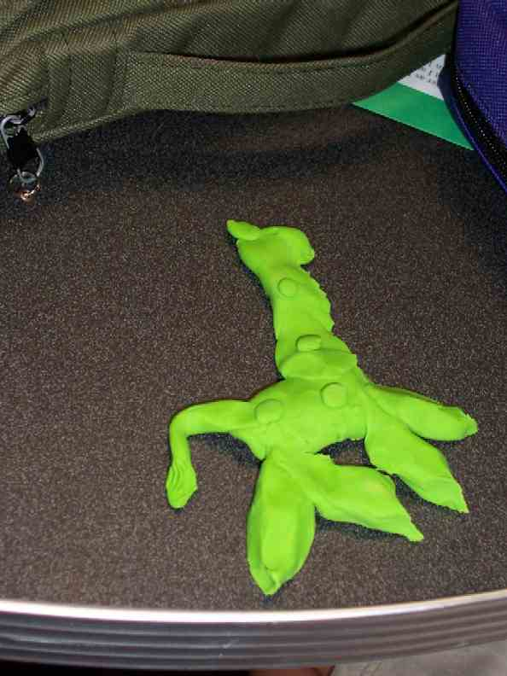

Examples of names for the friendship creatures might include: Libby the Loving Lizard, or Timmy the Trustworthy Tiger.

As students mold their plasticine, read 2 Corinthians 5:17.

“If anyone belongs to Christ, there is a new creation. The old things have gone; everything is made new!”

This verse reminds us that we are made new in the image of Christ when we trust and follow Him. He is a friend who laid down His life for us. When we trust in Him, His Holy Spirit lives in us so that we can be the same kind of friend to others.

Just as God fashioned the first people from clay in the ground, they were made in His image perfect and holy. But when they sinned, that image was lost. Through faith in Christ, we are refashioned to be new creatures like Jesus.

Now we too are fashioning creatures that remind us that Jesus is reshaping our lives to have friendship characteristics we can show to others.
Some of these ideas may be too abstract for the kids to grasp, so use your own discretion in making the connection, however, discuss as the kids are willing and able while making their friendship creatures.

Some of these ideas may be too abstract for the kids to grasp, so use your own discretion in making the connection, however, discuss as the kids are willing and able while making their friendship creatures.

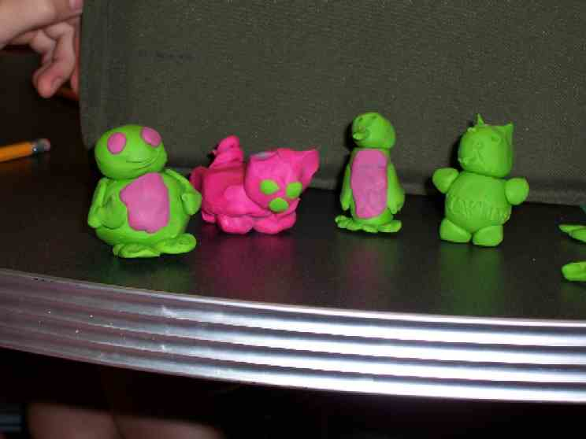

Have each child give an example of a way they can be a friend to another person, demonstrating the characteristic for which the creature is named. Then conclude:

Today we learned to *let God guide the ways we choose to be friends to others. Jesus tells us in John 15:12, "This is my command: Love each other as I have loved you.” Let us each make the choice to love others like Jesus loves us.

Memory Verse Learning: 5 minutes
Purpose: Help kids to memorize and keep scriptures at heart. Using creative ways to help kids enjoy learning the key verse and in small group setting.

Supplies needed: CD and player

Memory Verse: John 15:12 ~ “This is my command: Love each other as I have loved you.” (NCV)

MV Presentation: “Find Your Friend”
Stand the children in two circles, the inner one facing the outer one. Tell them the person opposite them is their friend. Put on the music and ask each circle to run around in different directions. When the music stops, they all have to find their partner and sit down. The last couple to sit down is out. Before they leave the game they have to recite the memory verse together.

Prayer Time:
Have kids pray for individuals they can befriend and show Jesus’ selfless love. Ask God to bless them with a friendship characteristic like Jesus so they can be that kind of friend to others.

Large Group Presentation

The A-MAZE-IN Life…What Will You Choose?
Friendship…What Kind of a Friend Will You Choose to Be?

Props Needed:
- Animal friendship labels from small group
- “The Mighty” video

Introduction

The Keeper of the Clues begins:

Welcome, kids, to the maze of life and all the choices you face. Yes, you know that life is meant to be an A-MAZE-IN adventure. But mazes can be hazardous, as well. Some of your choices may lead you to dead ends and detours. Along the way, as you seek God’s direction, you will discover that He is the Maze Master who will lead you on a path that encounters Him. As a matter of fact, every day He invites you to make choices that lead you to the destination of meeting His own Son, Jesus, who will lead you through the maze of life. Your final destination can be a wonderful life with Him forever.

I am the Keeper of the Clues who will give you some help in your choices throughout the maze. Today we are looking at the choices you make in the way that you are a friend to others. I would like to show you a video clip from the movie, The Mighty.

Attention Grabber: Video Clip
The Mighty, copyright is 1998 from Miramax Film Corporation, is a great movie based on the book titled, Freak the Mighty, about what it means to be friends, how to fight off the labels people put on us, and how—together—we can work for the common good.
Begin with the explanation:

Max has no friends and has failed the seventh grade twice due to his low ability to read. Even though he is very tall compared to his classmates, he is a gentle person who never fights back from cruel ridicule, taunts and teases. He eventually gets a new next-door neighbor, Kevin Dillon, who also has trouble making friends and is afflicted with a disease leaving him unable to walk without crutches. But despite his deformity, Kevin is an extremely smart boy who is not afraid to speak his mind. The relationship between these two begins with Kevin tutoring Max in reading. They then form a relationship helpful to them both, with Kevin riding atop Max's shoulders, and the two boys functioning as one person. Kevin shares his intelligence with Max to help him become a better student, while Max shares his physical strength and size so that Kevin can participate in activities that would otherwise be out of his reach.
Clip #1:
Begin Time; 16:51
Begin Cue: “Do you think it’s easy for me?”
End Time: 21:22
End Cue: “Hurry up, they’re gaining on us!”
Total Time: 5:11

Clip #2:

Begin Time: 25:47
Begin Cue: “Rise and shine!”
End Time: 27:24
End Cue: (Max with Kevin joyfully walking across the bridge together.)
Total Time: 2:17

After the video clips, say:

Do you see yourself as having the friendship traits of either of these two characters? Think about this as we continue to discover what are good qualities to have as a friend to others.

Interactive Game: Friendly Animal Guests

Have all students stand and face the presenter while the Shepherds gather animal/friendship characteristic cards and quickly stick them to students’ backs without letting the student see what the card says. Then explain the rules.

We are now going to turn you into friendly animals. You will receive an animal name from one of the Shepherds who is taping a friendship label to your back. You cannot see it and you cannot ask anyone else what it says. Kids, don’t tell or read what another kid’s label says on their back. Shepherds, continue to apply the cards while I continue to explain the game.

The object of the game is to find out what your card says. To find out, you may ask another person only three “yes” or “no” questions to help you discover what animal you are. Here is a tip: Start with questions that are very broad and quickly narrow the possibilities to help you formulate your next question. For example, “Am I a mammal?” or “Can I be found in a zoo?”

Keep asking questions until you find out what animal you are. Remember, after three questions with one person, you must move on to another person to ask more. Be sure to answer three questions for someone, as well.

When you discover your animal, then you will have to discover the friendly characteristic of that animal. For example, if you discovered that you were labeled as a lion, then you automatically know that your friendship characteristic also begins with the letter “L.” Think of adjectives, or descriptive words, that begin with your corresponding letter and ask “yes” and “no” questions to figure out what characteristic you received. For example, “Am I a loyal lion?”

As students guess his/her friendship trait, have them stick their labels on the wall behind them. The first person that finished, or won the game, must go to the front along with the next four runners-up to participate in the next teaching.

Choose to be a Friend Like Jesus

Have the winner sit in a chair and ask the four runners-up:

What are some admirable traits this person might possess that would make him/her a friend that Jesus would choose?

Next, have each of the five students in front choose a friendship label from the back wall and attach it to him/her to demonstrate what he/she thinks is an admirable friendship trait. Mention what these students have chosen and then have them return to their seats.

Keeper of the Clues:

In the maze of life, what are the characteristics that would make God want to choose us to be His friends? We have four dandies selected, but is there something wrong with this picture? Who wants to guess what it is?

Let kids guess until you arrive at the answer.

God does not choose us based on our performance or likeable qualities, but God chooses us because of His characteristics as a friend. In other words, because He is such a gracious friend, He chooses us to be His friends.
As we read from the Bible, think about the way you can show the greatest love to a friend.

John 15:12-17 says, “This is my command: Love each other as I have loved you. The greatest love a person can show is to die for his friends. You are My friends if you do what I command you. I no longer call you servants, because a servant does not know what his master is doing. But I call you friends, because I have made known to you everything I heard from My Father. You did not choose Me; I chose you. And I gave you this work: to go and produce fruit, fruit that will last. Then the Father will give you anything you ask for in My name. This is My command: Love each other.”

What is the greatest way one can show love and friendship? A person can give his/her life away for others. Jesus did that when He died on the cross for us. Many of us know that He did that to take away our sins so we could be forgiven and someday go to heaven. But many don’t know that when we trust Him, He lives in our lives and gives us power to have this same kind of love.

When we trust Jesus as our Savior, we can have the power to love others the way that Jesus selflessly loves us. That doesn’t necessarily mean we have to die for someone else, but to possess that abandoned selflessness in putting another’s needs before our own.

Demonstration of selfless love
Choose two other volunteers to each select a friendship label and tell a story of how someone chose to be a friend to him or her using that particular friendship characteristic. Then conclude with:

When we have Jesus in our lives, God will give us the power we need to selflessly give to others. It will not be easy, but we can trust God to help us as we think about how much He gave up for us.
Prayer:
Thank You, God, for this time together to learn about Your unconditional and selfless love. Give us strength to use the gifts You have given, that we might be friends to others as You are a friend to us. Let us be a light, showing love, peace, joy and understanding to all who come our way. In Jesus’ name. Amen.

Lesson 8
Small Group Warm-Up
Friendship Labels:
- one 3x5 inch card per student
- strong tape
- markers

Large Group
- animal friendship labels from small group
- tape
- The Mighty video, copyright 1998 from Miramax Film Corp, ISBN 0-7888-1569-5

Small Group Application
- different colored plasticine for each group
- Bibles

Memory Verse Learning
- CD player

