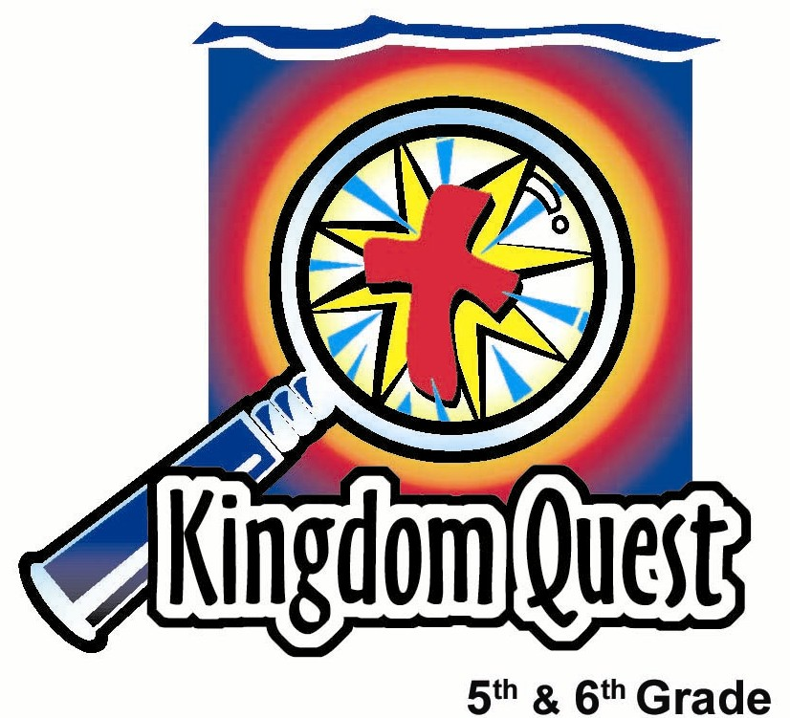
Date: _________________________
Series: A-MAZE-IN Life (Jun-Aug)
Year 2, Lesson 9
Attitudes…
What Will You Choose?

Take Home Point: *Let God guide you into a faith-filled attitude.
*Repeat this phrase throughout the lesson.

Bible Event: Exodus 14 & 16; Numbers 13:27-14:3, 21:4-9; Acts16:16-40
Key Verses: Philippians 4:13, “I can do all things through Christ, because He gives me strength.”

We will help kids know:
- Attitudes are one’s thoughts that shape one’s behaviors.
- When we choose a complaining attitude, we not only displease God, but we limit what we can do.
- When we let God guide us so that we have a faith-filled attitude, we see God working in wonderful ways through any circumstances.

We will help kids feel:
- Convicted of times that they have complained.
- Excited about God doing wonderful things through them as they have faith to trust Him to work.

We will help kids do:
- Identify areas we call “Sour Power,” in which complaining attitudes affect our lives while kids eat sour candy.
- Practice thinking faith-filled attitudes as they apply to students’ typical areas of complaint.

THIS LESSON’S ROADMAP

DESTINATION | PAGE # | DISCOVERIES ON YOUR JOURNEY | SUPPLIES NEEDED
Small Group Warm-Up   | 3 | Students will be manipulated into complaining about not getting the same snack as other students, demonstrating a sour attitude. | - sour mango strips and one a larger piece of mango  - plastic bag to hold the snacks
Large Group   | 4  8  9  13  15 | Overview  Introduction: The Keeper of the Clues explains that the Maze Master (God) helps us through the “A-MAZE-IN” adventure of life as we discover clues to help us have a faith-filled attitude instead of a complaint-filled attitude.  Attitude Maze  Sour Power vs. Victory Vision:  Two winding pieces of yarn laid out on the floor in opposite directions lead students down a path of whining or faith.  Video Clip: Visual Bible: Acts 16:16-36 – Paul demonstrates a faith-filled attitude after his poor treatment.  Appendices | - two sections of yarn 15 feet each  - four scenarios (Appendix A) printed on the same color of cardstock or construction paper  - four Bible verses (Appendix B) printed on a different color cardstock or construction paper  - video—Visual Bible: Acts 16:16-36 by Visual Bible International, 1997  - props  - rubber snakes  - funnel  - hand-held weight  - cross
Small Group Application   | 5 | Students will discuss how they can look to the cross for help as God’s people looked to the bronze serpent on a pole for healing.  Memory Verse Learning:  “Traffic Lights”  John 15:12 will be repeated for lesson 8 and 9 to motivate the children to have right attitude and be pleasing to God. | - none  - no supplies needed
Small Group Warm-Up: 15 minutes
Purpose: Get pointed in the right direction! Build relationships and help guests feel at ease. Do the learning readiness activity that will point your group in the right direction for the lesson.

As kids gather: Listen to memory verses from last week and give coupons for memory verses, remembering to bring your Bible, and bringing a guest.

Supplies needed: sour mango strips and one a larger piece of mango; plastic bags to hold the snack

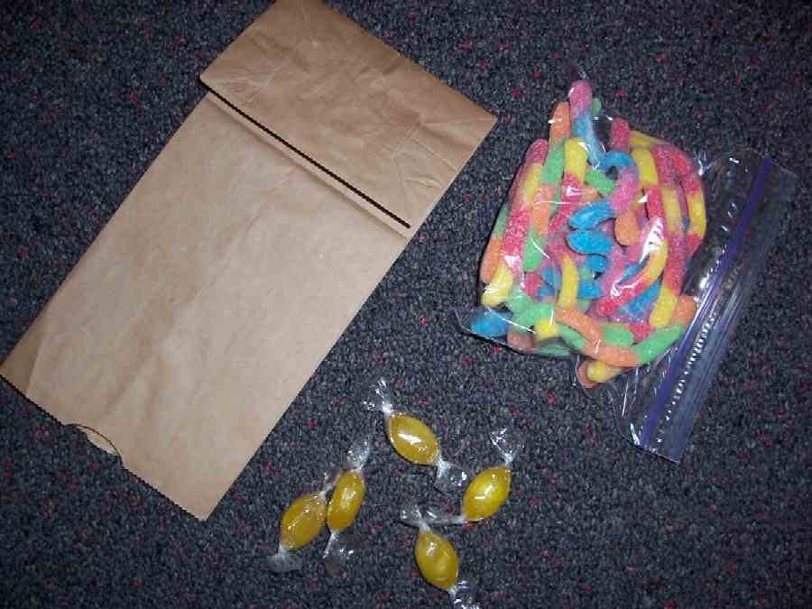

Beforehand, count the number of students in your group and get out enough sour mango strips for everyone except one student. Make this appear that this is all the mango you have. Place the mango on a piece of paper in the middle of the group.

Help yourself to one of the sour mango. Today we are going to talk about sour attitudes. What do you think a sour attitude looks like?

As you gather ideas from the kids, note that one child will come up without a sour mango and perhaps complaining will start, illustrating a sour attitude. Even if it does not, continue to discuss what it means to “have a sour attitude.” As you are discussing the missing sour mango, reach into your snack bag and pull out a larger piece of mango. Then give it to the person who didn’t get a mango. Listen for other students to complain that it isn’t fair and share their desire for the larger piece.

Note how easy it is to whine or even complain when something doesn’t go our way. As the kids enjoy their snack, ask the following question:

What would your parents say that you complain about the most? Would you agree? Why or why not?

Before going into large group, prepare students with the following:

We can choose our attitudes. Our attitudes can be filled with complaints or they can be filled with faith. Attitudes are very important because they influence what we do. Attitudes are determined by the kinds of thoughts we allow in our minds. So today, we want to let God guide us into faith-filled attitudes. We will find examples in the Bible of God’s people who chose complaining attitudes and had serious consequences. As a matter of fact, they were bitten by snakes and many of them died.

Additionally, we will hear of people who had such great attitudes that they were happy even when they were beaten and in prison.

Will you choose to have a complaint–filled attitude or a faith-filled attitude? *Let God guide you into a faith-filled attitude.

Large Group: 20-30 minutes
Purpose: Help kids observe what the Bible says. Present the Bible event in creative fashion. Help kids begin to interpret what it means.

Overview

Introduction: The Keeper of the Clues explains that the Maze Master (God) helps us through the A-MAZE-IN adventure of life as we discover clues to help us have a faith-filled attitude instead of a complaint-filled attitude.

Attitude Maze: Sour Power vs. Victory Vision: Two winding pieces of yarn laid out on the floor in opposite directions lead students down a path of whining or faith.

Video Clip: Visual Bible: Acts 16:16-36 by Visual Bible International, 1997. Paul demonstrates a faith-filled attitude after his poor treatment.

Small Group Application: 20-25 minutes
Purpose: Help kids map out the meaning of the Bible event in their lives. Use the questions to stimulate discussion, but don't feel tied to them. Allow the Holy Spirit to guide you. Include personal examples from your own faith journey. The example of Christ at work in your life will leave lasting impressions of how Christ can work in the children's lives.

Use your Bibles! Children need to learn how to look up references and follow along when scripture is read aloud. Allow for quality time of prayer at the close of the lesson.

Observation Questions: What happened?
Review some the complaints of the Israelites against God and Moses as presented in large group. For reference see: Exodus 14:11-12, 16:2,12; Numbers 13:27-14:3, 21:4-9. (Caught between the Red Sea and pursuing Egyptians, no water in the desert, then only bitter water, no food, then wanting meat for food, afraid to enter the Promised Land, more complaining about food.)

What were some of the consequences of the Israelite’s complaints against God and Moses?

Read Numbers 21:7-9.
What cure did God give for the consequence of the Israelite’s complaining? (God had Moses make a bronze snake and put it on a pole. Anyone who was bitten could look at it and live.)

Interpretation Questions: What does this mean?
Read John 3:14-15.
Instead of looking around for things to complain about, we need to look up and see something that will heal us of our complaining attitudes. What do we need to look at to have victory? This isn’t a bronze serpent on a pole, what it is? (The cross of Jesus.)

Read Acts 16:22-25.
What hurtful things happened to Paul that may have been good reasons for him to complain?

Why do you think Paul was praying and singing hymns instead of complaining? What do you think he was happy about?

Application Questions: What does this mean to me?
Let me tell you a story about a fifth grader named Jeremiah. He loved to go fishing with his dad. It was his absolutely most favorite thing to do. But he didn’t have a chance to go very often. They only went twice each year for vacation.

Jeremiah and his dad stayed at a cabin for the weekend. Jeremiah looked forward to it for months ahead of time and dreamed of fishing all day long. But this time, when they arrived at the lake cabin, it was raining. Jeremiah hoped and prayed that the rain would go away that morning so he and his father could go out and fish. Instead, it rained all morning.

“Stupid rain,” Jeremiah muttered to himself. “Why does it have to rain today of all days!”

He sulked around the cabin all afternoon and complained not only about the weather, but also about the “stupid cabin,” and the “stupid food,” and the “whole stupid weekend.” But still it rained all afternoon.

That evening, just before sunset, the rain cleared up and there was just enough time to get onto the lake for the last 30 minutes of fishing. Because of the rain and all the new food that washed into the lake, the fish were hungrily biting. In 30 minutes, Jeremiah caught his complete legal limit and some of the fish were the biggest he had ever caught! It was the most fun he’d ever had fishing.

Later, Jeremiah and his dad went back to the cabin and cleaned the fish, getting ready for a midnight fish fry. It was one of the most fun times he could remember with his father. When they sat down for their late night dinner, Jeremiah prayed this, “About complaining today, God, I’m sorry. I guess I just couldn’t see far enough ahead. Thank you for taking care of everything. In Jesus’ name. Amen.”

Sometimes we don’t see far enough ahead and are quick to complain about the bad things, instead of trusting God and letting Him work them out for our good.

What are some things that are easy to complain about? Instead of complaining, think of ways that God could use those things to advance His kingdom or help others.

Think of one thing you complain about the most. Now, think of a way that you could change that complaint into an attitude that shows you have faith in God’s plan for working out everything in a way that is good for you.

It may seem hard at first but remember our key verse Philippians 4:13, “I can do all things through Christ, because He gives me strength.”

It will become easier over time as you choose to have a faith-filled attitude through prayer and thanksgiving for what God has given, instead of complaining. Remember to *let God guide you into a faith-filled attitude.

Memory Verse Learning: 5 minutes
Purpose: Help kids to memorize and keep scriptures at heart. Using creative ways to help kids enjoy learning the key verse and in small group setting.

Supplies needed: none

Memory Verse: John 15:12 ~ “This is my command: Love each other as I have loved you.” (NCV)

MV Presentation: “Traffic Lights”
All the children run around the room pretending to be vehicles. When you shout out, ‘Red Light!’ they all have to stop and keep absolutely still. The person who moves will be out. Before the game begins, have all the children recite the memory verse together several times. Then you call ‘Green Light!’ and they can start running around the room. When you say ‘Orange Light!’ they have to slow right down to a walking pace. Play as time permits. Before moving on to the next activity, have all the children recite the memory verse again.

Prayer Time:
Thank God for sending Jesus to die on the cross to heal us. Ask that the Holy Spirit make our hearts thankful in all circumstances. Ask that all would become like Paul who endured prison and hardship with joy and praise, trusting that God would work things out. Thank God that He gives us strength to do all things through Christ.
Large Group Presentation

A-MAZE-IN Life…What Will You Choose?
Attitudes

Supplies needed:
- Two sections of yarn, 15 feet each
- Four scenarios (Appendix A) printed on the same color of cardstock or construction paper
- Four Bible verses (Appendix B) printed on a different color cardstock or construction paper
- Video -- Visual Bible: Acts
- Props
  - rubber Snakes
  - Funnel
  - Hand-Held Barbell
  - Cross

Set up string and construction paper stations on the floor as shown in Appendix C. The props are to be set up next to their corresponding paper on the victory vision maze stations.

Station 1: Rubber snakes – Philippians 2:14 – “Do everything without complaining or arguing.”
Station 2: Funnel – Philippians 4:8 – “Brothers and sisters, think about the things that are good and worthy of praise. Think about the things that are true and honorable and right and pure and beautiful and respected.”
Station 3: Hand-held weight – Philippians 4:13 – “I can do all things through Christ, because He gives me strength.”
Station 4: Cross – Romans 8:31-32 –“So what should we say about this? If God is with us, no one can defeat us. He did not spare His own Son but gave Him for us all. So with Jesus, God will surely give us all things.”

Keeper of the Clues:
Welcome, kids, to today’s maze and all the choices you face. I’m the Keeper of the Clues who will guide your choices through the maze of life. Today we are talking about choices you make when you put thoughts in your head. These thoughts and feelings combined become ways you respond to certain things around you. You can choose between two different attitudes. You can have a complaint-filled attitude or you can have a faith-filled attitude. God wants you to have a faith-filled attitude and, in the A-MAZE-IN Life, He is the maze master who can give you a faith-filled attitude.

Attitude Maze
Sour Power vs. Victory Vision

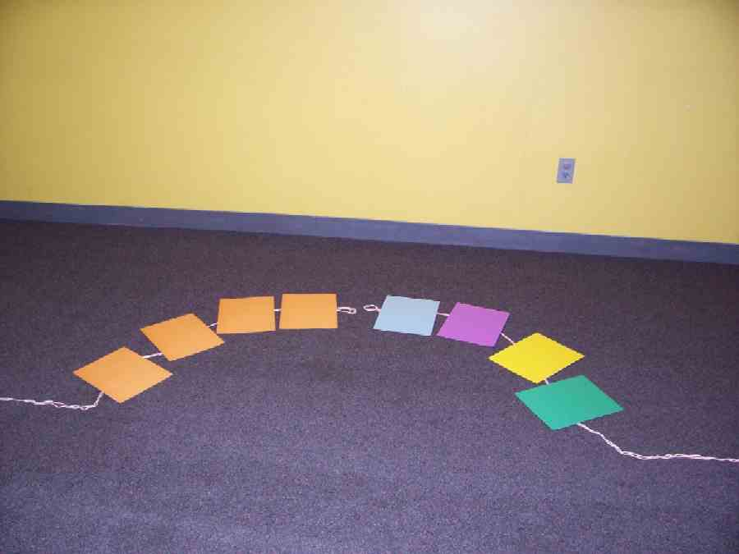

Sour Power Trail

The first part of our maze requires five contestants. But these need to be kids who are very good at acting out a whine or complaint. So, if you have the spiritual gift of complaining (ha, ha) or are ready to do a great job faking it, raise your hand to be chosen now.

Gather the five kids in the front. The following describes how the contest works.

You can see that the maze begins here in the center point where I am standing. The path progresses through four stopping points or stations. Each station provides us with a contest between two people to see how you would respond to certain scenarios with the very best whine or complaint you can make. You will have about five seconds to think of your answer and then give it, using your best whiny voice or complaining attitude. Since I am a parent, I will choose the most professional whiner from the group. This whiner winner will progress to the next round to have a contest with the next person down the sour power trail.

Let’s have four of you each stand on a colored paper stop and the challenger stands right next to the person on station number one. Pick up the colored paper and read what it says on the back.

These questions are listed below and are included in the appendices.
- You can’t spend the night with your friend because you seem too tired lately and need a good night’s rest.
- Turn off the TV. It’s time to do your homework.
- You need to clean up your room before you can play.
- I’m sorry, but I won’t allow you to go to that movie with your friends. It is PG-13 and parts of it are not appropriate for you.

The winner of each whine station moves to challenge the person at the next station. The final whiner winner receives a sour mango. Ask the group who else wants a sour mango and if they can give a huge whine to get it. When they do this, refuse to give it to them. Then have the contestants go back to their seats.

We may think it is funny and commonplace to complain and whine, but in the Bible, it was a very serious offense to God. As a matter of fact, I’m going to read the following verse about how God’s people complained against Him.

Exodus 14 tells the event of God delivering His children from slavery in Egypt. They left the land, but when they got to the Red Sea, they saw that the Egyptians were coming after them. Terrified, the Israelites cried out to the Lord.

Listen to these verses of complaint against Moses. Use your best whiny voice to impersonate the following paraphrased quotes from the Israelites.

They said to Moses, "What have you done to us? Why did you bring us out of Egypt to die in the desert? There were plenty of graves for us in Egypt!” (Exodus 14:11-12)

Then God provided a miracle. He destroyed the Egyptians and let the Israelites cross the Red Sea. Soon after that, the only water they had was bitter. Can you hear them now? “This water tastes terrible, we can’t even drink it.” But God provided a miracle. He made it sweet.

Not long after that, they had another complaint. “We’re so hungry. We have nothing to eat.” (Exodus 16:2) God provided another miracle, manna. After that, they needed water. “We’re so thirsty. I want a drink.” God miraculously provided them with water. Were they thankful then? No way! they were still complaining. “We might have water, we might have bread, but we are sick and tired of the same old food. What about a cheeseburger… or some kind of meat.” (Exodus 16:12) God provided them quail to eat.

After all that God provided, do you think they learned not to complain but to trust Him? No. When they reached the Promised Land, this is what they said. “Did you see the giants that live in that land? We’re all going to die. They’ll squash us like bugs. We want to go back to Egypt.” (Numbers 13:27-14:3)

As a result of this complaining and lack of faith, every adult had to wander through the desert for another 40 years until that entire generation of people had died and their children had come of age.

Do you think they ever stopped their complaining? No, the people became impatient and criticized Moses. They said, “Why did you make us leave Egypt? We’re going to die in the desert. We don’t have any REAL food, just this awful food. I want to go back to Egypt.” (Numbers 21:5) So the Lord had enough of their complaining and He sent poisonous snakes among the people. They bit the people and many of the Israelites died.

However, God gave them a cure for the poisonous snakebites. This is what it says in Numbers 21:8-9,“ The LORD said to Moses, "Make a bronze snake, and put it on a pole. When anyone who is bitten looks at it, that person will live." So Moses made a bronze snake and put it on a pole. People looked at the bronze snake after they were bitten, and they lived.”

Even today in doctor’s offices you will see the symbol of a serpent on a pole as a symbol of healing. As Christians, we see something else lifted up as a symbol of our spiritual healing… and that is the cross.

Victory Vision Trail
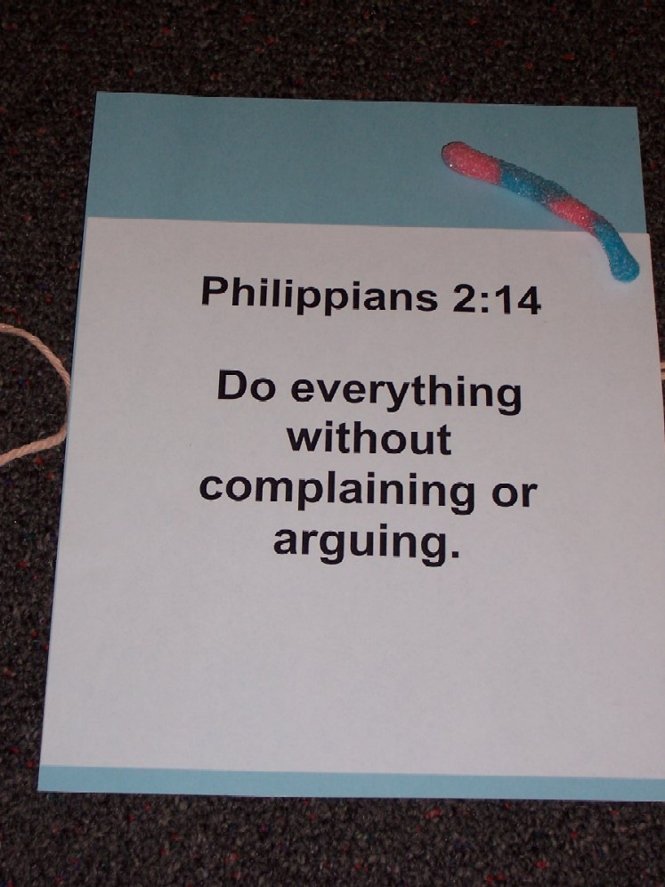
Over here, we have the Victory Vision Maze. This one is a little bit different. Let’s have four more contestants come up here and bring your Bibles. The rest of you follow along, using your own Bibles.

After choosing contestants, have each stand on a different sheet of construction paper and read the Bible verse underneath. Have each contestant try and guess what the prop with it symbolizes.

Station #1: Have student read the verse.

Philippians 2:14, “Do everything without complaining or arguing.”

Can you guess how this verse is related to a rubber snake? Accept any answer that might be correct, but point out the following:
Remember how the people of Israel looked up to see a bronze snake on a pole and they were healed and saved from death? We want to take that complaining attitude and throw it out just as we throw out this rubber snake away.

But we don’t have to look at a bronze serpent on a pole as God’s people did for healing; we look to the cross to find our help and healing. When we look to Jesus, that is when we begin to have a faith-filled attitude.

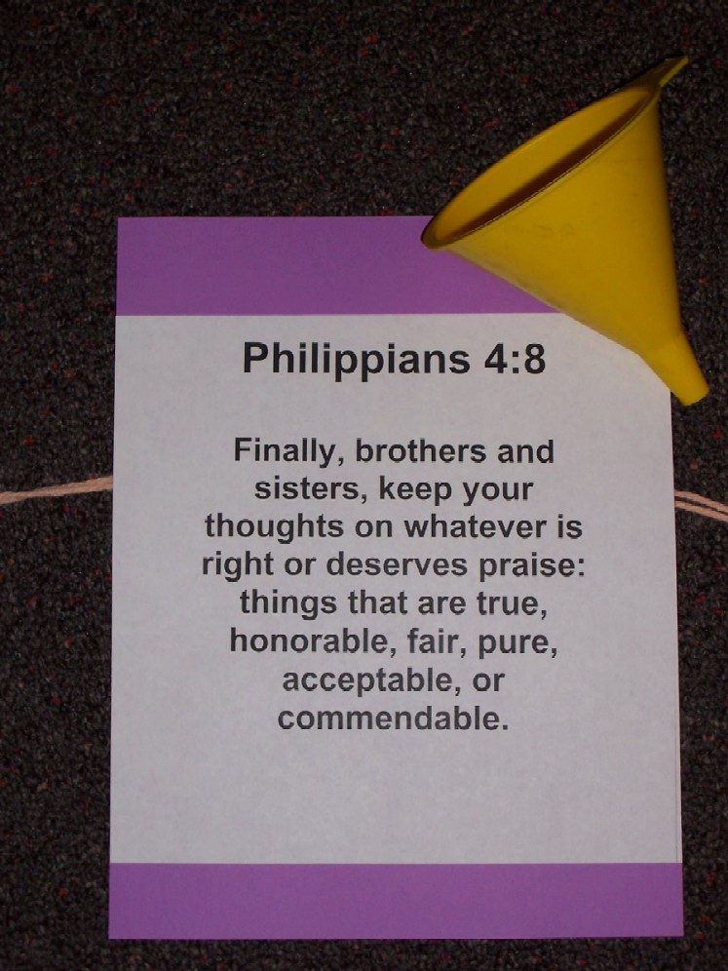
Another step in having a faith-filled attitude is to control the thoughts we allow to bounce around in our heads.

Station #2: Have the next student read this Bible verse.

Philippians 4:8, “Brothers and sisters, think about the things that are good and worthy of praise. Think about the things that are true and honorable and right and pure and beautiful and respected.”

Tip the person’s head to the side and point the funnel at their ear and pretend to grab positive thoughts out of the air and put them into the funnel.

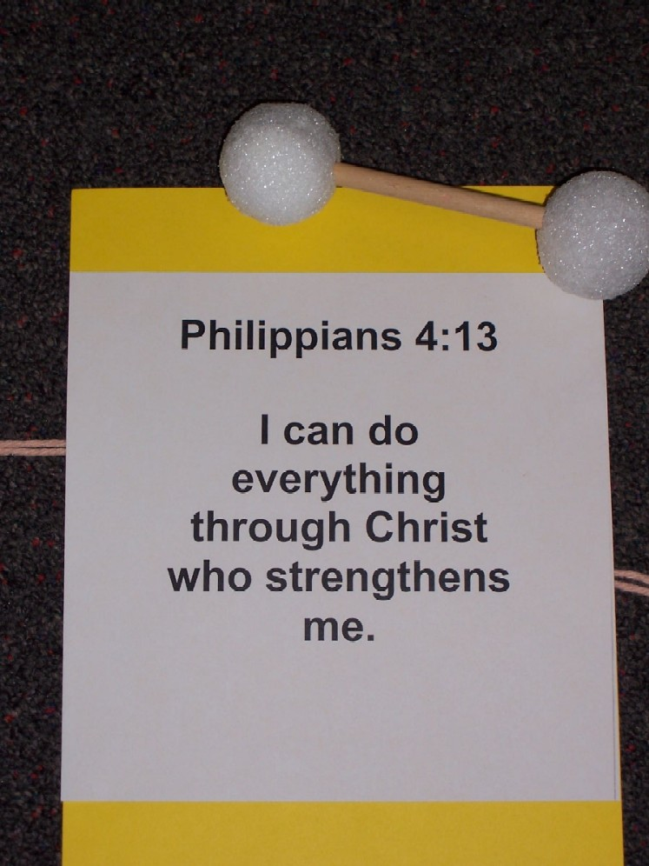
Paul reminds us that we can keep our minds on things that are right, deserving praise, true, honorable, fair, pure, acceptable, or commendable. We must only think about those things and not let ourselves think about any negative things.

Station #3: Have the next volunteer read this Bible verse.

Philippians 4:13,“I can do all things through Christ because He gives me strength.”

Show the hand-held barbell. How does this weight remind you of the verse you just read?

How does this show you how to have a faith-filled attitude?

In every circumstance, we can have confidence that God will use it for good. Then we don’t concentrate only on how the bad parts of it affect us.

Station #4: Have the final volunteer read this Bible verse.
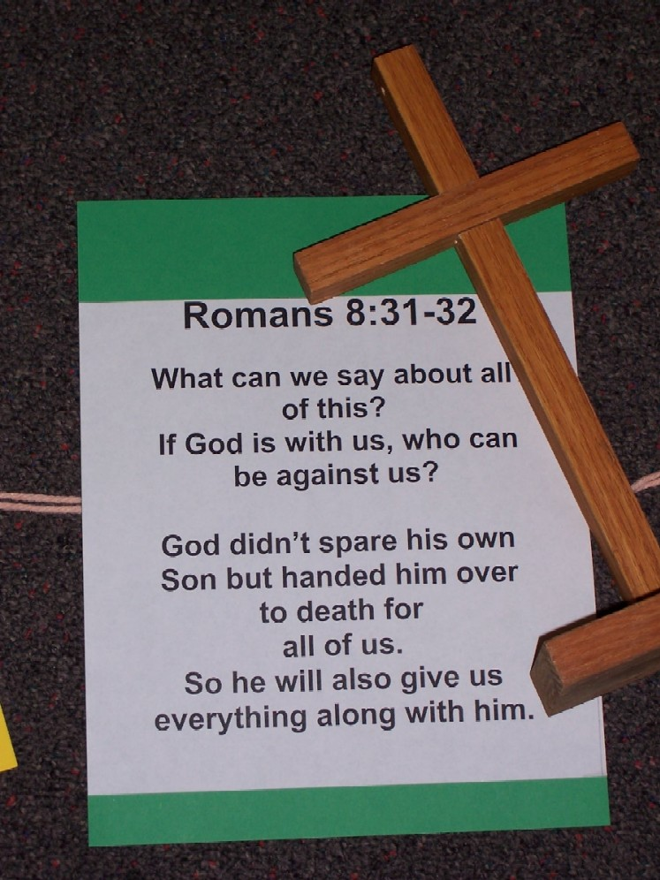
Romans 8:31-32, “So what should we say about this? If God is with us, no one can defeat us. He did not spare His own Son but gave Him for us all. So with Jesus, God will surely give us all things.”

Show the cross. What is the connection between the cross and this Bible verse? Discuss.

The cross is proof that if God gave us Jesus for the power of forgiveness and the power of Him living in our life, He will also take care of the details in our life.

Video Clip

In the following movie, you will see Paul, the writer of all the passages we just discussed, unjustly treated. He showed kindness by casting out a demon; but was then falsely arrested, beaten, mocked, and thrown in jail.

The main thing that I want you to watch for in the video clip is this: What attitude did Paul display in jail after all those horrible things were done to him? Surely he had the right to complain about his unfair treatment, but if he wasn’t complaining, what was he doing? Watch and find out.

Show video clip of Visual Bible: Acts 16:16-40 by Visual Bible International, 1997 with Paul in jail worshipping and praising God. Begin at Acts 16:16 and end at Acts 16:40.

What was Paul doing while in jail? (He was worshipping and singing and praising God.) Why? (Because he had a faith-filled attitude and could see that God would use that situation for good.)

Prayer:

Heavenly Father, show us areas where we complain. We don’t want to be on the path of sour power, but instead to have victory vision. In everything we want to see Your victory, because we trust that You will use us to advance Your kingdom. So, please help us learn this as we discuss and learn more in our small groups. In Jesus’ name. Amen.

Lesson 9
Small Group Warm-Up
- sour mango strips
- plastic bag to hold the snacks

Large Group
- two sections of yarn 15 feet each
- four scenarios (Appendix A) printed on the same color of cardstock or construction paper
- four Bible verses (Appendix B) printed on a different color cardstock or construction paper
- video—Visual Bible: Acts 16:16-36 by Visual Bible International, 1997
- props
  - rubber snakes
  - funnel
  - hand-held weight
  - cross

Small Group Application
- none

Memory Verse Learning
- no supplies needed
HEADS UP!

In this series, lesson 11 uses empty bottle containers with caps. The smaller the better, though up to 16 oz size will be acceptable. Gather these beforehand by sending home this note at least eight weeks ahead of time:

SUPPLIES NEEDED FOR LESSON 11

EMPTY PLASTIC DRINKING BOTTLES
WITH CAPS

Empty plastic drinking bottles with caps are needed for a craft project in Lesson 11. Please bring your clean empties with the paper peeled off and bottle caps attached.

Drop them off at:

THANK YOU!!

Appendix A-1

“You can’t spend the night with your friend
because you seem too tired lately
and need a
good night’s rest.”

Appendix A-2

“Turn off
the TV,
it’s time to do
your homework!”
Appendix A-3

“You need to
clean up
your room
before you
can play!”

Appendix A-4

“I’m sorry, but I won’t allow you to go to that movie with your friends. It is PG-13 and parts of it are not appropriate for you.”
Appendix B-1

Philippians 2:14

Do everything without
complaining or arguing.
Appendix B-2

Philippians 4:8

Finally, brothers and sisters, keep your thoughts on whatever is right or deserves praise: things that are true, honorable, fair, pure, acceptable, or commendable.

Appendix B-3

Philippians 4:13

I can do
all things
through Christ
because He gives me strength.

Appendix B-4

Romans 8:31-32

So what should we say about this?
If God is for us, no one can defeat us.

He did not spare His own Son but give Him for us all.
So with Jesus God will surely give us all things.
Yarn
Sour Power Maze
Victory Vision Maze
Props:
- Gummy Worm
- Funnel
- Barbell
- Cross
Appendix C
Scenario under each paper
Bible verse under each paper
1
2

3
4

