
Date: _________________
Series: Character Shapers
(Apr-May) Year 2, Lesson 52

Showing Service

Take Home Point: *Don’t miss your chance to serve others for Jesus’ sake. *Repeat this phrase throughout the lesson.

Bible Event: John 13:1-17; Colossians 3:23-24
Key Verse: Colossians 3:23, “In all the work you are doing, work the best you can. Work as if you were doing it for the Lord, not for people.” (NCV)

We will help kids know:
- The Bible event of Jesus washing the disciples’ feet and commissioning them to servanthood roles.
- Serving others because Jesus first served us is a privilege not something God forces us to do.
- We serve others as if we are serving Jesus.

We will help kids feel:
- Energized as they recall episodes of having served others.
- Help them feel humbled as they receive a shoe cleaning from their shepherd.

We will help kids do:
- Identify acts of service they have offered to others and how they felt after doing this.
- Put hands on their group sculpture reminding them of their act of service to others.
- Brainstorm and pray about opportunities to serve others during the week.

THIS LESSON’S ROADMAP

DESTINATION | PAGE # | DISCOVERIES ON YOUR JOURNEY | SUPPLIES NEEDED
  Small Group Warm-Up | 3 | Students will fill latex gloves with tissue paper as they discuss serving others. | - two clear disposable latex gloves (Do not use dishwashing or chore gloves as they will not inflate.)  - colored tissue paper cut into 4 X 4 inch squares—several for each student  - washable markers
Large Group   | 4  7 | Overview  Volunteers inflate latex gloves in a unique way to help demonstrate today’s character shaper.  The Gospel of John video, produced by Visual Bible International, 2003. Show washing the disciples’ feet by Jesus in John 13:1-17.  Pablo Pistachio personally illustrates serving as he shines the shoes of someone in the audience. | - two latex gloves  - video, The Gospel of John produced by Visual Bible international, 2003—show video cued up to John 13:1-17—order from www.visualbible.com  - shoe polish and shining rag  - two stick pins
Small Group Application   | 4 | While discussing missed opportunites to serve one another, the shepherd cleans the shoes of the group members.  Memory Verse Learning:  “Puzzle Verses”  Romans 8:28 will be repeated for lessons 51- 54 to help the children be released from the shame of failures and have confidence in God’s love and mercy. | - rags and water for washing the shoes  - two stick pins  - plastic gloves from small group  - head sculpture from last week  - print the verse on 2 art card paper with puzzle design (appendix)

Small Group Warm-Up: 15 minutes
Purpose: Get pointed in the right direction! Build relationships and help guests feel at ease. Do the learning readiness activity that will point your group in the right direction for the lesson.

Supplies: colorful tissue paper cut into 4 X 4 inch squares (several pieces for each kid), washable markers, two clear, disposable latex gloves

Special note for this Sunday. Have your supplies located in a different part of the room and create opportunities for children to serve. For example: forget your marker and ask if someone could get it for you, drop the gloves or tissue paper and see if someone will help pick them up or knock something off the table to see if anyone responds. Use your imagination as to how you can create other opportunities for the kids to see your need and serve (or neglect to serve).

Today we will talk about times we have helped others in the past. Let’s begin by thinking about this last week.

What is something you did last week to help another person?

Pass out tissue paper (possibly dropping them on the floor).

I would like you to write that person’s name or a couple of words to describe what happened on one of these pieces of tissue paper.

Pretend you can’t find the markers.

Where did I put those markers? Has anyone seen them?

See if anyone will help you locate the markers, then pass them out.

You may fill out as many pieces of tissue paper as you would like. I am going to pass this glove around, and I would like you to wad up your piece of paper and put them into the fingers of these gloves.

Next, ask:

What did you do last year to help someone that it really made you feel good? Again, write this down on the tissue paper sheets, wad them up and place them in the gloves.

Next, recall a time you noticed an opportunity to help, but it seemed as if no one else noticed.

Have them write this on a tissue paper and again place in the glove.

How hard was it to notice that I needed help this morning?

We are going to continue to talk about shaping our character. Today we want to remember, *Don’t miss your chance to serve others for Jesus’ sake.

Large Group Overview: 20-30 minutes
Purpose: Help kids observe what the Bible says. Present the Bible event in creative fashion. Help kids begin to interpret what it means.

Volunteers inflate latex gloves in a unique way to help demonstrate today’s character shaper.

Show The Gospel of John video, produced by Visual Bible International, 2003, John 13:1-17. Order from www.visualbible.com.

Pablo Pistachio personally illustrates serving as he shines the shoes of someone in the audience.

Small Group Application: 20-25 minutes
Purpose: Help kids map out the meaning of the Bible event in their lives. Use the questions to stimulate discussion but don't feel tied to them. Allow the Holy Spirit to guide you. Include personal examples from your own faith journey. The example of Christ at work in your life will leave lasting impressions of how Christ can work in the children's lives.

Use your Bibles! Children need to learn how to look up references and follow along when scripture is read aloud. Allow for quality time of prayer at the close of the lesson.

Observation Questions: What happened?/ Interpretation Questions: What does this mean?

Have kids refer to John 13:1-17 in their Bibles.

How does Jesus show humility in John 13:4-5? (He took off His outer clothing and tied a towel around His waist like a servant would. Then He washed the disciples’ feet.)
Going deeper:
If this act of service is like Jesus setting aside His divinity or God power and coming to earth as a human, what could be the symbolism of verse 12, “When He had finished washing their feet, He put on his clothes and sat down again.?” (After Jesus died and rose for us as God sent Him to do, He received His heavenly body and returned to His place in heaven again.)

Why do you think Peter did not want Jesus to wash his feet? (John 13:8. Because Jesus was his master, not his servant.)

Why did Jesus tell Peter He must wash his feet? (John 13:8. In order for Peter to belong to Jesus, he had to let Jesus serve him.)

What must we do in order to belong to Jesus? (We must accept that He served us when He died on the cross for our sins.)

Read together John 13:12-17.

What did Jesus command His disciples to do? Why? (John 13:14-15. He commands His disciples to wash others’ feet because He is our Lord and teacher. He set the example He wants us to follow.)

Application Questions: What does this mean to me?

In our Warm-Up time, we talked about ways we have served others and opportunities of service that were missed.

Today’s key verse from Colossians 3:23 says, “In all the work you are doing, work the best you can. Work as if you were doing it for the Lord, not for people.”

How does remembering this verse help you become a better servant? (We can remember that we are really serving Jesus by our actions.)

Application Activity
Supplies: gloves from Warm-Up activity, rag to shine shoes with, water to wash the shoes, head sculpture, two stick pins

What serving opportunities have you sometimes missed? As we discuss this, I will clean the shoes of each one of you, if you will allow me to.

While doing this, let’s also brainstorm ways we can serve others this coming week.

Realize it can be a distraction at times to discuss while doing an activity.
This discussion and activity should fit together.

Expect the kids to feel uncomfortable, but this is similar to what the disciples felt. Help them remember that someone greater than them, Jesus Himself, has served them, so they can serve others.

Pin the gloves to the group’s head sculpture from last week.

Remember our take home point, *Don’t miss your chance to serve others for Jesus’ sake.

Memory Verse Learning: 5 minutes
Purpose: Help kids to memorize and keep scriptures at heart. Using creative ways to help kids enjoy learning the key verse and in small group setting.

Supplies needed: 2 art-card paper with the puzzle designs preprinted with verse

Memory Verse: Romans 8:28 ~ “We know that in everything God works for the good of those who love Him. They are the people He called, because that was His plan.” (NCV)

MV Presentation: “Puzzle Verse”
Before class, cut the puzzle pieces preprinted with the memory verse and place them in separate boxes. Divide the children into two teams. Have all the children recite the memory verse together. Give each team a set of the puzzle pieces. At your signal, each team is to assemble their puzzles. The first team who put the puzzle together the fastest wins.

Closing Prayer:

Thank God that He sent Jesus who became the ultimate servant for us when He died on the cross in our place. Thank Him for the example of Jesus washing His disciples’ feet. Pray that the Holy Spirit would help all to see opportunities to serve others and would do so remembering they are doing it for the Lord.

Safety and Security: Safety and security procedures are important for each church to carefully define and implement according to their unique needs. The security, safety, illness and accident procedures described in this curriculum are provided for example purposes only and may not be appropriate, applicable or adequate for every situation. Each church is responsible for determining whether any security, safety, illness and accident procedures contained in the curriculum are appropriate, applicable or adequate for its unique situation. The activities described in this curriculum require adult supervision and may not be suitable for each child and each situation. Each church is responsible for ensuring that adequate adult supervision is provided for all activities and for determining whether an activity is appropriate for each child and each situation. Kids Kount Publishing disclaims all liability for the implementation of any procedures or the performance of any activities described in this curriculum.
Large Group Presentation: 20-30 minutes

Character Shapers: Showing Service
Introduction to the series: “Character Shapers”

We face challenges in life that God can use to shape our character if we let him. These are called character shapers. These challenges might seem negative, such as encountering troubles or facing personal failures. Or they may be positive, such as encountering opportunities to show service of faithfulness. All of these can be character shapers if we allow God to shape us through them.

Pablo Pistachio will present this series. This artistic character might be costumed with an artist’s smock, palette and beret. A prop used from week to week is the figure of a sculpted head on a table. This will be a significant visual prop as different features are applied in conjunction with weekly discussions about how God shapes our character. The features added will create abstract art, but will give clear visual illustration to the concept of the day.

Create a head for this series that will act as the focal point for “shaping one’s character.” Form a paper maché head with a filled balloon, strips of paper and paste. Create eyes, nose, ears, eyebrows, and lips from magazine cutouts or with markers. This needs to be prepared ahead of time and dried. Other options that could be used are a Styrofoam head and straight stickpins, or a mannequin head.

Supplies: two latex gloves, shoe polish, cloth for polishing, stick pins or tacks, Gospel of John video, produced by Visual Bible International 2003— order from www.visualbible.com

Introduction

Hello, everyone. As you can remember from last week, I am the famous artist, Pablo Pistachio. My latest creation is Alfred. Alfred reminds us how God is shaping our character. Last week we talked about how God shapes our character through the failures we face.

This week we will discuss another way God shapes our character. This is for you to guess.

Inflated Glove on the Head Sculpture

I will give you one hint and it has to do with these gloves.

Show the latex gloves.

These will remind us of something very important.

Let’s experiment with how these gloves might be used in a sculpture. I need two volunteers from the audience who would be willing to have one of these gloves stretched over your face and inflated with your nose. It may sound silly, but this is a very serious sculpture.

Choose two volunteers. Stretch the gloves over their heads all the way to their upper lip. Hold the glove positioned on the head by placing hands on cheeks. The contestants will inhale through their mouths and exhale through their noses to inflate the gloves on top of their heads.

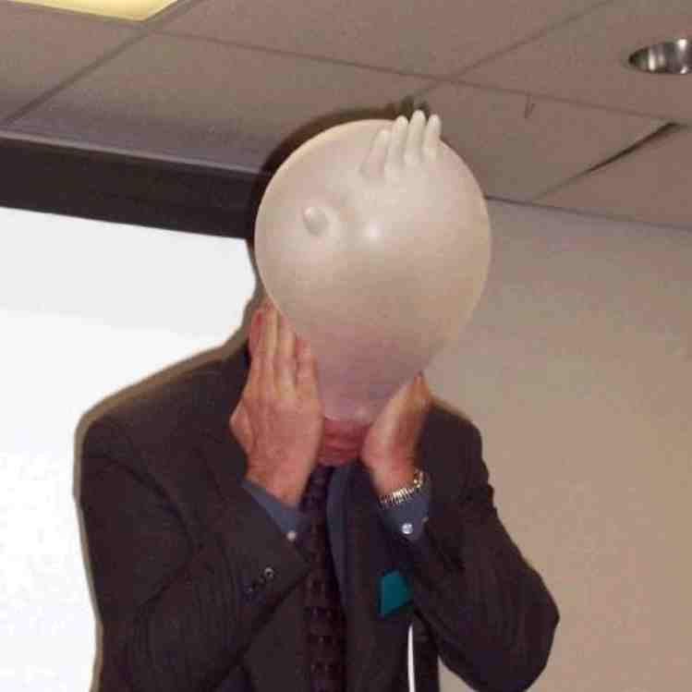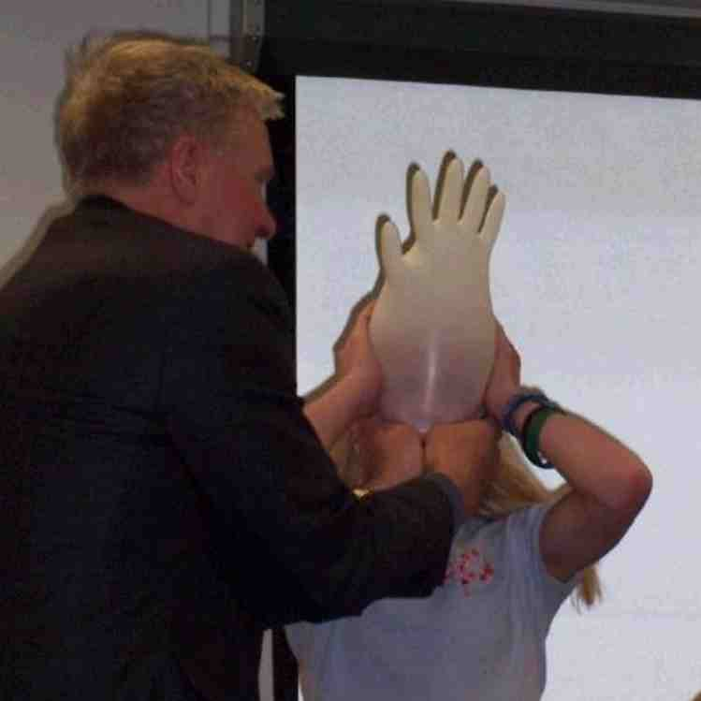

When I say go, you will have 30 seconds to inflate your glove by inhaling through your mouth and exhaling through your nose. Ready, set, go.

Stop them after 30 seconds or when the glove is inflated.

Look at these incredible art projects. But, every masterpiece needs a name. Who can help me name these priceless pieces of art?

Take suggestions from the audience. Have volunteers remove the gloves and sit down.

What’s the Point?

In my studio, there is a special point that is portrayed through every art project. More than just the pleasing look to the eye, these hands remind us of a very important way God wants to shape our character.

What do these gloves remind you that we are to do? If you think you have an answer, hang onto that thought. We will discuss this more after this video clip. This Bible event from John 13:1-17 should give you a clear idea on what these gloves should remind us to do.
Video

Show the Gospel of John video produced by Visual Bible International, 2003, of Jesus washing his disciples’ feet (John 13:1-17). Order from www.visualbible.com.

Now, who can answer the question of what these gloves remind us to do? We are to serve others. Jesus says it this way. “If I have washed your feet, you should wash other’s feet. If I have served you, you are to serve others.”

Example of Service

We have opportunities to do this all the time! Sometimes though, we miss it. As a matter of fact, I see a chance right now.

Put on the plastic gloves that were used earlier. Invite up a student who has shoes the same color as the polish you have and polish his/her shoes. Allow your gloves to get polish on them. Interview the student as you are polishing his/her shoes:

Why would a famous artist as myself be willing to polish your shoes? (Take any answer.)

If Jesus was here, do you think He would shine your shoes? (Yes.) He would.

What has Jesus done for you that is even greater than shining your shoes or washing the disciples’ feet? He gave His life for you. He died on the cross and rose again so you could be friends with Him forever.

If Jesus would do that for you and for everyone else here, what does He ask us to do? He asks us to serve others so they know how much Jesus loves them.

Have the volunteer return to his/her seat.

Take off your gloves and pin them to Alfred, giving him hands.

Create Your Own Story

The Bible says that when we do this for others, it is as if we are doing it for Jesus. (Colossians 3:23) Let me give you an example of this.

Give your own personal testimony, if possible. Or use the following:

There is one thing in my house I do not like to do. That is to take out the garbage. My spouse asked if I would be responsible for this job every week. I love her very much, and I would do anything for her. But this is one job that I really do not like to do and sometimes refuse to do.

One day I read in the Bible Colossians 3:23-24. It says, “In all the work you are doing, work the best you can. Work as if you were doing it for the Lord, not for people. Remember that you will receive your reward from the Lord, which he promised to his people. You are serving the Lord Christ.”

This reminds me that I serve Jesus as I serve others, even if it’s taking out the garbage. Now, every time I take out the trash, I am thankful for the opportunity to serve Jesus. Jesus did more than just take out the trash; He took out the trash of all my sin and guilt.

Conclude with:

*Don’t miss your chance to serve others for Jesus’ sake.

Closing Prayer
Heavenly Father, thank You so much that You served us by giving us Your Son Jesus. Sometimes we take this for granted and we are sorry for that. Help us be thankful, and help us remember to serve others in Jesus’ name. This is just like serving You. Thank You that we do not have to do this because You are forcing us, but we are doing this simply as a way to show that we love You and want to obey You. In Jesus’ name. Amen.

Lesson 52
Small Group Warm-Up
- two clear disposable latex gloves (Do not use dishwashing or chore gloves as they will not inflate.)
- colored tissue paper cut into 4 X 4 inch squares—several for each student
- washable markers

Large Group
- two latex gloves
- video, The Gospel of John produced by Visual Bible international, 2003—show video cued up to John 13:1-17—order from www.visualbible.com
- shoe polish and shining rag
- two stick pins

Small Group Application
      - rags and water for washing the shoes
      - two stick pins
      - plastic gloves from small group
      - head sculpture from last week

Memory Verse Learning
- print the verse on 2 art card paper with puzzle design (page 12)


