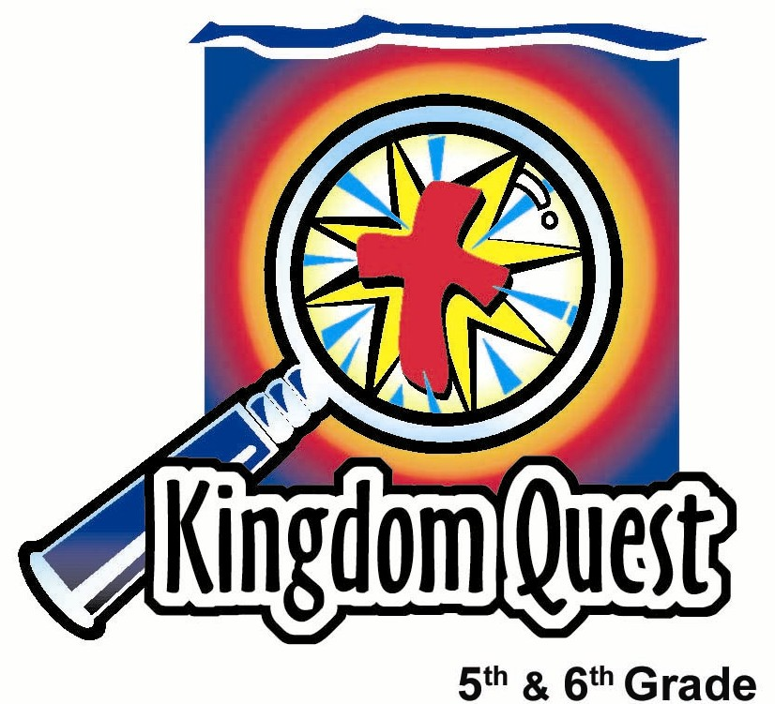
Date: _________________________
Series: Giving to God (Dec-Feb)
Year 2, Lesson 28

Winter Year 2, Lesson 28

Give to God
By Giving to Others

Take Home Point: *We give to God by giving to others.
*Repeat this phrase throughout the lesson.

Bible Event: Matthew 25:31-40
Key Verse: Matthew 25: 40b, “I tell you the truth, anything you did for even the least of My people here, you also did for Me.” (NCV)

We will help kids know:
- Christmas is a celebration of God’s gift to the world: His own Son took our sin on Himself.
- When they give to others, it’s just like giving to Jesus.
- It’s more blessed to give than to receive.

We will help kids feel:
- Blessed because they’ve been given so much.
- Motivated to give to others as a way of giving to Jesus.

We will help kids do:
- Eat popcorn as they name blessings God has given to them.
- Identify ways to give to God by giving to others.
THIS LESSON’S ROADMAP

DESTINATION | PAGE # | DISCOVERIES ON YOUR JOURNEY | SUPPLIES NEEDED
  Small Group Warm-Up | 3 | Students will eat a piece of popcorn for every gift from God they mention. Then they will give a piece of popcorn back for every gift they have given to God. | - sack of precooked popcorn  - one large popcorn bowl  - serviettes or coffee filters for every child
Large Group   | 4  6  7  8 | Overview  Introduction: General (Gen) R. Osity is a storefront holiday bell ringer for charity who encourages people to give.  Interactive Sketch: Kids act out a story of people with a giving spirit and those without it.  Wrap Up: Presenter demonstrates how we can act in a giving way toward each other with the use of gift nametags. | Costume:  - presenter is dressed as a storefront holiday bell ringer for charity  - Props:  - pot with lid hanging from a pole  - several gift tags in the pot that say: “To Jesus, From: ________.”  - a hand bell that rings  - bowl of popcorn  - six rulers or other splint-like objects  - duct tape or other heavy tape  - six arm-extension toy hand grabbers
Small Group Application   | 4  5 | Kids will discuss the scripture passage and write the names of those in need on gift nametags. They are challenged to give to these people and pray for them.  Memory Verse Learning:  “Give It Away”  Matthew 25:40 will be repeated for lessons 28-32 to help children to learn to give to others as a way of giving to God. | - gift nametags  - thin line markers  - several objects - large, small or any shape i.e. ping pong ball, purse, tennis ball, plastic cup etc
Series Overview

Giving to God

As the Christmas season comes upon us, pre-teen kids will ask the question: “What will I get for Christmas?” This series changes that question into: “What will I give for Christmas?” Kids will learn four important truths about giving. They will apply these truths to their lives and discover that “it is more blessed to give than to receive.” The very foundation of such giving is receiving what God has given to us. He gave us His best when He gave us His Son, Jesus. God fully demonstrated this truth: “It is more blessed to give than to receive.”

Week 1: Give to God – By Giving to Others.
Week 2: Give Gifts That Fit the Person.
Week 3: Give Gifts of Kindness and Encouragement.
Week 4: Give Gifts Every Day

Small Group Warm-Up: 15 minutes
Purpose: Get pointed in the right direction! Build relationships and help guests feel at ease. Do the learning readiness activity that will point your group in the right direction for the lesson.

As kids gather: Listen to memory verses from last week and give coupons for memory verses, remembering to bring your Bible, and bringing a guest.

Supplies: A sack of popcorn, one large bowl, serviettes or coffee filter for every student

Give each student a serviettes (or coffee filter bowl) and a handful of popcorn. Pour the rest of the popcorn into a large bowl and place in the center of the group.

We have just finished Thanksgiving and now we are getting ready for Christmas. It’s a good time to think of the gifts God has given us. So, for every time you tell about a gift God has given, you can take a piece of popcorn from the bowl and eat it. For example, I thank God for giving me the gift to be your Shepherd. (Or name something else you consider a gift from God.)

Be sure kids take turns and someone does not dominate the discussion. As kids share their gift lists, direct someone to mention Jesus as his/her Savior.

Now, let’s put one piece of popcorn back into the bowl for every gift that you have given back to God. For example: We give God worship and praise during church.

When they run out of ideas, suggest the following:

Did you know that when you give something to another person it’s just like giving something back to Jesus? For example, this week, for Jesus’ sake, I gave the gift of a kind word to … (name someone).

Today we discover that *we give to God by giving to others.

Large Group Overview: 20-30 minutes
Purpose: Help kids observe what the Bible says. Present the Bible event in creative fashion. Help kids begin to interpret what it means.

Introduction: General (Gen) R. Osity is a storefront holiday bell ringer for charity who encourages people to give.

Interactive Sketch: Kids act out a story of people with a giving spirit and those without it.

Wrap Up: With the use of gift nametags, the presenter demonstrates how we can act in a giving way toward each other.

Small Group Application: 20-25 minutes
Purpose: Help kids map out the meaning of the Bible event in their lives. Use the questions to stimulate discussion, but don't feel tied to them. Allow the Holy Spirit to guide you. Include personal examples from your own faith journey. The example of Christ at work in your life will leave lasting impressions of how Christ can work in the children's lives.

Use your Bibles! Children need to learn how to look up references and follow along when scripture is read aloud. Allow for quality time of prayer at the close of the lesson.

Observation Questions: What happened?
Have kids refer to Matthew 25:31-40 in their Bibles. Say:

Our key verse today is Matthew 25:40b, “I tell you the truth, anything you did for even the least of My people here, you also did for Me.”

In Matthew 25:35-36, who does Jesus say are those that seem unimportant? (The hungry and thirsty, those who need clothing and shelter, sick people, those in prison.)

Who does Jesus say these people are to Him? (His brothers and sisters.)

Interpretation Questions: What does this mean?
What people do you think of when you read this passage? (The homeless, poor inner city single moms and families, prisoners and their families, older people in nursing homes, poor people in other countries.)

Who are we really giving to when we help or serve these people? (Matthew 25:40b. Jesus.)

Application Questions: What does this mean to me?
What can you do for these people to serve them? (Serve a meal in a homeless shelter; make donations to charities such as Shelter Home; deliver Christmas presents to needy people; say kind words to those in need, showing them respect; volunteer at a hospital or nursing home, etc.)

How might your neighbors and friends be in need? (Kids may know someone very sick; a family who has lost a loved one; a family going through a divorce; someone who has lost a job, etc.)

What can you do for them to give to God?

Activity
Supplies: Gift nametags and thin line markers

Give each kid a gift nametag that says, “To Jesus, From _____________.” Have them write their own name in the blank. On the back, list the names of all those to whom they can give something. Challenge kids to take the gift nametags home and follow through with giving to God by giving to others. Use the nametags to remember these people in prayer.

Remind students of the Take Home Point: *We give to God by giving to others.

Memory Verse Learning: 5 minutes
Purpose: Help kids to memorize and keep scriptures at heart. Using creative ways to help kids enjoy learning the key verse and in small group setting.

Supplies needed: several objects - large, small or any shape i.e. ping pong ball, purse, tennis ball, plastic cup etc

Memory Verse: Matthew 25:40b ~ I tell you the truth, anything you did for even the least of My people here, you also did for Me.” (NCV)

MV Presentation: “Give it Away”
The entire group of children forms a circle. Before introducing the game, have all the children recite the memory verse. Then have only the girls recite and then followed by the boys. Repeat the verse as a group. Every other child is given an object, which can be large, small or any shape. On a signal, every one passes his object to the person on the right, keeping the objects moving at all times. When a person drops any object, he will be eliminated and also have to recite the verse before being seated. His object stays within the group. As the game progresses, more children will leave the game making it harder and harder to avoid dropping an object since there are more objects than children. The winner is the last person remaining.

Closing prayer:
Thank God for giving the best gift, His Son, Jesus. Pray for the Holy Spirit to convict us of how much we have been given through Jesus’ death and resurrection. Thank God for other blessings and for the privilege of serving Him by giving to others. Pray for those names or people written on the gift nametags.
Safety and Security: Safety and security procedures are important for each church to carefully define and implement according to their unique needs. The security, safety, illness and accident procedures described in this curriculum are provided for example purposes only and may not be appropriate, applicable or adequate for every situation. Each church is responsible for determining whether any security, safety, illness and accident procedures contained in the curriculum are appropriate, applicable or adequate for its unique situation. The activities described in this curriculum require adult supervision and may not be suitable for each child and each situation. Each church is responsible for ensuring that adequate adult supervision is provided for all activities and for determining whether an activity is appropriate for each child and each situation. Kids Kount Publishing disclaims all liability for the implementation of any procedures or the performance of any activities described in this curriculum.

Large Group Presentation

Give to God – By Giving to Others
Dramatic Presentation

Costume:
- presenter is dressed as a storefront holiday bell ringer for charity

Props:
- pot with lid hanging from a pole serving as a collection place for gifts
- several gift tags are in the pot that say: “To Jesus, From: ________”
- a hand bell that rings
- bowl of popcorn
- six rulers or other splint-like objects to keep elbows locked and arms straight
- duct tape or other heavy tape
- six arm extension toy hand grabbers

Introduction

Welcome, everyone! My name is General R. Osity! But my friends call me Gen, for short. You can call me Gen or Gen R. Osity, whichever you prefer. Today I am ringing my bell for charity and I want to invite you to give, give, give. Give until it helps someone. You might have seen some of my other helpers at different stores reminding you that it is more blessed to give than to receive. Oh, this reminds me of a story!

Invite six people to come up to the stage. If possible, take three boys and three girls.

Before I begin my story, I will give each of these volunteers an arm extension hand grabber.

(To the volunteers) But to use these you have to follow a special rule. You cannot bend your elbows.

For special effect, take a ruler or other splint-like object and tape it to each volunteer’s arm to immobilize their elbows, keeping them from bending.

As I tell the story, I’d like to have the volunteers act out their parts.

Have three of the volunteers act out the first scene while the other three sit down. Put a bowl of popcorn in the middle of the volunteers.

Interactive Sketch:

Once I had a dream. In that dream I visited some friends at a party. The people there were thin and sickly and yet, all around them was a great big feast. If you use your imagination, this popcorn will represent the great feast. But look at the people…

Point to the volunteers standing.

See their faces? Their expressions are sad and sickly.

Prompt volunteers to look sad and sickly. Emphasize this action by repeating:

I said, their expressions are sad and sickly. Why, they’re trying to eat! Let’s take a look.

Ad-lib with the kids as they try to feed themselves popcorn with their locked elbows and hand grabbers.

They’re trying to eat, but they can’t reach their mouths to feed themselves!

Encourage kids to keep trying different ways of feeding themselves, even if it means tossing popcorn in the air and catching it in their mouths, or placing a popcorn piece on their knee or foot to try to eat.

Wow, no wonder they are so thin, sad, and sick! Yes, it seems like a most unpleasant place indeed. But in this dream, I also dreamed that I went to heaven.

Invite those three kids to sit down and the other three to stand up.

In heaven, they, too, had a great feast and had to eat with locked elbows and hand grabbers. But this feast was different. Instead of thin and sickly, they were jolly and well fed! How can this be? Look at what they are doing. They use their hand grabbers and feed each other!

Pause and interact with the volunteers until they successfully get some popcorn in the mouth of another.

Heaven is a delightful place. But what made the difference between the first and the second scenario? In the second scenario, the volunteers were enjoying the gift of giving to one another. Now, I know this is only a dream but it illustrates a very important truth that we will discuss this Christmas season. The truth is this: “It is more blessed to give than to receive.” (Acts 20:35.)

You remember the words of Jesus that it is more blessed to give than it is to receive. You know that to be true because at Christmas we celebrate His gift.

God loved the world this way: He gave His only Son so that everyone who believes in Him will not die but will have eternal life. (John 3:16.)

John 3:16 says that God loved the world so much that He gave His only Son. Christmas is about giving: God giving to us and us having a chance to give to God.

Encourage applause and have volunteers return to the audience.

Wrap Up:

Take out a few of the gift tags from the hanging pot that say: “To Jesus, From: ________.” Say:

These are gift nametags that go on gifts to other people. But here, surprisingly enough, it says, “To Jesus.” Now, if you can’t see Jesus, how can you give Him a gift? The Bible is very clear about this in Matthew 25:40b, “I tell you the truth, anything you did for even the least of My people here, you also did for Me.”
So today I’m going to give some gifts to Jesus. I’d like to give Jesus a word of blessing.

Tape a gift nametag to someone while you give him/her a compliment or kind word. Take another gift card and say:

I think I’d like to offer Jesus some popcorn.

Put a gift nametag on someone and give him or her some popcorn.

I’d like to offer Jesus another gift of serving Him.

Put a gift nametag on a shepherd and say:

After class, I’d like to stay and help you clean up.

This demonstrates how we can *give to God by giving to others.

Teaching Point:

It is so important that you understand how much God gave to you, not only in material things, but He gave you the best gift, His Son, Jesus. When we remember this, we can’t help but to give back to Him. The way to do this is by giving to others. Perhaps when we give to others, we are really giving to Jesus.

Mother Theresa is an example of this very important principle of giving. She is famous for her ministry of giving to the poorest of the poor people in India. She could serve these sick and dying people living on the streets because on each one of their faces, she saw the face of Jesus. In serving them, in fact, she was serving Jesus.

Prayer:

Dear God, we ask that You give us hearts to receive the gift of Jesus, Your Son. Because You have given us so much, we want to *give back to You by giving to others. Help us to be generous and to do that. Today and throughout the whole Christmas season, give us ideas of ways to give to others rather than just getting for ourselves. In Jesus’ name. Amen.

Lesson 28
Small Group Warm-Up

- sack of precooked popcorn
- one large popcorn bowl
- serviette or coffee filters for every

Large Group
Costume:
- presenter is dressed as a storefront holiday bell ringer for charity

- Props:
- pot with lid hanging from a pole
- several gift tags in the pot that say: “To Jesus, From: ________.”
- a hand bell that rings
- bowl of popcorn
- six rulers or other splint-like objects
- duct tape or other heavy tape
- six arm-extension toy hand grabbers

Small Group Application
- gift nametags
- thin line markers

Memory Verse Learning
- several objects- large, small or any shape i.e. ping pong ball, purse, tennis ball, plastic cup etc

