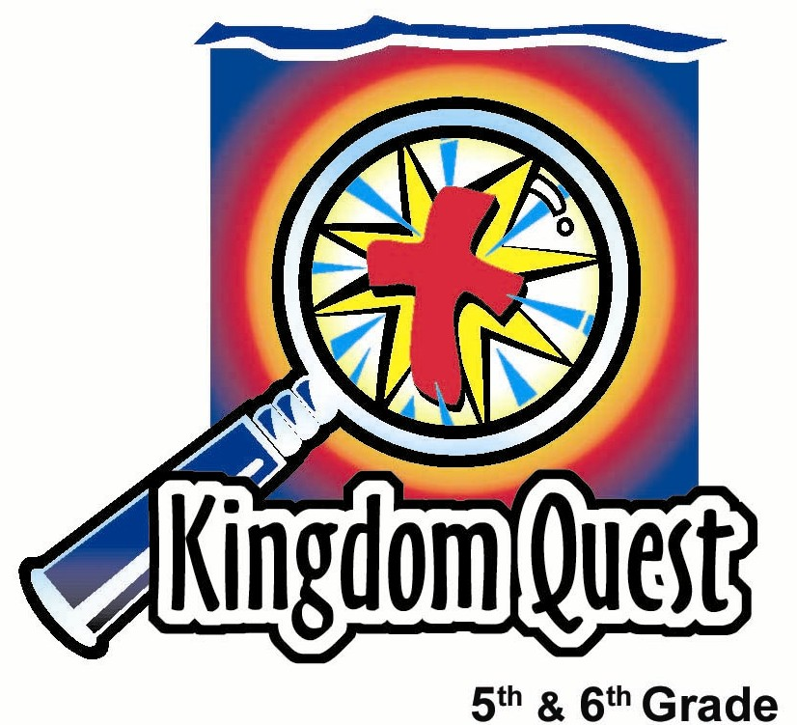
Date: _________________________
Series: Giving to God (Dec-Feb)
Year 2, Lesson 29
Give Gifts that Fit
the Person

Take Home Point: *Give gifts that fit the person.
*Repeat this phrase throughout the lesson.

Bible Event: 1 John 3:16-18, 4:7-13
Key Verse: 1 John 3:18, “My children, we should love people not only with words and talk, but by our actions and true caring.” (NCV)

We will help kids know:
- They need to pay attention to others so they can best give gifts that will really bless that person.
- God became one of us in Jesus so that He could give us what we need most, our salvation.
- Since God so loved us and gave to us, we can love and give to others.

We will help kids feel:
- Blessed by God so they will want to give to others.
- Surprised at how little they pay attention to others’ needs.

We will help kids do:
- Choose actual gifts from an assortment to initiate discussion about getting and giving gifts.
- Play a game that makes kids think quickly about what someone else might want or need.
- Take gift cards home to help them give to others something that fits that person.

THIS LESSON’S ROADMAP

DESTINATION | PAGE # | DISCOVERIES ON YOUR JOURNEY | SUPPLIES NEEDED
  Small Group Warm-Up | 3 | Shepherd gives each kid a gift. The kids share whether or not they liked what they received and if they would like to exchange with someone else. | - one small trinket gift (no duplicates) per student (These can be supplied by the Shepherd’s garage sale closet, or cheap gifts purchased by the supply coordinator.)  - sack or container big enough to hold all the trinket gifts  - a small piece of paper for each kid  - pencils or pens
Large Group   | 4  7  7  8  11 | Overview  Introduction: General (Gen) R. Osity is a storefront holiday bell ringer for charity who encourages people to give.  Play the game “Gifts that Fit” A volunteer invites a friend to the front to guess which of three gifts on the table the second volunteer would want the most.  Teaching Points: Gen R. Osity reaches into his charity kettle to demonstrate how we need to pay attention to others’ needs.  Appendices | Costume:  - presenter is dressed as a storefront holiday bell ringer for charity  Props:  - pot with lid hanging from a pole  - three unusual gifts on a table  - standing up number signs: #1, #2, #3  - paper and pencil  - “applause” sign and “awwwwww” sign  - rubber ear  - eye glasses  - glove  - set of gift cards from appendix
Small Group Application   | 4  7 | Students will play a fun memory game with the trinket gifts from Warm-Up and discuss why people chose certain ones. Finally, they will choose a gift card to help them give something to others.  Memory Verse Learning:  “Memory Blitz”  Matthew 25:40 will be repeated for lessons 28-32 to help children  to learn to give to others as a way of giving to God. | - gift cards from appendix (enough for each kid to have at least one)  - sack of trinkets from Warm-Up activity  - a stack of A4 paper pre-printed with memory verse

Small Group Warm-Up: 15 minutes
Purpose: Get pointed in the right direction! Build relationships and help guests feel at ease. Do the learning readiness activity that will point your group in the right direction for the lesson.

As kids gather: Listen to memory verses from last week and give coupons for memory verses, remembering to bring your Bible, and bringing a guest.

Supplies: Different small trinket gifts (one per student), sack or container, a small piece of paper for each kid, pencils or pens

*If you choose not to use gifts for the following, then you can simply talk about gifts that you had received once. In this case, you can simply say:

Tell about a gift you received that didn’t fit you very well or one you didn’t appreciate.

If using the trinkets, lay out all the gifts in the middle of the group so everyone can see.

I would like to give these gifts away but I’m not sure what is the best way to distribute them. I think I will just randomly pass them out.

Randomly pass out gifts. Do this and the following quickly to save time for the rest of the activity.

Show me by raising your hand how many of you would rather have received a different gift than the one I gave to you?

Can anyone share with our group about a time you received a gift that didn’t fit you very well or you just didn’t like? Discuss briefly.

Now we’ll distribute the gifts a different way.

Have kids return their gifts to the middle of the group. Then have them each write their name on a small piece of paper and put it in a container for a drawing. Explain that you are going to have the kids select their gifts in an unusual but fun way. They might not all get exactly what they want, but will have a better chance of getting something they like.

Draw a kid’s name from the container. They can pick a gift they want from the center. Draw another student’s name. This kid can pick a gift from the center or the gift the first kid selected. If a student’s gift is taken, he/she can choose again from the center or take from another student.

The next student whose name is drawn can select a gift from the center or one that has already been selected. The game continues in like fashion. However, a gift can be passed only two times. The second time a gift is taken from another person, it cannot be selected again. It belongs to the third person that picked it.

Have kids discuss why they picked the gift they did. (Some may have picked a gift only because it was popular or to tease someone.) Say:

You all received a gift in this activity, but what we really want to do is learn to give for Christmas. When we give gifts, we want them to fit the needs of the people that we give them to.

God gave us a gift that fits our need perfectly. That gift was His Son, Jesus. Because God gave us such an extravagant gift, He wants us to give to others. But, what do we give? Well, that depends. Today we’ll talk about: *Giving gifts that fit the person.

Before leaving for large group, place all the gifts back in a sack.

Large Group Overview: 20-30 minutes
Purpose: Help kids observe what the Bible says. Present the Bible event in creative fashion. Help kids begin to interpret what it means.

Introduction: General (Gen) R. Osity is a storefront holiday bell ringer for charity who encourages people to give.

Play the game “Gifts That Fit.” A volunteer invites a friend to the front to guess which of three gifts on the table the first volunteer would want the most. As volunteers are cycled through the process and gifts are correctly identified and given away, spiritual gift cards take their place as items to choose.

Teaching Points: Gen R. Osity reaches into his charity kettle to pull out props that help demonstrate how we need to pay attention to others’ needs to give them gifts that fit.

Small Group Application: 20-25 minutes
Purpose: Help kids map out the meaning of the Bible event in their lives. Use the questions to stimulate discussion, but don't feel tied to them. Allow the Holy Spirit to guide you. Include personal examples from your own faith journey. The example of Christ at work in your life will leave lasting impressions of how Christ can work in the children's lives.

Use your Bibles! Children need to learn how to look up references and follow along when scripture is read aloud. Allow for quality time of prayer at the close of the lesson.

Observation Questions: What happened?/Interpretation Questions: What does this mean?
Have kids refer to 1 John 3:16-18.

When do we truly understand what love looks like? (1 John 3:16. When we realize just how much Christ gave us with His life.)

What should we do in return for all God has done for us? (1 John 3:16. We must give our lives for other believers.)

How do we do this? (1 John 3:17-18. We take notice of others’ needs and help them. We show love with sincere action, not empty words.)

Read 1 John 4:7-13.

According to these verses, where does love originate? (From God. God is love and He demonstrated His lavish love “by sending His only Son into the world so that we could have life through Him.”)

Do you think a person who doesn’t know God, can really show true love?

What do you think true love looks like? (Unselfish. Giving to others without wanting anything, even to be loved, back.)

Because God loves us, what must we also do? (1 John 4:11. Love each other.)

How is God’s love “perfected in us?” Review verse 12. (1 John 4:12-13. When His Spirit lives in us and we demonstrate His love to others.)

Application Questions: What does this mean to me?
God gave us His Son, Jesus, because He wanted to show us He pays attention to our needs. Jesus gave people many gifts they needed. He healed the sick, helped the lonely, fed the poor, and taught truth.

Jesus came to watch, listen and notice us so He could give us what we needed. What is the greatest gift Jesus gave to us sinful people? (His life for our salvation.)

Activity:
Supplies needed: sack of trinkets from Warm-Up activity and gift cards from appendix (enough for each kid to have at least one)

Play a memory game to see how well kids were noticing others. First, have kids remember and list as many of the gifts from the small group as possible. Then have them share who chose each gift and why they chose that particular gift.

In the Warm-Up activity, did you pay attention to others, or were you thinking mostly about what you wanted?

Lay out the gift cards from the appendix. Have kids take turns reading them. Then say:

Think about someone you know that may be blessed by receiving a gift like one of these from you. How might you recognize or encourage that person? More importantly, can you share your faith in Christ with them?

The key verse for today from 1 John 3:18 says, “Dear children, we must show love through actions that are sincere, not through empty words.”

Take one of these gift cards, not for yourself, but, as reminder, to give someone else a gift that would really fit their need. Let’s remember to *give gifts that fit the person.

Memory Verse Learning: 5 minutes
Purpose: Help kids to memorize and keep scriptures at heart. Using creative ways to help kids enjoy learning the key verse and in small group setting.

Supplies needed: a stack of A4 size paper preprinted with the memory verse.

Memory Verse: Matthew 25:40b ~ I tell you the truth, anything you did for even the least of My people here, you also did for Me.” (NCV)

MV Presentation: “Memory Blitz”
Prior to the class, prepare lots and lots of paper airplanes. When the children arrive, divide them into half. Tell the children that they are going to bombard the other teams with paper airplanes. But only airplanes with the memory verse written can only be used. Therefore, they are given 2 minutes to write Matt. 25:40b on as many airplanes as they can for their team. When the time is up, place a row of chairs to divide the room into half – a tall divider is better. Each team is placed at one half of the room with their airplanes. Explain that at your signal, they are to throw the airplanes over the divider as fast as they can. But they can only throw ONE plane at a time. When the shepherd gives the signal to stop; airplanes intact will be counted. The team with the least number of planes wins.

Closing prayer:
Thank God for the extravagant gift of His Son, Jesus for us. Ask God to show students a new way to demonstrate their love for Him to others.

Safety and Security: Safety and security procedures are important for each church to carefully define and implement according to their unique needs. The security, safety, illness and accident procedures described in this curriculum are provided for example purposes only and may not be appropriate, applicable or adequate for every situation. Each church is responsible for determining whether any security, safety, illness and accident procedures contained in the curriculum are appropriate, applicable or adequate for its unique situation. The activities described in this curriculum require adult supervision and may not be suitable for each child and each situation. Each church is responsible for ensuring that adequate adult supervision is provided for all activities and for determining whether an activity is appropriate for each child and each situation. Kids Kount Publishing disclaims all liability for the implementation of any procedures or the performance of any activities described in this curriculum.

Large Group Presentation

Give Gifts That Fits The Person
Dramatic Presentation

Costume:
- presenter is dressed as a storefront holiday bell ringer for charity

Props:
- pot with lid hanging from a pole to serve as a collection place for gifts
- three presents, unusual in nature, placed on the table
- stand up number signs: #1, #2, #3 in front of each gift
- “applause” sign and “awwwwww” sign
- paper and pencil
- six gift certificates cut from the appendix page
- rubber ear from a costume or novelty shop, or a funnel that you can hold to your ear as a hearing device
- eye glasses

Introduction

Welcome, everyone! My name is General R. Osity! But my friends call me Gen, for short. You can call me Gen or Gen R. Osity - whichever you prefer. Today I am ringing my bell for charity and I want to invite you to give, give, give. Give until it helps someone. You might have seen some of my other helpers at different stores reminding you that it is more blessed to give than to receive. But when you give to another, are you paying attention and noticing enough about that person to give gifts that really fit that person? That’s what we’re talking about today.

Play “Gifts that Fit”

Three gifts are on a display table in the front with the presenter. Call up a volunteer to be a contestant. This should be someone with at least one known friend in the audience.

I’ve got three gifts here on the table and we’re going to play “Gifts that Fit.” In order to play, I will need my volunteer to choose a friend from the audience to come up and help. (To the volunteer) You want to choose a person that you know very well. You are going to help him/her receive a gift that fits them.

Have the volunteer choose a friend to join him/her up front. Have the second volunteer write on a piece of paper so only you can see the number of the gift he/she has chosen. Then fold the paper in half. Addressing the first volunteer, say:

Your job is to guess which of these three gifts on the table your friend would want the most. Without pointing to it, which gift will you choose for him/her? Will it be gift number one, gift number two, or gift number three?

Make sure the second volunteer doesn’t give it away through nonverbal cues. Allow the partner friend to make the choice.

Say to the second volunteer:

Now, if your friend chooses the gift you want, you get to take the gift with you. If he/she doesn’t get it right, you have to sit down.

And now, ladies and gentlemen, for the big reveal. (To the first volunteer.) Tell us, which gift do you choose for your friend?

Volunteer says his/her choice.

And your friend said that he/she would like number…

Open the paper and read it.

If the choice was the same as the number written, hold up “applause” sign or the “awwwwww” sign if it was not. Let the second volunteer take the gift and return to his/her seat. If the friend did not pick the correct gift, still have them sit down. Ask the first volunteer to pick someone else. If a gift was taken, replace it with one of the six gift cards. Read it out loud and have the new volunteer choose it or one of the remaining gifts. Have the next volunteer write down on paper the gift he/she would like.

Repeat the choosing process. If the friend chooses correctly, make a dramatic presentation of that gift to the volunteer. Continue replacing the gifts chosen with the remaining gift cards until the gifts and cards are gone or time has run out. Have all contestants return to their seats.

Teaching introduction:

We know that it is more blessed to give than to receive. Certainly God believed that because He gave us the best gift we could ever have – Jesus. Listen to these words. 1 John 3:16 says, “This is how we know what real love is: Jesus gave His life for us. So we should give our lives for our brothers and sisters.”

What does it mean to give our lives for other believers? I have some clues in my charity kettle that might help us give the best gifts to others. Listen to God’s word and think about these clues.

1 John 3:17 says, “Suppose someone has enough to live and sees a brother or sister in need, but does not help. Then God's love is not living in that person.”

Ears and eyes props:

Presenter Gen R. Osity pulls a rubber ear and a pair of eye glasses from his charity kettle.

Who would like to guess how this ear and this pair of eye glasses relate to the verse from 1 John 3:17?

Take answers.

Yes, we must listen to other people, we must notice them, we must pay attention to other people so we can give them what they really need and bless them.

Hands prop:

Let’s see what else is in my charity kettle.

Pull out the glove.

Hum. So far I have pulled out an ear, eye glasses and now a glove. Okay. Gloves go with hands. What do we do with our hands? More importantly, what does God want us to do with them?

Accept answers.

God wants us to use our hands to help others. Let’s take a look at what the Bible says about this.

1 John 3:18 says, “My children, we should love people not only with words and talk, but by our actions and true caring.”

That means that when we see the needs of others, we must act, we must give gifts to people that will help them.

Bible conclusion:

Have two good readers come up to read 1 John 4:7-13. Decide whether to have them alternate reading each verse or alternate reading every two verses. (Verse numbers are indicated in brackets.)

[7 ]“ Dear friends, we should love each other, because love comes from God. Everyone who loves has become God's child and knows God.
[8] Whoever does not love does not know God, because God is love.
[9] This is how God showed His love to us: He sent His one and only Son into the world so that we could have life through Him.
[10]This is what real love is: It is not our love for God; it is God's love for us in sending His Son to be the way to take away our sins.
[11] Dear friends, if God loved us that much we also should love each other.
[12] No one has ever seen God, but if we love each other, God lives in us, and His love is made perfect in us.
[13] We know that we live in God and He lives in us, because He gave us His Spirit.”

Remember to *give gifts that fit the person.

Prayer:

Dear God, thank You for the gift of Your Son, Jesus. Thank You that He gave His life for us because that’s just what we need. Thank You that You paid attention to us by sending Jesus to do what we couldn’t do: live a perfect life. Thank You that Jesus died on the cross and suffered the punishment for our sins so we wouldn’t have to. Help us now pay attention to the need of others around us so that we can give them gifts that really help them. Help us to especially give them gifts that lead them to You. In Jesus’ name, we pray. Amen.

Lesson 29

Small Group Warm-Up
- one small trinket gift (no duplicates) per student (These can be supplied by the Shepherd’s garage sale closet, or cheap gifts purchased by the supply coordinator.)
- sack or container big enough to hold all the trinket gifts
- a small piece of paper for each kid
- pencils or pens

Large Group
Costume:
- presenter is dressed as a storefront holiday bell ringer for charity
Props:
- pot with lid hanging from a pole
- three unusual gifts on a table
- standing up number signs: #1, #2, #3
- paper and pencil
- “applause” sign and “awwwwww” sign
- rubber ear
- eye glasses
- glove
- set of gift cards from appendix

Small Group Application
- gift cards from appendix (enough for each kid to have at least one)
- sack of trinkets from Warm-Up activity

Memory Verse Learning
- a stack of A4 paper pre-printed with memory verse

Appendix: Gift Cards

The gift of a friend who will help me with my homework.

The gift of
a friend when I feel left out.

The gift of a compliment about something I’ve done.

The gift of someone praying for me.

The gift of someone who points out how God is working through me to help.

The gift of someone reminding me about how God can help me.

APPLAUSE

AWWW…

