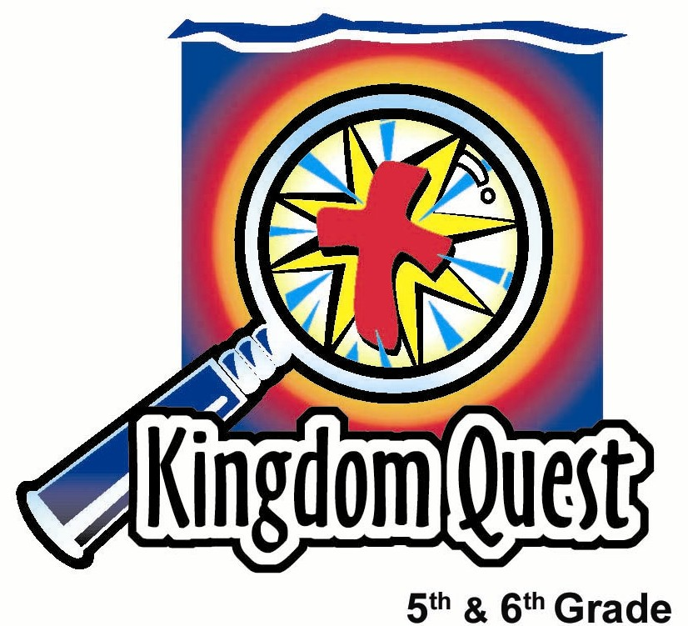
Date: _________________________
Series: Giving to God (Dec-Feb)
Year 2, Lesson 32

Receive the Christmas Gift: Jesus

Take Home Point: *Receive the gift of Jesus.
*Repeat this phrase throughout the lesson.

Bible Event: John 3:16-18; Luke 2:1-20; Luke 1:26-38; Matthew 1:18-24
Key Verse: John 3:16, “God loved the world so much that He gave His one and only Son so that whoever believes in Him may not be lost, but have eternal life.” (NCV)

We will help kids know:
- A review of the Christmas story.
- The greatest gift possible is Jesus, but one must receive this gift through faith.
- If you reject the gift of Jesus, you stand condemned.

We will help kids feel:
- Excited as they talk about the joys of giving and receiving gifts.
- Confident of their status with God if they have received the gift of Jesus as their Savior.

We will help kids do:
- Talk about their Christmas experiences of giving and receiving gifts.
- Watch a video capturing the Biblical narrative of Christmas and the importance of receiving Christ by faith.
- Play a game that illustrates the point that some people will reject the gift of Jesus and how dangerous that can be.
THIS LESSON’S ROADMAP

DESTINATION | PAGE # | DISCOVERIES ON YOUR JOURNEY | SUPPLIES NEEDED
Small Group Warm-Up   | 3 | Kids eat Christmas goodies and discuss gifts the kids received and gave for Christmas. | - Christmas snacks
Large Group   | 4  6  6  7 | Overview  Option 1: Large group presenter or special guest shares a personal experience of when he/she shared the Christmas story with someone who hadn’t heard it before. He/she then reads the Christmas story from Luke 1:26-38, Matthew 1:18-24, Luke 2:1-20.  Option 2: Watch the video, The Visual Bible for Kids: The Birth of Jesus, published by Tommy Nelson, Inc., 1998—order from www.tommynelson.com.  Play a “hot potato” game using a gift bow to illustrate God giving the gift of Jesus. Instead of holding on to it and receiving the gift, it is thrown back. | - gift bows—one for each group of six to nine kids  - video: The Visual Bible for Kids: The Birth of Jesus,produced by Tommy Nelson Inc., 1998  - CD or cassette player  - Christmas music on CD or cassette for the game
Small Group Application   | 4 | Close the lesson in prayer giving everyone an opportunity to receive the gift of Jesus and not be condemned.  Memory Verse Learning:  “Friendly Verse”  Matthew 25:40 will be repeated for lessons 28-32 to help children  learn to give to others as a way of giving to God. | - None  - pink and blue A4 paper  - marker
Small Group Warm Up: 15 minutes
Purpose: Get pointed in the right direction! Build relationships and help guests feel at ease. Do the learning readiness activity that will point your group in the right direction for the lesson.

As kids gather: Listen to memory verses from last week and give coupons for memory verses, remembering to bring your Bible, and bringing a guest.

Note: Since this is the Sunday after Christmas and many shepherds may be out of town, the following lesson is designed with for more time in large group. The small group time can be done in triads (groups of three) with minimal supervision required.

Supplies: Christmas cookies, or some other special Christmas snack

Have the kids divide into triads (groups of three) and pass out some refreshments to eat while they have discussion.

Presenter:

These past few weeks we discussed the gifts we gave for Christmas. Let’s find out what are some of the gifts you received for Christmas.

I would like each person in your triad to share some of the favorite things you received.

After kids have shared, continue with:

Tell your triad about some of the not so favorite things you received for Christmas.

Now, share some of the gifts you gave for Christmas.

Was anyone in your house disappointed with any gifts they received? Tell what happened.

Have you ever seen anyone not use a gift that they received? Or have you ever not used a gift that you received?

Today we will learn how important it is to *receive the gift of Jesus.

Large Group Overview: 20-30 minutes
Purpose: Help kids observe what the Bible says. Present the Bible event in creative fashion. Help kids begin to interpret what it means.

Option 1: Large group presenter or special guest shares a personal experience of when he/she shared the Christmas story with someone who hadn’t heard it before. He/she then reads the Christmas story from Luke 1:26-38, Matthew 1:18-24, Luke 2:1-20.

Option 2: Watch video: The Visual Bible for kids: The Birth of Jesus produced by Tommy Nelson Inc., 1998—order from: http://www.thomasnelson.com/consumer/product_detail.asp?sku=0849986710.

Play a “hot potato” game using a gift bow to illustrate God giving the gift of Jesus. Instead of holding onto it and receiving the gift, it is thrown back.

Small Group Application: 20-25 minutes
Purpose: Help kids map out the meaning of the Bible event in their lives. Use the questions to stimulate discussion, but don't feel tied to them. Allow the Holy Spirit to guide you. Include personal examples from your own faith journey. The example of Christ at work in your life will leave lasting impressions of how Christ can work in the children's lives.

Use your Bibles! Children need to learn how to look up references and follow along when scripture is read aloud. Allow for quality time of prayer at the close of the lesson.

Observation Questions: What happened?/Interpretation Questions: What does this mean?
In Large Group, we tossed the gift bow around like we didn’t want it. How did it feel to think of yourself rejecting Jesus in the same way?

How do people reject the free gift of Jesus and His salvation?

Application Questions: What does this mean to me?
Think about people that you know who might be missing the greatest gift of Christmas, Jesus. Spend some time now praying silently for them.

Allow time for all to pray silently. Then pray the following aloud.

Heavenly Father, thank You for loving us so much that You gave Your only Son, Jesus, for our sin. Thank You that we can simply believe in Him and not be condemned or blamed. Thank You that through Jesus we can have everlasting life with You.

We believe that Jesus is Your Son and that He gave His life for us. He died on the cross, but is alive now with You in heaven. We ask Your Holy Spirit to show us how important it is to receive the gift of Jesus. Help us to simply believe and trust in You.

Say to the students:

I am going to give you a few seconds of quiet so that You might talk to God regarding Your relationship with Him.

Memory Verse Learning: 5 minutes
Purpose: Help kids to memorize and keep scriptures at heart. Using creative ways to help kids enjoy learning the key verse and in small group setting.

Supplies needed: pink and blue A4 paper, marker

Memory Verse: Matthew 25:40b ~ I tell you the truth, anything you did for even the least of My people here, you also did for Me.” (NCV)

MV Presentation: “Friendly Verse”
Cut strips of paper whereby you can write the names of every child in the class. Put all the names in a bag and let each student pick one (hopefully it is not their own, if it is they have to pick another name). Tell the children that at your signal, they must quickly find their friend and together make plans as how they should recite the memory verse. At your signal, the pairs line up before you. Give each pair a chance to present the memory verse.

Have students pray silently for a few seconds.

Heavenly Father, You have said that for all who receive Jesus as their personal Savior, there is no condemnation or blame. We thank You for Your gift of Jesus. If there is anyone here who has not received Him, we pray that You would help each one to not throw the gift away, but receive it today. In Jesus’ name. Amen.

Safety and Security: Safety and security procedures are important for each church to carefully define and implement according to their unique needs. The security, safety, illness and accident procedures described in this curriculum are provided for example purposes only and may not be appropriate, applicable or adequate for every situation. Each church is responsible for determining whether any security, safety, illness and accident procedures contained in the curriculum are appropriate, applicable or adequate for its unique situation. The activities described in this curriculum require adult supervision and may not be suitable for each child and each situation. Each church is responsible for ensuring that adequate adult supervision is provided for all activities and for determining whether an activity is appropriate for each child and each situation. Kids Kount Publishing disclaims all liability for the implementation of any procedures or the performance of any activities described in this curriculum.

Large Group Presentation

Receive the Christmas Gift: Jesus

Supplies: Video: The Visual Bible for Kids: The Birth of Jesus produced Tommy Nelson, 1998. Order from www.christiancinema.com or www.amazon.com, gift bow for each group of 6-9 kids, CD or cassette player, music CD or cassette

Introduction:

Welcome, everyone! My name is General Osity! I’m standing here ringing my bell for charity and I want to invite you to give, give, give. Give until it helps someone. You might have seen some of my other helpers at different stores reminding you that it is more blessed to give than to receive. Today we want to share the gift of Jesus with others.

Option 1: Personal Story

Today we will have a guest share a story about a time he/she told the Christmas story to a person who had never heard it before. Here to share his/her story is (insert volunteer’s name).

The large group presenter or a special guest shares a story about a time he/she has told the Christmas story with someone who had never heard it before.

Then read the Christmas story from the Bible – Luke 1:26-38; Matthew 1:18-24; Luke 2:1-20.

Option 2: Watch the Video: The Visual Bible for Kids: The Birth of Jesus

Watch the 30 minutes video.

Teaching Point #1

The gift of Christmas is Jesus. This gift is freely given, but it must be received. I think most of us are familiar with the Christmas account of how God gave His Son, Jesus, to be born as a baby in Bethlehem.

This is not just a story. This is the truth. God sent His Son to the world to take our place on the cross. He paid the price for our sins and made forgiveness available to all of us.

Because of Jesus, we have the opportunity to be grafted into God’s family. But in order to do so, we must receive the gift of Jesus and believe it.

How do you think God would feel if He offered such an incredible gift and someone said, “No thank You, I don’t want it”? (Take answers: mad, angry, heartbroken.)

We might be able to relate a little bit if we have ever had a gift we were excited about giving and it was rejected.

Play “Hot Potato” With a Gift Bow

Have 6-9 kids get into groups and sit in a circle. Give one bow to each group. The kids will toss the bow around the circle as the music plays. When the Large Group presenter stops the music, the last person holding the bow is out of the game. The goal is to be the last remaining person in the circle who was not caught holding the bow when the music stopped.

Play the game until only one person remains in each group. Then say:

The winners in the game today are not the ones left in the circle who did not have the bow. But, rather, the winners are the kids standing outside the circle who were caught with the bow.

You see, there is a time when a similar game is played with God. This is when God tries to give us the gift of His Son, Jesus—just like this bow. Instead of holding onto it and receiving the gift, we may try to throw it back.

Teaching Point #2

Rejecting God’s gift places us under condemnation. The word “condemn” means being rejected by God and unable to live in His presence forever. This is what hell is.

The following Bible verses describes how God has given the gift of Jesus so we would not be condemned. However, if we choose to reject the gift and choose to have no part of Jesus in our lives, He will honor this. But, with the decision to reject Jesus, there is no forgiveness of sin and only condemnation.

John 3:16-18 tells us, “God loved the world so much that He gave His one and only Son so that whoever believes in Him may not be lost, but have eternal life. God did not send His Son into the world to judge the world guilty, but to save the world through Him. People who believe in God's Son are not judged guilty. Those who do not believe have already been judged guilty, because they have not believed in God's one and only Son.”

If you do not receive the gift of Jesus, you choose condemnation.

Do you sense God nudging you to see your need for a Savior? Let’s go back to our small groups and further discuss the application questions.

Lesson 32
Small Group Warm-Up

- Christmas snacks

Large Group
- gift bows—one for each group of six to nine kids
- video: The Visual Bible for Kids: The Birth of Jesus, produced by Tommy Nelson Inc., 1998
- CD or cassette player
- Christmas music on CD or cassette for the game

Small Group Application
- none

Memory Verse Learning
- pink and blue A4 paper
- marker

