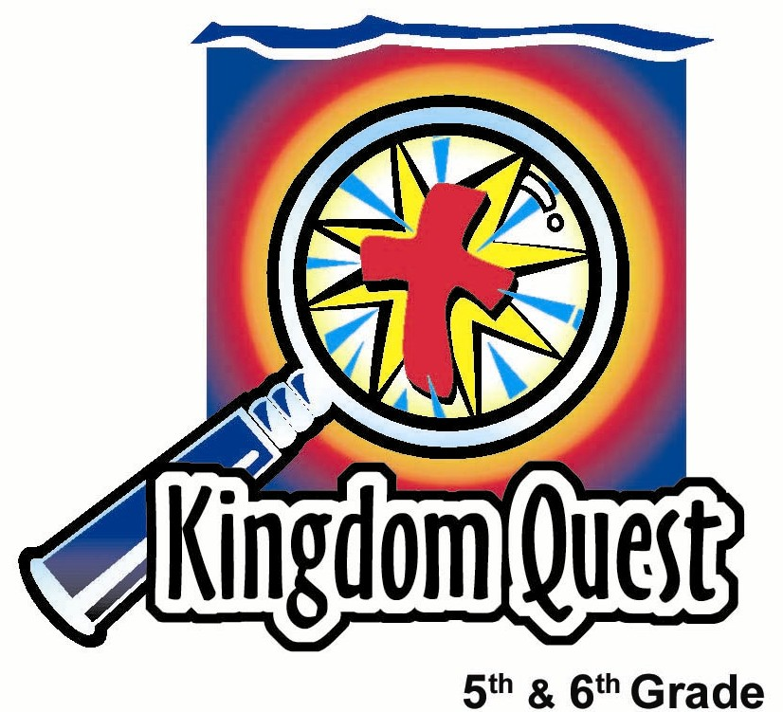
Date: _________________________
Series: Special Lesson (Dec-Feb)
Year 2, Lesson 33

No Worries
in a
New Year
Take Home Point: *Take off your “worry warts” and put on your “kingdom vision.” *Repeat this phrase throughout the lesson.

Bible Event: Matthew 6:25-34; Jeremiah 29:11
Key Verse: Jeremiah 29:11, “I say this because I know what I am planning for you," says the Lord. "I have good plans for you, not plans to hurt you. I will give you hope and a good future.” (NCV)

We will help kids know:
- Worry is about being afraid of something bad happening in the future. Jesus tells us not to worry.
- Instead of worrying about the future, Jesus invites us to look for what God wants to do in our lives right now.
- We can be confident of the future because we can trust God in the present, moment by moment.

We will help kids feel:
- Confidence in the promises of God for the present and the future.
- Excitement as they think about their prospects for the New Year.

We will help kids do:
- Identify worries in their lives.
- Identify ways God is working in their lives and providing for their needs.
- Decorate one another with “worry warts” using icing and then wiping them away when glasses are put on to help see what God is doing right now.

THIS LESSON’S ROADMAP

DESTINATION | PAGE # | DISCOVERIES ON YOUR JOURNEY | SUPPLIES NEEDED
  Small Group Warm-Up | 4 | Students may not have any real warts, but they will see that they DO have “worry warts.” They will share things they are afraid will happen and represent them with dabs of icing on their skin. | - bowl with a ¼ cup of icing (any color)  - cream crackers  - serviettes  - cotton swab sticks
Large Group   | 5  8  9  12 | Overview  Video Clip: Wizard of Oz – Dorothy meets the Cowardly Lion and invites him to join her and her other new friends  Game: “Name That Worry” – As verses from Matthew 6:25-34 are read, the audience will answer related questions about the verses. For each correct answer, a volunteer artist will decorate the face of a volunteer subject with “Worry Warts.”  Teaching Point: Because God is with us right now, He will certainly take care of us in the future. There is no need to fill our thoughts with worry, but rather with thoughts of the good things God is doing in our lives. | Costuming:  - drape for subject  - French-looking artist’s cap or white painter’s overalls  Props:  - game sign, NAME THAT WORRY  - fresh bowl (or palette) of colored icing  - cotton swab or paint brush  - stool for subject  - portable mirror  - camera (optional)  - Bible with markings to indicate where the reader will stop for audience participation  - one pair of pre-ordered glasses or pre-made craft glasses from the Small Group Application activity  - video: Wizard of Oz, by Warner Entertainment Co., 1935, ISBN # 0790745178
Small Group Application   | 5 | Kids put on new glasses that are either pre-purchased or made as a craft activity to see the good things that God is doing in their lives right now as they use a towel to wipe away their “Worry Warts.”  Memory Verse Learning:  “Turn It Over”  Jeremiah 29:11 will be repeated for lessons 33-37 to help children to learn to feel confidence in the promises of God for the present and the future. | - glasses (see appendix) with scissors, markers, glue, and shiny bits for decorating  - wet cloth or paper towels  - cream crackers  - serviettes  - icing  - blunt knife for spreading icing  - eight sheets of A4 art-card printed with different portion of the memory verse (see appendix)

Small Group Warm-Up: 15 minutes
Purpose: Get pointed in the right direction! Build relationships and help guests feel at ease. Do the learning readiness activity that will point your group in the right direction for the lesson.

As kids gather: Listen to memory verses from last week and give coupons for memory verses, remembering to bring your Bible, and bringing a guest.

Supplies: Bowl with ¼ cup of icing (any color), cream crackers, serviettes, cotton swab sticks (enough for one time only use), small portable mirror

Take a look at the skin on your hands, arms, legs and face. You may borrow this mirror if you’d like. Do you see any warts there? No? I bet our group can find some on you.

Today we’re going to collect “worry warts.”

How would you define “worry?” (It means that you’re afraid of something bad happening in the future. You feel unsettled inside and your mind thinks about how much you don’t want it to happen.)

Think about something you worry about either right now, or something you have worried about in the past.

Let one minute pass for quiet reflection.

When you have identified your worry, I want you to share it with our group. After you’ve shared, you get to take this cotton swab and dab it in this frosting and make a mark on your hand or, if you want, on your face. We will call this a “worry wart.” Let’s see how many worry warts we have on us today.

Let everyone share his/her greatest worry and apply one “worry wart.”

After every student has had a turn, we will pass the icing bowl around the group again and see how many you can identify in your second turn. Each time someone shares a worry, he/she can make a frosting mark (worry wart) on his/her skin.

Does anyone have any worries when they think about the coming New Year?

What do you think most kids your age worry about?

Things we worry about give us “worry warts.” When we stay focused on what God is doing here and now, we have “kingdom vision” and it helps us not worry about tomorrow. Today we will learn to *take off “worry warts” and put on “kingdom vision.”

Tell kids they will go to large group wearing their “worry warts.” They will come off later.

Large Group Overview: 20-30 minutes
Purpose: Help kids observe what the Bible says. Present the Bible event in creative fashion. Help kids begin to interpret what it means.

Video Clip: Wizard of Oz – Dorothy meets the Cowardly Lion and invites him to join her and her other new friends to find the all-powerful Wizard of Oz and get him some courage to face his fears and worries.

Game: “Name That Worry” – As verses from Matthew 6:25-34 are read, the audience will answer related questions about the verses. For each correct answer, a volunteer artist will decorate the face of a volunteer subject with “Worry Warts.”

Teaching Point: Because God is with us right now, He will certainly take care of us in the future. There is no need to fill our thoughts with worry, but rather with thoughts of the good things God is doing in our lives.

Small Group Application: 20-25 minutes
Purpose: Help kids map out the meaning of the Bible event in their lives. Use the questions to stimulate discussion, but don't feel tied to them. Allow the Holy Spirit to guide you. Include personal examples from your own faith journey. The example of Christ at work in your life will leave lasting impressions of how Christ can work in the children's lives.

Use your Bibles! Children need to learn how to look up references and follow along when scripture is read aloud. Allow for quality time of prayer at the close of the lesson.

Observation Questions: What happened?/Interpretation Questions: What does this mean?
Have kids take turns reading out loud the Bible passage from Matthew 6:25-34.

According to verse 25, there is more to life than worrying about what? (What we eat, drink, or what we wear.)

How do the birds get fed? (Verse 26. God provides.)

How well does God clothe the flowers? (Verse 29. More splendidly than Solomon, the richest king, in all his majesty.)

Why do you think Jesus made a comparison with our needs and those of the birds and flowers? (The birds and flowers are God’s creation. They go about doing what God made them to do without worrying, because God provides. Even though the birds and flowers are also God’s creation, we are even more important to Him because we are created in His image and because He sent His Son to die for us. )

According to verse 32, what does God know about us? (He knows our every need.)

What do you think Jesus meant in saying, “So don’t ever worry about tomorrow…Each day has enough trouble of its own.” (We should not worry about the future but live for what God wants us to do day by day.)

Application Questions: What does this mean to me?
We do not have to worry about our needs. Instead, what should we be concerned about? Or what should be our priorities? (We should seek first God’s kingdom or His ways. We should be concerned about what is important to God.)

What are examples of seeking God’s kingdom or being concerned about God’s priorities? (Doing what God made us to do: worship Him, pray for another’s salvation, witness to others, etc.)

God wants us to be concerned about eternal matters or things that make a difference for His kingdom rather than things like “grass that is alive today and tomorrow is thrown into the incinerator.”

Application Activity:
Supplies: wet towels or wet paper towels for clean up, novelty glasses with the New Year number outlining the lenses or pattern of glasses (see appendix) for each kid, scissors, markers, glue, and shiny bits for decoration to make glasses), cream crackers, serviettes, icing, and blunt knife for spreading icing

Make glasses from appendix as a craft project or pass out pre-purchased novelty glasses.

Give kids a wet towel to wipe off their “worry warts.” As they do this, state the Take Home Point: *Take off your “Worry Warts” and put on your “Kingdom Vision.”
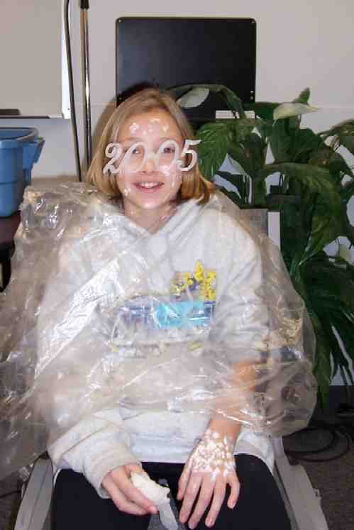
Have kids put on their new glasses.

Right now God is blessing you and providing for your needs. The “Kingdom Vision” glasses you now have are meant to help you see the good things that God is doing in your life.

Pass out cream crackers, serviettes, and icing for a snack while discussing the following:

What are things you worried about in the past, but today can see that they ended up okay? Or how is God providing for your needs right now?

Unlike the Wizard of Oz who was only a man but gave the cowardly lion something to believe in, the one true, living God gives us His solemn promises. And, because He is perfect, He can never go against His word.

Our key verse today from Jeremiah 29:11 says, “I know the plans that I have for you, declares the Lord. They are plans for peace and not disaster, plans to give you a future filled with hope.”

You can also use your glasses to look and see how God will be with you in the future. You can have confidence about how God will work in your life. He will always be with you to help you *take off your “worry warts” and put on your “kingdom vision.”

Memory Verse Learning: 5 minutes
Purpose: Help kids to memorize and keep scriptures at heart. Using creative ways to help kids enjoy learning the key verse and in small group setting.

Supplies needed: eight sheets of A4 artcard each printed with a different portion of the memory verse. (See Appendix)

Memory Verse: Jeremiah 29:11 ~ “I say this because I know what I am planning for you," says the Lord. "I have good plans for you, not plans to hurt you. I will give you hope and a good future.” (NCV)

MV Presentation: “Turn It Over”
Have all the children recite the memory verse together several times. Then choose eight children and give each a sheet of the art-card printed with different portion of the memory verse. Have them form a line, in the order of the memory verse, facing the other children so the children can see the verse. Explain to them that when you tap them on the shoulder they need to turn around with their back facing the children so that the children cannot see the part of the memory verse they are holding. Have the children read the memory verse as you point to each piece of paper. Once you have done this several times, turn one of the children around so that the words they are holding cannot be seen. Repeat this until all of the children holding the memory verse are turned away from the other children.

Closing prayer:
Thank God that we are created in His own image and that He loved us so much, He sent His Son to die for us. Thank Him that He keeps His promises to provide for our every need. Thank Him that He has a future of hope planned for each one of us. Encourage kids to pray for God to help them release any worries they may have to Him and ask for the Holy Spirit to give them a greater measure of trust in God’s promises.

Safety and Security: Safety and security procedures are important for each church to carefully define and implement according to their unique needs. The security, safety, illness and accident procedures described in this curriculum are provided for example purposes only and may not be appropriate, applicable or adequate for every situation. Each church is responsible for determining whether any security, safety, illness and accident procedures contained in the curriculum are appropriate, applicable or adequate for its unique situation. The activities described in this curriculum require adult supervision and may not be suitable for each child and each situation. Each church is responsible for ensuring that adequate adult supervision is provided for all activities and for determining whether an activity is appropriate for each child and each situation. Kids Kount Publishing disclaims all liability for the implementation of any procedures or the performance of any activities described in this curriculum.

Large Group Presentation

No Worries in the New Year

Costuming:
- protective drape for subject
- French-looking artist’s cap or white painter’s overalls for artist

Props:
- brightly colored sign with the game title in large letters: “Name That Worry”
- fresh bowl (or palette) of colored icing, cotton swab or paint brush
- stool for subject
- portable mirror
- camera (optional)
- Bible with markings to indicate where the reader will stop for audience participation
- one pair of pre-ordered glasses (Oriental Trading Company catalog # IN-83/156 G-I-D “Year 2005” Glasses $3.95/dz.) or pre-made craft glasses from the Small Group Application activity

Video:
- Wizard of Oz. produced by Turner Entertainment Co., 1935, ISBN # 0-7907-4517-8. The clip begins at 53:00 when Dorothy meets the Cowardly Lion, and ends after the lion, Dorothy, Tin Man, and Scarecrow dance their way to meet the Wizard of Oz.
- Option: “Lion King” by Walt Disney Home Video, 2003. ASIN # B00008VPUP. Show portion regarding “No worries…”

Video

When you think about the New Year coming up, do you feel excited about some of the opportunities you might have to do special things? Hopefully, everyone has something to be excited about and look forward to.

But, sometimes people find themselves worried about something that might happen in the future. Worry is being afraid of what may happen in the future. Many times we can’t control what will happen in the future, so we worry about it instead. Today we will talk about our worries and how to get rid of them. Let’s take a look at a movie clip featuring a character that is afraid of something that caused his life to be filled with worry.

Show the video clip from the film, The Wizard of Oz, produced by Turner Entertainment Co., 1935, ISBN # 0-7907-4517. Rent from your local video store or order from: http://www.amazon.com/gp/product/B00000JS62/002-4057945-1179217?v=glance&n=130&v=glance.

The clip begins at 53:00 when Dorothy meets the Cowardly Lion, and ends after the lion, Dorothy, Tin Man, and Scarecrow dance their way to meet the Wizard of Oz.

After the video say:

In the Wizard of Oz, what was the Lion afraid of? That’s right, almost everything. Because of fear, he was worried about the future.

His cowardice changed dramatically after the All-powerful Oz (who turned out to be just a man) pinned the medal of courage on him. His attitude changed when he had something in which to believe.

How does this help us face our fears and worries? Well, we can believe that the Almighty God of the Universe loved us enough to send His Son to die for us. Because He loves us so, He promises He will never leave us or forsake us. We can trust God to keep His promises because He can’t go against His word.

Game: Name That Worrry

Today we will have a contest to (refer to sign) “Name That Worry!”

Note: You may want to pre-select the volunteers for this game since it will require a certain level of maturity, both on the part of the artist and the subject who gets decorated.

Select two volunteers. Have the artist put on the hat or painter pants. Hand him/her the palette or bowl of frosting and paintbrush or cotton swab. Have the subject volunteer put on protective clothing. Then continue with:

I am going to read a verse from the Bible, and it will be your job to listen carefully to the words in it. Then I will ask you, the audience, a question about the verse. If I hear someone from the audience “Name that Worry” correctly, then, the artist volunteer gets to decorate my subject, an official good sport, with one “Worry Wart,” on his/her face, after each correct answer.

Hum, now I’m only missing one very important game piece. Oh, yes. I need a volunteer who likes to read out loud.

Select a volunteer to read. As he/she comes up onto the stage, hand the reader a Bible opened to the verse below. Be sure the stopping points for audience participation are marked. Check the reader for understanding.

Now, let’s play, “Name that Worry!” Audience, listen carefully to these verses from the book of Matthew where Jesus’ is teaching from his Sermon on the Mount.

He says in Matthew 6:25, “So I tell you, don't worry about the food or drink you need to live, or about the clothes you need for your body. Life is more than food, and the body is more than clothes.”

Audience, what three things did Jesus warn the people not to worry about? (What they would eat, drink, or wear.)

Artist decorates the subject’s face with one “Worry Wart” for each item. Reader continues reading where he/she stopped.

“Life is more than food, and the body is more than clothes. Look at the birds in the air. They don't plant or harvest or store food in barns, but your heavenly Father feeds them. And you know that you are worth much more than the birds. (Matthew 6:26.)
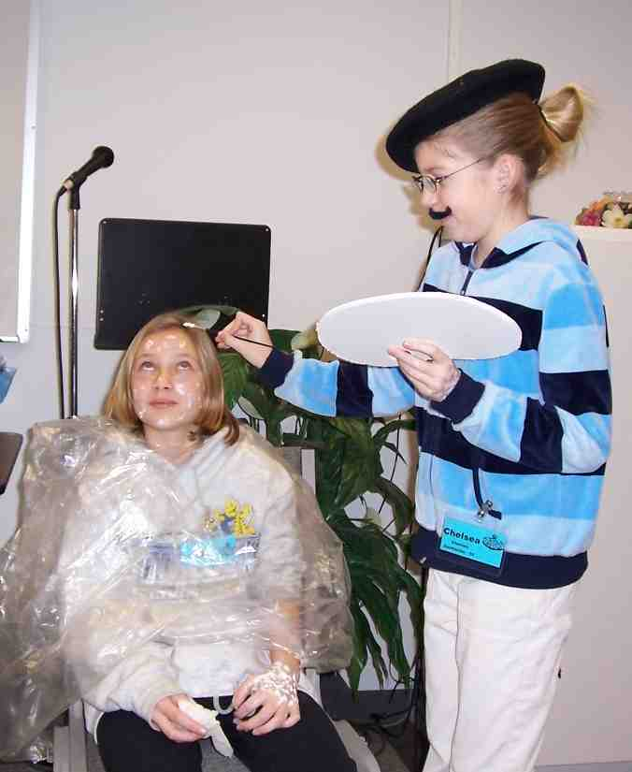
Audience, do birds worry about eating? (No.)

Artist decorates the subject’s face with one “Worry Wart.” Reader continues with verse 27.

“You cannot add any time to your life by worrying about it. “

Can any of you add an extra hour to your life when you worry more? (No.)

Artist decorates the subject’s face with one “Worry Wart.” Reader continues reading:

“And why do you worry about clothes? Look at how the lilies in the field grow. They don't work or make clothes for themselves. But I tell you that even Solomon with his riches was not dressed as beautifully as one of these flowers. God clothes the grass in the field, which is alive today but tomorrow is thrown into the fire. So you can be even more sure that God will clothe you. Don't have so little faith!
(Matthew 6:28-30.)

Do flowers worry about looking nice? (No.)

Artist decorates the subject’s face with one “Worry Wart.”

Jesus continues His sermon by saying, “Don't worry and say, 'What will we eat?' or 'What will we drink?' or 'What will we wear?' (Matthew 6:31.)

So, what does Jesus say you should never be worried about? (What are we going to eat, drink, or wear.)

Artist decorates the subject’s face with one “Worry Wart” for each item. Reader continues.

“The people who don't know God keep trying to get these things, and your Father in heaven knows you need them. “ (Matthew 6:32.)

Does your heavenly Father care for you? (Yes.)

Does He know you need these things? (Yes.)

Will he make sure you have what you need? (Yes.)

So, we are not to think about what bad things might happen in the future. That is called worrying.

Artist decorates the subject’s face with one “Worry Wart.”

Instead, we must do this.

Presenter continues reading scripture.

Matthew 6:33 says, “The thing you should want most is God's kingdom and doing what God wants....”

What should we be concerned about first? (His kingdom.)

“…be concerned about His kingdom and doing what God wants. Then all these things will be provided for you.”

What also should we be concerned about? (What has his approval.)

So, if you’re concerned about His kingdom and doing what God wants, what happens to all these other things? (Then all other things will be provided for you.)

“So don't worry about tomorrow, because tomorrow will have its own worries. Each day has enough trouble of its own.” (Matthew 6:34.)

This next question requires you to fill in the blank. Here it is. Don’t worry about _________________________. (Tomorrow.)

Artist decorates the subject’s face with one “Worry Wart.” Have volunteer reader return to his/her seat.

Teaching Point:

Look at our subject volunteer. He/she has “Worry Warts” all over!

Hand the subject a mirror to see how he/she looks. Possibly take a picture to add effect.

The Bible tells us many people worry about physical or material needs. This means they worry about things like getting enough food to eat or what to wear. What do you think many Primary 5 and Primary 6 students worry about today?

As I call on audience members who have raised hands, our expert artist here will continue decorating the subject with one “Worry Wart” for each of the kid’s worries discussed. Now, you don’t have to only suggest worries that you have. You can also share some of the worries that your friends might have.

Take five or six suggestions, and by now, the subject is getting a well-decorated face.

Instead of so much worry, let’s see what God would rather have us do. Instead of worrying about the future, He says this in Jeremiah 29:11, “I say this because I know what I am planning for you," says the Lord. "I have good plans for you, not plans to hurt you. I will give you hope and a good future.”

Put on glasses.

These glasses will represent the year _____ (insert the upcoming year).

When we look through these glasses and think of all the exciting things to come in the future, rather than worrying about the things that might go badly, we can look to see what God is doing right now. We can see His kingdom working in our lives in every circumstance. Because He is with us right now, He will certainly take care of us in the future.

I have one last, very important question. What is the one thing that God does for us right now that gives us the gift of forgiveness and life forever with Him? It’s the gift of His Son, Jesus. Because of Jesus, we are assured of life with God forever, now and throughout the year.

Prayer:

Heavenly Father, we realize that there is nothing good that can come to us from worrying about bad things happening in this brand New Year and in the future. When we think of things we have worried about in the past, we are able to see that those things worked out for good whether or not we worried about them. Help us to place our trust in you and have faith that in all things, you are the great provider and will give us exactly what we need. When we find ourselves starting to worry about things, place in our minds thoughts of you instead. Help us take off our “Worry Warts” and put on “Kingdom Vision” as a reminder of your gift of Jesus to us. That in all things and in all places, our sins are forgiven, and in that knowledge, help us find our peace. In Jesus’ name, we pray. Amen.

Lesson 33
Small Group Warm-Up
- bowl with a ¼ cup of icing (any color)
- cream crackers
- serviettes
- cotton swab sticks

Large Group
Costuming:
- drape for subject
- French-looking artist’s cap or white painter’s overalls
Props:
- game sign, NAME THAT WORRY
- fresh bowl (or palette) of colored icing
- cotton swab or paint brush
- stool for subject
- portable mirror
- camera (optional)
- Bible with markings to indicate where the reader will stop for audience participation
- one pair of pre-ordered glasses or pre-made craft glasses from the Small Group Application activity
video: Wizard of Oz, by Warner Entertainment Co., 1935, ISBN # 0790745178

Small Group Application
- glasses (see appendix) with scissors, markers, glue, and shiny bits for decorating
- wet cloth or paper towels
- cream crackers
- serviettes
- icing
- blunt knife for spreading icing

Memory Verse Learning
- eight sheets A4 art-card each printed with different portion of the memory verse
(see Appendix).

"I say this because I know | what I am planning for you," | says the Lord.
"I have good plans for you, | not plans to hurt you | I will give you hope
and a good future. | Jeremiah 29:11

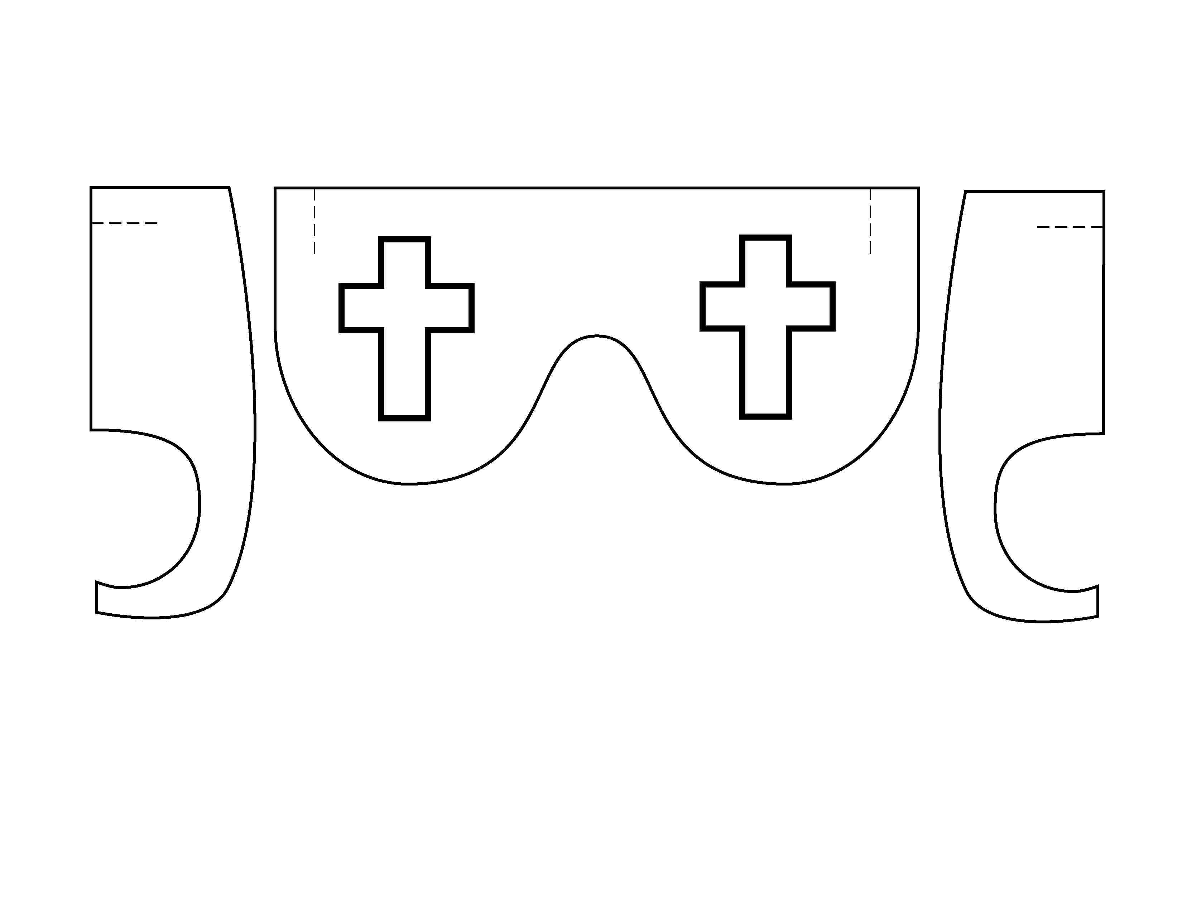
Appendix

NAME THAT WORRY

