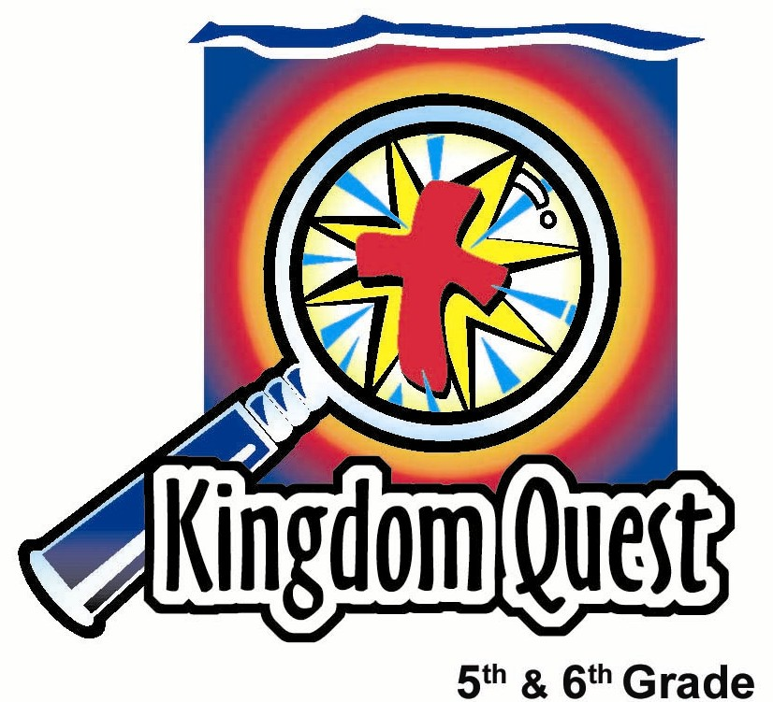
Date: _________________________
Series: God What About…?
(Apr-May) Year 2, Lesson 55

God, What About… Satan?

Take Home Point: *Jesus won the victory over Satan. *Repeat this phrase throughout the lesson.

Bible Event: 2 Thessalonians 3:3
Key Verse: 2 Thessalonians 3:3, “But the Lord is faithful and will give you strength and will protect you from the Evil One.” (NCV)

We will help kids know:
- Satan is a real creature, an angel who rebelled against God and was thrown out of heaven.
- Satan battles God by trying to deceive and lead people away from Him. He is our enemy.
- Two great lies of Satan are, “I am not real” or “I am so powerful you cannot stop me!”
- Our only sure defense against Satan is calling on God’s power to rescue and protect us!

We will help kids feel:
- Caution because Satan is real and is powerful.
- Comfort because God conquered him through the cross.

We will help kids do:
- Talk about some of their beliefs and feelings about Satan.
- Use an aluminum can to illustrate the main points of the lesson.
- Investigate Bible references regarding Satan.
THIS LESSON’S ROADMAP

DESTINATION | PAGE # | DISCOVERIES ON YOUR JOURNEY | SUPPLIES NEEDED
  Small Group Warm-Up | 3 | Red Hot candies and lemon-lime pop are used to illustrate God’s victory over Satan while students discuss their ideas about Satan. | - one can of lemon-lime pop  - small cups (one for each student)  - Red Hots candies  - bowl  - permanent marker  - Appendix A
Large Group   | 4  7 | Overview  Kids try to build a pyramid with empty pop cans. This demonstrates Satan wanting to be on top causing his fall from heaven.  The presenter uses an empty can to illustrate other characteristics and ideas of Satan. | - five to six extra empty pop cans  - permanent marker  - question marks copied from Appendix C page used for covering the walls on stage  - question marks copied and placed on presenter  - box covered with question marks  - Bible in the box  - table
Small Group Application   | 4  6 | Kids find proof in the Bible about questions discussed in large group.  Memory Verse Learning:  “Ball Hoops”  2 Thess. 3:3 will be repeated for lessons 55- 58 to assure the children of God’s power to rescue and protect believers. | - Appendix B copied for each student  - empty pop can  - tape and markers  - 3 medium beach ball,  - hula hoop  - masking tape

Small Group Warm-Up: 15 minutes
Purpose: Get pointed in the right direction! Build relationships and help guests feel at ease. Do the learning readiness activity that will point your group in the right direction for the lesson.

Supplies: a can of lemon-lime soda, a small paper cup for each student, Red Hot candies, Appendix A copied with questions cut apart, permanent marker, bowl for the extra Red Hot candies

We are going to try an experiment. Each one of you will receive a Red Hot candy to place in your cup. I am going to pour some of this lemon-lime soda on top of it.

Give each kid a cup, a Red Hot, and pour the cup half-full with soda.

How long do you think it will take for the soda to overpower the Red Hot?

Today we will talk about how Jesus won the victory over Satan. The Red Hot in this soda represents Satan. Notice that the soda is turning red, which reminds us of how Jesus won that battle over Satan. How did Jesus defeat Satan? (Jesus won the battle by shedding His blood on the cross.)

There is a lot of confusion in the world as to who Satan really is and how he works. Let’s discuss what you think about Satan using these discussion starter cards.

I would like each one of you to answer at least one of these. We are not looking for right or wrong answers, just what you think about the question.

I will read the card and, if you would like to answer it, I will hand you the card to hold as you answer. If others would also like to answer the question, hand the card to them when you are finished. Let’s enjoy some of these Red Hot candies and our lemon-lime soda while we share.

Place the bowl of candies in the center of the group and pour kids each a little soda to empty the can.

The questions to be asked are in the appendix page. These questions include: What do you think Satan looks like? What movies have you seen that have a demonic character in them and does it scare you? When have you sensed a strong presence of evil in a person or place? Where do you think Satan lives? How many other demons do you think there are? Do you think Satan is real or just a made-up character? What do you think is the worst thing the devil could do to us?

Before going to large group, make a special mark on the can with the marker to distinguish your group’s can from the others. Say:

Today we will discuss how *Jesus won the victory over Satan.

Large Group Overview: 20-30 minutes
Purpose: Help kids observe what the Bible says. Present the Bible event in creative fashion. Help kids begin to interpret what it means.

Kids try to build a pyramid with empty pop cans. This demonstrates Satan wanting to be on top causing his fall from heaven.

The presenter uses an empty can to illustrate other characteristics and ideas of Satan.

Small Group Application: 20-25 minutes
Purpose: Help kids map out the meaning of the Bible event in their lives. Use the questions to stimulate discussion, but don't feel tied to them. Allow the Holy Spirit to guide you. Include personal examples from your own faith journey. The example of Christ at work in your life will leave lasting impressions of how Christ can work in the children's lives.

Use your Bibles! Children need to learn how to look up references and follow along when scripture is read aloud. Allow for quality time of prayer at the close of the lesson.

Observation Questions: What happened?

Under each topic assign a different Bible verse to each kid to look up and read out loud. Have them look up their verses at the same time and wait for their turn to read. You may encourage the kids to underline the verses in their Bibles, or write the reference down, if it is meaningful to them.
Don’t feel like you have to cover every Bible reference. You may want to pick only one or two from each question as time allows or for what is most relevant to your group. Please try and cover at least every question with one scripture reference.

What does the Bible say about Satan’s fall?

Have kids look up Isaiah 14:12, Luke 10:18, and Revelation 12:7-9.

How does Satan get back at God by getting to us?

Have students read John 8:44, Matthew 13:19, and 1 John 3:7.

Can Satan suggest ideas into our minds?

Have kids refer to Genesis 3:1 & 13, Matthew 4:3, 2 Corinthians 4:4, and 2 Corinthians 11:14.

How is Satan defeated?

Look up Revelation 12:11, Revelation 17:14, Romans 16:20, Colossians 2:15, and John 12:31.

How do we battle against Satan?

See Ephesians 6:11, Hebrews 4:7, Luke 10:19, and Matthew 6:13.

Interpretation Questions: What does this mean?

How is your perspective about Satan different than when we had our warm-up discussion? Did your ideas about Satan change? Why?

How does reading the truth from God’s word make you feel?

Application Questions: What does this mean to me?

Supplies: empty pop can and paper cut out the size of a pop can for each kid (Appendix B), tape and markers

The key verse for today is 2 Thessalonians 3:3 and says, “But the Lord is faithful and will give you strength and will protect you from the Evil One.”

Give kids a strip of paper and markers.

Color in the cross on the paper and copy the key verse onto it. (Kids can copy the key verse from their Bibles.)
When they have finished, give kids each a pop can and have them wrap the paper around it and tape it.

This pop can symbolizes you and how Satan wants to crush you, but you receive protection from God when you cover yourself with Jesus Christ.

Jesus defeated Satan on the cross, so now we can call upon Him in times of need and He will hear us and deliver us. He will give us the power of His forgiveness and the power to resist Satan. *Jesus won the victory over Satan and he is no longer a threat to us.

Memory Verse Learning: 5 minutes
Purpose: Help kids to memorize and keep scriptures at heart. Using creative ways to help kids enjoy learning the key verse and in small group setting.

Supplies needed: 3 medium beach ball, hula hoop, masking tape

Memory Verse: 2 Thessalonians 3:3, “But the Lord is faithful and will give you strength and will protect you from the Evil One.” (NCV)

MV Presentation: “Ball Hoops”
Before class, if space permit, consider using rope to suspend the hula hoop from the ceiling. Have all the children recite the memory verse together. Two helpers hold the hula hoop as the players attempt to throw the beach ball through the hula hoop. Position the hula hoop so that the beach ball will be away from the children. Each player will have 3 chances to throw the beach ball through the hoop. Before they throw the first ball, they must recite the memory verse first. Divide the children into two teams. Score two points for each successful throw. The team with the most points wins.

Prayer Time:

Thank God that through the death and resurrection of Jesus, Satan is defeated. Pray for the Holy Spirit to remind kids that once they have received Jesus, they are covered in His protection. They no longer need to fear Satan.

Have kids pray for any areas in which they struggle, asking the Holy Spirit to remind them they are victorious in Christ.

Safety and Security: Safety and security procedures are important for each church to carefully define and implement according to their unique needs. The security, safety, illness and accident procedures described in this curriculum are provided for example purposes only and may not be appropriate, applicable or adequate for every situation. Each church is responsible for determining whether any security, safety, illness and accident procedures contained in the curriculum are appropriate, applicable or adequate for its unique situation. The activities described in this curriculum require adult supervision and may not be suitable for each child and each situation. Each church is responsible for ensuring that adequate adult supervision is provided for all activities and for determining whether an activity is appropriate for each child and each situation. Kids Kount Publishing disclaims all liability for the implementation of any procedures or the performance of any activities described in this curriculum.

Large Group Presentation: 20-30 minutes

God, What About…Satan?

This series “God, What About…?,” is designed to help kids learn to ask questions of God and seek the answers in the Bible. The prominent room decorations are question marks that can be copied from the appendix page and placed all around the stage area. (See attachments.)

The large group presenter is Mr. (Mrs. or Ms.) Answer Man (Answer Woman). Question marks can be pinned onto his/her clothing to help him (her) get into character. This character’s main line is “That’s a good question.”

A special box should be onstage that has question marks on the outside. Mr. Answer Man will open the box and find a Bible inside to help all realize this is where we are to find the true answers to our questions.

The presenter’s presentation will not be highly scripted and can be ad-libbed by working “That’s a good question” into much of the dialog.

Supplies: 5-6 empty pop cans, table, permanent marker, piece of paper cut out to fit around a pop can

Opening contest

Let’s have a contest to see which group is the best in the entire world. We will determine this by amount of points your group receives in the Great Aluminum Stack Up.

Each group needs to label two more cans just like the one brought in from small group so you will have a total of three labeled cans. After you have finished this, please send up one representative from your group with the three cans.

After kids come forward, explain the following.

All of these representatives need to work together to build a pyramid. Remember that you want to have the most points for your group. Each layer of the pyramid will have a different point value. The first layer will receive one point. Any pop can on the second layer will receive two points, and the third layer will receive five points. If there is a fourth layer, those cans will receive ten points.

Have kids build the pyramid on a table. Be sure to have a few unlabeled cans to add to the mix. If the pyramid does not fall down, the presenter needs to add his own cans and make it collapse.

Have kids return to their seats.

This will illustrate that, as each struggles to get their can on top, it gets more and more chaotic and it is impossible to stay on top very long. The pyramid is likely to collapse. This is used to demonstrate the first teaching point.

Where did Satan come from?

Do you know where Satan came from or where he originated? That’s a good question. *Jesus won the victory over Satan. He fell from heaven where he was once a beautiful angel. He said, “If I stay in heaven, I am not number one. We all know that I am as good as God and everyone should be worshiping me, not God.”

Because of this attitude, Satan was cast out of heaven. Demons are other angels that worshiped Satan instead of God and they were cast out along with him.

Our pyramid falling down is an example of this. Satan wanted to be on top, but the result was a complete collapse for him and his followers.

Satan gets back at God by getting to us

How does Satan get back at God? That’s a good question. *Jesus won the victory over Satan. When Satan fell, he became an enemy of God. Because of this, he will do whatever he can to hurt God’s prized creation—people. People were meant to have a perfect relationship with God. Satan wants to mix that up.

Satan will hurt this relationship between God and man by lying and deceiving. He is known as a murderer and tempter. He helped usher sin into the world through Adam and Eve and continues even today to get back at God by trying to rob us of our relationship with Him.

Satan wants to smash and destroy us.

Smash a pop can that had fallen from the pyramid.

Satan can suggest ideas into our minds

Breathe into another empty pop can.

Does Satan have the power to suggest ideas into our minds? That’s a good question. He sure does. He can use the influences of the world around us, or our own thought patterns to suggest ideas.

Just because a thought comes from him doesn’t mean that we must believe it or continue to dwell on it. *Jesus won the victory over Satan. We can reject it as soon as we realize that it came from the enemy. For example, when you are tempted to do something wrong and you hear that voice say, “Go ahead, no one will know,” you do not need to listen and follow that suggestion.

How is Satan defeated?

Take the cutout paper and draw a cross on it in front of the kids.

How is Satan defeated? That’s a good question. *Jesus won the victory over Satan. Satan is defeated by God’s power. God could have crushed Satan like a tin can. He could have forced him to obey. But God would not do that.

Instead, God took away Satan’s power giving us freedom from our sin. He did that when He sent Jesus to die on the cross and raised Him again.

When Jesus’ blood was poured out for us, we received the power of God for forgiveness. When we have faith in Jesus, we are not held in the grip of Satan. Instead, we are freed so that we can live forever with God and serve Him.

How do we battle against Satan?

Here’s another great question for you. How do we battle against Satan? That’s a good question.

Place the paper with the cross around a pop can and tape it on.

We do battle with Satan by covering ourselves with Jesus Christ. *Jesus won the victory over Satan. This means that we can call upon Him in times of need and He will hear us and deliver us. He will give us the power of His forgiveness and the power to resist Satan.

Those were some great questions we just discussed, but where do we look to find proof of the answer we talked about?

Go to the question box and pull out a Bible.

All the answers we need in our life are here in the Bible. You will go back to your small groups and explore these questions by reading God’s answer in the Bible.

Let’s pray before we go.

Heavenly Father, thank You for sending Jesus to die on the cross and raising Him again. *Jesus won the victory over Satan. Through Jesus, you give us the power of forgiveness and the power to resist Satan. Thank You that we can have a personal relationship with You and that Satan is already defeated. In Jesus’ name. Amen.

Lesson 55
Small Group Warm-Up
- one can of lemon-lime pop
- small cups (one for each student)
- Red Hots candies
- bowl
- permanent marker
- Appendix A

Large Group
- five to six extra empty pop cans
- permanent marker
- question marks copied from Appendix C page used for covering the walls on stage
- question marks copied and placed on presenter
- box covered with question marks
- Bible in the box
- table

Small Group Application
- Appendix B copied for each student
- empty pop can
- tape and markers

Memory Verse Learning
- 3 medium beach ball, hula hoop, masking

Appendix A

What do you think What movies have you seen
Satan looks like? that have a demonic
character in them? Did it
scare you?

When have you sensed Where do you think Satan
a strong presence of evil lives?
in a person or place?

How many other demons Do you think Satan is real
do you think there are? or just a made-up character?

What do you think is the
worst thing Satan can do?

Appendix B Cut one copy of template for each student. They can color the cross and stick the strip to their can.



Appendix C: Question marks of different colors to be copied for decorating the stage area.
?

