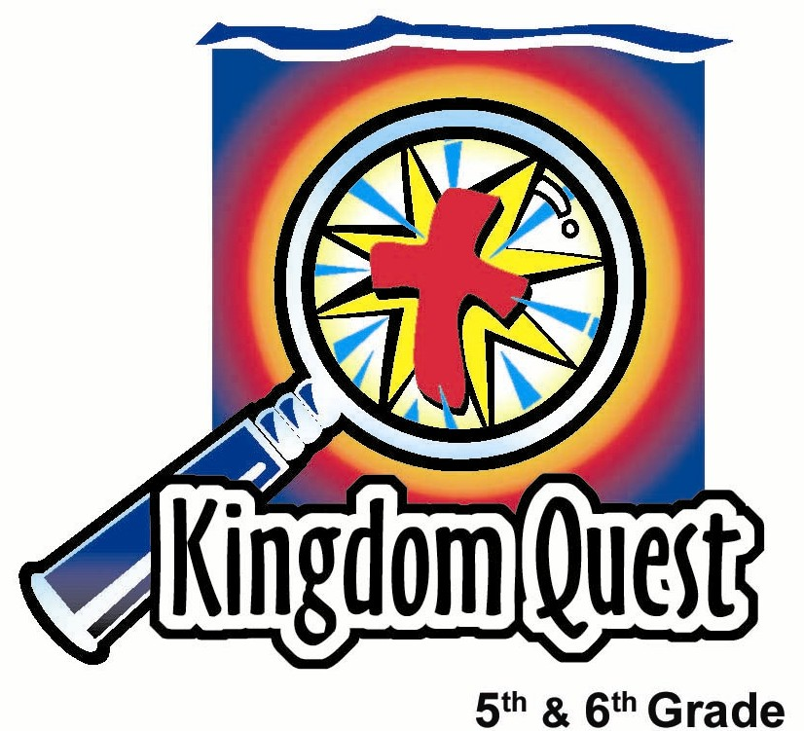
Date: _________________________
Series: God What About…
(Apr-May) Year 2, Lesson 57
God, What About…
Heaven and Hell?

Take Home Point: *Heaven is life forever with God—hell is life forever without God.
*Repeat this phrase throughout the lesson.

Bible Event: Matthew 13:41-43; 1 Corinthians 13:12; 1 Corinthians 15:51-57
Key Verse: John 3:36, “Those who believe in the Son have eternal life, but those who do not obey the Son will never have life. God's anger stays on them.” (NCV)

We will help kids know:
- Death becomes a door to eternal life for those who know Jesus and eternal punishment for those who have rejected Him.
- Heaven is a real place. The main feature is enjoying a perfect relationship with God.
- Hell is a real place, a place filled with real pain, the worst being the complete absence of God.

We will help kids feel:
- Joyful anticipation in someday being home in heaven.
- Cautious alertness that hell is a real place and we do not want to be there.

We will help kids do:
- Play a chee cheong fun “stabbing” game
- Place waxed paper over their eyes to see how heaven and hell are not clear yet.
- Place a piece of black paper over their eyes to help understand the darkness there is in hell.

THIS LESSON’S ROADMAP

DESTINATION | PAGE # | DISCOVERIES ON YOUR JOURNEY | SUPPLIES NEEDED
  Small Group Warm-Up | 3 | Kids share ideas of what they think heaven and hell are like. | - none
Large Group   | 4  8 | Overview  Teaching point: Contestants for the boys’ team and girls’ team try to stab chee cheong fun with toothpicks while waxed paper covers their eyes to demonstrate Matthew 13:41-43 and how we cannot see heaven clearly right now.  Death becomes a doorway to heaven (demonstrate using a large piece of waxed paper). | - table  - two sheets of white paper  - a piece of waxed paper cut 5 x 12-inches for each kid  - a piece of black construction paper cut 5 x 12-inches for each kid  - question box - box cover with question marks  - one 12 x 12-inch piece of waxed paper  - marker  - scissors  - a roll of chee cheong fun cut into six sections  - toothpicks
Small Group Application   | 4  6 | Kids are given the opportunity to discuss their questions about heaven and hell.  Memory Verse Learning:  “Cloud to Cloud”  2 Thess. 3:3 will be repeated for lessons 55- 58 to assure the children of God’s power to rescue and protect believers. | - none  - 20 “cloud” shapes with memory verse written  - plastic sheet

Small Group Warm-Up: 15 minutes
Purpose: Get pointed in the right direction! Build relationships and help quests feel at ease. Do the learning readiness activity that will point your group in the right direction for the lesson.

Supplies: none

Begin by saying:

Kids, let’s talk about your ideas about heaven and hell. Let’s begin with heaven. If you have any ideas to share about what you think heaven might be like.

To help kids share, you might ask further questions like:

What kind of creatures do you think would be there? What will be the best thing about heaven? What do you think people will look like? What do you think people will do in heaven?

Do not rush the discussion as the children may not have had a previous chance or desire to think about the topic.

Now, what are some ideas you have about hell? Do you think hell is a real place? Do you think there is fire there?

Further questions that can be asked:

What do you think is the worst thing about hell? What is the best thing about it?

Today as we talk about heaven and hell, we will learn *heaven is life forever with God; hell is life forever without God.

Large Group Overview: 20-30 minutes
Purpose: Help kids observe what the Bible says. Present the Bible event in creative fashion. Help kids begin to interpret what it means.

Teaching Point: Contestants for the boys’ team and girls’ team try to stab chee cheong fun with toothpicks while waxed paper covers their eyes to demonstrate Matthew 13:41-43 and how we cannot see heaven clearly right now.

Death becomes a doorway to heaven (told using a large piece of waxed paper).
Small Group Application: 20-25 minutes
Purpose: Help kids map out the meaning of the Bible event in their lives. Use the questions to stimulate discussion, but don't feel tied to them. Allow the Holy Spirit to guide you. Include personal examples from your own faith journey. The example of Christ at work in your life will leave lasting impressions of how Christ can work in the children's lives.

Use your Bibles! Children need to learn how to look up references and follow along when scripture is read aloud. Allow for quality time of prayer at the close of the lesson.

Observation Questions: What happened?/ Interpretation Questions: What does this mean?

How does Matthew 13:41-43 compare heaven and hell? (Hell is like a blazing furnace where people will cry out because of extreme pain. Heaven is the Father’s kingdom where His people will shine like the sun because they have His approval.)

Read 1 Corinthians 13:12.

How is our vision and knowledge now as compared to how it will be in heaven? (Now our vision is unclear like a blurred image in a mirror. In heaven we will see clearly. Now our knowledge is incomplete. In heaven we will have complete knowledge.)

What do you think this means? (We do not understand many of the things of God or why He does what He does, but when we meet Him face to face, all this will be revealed.)

Application Questions: What does this mean to me?

Supplies: none

It is very important that time does not run out before letting each child share how they feel about the reality of heaven and hell. Offer the assurance that they can spend forever with God in heaven based on what Jesus Christ has done for them. The prayer following the activity will help.

Let kids ask questions, but following are more questions to help discussion get going. Be prepared to answer any questions kids have with scripture references. If you are unsure about an answer, tell kids you will ask the pastor or some other scholar for help and will relay the information back next week.

Remember, we may not have the answer. We still “cannot see clearly” everything about heaven and hell.

What does Jesus talk about more in the Bible, heaven or hell? (Jesus talks more about hell than heaven. That is because He is warning people that they don’t want to suffer God’s punishment in hell. He doesn’t give more details about heaven because we may get more attracted by the details of heaven than the main attraction…God Himself.)

Which people are the most excited about heaven? (Those who are the most excited about knowing, loving and serving God here on earth. They have an understanding of how great it will be to know, love, and serve God in heaven.)

Who will go to hell? (Those who reject God and the salvation that He offers will enter hell at death. Psalm 9:17 says, “Wicked people will go to the grave, and so will all those who forget God.”)

What will we do when we get to heaven? (Worship God and enjoy a friendship with Him; enjoy the people and creatures with us; have the greatest party with the greatest friends and the greatest God forever.)

What does heaven look like? (See Revelation 21 and 22. This is John’s vision that describes heaven in picture language, sometimes using symbols. He describes as best as possible in human words, but the glory of heaven is beyond our comprehension.)

Will we wear white robes? (Revelation 3:4 and 7:13 talk about white robes. The picture might be like the white linens people wore for weddings in Jesus’ time. Another picture of believers is as the bride of Christ made spotless and clean and radiant in heaven. This may be describing more about our holiness and perfection than the clothes we wear.)

Do we get to fly? (Scripture does not address this. Heaven will be in a different dimension than time and space we have on earth, so again this is beyond our imagination. Certainly, flying heavenly creatures are described around God’s throne. Seraphs are mentioned in Isaiah 6:2.)

Who will be there? (All who have trusted in God’s forgiveness purchased by Christ will be there. This is from Adam and Eve’s day through the last day. In addition, there will be many heavenly creatures. But best of all will be God the Father, His Son Jesus, and the Holy Spirit that fills all of heaven.)

Do people become angels? (No. People are created beings. We receive a new body but do not become something else.)

Do we get new parts to our body if present parts have become disabled or removed? (We receive an entirely new body. See 1 Corinthians 15:53-54.)

Will I live with my family? (Don’t know. But, in heaven, all are united as one family of God. We won’t have the same kind of needs as we do now for a family to nurture us and teach us like we do now. We will be as close as family to everyone.)

Do we live in mansions? (Yes, better than we can imagine here on earth.)

Remember *heaven is life forever with God; hell is life forever without God.

Who will go to heaven? Our key verse from John 3:36 says, “Those who believe in the Son have eternal life, but those who do not obey the Son will never have life. God's anger stays on them.”

If you are not sure whether you will go to heaven or hell when you die, please talk to me after dismissal. Jesus and I want all of you to be with us in heaven together. Let’s pray.

Memory Verse Learning: 5 minutes
Purpose: Help kids to memorize and keep scriptures at heart. Using creative ways to help kids enjoy learning the key verse and in small group setting.

Supplies needed: 20 “cloud” shapes with memory verse written; plastic sheet

Memory Verse: 2 Thessalonians 3:3, “But the Lord is faithful and will give you strength and will protect you from the Evil One.” (NCV)

MV Presentation: “Cloud to Cloud”
Paste the clouds randomly on the piece of plastic sheet. Lay it out before the children and say that the clouds remind us of heaven. Then ask for volunteers to jump from cloud to cloud according to the memory verse. End by having everyone recite the memory verse.

Prayer:

Dear God, thank You so much that You did not want to spend forever without us. Even though our world is sinful and we can’t see clearly your presence, we know that You are here. Even though we see but a glimpse of Your love, we know that Your love is real. You loved us enough to give us Your Son Jesus. He took all the punishment of our sin on Himself when He died on the cross.

Thank You for giving us the gift of Jesus. Right now we want to tell You that we trust Jesus as our Savior. Because of Him, we are sure we can go to heaven through the door He provided and be with You forever. Help us to always follow You and love You with our whole heart. In Jesus’ name. Amen.

Safety and Security: Safety and security procedures are important for each church to carefully define and implement according to their unique needs. The security, safety, illness and accident procedures described in this curriculum are provided for example purposes only and may not be appropriate, applicable or adequate for every situation. Each church is responsible for determining whether any security, safety, illness and accident procedures contained in the curriculum are appropriate, applicable or adequate for its unique situation. The activities described in this curriculum require adult supervision and may not be suitable for each child and each situation. Each church is responsible for ensuring that adequate adult supervision is provided for all activities and for determining whether an activity is appropriate for each child and each situation. Kids Kount Publishing disclaims all liability for the implementation of any procedures or the performance of any activities described in this curriculum.

Large Group Presentation: 20-30 minutes

God, What About…Heaven and Hell?

This series “God, What About…?” is designed to help kids learn to ask questions of God and seek the answers in the Bible. The prominent room decorations are question marks that can be copied from the appendix page and placed all around the stage area. (See Lesson 55.)

The large group presenter is Mr. Answer Man ((Mrs. or Ms. Answer Woman). Question marks can be pinned on his/her clothing to help him (her) get into character. This character’s main line is “That’s a good question.”

A special box should be onstage that has question marks on the outside. Mr. Answer Man will open the box and find a Bible inside to help the kids realize this is where we are to find the true answers to our questions.

The presenter’s presentation will not be highly scripted, and can be ad-libbed by working “That’s a good question” into much of the dialog.

Supplies: table, two sheets of white paper, a piece of waxed paper cut 5 x 12-inches for each kid, a piece of black construction paper cut 5 x 12-inches for each kid, question box - box cover with question marks, one 12 x 12-inch piece of waxed paper, marker,
scissors, a roll of chee cheong fun cut into six sections, toothpicks

Optional: tape

Introduction of Mr. (Mrs. or Ms.) Answer Man (Answer Woman)

In advance, set up a table at one end of the room with enough room behind it for two kids to stand side by side. Set the table with two pieces of white paper and six mini chee cheong fun. Say:

Good morning, girls and boys. As many of you already know, I am Mr. Answer Man (Mrs. or Ms. Answer Woman). I love to hear questions so I can find the answers in a very special book that will be revealed in a while.

Today we will talk about heaven and hell, and I am sure you have many questions about it. We will be able to answer them soon, but first, here is a challenge for you.

Chee Cheong Fun “Stabbing” Contest

For this exciting contest, I need one boy and one girl to come stand behind this table as representatives for their teams.

Choose one boy and one girl.

_______ (insert the girl’s name) will “hide” a chee cheong fun on a white sheet of paper for the boys’ team to find and _______ (insert the boy’s name) will hide a chee cheong fun for the girls to find.

I need each team (boys and girls) to pick three participants who will stab their chee cheong fun with a toothpick.

The presenter or the kids may choose the three girl and three boy contestants.

Each participant’s goal is to walk to the table with a toothpick in his/her mouth, stab a chee cheong fun and eat it. Then he/she will tag the next person who will continue the game. The first team to successfully get all their chee cheong fun stabbed and eaten wins.

You may think this will be pretty easy. But there is another challenge added to the game. The participants must keep their eyes covered with waxed paper.

Our helpers over here at the table will be “hiding” the chee cheong fun on a piece of white paper to add one more level of difficulty. Those doing the relay must make sure there is no peeking. Your eyes must be covered with the waxed paper.

Give each of the six kids participating in the relay a toothpick. Make sure they hold the waxed paper tightly to their faces to ensure no peaking. If tape is used, the hands of the contestants need to be behind their backs.

Ready, get set, go!

If you have more time, play another round. Also, if it is too difficult, allow team members to help direct the “stabber” to the chee cheong fun.

Seeing Through Waxed Paper

When finished playing the game, bring out the question box.

Today we are talking about heaven and hell. I have a piece of waxed paper for each of you.

Pass out the waxed paper.

Hold the waxed paper over your eyes and try to look through it as I read the following verse. This is from 1 Corinthians 13:12, “Now we see a blurred image in a mirror. Then we will see very clearly. Now my knowledge is incomplete. Then I will have complete knowledge as God has complete knowledge of me.”

Have the kids put the waxed paper down.

This is a verse that begins to describe what it will be like in heaven. Right now, being in this world, we cannot see the majesty, the power, and the love of God as clearly as we will in heaven.

We see how much God loves us through His gift of Jesus and His power in all His created work. But, it is not face-to-face. It is not clear, like looking through this waxed paper.

Place your waxed paper over your eyes again and have a short conversation with a person sitting next to you.

Take a minute for the kids to talk to one another.

Though your friends were there, it was hard to see them clearly. The same is true in our life here. We know God is here and is all around us. We also know His love for us. But it isn’t as clear as it will be someday.
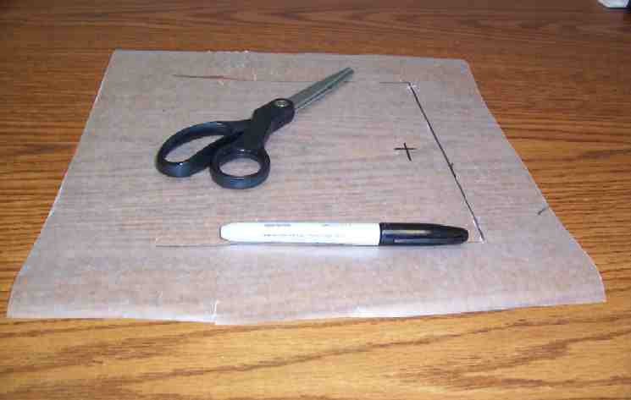
Death Becomes a Doorway to Heaven

Have the 12 by 12-inch piece of waxed paper, scissors, and marker ready. Be ready to cut a door into the piece of waxed paper by cutting the top, side and bottom frame of the door two inches from the sides. Do not cut the left side. This will be the hinge to open it. (See picture.)

The Bible tells us that death is a consequence of our sin and rebellion against God. Death is a terrible thing because it separates us from our loved ones. This was not a part of God’s design.

But God took a terrible thing and turned it into a wonderful thing. He did this.

Cut the door in the waxed paper.

He made death a doorway to heaven. God does not want us to live forever here in a world where we can only see Him through waxed paper. Instead, He wants us to live forever with Him in heaven where we will see Him clearly.

When we die, we have the opportunity to live with Him forever. This is what God has created for us. John 3:36 says, “Whoever believes in the Son has eternal life, but whoever rejects the Son will not see life. Instead, he will see God’s constant anger.”

It also says in 1 Corinthians 15:51-57, “But look! I tell you this secret: We will not all sleep in death, but we will all be changed. It will take only a second -- as quickly as an eye blinks -- when the last trumpet sounds. The trumpet will sound, and those who have died will be raised to live forever, and we will all be changed. This body that can be destroyed must clothe itself with something that can never be destroyed. And this body that dies must clothe itself with something that can never die. So this body that can be destroyed will clothe itself with that which can never be destroyed, and this body that dies will clothe itself with that which can never die. When this happens, this Scripture will be made true:"

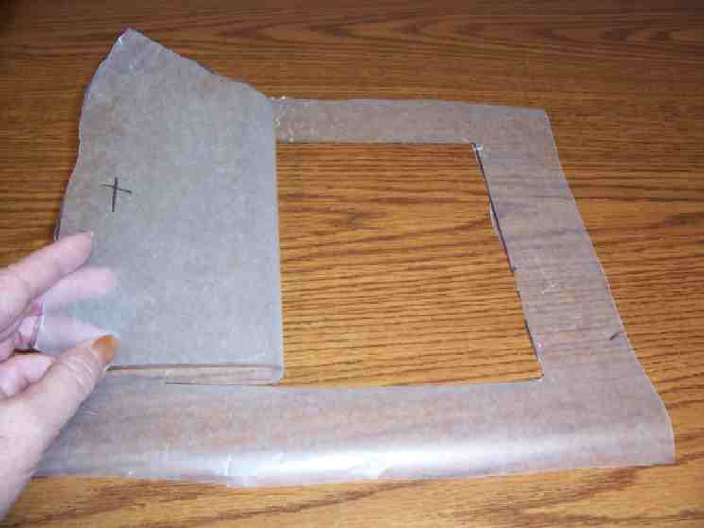
“Death is destroyed forever
in victory!
Death, where is your victory?
Death, where is your pain?

Death's power to hurt is sin, and the power of sin is the law. But we thank God! He gives us the victory through our Lord Jesus Christ.”
Use a marker to draw a door handle in the shape of a cross.

When we hang on to what Jesus has done for us by His death and His resurrection, then death becomes a doorway for us to live forever face to face with God.

When I open this door,

Open the door of the waxed paper.

I see clearly that God wants to invite us into His presence and His home so we can enjoy each other forever. Later we will talk about what it means to be in that home.

The Reality of Hell

But what about those who decide that they do not want to go through the door to eternal life with God?

These people are saying, “I don’t want to receive what you have done for me. Instead, I think I can earn my own way to heaven or maybe there are other gods to follow.”

Some people even believe there are many different ways that lead to heaven. Have you ever met someone who didn’t believe that there is a heaven and hell?

All of these people are telling God, “No, thank You. I don’t want any part of You in my life!” Throughout their lives they have said this many times. “No thank You, God. I don’t want You in my life. No, thank You. I don’t want You in any part of me.”

Finally, God will respond, “Okay, you have your wish.”

So, at death, instead of the door to heaven being opened for them, it will be closed. Hell is a place where they experience the complete absence of God.

Pass out the black pieces of paper.

Take this black piece of paper and put it over your eyes. Imagine what hell would be like. There is no feeling of being loved here. There is no hope of your world getting better tomorrow. There will be no people to talk to and share your suffering with. There will be complete darkness. The only feeling you have is pain because the punishment of God is upon you.

The Bible describes it this way. Matthew 13:41-42, “The Son of Man
will send out His angels, and they will gather out of His kingdom
all who cause sin and all who do evil. The angels will throw them into
the blazing furnace, where the people will cry and grind their teeth
with pain.”

Stop and be quiet for just a moment. Keep the darkness over your eyes. Everyone please be very still. Think about what this might feel like. Wouldn’t it be horrible? We wouldn’t want this for ourselves or for anyone else.

Do you know who wants even more not to see this happen to anyone? God. He cares more than anyone else. He doesn’t want people to say “no” to Him. But, God will never force people to grab the door handle of Jesus Christ and have the doorway to heaven opened to them. He will give them their wish if they say “no.”

In your small groups, you will have a chance to talk about this. Is the thought of hell scary to you or is the thought of heaven comforting?

If you are not sure if you would go to heaven or hell if you died, you will have a chance to talk in your small group and understand how you can know for sure. It is being able to take hold of Jesus Christ who is the doorknob and open the door to everlasting life in heaven with God.

Let’s close in prayer:

Dear God, even though we cannot clearly see You now or even know what heaven and hell are actually like, we thank You that You have made a way to be with You through the cross of Jesus.

Help all of us who are not sure about where we will go when we die accept the free gift of Jesus so that we can be with You in heaven. In Jesus’ name. Amen.

Dismiss kids to go back to small groups.

Lesson 57
Small Group Warm-Up
- none

Large Group
- table
- two sheets of white paper
- a piece of waxed paper cut 5 x 12-inches for each kid
- a piece of black construction paper cut 5 x 12-inches for each kid
- question box - box cover with question marks
- one 12 x 12-inch piece of waxed paper
- marker
- scissors
- a roll of chee cheong fun cut into six sections
- toothpicks

Small Group Application
- none

Memory Verse Learning
- 20 “cloud” shapes with memory verse written (see below)
- plastic sheet
2 Thessalonians
3:3

