
Date: _________________________
Series: God, What About…?
(Mar-May) Year 2, Lesson 58
God, What About… Knowing If I’m Saved

Take Home Point: *I am saved by the blood of the lamb, Jesus. *Repeat this phrase throughout the lesson.

Bible Event: John 20:31; Ephesians 2:8-9
Key Verse: Romans 6:23, “When people sin, they earn what sin pays -- death. But God gives us a free gift -- life forever in Christ Jesus our Lord.”

We will help kids know:
- The definition of being saved is to be rescued from a life apart from God and brought into a life with Him. This life begins now and will last eternally.
- Feeling is not where their certainty of salvation lies. It lies in the fact that Jesus died and rose again.
- They must receive the gift of Jesus’ sacrifice by faith. They need to believe the truth about Jesus, trust Him as their Savior, and turn their life over to His control.

We will help kids feel:
- Secure and at peace because of their faith in Jesus Christ as their Savior.
- Joy in the assurance of their salvation.

We will help kids do:
- If they have never received Jesus as their Savior, they will have the opportunity to receive Him as the Holy Spirit leads.
- Make a witness card that gives the steps to salvation.

THIS LESSON’S ROADMAP

DESTINATION | PAGE # | DISCOVERIES ON YOUR JOURNEY | SUPPLIES NEEDED
  Small Group Warm-Up | 3 | Discuss why God should let them into heaven. | - snacks (optional)
Large Group   | 3  6  13 | Overview  Audience participation drama—The kids meet Mr. Success Chan, Pauline Popularity, May Dogooder, and Benjamin Believer who all want to get to heaven.  Appendices (4) | - box  - wallet or bag filled with play money  - high school letter jacket or cheerleader pom-poms  - hymn book  - list of all the good things May Dogooder did  - cross (could just be a paper cross)  - script cards for Success Chan and May Dogooder (see Appendix B)  - Appendix D with steps of the bridge illustration  - gates of heaven or something that represents heaven (optional)
Small Group Application   | 4  5 | Kids review the bridge illustration and make a testimony card.  Memory Verse Learning:  “Zoo”  2 Thess. 3:3 will be repeated for lessons 55- 58 to assure the children of God’s power to rescue and protect believers. | - Appendix C, “bridge”—one copy per kid  - Appendix A, “God’s Guarantee”—one copy per kid  - chairs

Small Group Warm-Up: 15 minutes
Purpose: Get pointed in the right direction! Build relationships and help guests feel at ease. Do the learning readiness activity that will point your group in the right direction for the lesson.

Supplies: snacks as the kids discuss (optional)

Begin discussion with:

I have a question for you. Let’s pretend a terrible tragedy happened. The roof of this building just caved in, and all of us were killed.

If you died today would you be absolutely sure that you would go to heaven? Take a few seconds to think about your answer, and then I would like you share with us.

Wait ten seconds then discuss. Don’t let them explain “why” yet.

Here is my next question. You are standing before God and He asks you this question. “Why should I let you into my heaven?”

What would you tell Him? I would like each of you to think about your answer before anyone else shares.

After a few seconds of silence, let kids explain.

Today we will find out how you can know for sure that you are going to heaven when you die. Today’s take home point is: *I am saved by the blood of the lamb, Jesus.

Large Group Overview: 20-30 minutes
Purpose: Help kids observe what the Bible says. Present the Bible event in creative fashion. Help kids begin to interpret what it means.

Audience participation drama—The kids meet Mr. Success Chan, Pauline Popularity, May Dogooder, and Benjamin Believer who all want to get to heaven.
.

Small Group Application: 20-25 minutes
Purpose: Help kids map out the meaning of the Bible event in their lives. Use the questions to stimulate discussion, but don't feel tied to them. Allow the Holy Spirit to guide you. Include personal examples from your own faith journey. The example of Christ at work in your life will leave lasting impressions of how Christ can work in the children's lives.

Use your Bibles! Children need to learn how to look up references and follow along when scripture is read aloud. Allow for quality time of prayer at the close of the lesson.

Supplies: Appendix page C (“Bridge”) and Appendix A (“God’s Guarantee”) copied for each kid, pencils

Let’s look at some other verses that help us know the truth about salvation.

Read 2 Timothy 3:16.

Can we trust what the Bible says? Why? (It is the inspired word of God.)

Read John 3:16.

How can we receive the gift of salvation? (Believe in Jesus and what He did to pay for our sins on the cross.)

Read Ephesians 2:8-9.

What does this passage say about how we are saved and not saved? (The Holy Spirit convicts our hearts of sin and by faith we receive God’s free gift. We don’t do anything to earn the gift.)

Pass out Appendix C so the kids can fill in the bridge illustration presented in large group.

I would like us to fill out our own bridge illustration that we talked about in large group.

Fill in the blanks and draw in the cross. Have the kids draw the arrow of faith.

How can we be sure of salvation? *We are saved by the blood of the lamb, Jesus. We can know this for sure because the Bible is all about what Jesus did for us, and the Bible is God’s inspired word.

We know that we are in need of a Savior as our key verse from Romans 6:23 says, “When people sin, they earn what sin pays -- death. But God gives us a free gift -- life forever in Christ Jesus our Lord.”

Pass out Appendix A (God’s Guarantee) to each student. Read through the points. Then say:

Let’s have a couple minutes of silence. I would like each of you to think through these three points and talk to God in your heart. If you have never trusted in Christ before, this is an incredible opportunity for you to know for sure that you will be allowed to enter the gates of heaven when you die.

If you have trusted Christ before, you can pray again as a commitment to Him. Please realize that no one is forcing you to pray. Listen to God talking to you through the Holy Spirit. Do you know for sure you will go to heaven? If not, would you like to place your trust in Jesus? Let’s pray.

Allow ample time for the kids to pray.

Is there anyone here who is sure of everlasting life now that wasn’t sure before you came this morning? What would your answer be now if you were standing before God and asked why you should be allowed to enter heaven? (Because I trust in—synonymous words: believe in, commit my life to—Jesus as my Savior and He gave His life for me.)

IMPORTANT: Be sensitive to the Holy Spirit. Those placing their trust in the prayer and not Christ’s finished work may have been obedient to your suggestion to pray and not to the Holy Spirit’s prodding. If this is the case, seek guidance and wisdom from the Lord or from godly counsel in your church.

Memory Verse Learning: 5 minutes
Purpose: Help kids to memorize and keep scriptures at heart. Using creative ways to help kids enjoy learning the key verse and in small group setting.

Supplies needed: chairs

Memory Verse: 2 Thessalonians 3:3, “But the Lord is faithful and will give you strength and will protect you from the Evil One.” (NCV)

MV Presentation: “Zoo”
Since this is the last class, we are going to have some fun and noise. Ask the group to sit in a circle and have one less chair than there are people. The extra person stands in the middle as the Zookeeper. Choose 4 animals and everyone is assigned the name of each animal. Before the game begin, call out the name of one of the assigned animal and have all the children with those names to recite the memory verse. Continue with the names of the other three animals.

The Zookeeper begins by reciting the memory verse and then call out several of the animal names. Anyone with those animal names must exchange chairs. At the same time, the Zookeeper tries to sit in one of the vacated chairs. The person who fails to get a chair becomes the new Zookeeper. The Zookeeper also has the option of calling out “Zoo” at which time all of the children must exchange chairs. (Be sure to use sturdy chairs. This game is really wild and can result in children landing in each other’s laps. Be sure to emphasize fun and safety before the game begins and be sure to monitor the game.) End by asking all the ‘Zoo animals’ to recite the memory verse together.

Closing Prayer:

Thank God for His grace and that we can receive eternal life through faith in the finished work of Jesus on the cross. Encourage kids to pray for those who do not yet have faith in Jesus.
Safety and Security: Safety and security procedures are important for each church to carefully define and implement according to their unique needs. The security, safety, illness and accident procedures described in this curriculum are provided for example purposes only and may not be appropriate, applicable or adequate for every situation. Each church is responsible for determining whether any security, safety, illness and accident procedures contained in the curriculum are appropriate, applicable or adequate for its unique situation. The activities described in this curriculum require adult supervision and may not be suitable for each child and each situation. Each church is responsible for ensuring that adequate adult supervision is provided for all activities and for determining whether an activity is appropriate for each child and each situation. Kids Kount Publishing disclaims all liability for the implementation of any procedures or the performance of any activities described in this curriculum.
Large Group Presentation: 20-30 minutes

Audience Participation Drama

This series “God, What About…?” is designed to help kids learn to ask questions of God and seek the answers in the Bible. The prominent room decorations are question marks that can be copied from the appendix page and placed all around the stage area. (See Lesson 55.)

The large group presenter is Mr. (Mrs. or Ms.) Answer Man (Answer Woman). Question marks can be pinned onto his clothing to help him (her) get into character. This character’s main line is “That’s a good question.”

A special box should be onstage that has question marks on the outside. Mr. Answer Man will open the box and find a Bible inside to help all realize this is where we are to find the true answers to our questions.

The presenter’s presentation will not be highly scripted, and can be ad-libbed by working “That’s a good question” into much of the dialog.

Props: gates of heaven or something that represents heaven (optional)

Supplies and volunteers:
- Volunteer #1 is given a box with the following items inside: wallet or moneybag filled with play money, script card for Success Chan (see appendix)
- Volunteer #2 is given a letter jacket to wear or pom-poms for cheerleader
- Volunteer #3 is given a grandma hat or wig, hymn book, paper with a list of good things May Dogooder did, i.e., went to church every Sunday, perfect attendance in Sunday School for 18 years, Sunday school teacher for 20 years, sang in the choir, etc., script card for May Dogooder (see appendix)
- copy of the large group presentation for the person representing “God”
- cross (could just be a paper cross)
- large poster board, clip board or white board to draw bridge illustration (see appendix)

God, What About…Knowing If I’m Saved?

Adult male needs to be in position before the large group begins behind a partition or on a microphone so only his voice will be heard. The speaker will need to modify voice into a majestic sound, as if it was the voice of God coming from the gates of heaven. He is given a copy of the large group presentation.

Today we have been talking about why God should allow us to enter His heaven. As the Answer Man (or Answer Woman), I want to help you find the answer to this very important question.

I will need the help of four people from the audience.

Choose four kids, two boys and two girls, to come forward.

First Person Wanting to Enter Heaven – Mr. Success Chan

Have first male volunteer step forward.

I would like to introduce to you a very successful and important person. His name is Mr. Success Chan. Chan leads a very successful life. He has done very well with his business, well with his family, and has been a model for all in his community.

Certainly, if he has been so successful in everything, he will be successful in getting into heaven.

Success Chan needs to have something in his hands when he gets to heaven. What will it be?

Reach into the box and hand him the wallet or moneybag.

Please, Mr. Success Chan, let’s walk over here.

Walk to where the gates of heaven are. This could be pretend or something that represents them.

You are now standing at the gates of heaven. I wonder if God will open the gates for you to enter.

Male volunteer with his “God voice” says through the partition or microphone,

Why should I let you into My heaven?

What would you like to tell him Mr. Success Chan?

Give the script card to the student. Student says:

I have been successful. I have been a good father and husband. I haven’t cheated too many people. I am a really nice guy. I am sure you will let me into your heaven. I am sure you will need a successful person like me there.

“God” replies:

One time Jesus told a story about a man who sought success his entire life. He built one financial empire upon another. But, when he died, he had no riches in the kingdom of God. Instead, he left his money on earth, could not enter heaven, and was separated from God for eternity. (Read Luke 12:16-21.) I am so sorry that you did not read Luke 12:16-21 earlier.

My answer to you concerning the gates of heaven being opened is, you have no riches here in heaven. Your request for entering heaven has been denied!

Second Person Wanting to Get Into Heaven – Pauline Popularity

Second volunteer steps forward. This should be a female.

Pauline Popularity, please come forward. I have something special for you in this box.

Pull out the pom-poms or letter jacket.

What is in your hands as you try to enter heaven? Why, it is all the great accomplishments you have done that everyone thought were so wonderful. These are accomplishments on the soccer field, cheerleading team, and homecoming queen. You were very popular and pretty. So, certainly, God would allow you to enter heaven since you are such a likeable person.

So, God, what do you say?

God speaks.

It is true that you knew a lot of people and they all really liked you. But, there is one very important person that you did not know. That is Me. My Son Jesus said it this way, “Unless you know Me you won’t know the Father.”

Your popularity with people will not get you into heaven. You had plenty of opportunities to get to know Me. But, now it is too late. John 10:14a says, “I am the good shepherd. I know my sheep, as the Father knows Me.” I do not know you. Therefore, your request to enter heaven has been rejected.

Third Person Wanting to Get Into Heaven-May Dogooder

Have the third volunteer step forward. This should be a female.

May Dogooder, it is so nice to see you today. I hear you were in church every Sunday. You even went to Wednesday night Bible studies and Monday night choir practices.

There is something special for you also in this box. Let’s see what it is. Why, it’s a hymnbook. Please open your hymnbook. What do you see?

Have the volunteer pull out the sheet of good things she had done and read it.

The one thing I know you are very proud of is your track record. You were at church a lot and even received several perfect attendance awards. One award was even for 20 years of teaching Sunday school. I heard you made the best Jell-O dessert dish for the church potlucks. How much more can anyone ask for?

So, May, what do you bring to get you into heaven?

Hand the volunteer her script card. She reads out loud:

I have my hymnbook just in case we need to rehearse a song. I even have a list of all the things that I have done good. I have done MANY more good things than bad things. So, I am sure God will let me into his heaven.

God, what do you say to May?

God speaks.

You will be rescued by a gift from Me, not by your works. Do you have faith that trusts Me to save you, or do you only trust in all the good things you do at church? You are trusting in your own ability to get into heaven. Ephesians 2:8-9 tells us, “I mean that you have been saved by grace through believing. You did not save yourselves; it was a gift from God. It was not the result of your own efforts, so you cannot brag about it.”
Sorry, no admission.

Fourth Person Wanting to Get Into Heaven-Benjamin B.

Have the fourth volunteer step forward.

The last person wanting to get into heaven is Benjamin B. Let’s see what we have in this box for you. Oh, the box is empty. There is nothing to place in your hands. So, Banejamin B., you must go empty handed to the gates of heaven.

There is something very unique about Benjamin B. You see, Benjamin realized that there is nothing he could bring that will earn him a place in heaven. Benjamin B. stands for Benjamin Believer. He placed his trust in Jesus before his life ended. God placed His free gift in Benjamin’s hands and Benjamin received it. That gift was what Jesus Christ did for him on the cross. He paid the penalty for our sin and grants us forgiveness.

Place a cross in his hand.

Benjamin Believer’s sins are forgiven and Jesus’ life is living in him. Let’s have Benjamin stand at the gate and see what God will say.

God, what do you say to Benjamin B.? Will he be allowed to enter your heaven with empty hands?

God replies,

I so loved Benjamin that I gave My only Son for Benjamin. Now, because Benjamin believes, he will not perish or die, but Benjamin will have everlasting life with Me in heaven. Please come in.

Summary:

What is the point of this skit? Most people probably believe that they can get to heaven by simply doing more good things than bad things. They believe heaven is a place where they can earn a place or can go because they deserve it themselves.

This is not what God says in the Bible about His plan for salvation. The reason you can be absolutely sure of being saved is because God paid the price of your sin when Jesus died on the cross for you. *We are saved by the blood of the lamb, Jesus. The Bible says it clearly and we can rely on what it says. Jesus is alive and ready to live in your heart if you will accept His free gift and make Him Lord and Savior of your life.

Bridge Illustration

Follow the steps on Appendix D as you draw the bridge illustration.

Step 1:
Draw a chasm and write the words “God” on one side and “Man” on the other. Say:

Here you are on one side of the chasm and God is on the other. Why is there separation? The Bible tells us that “Because all people have sinned, they have fallen short of God’s glory.” (Romans 3:23.)

Step 2:
Many people try to earn their way into heaven by good works, fame, popularity, and maybe money. But, all these things fall short. They will not carry us across the chasm.

Step 3:
Romans 6:23 says, “When people sin, they earn what sin pays -- death.…” What is a reward? It is something you earn. By sin and rebellion against God you have earned death. Not just physical death, but everlasting death. You will be separated from God FOREVER!

Write in the words “rewards,” “sin,” “death.”

Step 4:
Continuing with that verse God says, “…But God gives us a free gift -- life forever in Christ Jesus our Lord.

Write in the words “gift,” “God,” “everlasting life.”

Do you see how these things are opposites? The opposite of reward is a gift. We don’t do anything to earn or deserve a gift.

The opposite of sin is God. God is perfect. Finally, the opposite of death is everlasting life. God wants to give each of us everlasting life because He loves us so much.

How can we have eternal life with God?

Step 5:
Draw a cross in the middle.

I drew a cross in the middle of the chasm. This bridges the gap between God and us. How does God give us the gift of everlasting life? We get this only through Jesus Christ our Lord. Jesus gave His life for us on the cross, rose again to prove that His gift was effective, and invites us to make Him our Lord. (Matthew 11:17-28.)

How do we get from one side to the other?

Step 6:
Draw an arrow from man to God.

This is having faith. We need to trust Jesus as our Savior. We do this by saying in our hearts and minds, “Dear Jesus, I trust You as my Savior. Please forgive my sin and live in my life.”

In our small groups today, you will be given the opportunity to know for sure that you would be allowed to enter heaven if you died today. It has to do with crossing the bridge of faith and trusting in what Jesus Christ has done for you.

Let’s close in prayer.

Dear Heavenly Father, we pray Your Holy Spirit will be in our lives and lead us to completely and fully trust You and the way You have provided for us to be with You forever. Thank You for the wonderful gift of Jesus. In His name, we pray. Amen.

Lesson 58
Small Group Warm-Up
- snacks (optional)

Large Group
- box
- wallet or bag filled with play money
- high school letter jacket or cheerleader pom-poms
- hymn book
- list of all the good things May Dogooder did
- cross (could just be a paper cross)
- script cards for Success Chan and May Dogooder (see Appendix B)
- Appendix D with steps of the bridge illustration
- gates of heaven or something that represents heaven (optional)

Small Group Application
- Appendix C, “bridge”—one copy per kid
- Appendix A, “God’s Guarantee”—one copy per kid

Memory Verse Learning
- chairs

Appendix A-God’s Guarantee

GOD’S GUARANTEE
of
Everlasting Life

Received By

_____________________________

*I admit I am a sinner and I deserve
eternal death. Romans 3:23

*I believe that Jesus is God’s Son who
gave his life for me on the cross, rose
to life, and lives forever. John 3:16 and 36

*I receive Jesus as my Savior and turn
my life over to him. Mark 12:30

Appendix B– Volunteers’ Scripts

Success Chan:

I have been successful. I have been a good father and husband. I haven’t cheated too many people. I am a really nice guy. I am sure you will let me into your heaven. I am sure you will need a successful person like me there.

May Dogooder:

I have my hymnbook here just in case we need to rehearse a song. I even have a list of all the things that I have done good. I have done MANY more good things than bad things. So, I am sure God will let me into his heaven.

Appendix C – Student copy—“The Bridge”


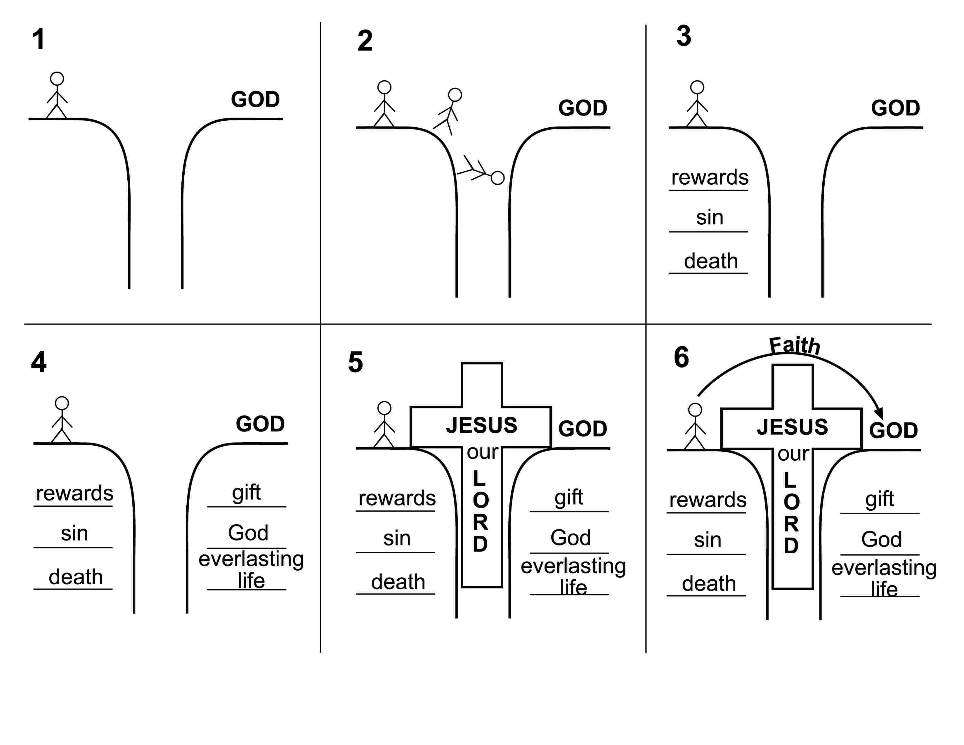
Appendix D – Presenter copy—“Steps of The Bridge” illustration

