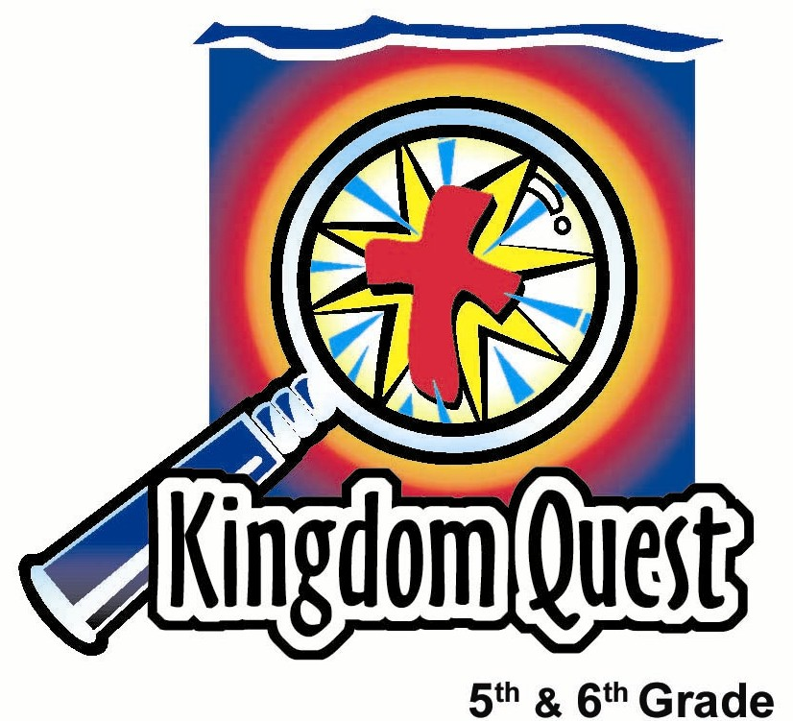
Date: _________________________
Series: Great Chapters in the Bible
(Dec-Feb) Year 2, Lesson 42
Grace
Chapter: Ephesians 2

Take Home Point: *We are saved by grace – a gift from God. *Repeat this phrase throughout the lesson.

Bible Event: Ephesians 2:1-10. God saved us because of His great love for us.
Key Verse: Ephesians 2:8, “I mean that you have been saved by grace through believing. You did not save yourselves; it was a gift from God.” (NCV)

We will help kids know:
- All people were born spiritually dead and sinful.
- Because of God’s love, He made it possible for us to be made spiritually alive. This is through Jesus’ death and resurrection.
- Salvation is a gift we must receive. We can’t earn it.

We will help kids feel:
- Overwhelmed with gratitude at the gift of God’s grace for us in Christ.
- Confident they can always turn to Him and receive the gift of His grace.

We will help kids do:
  - Identify great gifts they have received for past birthdays, the best of which are the gifts of physical and spiritual birth.
  - Identify how we are made spiritually alive (through grace) and some of the blessings.
  - As a group challenge, make a paper tower project to reach the ceiling (which will be impossible). The task will only be accomplished through the grace of a leader doing it for them.
THIS LESSON’S ROADMAP

DESTINATION | PAGE # | DISCOVERIES ON YOUR JOURNEY | SUPPLIES NEEDED
  Small Group Warm-Up | 4 | Kids will discuss the best gifts they received on past birthdays. Undoubtedly, all kids will miss the point of the BEST gifts received on their birthdays: the gift of life. | - decorative gift paper bow for each group
Large Group   | 5  8  10  14 | Overview  Game – “Tower to the Ceiling” Students build a freestanding tower that will reach all the way from the floor to the ceiling using only magazine pages and masking tape.  Teaching Points – Students learn from Ephesians 2:1-10 what it means to be spiritually dead, then spiritually alive, and how to receive the gift of God’s grace through faith.  Appendices | - librarian costume for presenter  - magazine (or newspaper) stack for each group  - masking tape for each group  - gift certificate for each student in an envelope (see Appendix B)  - sign saying “Tear Out Pages” (Appendix A)  - secret note for child (see Appendix C), paper cross rolled up (see Appendix D): Cross is made from a three or four inch paper strip of magazine pages taped together that is as long as the distance from the floor to the ceiling, with a paper roll section (three foot long) perpendicular to the strip (to look like a cross) about three-fourths the way up  - clipboard with group names for tower judging  - digital kitchen timer that can be speeded up if necessary without making noise  - step ladder

Small Group Application   | 5  6 | Students will receive Christian themed gifts to give away and help others come to know God’s kindness.  Memory Verse Learning:  “Verse First”  Ephesians 2:8 will be repeated for lessons 42-46 to help children to learn to feel confidence they can turn to God and receive the gift of His grace. | - Grace chapter sheet (see appendix)  - two small Christian gifts per student (one they exchange with their coupon and keep; one they give away)—select from a novelty company such as Oriental Trading Company’s Inspirations catalog.  This typically comes out before Easter and is filled with many ideas for crosses, jewelry, and games your kids may enjoy. Call 1-800-228-2269 for a catalog or check their web site at www.orientaltrading.com.  - two mahjong paper  - two markers  - masking tape

Small Group Warm-Up: 15 minutes
Purpose: Get pointed in the right direction! Build relationships and help guests feel at ease. Do the learning readiness activity that will point your group in the right direction for the lesson.

As kids gather: Listen to memory verses from last week and give coupons for memory verses, remembering to bring your Bible, and bringing a guest.

Supplies: gift bow

Today we will talk about birthday presents. (Show the bow.) This wrapping bow is a pleasant reminder of them.

I’d like to hear stories about the best birthday present you ever received. It could be a special toy or it could be the gift of a special party. It will also help us to get to know each other when we find out about another person’s favorite gift.

Pass the bow to the person speaking. Be sure to share your story, too. After all kids have talked about favorite presents, ask this question:

How much did you pay the person to give you that special birthday present or birthday party? (Obviously nothing.)

How do you think it would make them feel if you insisted on paying them when they were giving you a gift? Would it still be a gift if you paid for it? (It might seem more like something that’s bought.)

All of you mentioned one of the best gifts you received on your birthday. But all of you missed the BEST gift you received on your birthday. Do you know what that is? (The gift of life.)

You were born on your birthday. Did you do anything to earn or deserve that gift? (No, the gift of being born and having life is a gift that God gives us.)

Today we will discover there is another gift God gives us that is even greater than the gift of physical life. It is the gift of spiritual life. The challenge is that you can only receive it as a gift. You can’t buy it or earn it, which some people may try to do. The Bible says that *we are saved by grace – a gift from God.

Large Group Overview: 20-30 minutes
Purpose: Help kids observe what the Bible says. Present the Bible event in creative fashion. Help kids begin to interpret what it means.

Game – “Tower to the Ceiling:” Students build a freestanding tower that will reach all the way from the floor to the ceiling using only magazine pages and masking tape.

Teaching Points: Students learn from Ephesians 2:1-10 what it means to be spiritually dead, then spiritually alive, and how to receive the gift of God’s grace through faith.

Small Group Application: 20-25 minutes
Purpose: Help kids map out the meaning of the Bible event in their lives. Use the questions to stimulate discussion, but don't feel tied to them. Allow the Holy Spirit to guide you. Include personal examples from your own faith journey. The example of Christ at work in your life will leave lasting impressions of how Christ can work in the children's lives.

Use your Bibles! Children need to learn how to look up references and follow along when scripture is read aloud. Allow for quality time of prayer at the close of the lesson.

Observation Questions: What happened?/Interpretation Questions: What does this mean?
Have kids refer to Ephesians 2:1-10 in their Bibles.

According to Ephesians 2:1-3, why were all of us considered spiritually dead? (Because of our failures and sins, we refused to obey God, we all followed the desires of our corrupt nature.)

What do we deserve because of this? (Ephesians 2:3. God’s anger.)

According to Ephesians 2:4-7, why did God make us alive together with Christ? (He is rich in mercy because of His great love for us. He wants to show us His “extremely rich kindness” and generosity.)

How are we saved? (Ephesians 2:8. I mean that you have been saved by grace through believing. You did not save yourselves; it was a gift from God.)

Why does God want our salvation to have nothing to do with us? (Ephesians 2:9. So no one can boast about it.)

What has God created us to do? (Ephesians 2:10. To live lives filled with good works that He has prepared for us to do.)

Application Questions: What does this mean to me?
Do we do good works, then, to be saved? (No. Salvation is a free gift from God, but He wants us to fulfill the unique purposes and calling He gave each of us to glorify Him.)

The key verse for today from Ephesians 2:8 says, “God saved you through faith as an act of kindness. You had nothing to do with it. Being saved is a gift from God.”

Just like receiving a birthday gift, we do not have to pay for the gift of salvation. It is not a gift if we have to buy it or do something for it. It can be an insult to God if we feel like we must pay for it instead of just graciously receiving it.

Application Activity
Supplies: the Grace chapter page (see appendix ) for each student, a small gift for each kid

Hand out the Grace chapter page and have kids fill in the blanks with gifts they receive from God according to this Bible passage.

After students review the Bible, give them a gift to give away. Say:

Today we learned that *we are saved by grace – a gift from God. After prayer, you can exchange your coupon for a gift as a reminder that God gives us the free gift of salvation. You will also receive an additional gift to give to someone else. Just as you receive this gift here today, you can also give a gift to help others come to know God’s kindness.

NOTE: Kids receive two gifts when they exchange their coupons: one to keep, the other to give away.

Another option for an application activity is to have students practice memorizing Ephesians 2:8-10 or a portion of these verses.

Memory Verse Learning: 5 minutes
Purpose: Help kids to memorize and keep scriptures at heart. Using creative ways to help kids enjoy learning the key verse and in small group setting.

Supplies needed: 2 mahjong paper, 2 markers, masking tape

Memory Verse: Ephesians 2:8 ~ “I mean that you have been saved by grace through believing. You did not save yourselves; it was a gift from God.” (NCV)

MV Presentation: “Verse First”
Before class, write the memory verse on a whiteboard. Make two starting lines with the masking tape on one side of the room. Have all the children recite the verse together twice. Explain what it means to be saved by grace and that salvation is a gift from God. Have all the girls recite the verses followed by the boys. Begin the game when you are confident that the children have memorized the verse. Divide the children into two groups. Paste the mahjong paper on the wall of one side of the room, three feet apart from each other. Have each group stand in two relay line behind the starting line. Hand the first child in each group a marker. At your signal, the first child race to the mahjong paper and write the first word of the memory verse. He/she is to race back to his group and hand the marker to the next child who will race to the paper and write the second word. The first child goes to the end of the relay line and position himself/herself there. The game continues until a child from each group has written the last word of the verse.

Closing Prayer:
Thank God for the free gift of salvation He has given us through Jesus’ death in our behalf. Thank Him that we can receive it not through any kind of good work, but only through faith. Ask that the Holy Spirit would show us the good works God created each of us to do to participate in His plan and bring Him glory.
Safety and Security: Safety and security procedures are important for each church to carefully define and implement according to their unique needs. The security, safety, illness and accident procedures described in this curriculum are provided for example purposes only and may not be appropriate, applicable or adequate for every situation. Each church is responsible for determining whether any security, safety, illness and accident procedures contained in the curriculum are appropriate, applicable or adequate for its unique situation. The activities described in this curriculum require adult supervision and may not be suitable for each child and each situation. Each church is responsible for ensuring that adequate adult supervision is provided for all activities and for determining whether an activity is appropriate for each child and each situation. Kids Kount Publishing disclaims all liability for the implementation of any procedures or the performance of any activities described in this curriculum.

Large Group Presentation

Great Chapters of the Bible
Grace Chapter – Ephesians 2

The large group presenter will assume the role of a librarian. His/her name will be either Ms. Rita Sim or Mr. Choon Meng. Costuming might include reading glasses (if you wear your own, place a piece of tape on the bridge), bow tie or special librarian hat. The presenter should portray the caricature of a “bookworm.”

Ms. Rita Sim or Mr. Choon Meng will introduce the favorite chapters in the best book in the library, the Bible. This librarian operates with a different set of rules than what is typical. Instead of the rule “no chewing gum,” now kids must chew gum and play with it. Every week, a new goofy rule will be revealed.

The stage for large group should be set up to look like a library: a bookshelf with some books, maybe a desk, and an old computer. Make it as elaborate as you would like. A sign should be hung somewhere that says “RULES of the Library.” Each week a new rule will be revealed. Hopefully, the rules are so absurd and goofy that the kids think it is funny. We are not advocating misbehavior.

Supplies: sign saying “Tear Out Pages” (Appendix A), stack of magazines for each group (Option: Newspapers can replace magazines), roll of masking tape for each group, prizes or handmade gift cards redeemable for a special gift at the library gift shop (See Appendix B), secret note for child (See Appendix C), paper cross rolled up (See Appendix D), clipboard with group names for tower judging, digital kitchen timer that can be speeded up if necessary without making noise, step ladder

Cross is made from a three or four inch paper strip of magazine pages taped together that is as long as the distance from the floor to the ceiling, with a paper roll section perpendicular to the strip (as a cross beam) about three-fourths the way up.

The Greatest Chapter on Grace
Ephesians 2:1-10
Audience Participation Teaching

Introduction of Ms. Rita Sim / Mr. Choon Meng

Hello, I am Mr. Choon Meng (or Ms. Rita Sim) of the ____________ (put in your church name) Memorial Library. This is a very special and unique library. When I am in charge, the rules are a little different than what you would see at your school or city library.
Tear Out Pages

The library rule you will learn today is to always:

Hold up the “Tear Out Pages,” sign and have kids read it aloud with you. Then hold up a magazine.

Please repeat the rule to me. Now look at this magazine. Can you believe THIS?

Hold up the magazine and flip through it to show your audience that the pages are all intact.

I will not tolerate THIS at my library! This magazine was checked out and returned EXACTLY the same way! In MY library, when you check out a magazine, a newspaper or book, you must rip out a page because you never know when you might need it for something! Don’t use a copy machine, just rip out the page and keep it! (Start tearing out random pages.)

Ah, but what are the people after you going to do when they want to read that same magazine and find a page missing? Well, I guess they will just finish it sooner! And, when they finish, THEY can tear out pages, too! Because remember, my rule is to keep the information you need. Now let’s play a little game.

Activity – “Tower to the ceiling”

I would like you to do a very simple activity. Each group has a stack of magazines (or newspapers) and a roll of masking tape. Your group challenge is to build a freestanding tower that will reach all the way from the floor to the ceiling using only magazine pages and masking tape. Freestanding means that it must stand on its own and you can’t hold it up.

For the team that is able to do this, every person will receive a gift certificate to the library gift shop. There you can exchange it for some of our riches.

Show prizes that might be candy, or other small Christian novelty gifts.

I’ll give each group three minutes to discuss strategy and when I indicate that it’s time to begin, you will have ten minutes to build your tower using only the magazine pages and masking tape. After the time is up, I will judge each tower.

Note: It’s very important that none of the groups complete this task successfully. If it looks like a group is approaching a successful completion, the librarian should stop the game before the ten-minute time frame has expired or find another way to sabotage the successful group. However, this will be extremely rare for a group to complete this task successfully.

Okay, are you ready to plan strategy for three minutes? When I start this time, you may talk to each other but not touch the materials. Ready, set, go!

Set timer for three minutes and when the time is up, tell kids to start building their tower. After ten minutes, tell the students they must stop, drop all the building materials, and step away from the tower.

In advance, have an assistant pass a note or secretly tell a child that when their tower fails to reach the ceiling and you ask for questions, to raise his/her hand and stand up to ask, “Would you come and do ours for us?” (Tell the student to make sure they keep this a secret.)

Everyone came up short

Holding up the prize coupons, say:

I can’t wait to give away these prize coupons! If I could just find a tower tall enough. Now let’s look at the towers we do have.

Go around and make comments on the various towers. Applaud towers for unique and creative components and certain people for exceptional teamwork.

Well, it looks like nobody’s tower reached the ceiling. Hum, what should I do? Do you think I should give the coupons to the team with the TALLEST tower?

Take audience feedback but reject this alternative.

No, if I did that, I wouldn’t be following the rules and the rules are that you were to build a freestanding tower that reached the ceiling. And guess what? No group made it!

The gift of grace

So, I have all these great prizes to give out but it looks like no team met the challenge. Sorry! Are there any other questions about this challenge?

That is the cue for the prepared child to ask the secret question – “Will you do it for us?”

Well, I’d be delighted to come and do it for you.

Bring out a stepladder and unroll the cross you prepared ahead of time. Climb the ladder to tape this cross to the ceiling while the bottom rests on the floor. Hand out prizes to each member of the group and point out how willing they are to accept the prizes.

Explanation

Everyone in this group received one of these gift certificates for the gift store. Did they follow the rules and successfully build the winning tower? No, they didn’t. I did it for them. But they were willing to receive the gift!

And, by the way, are these gifts free? They were free for the group, but were they free for me? No, they had to be paid for by the library.

Teaching Comparison

Part 1 - Spiritually dead

Bring forward the student who had earlier asked for help and received the gift certificates. After you read the verses, he/she will act out the explanation.

Read Ephesians 2:1-3 in your Bible. Invite kids to follow along in their Bibles.

“In the past you were spiritually dead because of your sins and the things you did against God. Yes, in the past you lived the way the world lives, following the ruler of the evil powers that are above the earth. That same spirit is now working in those who refuse to obey God. In the past all of us lived like them, trying to please our sinful selves and doing all the things our bodies and minds wanted. We should have suffered God's anger because of the way we were. We were the same as all other people.”
This says that you were once dead because of your failures and sins.

Ask the volunteer to lie on the floor and pretend to be dead.

The death this Bible passage describes is not physical death. Physical death is when your soul separates from your body. Instead, the Bible is describing spiritual death. Spiritual death means that your soul is separated spiritually from God.

Remember in your groups when you were trying to build your tower to the heavens? That’s an image of spiritual separation from God. No matter what you do or how far you reach, by your own power, you can’t fix the relationship. Look at verse three. How many of us does it say were once spiritually dead? It says all of us were. It also says that spiritually dead people follow the ways of this world’s ruler – that is Satan. So our volunteer here, pretending to be dead, reminds us that we all were born spiritually dead in this world.

Part 2 - Spiritually alive

Ephesians 2:4-5 says,

“But God's mercy is great, and He loved us very much. Though
we were spiritually dead because of the things we did against God,
He gave us new life with Christ. You have been saved by God's grace.

When we were dead, what did God do? He made us spiritually alive. Why? He made us spiritually alive because of His great love for us. How did He do it? Remember the cross that connected the ceiling to floor? Anyone who trusts in what God did in sending Christ to die for our sins is made spiritually alive.

Part 3 - Placed with Him in heaven

Ephesians 2:6 says, “And He raised us up with Christ and gave us a seat with Him in the heavens. He did this for those in Christ Jesus.”

Note that some Bible translations define “grace” as kindness. That’s what grace is. Being so kind that you give completely of yourself to the other person. When God was kind to us and brought us back to life together with Christ, what did He give us? The Bible says a position in heaven with Him.

Show gift certificates.

Each of these coupons can be redeemed for a special gift. Are they free? Yes, they are free to the person I gave them to. But they did cost something. Someone had to pay for those gifts. In God’s case, it was Jesus who paid for our spiritual life by giving His life.

Part 4 - How do we get it?

Ephesians 2:7-9 says,

“so that for all future time He could show the very great riches of His grace by being kind to us in Christ Jesus. I mean that you have been saved by grace through believing. You did not save yourselves; it was a gift from God. It was not the result of your own efforts, so you cannot brag about it.”

Grace is an act of kindness. Through this grace we are offered salvation, which means we are made spiritually alive. But how do we receive it? Verse eight says we receive grace through faith. Faith is simply trusting God’s promise and receiving the gift. It’s like a birthday present. We don’t deserve it, we can’t earn it, and we can’t buy it to obtain it.

Notice how we started from the ground and tried to reach up. I hung the cross from the top and it reached down to the floor. This reminds us that it is impossible to earn our way up to heaven, but God in His mercy reached down to us and extended His love when He sent Jesus to die on the cross for our failures.

Part 5 - Live good lives

Ephesians 2:10 says,

“God has made us what we are. In Christ Jesus, God made us to do good works, which God planned in advance for us to live our lives doing.”

Why has God created us? So we can live lives filled with good works. We don’t do good works to try to buy his grace, but we do good works because of His grace. It’s like this:

Talking to the volunteer, say:

Some of these coupons were given to you and you received God’s kindness. But because of that, you have coupons to share with others. Would you like to do that now?

Let him/her pass out coupons throughout the room, giving everyone a chance to receive the free gift. Then end in prayer.

Dear God, we thank You that You saved us because of Your great love for us. We are saved by grace not by works. We had nothing to do with it because it was a gift from You. Thank You.

Father God, if some here aren’t sure they have ever received that gift from You by trusting in Jesus, help them receive and believe it today. Help them change from being spiritually dead to spiritually alive. Come and live in their lives.

For those who would like to accept God’s free gift of Jesus, follow with me with this simple prayer:

Heavenly Father, I admit that I am a sinner. I admit that I am spiritually dead. I recognize Jesus gave His life for me on the cross and rose again. I trust Him as my Savior and ask Him to come into my life. Help me live my life filled with your grace. Let me do good works to show You my thankfulness. In Jesus’ name. Amen.

Lesson 42
Small Group Warm-Up
- decorative gift paper bow for each group

Large Group
- librarian costume for presenter
- magazine (or newspaper) stack for each group
- masking tape for each group
- gift certificate for each student in an envelope (see Appendix B)
- sign saying “Tear Out Pages” (Appendix A)
- secret note for child (see Appendix C), paper cross rolled up (see Appendix D): Cross is made from a three or four inch paper strip of magazine pages taped together that is as long as the distance from the floor to the ceiling, with a paper roll section (three foot long) perpendicular to the strip (to look like a cross) about three-fourths the way up
- clipboard with group names for tower judging
- digital kitchen timer that can be speeded up if necessary without making noise
step ladder.

Small Group Application
- Grace chapter sheet (see appendix)
- two small Christian gifts per student (one they exchange with their coupon and keep; one they give away)—select from a novelty company such as Oriental Trading Company’s Inspirations catalog.
This typically comes out before Easter and is filled with many ideas for crosses, jewelry, and games your kids may enjoy. Call 1-800-228-2269 for a catalog or check their web site at www.orientaltrading.com.

Memory Verse Learning
- two mahjong paper
- two markers
- masking tape

Appendix Table:

- Appendix A - Library Rules Sign:
TEAR OUT PAGES

- Appendix B
Gift Certificate
Library Gift Shop

- Appendix C
Secret Note

- Appendix D
Camera picture of prepared cross tower

- Appendix E
Great Chapters of the BIBLE
Grace Chapter

Appendix A

Tear Out Pages

Appendix B -- Gift Certificate Library Gift Shop

Gift Certificate

The bearer of this certificate is entitled to one gift from the library gift shop.

Appendix C

Secret Note:

After the librarian judges the towers and discusses how no team won and asks for questions, raise your hand and ask loudly, “Would you come and do ours for us?”

(Be sure to keep this note a secret.)

Appendix D
PICTURE

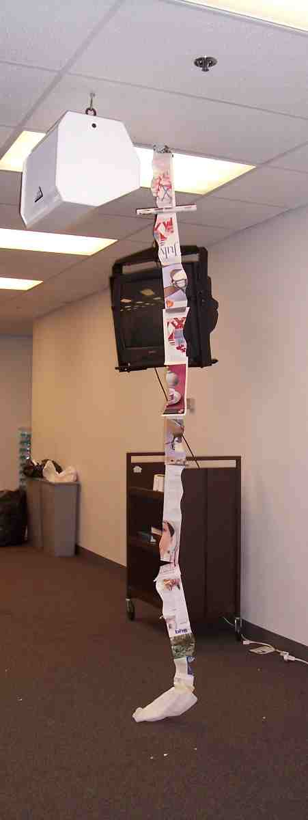

Appendix E

Make two copies of this sheet. Copy them back-to-back and then cut in half—one half sheet per kid. Each half will contain the scripture on one side and room for notes on the other.
Grace Chapter
This chapter reminds me of the following gifts
from God to me…

Grace Chapter
Ephesians 2:1-10

God’s Word Translation

You were once dead because of your failures and sins. You followed the ways of this present world and its spiritual ruler. This ruler continues to work in people who refuse to obey God. All of us once lived among these people, and followed the desires of our corrupt nature. We did what our corrupt desires and thoughts wanted us to do. So, because of our nature, we deserved God’s anger just like everyone else.
But God is rich in mercy because of His great love for us. We were dead because of our failures, but He made us alive together with Christ. (It is God’s kindness that saved you.) God has brought us back to life together with Christ Jesus and has given us a position in heaven with Him. He did this through Christ Jesus out of His generosity to us in order to show His extremely rich kindness in the world to come. God saved you through faith as an act of kindness. You had nothing to do with it. Being saved is a gift from God. It’s not the result of anything you’ve done, so no one can brag about it. God has made us what we are. He has created us in Christ Jesus to live lives filled with good works that He has prepared for us to do.

