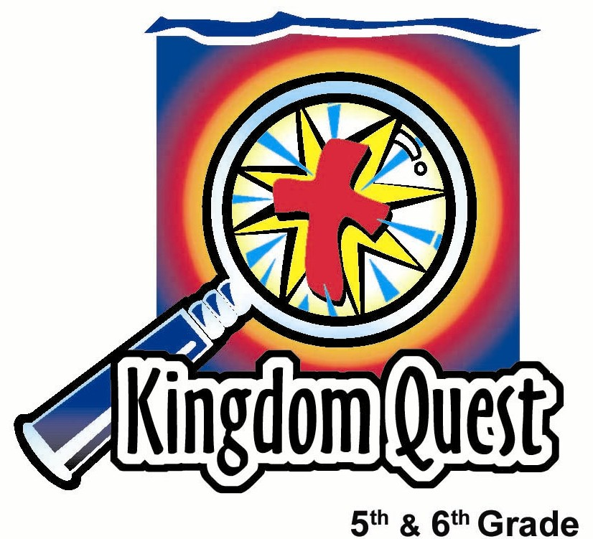
Date: _________________________
Series: Great Chapters of the Bible
(Dec-Feb) Year 2, Lesson 44
Faith Chapter:
Hebrews 11

Take Home Point: *Trust God with your future.
*Repeat this phrase throughout the lesson.

Bible Event: Hebrews 11 (Selected verses).
Key Verse: Hebrews 11:1, “Faith means being sure of the things we hope for and knowing that something is real even if we do not see it.” (NCV)

We will help kids know:
- The definition of faith is being certain of things we cannot see.
- Some of the Old Testament heroes of faith, such as Noah, Abraham and Moses, are listed in Hebrews 11. Hebrews 11 is considered the “Faith” chapter.
- With faith in Christ, we, too, can be heroes of the faith.

We will help kids feel:
- Secure despite taking the risk of faith and trusting someone you cannot see.
- Inspired to learn how God used ordinary people to become heroes of faith.
- Challenged to be a hero of faith.

We will help kids do:
- Participate in some faith building activities such as trust falls.
- Identify people in their life in whom they have complete trust.
- Write down what it is they are trusting God for in their future.

THIS LESSON’S ROADMAP

DESTINATION | PAGE # | DISCOVERIES ON YOUR JOURNEY | SUPPLIES NEEDED
  Small Group Warm-Up | 3 | Kids participate in a faith/trust fall. They talk about those in whom they have trust and faith. | - none
Large Group   | 4  8  8  11 | Overview  Blindfolded Pudding Feed: Kids enjoy eating “tau foo fa” while blindfolded.  Teaching Point: Kids identify the heroes of faith in Hebrews 11. They will also learn that faith doesn’t mean we are without trials or pain on earth, but faith brings us peace knowing our eternal future is secure in heaven.  Appendix | - “tau foo fa”  - spoons  - blindfolds  - four garbage bags with holes cut out for the head of each team member  - serviettes or wet cloths  - white board, chalk board or mahjong paper  - pens, markers or chalks  - biscuits  - Option: In the library large group setting, you could have some books set up in the back with the Bible heroes’ names written on book bindings so it looks like you are pulling books about the heroes of faith from the shelf.  - sign that says, “EAT IN THE LIBRARY”
Small Group Application   | 4  6 | Kids take part in a faith/trust walk.  Memory Verse Learning:  “Please Pass the Verse”  Ephesians 2:8 will be repeated for lessons 42-46 to help children to learn to feel confidence they can turn to God and receive the gift of His grace. | - blindfolds  - tissue  - sweets/prizes (optional)  - drinking straws  - a box of facial tissues  - masking tape

Small Group Warm-Up: 15 minutes
Purpose: Get pointed in the right direction! Build relationships and help guests feel at ease. Do the learning readiness activity that will point your group in the right direction for the lesson.
As kids gather: Listen to memory verses from last week and give coupons for memory verses, remembering to bring your Bible, and bringing a guest.

Supplies: no supplies needed

Today let’s start off by doing an activity that will take some faith and trust on your part to make it successful. This activity is called a “trust fall.” Who would like to volunteer and trust that your friends will catch you?

Select a volunteer.

To do a trust fall, you will stand straight, grab your shoulders, cross your arms, and fall back on people who will catch you.

Have kids make two lines of two people behind the volunteer on each side. They will place their arms in the following way as to provide a zipper catch. A zipper catch means that the catchers’ arms are in between each other’s arms. Each arm alternates between the arms of the person facing them.

NOTE to keep this a safe exercise: If the person loses confidence and decides not to keep their back stiff or straight and falls by sitting down, then it is harder to catch the person. Also, the group of people that are catching must say they are ready and give a verbal or audible “ready” before the person can fall back.

Do “trust fall” activity. Let kids take turns if time allows.

You can try a higher challenge with the person standing on a chair and falling. If you try this, put six people (three people on each side) in zipper format.

Then say:

Today we are talking about trust and faith. Faith believes in something or someone you can’t see.

In the trust fall, the volunteers couldn’t see who was willing to catch them, however, they trusted that they would be safely caught.

Who is it that you have trust or faith in? A way to decide might be to pretend you had a thousand dollars. You need to have someone keep it for you for a year. Who would you trust to keep your money for a year?

Discuss how they came to their answer.

What qualities does this person have?

Today we will talk about how you can *trust God with your future. We will also hear about some heroes of faith in the Bible who trusted God with their futures, as well.

Large Group Overview: 20-30 minutes
Purpose: Help kids observe what the Bible says. Present the Bible event in creative fashion. Help kids begin to interpret what it means.

Blindfolded Pudding Feed: Kids enjoy eating “tau foo fa” while blindfolded.

Teaching Point: Kids identify the heroes of faith in Hebrews 11. They will also learn that faith doesn’t mean we are without trials or pain on earth, but faith brings us peace knowing our eternal future is secure in heaven.

Small Group Application: 20-25 minutes
Purpose: Help kids map out the meaning of the Bible event in their lives. Use the questions to stimulate discussion, but don't feel tied to them. Allow the Holy Spirit to guide you. Include personal examples from your own faith journey. The example of Christ at work in your life will leave lasting impressions of how Christ can work in the children's lives.

Use your Bibles! Children need to learn how to look up references and follow along when scripture is read aloud. Allow for quality time of prayer at the close of the lesson.

Observation Questions: What happened?
Interpretation Questions: What does this mean?
Have kids open their Bibles to Hebrews 11 and once again scan the names of the heroes of faith. Then have them read Hebrews 11:13-16.

According to Hebrews 11:13 and 16, these people died having faith. What did they have faith in, even though they had not yet received it? (A heavenly home.)

What has God told us He has prepared for these people of faith? (Hebrews 11:16. He has prepared a city for them.)

In Warm-Up you talked about qualities of a person you could trust. What qualities does God have that you can trust?

Application Questions: What does this mean to me?
Supplies: strips of cloth used as blindfolds, tissue, sweets/prizes (optional)

Application Activity: Faith Walk
Have kids get into pairs and give the following directions.

You and a partner will go on a faith/trust walk. One of you will be blindfolded while the other will lead you on a walk. You will participate in different levels of faith or trust in this walk. This means that first your partner guides you by your arm, then they will guide you for a ways only slightly touching your hand, finally your partner will ask you to move to just verbal cues.

Place tissue on the eyes before putting on the blindfold to eliminate peeking if the blindfold is not dark enough or wide enough to cover the eyes, or if the students are not truthful about opening their eyes.

If kids don’t use blindfolds, the contest changes a little and the kids must report how many times they opened their eyes because it showed they lacked trust or faith.
Option: You might have prizes or other objects set at different parts of the building that the kids have to retrieve. This makes it more interesting.

Give the “seeing” partner directions to some part of your building. Break it up in three stages so that after directing the blindfolded partner by his/her arm for a distance, he/she should only guide with a slight touch of the hand for a distance and then finally only give verbal cues to the final destination.

When kids return, discuss how it felt.

One of the things that you might have felt was nervous because you couldn’t see what was in front of you. You were not in control and had to trust your partner.

Do you ever feel nervous or worried about things in your future?

What kinds of things are you anxious about?

What are you trusting God for or are hopeful for in your future?

Isn’t it wonderful that we have God as our partner to guide us right now and in our future?

Where can we be assured we will go when we die because we believe in Jesus?

Today’s key verse from Hebrews 11:1 says, “Faith means being sure of the things we hope for and knowing that something is real even if we do not see it.”

Just like the heroes of faith trusted God to guide them, you can *trust God with your future.

Memory Verse Learning: 5 minutes
Purpose: Help kids to memorize and keep scriptures at heart. Using creative ways to help kids enjoy learning the key verse and in small group setting.

Supplies needed: plastic drinking straws, a box of facial tissues, masking tape

Memory Verse: Ephesians 2:8 ~ “I mean that you have been saved by grace through believing. You did not save yourselves; it was a gift from God.” (NCV)

MV Presentation: “Please Pass the Verse”
Before class, tape two parallel line 10 feet apart for the game. During memory verse learning, divide the children into two groups. Put half the team at one line and the other half at the opposite end for a relay. Each player is given a straw and the first player a tissue. Demonstrate how they are to hold the tissue by sucking through the straw. In the challenge, one cannot touch the tissue with hands and can only begin after reciting the memory verse. If a tissue is dropped, the team member must start over with a new tissue. The team that completes in the quickest time is the wining team. Before dismissal, have the children recite the memory verse again.

Prayer time:
Let kids pray for faith and trust that brings peace. They can pray for God to be right here, right now, to be with them no matter what the circumstances. Pray for peace in knowing our eternal future is secure.
Safety and Security: Safety and security procedures are important for each church to carefully define and implement according to their unique needs. The security, safety, illness and accident procedures described in this curriculum are provided for example purposes only and may not be appropriate, applicable or adequate for every situation. Each church is responsible for determining whether any security, safety, illness and accident procedures contained in the curriculum are appropriate, applicable or adequate for its unique situation. The activities described in this curriculum require adult supervision and may not be suitable for each child and each situation. Each church is responsible for ensuring that adequate adult supervision is provided for all activities and for determining whether an activity is appropriate for each child and each situation. Kids Kount Publishing disclaims all liability for the implementation of any procedures or the performance of any activities described in this curriculum.

Large Group Presentation

Great Chapters of the Bible
The Faith Chapter – Hebrews 11

The large group presenter will assume the role of a librarian. His/her name will be either Ms. Rita Sim or Mr. Choon Meng. Costuming might include reading glasses (if you wear your own, place a piece of tape on the bridge), bow tie or special librarian hat. The presenter should portray the caricature of a “bookworm.”

Ms. Rita Sim or Mr. Choon Meng will introduce the favorite chapters in the best book in the library, the Bible. This librarian operates with a different set of rules than what is typical. Instead of the rule “no chewing gum,” now kids must chew gum and play with it. Every week, a new goofy rule will be revealed.

The stage for large group should be set up to look like a library: a bookshelf with some books, maybe a desk, and an old computer. Make it as elaborate as you would like. A sign should be hung somewhere that says “RULES of the Library.” Each week a new rule will be revealed.

Supplies: “ tau foo fah”; spoons; blindfold;, four garbage bags with holes cut out for the head of each team member; biscuits; serviettes or wet cloths; white board, chalk board or mahjong paper; pens or marker or chalk; sign that says, “EAT IN THE LIBRARY.”

Option: In the library large group setting, you could have some books set up in the back with the Bible heroes’ names written on book bindings so it looks like you are pulling books about the heroes of faith from the shelf.

The Heroes of the Bible Chapter
Hebrews 11
Audience Participation Teaching of the Faith Chapter

Introduction of Ms. Rita Sim / Mr. Choon Meng

Hello, I am Mr. Choon Meng (or Ms. Rita Sim) of the _________________ (put in your church name) Memorial Library. This is a very special and unique library. When I am in charge, the rules are a little different than what you would see at your school or city library.

Our goofy rule this week is “EAT IN THE LIBRARY.”

Show sign.

You must eat tau foo fah in the library… blindfolded!

Blindfold “Tau Foo Fah” Feed

Round One:
Using “tau foo fah” or some other messy food item, select two boys and two girls from the audience. Bring them forward and cover them with a garbage bag that has a hole cut out for the team member’s head. Blindfold all the kids but give only one of each pair a spoon and bowl of “tau foo fah.” The goal is for them to see how much “tau foo fah” they can get in the mouth of their teammate. The librarian will be the judge.

Okay. Is everyone set? Those who are feeding, pick up your spoon and “tau foo fah.” When I give the signal, your partner can begin giving you verbal signals so you try to get the “tau foo fah” in their mouth. You may begin!

After a couple of minutes, have them stop.

Stop. Now, we are going to round two of the blindfold “tau foo fah” feed.

Round Two:
Invite a third person to each team who will now give directions to the blindfolded team members to help get the “tau foo fah” in the mouths of their partners.

This should help the teams be more successful in getting “tau foo fah” in the mouths. Now, let’s try this again. Begin!

They should have a much easier time with the third person giving directions. Ask them to stop and see how much more “tau foo fah” they ate.

Stop. Hopefully, you should have been much more successful having the third team member giving you directions.

Dismiss contestants.

Teaching of Hebrews 11
In a way, faith is like this contest. The contestants couldn’t see but knew a bowl of “tau foo fah” was out there… and his/her partner would feed them.

Faith is being sure of what you can’t see and acting on it. Faith convinces us of the existence of things we cannot see.

But how is it we get faith? We need to have someone whom we trust tell us. In this case, when we added a third person to the team and he/she told us how to better direct the spoon to the mouth, it became much easier. This is very much like the heroes of faith.

The heroes of faith needed to hear God’s word and believe in Him. When you see someone else’s faith, you become inspired to have it, too.

Heroes of Faith
We will hear about the Heroes of Faith who *trusted God with their future.

I have a treat for those of you who can look through your Bible in Hebrews 11 and find some of the names of the people who were on the hero list of faith. Then, find the word that describes what they did. Raise your hand when you are ready to share. I’ll give you an example. Enoch – was taken to heaven, instead of dying.

When the students share, give them a piece of biscuit and write the information on the board or chart paper.

Abel offered God a better sacrifice.
Enoch was taken to heaven, instead of dying.
Noah listened when God warned him about the things in the future that he could not see.
Abraham lived as a foreigner in the country and became a father even though he was old and offered his only son as a sacrifice.
Isaac blessed Jacob and Esau.
Joseph spoke about the Israelites leaving Egypt.
Moses’ parents hid him for three months after he was born, not afraid to disobey the king’s order.
Moses refused to be known as a son of Pharaoh’s daughter.
Moses left Egypt without being afraid of the king’s anger.
Moses established the Passover and saved the firstborn sons by spreading the blood on the doorposts.
Israelites marched around the Walls of Jericho for seven days until they fell.
Rahab welcomed spies as friends.

Now I have a bonus question. What about those people that prayed that God would deliver them when they were being tortured for their faith, and yet, God did not deliver them? Did He answer their prayer? Let’s read about some of them.

Begin reading in Hebrews 11:35b – 38a.

“Others were tortured and refused to accept their freedom
so they could be raised from the dead to a better life. Some
were laughed at and beaten. Others were put in chains and
thrown into prison. They were stoned to death, they were cut
in half, and they were killed with swords. Some wore the skins
of sheep and goats. They were poor, abused, and treated badly.
The world was not good enough for them!”

Hebrews 39 says, “All these people are known for their faith, but none of them received what God had promised.”

What did they not receive? All of these faithful ones were waiting and watching for the promised Savior and He didn’t come in their time. But they never gave up hope.

Faith does produce patience (James 1:3) and “After they have proved their faith, God will reward them with life forever. God promised this to all those who love Him.” (James 1:12b). Because of belief in the Savior, these faithful ones will see Jesus in heaven.

As people of faith, depend on God and trust Him. Hebrews 11:1 says, “Faith means being sure of the things we hope for and knowing that something is real even if we do not see it.”

Just as the heroes of faith believed in God and trusted Him for their future, you can *trust God with your future.

Let’s close with prayer.

Heavenly Father, we trust and have faith in You. Help us not to base our faith in the people of this world or in things of this world but base our faith on You and Your word. Thank You for the gift of peace that You give us even during tough times. In Jesus’ name. Amen.

Lesson 44
Small Group Warm-Up
- none

Large Group
      - “tau foo fa”
      - spoons
      - blindfolds
      - four garbage bags with holes cut out for the head of each team member
      - serviettes or wet cloths
      - white board, chalk board or mahjong paper
      - pens, markers or chalks
      - biscuits
      - Option: In the library large group setting, you could have some books set up in the back with the Bible heroes’ names written on book bindings so it looks like you are pulling books about the heroes of faith from the shelf.
      - sign that says, “EAT IN THE LIBRARY”

Small Group Application
- blindfolds
- tissue
- sweets/prizes (optional)

Memory Verse Learning
- drinking straws
- two boxes of facial tissues
- masking tape

EAT IN THE LIBRARY

