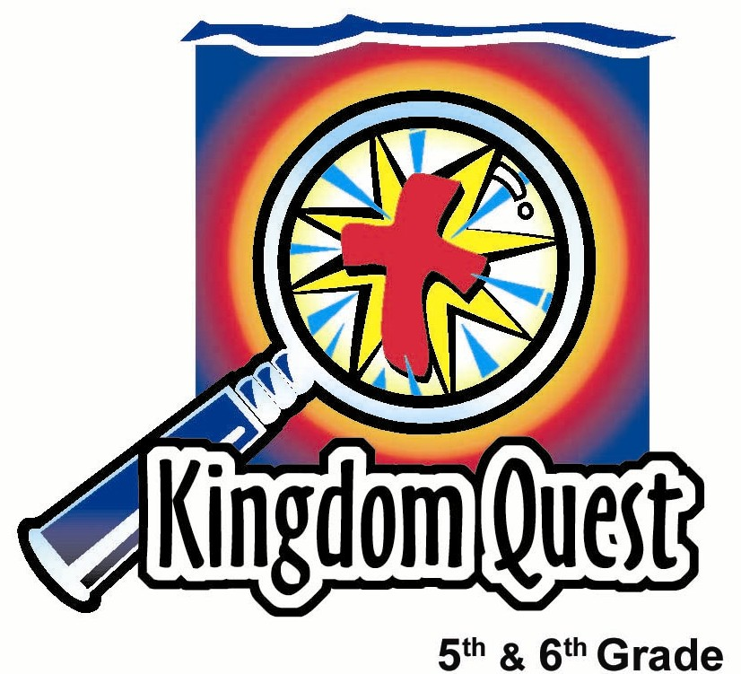
Date: _________________________
Series: Great Chapters of the Bible
(Dec-Feb) Year 2, Lesson 45

Repentance Chapter: Psalm 51

Take Home Point: *Confess your sins and receive God’s forgiveness. *Repeat this phrase throughout the lesson.

Bible Event: Psalm 51:1-12; 2 Samuel 11:1—12:13
Key Verse: 1 John 1:9, “But if we confess our sins, He will forgive our sins, because we can trust God to do what is right. He will cleanse us from all the wrongs we have done.”

We will help kids know:
- They are all sinful from birth and are in need of God’s forgiveness.
- They should not hide their sins or blame others when they are guilty, but admit it to God.
- Through Jesus’ life, death and resurrection, they are forgiven when they turn to Him.
- Repentance means turning away from their sin and turning towards God as King for His forgiveness.

We will help kids feel:
- Convicted of any sin that is hidden.
- Lifted from any guilt because of God’s promised forgiveness.

We will help kids do:
- Play a blame game where they pretend to cast blame on others in their group.

THIS LESSON’S ROADMAP

DESTINATION | PAGE # | DISCOVERIES ON YOUR JOURNEY | SUPPLIES NEEDED
  Small Group Warm-Up | 3 | Kids play the “Blame Game” which opens discussion for kids to see how they might try to hide their own sin. | - none
Large Group   | 4  7  7 | Overview  Personal Testimony: Someone from the congregation gives a personal testimony about something they had done wrong, but repented and received God’s forgiveness.  Bible Teaching: The Bible event of David and Bathsheba from 2 Samuel 11:1-12:13 is told. Then David’s words of repentance from Psalm 51:1-12 is shared as kids also repent over hidden sin. | - paper—one for each kid  - pencils—one for each kid  - two or three candles  - matches or lighter  - trash can with a cross on the outside made with masking tape  - sign printed “Blame Someone Else”  - guest speaker to share a personal testimony (see lesson)
Small Group Application   | 4  5 | Kids identify with David’s repentance in Psalm 51.  Memory Verse Learning:  “Catch It!”  Ephesians 2:8 will be repeated for lessons 42-46 to help children to learn to feel confidence they can turn to God and receive the gift of His grace. | - None  - blindfolds  - two tall containers e.g. waste paper basket  - small plastic balls  - masking tape

Small Group Warm-Up: 15 minutes
Purpose: Get pointed in the right direction! Build relationships and help guests feel at ease. Do the learning readiness activity that will point your group in the right direction for the lesson.

As kids gather: Listen to memory verses from last week and give coupons for memory verses, remembering to bring your Bible, and bringing a guest.

Today we will play the “Blame Game.” To play this game, you pass blame around the group. I will choose one person to begin. This person will make up a false or crazy story that one of you did wrong.

For example, I might say, “_______ (insert name of someone in your group) stole my shoe laces.”

_______ (the name of the person in your group) would respond, “No, I didn’t but, …” and in turn makes another false accusation of someone else in the group. (For an example, “No, I didn’t, but Jennifer pulled my hair.”)

When someone accuses you, you always reply with “No, I didn’t, but…” and accuse someone else. Let’s play and I will begin.

Begin the accusations.
Perhaps the kids will make very funny accusations about one another. As they laugh about it, in a way they may be dealing with the human tendency to deal with their guilt by blaming others. Blaming others will be pointed out several times in the lesson as one of the ways we hide our own guilt.

After playing for a while, continue with:

In the Blame Game, we made up things we may have done wrong. Now let’s talk about some real things that we might have done when we were younger. Maybe we tried to hide our wrongdoing by blaming others and saying they did it.

I will go first and share a time when I did something wrong.

Share a personal example of what you did wrong and how you tried to hide it. Encourage kids to take turns sharing their personal examples.

Today we will learn not to hide or blame others for our guilt. Instead we will learn to *confess our sins and receive God’s forgiveness.

Large Group Overview: 20-30 minutes
Purpose: Help kids observe what the Bible says. Present the Bible event in creative fashion. Help kids begin to interpret what it means.

Personal Testimony: Someone from the congregation gives a personal testimony about something he/she did wrong, but repented and received God’s forgiveness.

Bible Teaching: The Bible event of David and Bathsheba from 2 Samuel 11:1-12:13 is told. Then David’s words of repentance from Psalm 51:1-12 are shared as kids also repent over hidden sin.

Small Group Application: 20-25 minutes
Purpose: Help kids map out the meaning of the Bible event in their lives. Use the questions to stimulate discussion, but don't feel tied to them. Allow the Holy Spirit to guide you. Include personal examples from your own faith journey. The example of Christ at work in your life will leave lasting impressions of how Christ can work in the children's lives.

Use your Bibles! Children need to learn how to look up references and follow along when scripture is read aloud. Allow for quality time of prayer at the close of the lesson.

Observation Questions: What happened?
Review the Bible event from 2 Samuel 11-12:13.

What was David’s hidden sin? (2 Samuel 11: 1-5. He gave into his lust for Bathsheba and took her as his own wife.)

How did David try and cover his sin after it was discovered Bathsheba became pregnant while her husband was fighting battles? (2 Samuel 11:6-16. At first David summoned Uriah home so it would appear he got Bathsheba pregnant. He would not go to Bathsheba since he was on duty, so David tried to get him drunk. When this still didn’t work, he had Uriah put on the front line so he would be killed in battle.)

What caused David to finally admit his sin? (2 Samuel 12:1-13. The prophet Nathan confronted David with how terrible his sin was.)

Interpretation Questions: What does this mean?
Even though David committed such a terrible sin, why do you think he is still called a man after God’s own heart? (He confessed his sin and repented from it.)
Application Questions: What does this mean to me?
Today’s key verse from 1 John 1:9 says, “But if we confess our sins, He will forgive our sins, because we can trust God to do what is right. He will cleanse us from all the wrongs we have done. “

Psalm 51 was David’s confession and repentance for this terrible sin. Which verse from Psalm 51:1-12 has the most meaning to you and why?

Have kids pick out a verse from Psalm 51:1-12. Conclude with the take home point:

Whenever you do something so wrong you want to hide it, just like David, you can *confess your sins and receive God’s forgiveness.

Memory Verse Learning: 5 minutes
Purpose: Help kids to memorize and keep scriptures at heart. Using creative ways to help kids enjoy learning the key verse and in small group setting.

Supplies needed: blindfold; two wastepaper baskets; small plastic ball; masking tape

Memory Verse: Ephesians 2:8 ~ “I mean that you have been saved by grace through believing. You did not save yourselves; it was a gift from God.” (NCV)

MV Presentation: “Catch It!”
Before class tape two 10 feet parallel lines 7 feet apart for the game. Review Eph. 2:8 with the children during this session. Then divide the children into two teams. In each team assign one person as the “Catcher” and the rest are “Throwers”. Position the throwers of a team behind one of the line and the catcher is to be on the opposite end holding the wastepaper basket. Each thrower will be blindfolded with a ball at hand. The objective of the game is that the throwers will throw the plastic ball and the Catcher is to catch their team’s ball with the wastepaper basket. The team can make plans as how the catcher can catch the maximum number of balls. The team who has the most number of balls in their wastepaper basket wins. End the game by reciting the memory verse together.

Prayer Time:
Thank God for the forgiveness He offers through Jesus Christ, who promises to be with us when we trust and believe in Him—and always gives us the gift of forgiveness when we confess our sin to Him.
Safety and Security: Safety and security procedures are important for each church to carefully define and implement according to their unique needs. The security, safety, illness and accident procedures described in this curriculum are provided for example purposes only and may not be appropriate, applicable or adequate for every situation. Each church is responsible for determining whether any security, safety, illness and accident procedures contained in the curriculum are appropriate, applicable or adequate for its unique situation. The activities described in this curriculum require adult supervision and may not be suitable for each child and each situation. Each church is responsible for ensuring that adequate adult supervision is provided for all activities and for determining whether an activity is appropriate for each child and each situation. Kids Kount Publishing disclaims all liability for the implementation of any procedures or the performance of any activities described in this curriculum.

Large Group Presentation

Great Chapters of the Bible
The Repentance Psalm – Psalm 51

The large group presenter will assume the role of a librarian. His/her name will be either Ms. Rita Sim or Mr. Choon Meng. Costuming might include reading glasses (if you wear your own, place a piece of tape on the bridge), bow tie or special librarian hat. The presenter should portray the caricature of a “bookworm.”

Ms. Rita Sim or Mr. Choon Meng will introduce the favorite chapters in the best book in the library, the Bible. This librarian operates with a different set of rules than what is typical. Instead of the rule “no chewing gum,” now kids must chew gum and play with it. Every week a new goofy rule will be revealed.

The stage for large group should be set up to look like a library: a bookshelf with some books, maybe a desk, and an old computer. Make it as elaborate as you would like. A sign should be hung somewhere that says “RULES of the Library.” Each week a new rule will be revealed.

The large group may be extended with the small group application done during the large group time or kids can go to small group as usual.

Supplies: paper and pencils for each kid, two or three candles, matches or lighter, trashcan with a cross on the outside made with masking tape, a sign printed “Blame Someone Else”

Introduction

As you know, in this library, we have some unusual rules. Our goofy rule today is that if you are ever accused of doing something wrong, even if you did it, you are never, ever to take responsibility for it. Instead, blame someone else.

Show the sign.

I saw some kids earlier who did an excellent job of keeping this rule. I heard some pretty wild things said to accuse others. I would like some of you to share with the group some of the accusations you heard in your group.

Take responses from a few kids from different groups.

Personal Testimony

The previous Warm-Up exercise was a lot of fun, but the tone of the message will change at this point.

In advance, invite a guest speaker from your church to share an experience how they had done something wrong or lived their life apart from God. Through repenting from their sin and turning to God, they received His forgiveness and a change in their life. As you think about whom to ask, consider this: each Christian has a story to tell. We all have repented and found newness of life in Christ Jesus.

Allow the speaker to share for about ten minutes. Also, make it clear that the focus is not on the details of the sins, but on how God changed him/her when he/she asked for forgiveness.

Introduce the Bible Event: David and Bethsheba
Based on 2 Samuel 11:1 – 12:13

David was king of God’s people. From his palace roof he would look down and gaze upon the city and even his neighbors’ roofs.

Below him was the house of Uriah, one of his generals, who was often out of town fighting battles for King David.

One day when David looked over his roof to admire the city, he noticed Uriah’s beautiful house, complete with a beautiful swimming pool, and a beautiful wife. “Who is this lady?” he asked his servant. “She is somebody’s daughter and somebody’s wife, my lord,” he replied. “She is the wife of Uriah, your general.”

David, knowing she was someone else’s wife, asked his servant to bring her to him. David’s heart was lured away by his desire to be with this beautiful woman.

Bathsheba was brought to the king and stayed there while her husband fought in the battle out of town because David claimed he loved her. She returned home when her husband returned from the battlefield.

A few days later, David received a letter from Bathsheba. The letter said, “I am going to have a baby.” The king knew he had done wrong. He had taken another man’s wife as his own. His biggest concern wasn’t about the sin, but about being discovered.

He planned a way that he might hide the sin. He sent Uriah back to battle. He gave secret orders to other leaders in the army that when the battle was the fiercest, Uriah was to be placed at the front and left alone. They were to let him die in battle.

To cover his sin, King David ordered the “accidental” execution of the man he had sinned against, his faithful general, Uriah. David had not only sinned by taking Bathsheba for his wife, but he covered his sin by killing her husband. Now he thought, “No one will find out!” But, someone already knew. That someone was God.

No one can hide his/her sin from God. God sent His prophet Nathan who told David this story: “A rich man’s friend was visiting him from out of town. He wanted to give a feast, but was unwilling to kill any of his own sheep. His neighbor, though quite poor, had a family pet. It was a gentle little lamb that was part of the family. The rich man decided to steal that lamb, kill it, and serve it at a feast to his guests.”

Nathan asked David, “What do think of my story?” David replied, “This man should die!”

Nathan looked in David’s eyes and said, “David you are this man. You are indeed king. Yet, you stole another man’s wife, and killed her husband who was faithful to you to try and cover your sin. The son Bathsheba bore to you shall surely die.”

David now realized his sin. He would not hide it any longer. He turned from his sin, admitted it to God, and asked Him for His forgiveness. David wrote Psalm 51 during this time of repentance.

Read Psalm 51- Kids Put Themselves in a Place of Repentance

Create a solemn mood by lighting a couple of candles and dimming the lights.

Before I read this Psalm, I want you to think what is the worst thing you have ever done. This could possibly be something that you tried to hide like David. The darkness in this room right now reminds us of the darkness in our souls when we try to hide sin.

Pass out pieces of paper and pencils. Ask that the room be quiet.

I would like you to write down any sin you have hidden now or in the past. No one will see what you have written. Write a word or two about that sin or wrong.

Give these examples if it appears the students are not writing anything down.

Here are some examples:

- I disobeyed a parent or a teacher.

- I was jealous of another person and wanted to see harm come to him/her.

- I wanted to get even with someone for doing something bad to me.

- I did not tell the truth.

- I continued to pick on someone else.

- I didn’t stand up for someone who was picked on.

- I said mean things about someone.

Give the kids time to write. Then continue with:

We do not want to hide these sins we have written on our paper. We want to give them to God. As I read Psalm 51, hold these pieces of paper in your hand upward as if you are giving them over to God.

Read Psalm 51:1-12. Then say:

I have good news and bad news for you, the bad news first. Your sin is so serious that Jesus had to die on the cross to take your sin away. He had to give His life for you. Sin is not allowed in heaven.

But the Good News is that because Jesus gave His life for your sin, it is lifted off of you when you repent. You are completely forgiven. In return for confessing your sin and trusting in Jesus, you have the presence of Jesus through His Holy Spirit.

You can tear up your paper and throw it in the trash.

Remember 1 John 1:9, which says, “But if we confess our sins, He will forgive our sins, because we can trust God to do what is right. He will cleanse us from all the wrongs we have done.”

If you have time, review this verse by repetition. Challenge the kids to memorize the verse. Then close in prayer.

OR

Have kids return to small group for application time.

Lesson 45
Small Group Warm-Up
- none

Large Group
- paper—one for each kid
- pencils—one for each kid
- two or three candles
- matches or lighter
- trash can with a cross on the outside made with masking tape
- sign printed “Blame Someone Else”
- guest speaker to share a personal testimony (see lesson)

Small Group Application
- none

Memory Verse Learning
- blindfolds
- two tall containers e.g. waste paper basket
- small plastic balls
- masking tape

BLAME

SOMEONE

ELSE.

