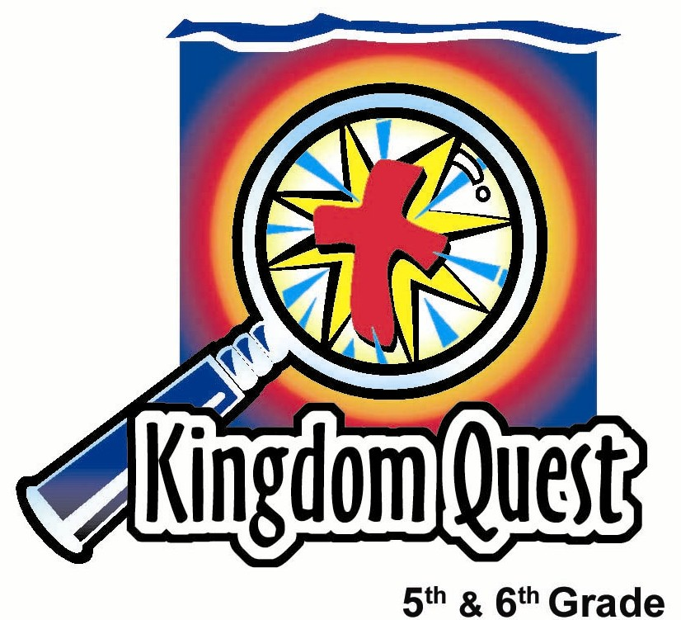
Date: _________________________
Series: Great Chapters of the Bible
(Dec-Feb) Year 2, Lesson 47

Suffering Servant Chapter:
Isaiah 53

Take Home Point: *Jesus took our punishment so we could go free.
*Repeat this phrase throughout the lesson.

Bible Event: Isaiah 52:13 to 53:12; 1 Peter 2:24-25
Key Verse: Isaiah 53:5b, “The punishment, which made us well, was given to Him, and we are healed because of His wounds.”

We will help kids know:
- Seven hundred years before Christ, Isaiah wrote about the coming Messiah that would be a suffering servant for His people.
- Jesus was punished in their place. He took the punishment of their sins upon Himself.
- They need to respond to Jesus’ sacrifice by repenting of their sin and receiving the freedom of His forgiveness.

We will help kids feel:
- Awe at the price of Jesus’ sacrifice for them.
- Grief over their own sin.

We will help kids do:
- Talk about punishments they have received and some of the “crimes” they have committed.
- See a visual illustration of a sin-bearer receiving the sin marks of the entire group.
- After an in-depth study of Isaiah 53, they will respond to the gospel by giving their sins to Jesus and placing their sin marks on a cross.
THIS LESSON’S ROADMAP

DESTINATION | PAGE # | DISCOVERIES ON YOUR JOURNEY | SUPPLIES NEEDED
  Small Group Warm-Up | 3 | Kids talk about and write messes they have done on a piece of foil with a marker. | - 12 X 12 inch piece of aluminum foil per group  - washable window markers or regular washable markers-one per group
Large Group   | 4  8  10  12 | Overview  Interactive Object Lesson: Kids participate in an activity that will capture emotion and understanding of a sin-bearer.  Video: They will watch a video of Jesus’ crucifixion.  Appendices | - foil pieces from small group  - lotion  - a volunteer contacted ahead of time and prompted in how to respond during the activity  - hat  - many slips of paper with the name of the volunteer on all of them and placed in the hat  - a small sign that reads, “YOU MUST MARK SOMEONE UP”  - Jesus of Nazareth video by Bridgestone Group Inc., 1995 or Gospel of John video by Visual Bible International, 2003. (see lesson link)
Small Group Application   | 4 | Kids study Isaiah 53 and wrap up the session with placing pieces of the messed up foil on a cross as a reminder of how God has taken our sin upon Himself.  Memory Verse Learning:  “Flip Flop!”  2 Cor 4:17 will be repeated for lessons 47- 50 to help the children know that God allowed challenges in life to be our character shapers. | - 5 X 8 inch cut-out of a cross per group (card stock or poster board)  - foil from small group  - Isaiah 53 chapter sheet for Great Chapters of the Bible folder (see appendix) per kid  - two chairs  - two pairs of flippers  - white board  - marker  - masking tape
Small Group Warm-Up: 15 minutes
Purpose: Get pointed in the right direction! Build relationships and help guests feel at ease. Do the learning readiness activity that will point your group in the right direction for the lesson.

As kids gather: Listen to memory verses from last week and give coupons for memory verses, remembering to bring your Bible, and bringing a guest.

Supplies: 12 x 12-inch piece of aluminum foil per group, washable window markers or regular washable markers

Lay the aluminum foil on a hard surface with the shiny side up.

Today we will discuss different punishments we have received. What is something you did wrong, and what was the punishment you received for it? For example, when I was your age, one time I…

Complete with a personal example.

Using the washable marker, write the example you shared on the foil. Then say:

As you share your wrongdoings and punishments, write them on this piece of foil with a marker.

Allow the discussion to continue for approximately ten minutes.

Can you think of serious crimes we have done to God? For example, have you ever failed to stand up for God? Have you ever failed to stand up for someone who was picked on? Have you ever taken God’s name and used it in a way that was not honoring to Him? Have you ever refused to think of yourself as belonging to God since He made you?

Have the kids continue to write any of these things on the foil sheet. Have the kids fill up the foil as much as possible. Then collect the markers. Have one student take the foil sheet to large group. Conclude with:

In large group, we will continue to talk about punishments. Today we are reminded that *Jesus took our punishment so we could go free.

Large Group Overview: 20-30 minutes
Purpose: Help kids observe what the Bible says. Present the Bible event in creative fashion. Help kids begin to interpret what it means.

Interactive Object Lesson: Kids participate in an activity that will capture emotion and understanding of a sin-bearer.

Video: Jesus of Nazareth video by Bridgestone Group Inc., 1995 (order from http://www.amazon.com/exec/obidos/tg/detail/-/6302643627/002-4057945-1179217?v=glance) or Gospel of John video by Visual Bible International, 2003 (order from http://www.christiancinema.com/catalog/product_info.php?products_id=752 )

Small Group Application: 20-25 minutes
Purpose: Help kids map out the meaning of the Bible event in their lives. Use the questions to stimulate discussion, but don't feel tied to them. Allow the Holy Spirit to guide you. Include personal examples from your own faith journey. The example of Christ at work in your life will leave lasting impressions of how Christ can work in the children's lives.

Use your Bibles! Children need to learn how to look up references and follow along when scripture is read aloud. Allow for quality time of prayer at the close of the lesson.

Observation Questions: What happened?
Read Isaiah 52:13-15 together.

How did Jesus fulfill the prophecy of these verses? Name as many ways as you can. (Jesus was praised and honored for His knowledge of scripture, His healings and miracles, and the wisdom He showed the religious leaders. When Pilate had Him beaten, He was hardly recognizable. He saved the world when He shed His blood for us.)

Continue in the same way, reading the scripture portion and then asking the above question:

Isaiah 53:1-3. (Jesus grew up the same as any young boy of His day. There was nothing exceptional about His physical looks or appearance. He was very normal. Later, the people despised Him and rejected Him. He was crucified like a criminal.)

Isaiah 53:4-5. (Jesus was wounded and beaten. Our sins and rebellious acts were placed upon Him and He carried them to the cross for us.)

Isaiah 53:6-7. (Jesus referred to His followers and us like sheep. He was the good shepherd. Sheep wander without their shepherd. Jesus remained silent when questioned by Herod. Lambs were sacrificed for sins of the people at Passover. It is said that Jesus died at about the same time the lamb for the Passover was sacrificed.)

Isaiah 53:8-9. (Jesus was arrested, taken away and judged. He was declared guilty even though He had done nothing wrong. He was crucified for our sins and He was buried in a rich man’s tomb.)

Isaiah 53:10-12. (It was God’s plan since the beginning to send a Savior for the sins of all people. Jesus had free will to follow God’s plan to the cross or not. He chose to die for us and God’s justice was served. Jesus lived a perfect life so He did not deserve death, but He willingly took what we deserve for our imperfect ways so we would be acquitted. Hebrews says that Jesus now sits on the throne at the right hand of God and intercedes for us.)

Interpretation Questions: What does this mean?
Read 1 Peter 2:24-25.

How is this passage like Isaiah 53:4-6? (Both passages describe how Jesus carried our sins on Himself. Both say His wounds healed us. And both passages describe us as lost sheep.)

How do Peter’s words give us hope and demonstrate the fulfillment of the Isaiah passage? (We are now freed from our sins to live a life that has God’s approval, and we can now come back to the shepherd of our lives.)

Application Questions: What does this mean to me?

Supplies: 5” X 8” cardboard cutout of a cross, Isaiah 53 sheet for each kid

Show kids the cross and say:

This cross helps us remember what Jesus did for each one of us. I would like you to tear off a piece of our foil and with the messy side facing in, wrap your foil around the cross.

The key verse from Isaiah 53:5b says, “He (Jesus) was punished so that we could have peace, and we received healing from His wounds.”

Jesus took the punishment for our sins. He was the sin-bearer. In return, Jesus gives us freedom, healing and peace.

When the kids have finished, the cross will look clean.
Look at our cross. It is clean. We see no sign of the messes we have made. This is just like our lives. Our sins have been erased. They have been taken care of, at one time, for all time. We can now have freedom, healing, and peace in place of all the messes.

I am going to keep this in my tub so we can be reminded of how God has taken our sin upon Himself. He promises to always do so as we turn to Him and give Him our messes. Today we remember that *Jesus took our punishment so we could go free.

Memory Verse Learning: 5 minutes
Purpose: Help kids to memorize and keep scriptures at heart. Using creative ways to help kids enjoy learning the key verse and in small group setting.

Supplies needed: two chairs, white board, markers, two pairs of flippers, masking tape

Memory Verse: 2 Corinthians 4:17, “We have small troubles for a while now, but they are helping us gain an eternal glory that is much greater than the troubles.” (NCV)

MV Presentation: “Flip Flop”
Before class, write the memory verse on the white board. Have all the children recite the memory verse several times. Randomly pick several children to recite the memory verse one child at a time. Recite the memory verse again together before the game begins. Use the masking tape to mark two starting lines. Place the two chair at the opposite end of the room. Divide the children into two groups and position them behind the starting line. At the shepherd’s signal, the first person from each team puts on the flippers, “flip flop” towards the chair, go around it and “flip flop” back to their team. But as a team member does that, every member must recite the memory verse. If anyone stops whoever “flip flopping” is not allowed to move. The team that completes in the quickest time, wins. In closing, have all the children recite the memory verse together.

Closing Prayer:
Spend time thanking God for allowing His only Son, Jesus, to die on the cross, taking our punishment so we can have freedom, healing, and peace.

Safety and Security: Safety and security procedures are important for each church to carefully define and implement according to their unique needs. The security, safety, illness and accident procedures described in this curriculum are provided for example purposes only and may not be appropriate, applicable or adequate for every situation. Each church is responsible for determining whether any security, safety, illness and accident procedures contained in the curriculum are appropriate, applicable or adequate for its unique situation. The activities described in this curriculum require adult supervision and may not be suitable for each child and each situation. Each church is responsible for ensuring that adequate adult supervision is provided for all activities and for determining whether an activity is appropriate for each child and each situation. Kids Kount Publishing disclaims all liability for the implementation of any procedures or the performance of any activities described in this curriculum.

Large Group Presentation

Great Chapters of the Bible
Jesus, the Suffering Servant – Isaiah 53

The large group presenter will assume the role of a librarian. His/her name will be either Ms. Rita Sim or Mr. Choon Meng. Costuming might include reading glasses (if you wear your own, place a piece of tape on the bridge), bow tie or special librarian hat. The presenter should portray the caricature of a “bookworm.”

Ms. Rita Sim or Mr. Choon Meng will introduce the favorite chapters in the best book in the library, the Bible. This librarian operates with a different set of rules than what is typical. Instead of the rule “no chewing gum,” now kids must chew gum and play with it. Every week, a new rule will be revealed.

The stage for large group should be set up to look like a library: a bookshelf with some books, maybe a desk, and an old computer. Make it as elaborate as you would like. A sign should be hung somewhere that says “RULES of the Library.” Each week a new goofy rule will be revealed.

Supplies: pieces of foil from small group, a small sign that reads, “YOU MUST MARK SOMEONE UP,” lotion, hat, many slips of paper with the volunteer’s name written on each of them and put inside the hat, Jesus of Nazareth video or Gospel of John video

The activity used at the beginning of large group is done to capture emotion. The kids will rub the “messes” they have written on the foil onto another child’s face and hands.

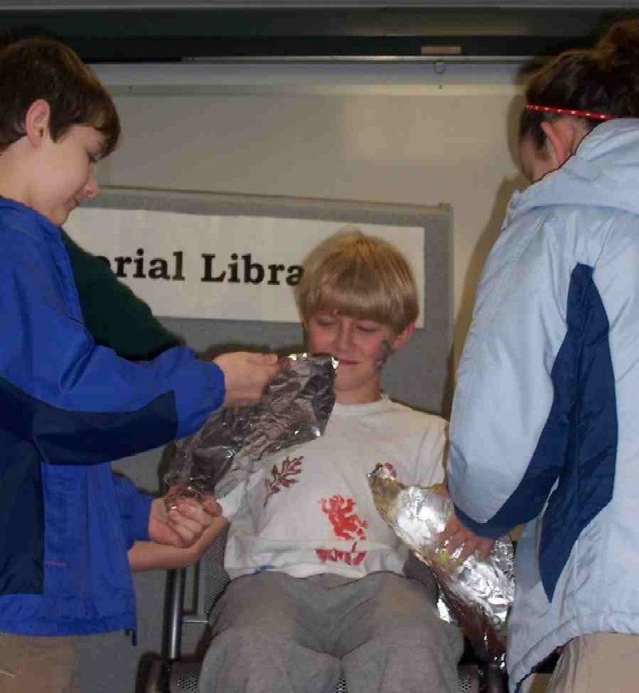
In advance, select a student who is somewhat serious in nature and is able to act. He/she must be willing to have ink smeared on his/her face and hands. Let him/her know that the presenter’s attitude during this activity will go from endearment to indifference. Remind him/her that this is not personal, but an act to help everyone have a greater understanding of the sins that Jesus bore for them. Also, make sure this student does not laugh or make light of the “messes” being placed on him/her. He/she should act upset.

The Suffering Servant
Isaiah 53

Introduction of Ms. Rita Sim / Mr. Choon Meng

Hello, I am Mr. Choon Meng (or Ms. Rita Sim) of the _______________ (put in your church name) Memorial Library. This is a very special and unique library. When I am in charge, the rules are a little different than what you would see at your school or city library. Today’s goofy rule is: YOU MUST MARK SOMEONE UP.

In most libraries, it is against the rules to mess with another person by marking on them. However, not here. In this library, someone must be marked on, and the bigger the mess, the better!

Selection process

Lead the kids to believe that you have all their names in a hat, when actually you only have one name on several slips. That name belongs to the student selected ahead of time for this activity.

Draw out a slip of paper and read the name of the volunteer.

Come on up and have a seat on this chair. It’s reserved for a very special person—you.

We are so glad you are here today to help us out. I have a very special treat for you. This is lotion that smells very good and will make your skin feel so soft. I would like to treat you in a very special way by putting lotion on your face and arms.
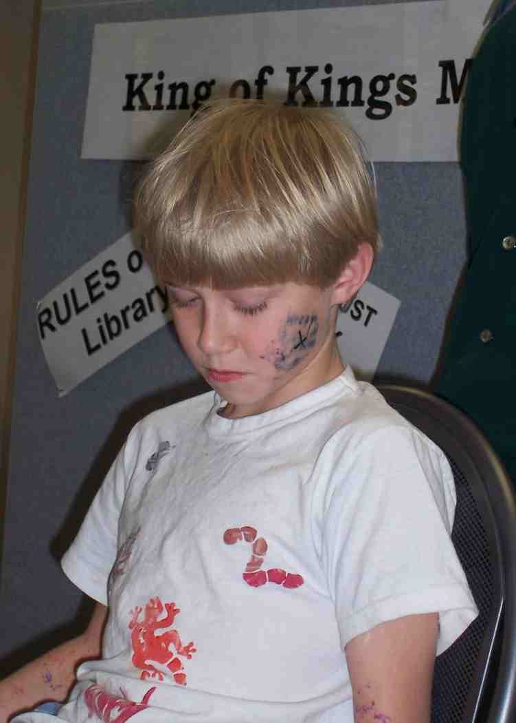
Spread the lotion on the helper’s face and arms. This should be done in an attitude of endearment. (This will also help the marker that will be rubbed on him/her come off easier when the activity is done.)

We are so thankful that even though you were chosen, you have volunteered to come forward.

Placing the messes on the volunteer

Say to the audience:

I saw you all walk in with sheets of foil. Who can tell me what was written on those sheets?

Let kids share some ways they messed up.

Those pieces of foil look pretty dirty. You have all had quite a few mess-ups. Well, we will now take care of those messes.

Choose a student from each group to come forward, one at a time.

I would like you to try and get these messes off your page and onto our volunteer. You will do this by pressing the foil where you have written, onto the face or arms of our volunteer. Press firmly and the writing will be imprinted on our wonderful volunteer.

The volunteer should look shocked and worried.

Continue until all have had a chance. As this is going on, the presenter needs to change his/her tone with the volunteer to become more indifferent or scornful.

Messes require punishment
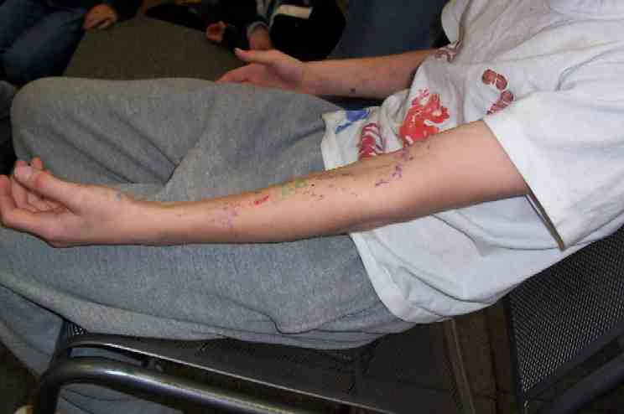
As groups are coming up to put their messes on the volunteer, say the following.

Messes require punishment. I want you to think about all the punishments that were received for all these “mess-ups.” Wouldn’t it be wonderful if instead of you having to take those punishments, that this person (point to your volunteer) would take them for you? Is this wonderful or not?

Discuss. Some will say “yes,” then they wouldn’t have to have the punishment. Others will say it isn’t fair.

What would happen if you were supposed to receive a punishment so horrible that you could not bear it? This person (referring to the volunteer) is the only one who could take it. This person is the sin-bearer—the one who has taken other people’s messes and placed them on himself/herself.

Seven hundred years before Jesus was born, the prophet Isaiah through the inspiration of God, looked into the future and wrote this as recorded in Isaiah 53:4-5,

“But He took our suffering on Him and felt our pain for us. We saw His suffering and thought God was punishing Him. But He was wounded for the wrong we did; He was crushed for the evil we did. The punishment, which made us well, was given to Him, and we are healed because of His wounds.”

So, who is our volunteer like? (Jesus.) Jesus suffered the punishment for all our messes so we would never have to. When Jesus died on the cross, our sins were attached to Him. God’s condemnation to us was given to His Son Jesus. It is as if Jesus experienced hell or separation from God when He was punished in our place. He did this so we wouldn’t have to receive that punishment.

Reviewing the activity

How did you feel as you watched our volunteer covered with all of our messes? At first it might have seemed funny, but then did any of you start feeling sorry for him/her? Did you feel bad that your messes were on him/her? Did it seem fair or not?

This is exactly what happened when God sent His only Son Jesus to die in our place on the cross.

Watch a video clip of the crucifixion

Option 1: The suggested clip is taken from the Jesus of Nazareth video series (Bridgestone Group Inc.—1995—. Order from http://www.amazon.com/exec/obidos/tg/detail/-/6302643627/002-4057945-1179217?v=glance)

Start viewing from Jesus’ final walk up the hill carrying His cross and ending ten minutes later right after Isaiah had been quoted. We see a pained expression on Jesus’ face and a look from Mary Magdalene at the foot of the cross.

Option 2: Continue the video three minutes longer when Jesus says “it is completed,” and Jesus is left on the cross alone. If you do this option, make sure you move quickly through the beginning activity to leave enough time in small group to fully read and discuss Isaiah 53.

(There is a significant part in this video where Isaiah 53 is quoted. It states, “He was despised and rejected of men. A man of sorrows, acquainted with grief. He was oppressed, and afflicted, but He opened not His mouth. He was lead as a lamb to slaughter, and as a sheep before a shearer. Surely, He has borne our griefs. Though we esteemed Him stricken, smitten of God and afflicted. He was wounded for our transgressions, He was abused for our iniquities, and through His wounds we are healed.” Be sure that it is shown.)

Option 3: Watch the same scene from the Gospel of John video or the Visual Bible: Matthew, produced by Visual Bible International. Order from: http://www.christiancinema.com/catalog/product_info.php?products_id=752.

Do you think it was fair that Jesus, who did no wrong, became the sin-bearer and suffered this horrible punishment for us? Discuss.

Prayer:

Dear Father God, we thank You that You sent Your Son Jesus to take our messes upon Himself and to take the punishment for them on the cross. Thank You that we are freed from our sin and can live our lives filled with hope and peace. In Jesus’ name. Amen.

Kids return to small group where they will do more in-depth reading of Isaiah 53. Have them take their foil back to small group for the application activity.

Lesson 47
Small Group Warm-Up
- 12 X 12 inch piece of aluminum foil per group
- washable window markers or regular washable markers-one per group

Large Group
- foil pieces from small group
- lotion
- a volunteer contacted ahead of time and prompted in how to respond during the activity
- hat
- many slips of paper with the name of the volunteer on all of them and placed in the hat
- a small sign that reads, “YOU MUST MARK SOMEONE UP”
- Jesus of Nazareth video by Bridgestone Group Inc., 1995 or Gospel of John video by Visual Bible International, 2003. (see lesson link)

Small Group Application
- 5 X 8 inch cut-out of a cross per group (card stock or poster board)
- foil from small group
- Isaiah 53 chapter sheet for Great Chapters of the Bible folder (see appendix) per kid

Memory Verse Learning
- two chairs
- white board
- marker
- two pairs of flippers
- masking tape

YOU MUST

MARK

SOMEONE UP.


ISAIAH 53
The Suffering Servant

Who has believed our message? To whom has the LORD’s power
been revealed? He grew up in his presence like a young tree, like a root out of dry ground. He had no form or majesty that would make us look at him. He had nothing in his appearance that would make us desire him. He was despised and rejected by people.

He was a man of sorrows familiar with suffering. He was despised like one from whom people turn their faces, and we didn’t consider him to be worth anything. He certainly has taken upon himself our suffering and carried our sorrows, but we thought that God had wounded him, beat him, and punished him. He was wounded for our rebellious acts. He was crushed for our sins. He was punished so that we could have peace and we received healing from his wounds.

We have all strayed like sheep. Each one of us has turned to go his own way, and the LORD has laid all our sins on him. He was abused and punished, but he didn’t open his mouth. He was led like a lamb to the slaughter. He was like a sheep that is cut off. He didn’t open his mouth.

He was arrested taken away, and judged. Who would have thought that he would be removed from the world? He was killed because of my people’s rebellion. He was placed in a tomb with the wicked. He was put there with the rich when he died, although he had done nothing violent and had never spoken a lie.

Yet, it was the LORD’s will to crush him with suffering. When the LORD has made his life a sacrifice for our wrong doings, he will see his descendants for many days. The will of the LORD will succeed through him. He will see and be satisfied because of his suffering. My righteous servant will acquit many people because of what he has learned through suffering. He will carry their sins as a burden.

So I will give him a share among the mighty, and he will divide the prize with the strong, because he poured out his life in death and he was counted with sinners. He carried the sins of many. He intercedes for those who are rebellious.
ISAIAH 53
The Suffering Servant

Who has believed our message? To whom has the LORD’s power been revealed? He grew up in his presence like a young tree, like a root out of dry ground. He had no form or majesty that would make us look at him. He had nothing in his appearance that would make us desire him. He was despised and rejected by people.

He was a man of sorrows familiar with suffering. He was despised like one from whom people turn their faces, and we didn’t consider him to be worth anything. He certainly has taken upon himself our suffering and carried our sorrows, but we thought that God had wounded him, beat him, and punished him. He was wounded for our rebellious acts. He was crushed for our sins. He was punished so that we could have peace and we received healing from his wounds.

We have all strayed like sheep. Each one of us has turned to go his own way, and the LORD has laid all our sins on him. He was abused and punished, but he didn’t open his mouth. He was led like a lamb to the slaughter. He was like a sheep that is cut off. He didn’t open his mouth.

He was arrested taken away, and judged. Who would have thought that he would be removed from the world? He was killed because of my people’s rebellion. He was placed in a tomb with the wicked. He was put there with the rich when he died, although he had done nothing violent and had never spoken a lie.

Yet, it was the LORD’S will to crush him with suffering. When the LORD has made his life a sacrifice for our wrong doings, he will see his descendants for many days. The will of the LORD will succeed through him. He will see and be satisfied because of his suffering. My righteous servant will acquit many people because of what he has learned through suffering. He will carry their sins as a burden.

So I will give him a share among the mighty, and he will divide the prize with the strong, because he poured out his life in death and he was counted with sinners. He carried the sins of many. He intercedes for those who are rebellious.

