
Date: _________________________
Series: Great Chapters of the Bible
(Apr-May) Year 2, Lesson 49

New Life

Take Home Point: *This body wears out—our new one will wear forever. *Repeat this phrase throughout the lesson.

Bible Event: 1 Corinthians 15:3-6; 42-44; 51-57 (NIV)
Key Verse: 1 Corinthians 15:54, “So this body that can be destroyed will clothe itself with that which can never be destroyed, and this body that dies will clothe itself with that which can never die. When this happens, this Scripture will be made true: "Death is destroyed forever in victory." (NCV)

We will help kids know:
- Death is turned into victory because Jesus died for them and rose from the dead.
- Those who trust in Him will receive a new spiritual body in heaven to live with Him forever.
- The Bible describes their bodies as perishable clothing and their heavenly bodies as imperishable.

We will help kids feel:
- Confident in their eternal future as they put their trust in Christ.
- Aware of the reality of death without reactions of great fear, but rather comfort in Christ’s victory.

We will help kids do:
- Identify favorite articles of clothing that wear out. These will be compared to their bodies.
- Talk about their experiences and emotions regarding death.
- Pray claiming the victory of Jesus’ death and resurrection for them so they have confidence in a forever future.
- Make a reminder with fabric that even though their bodies wear out, they can live forever.
THIS LESSON’S ROADMAP

DESTINATION | PAGE # | DISCOVERIES ON YOUR JOURNEY | SUPPLIES NEEDED
  Small Group Warm-Up | 3 | Kids talk about their favorite article of clothing and understand these clothes will wear out someday just like our bodies. | - a favorite old article of clothing
Large Group   | 3  6 | Overview  Kids have a dress-up competition among the groups to introduce 1 Corinthians 15. They learn what perishable and imperishable mean and how they apply to our old perishable bodies on earth and our new imperishable bodies in heaven. | - prizes for the winning group (old unmatched socks or old clothes) Be creative.  - large group presenter needs a new bright colored shirt or jacket to put on  - hat  - appendix page with the questions cut apart but kept in order  - sign—NO NORMAL CLOTHES IN THIS LIBRARY  - tape off a modeling runway prior to presentation  - Option: music for “modeling”  - Option: dress up a shepherd instead of kid  - Option: overheads of scripture or microphones for those who speak softly
Small Group Application   | 4  6 | Talk about death and decorate fabric to place in their Great Chapters of the Bible booklet. This will be a reminder that even though their bodies wear out, they can have life with God forever in heaven.  Memory Verse Learning:  “Step-by-Step”  2 Cor 4:17 will be repeated for lessons 47- 50 to help the children know that God allowed challenges in life to be our character shapers. | - 1 Corinthians 15 page copied for each kid  - scraps of fabric  - sequins, ribbon, other decorating notions  - markers  - glue and/or double-sided tape  - a pair of footprints or shoe-prints made from manila card  - masking tape  - a chair for each team

Small Group Warm-Up: 15 minutes
Purpose: Get pointed in the right direction! Build relationships and help quests feel at ease. Do the learning readiness activity that will point your group in the right direction for the lesson.

Supplies: a favorite old article of clothing from home (the more worn the better)

Show the kids your favorite old article of clothing and say:

This is my favorite article of clothing. I love to wear it because it is so comfortable. As you can tell, I have worn it for a long time.

Ask the kids to each share the following:

What is your favorite article of clothing? Is it old or new?

How long do you think you will keep this favorite article of clothing?

Let’s imagine that your body is a set of clothes. We wear it for a while and then it is worn out. How long do you think this “set of clothes” or this body will last?

Is it scary for you to think that someday your body will wear out and you will die?

In large group we will talk more about this “set of clothes” that is perishable, but we will also find out how to get a new set that is imperishable. *This body wears out—our new one will wear forever.

Large Group Overview: 20-30 minutes
Purpose: Help kids observe what the Bible says. Present the Bible event in creative fashion. Help kids begin to interpret what it means.

Kids have a dress-up competition among the groups to introduce 1 Corinthians 15. They learn what perishable and imperishable mean and how they apply to our old perishable bodies on earth and our new imperishable bodies in heaven.

Small Group Application: 20-25 minutes
Purpose: Help kids map out the meaning of the Bible event in their lives. Use the questions to stimulate discussion, but don't feel tied to them. Allow the Holy Spirit to guide you. Include personal examples from your own faith journey. The example of Christ at work in your life will leave lasting impressions of how Christ can work in the children's lives.

Use your Bibles! Children need to learn how to look up references and follow along when scripture is read aloud. Allow for quality time of prayer at the close of the lesson.

Observation Questions: What happened?

Have kids refer to 1 Corinthians 15 in their Bibles or on their Great Chapters of the Bible page (hand-out).

Read together 1 Corinthians 15:3-6.

What is the most important teaching that Paul passed on? (That Jesus died for our sins, that He was placed in a tomb, and that He was brought back to life on the third day as the scriptures predicted. The twelve disciples and 500 other believers saw Him after He arose.)

Read 1 Corinthians 15:51-54.

What will happen to us all at the last trumpet? (Verse 52. In a flash, we will be changed. The dead will be raised imperishable.)

Interpretation Questions: What does this mean?
What does it mean for the perishable to be clothed with the imperishable, the mortal with immortality? (Our bodies will change from those that get old, die and decay, to those that last forever.)

Our key verse 1 Corinthians 15:54 says, “When the perishable has been clothed with the imperishable, and the mortal with immortality, then the saying that is written will come true: ‘Death has been swallowed up in victory.’” (NIV)

How has death been swallowed up in victory? (Death is not the end for believers but the beginning of eternal life with God in heaven.)

Who won this victory for us? (Jesus.)

How can we be a part of this victory? (Believe that Jesus is the Savior and has won salvation for us.)

Application Questions: What does this mean to me?

Supplies: 1 Corinthians 15 page (one per student), scraps of fabric, markers, ribbon, sequins or other supplies available to decorate the fabric, glue, or double-sided tape

What do you think heaven will to be like? (The best thing is there will be no sin. In heaven, we will enjoy an incredible relationship with God and others. There will be a lot of activity and all of it will bring glory to God and joy to the people doing the activity.)

On a scale from one to ten, one being the least and ten the most, how afraid are you of dying? (This question is to stimulate further discussion about heaven.)

Today we learned that *this body wears out—our new one will wear forever. How does this change (or not change) how you feel about death?

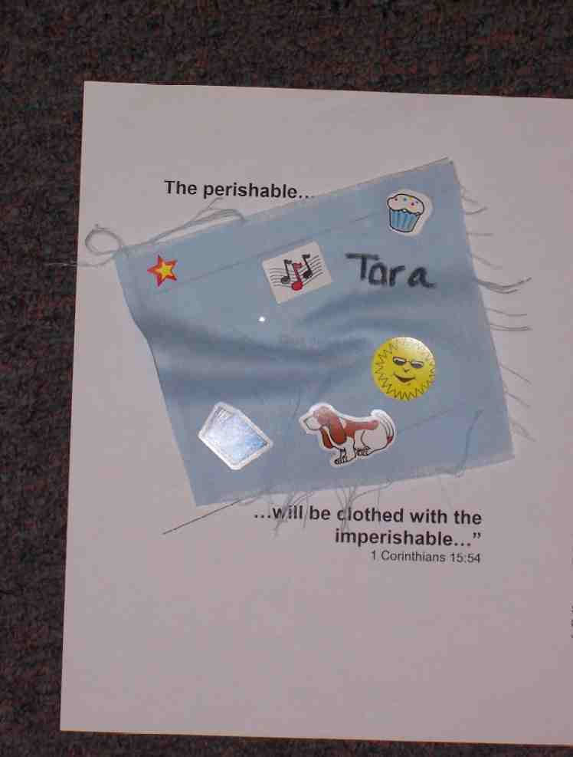
Pass out the page to be placed into their book of Great Chapters of the Bible. Have the kids cut out a piece of fabric to fit in the center of the page. They can decorate it however they would like, but they should personalize it with their name. This is a reminder that our “old clothes” will perish, but we will receive new ones in heaven through faith in Jesus Christ.

Memory Verse Learning: 5 minutes
Purpose: Help kids to memorize and keep scriptures at heart. Using creative ways to help kids enjoy learning the key verse and in small group setting.

Supplies needed: a pair of footprints or shoe-prints made from manila card, masking tape, a chair for each team

Memory Verse: 2 Corinthians 4:17, “We have small troubles for a while now, but they are helping us gain an eternal glory that is much greater than the troubles.” (NCV)
MV Presentation: “Step-by-Step”
Before class, set two parallel lines 10 feet apart with masking tape. Gather the children and say that today relay is a Mini Olympics called “Step-by-Step.” Demonstrate: recite 2 Cor. 4:17 then put one footstep down and stepping on it; putting the next footstep ahead and stepping on it with the other feet; pick up the one behind and place it in front for the next step, continue doing as one has to reach chair to make a U-turn back. Now divide the children into two groups and set them behind one line. Before the game begins, have all the children recite the memory verse together. Repeat until all the children are able to recite the verse accurately. Also tell the children that if their feet touch the floor, one have to come back to the starting line and begin again. The team that finishes the course first is the winner. Before prayer, have all the teams recite the memory verse again.

Closing Prayer:

Thank God for the victory over death we have received because of Jesus. Ask that the Holy Spirit comfort us when we fear death and remind us that it is not the end but the beginning for believers in Christ. Pray to share this good news with others who do not believe in the hope of the resurrection.
Safety and Security: Safety and security procedures are important for each church to carefully define and implement according to their unique needs. The security, safety, illness and accident procedures described in this curriculum are provided for example purposes only and may not be appropriate, applicable or adequate for every situation. Each church is responsible for determining whether any security, safety, illness and accident procedures contained in the curriculum are appropriate, applicable or adequate for its unique situation. The activities described in this curriculum require adult supervision and may not be suitable for each child and each situation. Each church is responsible for ensuring that adequate adult supervision is provided for all activities and for determining whether an activity is appropriate for each child and each situation. Kids Kount Publishing disclaims all liability for the implementation of any procedures or the performance of any activities described in this curriculum.

Large Group Presentation: 20 minutes

Great Chapters of the Bible

The large group presenter will assume the role of a librarian. His/her name will be either Ms. Rita Sim or Mr. Choon Meng. Costuming might include special reading glasses (if you wear your own, place a piece of tape on the bridge), bow tie or special librarian hat. The presenter should portray the caricature of a “bookworm.”

Ms. Rita Sim or Mr. Choon Meng will introduce the favorite chapters in the best book in the library, the Bible. This librarian operates with a different set of rules than what is typical. Instead of the rule “no chewing gum,” now kids must chew gum and play with it. Every week, a new rule will be revealed.

The stage for large group should be set up to look like a library: a bookshelf with some books, maybe a desk, and an old computer. Make it as elaborate as you would like. A sign should be hung somewhere that says “RULES of the Library.”

Supplies: sign—NO NORMAL CLOTHES IN THIS LIBRARY, the “librarian” should dress in old clothes for today’s lesson, have a new colorful shirt, blouse, or nice jacket to put on (an example would be a Hawaiian shirt), prizes for the most outrageous outfit (this could be unmatched old socks for each, old doll clothes, etc.), hat, appendix page with the questions cut apart but kept in order

Options: a runway marked down the center of large group area with tape prior presentation; use a shepherd instead of kid to dress; music and player to go with the runway walk; prepare overheads of scripture to be read by kids; microphone (to hear those with soft voices)

The Resurrection Chapter
1 Corinthians 15
Audience Participation Teaching of the Resurrection Chapter

Today’s lesson is taken from the NIV translation.

Introduction of Ms. Rita Sim/ Mr. Choon Meng

Hello, I am Mr. Choon Meng (or Ms. Rita Sim) of the _____________ (insert your church name) Memorial Library. This is a very special and unique library. When I am in charge, the rules are a little different than what you would see at your school or city library. Today we will strictly enforce our dress code rule: NO NORMAL CLOTHES IN THIS LIBRARY.

I see that all of you are already breaking the rules! How dare you! I will insist that each group select one person who will keep my rule completely: NO NORMAL CLOTHES IN THIS LIBRARY.

Choose one person from your group who you will dress up. You may use any clothing you find to complete the ensemble. If you would like your person to wear belts for earrings, that would be lovely. Socks for gloves would be a great fashion statement.

Following this activity, we will have a modeling competition and prize for the best non-normal outfit. I will look for the MOST outrageous outfit designed by the group in three minutes. I will have a very special prize for the winning group. Are you ready? Go.

Model Show and Prizes for the Winning Team

When three minutes are up, have the “models” come forward and walk the runway showing off their very unusual outfit. (If you have music available, play it during the ”modeling” segment.)

To the models, say:

Included in the points for the outfit, I am also adding presentation points for how well you model your outfit on the runway.

Have one person at a time come forward and model. Judge them and give prizes to the winning team. The sillier the prize the better, an example might be an old unmatched pair of socks, old shirts, or old worn-out shoes. Be creative.

After the contest, have the models return to their seats.

The Most Important Thing: Jesus’ Death and Resurrection

Take the Bible off the shelf and say:

In our library, the most important book is the Bible. Today, we will look at another great chapter that talks about how we can wear clothes that won’t ever become old and worn out. These aren’t clothes that you put on your body, but rather they ARE your body. It is a new body you will receive someday if you put your faith in Jesus Christ.

We will have a competition to see if the boys or girls are better listeners. As I read the following scriptures, I will have questions in this hat that one girl and one boy will draw and try to answer. If answered correctly, your team will receive a point. Let’s see who are the best listeners, the boys or the girls.

Choose one boy and one girl to come forward.
BE SURE TO READ FROM AN NIV TRANSLATION.

Round One: The Most Important Thing
Read 1 Corinthians 15:3-6. Let a girl draw one of the following questions from the hat and answer it. Then have a boy pull out the last question, read it, and answer.

Cut apart the questions for “the most important thing” and put in the hat:

This is from 1 Corinthians 15:3-6. Listen closely. Read the verses.

From what book of the Bible and what chapter did I just read? (1 Corinthians 15.)

What was the most important thing Paul had to say in these verses? (Jesus died, was buried and rose again on the third day.)

Congratulate the contestants and write down the points from the first round. Have kids sit down.

Round Two: Understanding of Perishable and Nonperishable

For the second round, I will keep reading in 1 Corinthians 15:42-44. Before I read this though, I need everyone to know what the word perishable means. Who can tell me? (Something that will decay or die.) Super! Now I need two more contestants, a boy and a girl, to answer the next round of questions.

Choose a boy and a girl. Read the scripture and place the next two questions in the hat. Have the boy draw a question first this time.

Questions to be placed in the hat are:

When Paul talks about the body perishing, what is he describing? (Death.)

What does Paul mean when he talks about the body raised as an imperishable body? (This is what it is going to be like in heaven with our new bodies that won’t wear out.)

Have contestants sit down and record the points.

Round Three: Death Has Been Swallowed Up in Victory

This will be our third and final round. Who would like to answer the questions for this next set of verses?

Choose another boy and girl. Read from 1 Corinthians 15:51-57. Again place the questions for this round in the hat. Have the girl draw out first and answer the question, and then the boy.

These are the two question placed in the hat:

What does it mean for the perishable to clothe itself with the imperishable? (The old body, which is dead, becomes new.)

Who gives us victory over death? (Jesus Christ.)

Add up the points and announce the winners.

A Change in Clothing

Take out your Hawaiian shirt (or bright colored shirt or jacket).

Here is a shirt that is nicer than the one that I am wearing. This is a picture of what God does for us. Our souls are clothed with a body. This body will eventually wear out just like clothes wear out. Our bodies wear out because sin has come into the world. Everyone dies.

Jesus, God’s Son, came into the world and had a perishable body just like you and me. On Jesus’ body all the sin of the world was placed. This body died on the cross. Three days later Jesus rose from the dead. He proved that He defeated death. Now, instead of death being the end of life, it is now the beginning of life forever with God.

When we reach heaven we are given a new set of “clothes” or a new body. If we trust in Jesus and put our faith in Him as our Savior, we will receive this new set of clothes. Now, these are not an ordinary set of clothes. They are better than anything we have ever owned! They are festive and joyful, just like heaven. A great celebration will happen in heaven when we are with God who loves us so very much.

In heaven, our bodies will NEVER wear out. They will be perfect, yet each one will be unique and beautiful. They will be SUPER bodies. Who knows, maybe we will be able to fly.

Let’s close with a word of prayer.

Dear Lord Jesus, thank You that You swallowed death in victory. You offer a forever life to anyone who trusts You as their Savior, surrendering their life to You. If there is anyone here today that is not sure about what happens to them after death, and they are afraid of being cut-off from You, please help them place their trust in You. Help them respond to Your Holy Spirit by praying with me:

“Jesus, I admit I am a sinner. I need Your forgiveness. I am sorry for my sin. I believe You died and rose for me, and because of that, I believe Your word that tells me that when this body is worn out, You will give me a new one that will last forever in heaven with You. In Jesus’ name. Amen.”

Lesson 49
Small Group Warm-Up
- a favorite old article of clothing

Large Group
- prizes for the winning group (old unmatched socks or old clothes) Be creative.
- large group presenter needs a new bright colored shirt or jacket to put on
- hat
- appendix page with the questions cut apart but kept in order
- sign—NO NORMAL CLOTHES IN THIS LIBRARY
- tape off a modeling runway prior to presentation
- Option: music for “modeling”
- Option: dress up a shepherd instead of kid
- Option: overheads of scripture or microphones for those who speak softly

Small Group Application
- 1 Corinthians 15 page copied for each kid
- scraps of fabric
- sequins, ribbon, other decorating notions
- markers
- glue and/or double-sided tape

Memory Verse Learning
- a pair of footprints or shoe-prints made from manila card
- masking tape
- a chair for each team
Lesson 49
Questions for Large Group

The Most Important Thing

1) From what book of the Bible and what chapter did I just read?

2) What was the most important thing Paul had to say in these verses?

Understanding perishable and imperishable

1) When Paul talks about the body perishing, what is he describing?

2) What does Paul mean when he talks about the body raised as an imperishable body?

Death has been swallowed up in victory

1) What does it mean for the perishable to clothe itself with the imperishable?

2) Who gives us victory over death?

NO

NORMAL

CLOTHES

IN THIS

LIBRARY
The perishable…

Glue decorated
cloth here.

…will be clothed with the imperishable…”
1 Corinthians 15:54

The RESURRECTION Chapter
1 Corinthians 15

Vs 3-6, Paul speaking. “I passed on to you the most important points of doctrine that I had received:
Christ died to take away our sins as the Scriptures predicted.
He was placed in a tomb.
He was brought back to life on the third day as the Scriptures predicted.
He appeared to Cephas. Next he appeared to the twelve apostles. Then he appeared to more than 500 believers at one time ...”

Vs 42-44, “That is how it will be when the dead come back to life. When the body is planted, it decays. When it comes back to life, it cannot decay. When the body is planted, it doesn’t have any splendor and is weak. When it comes back to life, it has splendor and is strong. It is planted as a physical body. It comes back to life as a spiritual body. As there is a physical body, so there is also a spiritual body.”

Vs 51-57, “I’m telling you a mystery. Not all of us will die, but we will all be changed. It will happen in an instant, in a split second at the sound of the last trumpet. Indeed, that trumpet will sound, and then the dead will come back to life. They will be changed so that they can live forever. This body that decays must be changed into a body that cannot decay. This mortal body must be changed into a body that will live forever. When this body that decays is changed into a body that cannot decay, and this mortal body is changed into a body that will live forever, then the teaching of Scripture will come true:
‘Death is turned into victory!
Death, where is your victory?
Death, where is your sting?’
Sin gives death its sting, and God’s standards give sin its power. Thank God that he gives us the victory through our Lord Jesus Christ.”

